**Report for MARTHA**

**Contents**

**1** **Nausea** 15

**1.1** **Distribution of dose across drugs** 15

**1.2** **Network graph** 16

**1.3** **Pairwise MA** 16

**1.3.1** **Grouping all drugs together, comparison vs. placebo** 16

**1.3.2** **Meta-analyses of comparisons with 10 or more studies** 17

**1.4** **Assessment of transitivity** 17

**1.5** **NMA** 19

**1.5.1** **Comparison vs. placebo** 19

**1.5.2** **Ranking according to P-scores** 20

**1.5.3** **Local inconsistency** 21

**1.5.4** **League table** 22

**1.5.5** **Estimated event rates** 24

**1.6** **Sensitivity analysis: splitting nodes according to dosage** 24

**1.7** **Sensitivity analysis: Keeping only low dropout arms** 26

**1.8** **Sensitivity analysis: Bayesian NMA** 27

**2** **Headache** 28

**2.1** **Distribution of dose across drugs** 28

**2.2** **Network graph** 29

**2.3** **Pairwise MA** 29

**2.3.1** **Grouping all drugs together, comparison vs. placebo** 29

**2.3.2** **Meta-analyses of comparisons with 10 or more studies** 30

**2.4** **Assessment of transitivity** 30

**2.5** **NMA** 32

**2.5.1** **Comparison vs. placebo** 32

**2.5.2** **Ranking according to P-scores** 33

**2.5.3** **Local inconsistency** 34

**2.5.4** **League table** 35

**2.5.5** **Estimated event rates** 37

**2.6** **Sensitivity analysis: splitting nodes according to dosage** 37

**2.7** **Sensitivity analysis: Keeping only low dropout arms** 39

**3** **Dry mouth** 40

**3.1** **Distribution of dose across drugs** 40

**3.2** **Network graph** 41

**3.3** **Pairwise MA** 41

**3.3.1** **Grouping all drugs together, comparison vs. placebo** 41

**3.3.2** **Meta-analyses of comparisons with 10 or more studies** 42

**3.4** **Assessment of transitivity** 42

**3.5** **NMA** 44

**3.5.1** **Comparison vs. placebo** 44

**3.5.2** **Ranking according to P-scores** 45

**3.5.3** **Local inconsistency** 46

**3.5.4** **League table** 47

**3.5.5** **Estimated event rates** 49

**3.6** **Sensitivity analysis: splitting nodes according to dosage** 49

**3.7** **Sensitivity analysis: Keeping only low dropout arms** 51

**4** **Insomnia** 52

**4.1** **Distribution of dose across drugs** 52

**4.2** **Network graph** 53

**4.3** **Pairwise MA** 53

**4.3.1** **Grouping all drugs together, comparison vs. placebo** 53

**4.3.2** **Meta-analyses of comparisons with 10 or more studies** 54

**4.4** **Assessment of transitivity** 54

**4.5** **NMA** 56

**4.5.1** **Comparison vs. placebo** 56

**4.5.2** **Ranking according to P-scores** 57

**4.5.3** **Local inconsistency** 57

**4.5.4** **League table** 58

**4.5.5** **Estimated event rates** 60

**4.6** **Sensitivity analysis: splitting nodes according to dosage** 60

**4.7** **Sensitivity analysis: Keeping only low dropout arms** 62

**5** **Sedation/somnolence** 63

**5.1** **Distribution of dose across drugs** 63

**5.2** **Network graph** 64

**5.3** **Pairwise MA** 64

**5.3.1** **Grouping all drugs together, comparison vs. placebo** 64

**5.3.2** **Meta-analyses of comparisons with 10 or more studies** 65

**5.4** **Assessment of transitivity** 65

**5.5** **NMA** 67

**5.5.1** **Comparison vs. placebo** 67

**5.5.2** **Local inconsistency** 69

**5.5.3** **League table** 70

**5.5.4** **Estimated event rates** 72

**5.6** **Sensitivity analysis: splitting nodes according to dosage** 72

**5.7** **Sensitivity analysis: Keeping only low dropout arms** 74

**6** **Dizziness** 75

**6.1** **Distribution of dose across drugs** 75

**6.2** **Network graph** 76

**6.3** **Pairwise MA** 76

**6.3.1** **Grouping all drugs together, comparison vs. placebo** 76

**6.4** **Assessment of transitivity** 77

**6.5** **NMA** 79

**6.5.1** **Comparison vs. placebo** 79

**6.5.2** **Local inconsistency** 80

**6.5.3** **League table** 81

**6.5.4** **Estimated event rates** 83

**6.6** **Sensitivity analysis: splitting nodes according to dosage** 83

**6.7** **Sensitivity analysis: Keeping only low dropout arms** 85

**7** **Diarrhoea** 86

**7.1** **Distribution of dose across drugs** 86

**7.2** **Network graph** 87

**7.3** **Pairwise MA** 87

**7.3.1** **Grouping all drugs together, comparison vs. placebo** 87

**7.3.2** **Meta-analyses of comparisons with 10 or more studies** 89

**7.4** **Assessment of transitivity** 89

**7.5** **NMA** 90

**7.5.1** **Comparison vs. placebo** 90

**7.5.2** **Ranking according to P-scores** 91

**7.5.3** **Local inconsistency** 92

**7.5.4** **League table** 92

**7.5.5** **Estimated event rates** 94

**7.6** **Sensitivity analysis: splitting nodes according to dosage** 94

**7.7** **Sensitivity analysis: Keeping only low dropout arms** 96

**8** **Constipation** 97

**8.1** **Distribution of dose across drugs** 97

**8.2** **Network graph** 98

**8.3** **Pairwise MA** 98

**8.3.1** **Grouping all drugs together, comparison vs. placebo** 98

**8.3.2** **Meta-analyses of comparisons with 10 or more studies** 99

**8.4** **Assessment of transitivity** 99

**8.5** **NMA** 100

**8.5.1** **Comparison vs. placebo** 100

**8.5.2** **Ranking according to P-scores** 101

**8.5.3** **Local inconsistency** 102

**8.5.4** **League table** 102

**8.5.5** **Estimated event rates** 104

**8.6** **Sensitivity analysis: splitting nodes according to dosage** 104

**8.7** **Sensitivity analysis: Keeping only low dropout arms** 106

**9** **Fatigue** 107

**9.1** **Distribution of dose across drugs** 107

**9.2** **Network graph** 108

**9.3** **Pairwise MA** 108

**9.3.1** **Grouping all drugs together, comparison vs. placebo** 108

**9.3.2** **Meta-analyses of comparisons with 10 or more studies** 109

**9.4** **Assessment of transitivity** 109

**9.5** **NMA** 111

**9.5.1** **Comparison vs. placebo** 111

**9.5.2** **Ranking according to P-scores** 112

**9.5.3** **Local inconsistency** 113

**9.5.4** **League table** 113

**9.5.5** **Estimated event rates** 115

**9.6** **Sensitivity analysis: splitting nodes according to dosage** 115

**9.7** **Sensitivity analysis: Keeping only low dropout arms** 117

**10** **Hyperhidrosis** 118

**10.1** **Distribution of dose across drugs** 118

**10.2** **Network graph** 119

**10.3** **Pairwise MA** 119

**10.3.1** **Grouping all drugs together, comparison vs. placebo** 119

**10.3.2** **Meta-analyses of comparisons with 10 or more studies** 120

**10.4** **Assessment of transitivity** 120

**10.5** **NMA** 121

**10.5.1** **Comparison vs. placebo** 121

**10.5.2** **Ranking according to P-scores** 122

**10.5.3** **Local inconsistency** 123

**10.5.4** **League table** 123

**10.5.5** **Estimated event rates** 125

**10.6** **Sensitivity analysis: splitting nodes according to dosage** 125

**10.7** **Sensitivity analysis: Keeping only low dropout arms** 127

**11** **Sexual disfunction** 128

**11.1** **Distribution of dose across drugs** 128

**11.2** **Network graph** 129

**11.3** **Pairwise MA** 129

**11.3.1** **Grouping all drugs together, comparison vs. placebo** 129

**11.3.2** **Meta-analyses of comparisons with 10 or more studies** 130

**11.4** **Assessment of transitivity** 130

**11.5** **NMA** 131

**11.5.1** **Comparison vs. placebo** 131

**11.5.2** **Ranking according to P-scores** 131

**11.5.3** **Local inconsistency** 132

**11.5.4** **League table** 132

**11.5.5** **Estimated event rates** 134

**11.6** **Sensitivity analysis: splitting nodes according to dosage** 135

**11.7** **Sensitivity analysis: Keeping only low dropout arms** 136

**12** **Anxiety** 137

**12.1** **Distribution of dose across drugs** 137

**12.2** **Network graph** 138

**12.3** **Pairwise MA** 138

**12.3.1** **Grouping all drugs together, comparison vs. placebo** 138

**12.3.2** **Meta-analyses of comparisons with 10 or more studies** 139

**12.4** **Assessment of transitivity** 139

**12.5** **NMA** 140

**12.5.1** **Comparison vs. placebo** 140

**12.5.2** **Ranking according to P-scores** 141

**12.5.3** **Local inconsistency** 142

**12.5.4** **League table** 142

**12.5.5** **Estimated event rates** 144

**12.6** **Sensitivity analysis: splitting nodes according to dosage** 145

**12.7** **Sensitivity analysis: Keeping only low dropout arms** 146

**13** **Tremor** 147

**13.1** **Distribution of dose across drugs** 147

**13.2** **Network graph** 148

**13.3** **Pairwise MA** 148

**13.3.1** **Grouping all drugs together, comparison vs. placebo** 148

**13.3.2** **Meta-analyses of comparisons with 10 or more studies** 149

**13.4** **Assessment of transitivity** 149

**13.5** **NMA** 150

**13.5.1** **Comparison vs. placebo** 150

**13.5.2** **Ranking according to P-scores** 150

**13.5.3** **Local inconsistency** 151

**13.5.4** **League table** 151

**13.5.5** **Estimated event rates** 153

**13.6** **Sensitivity analysis: splitting nodes according to dosage** 154

**13.7** **Sensitivity analysis: Keeping only low dropout arms** 155

**14** **Arrhythmia/Heart rate disorder** 156

**14.1** **Distribution of dose across drugs** 156

**14.2** **Network graph** 157

**14.3** **Pairwise MA** 157

**14.3.1** **Grouping all drugs together, comparison vs. placebo** 157

**14.3.2** **Meta-analyses of comparisons with 10 or more studies** 158

**14.4** **Assessment of transitivity** 158

**14.5** **NMA** 158

**14.5.1** **Comparison vs. placebo** 159

**14.5.2** **Ranking according to P-scores** 159

**14.5.3** **Local inconsistency** 160

**14.5.4** **League table** 160

**14.5.5** **Estimated event rates** 162

**14.6** **Sensitivity analysis: splitting nodes according to dosage** 163

**14.7** **Sensitivity analysis: Keeping only low dropout arms** 164

**15** **Musculoskeletal pain and discomfort** 165

**15.1** **Distribution of dose across drugs** 165

**15.2** **Network graph** 166

**15.3** **Pairwise MA** 166

**15.3.1** **Grouping all drugs together, comparison vs. placebo** 166

**15.3.2** **Meta-analyses of comparisons with 10 or more studies** 167

**15.4** **Assessment of transitivity** 167

**15.5** **NMA** 167

**15.5.1** **Comparison vs. placebo** 168

**15.5.2** **Ranking according to P-scores** 169

**15.5.3** **Local inconsistency** 169

**15.5.4** **League table** 169

**15.5.5** **Estimated event rates** 171

**15.6** **Sensitivity analysis: splitting nodes according to dosage** 172

**15.7** **Sensitivity analysis: Keeping only low dropout arms** 173

**16** **Visual disorder/impairment** 174

**16.1** **Distribution of dose across drugs** 174

**16.2** **Network graph** 175

**16.3** **Pairwise MA** 175

**16.3.1** **Grouping all drugs together, comparison vs. placebo** 175

**16.3.2** **Meta-analyses of comparisons with 10 or more studies** 176

**16.4** **Assessment of transitivity** 176

**16.5** **NMA** 176

**16.5.1** **Comparison vs. placebo** 177

**16.5.2** **Ranking according to P-scores** 177

**16.5.3** **Local inconsistency** 178

**16.5.4** **League table** 178

**16.5.5** **Estimated event rates** 180

**16.6** **Sensitivity analysis: splitting nodes according to dosage** 181

**16.7** **Sensitivity analysis: Keeping only low dropout arms** 182

**17** **Vomiting** 183

**17.1** **Distribution of dose across drugs** 183

**17.2** **Network graph** 184

**17.3** **Pairwise MA** 184

**17.3.1** **Grouping all drugs together, comparison vs. placebo** 184

**17.3.2** **Meta-analyses of comparisons with 10 or more studies** 185

**17.4** **Assessment of transitivity** 185

**17.5** **NMA** 185

**17.5.1** **Comparison vs. placebo** 186

**17.5.2** **Ranking according to P-scores** 187

**17.5.3** **Local inconsistency** 187

**17.5.4** **League table** 188

**17.5.5** **Estimated event rates** 190

**17.6** **Sensitivity analysis: splitting nodes according to dosage** 191

**17.7** **Sensitivity analysis: Keeping only low dropout arms** 192

**18** **Agitation** 193

**18.1** **Distribution of dose across drugs** 193

**18.2** **Network graph** 194

**18.3** **Pairwise MA** 194

**18.3.1** **Grouping all drugs together, comparison vs. placebo** 194

**18.3.2** **Meta-analyses of comparisons with 10 or more studies** 195

**18.4** **Assessment of transitivity** 195

**18.5** **NMA** 195

**18.5.1** **Comparison vs. placebo** 196

**18.5.2** **Ranking according to P-scores** 197

**18.5.3** **Local inconsistency** 198

**18.5.4** **League table** 198

**18.5.5** **Estimated event rates** 200

**18.6** **Sensitivity analysis: splitting nodes according to dosage** 201

**18.7** **Sensitivity analysis: Keeping only low dropout arms** 202

**19** **Ejaculation disorder/erectile disfunction** 203

**19.1** **Distribution of dose across drugs** 203

**19.2** **Network graph** 204

**19.3** **Pairwise MA** 204

**19.3.1** **Grouping all drugs together, comparison vs. placebo** 204

**19.3.2** **Meta-analyses of comparisons with 10 or more studies** 205

**19.4** **Assessment of transitivity** 205

**19.5** **NMA** 205

**19.5.1** **Comparison vs. placebo** 206

**19.5.2** **Ranking according to P-scores** 206

**19.5.3** **Local inconsistency** 207

**19.5.4** **League table** 207

**19.5.5** **Estimated event rates** 209

**19.6** **Sensitivity analysis: Mantel-Haenszel NMA** 209

**19.7** **Sensitivity analysis: splitting nodes according to dosage** 210

**19.8** **Sensitivity analysis: Keeping only low dropout arms** 211

**20** **Weight increase** 212

**20.1** **Distribution of dose across drugs** 212

**20.2** **Network graph** 213

**20.3** **Pairwise MA** 213

**20.3.1** **Grouping all drugs together, comparison vs. placebo** 213

**20.3.2** **Meta-analyses of comparisons with 10 or more studies** 214

**20.4** **Assessment of transitivity** 214

**20.5** **NMA** 214

**20.5.1** **Comparison vs. placebo** 215

**20.5.2** **Ranking according to P-scores** 215

**20.5.3** **Local inconsistency** 216

**20.5.4** **League table** 216

**20.5.5** **Estimated event rates** 218

**20.6** **Sensitivity analysis: Mantel-Haenszel NMA** 218

**20.7** **Sensitivity analysis: splitting nodes according to dosage** 219

**20.8** **Sensitivity analysis: Keeping only low dropout arms** 220

**21** **Blood pressure decreased** 221

**21.1** **Distribution of dose across drugs** 221

**21.2** **Network graph** 222

**21.3** **Pairwise MA** 222

**21.3.1** **Grouping all drugs together, comparison vs. placebo** 222

**21.3.2** **Meta-analyses of comparisons with 10 or more studies** 223

**21.4** **Assessment of transitivity** 223

**21.5** **NMA** 223

**21.5.1** **Comparison vs. placebo** 224

**21.5.2** **Ranking according to P-scores** 224

**21.5.3** **Local inconsistency** 225

**21.5.4** **League table** 225

**21.5.5** **Estimated event rates** 227

**21.6** **Sensitivity analysis: Mantel-Haenszel NMA** 227

**21.7** **Sensitivity analysis: splitting nodes according to dosage** 228

**21.8** **Sensitivity analysis: Keeping only low dropout arms** 229

**22** **Accidental overdose** 230

**22.1** **Distribution of dose across drugs** 230

**22.2** **Network graph** 231

**22.3** **Pairwise MA** 231

**22.3.1** **Grouping all drugs together, comparison vs. placebo** 231

**22.3.2** **Meta-analyses of comparisons with 10 or more studies** 232

**22.4** **Assessment of transitivity** 232

**22.5** **NMA** 232

**22.5.1** **Comparison vs. placebo** 232

**22.5.2** **Ranking according to P-scores** 233

**22.5.3** **Local inconsistency** 234

**22.5.4** **League table** 234

**22.5.5** **Estimated event rates** 235

**22.5.6** **Additional sensitivity analyses** 235

**23** **Cardiac disorders signs and symptoms** 236

**23.1** **Distribution of dose across drugs** 236

**23.2** **Network graph** 237

**23.3** **Pairwise MA** 237

**23.3.1** **Grouping all drugs together, comparison vs. placebo** 237

**23.3.2** **Meta-analyses of comparisons with 10 or more studies** 238

**23.4** **Assessment of transitivity** 238

**23.5** **NMA** 238

**23.5.1** **Comparison vs. placebo** 239

**23.5.2** **Ranking according to P-scores** 239

**23.5.3** **Local inconsistency** 240

**23.5.4** **League table** 240

**23.5.5** **Estimated event rates** 240

**23.6** **Sensitivity analysis: Mantel-Haenszel NMA** 241

**23.7** **Sensitivity analysis: splitting nodes according to dosage** 241

**23.8** **Sensitivity analysis: Keeping only low dropout arms** 241

**24** **ECG Abnormalities** 242

**24.1** **Distribution of dose across drugs** 242

**24.2** **Network graph** 243

**24.3** **Pairwise MA** 243

**24.3.1** **Grouping all drugs together, comparison vs. placebo** 243

**24.3.2** **Meta-analyses of comparisons with 10 or more studies** 244

**24.4** **Assessment of transitivity** 244

**24.5** **NMA** 244

**24.5.1** **Comparison vs. placebo** 245

**24.5.2** **Ranking according to P-scores** 245

**24.5.3** **Local inconsistency** 246

**24.5.4** **League table** 246

**24.5.5** **Estimated event rates** 248

**24.6** **Sensitivity analysis: Mantel-Haenszel NMA** 248

**24.7** **Sensitivity analysis: splitting nodes according to dosage** 248

**24.8** **Sensitivity analysis: Keeping only low dropout arms** 248

**25** **Suicide attempt** 249

**25.1** **Distribution of dose across drugs** 249

**25.2** **Network graph** 250

**25.3** **Pairwise MA** 250

**25.3.1** **Grouping all drugs together, comparison vs. placebo** 250

**25.3.2** **Meta-analyses of comparisons with 10 or more studies** 250

**25.4** **Assessment of transitivity** 251

**25.5** **NMA** 251

**25.5.1** **Comparison vs. placebo** 252

**25.5.2** **Ranking according to P-scores** 252

**25.5.3** **Local inconsistency** 253

**25.5.4** **League table** 253

**25.5.5** **Estimated event rates** 254

**25.5.6** **Additional sensitivity analyses** 254

**26** **Suicidal ideation** 255

**26.1** **Distribution of dose across drugs** 255

**26.2** **Network graph** 256

**26.3** **Pairwise MA** 256

**26.3.1** **Grouping all drugs together, comparison vs. placebo** 256

**26.3.2** **Meta-analyses of comparisons with 10 or more studies** 256

**26.4** **Assessment of transitivity** 257

**26.5** **NMA** 257

**26.5.1** **Comparison vs. placebo** 257

**26.5.2** **Ranking according to P-scores** 258

**26.5.3** **Local inconsistency** 259

**26.5.4** **League table** 259

**26.5.5** **Estimated event rates** 259

**26.5.6** **Additional sensitivity analyses** 259

**27** **Suicidal behavior or self harm** 260

**27.1** **Distribution of dose across drugs** 260

**27.2** **Network graph** 261

**27.3** **Pairwise MA** 261

**27.3.1** **Grouping all drugs together, comparison vs. placebo** 261

**27.3.2** **Meta-analyses of comparisons with 10 or more studies** 261

**27.4** **Assessment of transitivity** 261

**27.5** **NMA** 262

**27.5.1** **Comparison vs. placebo** 262

**27.5.2** **Ranking according to P-scores** 262

**27.5.3** **Local inconsistency** 262

**27.5.4** **League table** 263

**27.5.5** **Estimated event rates** 263

**27.5.6** **Additional sensitivity analyses** 263

**28** **Completed suicide** 264

**28.1** **Distribution of dose across drugs** 264

**28.2** **Network graph** 265

**28.3** **Pairwise MA** 265

**28.3.1** **Grouping all drugs together, comparison vs. placebo** 265

**28.3.2** **Meta-analyses of comparisons with 10 or more studies** 265

**28.4** **Assessment of transitivity** 265

**28.5** **NMA** 265

**28.5.1** **Comparison vs. placebo** 266

**28.5.2** **Ranking according to P-scores** 266

**28.5.3** **Local inconsistency** 266

**28.5.4** **League table** 266

**28.5.5** **Estimated event rates** 266

**28.5.6** **Additional sensitivity analyses** 266

**29** **Death** 267

**29.1** **Distribution of dose across drugs** 267

**29.2** **Network graph** 268

**29.3** **Pairwise MA** 268

**29.3.1** **Grouping all drugs together, comparison vs. placebo** 268

**29.3.2** **Meta-analyses of comparisons with 10 or more studies** 268

**29.4** **Assessment of transitivity** 268

**29.5** **NMA** 269

**29.5.1** **Comparison vs. placebo** 269

**29.5.2** **Ranking according to P-scores** 270

**29.5.3** **Local inconsistency** 270

**29.5.4** **League table** 270

**29.5.5** **Estimated event rates** 272

**29.5.6** **Additional sensitivity analyses** 272

**30** **Aggression** 273

**30.1** **Distribution of dose across drugs** 273

**30.2** **Network graph** 274

**30.3** **Pairwise MA** 274

**30.3.1** **Grouping all drugs together, comparison vs. placebo** 274

**30.3.2** **Meta-analyses of comparisons with 10 or more studies** 275

**30.4** **Assessment of transitivity** 275

**30.5** **NMA** 275

**30.5.1** **Comparison vs. placebo** 275

**30.5.2** **Ranking according to P-scores** 276

**30.5.3** **Local inconsistency** 276

**30.5.4** **League table** 277

**30.5.5** **Estimated event rates** 277

**30.5.6** **Additional sensitivity analyses** 277

**31** **Confusional state** 278

**31.1** **Distribution of dose across drugs** 278

**31.2** **Network graph** 279

**31.3** **Pairwise MA** 279

**31.3.1** **Grouping all drugs together, comparison vs. placebo** 279

**31.3.2** **Meta-analyses of comparisons with 10 or more studies** 279

**31.4** **Assessment of transitivity** 279

**31.5** **NMA** 280

**31.5.1** **Comparison vs. placebo** 280

**31.5.2** **Ranking according to P-scores** 280

**31.5.3** **Local inconsistency** 280

**31.5.4** **League table** 281

**31.5.5** **Estimated event rates** 281

**31.5.6** **Additional sensitivity analyses** 281

**32** **Fall** 282

**32.1** **Distribution of dose across drugs** 282

**32.2** **Network graph** 282

**32.3** **Pairwise MA** 282

**32.3.1** **Grouping all drugs together, comparison vs. placebo** 282

**32.3.2** **Meta-analyses of comparisons with 10 or more studies** 282

**32.4** **Assessment of transitivity** 282

**32.5** **NMA** 283

**32.5.1** **Comparison vs. placebo** 283

**32.5.2** **Ranking according to P-scores** 283

**32.5.3** **Local inconsistency** 283

**32.5.4** **League table** 283

**32.5.5** **Estimated event rates** 284

**32.5.6** **Additional sensitivity analyses** 284

**33** **Memory impairment** 285

**33.1** **Distribution of dose across drugs** 285

**33.2** **Network graph** 285

**33.3** **Pairwise MA** 285

**33.3.1** **Grouping all drugs together, comparison vs. placebo** 285

**33.3.2** **Meta-analyses of comparisons with 10 or more studies** 286

**33.4** **Assessment of transitivity** 286

**33.5** **NMA** 286

**33.5.1** **Comparison vs. placebo** 286

**33.5.2** **Ranking according to P-scores** 287

**33.5.3** **Local inconsistency** 287

**33.5.4** **League table** 288

**33.5.5** **Estimated event rates** 288

**33.5.6** **Additional sensitivity analyses** 288

**34** **Suicidal ideation/behavior or self harm** 289

**35** **Weight decreased** 289

**35.1** **Distribution of dose across drugs** 289

**35.2** **Network graph** 290

**35.3** **Pairwise MA** 290

**35.3.1** **Grouping all drugs together, comparison vs. placebo** 290

**35.3.2** **Meta-analyses of comparisons with 10 or more studies** 291

**35.4** **Assessment of transitivity** 291

**35.5** **NMA** 291

**35.5.1** **Comparison vs. placebo** 292

**35.5.2** **Ranking according to P-scores** 292

**35.5.3** **Local inconsistency** 293

**35.5.4** **League table** 293

**35.5.5** **Estimated event rates** 295

**35.6** **Sensitivity analysis: Mantel-Haenszel NMA** 296

**35.7** **Sensitivity analysis: splitting nodes according to dosage** 297

**36** **Withdrawal syndrome** 298

# **Nausea**

We remove all arms for which dose range was not “Licenced”. After this:

* Removed 19 one-arm studies: Kennedy2006 (CL3-20098-043), Montgomery2004b (CL3-20098-030), Hormazabal1985, Settle1999 (WELL212), Hewett2010a (AK130940) (NCT00093288), AK1102365, Kavoussi1997, Kyle1998 (Study 92032 - FDA), Mendels1999 (Study 85A - FDA), Lieberman2008a (Study 309)(EUCTR2004-000562-13, 3151A1-309-EU, NCT00090649), Lieberman2008b (Study 317), Masco1985, Itil1983, Szegedi2006, Ansseau1994c, Armitage1997, Staner1995 (063), 29060/299, Sacchetti2002 (BRL-29060/109).
* Total number of studies with number randomized being smaller than event rates: 1. Removed the following studies: Rush1998 (excluding Armitage1997 and Gillin1997).
* Total number of arms 698. Total number of studies 300.
* Total events in placebo 1876, out of a total of 21463 patients. Event rate placebo 0.087.
* Total events in drugs 12427, out of a total of 62469 patients. Event rate drugs 0.199

## **Distribution of dose across drugs**

Here we count the number of arms per drug, and the percent of these arms where Dose_intended_min was equal to the minimum licensed dose or lower. The values we used as minimum licensed dose are as follows:

agomelatine: 25; amitriptyline: 75; bupropion:300; citalopram:20; clomipramine:30; desvenlafaxine:50; duloxetine:40; escitalopram:10; fluoxetine:20; fluvoxamine:50; levomilnacipran:40; milnacipran:50; mirtazapine:15; nefazodone:300; paroxetine:20; reboxetine:8; sertraline:50; trazodone:150; venlafaxine:75; vilazodone:20; vortioxetine:5

Drug number.arms percent.low.dose

1 agomelatine 17 0.88

2 escitalopram 38 0.82

3 paroxetine 79 0.81

5 fluoxetine 77 0.90

6 bupropion 19 0.89

7 sertraline 35 0.94

8 vortioxetine 29 0.38

9 venlafaxine 43 0.70

10 mirtazapine 11 0.73

11 milnacipran 9 0.00

12 amitriptyline 25 0.68

13 fluvoxamine 17 0.35

14 levomilnacipran 9 0.56

15 nefazodone 7 0.57

16 reboxetine 12 1.00

17 duloxetine 31 0.13

18 trazodone 11 1.00

19 citalopram 24 0.75

20 desvenlafaxine 12 0.58

21 vilazodone 6 0.17

22 clomipramine 8 0.00

## **Network graph**

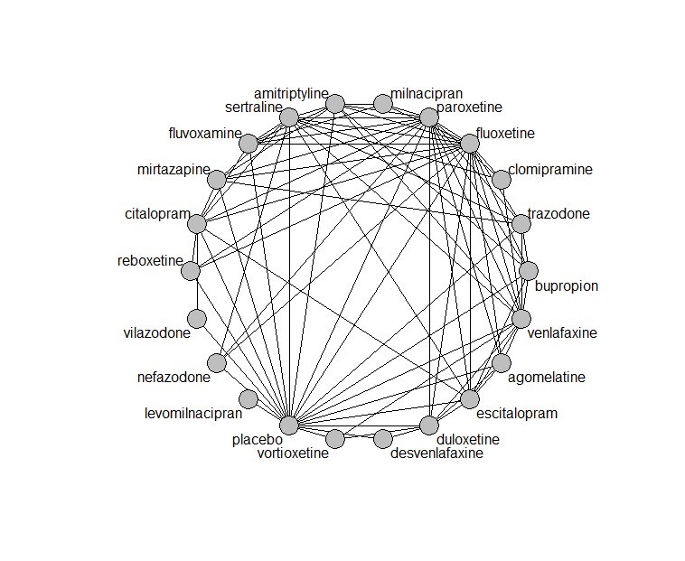

## **Pairwise MA**

### **Grouping all drugs together, comparison vs. placebo**

Number of studies: 176

Random effects meta-analysis: OR=2.62. 95% CI 2.42 to 2.84

Prediction interval 1.3 to 5.29

Heterogeneity (tau squared) was estimated to be 0.13

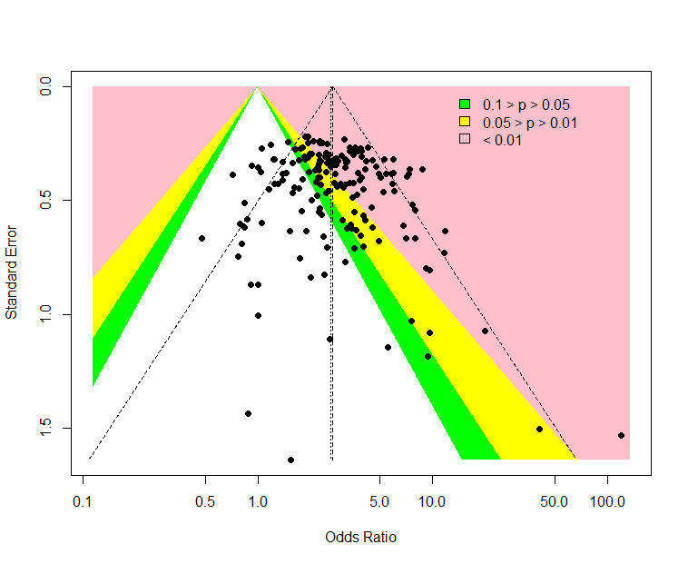

There is no evidence of asymmetry in the graph (Harbord’s test p-value=0.48)

### **Meta-analyses of comparisons with 10 or more studies**

We show results from pairwise comparisons informed by 10 studies or more. An OR larger than 1 favors the first treatment in the comparison.

comparisons Number.of.studies OR lower.CI upper.CI tau.sq I.sq

1 placebo - bupropion 11 1.48 1.20 1.86 0.00 0.00

2 placebo - duloxetine 21 4.22 3.67 5.11 0.05 0.25

3 placebo - escitalopram 17 1.96 1.64 2.41 0.00 0.00

4 placebo - fluoxetine 26 1.94 1.68 2.26 0.12 0.42

5 placebo - paroxetine 39 2.47 2.24 2.89 0.00 0.00

6 placebo - sertraline 12 2.96 2.48 3.75 0.10 0.40

7 placebo - venlafaxine 17 3.69 2.99 4.16 0.16 0.56

8 placebo - vortioxetine 14 3.54 3.04 4.28 0.01 0.09

9 citalopram - escitalopram 11 0.95 0.73 1.22 0.00 0.00

10 fluoxetine - paroxetine 10 1.27 1.05 1.54 0.00 0.00

11 fluoxetine - venlafaxine 12 1.68 1.39 1.94 0.09 0.49

## **Assessment of transitivity**

We compare studies grouped by treatment comparison, by mean baseline severity (in HAMD17), mean age, dosing schedule and mean percent female. Number in parentheses are standard deviations of the means across the studies. Note that not all studies reported all these characteristics. The numbers are for the studies that did report them.

comparison studies baseline_SD age_SD female

1 agomelatine - escitalopram 2 26 (0.7) 42 (1.3) 0.71 (NA)

2 paroxetine - placebo 39 24 (2.6) 42 (6.8) 0.57 (0.14)

3 fluoxetine - paroxetine 10 23 (1.6) 45 (10.3) NaN (NA)

4 bupropion - placebo 11 24 (2.4) 39 (4.1) 0.59 (0.08)

5 paroxetine - sertraline 2 22 (2) 43 (NA) NaN (NA)

6 fluoxetine - sertraline 5 22 (2.6) 52 (10.6) NaN (NA)

7 escitalopram - placebo 17 22 (2.5) 44 (10.8) 0.62 (0.13)

8 escitalopram - sertraline 2 20 (0.5) 40 (0.5) NaN (NA)

9 placebo - sertraline 12 21 (3.3) 43 (8.9) 0.59 (0.08)

10 placebo - venlafaxine 17 22 (1.9) 44 (8) 0.6 (0.1)

11 placebo - vortioxetine 14 24 (1.8) 46 (7.4) 0.65 (0.07)

12 venlafaxine - vortioxetine 2 23 (2.5) 42 (2.2) 0.61 (0.02)

13 fluoxetine - venlafaxine 12 24 (2.8) 45 (8.9) 0.65 (0.06)

14 fluoxetine - mirtazapine 4 26 (2.1) 44 (5.2) NaN (NA)

15 amitriptyline - milnacipran 1 26 (NA) 50 (NA) NaN (NA)

16 fluvoxamine - milnacipran 2 24 (0.4) 49 (2) NaN (NA)

17 fluvoxamine - paroxetine 2 22 (1.4) 42 (1.6) 0.57 (NA)

18 fluoxetine - milnacipran 2 25 (3.3) 45 (0.4) NaN (NA)

19 levomilnacipran - placebo 6 24 (1.1) 43 (1.4) 0.63 (0.02)

20 nefazodone - paroxetine 2 25 (NA) 40 (3.4) 0.49 (0.09)

21 paroxetine - reboxetine 3 22 (2.1) 41 (2.7) 0.69 (0.07)

22 escitalopram - paroxetine 2 25 (2.8) 45 (0.5) NaN (NA)

23 duloxetine - placebo 21 21 (2.7) 45 (9) 0.65 (0.04)

24 duloxetine - vortioxetine 6 24 (2) 49 (10.8) 0.67 (0.04)

25 placebo - reboxetine 8 23 (2) 42 (3.2) 0.64 (0.07)

26 fluoxetine - trazodone 3 21 (0.8) 49 (17.2) 0.67 (NA)

27 mirtazapine - sertraline 1 NaN (NA) 42 (NA) NaN (NA)

28 mirtazapine - paroxetine 3 23 (1.2) 53 (16.7) NaN (NA)

29 fluoxetine - nefazodone 2 24 (NA) 41 (NA) 0.77 (NA)

30 escitalopram - venlafaxine 2 20 (0.4) 43 (7.5) NaN (NA)

31 amitriptyline - paroxetine 7 24 (3.3) 54 (11.9) 0.76 (0.34)

32 fluoxetine - placebo 26 22 (2.5) 44 (10.5) 0.62 (0.07)

33 fluoxetine - reboxetine 3 24 (1.1) 41 (2.8) 0.66 (0.05)

34 citalopram - fluoxetine 2 24 (1.1) 43 (1.1) NaN (NA)

35 desvenlafaxine - placebo 7 23 (0.5) 43 (4.8) 0.68 (0.17)

36 amitriptyline - mirtazapine 1 28 (NA) 38 (NA) NaN (NA)

37 amitriptyline - placebo 5 25 (3.4) 40 (1.2) NaN (NA)

38 mirtazapine - placebo 2 25 (4.4) 50 (16.7) 0.54 (NA)

39 citalopram - escitalopram 11 24 (2) 39 (5.3) 0.55 (0.03)

40 citalopram - placebo 7 22 (2.6) 46 (14.7) 0.59 (0.02)

41 agomelatine - paroxetine 3 27 (0.6) 51 (14.9) 0.64 (0.03)

42 agomelatine - placebo 7 27 (0.1) 48 (10.7) 0.68 (0.04)

43 fluvoxamine - placebo 8 23 (2.3) 42 (3.1) NaN (NA)

44 amitriptyline - bupropion 1 23 (NA) 37 (NA) NaN (NA)

45 amitriptyline - fluoxetine 5 24 (1.9) 47 (12.3) 0.71 (0.07)

46 agomelatine - duloxetine 1 26 (NA) 43 (NA) NaN (NA)

47 bupropion - escitalopram 2 24 (NA) 36 (0.6) NaN (NA)

48 amitriptyline - sertraline 5 24 (1.5) 49 (12.6) 0.59 (0.16)

49 bupropion - fluoxetine 3 23 (2.2) 39 (2.7) NaN (NA)

50 placebo - vilazodone 5 24 (0.6) 41 (1) 0.56 (0.03)

51 placebo - trazodone 4 22 (0.4) 46 (10.6) 0.61 (0.05)

52 trazodone - venlafaxine 1 22 (NA) 41 (NA) 0.66 (NA)

53 fluoxetine - fluvoxamine 2 22 (0.4) 41 (1.9) NaN (NA)

54 duloxetine - paroxetine 5 20 (1.7) 42 (2.7) NaN (NA)

55 citalopram - sertraline 2 26 (4.9) 44 (4.9) NaN (NA)

56 nefazodone - sertraline 1 23 (NA) 44 (NA) 0.52 (NA)

57 nefazodone - placebo 3 26 (2.1) 41 (2.8) 0.62 (0.02)

58 amitriptyline - venlafaxine 2 21 (0) 43 (6.2) NaN (NA)

59 clomipramine - fluoxetine 3 25 (4.5) 47 (2.8) 0.67 (0.05)

60 duloxetine - fluoxetine 2 18 (0.2) 41 (0.6) NaN (NA)

61 agomelatine - fluoxetine 2 28 (1.1) 41 (2.3) 0.74 (0.06)

62 mirtazapine - trazodone 1 22 (NA) 62 (NA) 0.54 (NA)

63 amitriptyline - fluvoxamine 1 23 (NA) 43 (NA) 0.73 (NA)

64 citalopram - paroxetine 1 24 (NA) 40 (NA) NaN (NA)

65 milnacipran - paroxetine 1 22 (NA) 36 (NA) 0.53 (NA)

66 escitalopram - fluoxetine 4 23 (1.5) 47 (18.4) 0.68 (NA)

67 paroxetine - trazodone 2 22 (2.1) 41 (3.6) 0.63 (NA)

68 duloxetine - escitalopram 3 20 (2.5) 43 (0.9) NaN (NA)

69 citalopram - mirtazapine 1 23 (NA) 42 (NA) NaN (NA)

70 agomelatine - venlafaxine 1 26 (NA) 40 (NA) 0.71 (NA)

71 clomipramine - sertraline 2 27 (4.6) 43 (1) 0.6 (0.14)

72 citalopram - vilazodone 1 24 (NA) 42 (NA) 0.57 (NA)

73 paroxetine - venlafaxine 1 23 (NA) 44 (NA) NaN (NA)

74 sertraline - venlafaxine 3 23 (0.8) 40 (2.8) NaN (NA)

75 sertraline - trazodone 1 22 (NA) 46 (NA) 0.65 (NA)

76 fluvoxamine - sertraline 1 21 (NA) 40 (NA) NaN (NA)

77 duloxetine - venlafaxine 2 23 (0.5) 43 (1.4) 0.68 (0.03)

78 clomipramine - paroxetine 2 24 (1.1) 57 (20.3) 0.81 (0.12)

79 clomipramine - venlafaxine 1 25 (NA) 47 (NA) NaN (NA)

80 citalopram - reboxetine 1 24 (NA) 42 (NA) 0.64 (NA)

81 bupropion - venlafaxine 1 24 (NA) 37 (NA) NaN (NA)

82 citalopram - fluvoxamine 1 24 (NA) NaN (NA) NaN (NA)

83 desvenlafaxine - duloxetine 1 23 (NA) 40 (NA) NaN (NA)

84 bupropion - trazodone 1 22 (NA) 40 (NA) NaN (NA)

85 bupropion - paroxetine 1 22 (NA) 37 (NA) NaN (NA)

## **NMA**

A total of 22 treatments are included in the network.

A total of 299 studies are included in this analysis.

Estimated heterogeneity tau-squared 0.04

Global test for inconsistency, p-value 0.22787 (Q=110,d.o.f.100)

### **Comparison vs. placebo**

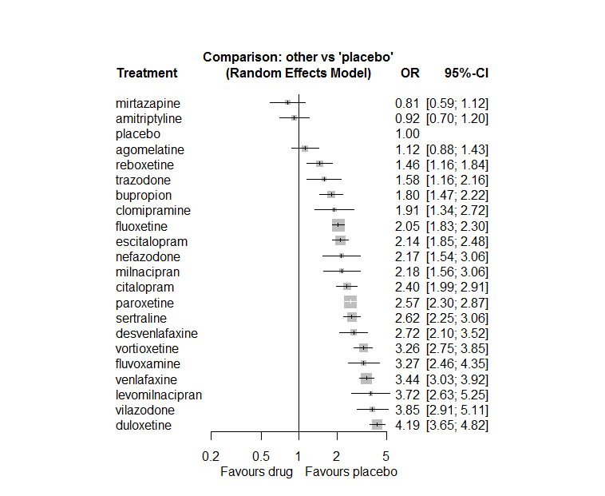

The same plot, but with prediction intervals (in red) also added:

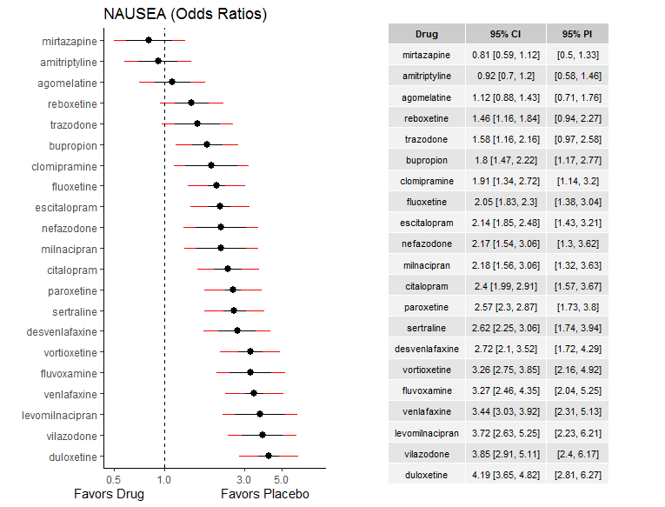

### **Ranking according to P-scores**

P-score

mirtazapine 0.98

amitriptyline 0.95

placebo 0.91

agomelatine 0.87

reboxetine 0.78

trazodone 0.74

bupropion 0.68

clomipramine 0.63

fluoxetine 0.59

escitalopram 0.55

nefazodone 0.53

milnacipran 0.52

citalopram 0.44

paroxetine 0.37

sertraline 0.35

desvenlafaxine 0.33

vortioxetine 0.19

fluvoxamine 0.19

venlafaxine 0.15

levomilnacipran 0.11

vilazodone 0.09

duloxetine 0.03

### **Local inconsistency**

Percent of comparisons where there is some evidence (p-value<0.05) of disagreement between direct and indirect sources: 0.05 (4 out of 84 comparisons)

comparison TE seTE lower upper z p

6 agomelatine:duloxetine -0.2387 0.41 -1.036 0.559 -0.587 0.5575

7 agomelatine:escitalopram 0.1408 0.36 -0.561 0.842 0.393 0.6941

8 agomelatine:fluoxetine 0.1778 0.29 -0.389 0.745 0.615 0.5388

14 agomelatine:paroxetine -0.3455 0.32 -0.967 0.276 -1.090 0.2757

15 agomelatine:placebo 0.0553 0.26 -0.456 0.566 0.212 0.8320

19 agomelatine:venlafaxine -0.4398 0.44 -1.310 0.430 -0.991 0.3219

22 amitriptyline:bupropion -0.6163 0.59 -1.782 0.550 -1.036 0.3003

28 amitriptyline:fluoxetine 0.0697 0.36 -0.627 0.767 0.196 0.8447

29 amitriptyline:fluvoxamine -0.7576 0.86 -2.443 0.927 -0.881 0.3782

31 amitriptyline:milnacipran 0.0737 0.66 -1.228 1.375 0.111 0.9117

32 amitriptyline:mirtazapine 0.3210 0.98 -1.595 2.237 0.328 0.7427

34 amitriptyline:paroxetine 0.4027 0.32 -0.234 1.039 1.240 0.2148

35 amitriptyline:placebo 0.0888 0.33 -0.556 0.734 0.270 0.7873

37 amitriptyline:sertraline -0.4595 0.30 -1.050 0.131 -1.525 0.1273

39 amitriptyline:venlafaxine 0.2249 0.48 -0.716 1.166 0.469 0.6394

46 bupropion:escitalopram 0.1430 0.29 -0.435 0.721 0.485 0.6278

47 bupropion:fluoxetine 0.5892 0.27 0.060 1.118 2.183 0.0290

53 bupropion:paroxetine 0.1211 0.44 -0.737 0.980 0.276 0.7822

54 bupropion:placebo -0.5873 0.22 -1.025 -0.150 -2.631 0.0085

57 bupropion:trazodone 0.4830 0.71 -0.906 1.872 0.682 0.4954

58 bupropion:venlafaxine -0.0475 0.36 -0.752 0.657 -0.132 0.8947

64 citalopram:escitalopram -0.0839 0.21 -0.495 0.327 -0.400 0.6890

65 citalopram:fluoxetine 0.2648 0.31 -0.348 0.877 0.847 0.3967

66 citalopram:fluvoxamine -0.5348 0.51 -1.527 0.457 -1.056 0.2908

69 citalopram:mirtazapine -0.3474 0.45 -1.228 0.533 -0.773 0.4392

71 citalopram:paroxetine 0.3483 0.41 -0.450 1.146 0.856 0.3922

72 citalopram:placebo -0.1609 0.20 -0.557 0.235 -0.797 0.4257

73 citalopram:reboxetine -0.2998 0.50 -1.275 0.675 -0.603 0.5468

74 citalopram:sertraline 0.1919 0.30 -0.394 0.777 0.642 0.5206

77 citalopram:vilazodone 0.4197 0.33 -0.231 1.071 1.264 0.2063

82 clomipramine:fluoxetine -0.6774 0.51 -1.681 0.326 -1.323 0.1859

88 clomipramine:paroxetine 0.0774 0.36 -0.622 0.776 0.217 0.8282

91 clomipramine:sertraline 0.5293 0.40 -0.246 1.305 1.338 0.1809

93 clomipramine:venlafaxine -0.7781 0.74 -2.235 0.679 -1.047 0.2952

96 desvenlafaxine:duloxetine -0.0619 0.34 -0.719 0.595 -0.185 0.8535

105 desvenlafaxine:placebo 0.1166 0.42 -0.698 0.932 0.280 0.7792

112 duloxetine:escitalopram -0.1451 0.22 -0.570 0.280 -0.669 0.5034

113 duloxetine:fluoxetine -0.6727 0.43 -1.516 0.170 -1.564 0.1177

119 duloxetine:paroxetine -0.1788 0.20 -0.563 0.205 -0.912 0.3616

120 duloxetine:placebo 0.0151 0.14 -0.263 0.293 0.107 0.9152

124 duloxetine:venlafaxine -0.0411 0.22 -0.474 0.391 -0.186 0.8521

126 duloxetine:vortioxetine 0.3881 0.19 0.024 0.752 2.090 0.0367

127 escitalopram:fluoxetine 0.1446 0.26 -0.366 0.655 0.555 0.5790

133 escitalopram:paroxetine 0.0820 0.25 -0.405 0.569 0.330 0.7416

134 escitalopram:placebo -0.1294 0.15 -0.426 0.167 -0.856 0.3922

136 escitalopram:sertraline 0.2825 0.30 -0.296 0.861 0.957 0.3384

138 escitalopram:venlafaxine -0.4493 0.30 -1.046 0.147 -1.477 0.1398

141 fluoxetine:fluvoxamine 0.9505 0.36 0.245 1.656 2.642 0.0082

143 fluoxetine:milnacipran 0.0440 0.37 -0.679 0.767 0.119 0.9050

144 fluoxetine:mirtazapine -0.1164 0.36 -0.817 0.584 -0.325 0.7449

145 fluoxetine:nefazodone -0.1070 0.62 -1.314 1.100 -0.174 0.8620

146 fluoxetine:paroxetine -0.0060 0.15 -0.300 0.288 -0.040 0.9680

147 fluoxetine:placebo -0.1201 0.12 -0.353 0.112 -1.012 0.3116

148 fluoxetine:reboxetine -0.4097 0.28 -0.956 0.136 -1.471 0.1414

149 fluoxetine:sertraline 0.2723 0.21 -0.136 0.680 1.308 0.1909

150 fluoxetine:trazodone 0.1642 0.39 -0.609 0.937 0.416 0.6771

151 fluoxetine:venlafaxine -0.0071 0.14 -0.289 0.275 -0.049 0.9608

155 fluvoxamine:milnacipran 0.3822 0.42 -0.436 1.201 0.915 0.3600

158 fluvoxamine:paroxetine -0.5725 0.41 -1.371 0.226 -1.405 0.1601

159 fluvoxamine:placebo 0.4119 0.31 -0.191 1.015 1.339 0.1806

161 fluvoxamine:sertraline 0.3253 0.54 -0.724 1.375 0.608 0.5435

179 milnacipran:paroxetine 0.3155 0.34 -0.357 0.988 0.920 0.3576

188 mirtazapine:paroxetine -0.2498 0.35 -0.926 0.427 -0.724 0.4691

189 mirtazapine:placebo 0.0642 0.60 -1.117 1.246 0.106 0.9152

191 mirtazapine:sertraline -0.1373 0.43 -0.989 0.715 -0.316 0.7521

192 mirtazapine:trazodone 0.3230 0.69 -1.034 1.680 0.467 0.6408

196 nefazodone:paroxetine -0.2552 0.39 -1.011 0.501 -0.662 0.5082

197 nefazodone:placebo -0.1697 0.35 -0.863 0.523 -0.480 0.6313

199 nefazodone:sertraline 0.5603 0.45 -0.318 1.439 1.250 0.2112

204 paroxetine:placebo -0.0548 0.11 -0.276 0.166 -0.486 0.6269

205 paroxetine:reboxetine 0.3915 0.24 -0.084 0.867 1.615 0.1064

206 paroxetine:sertraline -0.1307 0.25 -0.621 0.359 -0.523 0.6009

207 paroxetine:trazodone -0.3272 0.45 -1.212 0.557 -0.725 0.4684

208 paroxetine:venlafaxine 0.2903 0.32 -0.337 0.918 0.907 0.3645

211 placebo:reboxetine 0.1331 0.24 -0.336 0.602 0.556 0.5782

212 placebo:sertraline -0.2032 0.16 -0.516 0.110 -1.273 0.2031

213 placebo:trazodone -0.3533 0.32 -0.981 0.274 -1.103 0.2698

214 placebo:venlafaxine -0.0213 0.13 -0.282 0.240 -0.160 0.8727

215 placebo:vilazodone -0.4364 0.41 -1.245 0.372 -1.057 0.2903

216 placebo:vortioxetine -0.3062 0.19 -0.672 0.059 -1.643 0.1004

222 sertraline:trazodone -0.0050 0.62 -1.219 1.209 -0.008 0.9936

223 sertraline:venlafaxine 0.2624 0.26 -0.241 0.766 1.021 0.3072

226 trazodone:venlafaxine -0.3848 0.45 -1.275 0.505 -0.848 0.3966

230 venlafaxine:vortioxetine -0.1048 0.24 -0.579 0.369 -0.433 0.6650

There are some inconsistencies in comparisons mainly with respect to bupropion (see highlights above). This may relate to the fact that bupropion was almost exclusively given to relatively younger patients (see section transitivity).

### **League table**

Below we show the league table. Upper triangle: direct evidence. Lower triangle: NMA. An odds ratio larger than 1 in the upper triangle favors the column-defining drug. An odds ratio larger than 1 in the bottom triangle favors the row-defining drug.

|  |  |  |  |  |  |  |  |  |  |  |  |  |  |  |  |  |  |  |  |  |  |
| --- | --- | --- | --- | --- | --- | --- | --- | --- | --- | --- | --- | --- | --- | --- | --- | --- | --- | --- | --- | --- | --- |
| AGOM | . | . | . | . | . | 0.22 [0.10; 0.46] | 0.59 [0.31; 1.11] | 0.62 [0.38; 1.01] | . | . | . | . | . | 0.33 [0.19; 0.58] | 1.16 [0.77; 1.75] | . | . | . | 0.22 [0.10; 0.50] | . | . |
| 1.22 [0.86; 1.75] | AMIT | 0.29 [0.09; 0.88] | . | . | . | . | . | 0.47 [0.25; 0.88] | 0.14 [0.03; 0.70] | . | 0.45 [0.13; 1.53] | 1.53 [0.24; 9.96] | . | 0.48 [0.28; 0.84] | 0.98 [0.56; 1.73] | . | 0.26 [0.16; 0.42] | . | 0.33 [0.13; 0.79] | . | . |
| 0.62 [0.45; 0.85] | 0.51 [0.37; 0.70] | BUPR | . | . | . | . | 0.94 [0.57; 1.57] | 1.38 [0.87; 2.20] | . | . | . | . | . | 0.79 [0.34; 1.80] | 1.49 [1.15; 1.91] | . | . | 1.78 [0.47; 6.78] | 0.50 [0.26; 0.97] | . | . |
| 0.47 [0.34; 0.63] | 0.38 [0.28; 0.52] | 0.75 [0.57; 0.99] | CITA | . | . | . | 1.07 [0.80; 1.45] | 1.47 [0.83; 2.61] | 0.46 [0.18; 1.16] | . | . | 2.24 [1.02; 4.93] | . | 1.29 [0.60; 2.79] | 2.17 [1.59; 2.97] | 1.26 [0.50; 3.17] | 1.07 [0.63; 1.83] | . | . | 0.81 [0.48; 1.36] | . |
| 0.59 [0.39; 0.90] | 0.48 [0.31; 0.74] | 0.95 [0.63; 1.42] | 1.26 [0.85; 1.87] | CLOM | . | . | . | 0.52 [0.21; 1.32] | . | . | . | . | . | 0.77 [0.48; 1.24] | . | . | 1.04 [0.55; 1.98] | . | 0.27 [0.07; 1.09] | . | . |
| 0.41 [0.29; 0.59] | 0.34 [0.23; 0.49] | 0.66 [0.48; 0.92] | 0.89 [0.64; 1.22] | 0.70 [0.45; 1.09] | DESV | 0.62 [0.35; 1.09] | . | . | . | . | . | . | . | . | 2.75 [2.09; 3.62] | . | . | . | . | . | . |
| 0.27 [0.20; 0.35] | 0.22 [0.16; 0.29] | 0.43 [0.34; 0.55] | 0.57 [0.46; 0.72] | 0.45 [0.31; 0.66] | 0.65 [0.49; 0.86] | DULO | 1.76 [1.21; 2.54] | 1.07 [0.47; 2.45] | . | . | . | . | . | 1.42 [1.02; 1.99] | 4.22 [3.49; 5.10] | . | . | . | 1.18 [0.80; 1.74] | . | 1.52 [1.20; 1.92] |
| 0.52 [0.40; 0.68] | 0.43 [0.32; 0.58] | 0.84 [0.66; 1.07] | 1.12 [0.92; 1.38] | 0.89 [0.61; 1.30] | 1.27 [0.94; 1.71] | 1.96 [1.63; 2.35] | ESCI | 1.18 [0.73; 1.91] | . | . | . | . | . | 0.89 [0.57; 1.41] | 2.00 [1.60; 2.48] | . | 1.04 [0.61; 1.79] | . | 0.41 [0.24; 0.73] | . | . |
| 0.55 [0.42; 0.70] | 0.45 [0.34; 0.59] | 0.88 [0.70; 1.10] | 1.17 [0.95; 1.44] | 0.93 [0.65; 1.33] | 1.32 [1.00; 1.75] | 2.04 [1.73; 2.42] | 1.04 [0.88; 1.23] | FLUO | 1.32 [0.71; 2.46] | . | 0.97 [0.53; 1.76] | 2.33 [1.29; 4.20] | 0.86 [0.27; 2.70] | 0.80 [0.62; 1.02] | 1.92 [1.61; 2.28] | 1.04 [0.65; 1.66] | 0.97 [0.68; 1.39] | 1.47 [0.74; 2.92] | 0.59 [0.48; 0.73] | . | . |
| 0.34 [0.24; 0.49] | 0.28 [0.19; 0.41] | 0.55 [0.39; 0.78] | 0.73 [0.53; 1.02] | 0.58 [0.37; 0.91] | 0.83 [0.56; 1.22] | 1.28 [0.94; 1.75] | 0.65 [0.48; 0.89] | 0.63 [0.47; 0.84] | FLUV | . | 1.93 [0.99; 3.75] | . | . | 0.79 [0.38; 1.64] | 4.30 [2.63; 7.03] | . | 1.68 [0.62; 4.55] | . | . | . | . |
| 0.30 [0.20; 0.46] | 0.25 [0.16; 0.38] | 0.49 [0.32; 0.73] | 0.65 [0.44; 0.96] | 0.51 [0.31; 0.84] | 0.73 [0.47; 1.13] | 1.13 [0.78; 1.64] | 0.58 [0.40; 0.84] | 0.55 [0.38; 0.80] | 0.88 [0.56; 1.38] | LEVO | . | . | . | . | 3.72 [2.63; 5.25] | . | . | . | . | . | . |
| 0.51 [0.34; 0.77] | 0.42 [0.28; 0.63] | 0.83 [0.56; 1.22] | 1.10 [0.75; 1.61] | 0.87 [0.54; 1.41] | 1.24 [0.81; 1.90] | 1.92 [1.34; 2.75] | 0.98 [0.68; 1.40] | 0.94 [0.67; 1.32] | 1.50 [1.02; 2.21] | 1.70 [1.05; 2.76] | MILN | . | . | 1.02 [0.61; 1.68] | . | . | . | . | . | . | . |
| 1.38 [0.93; 2.04] | 1.13 [0.76; 1.68] | 2.22 [1.53; 3.23] | 2.96 [2.09; 4.19] | 2.35 [1.48; 3.73] | 3.35 [2.22; 5.04] | 5.17 [3.67; 7.27] | 2.64 [1.88; 3.70] | 2.53 [1.84; 3.48] | 4.03 [2.66; 6.12] | 4.58 [2.86; 7.33] | 2.69 [1.71; 4.23] | MIRT | . | 0.27 [0.15; 0.47] | 0.86 [0.28; 2.68] | . | 0.28 [0.13; 0.60] | 0.68 [0.19; 2.45] | . | . | . |
| 0.52 [0.34; 0.78] | 0.42 [0.27; 0.65] | 0.83 [0.56; 1.24] | 1.11 [0.75; 1.63] | 0.88 [0.54; 1.43] | 1.25 [0.81; 1.92] | 1.93 [1.34; 2.79] | 0.99 [0.68; 1.43] | 0.95 [0.66; 1.35] | 1.51 [0.97; 2.34] | 1.71 [1.05; 2.79] | 1.01 [0.63; 1.62] | 0.37 [0.24; 0.59] | NEFA | 0.71 [0.38; 1.33] | 1.97 [1.18; 3.32] | . | 1.29 [0.59; 2.80] | . | . | . | . |
| 0.44 [0.34; 0.56] | 0.36 [0.27; 0.47] | 0.70 [0.56; 0.88] | 0.94 [0.76; 1.15] | 0.74 [0.52; 1.05] | 1.06 [0.80; 1.40] | 1.63 [1.39; 1.92] | 0.83 [0.70; 0.99] | 0.80 [0.70; 0.91] | 1.28 [0.95; 1.71] | 1.45 [1.01; 2.08] | 0.85 [0.61; 1.19] | 0.32 [0.23; 0.43] | 0.85 [0.60; 1.20] | PARO | 2.50 [2.16; 2.91] | 2.18 [1.53; 3.10] | 0.88 [0.56; 1.38] | 1.23 [0.54; 2.77] | 0.98 [0.53; 1.79] | . | . |
| 1.12 [0.88; 1.43] | 0.92 [0.70; 1.20] | 1.80 [1.47; 2.22] | 2.40 [1.99; 2.91] | 1.91 [1.34; 2.72] | 2.72 [2.10; 3.52] | 4.19 [3.65; 4.82] | 2.14 [1.85; 2.48] | 2.05 [1.83; 2.30] | 3.27 [2.46; 4.35] | 3.72 [2.63; 5.25] | 2.18 [1.56; 3.06] | 0.81 [0.59; 1.12] | 2.17 [1.54; 3.06] | 2.57 [2.30; 2.87] | PLAC | 0.72 [0.53; 0.98] | 0.34 [0.27; 0.43] | 0.52 [0.32; 0.83] | 0.29 [0.24; 0.35] | 0.24 [0.18; 0.33] | 0.28 [0.23; 0.34] |
| 0.77 [0.55; 1.07] | 0.63 [0.44; 0.89] | 1.24 [0.91; 1.68] | 1.65 [1.24; 2.19] | 1.31 [0.86; 1.98] | 1.86 [1.32; 2.63] | 2.87 [2.21; 3.74] | 1.47 [1.12; 1.91] | 1.41 [1.10; 1.79] | 2.24 [1.57; 3.21] | 2.55 [1.68; 3.86] | 1.50 [1.00; 2.23] | 0.56 [0.38; 0.82] | 1.49 [0.99; 2.24] | 1.76 [1.39; 2.23] | 0.69 [0.54; 0.86] | REBO | . | . | . | . | . |
| 0.43 [0.32; 0.57] | 0.35 [0.26; 0.46] | 0.69 [0.54; 0.88] | 0.92 [0.73; 1.15] | 0.73 [0.51; 1.04] | 1.04 [0.77; 1.40] | 1.60 [1.31; 1.95] | 0.82 [0.67; 0.99] | 0.78 [0.66; 0.93] | 1.25 [0.92; 1.70] | 1.42 [0.97; 2.07] | 0.83 [0.58; 1.19] | 0.31 [0.22; 0.43] | 0.83 [0.58; 1.19] | 0.98 [0.83; 1.16] | 0.38 [0.33; 0.44] | 0.56 [0.43; 0.73] | SERT | 1.65 [0.51; 5.27] | 0.95 [0.60; 1.51] | . | . |
| 0.71 [0.48; 1.04] | 0.58 [0.39; 0.87] | 1.14 [0.79; 1.64] | 1.52 [1.06; 2.17] | 1.20 [0.76; 1.91] | 1.71 [1.14; 2.57] | 2.65 [1.89; 3.71] | 1.35 [0.96; 1.90] | 1.30 [0.94; 1.78] | 2.07 [1.36; 3.13] | 2.35 [1.47; 3.74] | 1.38 [0.88; 2.17] | 0.51 [0.33; 0.79] | 1.37 [0.87; 2.17] | 1.62 [1.18; 2.23] | 0.63 [0.46; 0.86] | 0.92 [0.63; 1.35] | 1.65 [1.18; 2.31] | TRAZ | 0.33 [0.15; 0.75] | . | . |
| 0.33 [0.25; 0.42] | 0.27 [0.20; 0.35] | 0.52 [0.42; 0.66] | 0.70 [0.56; 0.87] | 0.55 [0.38; 0.80] | 0.79 [0.59; 1.05] | 1.22 [1.03; 1.44] | 0.62 [0.52; 0.74] | 0.60 [0.52; 0.69] | 0.95 [0.70; 1.29] | 1.08 [0.75; 1.56] | 0.63 [0.45; 0.90] | 0.24 [0.17; 0.33] | 0.63 [0.44; 0.91] | 0.75 [0.64; 0.87] | 0.29 [0.26; 0.33] | 0.42 [0.33; 0.55] | 0.76 [0.63; 0.91] | 0.46 [0.33; 0.64] | VENL | . | 0.97 [0.64; 1.48] |
| 0.29 [0.20; 0.42] | 0.24 [0.16; 0.35] | 0.47 [0.33; 0.66] | 0.62 [0.46; 0.85] | 0.49 [0.32; 0.78] | 0.70 [0.48; 1.03] | 1.09 [0.80; 1.49] | 0.56 [0.41; 0.76] | 0.53 [0.39; 0.72] | 0.85 [0.57; 1.27] | 0.96 [0.62; 1.51] | 0.57 [0.37; 0.88] | 0.21 [0.14; 0.32] | 0.56 [0.36; 0.88] | 0.67 [0.49; 0.90] | 0.26 [0.20; 0.34] | 0.38 [0.26; 0.54] | 0.68 [0.49; 0.93] | 0.41 [0.27; 0.62] | 0.89 [0.66; 1.22] | VILA | . |
| 0.34 [0.26; 0.46] | 0.28 [0.21; 0.38] | 0.55 [0.43; 0.72] | 0.74 [0.57; 0.95] | 0.59 [0.40; 0.86] | 0.83 [0.62; 1.13] | 1.29 [1.08; 1.54] | 0.66 [0.53; 0.81] | 0.63 [0.52; 0.77] | 1.01 [0.72; 1.40] | 1.14 [0.78; 1.68] | 0.67 [0.46; 0.97] | 0.25 [0.17; 0.36] | 0.67 [0.46; 0.98] | 0.79 [0.65; 0.96] | 0.31 [0.26; 0.36] | 0.45 [0.34; 0.59] | 0.80 [0.64; 1.01] | 0.49 [0.34; 0.69] | 1.06 [0.87; 1.28] | 1.18 [0.85; 1.64] | VORT |

### **Estimated event rates**

For an event rate in placebo equal to the average event rate (i.e. fixed to 0.09) the estimated event rates for each drug are as follows

drug rate

1 agomelatine 0.1 [0.08, 0.12]

2 amitriptyline 0.08 [0.06, 0.1]

3 bupropion 0.15 [0.12, 0.18]

4 citalopram 0.19 [0.16, 0.22]

5 clomipramine 0.15 [0.11, 0.21]

6 desvenlafaxine 0.21 [0.17, 0.25]

7 duloxetine 0.29 [0.26, 0.32]

8 escitalopram 0.17 [0.15, 0.19]

9 fluoxetine 0.16 [0.15, 0.18]

10 fluvoxamine 0.24 [0.19, 0.29]

11 levomilnacipran 0.26 [0.2, 0.33]

12 milnacipran 0.17 [0.13, 0.23]

13 mirtazapine 0.07 [0.05, 0.1]

14 nefazodone 0.17 [0.13, 0.23]

15 paroxetine 0.2 [0.18, 0.22]

17 reboxetine 0.12 [0.1, 0.15]

18 sertraline 0.2 [0.18, 0.23]

19 trazodone 0.13 [0.1, 0.17]

20 venlafaxine 0.25 [0.22, 0.27]

21 vilazodone 0.27 [0.22, 0.33]

22 vortioxetine 0.24 [0.21, 0.27]

## **Sensitivity analysis: splitting nodes according to dosage**

All treatment arms for drug X, with dose_intended_min equal to or smaller to the minimum licensed dose were set as “X_L”. All other arms of X are “X_H”. Studies with no information on dose are excluded. Results are shown below:

|  |  |  |
| --- | --- | --- |
| **Low dose vs. placebo** | **High dose vs. placebo** | **High dose vs. low dose** |
|  |  |  |

## **Sensitivity analysis: Keeping only low dropout arms**

The average dropout in the dataset is 0.27.

The average dropout in placebo is 0.29.

The average dropout in drugs is 0.26.

Below we show a histogram of the percent of total dropout in the included arms.

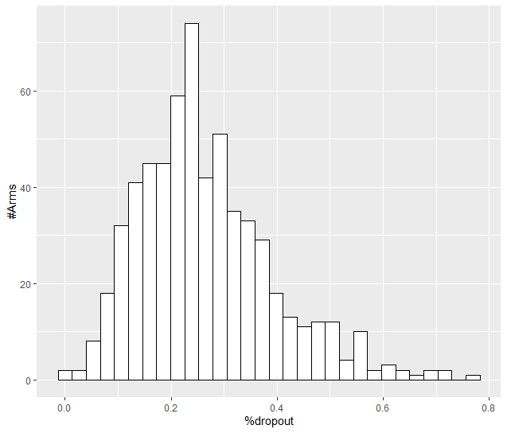

The average dropout by drug is as follows:

Drug Dropout

1 agomelatine 0.17

22 vortioxetine 0.17

4 citalopram 0.18

6 desvenlafaxine 0.18

8 escitalopram 0.18

12 milnacipran 0.22

13 mirtazapine 0.23

11 levomilnacipran 0.24

18 sertraline 0.24

21 vilazodone 0.24

20 venlafaxine 0.26

9 fluoxetine 0.27

7 duloxetine 0.27

17 reboxetine 0.28

5 clomipramine 0.28

15 paroxetine 0.28

2 amitriptyline 0.28

14 nefazodone 0.29

16 placebo 0.29

3 bupropion 0.33

10 fluvoxamine 0.33

19 trazodone 0.35

We exclude all treatment arms with dropout rates larger than 25%, and we re-analyse the network.

Total number of arms included in the analysis 261. Total number of studies 124

Total events in placebo 733, out of a total of 10212 patients. Event rate placebo 0.072

Total events in drugs 5440, out of a total of 29481 patients. Event rate drugs 0.185

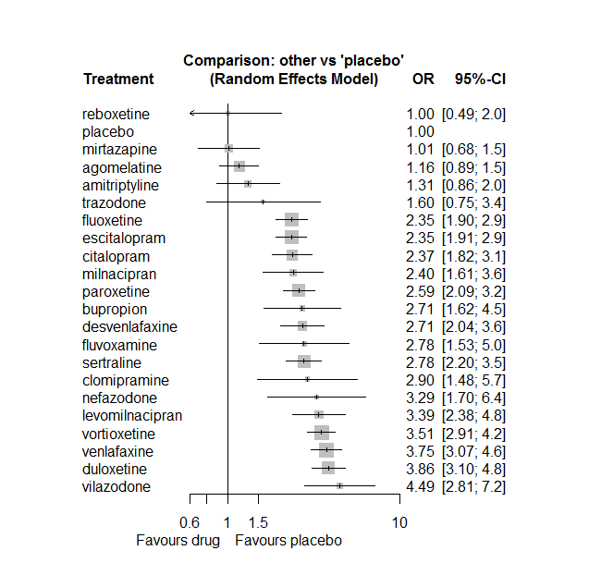

## **Sensitivity analysis: Bayesian NMA**

No important differences found. Results not shown.

# **Headache**

We remove all arms for which dose range was not “Licenced”. After this:

* Removed 16 one-arm studies: Roffman1982, Settle1999 (WELL212), Hewett2010a (AK130940) (NCT00093288), AK1102365, Kavoussi1997, Kyle1998 (Study 92032 - FDA), Jiang2009, Study 19 (FDA) (Fabre1985), Study 25 (FDA) (Rickels1986), Itil1983, Harris1991, Ansseau1994c, Staner1995 (063), 29060/299, Sacchetti2002 (BRL-29060/109), Kellams1979
* Total number of studies with number randomized being smaller than event rates: 1. Removed the following studies: Rush1998 (excluding Armitage1997 and Gillin1997).
* Total number of arms 654. Total number of studies 283.
* Total events in placebo 3368, out of a total of 19962 patients. Event rate placebo 0.169.

Total events in drugs 10233, out of a total of 59220 patients. Event rate drugs 0.173.

## **Distribution of dose across drugs**

Here we count the number of arms per drug, and the percent of these arms where Dose_intended_min was equal to the minimum licensed dose or lower. The values we used as minimum licensed dose are as follows:

agomelatine: 25; amitriptyline: 75; bupropion:300; citalopram:20; clomipramine:30; desvenlafaxine:50; duloxetine:40; escitalopram:10; fluoxetine:20; fluvoxamine:50; levomilnacipran:40; milnacipran:50; mirtazapine:15; nefazodone:300; paroxetine:20; reboxetine:8; sertraline:50; trazodone:150; venlafaxine:75; vilazodone:20; vortioxetine:5

Drug number.arms percent.low.dose

1 agomelatine 18 0.89

2 escitalopram 36 0.81

3 paroxetine 80 0.81

5 fluoxetine 64 0.94

6 bupropion 20 0.90

7 sertraline 34 0.91

8 vortioxetine 29 0.38

9 venlafaxine 35 0.63

10 mirtazapine 13 0.69

11 milnacipran 9 0.00

12 amitriptyline 28 0.64

13 fluvoxamine 15 0.33

14 nefazodone 8 0.50

15 levomilnacipran 9 0.56

16 reboxetine 14 0.93

17 duloxetine 30 0.13

18 trazodone 10 1.00

19 citalopram 22 0.73

20 desvenlafaxine 5 0.80

21 vilazodone 5 0.20

22 clomipramine 5 0.00

## **Network graph**

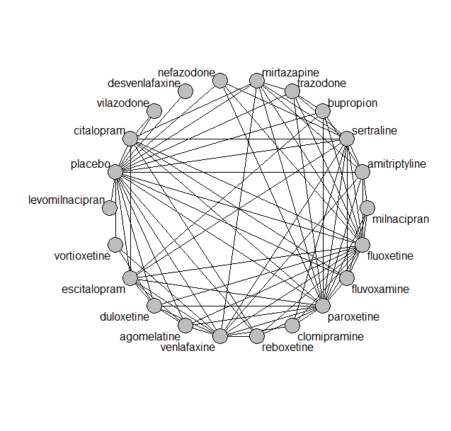

## **Pairwise MA**

### **Grouping all drugs together, comparison vs. placebo**

Number of studies: 164

Random effects meta-analysis: OR=1.11. 95% CI 1.06 to 1.17

Prediction interval 1.06 to 1.17

Heterogeneity (tau squared) was estimated to be 0

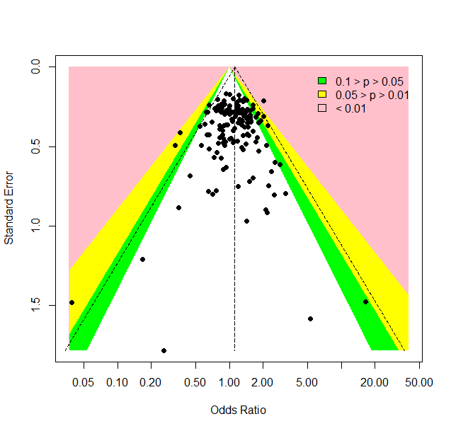

No evidence of small-study effects or publication bias (Harbord’s test p-value 0.4)

### **Meta-analyses of comparisons with 10 or more studies**

We show results from pairwise comparisons informed by 10 studies or more. An OR larger than 1 favors the first treatment in the comparison.

comparisons Number.of.studies OR lower.CI upper.CI tau.sq I.sq

1 placebo - bupropion 13 1.1 0.90 1.3 0.03 0.23

2 placebo - duloxetine 20 1.1 0.98 1.3 0.03 0.21

3 placebo - escitalopram 17 1.0 0.90 1.2 0.01 0.10

4 placebo - fluoxetine 17 1.0 0.90 1.2 0.04 0.30

5 placebo - paroxetine 39 1.0 0.94 1.2 0.00 0.00

6 placebo - sertraline 11 1.3 1.09 1.6 0.00 0.00

7 placebo - venlafaxine 10 1.1 0.93 1.4 0.00 0.00

8 placebo - vortioxetine 14 1.1 0.91 1.2 0.00 0.00

9 fluoxetine - paroxetine 10 1.0 0.84 1.2 0.00 0.00

## **Assessment of transitivity**

We compare studies grouped by treatment comparison, by mean baseline severity (in HAMD17), mean age, dosing schedule and mean percent female. Number in parentheses are standard deviations of the means across the studies. Note that not all studies reported all these characteristics. The numbers are for the studies that did report them.

comparison studies baseline_SD age_SD female

1 agomelatine - escitalopram 2 26 (0.7) 42 (1.3) 0.71 (NA)

2 paroxetine - placebo 39 24 (2.6) 43 (6.8) 0.57 (0.14)

3 fluoxetine - paroxetine 10 23 (1.6) 45 (10.3) NaN (NA)

4 bupropion - placebo 13 24 (2.3) 40 (4.4) 0.52 (0.18)

5 paroxetine - sertraline 2 22 (2) 43 (NA) NaN (NA)

6 fluoxetine - sertraline 5 22 (2.6) 52 (10.6) NaN (NA)

7 escitalopram - placebo 17 22 (2.5) 44 (10.8) 0.62 (0.13)

8 escitalopram - sertraline 3 22 (3.3) 38 (3.1) NaN (NA)

9 placebo - sertraline 11 21 (3.4) 43 (9.3) 0.58 (0.08)

10 placebo - venlafaxine 10 22 (1.4) 45 (9.5) 0.58 (0.12)

11 placebo - vortioxetine 14 24 (1.8) 46 (7.4) 0.65 (0.07)

12 venlafaxine - vortioxetine 2 23 (2.5) 42 (2.2) 0.61 (0.02)

13 fluoxetine - mirtazapine 4 26 (2.1) 44 (5.2) NaN (NA)

14 amitriptyline - milnacipran 1 26 (NA) 50 (NA) NaN (NA)

15 fluvoxamine - milnacipran 2 24 (0.4) 49 (2) NaN (NA)

16 fluvoxamine - paroxetine 2 22 (1.4) 42 (1.6) 0.57 (NA)

17 fluoxetine - milnacipran 2 25 (3.3) 45 (0.4) NaN (NA)

18 fluoxetine - nefazodone 2 24 (0.4) 39 (2.5) 0.7 (0.1)

19 levomilnacipran - placebo 6 24 (1.1) 43 (1.4) 0.63 (0.02)

20 amitriptyline - placebo 8 26 (4.9) 41 (2) NaN (NA)

21 nefazodone - paroxetine 2 25 (NA) 40 (3.4) 0.49 (0.09)

22 paroxetine - reboxetine 3 22 (2.1) 41 (2.7) 0.69 (0.07)

23 escitalopram - paroxetine 2 25 (2.8) 45 (0.5) NaN (NA)

24 duloxetine - placebo 20 21 (2.7) 46 (9.1) 0.65 (0.04)

25 duloxetine - vortioxetine 6 24 (2) 49 (10.8) 0.67 (0.04)

26 placebo - reboxetine 9 24 (3.9) 42 (3.1) 0.62 (0.09)

27 fluoxetine - trazodone 3 21 (0.8) 49 (17.2) 0.67 (NA)

28 mirtazapine - sertraline 1 NaN (NA) 42 (NA) NaN (NA)

29 mirtazapine - paroxetine 3 23 (1.2) 53 (16.7) NaN (NA)

30 escitalopram - venlafaxine 2 20 (0.4) 43 (7.5) NaN (NA)

31 amitriptyline - paroxetine 7 25 (1.3) 50 (10) 0.81 (0.24)

32 fluoxetine - placebo 17 22 (1.9) 45 (12.7) 0.61 (0.05)

33 fluoxetine - reboxetine 3 24 (1.1) 41 (2.8) 0.66 (0.05)

34 citalopram - fluoxetine 2 24 (1.1) 43 (1.1) NaN (NA)

35 amitriptyline - mirtazapine 2 26 (2) 38 (NA) NaN (NA)

36 mirtazapine - placebo 3 25 (3.1) 50 (16.7) 0.54 (NA)

37 citalopram - escitalopram 9 24 (2.2) 39 (5.8) 0.54 (0.04)

38 citalopram - placebo 7 22 (2.6) 46 (14.7) 0.59 (0.02)

39 agomelatine - paroxetine 3 27 (0.6) 51 (14.9) 0.64 (0.03)

40 agomelatine - placebo 8 27 (0.1) 51 (13) 0.68 (0.04)

41 fluvoxamine - placebo 7 23 (2) 43 (3.1) NaN (NA)

42 amitriptyline - bupropion 1 23 (NA) 37 (NA) NaN (NA)

43 amitriptyline - fluoxetine 6 24 (1.7) 42 (2) 0.7 (0.06)

44 agomelatine - duloxetine 1 26 (NA) 43 (NA) NaN (NA)

45 bupropion - escitalopram 2 24 (NA) 36 (0.6) NaN (NA)

46 desvenlafaxine - placebo 4 23 (0.5) 44 (6) 0.68 (0.21)

47 fluoxetine - venlafaxine 8 24 (3.3) 47 (10.5) 0.68 (0.05)

48 amitriptyline - sertraline 5 24 (1.5) 49 (12.6) 0.59 (0.16)

49 bupropion - fluoxetine 3 23 (2.2) 39 (2.7) NaN (NA)

50 placebo - vilazodone 4 24 (0.6) 41 (1) 0.56 (0.03)

51 fluoxetine - fluvoxamine 2 22 (0.4) 41 (1.9) NaN (NA)

52 duloxetine - paroxetine 5 20 (1.7) 42 (2.7) NaN (NA)

53 citalopram - sertraline 3 25 (3.5) 41 (6.7) NaN (NA)

54 nefazodone - sertraline 1 23 (NA) 44 (NA) 0.52 (NA)

55 nefazodone - placebo 3 26 (2.1) 41 (2.8) 0.62 (0.02)

56 amitriptyline - venlafaxine 2 21 (0) 43 (6.2) NaN (NA)

57 duloxetine - fluoxetine 2 18 (0.2) 41 (0.6) NaN (NA)

58 agomelatine - fluoxetine 2 28 (1.1) 41 (2.3) 0.74 (0.06)

59 mirtazapine - trazodone 1 22 (NA) 62 (NA) 0.54 (NA)

60 placebo - trazodone 3 22 (0.4) 48 (12.2) 0.6 (0.05)

61 citalopram - paroxetine 1 24 (NA) 40 (NA) NaN (NA)

62 milnacipran - paroxetine 1 22 (NA) 36 (NA) 0.53 (NA)

63 escitalopram - fluoxetine 4 23 (1.5) 47 (18.4) 0.68 (NA)

64 paroxetine - trazodone 2 22 (2.1) 41 (3.6) 0.63 (NA)

65 duloxetine - escitalopram 3 20 (2.5) 43 (0.9) NaN (NA)

66 citalopram - mirtazapine 1 23 (NA) 42 (NA) NaN (NA)

67 agomelatine - venlafaxine 1 26 (NA) 40 (NA) 0.71 (NA)

68 clomipramine - sertraline 1 30 (NA) 42 (NA) 0.7 (NA)

69 citalopram - vilazodone 1 24 (NA) 42 (NA) 0.57 (NA)

70 paroxetine - venlafaxine 1 23 (NA) 44 (NA) NaN (NA)

71 sertraline - venlafaxine 3 23 (0.8) 40 (2.8) NaN (NA)

72 sertraline - trazodone 1 22 (NA) 46 (NA) 0.65 (NA)

73 fluvoxamine - sertraline 1 21 (NA) 40 (NA) NaN (NA)

74 duloxetine - venlafaxine 2 23 (0.5) 43 (1.4) 0.68 (0.03)

75 clomipramine - paroxetine 2 24 (1.1) 57 (20.3) 0.81 (0.12)

76 clomipramine - fluoxetine 1 20 (NA) 44 (NA) 0.65 (NA)

77 clomipramine - venlafaxine 1 25 (NA) 47 (NA) NaN (NA)

78 reboxetine - venlafaxine 1 29 (NA) 42 (NA) 0.69 (NA)

79 citalopram - reboxetine 1 24 (NA) 42 (NA) 0.64 (NA)

80 mirtazapine - venlafaxine 1 25 (NA) NaN (NA) NaN (NA)

81 citalopram - fluvoxamine 1 24 (NA) NaN (NA) NaN (NA)

82 bupropion - trazodone 1 22 (NA) 40 (NA) NaN (NA)

83 bupropion - paroxetine 1 22 (NA) 37 (NA) NaN (NA)

## **NMA**

A total of 22 treatments are included in the network.

A total of 283 studies are included in this analysis.

Estimated heterogeneity tau-squared 0.00

Global test for inconsistency, p-value 0.73949 (Q=89,d.o.f.98)

### **Comparison vs. placebo**

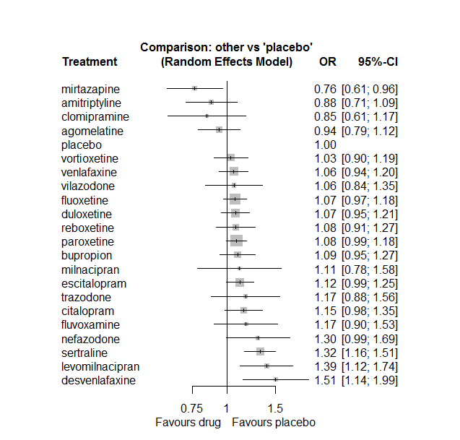

No prediction interval needed (tau zero)

### **Ranking according to P-scores**

P-score

mirtazapine 0.97

amitriptyline 0.88

clomipramine 0.87

agomelatine 0.81

placebo 0.74

vortioxetine 0.62

venlafaxine 0.56

vilazodone 0.55

fluoxetine 0.54

duloxetine 0.52

reboxetine 0.52

paroxetine 0.50

bupropion 0.48

milnacipran 0.46

escitalopram 0.42

trazodone 0.36

citalopram 0.36

fluvoxamine 0.35

nefazodone 0.20

sertraline 0.13

levomilnacipran 0.10

desvenlafaxine 0.06

### **Local inconsistency**

Percent of comparisons where there is some evidence (p-value<0.05) of disagreement between direct and indirect sources: 0.02. (2 out of 81 comparisons)

comparison TE seTE lower upper z p

6 agomelatine:duloxetine 0.50699 0.291 -0.064 1.078 1.7404 0.082

7 agomelatine:escitalopram -0.54350 0.283 -1.099 0.012 -1.9183 0.055

8 agomelatine:fluoxetine 0.52567 0.229 0.076 0.975 2.2905 0.022

14 agomelatine:paroxetine -0.15854 0.236 -0.620 0.303 -0.6727 0.501

15 agomelatine:placebo -0.26826 0.180 -0.621 0.084 -1.4915 0.136

19 agomelatine:venlafaxine -0.12438 0.371 -0.852 0.603 -0.3352 0.738

22 amitriptyline:bupropion -0.23878 0.412 -1.046 0.568 -0.5799 0.562

28 amitriptyline:fluoxetine -0.26997 0.310 -0.877 0.337 -0.8716 0.383

31 amitriptyline:milnacipran 0.31023 0.572 -0.811 1.432 0.5422 0.588

32 amitriptyline:mirtazapine 1.05917 0.548 -0.014 2.133 1.9339 0.053

34 amitriptyline:paroxetine -0.15612 0.299 -0.742 0.430 -0.5224 0.601

35 amitriptyline:placebo 0.10277 0.223 -0.335 0.540 0.4604 0.645

37 amitriptyline:sertraline -0.06153 0.261 -0.574 0.451 -0.2354 0.814

39 amitriptyline:venlafaxine 0.51762 0.492 -0.447 1.482 1.0516 0.293

46 bupropion:escitalopram 0.35799 0.222 -0.078 0.794 1.6109 0.107

47 bupropion:fluoxetine -0.02392 0.193 -0.401 0.354 -0.1242 0.901

53 bupropion:paroxetine -0.64937 0.357 -1.350 0.051 -1.8170 0.069

54 bupropion:placebo -0.12624 0.180 -0.479 0.226 -0.7018 0.483

57 bupropion:trazodone 0.69088 0.440 -0.172 1.554 1.5687 0.117

64 citalopram:escitalopram 0.38045 0.183 0.021 0.740 2.0761 0.038

65 citalopram:fluoxetine -0.11216 0.331 -0.761 0.537 -0.3386 0.735

66 citalopram:fluvoxamine -0.46381 0.505 -1.453 0.526 -0.9185 0.358

69 citalopram:mirtazapine 0.06143 0.409 -0.741 0.864 0.1500 0.881

71 citalopram:paroxetine 0.22194 0.302 -0.370 0.814 0.7344 0.463

72 citalopram:placebo 0.04814 0.162 -0.269 0.365 0.2979 0.766

73 citalopram:reboxetine -0.90847 0.583 -2.052 0.235 -1.5570 0.119

74 citalopram:sertraline -0.41263 0.228 -0.859 0.034 -1.8117 0.070

77 citalopram:vilazodone -0.09895 0.270 -0.628 0.430 -0.3667 0.714

82 clomipramine:fluoxetine -0.77102 0.871 -2.479 0.937 -0.8849 0.376

88 clomipramine:paroxetine 0.16223 0.371 -0.566 0.890 0.4369 0.662

91 clomipramine:sertraline 0.20159 0.452 -0.685 1.088 0.4455 0.656

93 clomipramine:venlafaxine -0.44610 0.624 -1.669 0.777 -0.7149 0.475

112 duloxetine:escitalopram -0.11511 0.176 -0.460 0.230 -0.6535 0.513

113 duloxetine:fluoxetine -0.50098 0.358 -1.203 0.201 -1.3995 0.162

119 duloxetine:paroxetine -0.00115 0.184 -0.362 0.359 -0.0062 0.995

120 duloxetine:placebo 0.11879 0.125 -0.125 0.363 0.9541 0.340

124 duloxetine:venlafaxine 0.11462 0.180 -0.238 0.467 0.6379 0.524

126 duloxetine:vortioxetine 0.09042 0.167 -0.236 0.417 0.5429 0.587

127 escitalopram:fluoxetine 0.00806 0.248 -0.478 0.494 0.0325 0.974

133 escitalopram:paroxetine 0.33652 0.196 -0.047 0.720 1.7199 0.085

134 escitalopram:placebo -0.15281 0.120 -0.388 0.082 -1.2759 0.202

136 escitalopram:sertraline -0.26801 0.226 -0.712 0.176 -1.1838 0.236

138 escitalopram:venlafaxine 0.17952 0.290 -0.389 0.748 0.6189 0.536

141 fluoxetine:fluvoxamine 0.26014 0.337 -0.401 0.921 0.7712 0.441

143 fluoxetine:milnacipran -0.04893 0.401 -0.835 0.737 -0.1219 0.903

144 fluoxetine:mirtazapine -0.24564 0.274 -0.782 0.290 -0.8980 0.369

145 fluoxetine:nefazodone -0.07031 0.409 -0.871 0.731 -0.1720 0.863

146 fluoxetine:paroxetine 0.01342 0.115 -0.212 0.239 0.1168 0.907

147 fluoxetine:placebo -0.04033 0.098 -0.232 0.152 -0.4114 0.681

148 fluoxetine:reboxetine 0.08407 0.223 -0.353 0.521 0.3768 0.706

149 fluoxetine:sertraline 0.16831 0.188 -0.201 0.537 0.8938 0.371

150 fluoxetine:trazodone -0.01089 0.367 -0.730 0.708 -0.0297 0.976

151 fluoxetine:venlafaxine -0.09176 0.137 -0.361 0.178 -0.6679 0.504

155 fluvoxamine:milnacipran 0.12960 0.486 -0.823 1.083 0.2665 0.790

158 fluvoxamine:paroxetine -0.36378 0.402 -1.152 0.424 -0.9048 0.366

159 fluvoxamine:placebo 0.20809 0.277 -0.334 0.750 0.7522 0.452

161 fluvoxamine:sertraline -0.12400 0.475 -1.055 0.807 -0.2609 0.794

179 milnacipran:paroxetine 0.15077 0.356 -0.546 0.848 0.4239 0.672

188 mirtazapine:paroxetine -0.33126 0.254 -0.828 0.166 -1.3066 0.191

189 mirtazapine:placebo -0.36891 0.397 -1.147 0.410 -0.9288 0.353

191 mirtazapine:sertraline 0.30911 0.325 -0.329 0.947 0.9502 0.342

192 mirtazapine:trazodone -0.00236 0.574 -1.126 1.122 -0.0041 0.997

193 mirtazapine:venlafaxine 0.42676 0.380 -0.319 1.172 1.1217 0.262

196 nefazodone:paroxetine 0.30176 0.320 -0.325 0.929 0.9431 0.346

197 nefazodone:placebo -0.27310 0.273 -0.809 0.262 -0.9996 0.318

199 nefazodone:sertraline 0.03705 0.357 -0.663 0.737 0.1038 0.917

204 paroxetine:placebo -0.08716 0.091 -0.265 0.091 -0.9610 0.337

205 paroxetine:reboxetine 0.18492 0.173 -0.154 0.524 1.0685 0.285

206 paroxetine:sertraline -0.03192 0.201 -0.425 0.362 -0.1589 0.874

207 paroxetine:trazodone -0.21909 0.706 -1.604 1.165 -0.3102 0.756

208 paroxetine:venlafaxine 0.32475 0.357 -0.375 1.025 0.9090 0.363

211 placebo:reboxetine -0.12455 0.182 -0.482 0.233 -0.6830 0.495

212 placebo:sertraline -0.00025 0.134 -0.264 0.263 -0.0019 0.999

213 placebo:trazodone -0.36812 0.298 -0.952 0.215 -1.2366 0.216

214 placebo:venlafaxine -0.09978 0.127 -0.349 0.150 -0.7843 0.433

215 placebo:vilazodone 0.11423 0.339 -0.550 0.779 0.3368 0.736

216 placebo:vortioxetine -0.11817 0.184 -0.478 0.242 -0.6433 0.520

219 reboxetine:venlafaxine 0.19131 0.619 -1.022 1.404 0.3091 0.757

222 sertraline:trazodone 1.62352 1.123 -0.577 3.824 1.4463 0.148

223 sertraline:venlafaxine -0.19588 0.223 -0.633 0.241 -0.8790 0.379

230 venlafaxine:vortioxetine 0.12524 0.235 -0.336 0.587 0.5321 0.595

### **League table**

Below we show the league table. Upper triangle: direct evidence. Lower triangle: NMA. An odds ratio larger than 1 in the upper triangle favors the column-defining drug. An odds ratio larger than 1 in the bottom triangle favors the row-defining drug.

|  |  |  |  |  |  |  |  |  |  |  |  |  |  |  |  |  |  |  |  |  |  |
| --- | --- | --- | --- | --- | --- | --- | --- | --- | --- | --- | --- | --- | --- | --- | --- | --- | --- | --- | --- | --- | --- |
| AGOM | . | . | . | . | . | 1.34 [0.79; 2.28] | 0.53 [0.32; 0.88] | 1.32 [0.89; 1.96] | . | . | . | . | . | 0.76 [0.50; 1.15] | 0.81 [0.63; 1.05] | . | . | . | 0.79 [0.39; 1.58] | . | . |
| 1.07 [0.81; 1.40] | AMIT | 0.65 [0.30; 1.39] | . | . | . | . | . | 0.65 [0.38; 1.14] | . | . | 1.03 [0.36; 2.91] | 3.02 [1.08; 8.41] | . | 0.71 [0.42; 1.21] | 0.93 [0.67; 1.31] | . | 0.64 [0.41; 0.98] | . | 1.34 [0.53; 3.42] | . | . |
| 0.86 [0.68; 1.07] | 0.80 [0.62; 1.03] | BUPR | . | . | . | . | 1.30 [0.88; 1.91] | 1.01 [0.73; 1.39] | . | . | . | . | . | 0.55 [0.28; 1.08] | 1.06 [0.90; 1.26] | . | . | 1.68 [0.76; 3.71] | . | . | . |
| 0.81 [0.65; 1.03] | 0.76 [0.59; 0.99] | 0.95 [0.77; 1.18] | CITA | . | . | . | 1.29 [0.98; 1.70] | 0.97 [0.52; 1.81] | 0.65 [0.25; 1.65] | . | . | 1.59 [0.75; 3.37] | . | 1.30 [0.74; 2.28] | 1.18 [0.95; 1.47] | 0.45 [0.15; 1.37] | 0.63 [0.43; 0.94] | . | . | 1.02 [0.69; 1.53] | . |
| 1.11 [0.77; 1.60] | 1.04 [0.71; 1.52] | 1.29 [0.91; 1.84] | 1.36 [0.95; 1.94] | CLOM | . | . | . | 0.38 [0.07; 2.01] | . | . | . | . | . | 0.81 [0.56; 1.18] | . | . | 0.76 [0.34; 1.69] | . | 0.53 [0.16; 1.71] | . | . |
| 0.62 [0.45; 0.86] | 0.58 [0.41; 0.83] | 0.73 [0.53; 0.99] | 0.76 [0.55; 1.05] | 0.56 [0.37; 0.86] | DESV | . | . | . | . | . | . | . | . | . | 1.51 [1.14; 1.99] | . | . | . | . | . | . |
| 0.87 [0.71; 1.07] | 0.82 [0.64; 1.04] | 1.02 [0.85; 1.23] | 1.07 [0.88; 1.30] | 0.79 [0.56; 1.11] | 1.40 [1.04; 1.90] | DULO | 0.88 [0.66; 1.19] | 0.62 [0.31; 1.24] | . | . | . | . | . | 0.99 [0.72; 1.37] | 1.13 [0.97; 1.32] | . | . | . | 1.11 [0.81; 1.50] | . | 1.09 [0.86; 1.38] |
| 0.84 [0.69; 1.02] | 0.79 [0.62; 1.00] | 0.98 [0.82; 1.17] | 1.03 [0.86; 1.23] | 0.76 [0.54; 1.07] | 1.35 [1.00; 1.83] | 0.96 [0.83; 1.12] | ESCI | 1.05 [0.66; 1.67] | . | . | . | . | . | 1.37 [0.96; 1.96] | 1.04 [0.89; 1.22] | . | 0.67 [0.45; 1.01] | . | 1.24 [0.72; 2.14] | . | . |
| 0.88 [0.73; 1.06] | 0.82 [0.66; 1.03] | 1.02 [0.87; 1.21] | 1.08 [0.90; 1.28] | 0.79 [0.57; 1.10] | 1.41 [1.05; 1.89] | 1.00 [0.87; 1.16] | 1.04 [0.91; 1.20] | FLUO | 1.12 [0.62; 2.00] | . | 0.93 [0.48; 1.81] | 1.17 [0.74; 1.85] | 0.78 [0.37; 1.63] | 1.00 [0.83; 1.19] | 1.05 [0.91; 1.21] | 1.06 [0.72; 1.57] | 0.93 [0.66; 1.29] | 0.91 [0.48; 1.72] | 0.96 [0.77; 1.18] | . | . |
| 0.80 [0.58; 1.10] | 0.75 [0.53; 1.05] | 0.93 [0.69; 1.26] | 0.98 [0.73; 1.32] | 0.72 [0.48; 1.09] | 1.28 [0.87; 1.89] | 0.92 [0.68; 1.22] | 0.95 [0.71; 1.27] | 0.91 [0.69; 1.20] | FLUV | . | 1.17 [0.51; 2.67] | . | . | 0.79 [0.38; 1.65] | 1.32 [0.88; 2.00] | . | 0.79 [0.33; 1.92] | . | . | . | . |
| 0.67 [0.51; 0.89] | 0.63 [0.46; 0.86] | 0.78 [0.60; 1.02] | 0.82 [0.63; 1.08] | 0.61 [0.41; 0.90] | 1.08 [0.76; 1.54] | 0.77 [0.60; 0.99] | 0.80 [0.62; 1.03] | 0.77 [0.60; 0.98] | 0.84 [0.59; 1.19] | LEVO | . | . | . | . | 1.39 [1.12; 1.74] | . | . | . | . | . | . |
| 0.84 [0.57; 1.24] | 0.79 [0.53; 1.17] | 0.99 [0.68; 1.44] | 1.04 [0.71; 1.51] | 0.76 [0.48; 1.22] | 1.36 [0.87; 2.12] | 0.97 [0.67; 1.40] | 1.00 [0.70; 1.45] | 0.96 [0.68; 1.37] | 1.06 [0.70; 1.59] | 1.25 [0.83; 1.90] | MILN | . | . | 1.11 [0.67; 1.84] | . | . | . | . | . | . | . |
| 1.23 [0.92; 1.63] | 1.15 [0.85; 1.56] | 1.43 [1.09; 1.88] | 1.51 [1.15; 1.97] | 1.11 [0.75; 1.64] | 1.97 [1.38; 2.83] | 1.41 [1.09; 1.82] | 1.46 [1.13; 1.88] | 1.40 [1.11; 1.77] | 1.54 [1.09; 2.18] | 1.83 [1.32; 2.52] | 1.46 [0.96; 2.20] | MIRT | . | 0.56 [0.38; 0.85] | 0.55 [0.26; 1.15] | . | 0.74 [0.42; 1.32] | 0.65 [0.23; 1.87] | 1.05 [0.52; 2.10] | . | . |
| 0.72 [0.53; 0.99] | 0.68 [0.48; 0.95] | 0.84 [0.62; 1.14] | 0.89 [0.65; 1.21] | 0.65 [0.43; 0.99] | 1.16 [0.79; 1.71] | 0.83 [0.62; 1.11] | 0.86 [0.64; 1.15] | 0.82 [0.63; 1.09] | 0.90 [0.62; 1.32] | 1.07 [0.76; 1.52] | 0.86 [0.55; 1.33] | 0.59 [0.42; 0.83] | NEFA | 1.50 [0.87; 2.58] | 1.12 [0.76; 1.66] | . | 1.01 [0.54; 1.88] | . | . | . | . |
| 0.87 [0.72; 1.04] | 0.81 [0.65; 1.01] | 1.01 [0.86; 1.19] | 1.06 [0.89; 1.26] | 0.78 [0.57; 1.07] | 1.39 [1.04; 1.86] | 0.99 [0.86; 1.14] | 1.03 [0.90; 1.18] | 0.99 [0.89; 1.10] | 1.08 [0.82; 1.42] | 1.29 [1.01; 1.64] | 1.03 [0.72; 1.45] | 0.71 [0.56; 0.89] | 1.20 [0.91; 1.57] | PARO | 1.05 [0.94; 1.17] | 1.11 [0.87; 1.42] | 0.80 [0.55; 1.14] | 0.75 [0.19; 2.90] | 1.40 [0.70; 2.77] | . | . |
| 0.94 [0.79; 1.12] | 0.88 [0.71; 1.09] | 1.09 [0.95; 1.27] | 1.15 [0.98; 1.35] | 0.85 [0.61; 1.17] | 1.51 [1.14; 1.99] | 1.07 [0.95; 1.21] | 1.12 [0.99; 1.25] | 1.07 [0.97; 1.18] | 1.17 [0.90; 1.53] | 1.39 [1.12; 1.74] | 1.11 [0.78; 1.58] | 0.76 [0.61; 0.96] | 1.30 [0.99; 1.69] | 1.08 [0.99; 1.18] | PLAC | 0.90 [0.74; 1.09] | 0.76 [0.62; 0.93] | 0.74 [0.51; 1.07] | 0.89 [0.73; 1.08] | 0.96 [0.74; 1.24] | 0.95 [0.81; 1.11] |
| 0.87 [0.69; 1.10] | 0.82 [0.63; 1.06] | 1.02 [0.82; 1.26] | 1.07 [0.86; 1.34] | 0.79 [0.55; 1.13] | 1.40 [1.02; 1.93] | 1.00 [0.82; 1.22] | 1.04 [0.85; 1.26] | 0.99 [0.83; 1.19] | 1.09 [0.80; 1.49] | 1.30 [0.98; 1.71] | 1.03 [0.71; 1.51] | 0.71 [0.54; 0.94] | 1.21 [0.88; 1.64] | 1.01 [0.85; 1.19] | 0.93 [0.79; 1.09] | REBO | . | . | 1.22 [0.37; 4.05] | . | . |
| 0.71 [0.57; 0.88] | 0.66 [0.53; 0.84] | 0.83 [0.68; 1.00] | 0.87 [0.72; 1.05] | 0.64 [0.46; 0.90] | 1.14 [0.84; 1.55] | 0.81 [0.68; 0.96] | 0.84 [0.72; 0.99] | 0.81 [0.70; 0.93] | 0.89 [0.67; 1.18] | 1.05 [0.82; 1.36] | 0.84 [0.58; 1.21] | 0.58 [0.45; 0.74] | 0.98 [0.74; 1.30] | 0.82 [0.71; 0.94] | 0.76 [0.66; 0.86] | 0.81 [0.66; 1.00] | SERT | 5.55 [0.63; 48.95] | 1.06 [0.71; 1.58] | . | . |
| 0.80 [0.57; 1.12] | 0.75 [0.53; 1.07] | 0.94 [0.69; 1.28] | 0.98 [0.71; 1.36] | 0.72 [0.47; 1.11] | 1.29 [0.87; 1.92] | 0.92 [0.67; 1.25] | 0.95 [0.70; 1.30] | 0.91 [0.68; 1.23] | 1.00 [0.68; 1.48] | 1.19 [0.83; 1.71] | 0.95 [0.61; 1.49] | 0.65 [0.46; 0.93] | 1.11 [0.75; 1.64] | 0.93 [0.69; 1.24] | 0.85 [0.64; 1.14] | 0.92 [0.66; 1.28] | 1.13 [0.83; 1.54] | TRAZ | . | . | . |
| 0.88 [0.72; 1.08] | 0.83 [0.65; 1.05] | 1.03 [0.86; 1.24] | 1.09 [0.90; 1.32] | 0.80 [0.57; 1.12] | 1.42 [1.05; 1.93] | 1.01 [0.87; 1.18] | 1.05 [0.90; 1.23] | 1.01 [0.89; 1.15] | 1.11 [0.83; 1.48] | 1.32 [1.02; 1.70] | 1.05 [0.73; 1.51] | 0.72 [0.56; 0.92] | 1.22 [0.92; 1.64] | 1.02 [0.89; 1.17] | 0.94 [0.84; 1.07] | 1.02 [0.83; 1.24] | 1.25 [1.06; 1.47] | 1.10 [0.81; 1.50] | VENL | . | 1.14 [0.75; 1.73] |
| 0.88 [0.66; 1.18] | 0.83 [0.60; 1.14] | 1.03 [0.78; 1.36] | 1.08 [0.83; 1.41] | 0.80 [0.53; 1.19] | 1.42 [0.99; 2.05] | 1.01 [0.78; 1.32] | 1.05 [0.81; 1.36] | 1.01 [0.78; 1.30] | 1.11 [0.78; 1.58] | 1.31 [0.95; 1.82] | 1.05 [0.69; 1.60] | 0.72 [0.52; 1.00] | 1.22 [0.86; 1.75] | 1.02 [0.79; 1.31] | 0.94 [0.74; 1.19] | 1.01 [0.76; 1.35] | 1.25 [0.95; 1.63] | 1.10 [0.76; 1.60] | 1.00 [0.77; 1.30] | VILA | . |
| 0.91 [0.73; 1.13] | 0.85 [0.66; 1.09] | 1.06 [0.86; 1.30] | 1.11 [0.90; 1.37] | 0.82 [0.57; 1.16] | 1.46 [1.07; 1.99] | 1.04 [0.88; 1.22] | 1.08 [0.90; 1.29] | 1.03 [0.88; 1.22] | 1.13 [0.84; 1.53] | 1.35 [1.04; 1.75] | 1.07 [0.74; 1.57] | 0.74 [0.56; 0.97] | 1.25 [0.93; 1.69] | 1.05 [0.89; 1.23] | 0.97 [0.84; 1.11] | 1.04 [0.84; 1.29] | 1.28 [1.06; 1.54] | 1.13 [0.82; 1.55] | 1.02 [0.86; 1.22] | 1.03 [0.78; 1.35] | VORT |

### **Estimated event rates**

For an event rate in placebo equal to the average event rate (i.e. fixed to 0.17) the estimated event rates for each drug are as follows

drug rate

1 agomelatine 0.16 [0.14, 0.18]

2 amitriptyline 0.15 [0.13, 0.18]

3 bupropion 0.18 [0.16, 0.2]

4 citalopram 0.19 [0.17, 0.21]

5 clomipramine 0.15 [0.11, 0.19]

6 desvenlafaxine 0.23 [0.19, 0.29]

7 duloxetine 0.18 [0.16, 0.2]

8 escitalopram 0.18 [0.17, 0.2]

9 fluoxetine 0.18 [0.16, 0.19]

10 fluvoxamine 0.19 [0.15, 0.24]

11 levomilnacipran 0.22 [0.18, 0.26]

12 milnacipran 0.18 [0.14, 0.24]

13 mirtazapine 0.13 [0.11, 0.16]

14 nefazodone 0.21 [0.17, 0.26]

15 paroxetine 0.18 [0.17, 0.19]

17 reboxetine 0.18 [0.16, 0.2]

18 sertraline 0.21 [0.19, 0.23]

19 trazodone 0.19 [0.15, 0.24]

20 venlafaxine 0.18 [0.16, 0.2]

21 vilazodone 0.18 [0.15, 0.21]

22 vortioxetine 0.17 [0.15, 0.19]

## **Sensitivity analysis: splitting nodes according to dosage**

All treatment arms for drug X, with dose_intended_min equal to or smaller to the minimum licensed dose were set as “X_L”. All other arms of X are “X_H”. Studies with no information on dose are excluded. Results shown below:

|  |  |  |
| --- | --- | --- |
| **Low dose vs. placebo** | **High dose vs. placebo** | **High dose vs. low dose** |
|  |  |  |

## **Sensitivity analysis: Keeping only low dropout arms**

We exclude all treatment arms with dropout rates larger than 25%, and we re-analyse the network.

Total number of arms included in the analysis 254. Total number of studies 120

Total events in placebo 1327, out of a total of 9785 patients. Event rate placebo 0.136

Total events in drugs 4273, out of a total of 29083 patients. Event rate drugs 0.147

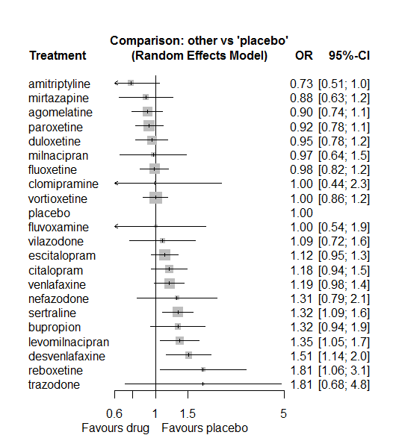

There are some differences with the primary analysis, e.g. with Reboxetine.

# **Dry mouth**

We remove all arms for which dose range was not “Licenced”. After this:

* Removed 22 one-arm studies: Kennedy2006 (CL3-20098-043), Roffman1982, Amsterdam1986, Carman1991, Settle1999 (WELL212), Hewett2010a (AK130940) (NCT00093288), AK1102365, Kavoussi1997, Shaw1986, Kyle1998 (Study 92032 - FDA), Mendels1999 (Study 85A - FDA), Lieberman2008a (Study 309)(EUCTR2004-000562-13, 3151A1-309-EU, NCT00090649), Lieberman2008b (Study 317), Jiang2009, Study 25 (FDA) (Rickels1986), Masco1985, Lydiard1989, Mullin1996, Szegedi2006, Ansseau1994c, 29060/299, Sacchetti2002 (BRL-29060/109).
* Total number of studies with number randomized being smaller than event rates: 1. Removed the following studies: Rush1998 (excluding Armitage1997 and Gillin1997).
* Total number of arms 635. Total number of studies 273.
* Total events in placebo 1608, out of a total of 18849 patients. Event rate placebo 0.085.
* Total events in drugs 8480, out of a total of 54976 patients. Event rate drugs 0.154.

## **Distribution of dose across drugs**

Here we count the number of arms per drug, and the percent of these arms where Dose_intended_min was equal to the minimum licensed dose or lower. The values we used as minimum licensed dose are as follows:

agomelatine: 25; amitriptyline: 75; bupropion:300; citalopram:20; clomipramine:30; desvenlafaxine:50; duloxetine:40; escitalopram:10; fluoxetine:20; fluvoxamine:50; levomilnacipran:40; milnacipran:50; mirtazapine:15; nefazodone:300; paroxetine:20; reboxetine:8; sertraline:50; trazodone:150; venlafaxine:75; vilazodone:20; vortioxetine:5.

Drug number.arms percent.low.dose

1 paroxetine 80 0.76

3 fluoxetine 60 0.92

4 bupropion 21 0.90

5 escitalopram 27 0.78

6 sertraline 20 1.00

7 citalopram 17 0.71

8 venlafaxine 40 0.68

9 vortioxetine 27 0.41

10 mirtazapine 12 0.75

11 milnacipran 10 0.10

12 amitriptyline 37 0.54

13 fluvoxamine 13 0.46

14 nefazodone 8 0.62

15 levomilnacipran 9 0.56

16 reboxetine 14 0.93

17 duloxetine 31 0.13

18 trazodone 6 1.00

19 agomelatine 16 0.88

20 desvenlafaxine 8 0.62

21 clomipramine 8 0.00

22 vilazodone 4 0.25

## **Network graph**

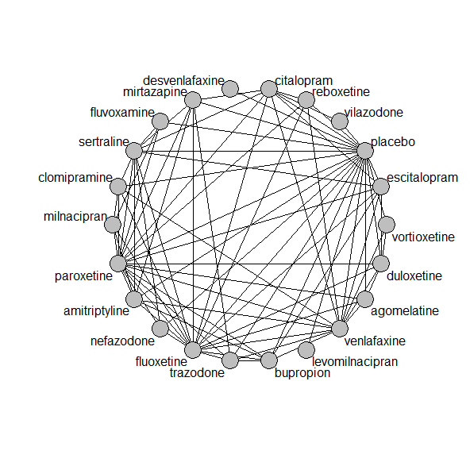

## **Pairwise MA**

### **Grouping all drugs together, comparison vs. placebo**

Number of studies: 165

Random effects meta-analysis: OR=2.00. 95% CI 1.79 to 2.22

Prediction interval 0.71 to 5.59

Heterogeneity (tau squared) was estimated to be 0.27

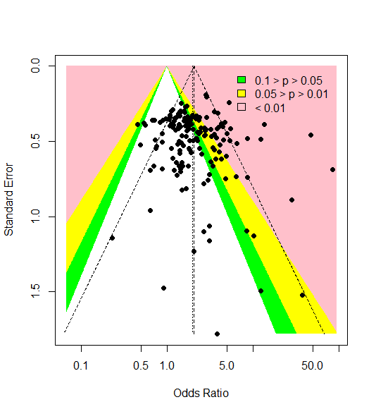

There is some weak evidence of small-study effects or publication bias (Harbord’s test p-value 0.09)

### **Meta-analyses of comparisons with 10 or more studies**

We show results from pairwise comparisons informed by 10 studies or more. An OR larger than 1 favors the first treatment in the comparison.

comparisons Number.of.studies OR lower.CI upper.CI tau.sq I.sq

1 placebo - amitriptyline 10 15.74 10.89 19.41 0.32 0.58

2 placebo - bupropion 13 1.91 1.63 2.46 0.18 0.54

3 placebo - duloxetine 21 2.62 2.25 3.24 0.04 0.16

4 placebo - escitalopram 15 1.37 1.11 1.74 0.00 0.00

5 placebo - fluoxetine 18 1.43 1.18 1.76 0.00 0.00

6 placebo - paroxetine 41 1.83 1.66 2.20 0.00 0.00

7 placebo - venlafaxine 15 2.28 1.86 2.80 0.06 0.26

8 placebo - vortioxetine 13 1.09 0.89 1.40 0.01 0.03

9 amitriptyline - paroxetine 11 0.26 0.20 0.35 0.20 0.42

10 fluoxetine - venlafaxine 11 1.86 1.51 2.34 0.00 0.00

## **Assessment of transitivity**

comparison studies baseline_SD age_SD female

1 paroxetine - placebo 41 24 (2.6) 42 (6.7) 0.57 (0.14)

2 fluoxetine - paroxetine 9 23 (1.6) 42 (1.2) NaN (NA)

3 bupropion - placebo 13 24 (2.3) 40 (4.4) 0.52 (0.18)

4 escitalopram - placebo 15 22 (2.1) 44 (11.5) 0.57 (0.13)

5 escitalopram - sertraline 2 20 (0.5) 40 (0.5) NaN (NA)

6 placebo - sertraline 6 22 (1.6) 40 (3.1) 0.67 (NA)

7 citalopram - venlafaxine 1 22 (NA) 73 (NA) NaN (NA)

8 placebo - venlafaxine 15 22 (1.8) 43 (7.8) 0.6 (0.1)

9 placebo - vortioxetine 13 24 (1.8) 46 (7.7) 0.64 (0.07)

10 venlafaxine - vortioxetine 2 23 (2.5) 42 (2.2) 0.61 (0.02)

11 fluoxetine - venlafaxine 11 25 (2.8) 46 (9.2) 0.65 (0.06)

12 fluoxetine - mirtazapine 3 25 (1.3) 44 (6.3) NaN (NA)

13 amitriptyline - milnacipran 2 26 (1.3) 49 (0.7) 0.66 (NA)

14 fluvoxamine - milnacipran 2 24 (0.4) 49 (2) NaN (NA)

15 fluvoxamine - paroxetine 2 22 (1.4) 42 (1.6) 0.57 (NA)

16 fluoxetine - milnacipran 1 23 (NA) 45 (NA) NaN (NA)

17 fluoxetine - nefazodone 1 24 (NA) 37 (NA) 0.63 (NA)

18 levomilnacipran - placebo 6 24 (1.1) 43 (1.4) 0.63 (0.02)

19 amitriptyline - placebo 10 26 (4.4) 41 (1.7) NaN (NA)

20 nefazodone - paroxetine 2 25 (NA) 40 (3.4) 0.49 (0.09)

21 paroxetine - reboxetine 3 22 (2.1) 41 (2.7) 0.69 (0.07)

22 duloxetine - placebo 21 21 (2.6) 47 (10.7) 0.65 (0.04)

23 duloxetine - vortioxetine 6 24 (2) 49 (10.8) 0.67 (0.04)

24 placebo - reboxetine 9 24 (3.9) 41 (2.6) 0.61 (0.08)

25 fluoxetine - trazodone 2 21 (0.4) 39 (1.9) 0.67 (NA)

26 mirtazapine - sertraline 1 NaN (NA) 42 (NA) NaN (NA)

27 mirtazapine - paroxetine 3 23 (1.2) 53 (16.7) NaN (NA)

28 amitriptyline - sertraline 5 25 (2.5) 49 (12.7) 0.6 (0.11)

29 escitalopram - venlafaxine 2 20 (0.4) 43 (7.5) NaN (NA)

30 amitriptyline - paroxetine 11 23 (2.8) 50 (11.3) 0.78 (0.23)

31 fluoxetine - reboxetine 3 24 (1.1) 41 (2.8) 0.66 (0.05)

32 escitalopram - paroxetine 1 27 (NA) 44 (NA) NaN (NA)

33 amitriptyline - mirtazapine 2 26 (2) 38 (NA) NaN (NA)

34 mirtazapine - placebo 4 24 (2.7) 49 (12.1) 0.54 (0.01)

35 citalopram - escitalopram 5 25 (2.6) 41 (3.8) 0.59 (NA)

36 citalopram - placebo 7 22 (2.6) 46 (14.7) 0.59 (0.02)

37 fluoxetine - placebo 18 22 (2.3) 44 (10.8) 0.63 (0.03)

38 agomelatine - paroxetine 3 27 (0.6) 51 (14.9) 0.64 (0.03)

39 agomelatine - placebo 7 27 (0.1) 52 (13.9) 0.67 (0.04)

40 fluvoxamine - placebo 8 23 (2.3) 41 (2.2) 0.43 (NA)

41 amitriptyline - bupropion 1 23 (NA) 37 (NA) NaN (NA)

42 amitriptyline - fluoxetine 8 24 (1.6) 42 (2.6) 0.67 (0.09)

43 agomelatine - duloxetine 1 26 (NA) 43 (NA) NaN (NA)

44 bupropion - escitalopram 2 24 (NA) 36 (0.6) NaN (NA)

45 desvenlafaxine - placebo 6 23 (0.4) 43 (4.9) 0.66 (0.17)

46 bupropion - fluoxetine 3 23 (2.2) 39 (2.7) NaN (NA)

47 placebo - trazodone 2 22 (0) 51 (15.1) 0.6 (0.08)

48 trazodone - venlafaxine 1 22 (NA) 41 (NA) 0.66 (NA)

49 duloxetine - paroxetine 5 20 (1.7) 42 (2.7) NaN (NA)

50 citalopram - sertraline 2 26 (4.9) 44 (4.9) NaN (NA)

51 fluoxetine - sertraline 4 22 (2.5) 50 (11.8) NaN (NA)

52 paroxetine - sertraline 1 21 (NA) 43 (NA) NaN (NA)

53 nefazodone - sertraline 1 23 (NA) 44 (NA) 0.52 (NA)

54 nefazodone - placebo 4 26 (1.7) 41 (2.5) 0.64 (0.04)

55 amitriptyline - venlafaxine 2 21 (0) 43 (6.2) NaN (NA)

56 clomipramine - fluoxetine 2 24 (6.4) 46 (3.7) 0.68 (0.05)

57 duloxetine - fluoxetine 2 18 (0.2) 41 (0.6) NaN (NA)

58 agomelatine - fluoxetine 2 28 (1.1) 41 (2.3) 0.74 (0.06)

59 mirtazapine - trazodone 1 22 (NA) 62 (NA) 0.54 (NA)

60 citalopram - paroxetine 1 24 (NA) 40 (NA) NaN (NA)

61 milnacipran - paroxetine 1 22 (NA) 36 (NA) 0.53 (NA)

62 escitalopram - fluoxetine 4 23 (1.5) 47 (18.4) 0.68 (NA)

63 duloxetine - escitalopram 3 20 (2.5) 43 (0.9) NaN (NA)

64 placebo - vilazodone 3 25 (0.6) 41 (1.1) 0.57 (NA)

65 clomipramine - placebo 1 18 (NA) 52 (NA) 0.66 (NA)

66 clomipramine - milnacipran 1 24 (NA) 48 (NA) NaN (NA)

67 citalopram - mirtazapine 1 23 (NA) 42 (NA) NaN (NA)

68 agomelatine - venlafaxine 1 26 (NA) 40 (NA) 0.71 (NA)

69 citalopram - vilazodone 1 24 (NA) 42 (NA) 0.57 (NA)

70 paroxetine - venlafaxine 1 23 (NA) 44 (NA) NaN (NA)

71 clomipramine - sertraline 1 24 (NA) 44 (NA) 0.5 (NA)

72 fluvoxamine - sertraline 1 21 (NA) 40 (NA) NaN (NA)

73 citalopram - fluoxetine 1 23 (NA) 44 (NA) NaN (NA)

74 duloxetine - venlafaxine 2 23 (0.5) 43 (1.4) 0.68 (0.03)

75 clomipramine - paroxetine 2 24 (1.1) 57 (20.3) 0.81 (0.12)

76 clomipramine - venlafaxine 1 25 (NA) 47 (NA) NaN (NA)

77 reboxetine - venlafaxine 1 29 (NA) 42 (NA) 0.69 (NA)

78 citalopram - reboxetine 1 24 (NA) 42 (NA) 0.64 (NA)

79 bupropion - venlafaxine 1 24 (NA) 37 (NA) NaN (NA)

80 paroxetine - trazodone 1 24 (NA) 39 (NA) NaN (NA)

81 bupropion - trazodone 1 22 (NA) 40 (NA) NaN (NA)

82 bupropion - paroxetine 1 22 (NA) 37 (NA) NaN (NA)

## **NMA**

A total of 22 treatments are included in the network.

A total of 271 studies are included in this analysis.

Estimated heterogeneity tau-squared 0.05

Global test for inconsistency, p-value 0.24438 (Q=103,d.o.f.94)

### **Comparison vs. placebo**

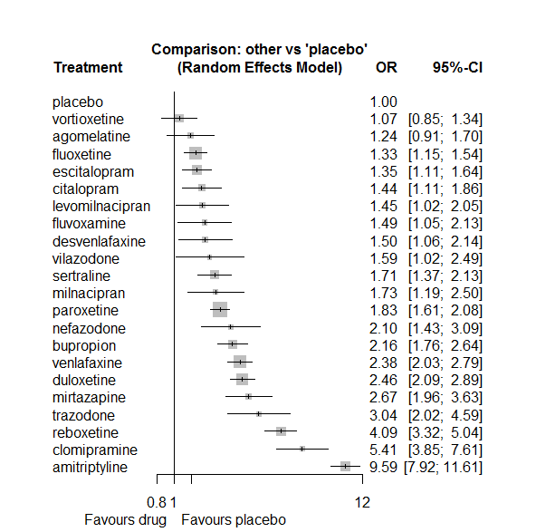

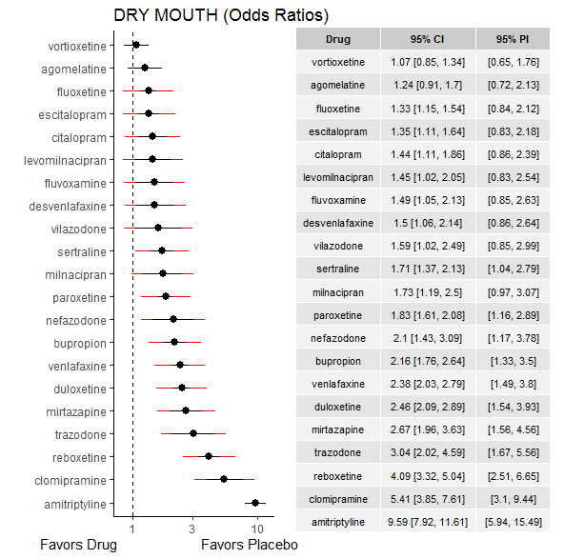

### **Ranking according to P-scores**

P-score

placebo 0.98

vortioxetine 0.93

agomelatine 0.83

fluoxetine 0.78

escitalopram 0.77

citalopram 0.70

levomilnacipran 0.69

fluvoxamine 0.67

desvenlafaxine 0.66

vilazodone 0.61

sertraline 0.54

milnacipran 0.54

paroxetine 0.48

nefazodone 0.38

bupropion 0.35

venlafaxine 0.28

duloxetine 0.26

mirtazapine 0.22

trazodone 0.18

reboxetine 0.10

clomipramine 0.05

amitriptyline 0.00

### **Local inconsistency**

Percent of comparisons where there is some evidence (p-value<0.05) of disagreement between direct and indirect sources: 0.05. (4 out of 80 comparisons)

comparison TE seTE lower upper z p

6 agomelatine:duloxetine 0.5604 0.44 -0.29 1.414 1.286 0.1984

8 agomelatine:fluoxetine 0.0367 0.43 -0.81 0.880 0.085 0.9320

14 agomelatine:paroxetine 0.3065 0.38 -0.44 1.050 0.808 0.4191

15 agomelatine:placebo -0.5312 0.32 -1.16 0.096 -1.659 0.0971

19 agomelatine:venlafaxine -0.0503 0.77 -1.56 1.460 -0.065 0.9480

22 amitriptyline:bupropion -0.1412 0.60 -1.31 1.025 -0.237 0.8125

28 amitriptyline:fluoxetine -0.0308 0.26 -0.53 0.473 -0.120 0.9046

31 amitriptyline:milnacipran -0.3540 0.41 -1.16 0.447 -0.866 0.3866

32 amitriptyline:mirtazapine 0.9410 0.42 0.11 1.770 2.224 0.0262

34 amitriptyline:paroxetine -0.4767 0.21 -0.90 -0.056 -2.219 0.0265

35 amitriptyline:placebo 0.6550 0.21 0.25 1.063 3.145 0.0017

37 amitriptyline:sertraline -0.0835 0.25 -0.57 0.407 -0.334 0.7387

39 amitriptyline:venlafaxine -0.1789 0.35 -0.86 0.501 -0.516 0.6059

46 bupropion:escitalopram 0.2410 0.32 -0.38 0.862 0.761 0.4465

47 bupropion:fluoxetine 0.1563 0.27 -0.37 0.687 0.577 0.5640

53 bupropion:paroxetine 0.6396 0.48 -0.31 1.586 1.325 0.1851

54 bupropion:placebo -0.3491 0.22 -0.78 0.082 -1.589 0.1121

57 bupropion:trazodone 0.7020 0.52 -0.32 1.728 1.342 0.1798

58 bupropion:venlafaxine -0.1763 0.36 -0.87 0.521 -0.495 0.6204

64 citalopram:escitalopram -0.0734 0.33 -0.72 0.571 -0.223 0.8233

65 citalopram:fluoxetine -2.4648 1.50 -5.41 0.485 -1.638 0.1015

69 citalopram:mirtazapine 0.0910 0.49 -0.88 1.060 0.184 0.8540

71 citalopram:paroxetine -0.0101 0.42 -0.83 0.810 -0.024 0.9807

72 citalopram:placebo -0.1910 0.27 -0.71 0.329 -0.720 0.4714

73 citalopram:reboxetine -0.2382 0.49 -1.21 0.730 -0.482 0.6296

74 citalopram:sertraline 0.3707 0.37 -0.35 1.093 1.006 0.3144

76 citalopram:venlafaxine 0.4157 0.58 -0.73 1.558 0.713 0.4758

77 citalopram:vilazodone -0.0473 0.49 -1.01 0.917 -0.096 0.9234

82 clomipramine:fluoxetine -0.2727 0.42 -1.10 0.555 -0.646 0.5183

85 clomipramine:milnacipran -0.0207 0.53 -1.07 1.025 -0.039 0.9690

88 clomipramine:paroxetine -0.0096 0.34 -0.68 0.661 -0.028 0.9776

89 clomipramine:placebo 1.7171 0.93 -0.11 3.549 1.837 0.0662

91 clomipramine:sertraline 0.0944 0.64 -1.15 1.344 0.148 0.8823

93 clomipramine:venlafaxine -0.1296 0.50 -1.11 0.855 -0.258 0.7964

112 duloxetine:escitalopram -0.0724 0.27 -0.60 0.452 -0.271 0.7864

113 duloxetine:fluoxetine -0.2739 0.40 -1.06 0.511 -0.684 0.4939

119 duloxetine:paroxetine -0.0842 0.24 -0.55 0.382 -0.354 0.7235

120 duloxetine:placebo 0.1615 0.17 -0.17 0.494 0.953 0.3407

124 duloxetine:venlafaxine 0.0096 0.25 -0.47 0.490 0.039 0.9686

126 duloxetine:vortioxetine 0.0570 0.25 -0.43 0.547 0.228 0.8194

127 escitalopram:fluoxetine -0.1046 0.37 -0.83 0.622 -0.282 0.7779

133 escitalopram:paroxetine -0.0704 0.43 -0.90 0.763 -0.166 0.8685

134 escitalopram:placebo 0.0636 0.20 -0.33 0.459 0.315 0.7524

136 escitalopram:sertraline -0.3164 0.37 -1.05 0.418 -0.844 0.3985

138 escitalopram:venlafaxine 0.1369 0.39 -0.63 0.906 0.349 0.7273

143 fluoxetine:milnacipran 0.1555 0.65 -1.12 1.432 0.239 0.8113

144 fluoxetine:mirtazapine -0.5151 0.49 -1.47 0.444 -1.053 0.2923

145 fluoxetine:nefazodone 0.8297 0.77 -0.67 2.333 1.082 0.2795

146 fluoxetine:paroxetine -0.1706 0.19 -0.54 0.197 -0.911 0.3624

147 fluoxetine:placebo 0.1255 0.15 -0.18 0.428 0.814 0.4155

148 fluoxetine:reboxetine -0.1440 0.29 -0.70 0.416 -0.504 0.6145

149 fluoxetine:sertraline -0.1314 0.34 -0.80 0.536 -0.386 0.6993

150 fluoxetine:trazodone 0.4645 0.67 -0.86 1.785 0.690 0.4905

151 fluoxetine:venlafaxine -0.1183 0.19 -0.48 0.246 -0.636 0.5250

155 fluvoxamine:milnacipran 0.3279 0.49 -0.63 1.288 0.670 0.5031

158 fluvoxamine:paroxetine 0.8954 0.60 -0.28 2.066 1.499 0.1338

159 fluvoxamine:placebo -0.5415 0.38 -1.28 0.198 -1.435 0.1512

161 fluvoxamine:sertraline -0.0266 0.60 -1.20 1.150 -0.044 0.9647

179 milnacipran:paroxetine -0.0751 0.41 -0.87 0.720 -0.185 0.8530

188 mirtazapine:paroxetine 0.3409 0.33 -0.30 0.987 1.035 0.3008

189 mirtazapine:placebo -0.0692 0.35 -0.76 0.626 -0.195 0.8453

191 mirtazapine:sertraline 0.0915 0.48 -0.86 1.039 0.189 0.8498

192 mirtazapine:trazodone -0.4880 0.54 -1.55 0.576 -0.899 0.3685

196 nefazodone:paroxetine -0.0123 0.51 -1.01 0.984 -0.024 0.9807

197 nefazodone:placebo 0.4077 0.40 -0.37 1.186 1.026 0.3048

199 nefazodone:sertraline -0.2773 0.50 -1.25 0.695 -0.559 0.5763

204 paroxetine:placebo 0.0466 0.13 -0.21 0.303 0.357 0.7211

205 paroxetine:reboxetine -0.3558 0.23 -0.81 0.103 -1.519 0.1287

206 paroxetine:sertraline -0.5127 0.48 -1.46 0.431 -1.065 0.2870

207 paroxetine:trazodone -0.0374 0.52 -1.05 0.974 -0.072 0.9422

208 paroxetine:venlafaxine 0.4431 0.58 -0.70 1.583 0.762 0.4463

211 placebo:reboxetine 0.2218 0.22 -0.21 0.658 0.997 0.3187

212 placebo:sertraline 0.2411 0.23 -0.21 0.693 1.044 0.2963

213 placebo:trazodone -1.2657 0.47 -2.19 -0.340 -2.681 0.0073

214 placebo:venlafaxine 0.0834 0.16 -0.23 0.401 0.515 0.6067

215 placebo:vilazodone 0.1036 0.61 -1.10 1.308 0.169 0.8661

216 placebo:vortioxetine -0.0766 0.27 -0.60 0.444 -0.288 0.7732

219 reboxetine:venlafaxine -0.3846 0.50 -1.37 0.597 -0.768 0.4426

226 trazodone:venlafaxine -0.3557 0.49 -1.32 0.611 -0.721 0.4709

230 venlafaxine:vortioxetine -0.0263 0.34 -0.69 0.633 -0.078 0.9377

### **League table**

Below we show the league table. Upper triangle: direct evidence. Lower triangle: NMA. An odds ratio larger than 1 in the upper triangle favors the column-defining drug. An odds ratio larger than 1 in the bottom triangle favors the row-defining drug.

|  |  |  |  |  |  |  |  |  |  |  |  |  |  |  |  |  |  |  |  |  |  |
| --- | --- | --- | --- | --- | --- | --- | --- | --- | --- | --- | --- | --- | --- | --- | --- | --- | --- | --- | --- | --- | --- |
| AGOM | . | . | . | . | . | 0.79 [ 0.37; 1.71] | . | 0.96 [ 0.45; 2.05] | . | . | . | . | . | 0.85 [ 0.45; 1.62] | 0.95 [ 0.61; 1.48] | . | . | . | 0.50 [ 0.11; 2.16] | . | . |
| 0.13 [0.09; 0.19] | AMIT | 3.89 [ 1.25; 12.08] | . | . | . | . | . | 7.04 [ 4.52; 10.97] | . | . | 4.40 [ 2.30; 8.43] | 7.59 [ 3.62; 15.89] | . | 3.80 [ 2.69; 5.37] | 14.91 [10.67; 20.85] | . | 5.37 [ 3.74; 7.71] | . | 3.45 [ 1.83; 6.51] | . | . |
| 0.57 [0.40; 0.83] | 4.44 [3.41; 5.79] | BUPR | . | . | . | . | 1.93 [ 1.12; 3.32] | 1.82 [ 1.15; 2.89] | . | . | . | . | . | 2.15 [ 0.86; 5.38] | 1.93 [ 1.51; 2.46] | . | . | 1.21 [ 0.49; 2.98] | 0.78 [ 0.41; 1.49] | . | . |
| 0.86 [0.58; 1.29] | 6.67 [4.90; 9.09] | 1.50 [1.09; 2.07] | CITA | . | . | . | 1.01 [ 0.59; 1.73] | 0.09 [ 0.00; 1.77] | . | . | . | 0.58 [ 0.24; 1.39] | . | 0.78 [ 0.36; 1.67] | 1.30 [ 0.89; 1.90] | 0.29 [ 0.12; 0.71] | 1.12 [ 0.59; 2.09] | . | 0.89 [ 0.30; 2.67] | 0.88 [ 0.43; 1.81] | . |
| 0.23 [0.15; 0.36] | 1.77 [1.22; 2.56] | 0.40 [0.27; 0.59] | 0.27 [0.17; 0.40] | CLOM | . | . | . | 3.30 [ 1.59; 6.82] | . | . | 3.09 [ 1.25; 7.63] | . | . | 2.94 [ 1.80; 4.81] | 28.33 [ 4.69; 171.15] | . | 3.45 [ 1.06; 11.24] | . | 2.04 [ 0.82; 5.04] | . | . |
| 0.82 [0.51; 1.32] | 6.38 [4.27; 9.52] | 1.43 [0.96; 2.15] | 0.96 [0.62; 1.48] | 3.60 [2.20; 5.87] | DESV | . | . | . | . | . | . | . | . | . | 1.50 [ 1.06; 2.14] | . | . | . | . | . | . |
| 0.50 [0.36; 0.71] | 3.90 [3.07; 4.97] | 0.88 [0.68; 1.13] | 0.58 [0.43; 0.79] | 2.20 [1.52; 3.19] | 0.61 [0.42; 0.90] | DULO | 1.73 [ 1.11; 2.71] | 1.43 [ 0.67; 3.05] | . | . | . | . | . | 1.26 [ 0.83; 1.90] | 2.62 [ 2.12; 3.25] | . | . | . | 1.04 [ 0.68; 1.58] | . | 2.36 [ 1.69; 3.28] |
| 0.92 [0.64; 1.32] | 7.12 [5.48; 9.25] | 1.60 [1.23; 2.08] | 1.07 [0.79; 1.44] | 4.02 [2.74; 5.90] | 1.12 [0.75; 1.67] | 1.82 [1.44; 2.30] | ESCI | 0.92 [ 0.47; 1.83] | . | . | . | . | . | 0.69 [ 0.31; 1.54] | 1.38 [ 1.07; 1.80] | . | 0.61 [ 0.31; 1.19] | . | 0.64 [ 0.31; 1.33] | . | . |
| 0.93 [0.67; 1.30] | 7.21 [5.84; 8.90] | 1.62 [1.29; 2.04] | 1.08 [0.81; 1.44] | 4.07 [2.88; 5.75] | 1.13 [0.77; 1.66] | 1.85 [1.50; 2.27] | 1.01 [0.81; 1.27] | FLUO | . | . | 0.89 [ 0.26; 2.98] | 0.32 [ 0.13; 0.78] | 1.36 [ 0.32; 5.76] | 0.64 [ 0.47; 0.88] | 1.43 [ 1.14; 1.81] | 0.29 [ 0.18; 0.48] | 0.70 [ 0.38; 1.29] | 0.66 [ 0.19; 2.28] | 0.52 [ 0.40; 0.69] | . | . |
| 0.83 [0.52; 1.33] | 6.42 [4.35; 9.49] | 1.45 [0.96; 2.17] | 0.96 [0.62; 1.49] | 3.62 [2.25; 5.85] | 1.01 [0.61; 1.66] | 1.64 [1.12; 2.42] | 0.90 [0.60; 1.35] | 0.89 [0.61; 1.30] | FLUV | . | 1.07 [ 0.49; 2.34] | . | . | 1.81 [ 0.60; 5.46] | 1.23 [ 0.79; 1.91] | . | 0.86 [ 0.29; 2.56] | . | . | . | . |
| 0.86 [0.54; 1.37] | 6.63 [4.46; 9.84] | 1.49 [1.00; 2.23] | 0.99 [0.64; 1.53] | 3.74 [2.30; 6.08] | 1.04 [0.63; 1.70] | 1.70 [1.16; 2.49] | 0.93 [0.63; 1.39] | 0.92 [0.63; 1.34] | 1.03 [0.63; 1.69] | LEVO | . | . | . | . | 1.45 [ 1.02; 2.05] | . | . | . | . | . | . |
| 0.72 [0.44; 1.16] | 5.56 [3.80; 8.13] | 1.25 [0.82; 1.90] | 0.83 [0.53; 1.30] | 3.14 [1.99; 4.94] | 0.87 [0.52; 1.46] | 1.42 [0.95; 2.12] | 0.78 [0.52; 1.18] | 0.77 [0.53; 1.13] | 0.87 [0.55; 1.36] | 0.84 [0.50; 1.39] | MILN | . | . | 0.90 [ 0.46; 1.73] | . | . | . | . | . | . | . |
| 0.46 [0.30; 0.72] | 3.59 [2.57; 5.03] | 0.81 [0.57; 1.16] | 0.54 [0.37; 0.78] | 2.03 [1.30; 3.16] | 0.56 [0.35; 0.90] | 0.92 [0.65; 1.29] | 0.50 [0.35; 0.72] | 0.50 [0.36; 0.69] | 0.56 [0.35; 0.89] | 0.54 [0.34; 0.86] | 0.65 [0.41; 1.03] | MIRT | . | 1.82 [ 1.08; 3.07] | 2.54 [ 1.40; 4.61] | . | 1.69 [ 0.71; 4.02] | 0.62 [ 0.25; 1.52] | . | . | . |
| 0.59 [0.36; 0.97] | 4.57 [3.00; 6.96] | 1.03 [0.67; 1.59] | 0.68 [0.43; 1.08] | 2.58 [1.55; 4.28] | 0.72 [0.42; 1.21] | 1.17 [0.77; 1.78] | 0.64 [0.42; 0.99] | 0.63 [0.42; 0.95] | 0.71 [0.42; 1.20] | 0.69 [0.41; 1.16] | 0.82 [0.48; 1.40] | 1.27 [0.78; 2.07] | NEFA | 1.14 [ 0.47; 2.77] | 2.52 [ 1.50; 4.24] | . | 1.00 [ 0.43; 2.32] | . | . | . | . |
| 0.68 [0.49; 0.94] | 5.24 [4.31; 6.39] | 1.18 [0.94; 1.48] | 0.79 [0.60; 1.03] | 2.96 [2.12; 4.13] | 0.82 [0.57; 1.20] | 1.34 [1.11; 1.62] | 0.74 [0.59; 0.92] | 0.73 [0.62; 0.86] | 0.82 [0.57; 1.18] | 0.79 [0.55; 1.14] | 0.94 [0.65; 1.36] | 1.46 [1.07; 1.98] | 1.15 [0.77; 1.71] | PARO | 1.87 [ 1.58; 2.21] | 0.36 [ 0.25; 0.52] | 0.66 [ 0.27; 1.65] | 0.58 [ 0.24; 1.43] | 1.18 [ 0.38; 3.64] | . | . |
| 1.24 [0.91; 1.70] | 9.59 [7.92; 11.61] | 2.16 [1.76; 2.64] | 1.44 [1.11; 1.86] | 5.41 [3.85; 7.61] | 1.50 [1.06; 2.14] | 2.46 [2.09; 2.89] | 1.35 [1.11; 1.64] | 1.33 [1.15; 1.54] | 1.49 [1.05; 2.13] | 1.45 [1.02; 2.05] | 1.73 [1.19; 2.50] | 2.67 [1.96; 3.63] | 2.10 [1.43; 3.09] | 1.83 [1.61; 2.08] | PLAC | 0.27 [ 0.20; 0.34] | 0.68 [ 0.48; 0.97] | 0.13 [ 0.06; 0.29] | 0.44 [ 0.35; 0.56] | 0.64 [ 0.39; 1.04] | 0.92 [ 0.70; 1.20] |
| 0.30 [0.21; 0.44] | 2.35 [1.79; 3.08] | 0.53 [0.40; 0.70] | 0.35 [0.26; 0.48] | 1.32 [0.90; 1.95] | 0.37 [0.24; 0.55] | 0.60 [0.46; 0.78] | 0.33 [0.25; 0.44] | 0.33 [0.26; 0.41] | 0.37 [0.24; 0.55] | 0.35 [0.24; 0.53] | 0.42 [0.28; 0.64] | 0.65 [0.45; 0.94] | 0.51 [0.33; 0.79] | 0.45 [0.36; 0.56] | 0.24 [0.20; 0.30] | REBO | . | . | 1.20 [ 0.47; 3.10] | . | . |
| 0.73 [0.50; 1.06] | 5.62 [4.40; 7.17] | 1.26 [0.95; 1.69] | 0.84 [0.62; 1.15] | 3.17 [2.16; 4.66] | 0.88 [0.58; 1.33] | 1.44 [1.10; 1.88] | 0.79 [0.60; 1.04] | 0.78 [0.61; 0.99] | 0.87 [0.59; 1.31] | 0.85 [0.56; 1.28] | 1.01 [0.67; 1.53] | 1.56 [1.10; 2.22] | 1.23 [0.81; 1.87] | 1.07 [0.85; 1.35] | 0.59 [0.47; 0.73] | 2.40 [1.78; 3.21] | SERT | . | . | . | . |
| 0.41 [0.24; 0.68] | 3.15 [2.03; 4.90] | 0.71 [0.46; 1.09] | 0.47 [0.29; 0.76] | 1.78 [1.05; 2.99] | 0.49 [0.29; 0.85] | 0.81 [0.52; 1.25] | 0.44 [0.28; 0.69] | 0.44 [0.29; 0.67] | 0.49 [0.29; 0.84] | 0.48 [0.28; 0.81] | 0.57 [0.33; 0.98] | 0.88 [0.54; 1.41] | 0.69 [0.39; 1.21] | 0.60 [0.40; 0.91] | 0.33 [0.22; 0.49] | 1.34 [0.85; 2.11] | 0.56 [0.36; 0.88] | TRAZ | 0.98 [ 0.43; 2.26] | . | . |
| 0.52 [0.37; 0.73] | 4.03 [3.21; 5.06] | 0.91 [0.71; 1.15] | 0.60 [0.45; 0.81] | 2.27 [1.59; 3.25] | 0.63 [0.43; 0.93] | 1.03 [0.84; 1.26] | 0.57 [0.45; 0.72] | 0.56 [0.47; 0.67] | 0.63 [0.43; 0.92] | 0.61 [0.42; 0.89] | 0.73 [0.49; 1.08] | 1.12 [0.80; 1.57] | 0.88 [0.58; 1.34] | 0.77 [0.64; 0.93] | 0.42 [0.36; 0.49] | 1.72 [1.34; 2.21] | 0.72 [0.55; 0.93] | 1.28 [0.84; 1.95] | VENL | . | 2.18 [ 1.20; 3.94] |
| 0.78 [0.45; 1.34] | 6.02 [3.71; 9.77] | 1.35 [0.83; 2.21] | 0.90 [0.56; 1.46] | 3.40 [1.94; 5.95] | 0.94 [0.53; 1.67] | 1.54 [0.96; 2.48] | 0.85 [0.52; 1.37] | 0.83 [0.52; 1.33] | 0.94 [0.53; 1.66] | 0.91 [0.52; 1.60] | 1.08 [0.61; 1.93] | 1.67 [0.98; 2.86] | 1.32 [0.73; 2.38] | 1.15 [0.72; 1.82] | 0.63 [0.40; 0.98] | 2.57 [1.57; 4.19] | 1.07 [0.65; 1.75] | 1.91 [1.04; 3.50] | 1.49 [0.93; 2.39] | VILA | . |
| 1.16 [0.79; 1.70] | 8.97 [6.69; 12.03] | 2.02 [1.49; 2.73] | 1.34 [0.95; 1.89] | 5.06 [3.37; 7.59] | 1.41 [0.92; 2.14] | 2.30 [1.80; 2.93] | 1.26 [0.94; 1.69] | 1.24 [0.95; 1.62] | 1.40 [0.92; 2.13] | 1.35 [0.89; 2.05] | 1.61 [1.05; 2.49] | 2.50 [1.71; 3.65] | 1.96 [1.25; 3.07] | 1.71 [1.32; 2.21] | 0.94 [0.74; 1.18] | 3.82 [2.81; 5.20] | 1.60 [1.17; 2.18] | 2.85 [1.79; 4.54] | 2.22 [1.72; 2.88] | 1.49 [0.90; 2.46] | VORT |

### **Estimated event rates**

For an event rate in placebo equal to the average event rate (i.e. fixed to 0.09) the estimated event rates for each drug are as follows

drug rate

1 AGO 0.1 [0.08, 0.14]

2 AMI 0.47 [0.42, 0.52]

3 BUP 0.17 [0.14, 0.2]

4 CIT 0.12 [0.09, 0.14]

5 CLO 0.34 [0.26, 0.41]

6 DES 0.12 [0.09, 0.16]

7 DUL 0.19 [0.16, 0.21]

8 ESC 0.11 [0.09, 0.13]

9 FLU 0.11 [0.1, 0.12]

10 FLU 0.11 [0.1, 0.12]

11 LEV 0.12 [0.09, 0.16]

12 MIL 0.14 [0.1, 0.19]

13 MIR 0.2 [0.15, 0.25]

14 NEF 0.16 [0.12, 0.22]

15 PAR 0.15 [0.13, 0.16]

17 REB 0.28 [0.24, 0.32]

18 SER 0.14 [0.12, 0.17]

19 TRA 0.22 [0.19, 0.3]

20 VEN 0.18 [0.19, 0.21]

21 VIL 0.13 [0.09, 0.19]

22 VOR 0.09 [0.08, 0.11]

## **Sensitivity analysis: splitting nodes according to dosage**

All treatment arms for drug X, with dose_intended_min equal to or smaller to the minimum licensed dose were set as “X_L”. All other arms of X are “X_H”. Studies with no information on dose are excluded. Results are shown below:

|  |  |  |
| --- | --- | --- |
| **Low dose vs. placebo** | **High dose vs. placebo** | **High dose vs. low dose** |
|  |  |  |

## **Sensitivity analysis: Keeping only low dropout arms**

We exclude all treatment arms with dropout rates larger than 25%, and we re-analyse the network.

Total number of arms included in the analysis 215. Total number of studies 101

Total events in placebo 589, out of a total of 8280 patients. Event rate placebo 0.071

Total events in drugs 2720, out of a total of 24201 patients. Event rate drugs 0.112

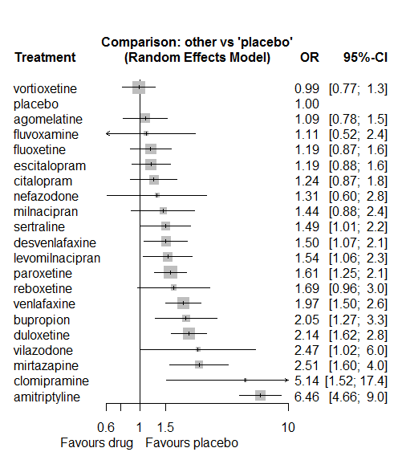

P-score

placebo 0.90

vortioxetine 0.89

agomelatine 0.81

fluvoxamine 0.75

fluoxetine 0.74

escitalopram 0.74

citalopram 0.70

nefazodone 0.64

milnacipran 0.56

sertraline 0.53

desvenlafaxine 0.52

levomilnacipran 0.50

paroxetine 0.45

reboxetine 0.44

venlafaxine 0.29

bupropion 0.29

vilazodone 0.25

duloxetine 0.24

mirtazapine 0.17

clomipramine 0.07

amitriptyline 0.02

# **Insomnia**

We remove all arms for which dose range was not “Licenced”. After this:

* Removed 15 one-arm studies: Stahl2010 (CAGO178A2302), Montgomery2004b (CL3-20098-030), Roffman1982, Settle1999 (WELL212), Hewett2010a (AK130940) (NCT00093288), Kavoussi1997, Li2010, Study 19 (FDA) (Fabre1985), Study 25 (FDA) (Rickels1986), Masco1985, Debus1988, Itil1983, Szegedi2006, Ansseau1994c, Sacchetti2002 (BRL-29060/109)
* Total number of studies with number randomized being smaller than event rates: 1. Removed the following studies: Rush1998 (excluding Armitage1997 and Gillin1997).
* Total number of arms 534. Total number of studies 227.
* Total events in placebo 1210, out of a total of 17279 patients. Event rate placebo 0.07.

Total events in drugs 5428, out of a total of 47545 patients. Event rate drugs 0.114

## **Distribution of dose across drugs**

Here we count the number of arms per drug, and the percent of these arms where Dose_intended_min was equal to the minimum licensed dose or lower. The values we used as minimum licensed dose are as follows:

agomelatine: 25; amitriptyline: 75; bupropion:300; citalopram:20; clomipramine:30; desvenlafaxine:50; duloxetine:40; escitalopram:10; fluoxetine:20; fluvoxamine:50; levomilnacipran:40; milnacipran:50; mirtazapine:15; nefazodone:300; paroxetine:20; reboxetine:8; sertraline:50; trazodone:150; venlafaxine:75; vilazodone:20; vortioxetine:5

Drug number.arms percent.low.dose

1 paroxetine 63 0.79

3 fluoxetine 56 0.91

4 bupropion 20 0.90

5 sertraline 30 0.90

6 escitalopram 29 0.79

7 vortioxetine 20 0.40

8 venlafaxine 35 0.66

9 milnacipran 8 0.00

10 amitriptyline 16 0.62

11 fluvoxamine 11 0.45

12 levomilnacipran 7 0.57

13 reboxetine 15 0.93

14 duloxetine 26 0.15

15 trazodone 6 1.00

16 mirtazapine 4 0.75

17 nefazodone 4 0.50

18 citalopram 17 0.65

19 desvenlafaxine 8 0.50

20 agomelatine 7 0.86

21 vilazodone 5 0.20

22 clomipramine 4 0.00

## **Network graph**

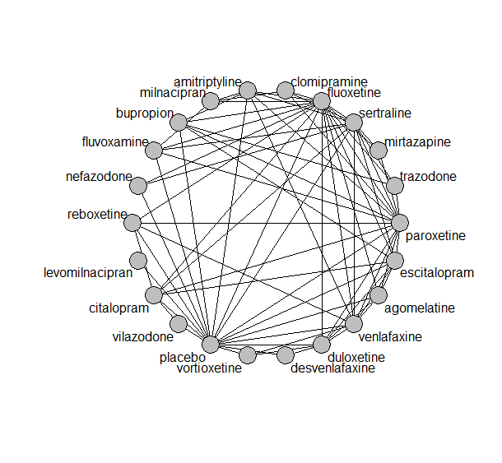

## **Pairwise MA**

### **Grouping all drugs together, comparison vs. placebo**

Number of studies: 140

Random effects meta-analysis: OR=1.73. 95% CI 1.57 to 1.91

Prediction interval 0.87 to 3.46

Heterogeneity (tau squared) was estimated to be 0.12

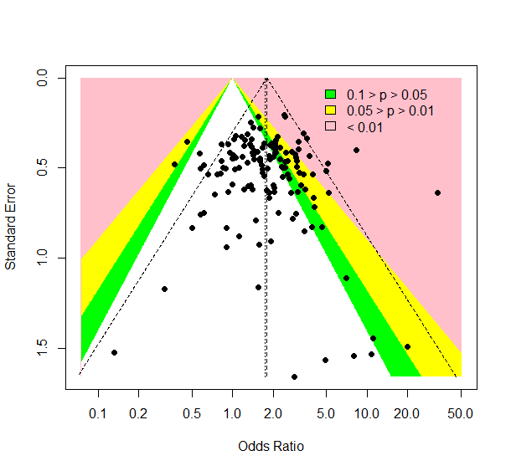

No evidence of small-study effects or publication bias (Harbord’s test p-value =0.3)

### **Meta-analyses of comparisons with 10 or more studies**

We show results from pairwise comparisons informed by 10 studies or more. An OR larger than 1 favors the first treatment in the comparison.

comparisons Number.of.studies OR lower.CI upper.CI tau.sq I.sq

1 placebo - bupropion 13 2.4 1.86 3.0 0.28 0.57

2 placebo - duloxetine 17 2.0 1.63 2.6 0.12 0.33

3 placebo - escitalopram 16 1.4 1.11 1.8 0.06 0.22

4 placebo - fluoxetine 21 1.8 1.49 2.1 0.00 0.00

5 placebo - paroxetine 34 1.4 1.27 1.7 0.00 0.00

6 placebo - sertraline 10 1.9 1.44 2.4 0.08 0.30

7 placebo - venlafaxine 13 2.0 1.64 2.6 0.05 0.21

8 fluoxetine - venlafaxine 10 1.1 0.86 1.3 0.08 0.34

## **Assessment of transitivity**

comparison studies baseline_SD age_SD female

1 paroxetine - placebo 35 23 (2.8) 43 (6.9) 0.6 (0.13)

2 fluoxetine - paroxetine 9 23 (1.9) 45 (10.9) NaN (NA)

3 bupropion - placebo 13 24 (2.3) 40 (4.4) 0.52 (0.18)

4 paroxetine - sertraline 2 22 (2) 43 (NA) NaN (NA)

5 fluoxetine - sertraline 4 22 (2.9) 53 (12.1) NaN (NA)

6 escitalopram - placebo 16 22 (2.5) 44 (11.1) 0.64 (0.12)

7 escitalopram - sertraline 3 22 (3.3) 38 (3.1) NaN (NA)

8 placebo - sertraline 10 21 (3.7) 43 (9.8) 0.55 (0.06)

9 placebo - venlafaxine 13 22 (2) 44 (8.4) 0.59 (0.1)

10 placebo - vortioxetine 9 24 (1.8) 43 (2) 0.64 (0.08)

11 venlafaxine - vortioxetine 2 23 (2.5) 42 (2.2) 0.61 (0.02)

12 fluoxetine - venlafaxine 10 25 (2.9) 46 (9.7) 0.62 (0.03)

13 amitriptyline - milnacipran 1 26 (NA) 50 (NA) NaN (NA)

14 fluvoxamine - milnacipran 2 24 (0.4) 49 (2) NaN (NA)

15 fluvoxamine - paroxetine 2 22 (1.4) 42 (1.6) 0.57 (NA)

16 fluoxetine - milnacipran 2 25 (3.3) 45 (0.4) NaN (NA)

17 levomilnacipran - placebo 5 25 (1.2) 43 (1.6) 0.63 (0.03)

18 amitriptyline - placebo 4 23 (0.8) 40 (1.9) NaN (NA)

19 paroxetine - reboxetine 3 22 (2.1) 41 (2.7) 0.69 (0.07)

20 escitalopram - paroxetine 2 25 (2.8) 45 (0.5) NaN (NA)

21 duloxetine - placebo 17 21 (2.6) 42 (1.8) 0.65 (0.05)

22 duloxetine - vortioxetine 3 25 (NA) 44 (1.2) 0.69 (0.05)

23 placebo - reboxetine 9 24 (3.9) 42 (3.1) 0.62 (0.09)

24 fluoxetine - trazodone 2 21 (1.1) 54 (20) 0.67 (NA)

25 mirtazapine - sertraline 1 NaN (NA) 42 (NA) NaN (NA)

26 fluoxetine - nefazodone 1 24 (NA) 41 (NA) 0.77 (NA)

27 escitalopram - venlafaxine 2 20 (0.4) 43 (7.5) NaN (NA)

28 fluoxetine - reboxetine 4 24 (0.9) 41 (2.3) 0.66 (0.04)

29 citalopram - fluoxetine 2 24 (1.1) 43 (1.1) NaN (NA)

30 desvenlafaxine - placebo 5 23 (0.4) 42 (2.3) 0.63 (0.06)

31 citalopram - escitalopram 6 25 (2.4) 40 (4.1) 0.56 (NA)

32 citalopram - placebo 7 22 (2.6) 46 (14.7) 0.59 (0.02)

33 fluoxetine - placebo 21 22 (2.5) 44 (11.5) 0.6 (0.04)

34 fluvoxamine - placebo 5 23 (2.3) 41 (2) NaN (NA)

35 amitriptyline - bupropion 1 23 (NA) 37 (NA) NaN (NA)

36 agomelatine - duloxetine 1 26 (NA) 43 (NA) NaN (NA)

37 bupropion - escitalopram 2 24 (NA) 36 (0.6) NaN (NA)

38 amitriptyline - sertraline 3 23 (1.3) 50 (17.8) 0.48 (NA)

39 bupropion - fluoxetine 3 23 (2.2) 39 (2.7) NaN (NA)

40 agomelatine - escitalopram 1 27 (NA) 43 (NA) 0.71 (NA)

41 placebo - vilazodone 4 24 (0.6) 41 (0.9) 0.56 (0.03)

42 duloxetine - paroxetine 4 19 (1.7) 43 (2) NaN (NA)

43 citalopram - sertraline 3 25 (3.5) 41 (6.7) NaN (NA)

44 amitriptyline - fluoxetine 3 23 (2.1) 42 (0.5) 0.71 (0.07)

45 nefazodone - sertraline 1 23 (NA) 44 (NA) 0.52 (NA)

46 nefazodone - placebo 2 26 (2.8) 41 (3.7) 0.63 (0.01)

47 amitriptyline - venlafaxine 1 21 (NA) 38 (NA) NaN (NA)

48 amitriptyline - paroxetine 5 25 (1.3) 52 (11.1) 0.94 (0.08)

49 duloxetine - fluoxetine 2 18 (0.2) 41 (0.6) NaN (NA)

50 citalopram - paroxetine 1 24 (NA) 40 (NA) NaN (NA)

51 escitalopram - fluoxetine 2 22 (NA) 56 (26.8) NaN (NA)

52 paroxetine - trazodone 2 22 (2.1) 41 (3.6) 0.63 (NA)

53 duloxetine - escitalopram 3 20 (2.5) 43 (0.9) NaN (NA)

54 clomipramine - milnacipran 1 24 (NA) 48 (NA) NaN (NA)

55 agomelatine - venlafaxine 1 26 (NA) 40 (NA) 0.71 (NA)

56 clomipramine - sertraline 1 30 (NA) 42 (NA) 0.7 (NA)

57 agomelatine - paroxetine 1 27 (NA) 42 (NA) 0.66 (NA)

58 agomelatine - placebo 2 27 (0) 43 (1.1) 0.67 (0)

59 citalopram - vilazodone 1 24 (NA) 42 (NA) 0.57 (NA)

60 paroxetine - venlafaxine 1 23 (NA) 44 (NA) NaN (NA)

61 sertraline - venlafaxine 3 23 (0.8) 40 (2.8) NaN (NA)

62 sertraline - trazodone 1 22 (NA) 46 (NA) 0.65 (NA)

63 fluvoxamine - sertraline 1 21 (NA) 40 (NA) NaN (NA)

64 duloxetine - venlafaxine 2 23 (0.5) 43 (1.4) 0.68 (0.03)

65 fluoxetine - fluvoxamine 1 22 (NA) 39 (NA) NaN (NA)

66 clomipramine - fluoxetine 1 20 (NA) 44 (NA) 0.65 (NA)

67 clomipramine - paroxetine 1 24 (NA) 71 (NA) 0.89 (NA)

68 mirtazapine - paroxetine 2 23 (1.4) 56 (22.5) NaN (NA)

69 reboxetine - venlafaxine 1 29 (NA) 42 (NA) 0.69 (NA)

70 agomelatine - fluoxetine 1 27 (NA) 39 (NA) 0.69 (NA)

71 citalopram - reboxetine 1 24 (NA) 42 (NA) 0.64 (NA)

72 desvenlafaxine - duloxetine 1 23 (NA) 40 (NA) NaN (NA)

73 fluoxetine - mirtazapine 1 28 (NA) 45 (NA) NaN (NA)

74 bupropion - trazodone 1 22 (NA) 40 (NA) NaN (NA)

75 bupropion - paroxetine 1 22 (NA) 37 (NA) NaN (NA)

## **NMA**

A total of 22 treatments are included in the network.

A total of 226 studies are included in this analysis.

Estimated heterogeneity tau-squared 0.01

Global test for inconsistency, p-value 0.49735 (Q=87,d.o.f.88)

### **Comparison vs. placebo**

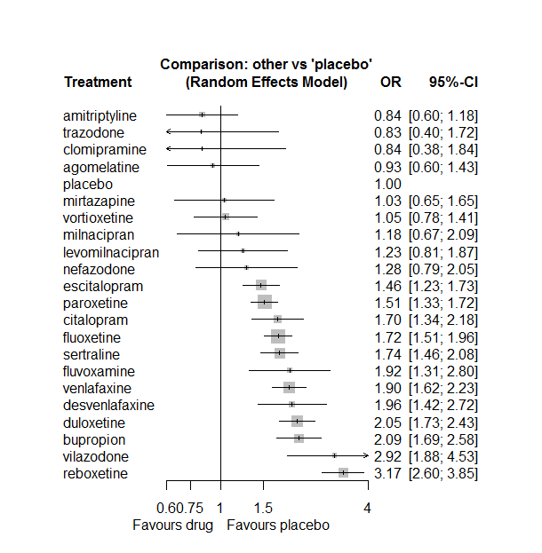

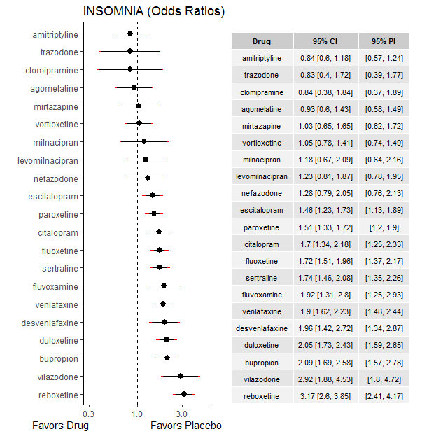

### **Ranking according to P-scores**

P-score

amitriptyline 0.89

trazodone 0.85

clomipramine 0.84

agomelatine 0.83

placebo 0.80

mirtazapine 0.76

vortioxetine 0.76

milnacipran 0.67

levomilnacipran 0.65

nefazodone 0.62

escitalopram 0.54

paroxetine 0.51

citalopram 0.38

fluoxetine 0.37

sertraline 0.35

fluvoxamine 0.27

venlafaxine 0.25

desvenlafaxine 0.25

duloxetine 0.18

bupropion 0.17

vilazodone 0.05

reboxetine 0.02

### **Local inconsistency**

Percent of comparisons where there is some evidence (p-value<0.05) of disagreement between direct and indirect sources: 0.08. (6 out of 74 comparisons)

comparison TE seTE lower upper z p

6 agomelatine:duloxetine 0.943629 0.51 -0.052 1.939 1.85808 0.0632

7 agomelatine:escitalopram -1.020472 1.15 -3.279 1.238 -0.88542 0.3759

8 agomelatine:fluoxetine 0.920502 0.56 -0.179 2.020 1.64124 0.1007

14 agomelatine:paroxetine -0.024912 0.69 -1.375 1.325 -0.03616 0.9712

15 agomelatine:placebo -1.006021 0.44 -1.871 -0.141 -2.28072 0.0226

19 agomelatine:venlafaxine -0.703996 1.15 -2.961 1.553 -0.61129 0.5410

22 amitriptyline:bupropion 1.162337 0.46 0.257 2.067 2.51702 0.0118

28 amitriptyline:fluoxetine -0.063544 0.63 -1.294 1.167 -0.10121 0.9194

31 amitriptyline:milnacipran -0.075173 1.01 -2.048 1.897 -0.07469 0.9405

34 amitriptyline:paroxetine 0.187733 0.49 -0.771 1.146 0.38380 0.7011

35 amitriptyline:placebo -0.471694 0.36 -1.168 0.224 -1.32817 0.1841

37 amitriptyline:sertraline -0.180114 0.36 -0.884 0.523 -0.50184 0.6158

39 amitriptyline:venlafaxine -0.926492 1.13 -3.145 1.292 -0.81859 0.4130

46 bupropion:escitalopram 0.057668 0.31 -0.551 0.666 0.18569 0.8527

47 bupropion:fluoxetine 0.141955 0.26 -0.370 0.654 0.54340 0.5869

53 bupropion:paroxetine -0.505588 0.45 -1.392 0.380 -1.11836 0.2634

54 bupropion:placebo 0.310729 0.23 -0.145 0.767 1.33510 0.1818

57 bupropion:trazodone 0.350427 0.83 -1.274 1.974 0.42291 0.6724

64 citalopram:escitalopram -0.450710 0.27 -0.974 0.073 -1.68652 0.0917

65 citalopram:fluoxetine 0.134068 0.42 -0.685 0.953 0.32080 0.7484

71 citalopram:paroxetine 0.000088 0.40 -0.779 0.779 0.00022 0.9998

72 citalopram:placebo 0.091999 0.25 -0.399 0.583 0.36726 0.7134

73 citalopram:reboxetine 0.111145 0.51 -0.882 1.105 0.21928 0.8264

74 citalopram:sertraline 0.564494 0.36 -0.149 1.278 1.54998 0.1211

77 citalopram:vilazodone 0.265447 0.48 -0.667 1.198 0.55776 0.5770

82 clomipramine:fluoxetine -2.101816 1.54 -5.117 0.913 -1.36626 0.1719

85 clomipramine:milnacipran -1.979377 0.98 -3.896 -0.062 -2.02375 0.0430

88 clomipramine:paroxetine -1.041175 1.22 -3.434 1.352 -0.85285 0.3937

91 clomipramine:sertraline 2.418373 0.81 0.824 4.012 2.97341 0.0029

96 desvenlafaxine:duloxetine -0.751406 0.36 -1.461 -0.042 -2.07620 0.0379

105 desvenlafaxine:placebo 0.984417 0.39 0.219 1.749 2.52207 0.0117

112 duloxetine:escitalopram 0.224817 0.25 -0.264 0.713 0.90172 0.3672

113 duloxetine:fluoxetine 0.034667 0.43 -0.807 0.876 0.08072 0.9357

119 duloxetine:paroxetine 0.163394 0.27 -0.375 0.702 0.59467 0.5521

120 duloxetine:placebo -0.130744 0.17 -0.470 0.209 -0.75471 0.4504

124 duloxetine:venlafaxine 0.022852 0.21 -0.394 0.440 0.10737 0.9145

126 duloxetine:vortioxetine -0.199826 0.31 -0.817 0.417 -0.63475 0.5256

127 escitalopram:fluoxetine -0.074670 0.34 -0.735 0.586 -0.22168 0.8246

133 escitalopram:paroxetine 0.141403 0.31 -0.475 0.758 0.44931 0.6532

134 escitalopram:placebo -0.162238 0.17 -0.505 0.180 -0.92877 0.3530

136 escitalopram:sertraline 0.424148 0.27 -0.107 0.955 1.56515 0.1175

138 escitalopram:venlafaxine 0.112243 0.35 -0.569 0.794 0.32281 0.7468

141 fluoxetine:fluvoxamine -0.269584 0.50 -1.249 0.710 -0.53931 0.5897

143 fluoxetine:milnacipran 0.952989 0.58 -0.183 2.089 1.64352 0.1003

144 fluoxetine:mirtazapine 0.160862 0.56 -0.946 1.268 0.28483 0.7758

145 fluoxetine:nefazodone 0.676724 0.62 -0.531 1.884 1.09834 0.2721

146 fluoxetine:paroxetine -0.186962 0.15 -0.484 0.110 -1.23375 0.2173

147 fluoxetine:placebo 0.058485 0.13 -0.201 0.318 0.44150 0.6589

148 fluoxetine:reboxetine 0.292451 0.24 -0.171 0.756 1.23650 0.2163

149 fluoxetine:sertraline -0.162942 0.27 -0.690 0.364 -0.60622 0.5444

150 fluoxetine:trazodone 1.049701 0.81 -0.545 2.644 1.29041 0.1969

151 fluoxetine:venlafaxine -0.053256 0.17 -0.391 0.284 -0.30907 0.7573

155 fluvoxamine:milnacipran -0.283331 0.64 -1.538 0.972 -0.44250 0.6581

158 fluvoxamine:paroxetine 0.131723 0.57 -0.981 1.244 0.23205 0.8165

159 fluvoxamine:placebo 0.185687 0.39 -0.579 0.950 0.47615 0.6340

161 fluvoxamine:sertraline -0.523192 0.51 -1.521 0.475 -1.02741 0.3042

188 mirtazapine:paroxetine 0.181912 0.47 -0.745 1.109 0.38448 0.7006

191 mirtazapine:sertraline -0.087453 0.53 -1.131 0.956 -0.16420 0.8696

197 nefazodone:placebo 0.183847 0.49 -0.769 1.136 0.37825 0.7052

199 nefazodone:sertraline 0.255768 0.50 -0.733 1.245 0.50686 0.6123

204 paroxetine:placebo -0.107991 0.13 -0.371 0.155 -0.80579 0.4204

205 paroxetine:reboxetine -0.007310 0.21 -0.411 0.397 -0.03545 0.9717

206 paroxetine:sertraline 0.105232 0.26 -0.407 0.618 0.40240 0.6874

207 paroxetine:trazodone -0.787657 0.84 -2.443 0.868 -0.93258 0.3510

208 paroxetine:venlafaxine 0.026314 0.51 -0.964 1.017 0.05207 0.9585

211 placebo:reboxetine -0.336989 0.20 -0.734 0.060 -1.66394 0.0961

212 placebo:sertraline -0.071685 0.18 -0.427 0.283 -0.39567 0.6923

214 placebo:venlafaxine -0.131299 0.17 -0.455 0.193 -0.79390 0.4273

215 placebo:vilazodone -0.177716 0.53 -1.221 0.866 -0.33381 0.7385

216 placebo:vortioxetine -0.199761 0.32 -0.820 0.421 -0.63092 0.5281

219 reboxetine:venlafaxine -0.562920 0.66 -1.860 0.734 -0.85075 0.3949

222 sertraline:trazodone -0.877917 0.94 -2.721 0.965 -0.93346 0.3506

223 sertraline:venlafaxine 0.442081 0.27 -0.081 0.965 1.65561 0.0978

230 venlafaxine:vortioxetine 0.430232 0.37 -0.305 1.165 1.14763 0.2511

### **League table**

Below we show the league table. Upper triangle: direct evidence. Lower triangle: NMA. An odds ratio larger than 1 in the upper triangle favors the column-defining drug. An odds ratio larger than 1 in the bottom triangle favors the row-defining drug.

|  |  |  |  |  |  |  |  |  |  |  |  |  |  |  |  |  |  |  |  |  |  |
| --- | --- | --- | --- | --- | --- | --- | --- | --- | --- | --- | --- | --- | --- | --- | --- | --- | --- | --- | --- | --- | --- |
| AGOM | . | . | . | . | . | 0.90 [0.38; 2.10] | 0.24 [0.03; 2.18] | 1.13 [0.42; 3.02] | . | . | . | . | . | 0.60 [0.17; 2.13] | 0.54 [0.28; 1.02] | . | . | . | 0.25 [0.03; 2.27] | . | . |
| 1.11 [0.64; 1.90] | AMIT | 1.00 [0.45; 2.22] | . | . | . | . | . | 0.46 [0.14; 1.49] | . | . | 0.67 [0.10; 4.24] | . | . | 0.65 [0.27; 1.57] | 0.63 [0.36; 1.09] | . | 0.44 [0.26; 0.74] | . | 0.18 [0.02; 1.60] | . | . |
| 0.44 [0.28; 0.72] | 0.40 [0.28; 0.59] | BUPR | . | . | . | . | 1.49 [0.88; 2.55] | 1.34 [0.87; 2.07] | . | . | . | . | . | 0.87 [0.37; 2.03] | 2.31 [1.78; 2.98] | . | . | 3.22 [0.82; 12.70] | . | . | . |
| 0.55 [0.33; 0.89] | 0.49 [0.33; 0.74] | 1.23 [0.89; 1.68] | CITA | . | . | . | 0.91 [0.62; 1.34] | 1.11 [0.52; 2.41] | . | . | . | . | . | 1.13 [0.55; 2.33] | 1.79 [1.24; 2.59] | 0.59 [0.23; 1.53] | 1.54 [0.81; 2.94] | . | . | 0.68 [0.34; 1.36] | . |
| 1.11 [0.45; 2.71] | 1.00 [0.43; 2.33] | 2.49 [1.11; 5.60] | 2.03 [0.90; 4.60] | CLOM | . | . | . | 0.07 [0.00; 1.27] | . | . | 0.18 [0.04; 0.89] | . | . | 0.22 [0.02; 2.09] | . | . | 1.25 [0.46; 3.41] | . | . | . | . |
| 0.47 [0.28; 0.81] | 0.43 [0.27; 0.68] | 1.07 [0.72; 1.57] | 0.87 [0.58; 1.30] | 0.43 [0.18; 1.00] | DESV | 0.60 [0.34; 1.05] | . | . | . | . | . | . | . | . | 2.48 [1.71; 3.60] | . | . | . | . | . | . |
| 0.45 [0.29; 0.71] | 0.41 [0.28; 0.59] | 1.02 [0.78; 1.33] | 0.83 [0.62; 1.11] | 0.41 [0.18; 0.91] | 0.96 [0.68; 1.35] | DULO | 1.65 [1.09; 2.51] | 1.23 [0.54; 2.79] | . | . | . | . | . | 1.56 [0.95; 2.55] | 1.92 [1.52; 2.44] | . | . | . | 1.09 [0.78; 1.53] | . | 1.76 [1.12; 2.76] |
| 0.64 [0.40; 1.00] | 0.58 [0.40; 0.83] | 1.43 [1.11; 1.85] | 1.17 [0.90; 1.51] | 0.57 [0.26; 1.28] | 1.34 [0.93; 1.93] | 1.40 [1.13; 1.74] | ESCI | 0.79 [0.42; 1.49] | . | . | . | . | . | 1.10 [0.61; 1.96] | 1.35 [1.06; 1.72] | . | 1.16 [0.73; 1.85] | . | 0.85 [0.45; 1.61] | . | . |
| 0.54 [0.35; 0.84] | 0.49 [0.34; 0.69] | 1.21 [0.96; 1.53] | 0.99 [0.76; 1.29] | 0.49 [0.22; 1.07] | 1.14 [0.80; 1.61] | 1.19 [0.98; 1.45] | 0.85 [0.70; 1.03] | FLUO | 0.72 [0.30; 1.74] | . | 2.27 [1.05; 4.93] | 1.88 [0.72; 4.96] | 2.32 [0.79; 6.84] | 1.02 [0.82; 1.28] | 1.77 [1.47; 2.14] | 0.67 [0.45; 0.99] | 0.86 [0.53; 1.39] | 4.35 [1.14; 16.67] | 0.88 [0.69; 1.12] | . | . |
| 0.48 [0.27; 0.86] | 0.44 [0.27; 0.72] | 1.09 [0.71; 1.67] | 0.89 [0.57; 1.39] | 0.44 [0.19; 1.03] | 1.02 [0.62; 1.68] | 1.07 [0.71; 1.61] | 0.76 [0.51; 1.15] | 0.90 [0.61; 1.32] | FLUV | . | 1.36 [0.51; 3.65] | . | . | 1.42 [0.51; 3.98] | 2.13 [1.20; 3.80] | . | 0.72 [0.30; 1.77] | . | . | . | . |
| 0.75 [0.41; 1.37] | 0.68 [0.40; 1.17] | 1.70 [1.06; 2.71] | 1.38 [0.85; 2.24] | 0.68 [0.28; 1.66] | 1.59 [0.94; 2.70] | 1.66 [1.06; 2.61] | 1.19 [0.76; 1.86] | 1.40 [0.90; 2.16] | 1.55 [0.89; 2.73] | LEVO | . | . | . | . | 1.23 [0.81; 1.87] | . | . | . | . | . | . |
| 0.79 [0.39; 1.60] | 0.71 [0.38; 1.35] | 1.77 [0.97; 3.24] | 1.44 [0.78; 2.67] | 0.71 [0.29; 1.72] | 1.66 [0.86; 3.21] | 1.74 [0.96; 3.14] | 1.24 [0.69; 2.24] | 1.46 [0.83; 2.57] | 1.62 [0.88; 2.99] | 1.04 [0.51; 2.12] | MILN | . | . | . | . | . | . | . | . | . | . |
| 0.90 [0.48; 1.69] | 0.81 [0.46; 1.43] | 2.02 [1.22; 3.36] | 1.65 [0.98; 2.78] | 0.81 [0.33; 2.00] | 1.90 [1.07; 3.35] | 1.99 [1.21; 3.25] | 1.42 [0.87; 2.31] | 1.67 [1.04; 2.67] | 1.85 [1.03; 3.36] | 1.19 [0.64; 2.24] | 1.14 [0.55; 2.37] | MIRT | . | 0.75 [0.39; 1.42] | . | . | 0.56 [0.23; 1.34] | . | . | . | . |
| 0.73 [0.38; 1.38] | 0.66 [0.37; 1.17] | 1.64 [0.98; 2.75] | 1.34 [0.79; 2.27] | 0.66 [0.27; 1.63] | 1.54 [0.87; 2.73] | 1.61 [0.97; 2.65] | 1.15 [0.70; 1.89] | 1.35 [0.83; 2.19] | 1.50 [0.82; 2.74] | 0.97 [0.51; 1.82] | 0.93 [0.44; 1.93] | 0.81 [0.42; 1.56] | NEFA | . | 1.41 [0.70; 2.84] | . | 0.86 [0.39; 1.86] | . | . | . | . |
| 0.61 [0.40; 0.96] | 0.56 [0.39; 0.79] | 1.38 [1.09; 1.75] | 1.13 [0.87; 1.46] | 0.55 [0.25; 1.22] | 1.30 [0.92; 1.84] | 1.36 [1.11; 1.65] | 0.97 [0.79; 1.18] | 1.14 [0.98; 1.32] | 1.27 [0.86; 1.87] | 0.82 [0.53; 1.26] | 0.78 [0.44; 1.39] | 0.68 [0.43; 1.09] | 0.84 [0.52; 1.37] | PARO | 1.45 [1.24; 1.70] | 0.48 [0.36; 0.63] | 0.94 [0.59; 1.50] | 1.01 [0.24; 4.21] | 0.81 [0.31; 2.15] | . | . |
| 0.93 [0.60; 1.43] | 0.84 [0.60; 1.18] | 2.09 [1.69; 2.58] | 1.70 [1.34; 2.18] | 0.84 [0.38; 1.84] | 1.96 [1.42; 2.72] | 2.05 [1.73; 2.43] | 1.46 [1.23; 1.73] | 1.72 [1.51; 1.96] | 1.92 [1.31; 2.80] | 1.23 [0.81; 1.87] | 1.18 [0.67; 2.09] | 1.03 [0.65; 1.65] | 1.28 [0.79; 2.05] | 1.51 [1.33; 1.72] | PLAC | 0.27 [0.21; 0.35] | 0.55 [0.42; 0.72] | . | 0.49 [0.38; 0.62] | 0.33 [0.20; 0.54] | 0.89 [0.62; 1.29] |
| 0.29 [0.18; 0.47] | 0.27 [0.18; 0.39] | 0.66 [0.50; 0.87] | 0.54 [0.40; 0.73] | 0.26 [0.12; 0.59] | 0.62 [0.42; 0.90] | 0.65 [0.50; 0.83] | 0.46 [0.36; 0.59] | 0.54 [0.44; 0.67] | 0.61 [0.40; 0.92] | 0.39 [0.25; 0.62] | 0.37 [0.21; 0.68] | 0.33 [0.20; 0.54] | 0.40 [0.24; 0.67] | 0.48 [0.39; 0.58] | 0.32 [0.26; 0.38] | REBO | . | . | 0.97 [0.27; 3.45] | . | . |
| 0.53 [0.34; 0.84] | 0.48 [0.34; 0.68] | 1.20 [0.92; 1.56] | 0.98 [0.74; 1.29] | 0.48 [0.22; 1.05] | 1.12 [0.78; 1.62] | 1.18 [0.93; 1.48] | 0.84 [0.67; 1.05] | 0.99 [0.81; 1.20] | 1.10 [0.74; 1.64] | 0.71 [0.45; 1.11] | 0.68 [0.38; 1.21] | 0.59 [0.37; 0.95] | 0.73 [0.45; 1.18] | 0.87 [0.71; 1.05] | 0.57 [0.48; 0.68] | 1.82 [1.41; 2.34] | SERT | 1.04 [0.20; 5.40] | 1.30 [0.82; 2.07] | . | . |
| 1.12 [0.48; 2.58] | 1.01 [0.46; 2.22] | 2.51 [1.20; 5.23] | 2.05 [0.96; 4.37] | 1.01 [0.35; 2.91] | 2.36 [1.07; 5.21] | 2.46 [1.18; 5.16] | 1.76 [0.84; 3.67] | 2.07 [1.00; 4.27] | 2.30 [1.02; 5.18] | 1.48 [0.64; 3.41] | 1.42 [0.57; 3.54] | 1.24 [0.53; 2.91] | 1.53 [0.65; 3.62] | 1.82 [0.88; 3.75] | 1.20 [0.58; 2.48] | 3.80 [1.81; 8.01] | 2.10 [1.01; 4.36] | TRAZ | . | . | . |
| 0.49 [0.31; 0.76] | 0.44 [0.31; 0.63] | 1.10 [0.85; 1.42] | 0.90 [0.68; 1.18] | 0.44 [0.20; 0.98] | 1.03 [0.72; 1.47] | 1.08 [0.88; 1.31] | 0.77 [0.62; 0.95] | 0.90 [0.76; 1.07] | 1.01 [0.67; 1.50] | 0.65 [0.41; 1.01] | 0.62 [0.35; 1.11] | 0.54 [0.33; 0.88] | 0.67 [0.41; 1.10] | 0.79 [0.66; 0.96] | 0.53 [0.45; 0.62] | 1.66 [1.31; 2.11] | 0.92 [0.74; 1.13] | 0.44 [0.21; 0.91] | VENL | . | 2.52 [1.33; 4.78] |
| 0.32 [0.17; 0.59] | 0.29 [0.17; 0.50] | 0.72 [0.44; 1.17] | 0.58 [0.37; 0.93] | 0.29 [0.12; 0.71] | 0.67 [0.39; 1.16] | 0.70 [0.44; 1.13] | 0.50 [0.31; 0.80] | 0.59 [0.37; 0.93] | 0.66 [0.37; 1.17] | 0.42 [0.23; 0.78] | 0.40 [0.20; 0.83] | 0.35 [0.19; 0.67] | 0.44 [0.23; 0.83] | 0.52 [0.33; 0.82] | 0.34 [0.22; 0.53] | 1.09 [0.67; 1.75] | 0.60 [0.37; 0.96] | 0.29 [0.12; 0.67] | 0.65 [0.41; 1.04] | VILA | . |
| 0.89 [0.53; 1.49] | 0.80 [0.51; 1.25] | 1.99 [1.39; 2.87] | 1.63 [1.11; 2.38] | 0.80 [0.35; 1.85] | 1.87 [1.21; 2.89] | 1.96 [1.44; 2.66] | 1.40 [1.00; 1.95] | 1.64 [1.20; 2.26] | 1.83 [1.13; 2.95] | 1.18 [0.70; 1.96] | 1.13 [0.59; 2.14] | 0.99 [0.57; 1.71] | 1.22 [0.70; 2.13] | 1.44 [1.05; 1.98] | 0.95 [0.71; 1.28] | 3.02 [2.13; 4.30] | 1.67 [1.19; 2.34] | 0.79 [0.36; 1.73] | 1.82 [1.33; 2.49] | 2.78 [1.64; 4.73] | VORT |

### **Estimated event rates**

For an event rate in placebo equal to the average event rate (i.e. fixed to 0.07) the estimated event rates for each drug are as follows

drug rate

1 agomelatine 0.07 [0.04, 0.1]

2 amitriptyline 0.06 [0.04, 0.08]

3 bupropion 0.14 [0.11, 0.16]

4 citalopram 0.11 [0.09, 0.14]

5 clomipramine 0.06 [0.03, 0.12]

6 desvenlafaxine 0.13 [0.1, 0.17]

7 duloxetine 0.13 [0.12, 0.15]

8 escitalopram 0.1 [0.08, 0.12]

9 fluoxetine 0.11 [0.1, 0.13]

10 fluvoxamine 0.13 [0.09, 0.17]

11 levomilnacipran 0.08 [0.06, 0.12]

12 milnacipran 0.08 [0.05, 0.14]

13 mirtazapine 0.07 [0.05, 0.11]

14 nefazodone 0.09 [0.06, 0.13]

15 paroxetine 0.1 [0.09, 0.11]

17 reboxetine 0.19 [0.16, 0.22]

18 sertraline 0.12 [0.1, 0.14]

19 trazodone 0.06 [0.03, 0.11]

20 venlafaxine 0.13 [0.11, 0.14]

21 vilazodone 0.18 [0.12, 0.25]

22 vortioxetine 0.07 [0.06, 0.1]

## **Sensitivity analysis: splitting nodes according to dosage**

All treatment arms for drug X, with dose_intended_min equal to or smaller to the minimum licensed dose were set as “X_L”. All other arms of X are “X_H”. Studies with no information on dose are excluded. Results vs. placebo are shown below:

|  |  |  |
| --- | --- | --- |
| **Low dose vs. placebo** | **High dose vs. placebo** | **High dose vs. low dose** |
|  |  |  |

## **Sensitivity analysis: Keeping only low dropout arms**

We exclude all treatment arms with dropout rates larger than 25%, and we re-analyse the network.

Total number of arms included in the analysis 181. Total number of studies 86

Total events in placebo 391, out of a total of 7378 patients. Event rate placebo 0.053

Total events in drugs 1746, out of a total of 20412 patients. Event rate drugs 0.086

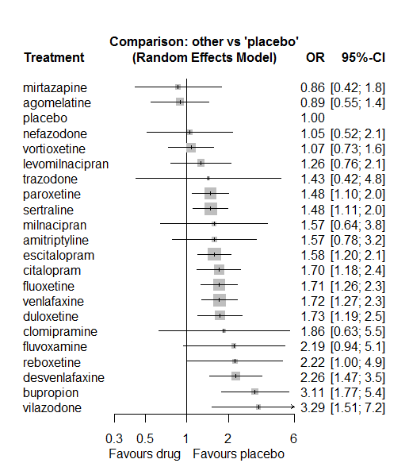

P-score

agomelatine 0.89

mirtazapine 0.87

placebo 0.85

vortioxetine 0.80

nefazodone 0.77

levomilnacipran 0.67

paroxetine 0.56

sertraline 0.55

trazodone 0.55

milnacipran 0.50

amitriptyline 0.50

escitalopram 0.49

citalopram 0.42

fluoxetine 0.41

venlafaxine 0.41

duloxetine 0.40

clomipramine 0.40

fluvoxamine 0.28

reboxetine 0.27

desvenlafaxine 0.22

vilazodone 0.10

bupropion 0.09

# **Sedation/somnolence**

We remove all arms for which dose range was not “Licenced”. After this:

* In remove.onearm(data1) : Removed 20 one-arm studies: CL3-20098-048,
* Quera-Salva2010 (CL3-20098-056), Roffman1982, Amsterdam1986, Carman1991, AK1102365, Kavoussi1997, Kyle1998 (Study 92032 - FDA), Mendels1999 (Study 85A - FDA), Lieberman2008a (Study 309)(EUCTR2004-000562-13, 3151A1-309-EU, NCT00090649), Lieberman2008b (Study 317), Study 19 (FDA) (Fabre1985), Masco1985, Lydiard1989, Harris1991, Armitage1997, Hutchinson1992, Staner1995 (063), 29060/299, Sacchetti2002 (BRL-29060/109)
* Total number of studies with number randomized being smaller than event rates: 1. Removed the following studies: Rush1998 (excluding Armitage1997 and Gillin1997).
* Total number of arms 561. Total number of studies 238.
* Total events in placebo 907, out of a total of 16003 patients. Event rate placebo 0.057.
* Total events in drugs 5660, out of a total of 48489 patients. Event rate drugs 0.117

## **Distribution of dose across drugs**

Here we count the number of arms per drug, and the percent of these arms where Dose_intended_min was equal to the minimum licensed dose or lower. The values we used as minimum licensed dose are as follows:

agomelatine: 25; amitriptyline: 75; bupropion:300; citalopram:20; clomipramine:30; desvenlafaxine:50; duloxetine:40; escitalopram:10; fluoxetine:20; fluvoxamine:50; levomilnacipran:40; milnacipran:50; mirtazapine:15; nefazodone:300; paroxetine:20; reboxetine:8; sertraline:50; trazodone:150; venlafaxine:75; vilazodone:20; vortioxetine:5

Drug number.arms percent.low.dose

1 paroxetine 73 0.82

3 fluoxetine 60 0.92

4 bupropion 12 0.92

5 sertraline 29 0.93

6 escitalopram 26 0.77

7 mirtazapine 13 0.69

8 milnacipran 8 0.00

9 amitriptyline 26 0.62

10 fluvoxamine 11 0.55

11 nefazodone 8 0.62

12 reboxetine 12 0.92

13 vortioxetine 21 0.48

14 duloxetine 27 0.15

15 trazodone 10 1.00

16 venlafaxine 32 0.75

17 citalopram 17 0.59

18 agomelatine 15 0.87

19 desvenlafaxine 6 0.50

20 clomipramine 4 0.00

21 vilazodone 3 0.33

22 levomilnacipran 1 1.00

## **Network graph**

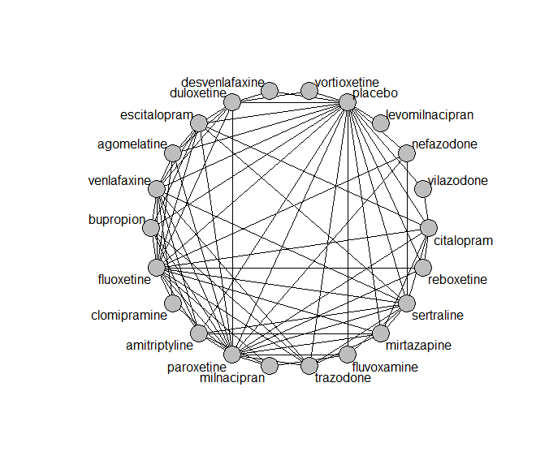

## **Pairwise MA**

### **Grouping all drugs together, comparison vs. placebo**

Number of studies: 144

Random effects meta-analysis: OR=2.52. 95% CI 2.28 to 2.8

Prediction interval 1.29 to 4.93

Heterogeneity (tau squared) was estimated to be 0.11

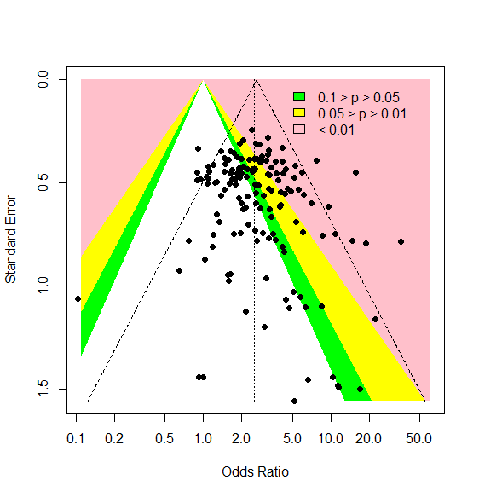

There is no evidence of small-study effects or publication bias (Harbord’s test p-value 0.5)

### **Meta-analyses of comparisons with 10 or more studies**

We show results from pairwise comparisons informed by 10 studies or more. An OR larger than 1 favors the first treatment in the comparison.

comparisons Number.of.studies OR lower.CI upper.CI tau.sq I.sq

1 placebo - amitriptyline 10 5.2 4.04 6.9 0.00 0.00

2 placebo - duloxetine 17 3.1 2.54 4.4 0.00 0.00

3 placebo - escitalopram 13 2.3 1.75 3.2 0.00 0.00

4 placebo - fluoxetine 20 2.3 1.88 3.0 0.00 0.00

5 placebo - paroxetine 39 2.8 2.54 3.5 0.07 0.22

6 placebo - sertraline 10 2.4 1.81 3.3 0.00 0.00

7 placebo - venlafaxine 13 2.5 2.03 3.3 0.01 0.04

8 placebo - vortioxetine 10 1.2 0.91 1.8 0.00 0.00

## **Assessment of transitivity**

comparison studies baseline_SD age_SD female

1 paroxetine - placebo 39 23 (2.6) 42 (6.8) 0.58 (0.13)

2 fluoxetine - paroxetine 9 23 (1.5) 42 (1.5) NaN (NA)

3 bupropion - placebo 6 24 (3.1) 39 (5.7) 0.59 (0.13)

4 paroxetine - sertraline 2 22 (2) 43 (NA) NaN (NA)

5 fluoxetine - sertraline 5 23 (1.7) 48 (6.3) NaN (NA)

6 escitalopram - placebo 14 22 (2.8) 45 (11.6) 0.63 (0.1)

7 escitalopram - sertraline 2 20 (0.5) 40 (0.5) NaN (NA)

8 placebo - sertraline 10 22 (2.5) 43 (9.8) 0.6 (0.06)

9 fluoxetine - mirtazapine 4 26 (2.1) 44 (5.2) NaN (NA)

10 amitriptyline - milnacipran 2 26 (1.4) 49 (0.7) 0.66 (NA)

11 fluvoxamine - milnacipran 2 24 (0.4) 49 (2) NaN (NA)

12 fluvoxamine - paroxetine 2 22 (1.4) 42 (1.6) 0.57 (NA)

13 fluoxetine - milnacipran 1 23 (NA) 45 (NA) NaN (NA)

14 amitriptyline - placebo 10 26 (4.4) 41 (1.7) NaN (NA)

15 nefazodone - paroxetine 2 25 (NA) 40 (3.4) 0.49 (0.09)

16 paroxetine - reboxetine 3 22 (2.1) 41 (2.7) 0.69 (0.07)

17 escitalopram - paroxetine 1 23 (NA) 45 (NA) NaN (NA)

18 duloxetine - placebo 17 20 (2.5) 46 (10) 0.65 (0.06)

19 duloxetine - vortioxetine 4 23 (3.1) 50 (13.6) 0.68 (0.04)

20 placebo - vortioxetine 10 24 (2) 46 (8.9) 0.64 (0.08)

21 placebo - reboxetine 8 24 (4.1) 42 (3.2) 0.61 (0.09)

22 fluoxetine - trazodone 2 21 (0.4) 39 (1.9) 0.67 (NA)

23 mirtazapine - sertraline 1 NaN (NA) 42 (NA) NaN (NA)

24 mirtazapine - paroxetine 3 23 (1.2) 53 (16.7) NaN (NA)

25 fluoxetine - nefazodone 2 24 (NA) 41 (NA) 0.77 (NA)

26 escitalopram - venlafaxine 2 20 (0.4) 43 (7.5) NaN (NA)

27 amitriptyline - paroxetine 6 26 (1.4) 47 (2.2) 0.8 (0.25)

28 fluoxetine - reboxetine 3 24 (1.1) 41 (2.8) 0.66 (0.05)

29 citalopram - fluoxetine 1 24 (NA) 42 (NA) NaN (NA)

30 amitriptyline - mirtazapine 2 26 (2) 38 (NA) NaN (NA)

31 mirtazapine - placebo 4 24 (3) 47 (13.3) 0.54 (NA)

32 citalopram - escitalopram 5 25 (2.6) 41 (3.8) 0.59 (NA)

33 citalopram - placebo 7 22 (2.6) 46 (14.7) 0.59 (0.02)

34 agomelatine - paroxetine 2 27 (0) 43 (0.4) 0.64 (0.03)

35 agomelatine - placebo 7 27 (0.1) 52 (13.9) 0.67 (0.03)

36 fluvoxamine - placebo 6 23 (2) 42 (2.1) 0.43 (NA)

37 amitriptyline - bupropion 1 23 (NA) 37 (NA) NaN (NA)

38 amitriptyline - fluoxetine 4 25 (0.8) 42 (1.5) 0.72 (0.05)

39 agomelatine - duloxetine 1 26 (NA) 43 (NA) NaN (NA)

40 fluoxetine - placebo 20 21 (2.2) 44 (10.2) 0.61 (0.05)

41 bupropion - escitalopram 2 24 (NA) 36 (0.6) NaN (NA)

42 desvenlafaxine - placebo 4 23 (0.3) 40 (1) 0.59 (0.06)

43 amitriptyline - sertraline 4 24 (1.2) 49 (14.6) 0.48 (NA)

44 bupropion - fluoxetine 3 23 (2.2) 39 (2.7) NaN (NA)

45 agomelatine - escitalopram 1 27 (NA) 43 (NA) 0.71 (NA)

46 fluoxetine - venlafaxine 6 24 (3.3) 46 (12.3) 0.71 (NA)

47 placebo - trazodone 4 22 (0.4) 46 (10.6) 0.61 (0.05)

48 placebo - venlafaxine 13 22 (1.4) 44 (8.4) 0.59 (0.11)

49 trazodone - venlafaxine 1 22 (NA) 41 (NA) 0.66 (NA)

50 duloxetine - paroxetine 5 20 (1.7) 42 (2.7) NaN (NA)

51 citalopram - sertraline 2 26 (4.9) 44 (4.9) NaN (NA)

52 nefazodone - sertraline 1 23 (NA) 44 (NA) 0.52 (NA)

53 nefazodone - placebo 3 26 (2.1) 41 (2.8) 0.62 (0.02)

54 amitriptyline - venlafaxine 1 21 (NA) 38 (NA) NaN (NA)

55 clomipramine - fluoxetine 2 24 (6.4) 46 (3.7) 0.68 (0.05)

56 duloxetine - fluoxetine 2 18 (0.2) 41 (0.6) NaN (NA)

57 citalopram - mirtazapine 2 23 (NA) 40 (1.7) 0.84 (NA)

58 agomelatine - fluoxetine 2 28 (1.1) 41 (2.3) 0.74 (0.06)

59 mirtazapine - trazodone 1 22 (NA) 62 (NA) 0.54 (NA)

60 citalopram - paroxetine 1 24 (NA) 40 (NA) NaN (NA)

61 milnacipran - paroxetine 1 22 (NA) 36 (NA) 0.53 (NA)

62 escitalopram - fluoxetine 3 23 (1.5) 50 (21.4) 0.68 (NA)

63 paroxetine - trazodone 2 22 (2.1) 41 (3.6) 0.63 (NA)

64 duloxetine - escitalopram 3 20 (2.5) 43 (0.9) NaN (NA)

65 agomelatine - venlafaxine 1 26 (NA) 40 (NA) 0.71 (NA)

66 citalopram - vilazodone 1 24 (NA) 42 (NA) 0.57 (NA)

67 placebo - vilazodone 2 24 (0.7) 41 (1.3) 0.57 (NA)

68 paroxetine - venlafaxine 1 23 (NA) 44 (NA) NaN (NA)

69 sertraline - venlafaxine 2 23 (0.4) 40 (3.9) NaN (NA)

70 sertraline - trazodone 1 22 (NA) 46 (NA) 0.65 (NA)

71 levomilnacipran - placebo 1 NaN (NA) 42 (NA) 0.62 (NA)

72 fluvoxamine - sertraline 1 21 (NA) 40 (NA) NaN (NA)

73 duloxetine - venlafaxine 2 23 (0.5) 43 (1.4) 0.68 (0.03)

74 clomipramine - paroxetine 1 24 (NA) 71 (NA) 0.89 (NA)

75 clomipramine - venlafaxine 1 25 (NA) 47 (NA) NaN (NA)

76 citalopram - reboxetine 1 24 (NA) 42 (NA) 0.64 (NA)

77 bupropion - venlafaxine 1 24 (NA) 37 (NA) NaN (NA)

78 desvenlafaxine - duloxetine 1 23 (NA) 40 (NA) NaN (NA)

79 bupropion - trazodone 1 22 (NA) 40 (NA) NaN (NA)

80 bupropion - paroxetine 1 22 (NA) 37 (NA) NaN (NA)

## **NMA**

A total of 22 treatments are included in the network.

A total of 235 studies are included in this analysis.

Estimated heterogeneity tau-squared 0.01

Global test for inconsistency, p-value 0.15967 (Q=107,d.o.f.93)

### **Comparison vs. placebo**

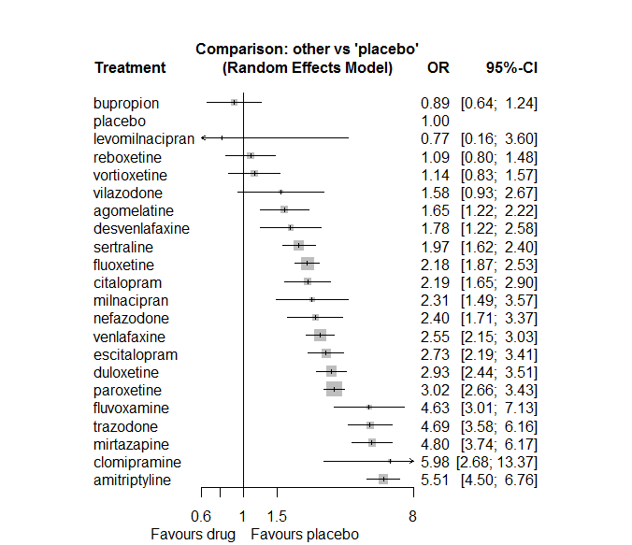

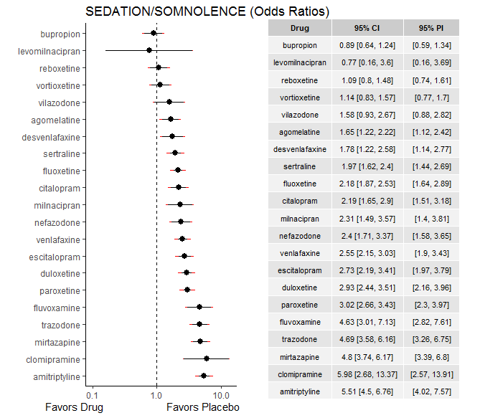

**Ranking according to P-scores**

P-score

bupropion 0.94

placebo 0.91

levomilnacipran 0.87

reboxetine 0.87

vortioxetine 0.85

vilazodone 0.71

agomelatine 0.71

desvenlafaxine 0.66

sertraline 0.62

fluoxetine 0.54

citalopram 0.53

milnacipran 0.49

nefazodone 0.46

venlafaxine 0.41

escitalopram 0.36

duloxetine 0.30

paroxetine 0.28

fluvoxamine 0.13

trazodone 0.12

mirtazapine 0.12

clomipramine 0.07

amitriptyline 0.06

### **Local inconsistency**

Percent of comparisons where there is some evidence (p-value<0.05) of disagreement between direct and indirect sources: 0.04. (3 out of 79 comparisons)

comparison TE seTE lower upper z p

6 agomelatine:duloxetine -0.5255 0.44 -1.394 0.343 -1.185 0.236

7 agomelatine:escitalopram 0.0675 0.69 -1.290 1.425 0.097 0.922

8 agomelatine:fluoxetine 0.4551 0.39 -0.303 1.213 1.177 0.239

14 agomelatine:paroxetine 0.2320 0.39 -0.525 0.989 0.601 0.548

15 agomelatine:placebo -0.4217 0.30 -1.018 0.174 -1.387 0.166

19 agomelatine:venlafaxine 0.1647 0.59 -0.994 1.324 0.279 0.781

22 amitriptyline:bupropion -0.6515 0.48 -1.600 0.297 -1.346 0.178

28 amitriptyline:fluoxetine 0.3129 0.33 -0.338 0.964 0.942 0.346

31 amitriptyline:milnacipran 1.3688 0.59 0.218 2.519 2.332 0.020

32 amitriptyline:mirtazapine -0.5787 0.37 -1.308 0.150 -1.556 0.120

34 amitriptyline:paroxetine -0.4610 0.29 -1.037 0.115 -1.569 0.117

35 amitriptyline:placebo -0.1238 0.21 -0.532 0.285 -0.594 0.552

37 amitriptyline:sertraline 0.5361 0.26 0.036 1.036 2.101 0.036

39 amitriptyline:venlafaxine 0.1035 0.60 -1.077 1.284 0.172 0.864

46 bupropion:escitalopram 0.1072 0.48 -0.837 1.051 0.223 0.824

47 bupropion:fluoxetine -0.0715 0.42 -0.886 0.743 -0.172 0.863

53 bupropion:paroxetine -1.6397 1.07 -3.742 0.462 -1.529 0.126

54 bupropion:placebo 0.0771 0.34 -0.584 0.738 0.229 0.819

57 bupropion:trazodone -0.6525 0.59 -1.809 0.504 -1.106 0.269

58 bupropion:venlafaxine -0.8093 0.60 -1.984 0.366 -1.350 0.177

64 citalopram:escitalopram -0.2992 0.36 -0.995 0.397 -0.843 0.399

65 citalopram:fluoxetine 0.3672 0.63 -0.867 1.601 0.583 0.560

69 citalopram:mirtazapine -0.0664 0.49 -1.033 0.900 -0.135 0.893

71 citalopram:paroxetine 0.6973 0.40 -0.084 1.479 1.749 0.080

72 citalopram:placebo 0.0323 0.29 -0.531 0.595 0.112 0.911

73 citalopram:reboxetine -0.8082 0.56 -1.903 0.287 -1.447 0.148

74 citalopram:sertraline -0.4194 0.48 -1.368 0.529 -0.867 0.386

77 citalopram:vilazodone 0.4248 0.59 -0.724 1.574 0.725 0.469

82 clomipramine:fluoxetine 0.3092 0.84 -1.334 1.952 0.369 0.712

88 clomipramine:paroxetine -0.0138 1.32 -2.606 2.579 -0.010 0.992

93 clomipramine:venlafaxine -0.3578 0.91 -2.141 1.425 -0.393 0.694

96 desvenlafaxine:duloxetine -0.2086 0.41 -1.018 0.601 -0.505 0.614

105 desvenlafaxine:placebo 0.4126 0.45 -0.467 1.292 0.919 0.358

112 duloxetine:escitalopram -0.6988 0.30 -1.297 -0.101 -2.291 0.022

113 duloxetine:fluoxetine -0.1473 0.46 -1.055 0.760 -0.318 0.750

119 duloxetine:paroxetine -0.0099 0.23 -0.459 0.439 -0.043 0.965

120 duloxetine:placebo 0.1119 0.19 -0.260 0.484 0.590 0.555

124 duloxetine:venlafaxine -0.0462 0.22 -0.485 0.393 -0.206 0.837

126 duloxetine:vortioxetine 0.3999 0.34 -0.257 1.057 1.192 0.233

127 escitalopram:fluoxetine 0.0255 0.40 -0.757 0.808 0.064 0.949

133 escitalopram:paroxetine -0.1929 0.52 -1.209 0.824 -0.372 0.710

134 escitalopram:placebo -0.3070 0.23 -0.749 0.135 -1.362 0.173

136 escitalopram:sertraline -0.1623 0.36 -0.864 0.540 -0.453 0.650

138 escitalopram:venlafaxine -0.2932 0.39 -1.065 0.479 -0.744 0.457

143 fluoxetine:milnacipran 0.1063 1.04 -1.941 2.154 0.102 0.919

144 fluoxetine:mirtazapine 0.3277 0.30 -0.252 0.907 1.108 0.268

145 fluoxetine:nefazodone 0.3374 0.69 -1.023 1.697 0.486 0.627

146 fluoxetine:paroxetine -0.0619 0.17 -0.386 0.262 -0.375 0.708

147 fluoxetine:placebo 0.1080 0.16 -0.205 0.421 0.677 0.498

148 fluoxetine:reboxetine -0.2243 0.39 -0.996 0.548 -0.569 0.569

149 fluoxetine:sertraline 0.2732 0.28 -0.275 0.822 0.976 0.329

150 fluoxetine:trazodone -0.3487 0.39 -1.108 0.411 -0.899 0.368

151 fluoxetine:venlafaxine 0.0110 0.20 -0.377 0.399 0.055 0.956

155 fluvoxamine:milnacipran -0.0994 0.59 -1.260 1.061 -0.168 0.867

158 fluvoxamine:paroxetine -0.4476 0.58 -1.582 0.687 -0.773 0.439

159 fluvoxamine:placebo 0.5767 0.44 -0.286 1.440 1.310 0.190

161 fluvoxamine:sertraline -0.4637 0.59 -1.611 0.684 -0.792 0.428

179 milnacipran:paroxetine 0.7772 0.45 -0.111 1.665 1.715 0.086

188 mirtazapine:paroxetine -0.3741 0.27 -0.895 0.147 -1.407 0.159

189 mirtazapine:placebo 0.5772 0.31 -0.021 1.176 1.890 0.059

191 mirtazapine:sertraline 0.2461 0.40 -0.538 1.030 0.616 0.538

192 mirtazapine:trazodone -0.0280 0.46 -0.934 0.878 -0.061 0.952

196 nefazodone:paroxetine 0.0162 0.39 -0.750 0.782 0.041 0.967

197 nefazodone:placebo 0.1174 0.35 -0.562 0.797 0.338 0.735

199 nefazodone:sertraline -0.0788 0.46 -0.971 0.813 -0.173 0.862

204 paroxetine:placebo -0.1890 0.13 -0.448 0.070 -1.432 0.152

205 paroxetine:reboxetine 0.1871 0.31 -0.426 0.800 0.598 0.550

206 paroxetine:sertraline 0.0985 0.36 -0.616 0.813 0.270 0.787

207 paroxetine:trazodone 0.0756 0.36 -0.622 0.773 0.212 0.832

208 paroxetine:venlafaxine -0.1453 0.49 -1.099 0.808 -0.299 0.765

211 placebo:reboxetine 0.0197 0.32 -0.609 0.648 0.061 0.951

212 placebo:sertraline -0.3131 0.20 -0.715 0.089 -1.528 0.127

213 placebo:trazodone 0.2644 0.28 -0.280 0.808 0.953 0.341

214 placebo:venlafaxine 0.0234 0.18 -0.320 0.367 0.133 0.894

215 placebo:vilazodone -0.2765 0.57 -1.398 0.845 -0.483 0.629

216 placebo:vortioxetine -0.3769 0.39 -1.140 0.386 -0.968 0.333

222 sertraline:trazodone -0.0151 0.75 -1.475 1.445 -0.020 0.984

223 sertraline:venlafaxine 0.2779 0.35 -0.414 0.970 0.787 0.431

226 trazodone:venlafaxine 0.2629 0.39 -0.504 1.030 0.672 0.502

### **League table**

Below we show the league table. Upper triangle: direct evidence. Lower triangle: NMA. An odds ratio larger than 1 in the upper triangle favors the column-defining drug. An odds ratio larger than 1 in the bottom triangle favors the row-defining drug.

|  |  |  |  |  |  |  |  |  |  |  |  |  |  |  |  |  |  |  |  |  |  |
| --- | --- | --- | --- | --- | --- | --- | --- | --- | --- | --- | --- | --- | --- | --- | --- | --- | --- | --- | --- | --- | --- |
| AGOM | . | . | . | . | . | 0.36 [0.17; 0.80] | 0.64 [0.17; 2.37] | 1.08 [0.55; 2.11] | . | . | . | . | . | 0.65 [0.33; 1.28] | 1.34 [0.89; 2.03] | . | . | . | 0.75 [0.25; 2.27] | . | . |
| 0.30 [0.21; 0.43] | AMIT | 3.63 [1.54; 8.56] | . | . | . | . | . | 3.31 [1.81; 6.04] | . | . | 7.16 [2.56; 20.04] | 0.73 [0.38; 1.39] | . | 1.25 [0.74; 2.10] | 5.19 [3.90; 6.91] | . | 3.88 [2.63; 5.73] | . | 2.38 [0.75; 7.55] | . | . |
| 1.85 [1.19; 2.86] | 6.19 [4.29; 8.92] | BUPR | . | . | . | . | 0.36 [0.15; 0.83] | 0.39 [0.19; 0.79] | . | . | . | . | . | 0.06 [0.01; 0.48] | 0.92 [0.59; 1.44] | . | . | 0.11 [0.04; 0.32] | 0.17 [0.06; 0.51] | . | . |
| 0.75 [0.50; 1.13] | 2.52 [1.80; 3.53] | 0.41 [0.27; 0.62] | CITA | . | . | . | 0.65 [0.37; 1.16] | 1.42 [0.43; 4.68] | . | . | . | 0.43 [0.18; 1.05] | . | 1.29 [0.63; 2.64] | 2.23 [1.49; 3.34] | 1.01 [0.37; 2.77] | 0.77 [0.32; 1.87] | . | . | 1.57 [0.85; 2.93] | . |
| 0.28 [0.12; 0.64] | 0.92 [0.40; 2.10] | 0.15 [0.06; 0.35] | 0.37 [0.16; 0.85] | CLOM | . | . | . | 3.09 [1.12; 8.51] | . | . | . | . | . | 1.96 [0.17; 22.61] | . | . | . | . | 1.81 [0.40; 8.19] | . | . |
| 0.93 [0.58; 1.49] | 3.11 [2.03; 4.74] | 0.50 [0.31; 0.82] | 1.23 [0.77; 1.97] | 3.37 [1.39; 8.16] | DESV | 0.53 [0.28; 1.01] | . | . | . | . | . | . | . | . | 1.96 [1.28; 3.00] | . | . | . | . | . | . |
| 0.56 [0.41; 0.78] | 1.88 [1.45; 2.46] | 0.30 [0.21; 0.44] | 0.75 [0.54; 1.04] | 2.04 [0.90; 4.63] | 0.61 [0.41; 0.90] | DULO | 0.63 [0.38; 1.06] | 1.17 [0.49; 2.82] | . | . | . | . | . | 0.96 [0.66; 1.41] | 3.13 [2.35; 4.16] | . | . | . | 1.11 [0.79; 1.58] | . | 3.08 [1.98; 4.81] |
| 0.60 [0.42; 0.86] | 2.02 [1.51; 2.69] | 0.33 [0.22; 0.48] | 0.80 [0.58; 1.11] | 2.19 [0.96; 5.01] | 0.65 [0.42; 1.00] | 1.07 [0.83; 1.39] | ESCI | 1.28 [0.61; 2.68] | . | . | . | . | . | 0.75 [0.28; 2.02] | 2.33 [1.69; 3.20] | . | 1.22 [0.65; 2.29] | . | 0.83 [0.40; 1.71] | . | . |
| 0.76 [0.55; 1.04] | 2.53 [2.01; 3.18] | 0.41 [0.29; 0.58] | 1.01 [0.74; 1.36] | 2.75 [1.24; 6.10] | 0.82 [0.55; 1.22] | 1.34 [1.08; 1.67] | 1.26 [0.98; 1.61] | FLUO | . | . | 1.04 [0.14; 7.68] | 0.58 [0.35; 0.94] | 1.24 [0.34; 4.58] | 0.69 [0.54; 0.89] | 2.33 [1.82; 2.99] | 1.68 [0.85; 3.31] | 1.38 [0.84; 2.25] | 0.35 [0.17; 0.69] | 0.86 [0.63; 1.16] | . | . |
| 0.36 [0.21; 0.60] | 1.19 [0.75; 1.90] | 0.19 [0.11; 0.33] | 0.47 [0.28; 0.79] | 1.29 [0.52; 3.21] | 0.38 [0.22; 0.68] | 0.63 [0.40; 1.00] | 0.59 [0.37; 0.95] | 0.47 [0.30; 0.74] | FLUV | . | 1.88 [0.73; 4.86] | . | . | 1.06 [0.38; 2.97] | 6.19 [3.36; 11.39] | . | 1.62 [0.58; 4.53] | . | . | . | . |
| 2.15 [0.45; 10.35] | 7.19 [1.51; 34.13] | 1.16 [0.24; 5.64] | 2.86 [0.59; 13.72] | 7.80 [1.37; 44.49] | 2.31 [0.47; 11.34] | 3.81 [0.81; 18.07] | 3.56 [0.75; 16.96] | 2.84 [0.60; 13.39] | 6.04 [1.21; 30.02] | LEVO | . | . | . | . | 0.77 [0.16; 3.60] | . | . | . | . | . | . |
| 0.71 [0.42; 1.20] | 2.39 [1.51; 3.78] | 0.39 [0.23; 0.66] | 0.95 [0.57; 1.58] | 2.59 [1.05; 6.43] | 0.77 [0.43; 1.36] | 1.27 [0.80; 2.02] | 1.18 [0.73; 1.92] | 0.94 [0.60; 1.48] | 2.01 [1.16; 3.46] | 0.33 [0.07; 1.66] | MILN | . | . | 1.02 [0.59; 1.74] | . | . | . | . | . | . | . |
| 0.34 [0.23; 0.50] | 1.15 [0.85; 1.54] | 0.19 [0.12; 0.28] | 0.46 [0.32; 0.65] | 1.25 [0.54; 2.87] | 0.37 [0.24; 0.58] | 0.61 [0.45; 0.82] | 0.57 [0.41; 0.78] | 0.45 [0.35; 0.59] | 0.96 [0.59; 1.57] | 0.16 [0.03; 0.76] | 0.48 [0.29; 0.78] | MIRT | . | 1.25 [0.82; 1.90] | 7.51 [4.43; 12.72] | . | 3.00 [1.46; 6.14] | 1.00 [0.44; 2.28] | . | . | . |
| 0.69 [0.44; 1.07] | 2.30 [1.56; 3.38] | 0.37 [0.23; 0.59] | 0.91 [0.59; 1.41] | 2.49 [1.05; 5.94] | 0.74 [0.45; 1.22] | 1.22 [0.83; 1.78] | 1.14 [0.76; 1.70] | 0.91 [0.63; 1.30] | 1.93 [1.12; 3.32] | 0.32 [0.07; 1.55] | 0.96 [0.56; 1.66] | 2.00 [1.33; 3.02] | NEFA | 0.80 [0.42; 1.53] | 2.55 [1.57; 4.12] | . | 1.15 [0.52; 2.52] | . | . | . | . |
| 0.55 [0.40; 0.74] | 1.82 [1.47; 2.27] | 0.30 [0.21; 0.42] | 0.72 [0.54; 0.97] | 1.98 [0.88; 4.43] | 0.59 [0.40; 0.87] | 0.97 [0.79; 1.18] | 0.90 [0.71; 1.15] | 0.72 [0.61; 0.84] | 1.53 [0.99; 2.37] | 0.25 [0.05; 1.20] | 0.76 [0.50; 1.17] | 1.59 [1.24; 2.04] | 0.79 [0.56; 1.12] | PARO | 2.79 [2.36; 3.30] | 3.03 [1.98; 4.65] | 1.68 [0.85; 3.30] | 0.68 [0.37; 1.27] | 1.03 [0.41; 2.62] | . | . |
| 1.65 [1.22; 2.22] | 5.51 [4.50; 6.76] | 0.89 [0.64; 1.24] | 2.19 [1.65; 2.90] | 5.98 [2.68; 13.37] | 1.78 [1.22; 2.58] | 2.93 [2.44; 3.51] | 2.73 [2.19; 3.41] | 2.18 [1.87; 2.53] | 4.63 [3.01; 7.13] | 0.77 [0.16; 3.60] | 2.31 [1.49; 3.57] | 4.80 [3.74; 6.17] | 2.40 [1.71; 3.37] | 3.02 [2.66; 3.43] | PLAC | 0.92 [0.63; 1.36] | 0.42 [0.31; 0.57] | 0.24 [0.17; 0.36] | 0.40 [0.31; 0.51] | 0.58 [0.30; 1.11] | 0.81 [0.56; 1.15] |
| 1.51 [0.99; 2.30] | 5.06 [3.53; 7.24] | 0.82 [0.53; 1.27] | 2.01 [1.36; 2.97] | 5.49 [2.34; 12.89] | 1.63 [1.01; 2.63] | 2.68 [1.90; 3.80] | 2.51 [1.74; 3.62] | 2.00 [1.45; 2.75] | 4.25 [2.52; 7.17] | 0.70 [0.15; 3.40] | 2.12 [1.26; 3.57] | 4.41 [3.01; 6.45] | 2.20 [1.40; 3.45] | 2.77 [2.04; 3.77] | 0.92 [0.68; 1.24] | REBO | . | . | . | . | . |
| 0.84 [0.59; 1.19] | 2.80 [2.19; 3.58] | 0.45 [0.31; 0.66] | 1.11 [0.81; 1.54] | 3.04 [1.34; 6.91] | 0.90 [0.59; 1.37] | 1.49 [1.15; 1.92] | 1.39 [1.06; 1.82] | 1.11 [0.89; 1.38] | 2.35 [1.49; 3.71] | 0.39 [0.08; 1.85] | 1.17 [0.74; 1.87] | 2.44 [1.83; 3.26] | 1.22 [0.84; 1.77] | 1.53 [1.24; 1.90] | 0.51 [0.42; 0.62] | 0.55 [0.39; 0.79] | SERT | 0.41 [0.10; 1.72] | 0.98 [0.52; 1.86] | . | . |
| 0.35 [0.24; 0.52] | 1.18 [0.85; 1.63] | 0.19 [0.13; 0.28] | 0.47 [0.32; 0.68] | 1.27 [0.55; 2.96] | 0.38 [0.24; 0.60] | 0.62 [0.45; 0.86] | 0.58 [0.41; 0.82] | 0.46 [0.35; 0.62] | 0.99 [0.60; 1.64] | 0.16 [0.03; 0.78] | 0.49 [0.30; 0.82] | 1.02 [0.72; 1.44] | 0.51 [0.33; 0.79] | 0.64 [0.49; 0.85] | 0.21 [0.16; 0.28] | 0.23 [0.16; 0.35] | 0.42 [0.30; 0.58] | TRAZ | 2.27 [1.14; 4.54] | . | . |
| 0.65 [0.47; 0.89] | 2.16 [1.68; 2.77] | 0.35 [0.24; 0.50] | 0.86 [0.62; 1.18] | 2.34 [1.05; 5.25] | 0.70 [0.46; 1.04] | 1.15 [0.93; 1.42] | 1.07 [0.83; 1.38] | 0.85 [0.71; 1.03] | 1.81 [1.15; 2.87] | 0.30 [0.06; 1.42] | 0.90 [0.57; 1.43] | 1.88 [1.41; 2.51] | 0.94 [0.65; 1.37] | 1.18 [0.98; 1.44] | 0.39 [0.33; 0.46] | 0.43 [0.30; 0.60] | 0.77 [0.61; 0.98] | 1.84 [1.36; 2.48] | VENL | . | . |
| 1.05 [0.57; 1.91] | 3.50 [1.99; 6.15] | 0.57 [0.30; 1.05] | 1.39 [0.82; 2.34] | 3.80 [1.45; 9.92] | 1.13 [0.59; 2.15] | 1.86 [1.06; 3.24] | 1.73 [0.99; 3.05] | 1.38 [0.80; 2.38] | 2.94 [1.49; 5.81] | 0.49 [0.10; 2.49] | 1.46 [0.74; 2.90] | 3.05 [1.71; 5.42] | 1.52 [0.81; 2.85] | 1.92 [1.12; 3.29] | 0.63 [0.37; 1.08] | 0.69 [0.38; 1.26] | 1.25 [0.72; 2.18] | 2.98 [1.65; 5.38] | 1.62 [0.93; 2.82] | VILA | . |
| 1.44 [0.94; 2.22] | 4.83 [3.33; 7.03] | 0.78 [0.50; 1.23] | 1.92 [1.26; 2.93] | 5.25 [2.22; 12.42] | 1.56 [0.96; 2.52] | 2.57 [1.85; 3.56] | 2.40 [1.64; 3.50] | 1.91 [1.35; 2.70] | 4.06 [2.38; 6.93] | 0.67 [0.14; 3.25] | 2.02 [1.18; 3.46] | 4.21 [2.82; 6.28] | 2.11 [1.33; 3.34] | 2.65 [1.89; 3.71] | 0.88 [0.64; 1.20] | 0.96 [0.62; 1.48] | 1.73 [1.19; 2.50] | 4.11 [2.72; 6.23] | 2.24 [1.58; 3.18] | 1.38 [0.75; 2.56] | VORT |

### **Estimated event rates**

For an event rate in placebo equal to the average event rate (i.e. fixed to 0.06) the estimated event rates for each drug are as follows

drug rate

1 agomelatine 0.09 [0.07, 0.12]

2 amitriptyline 0.25 [0.21, 0.29]

3 bupropion 0.05 [0.04, 0.07]

4 citalopram 0.12 [0.09, 0.15]

5 clomipramine 0.26 [0.14, 0.45]

6 desvenlafaxine 0.1 [0.07, 0.13]

7 duloxetine 0.15 [0.13, 0.17]

8 escitalopram 0.14 [0.12, 0.17]

9 fluoxetine 0.12 [0.1, 0.13]

10 fluvoxamine 0.22 [0.15, 0.3]

11 levomilnacipran 0.04 [0.01, 0.18]

12 milnacipran 0.12 [0.08, 0.18]

13 mirtazapine 0.22 [0.18, 0.27]

14 nefazodone 0.13 [0.09, 0.17]

15 paroxetine 0.15 [0.14, 0.17]

17 reboxetine 0.06 [0.05, 0.08]

18 sertraline 0.11 [0.09, 0.13]

19 trazodone 0.22 [0.18, 0.27]

20 venlafaxine 0.13 [0.11, 0.15]

21 vilazodone 0.09 [0.05, 0.14]

22 vortioxetine 0.06 [0.05, 0.09]

## **Sensitivity analysis: splitting nodes according to dosage**

All treatment arms for drug X, with dose_intended_min equal to or smaller to the minimum licensed dose were set as “X_L”. All other arms of X are “X_H”. Studies with no information on dose are excluded. Results shown below:

|  |  |  |
| --- | --- | --- |
| **Low dose vs. placebo** | **High dose vs. placebo** | **High dose vs. low dose** |
|  |  |  |

## **Sensitivity analysis: Keeping only low dropout arms**

We exclude all treatment arms with dropout rates larger than 25%, and we re-analyse the network.

Total number of arms included in the analysis 189. Total number of studies 90

Total events in placebo 265, out of a total of 6439 patients. Event rate placebo 0.041

Total events in drugs 1692, out of a total of 21847 patients. Event rate drugs 0.077

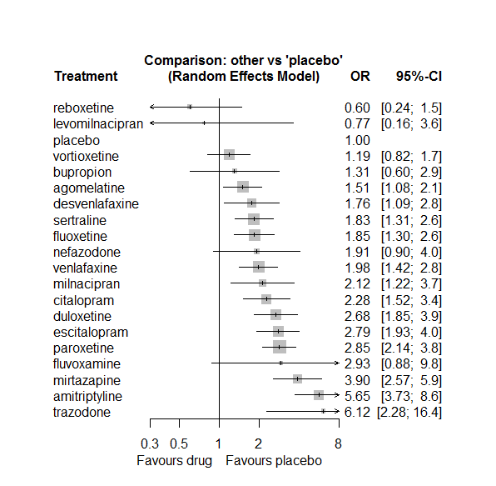

P-score

reboxetine 0.96

placebo 0.89

levomilnacipran 0.84

vortioxetine 0.82

bupropion 0.74

agomelatine 0.71

desvenlafaxine 0.59

sertraline 0.58

fluoxetine 0.57

nefazodone 0.53

venlafaxine 0.52

milnacipran 0.47

citalopram 0.41

fluvoxamine 0.32

duloxetine 0.30

escitalopram 0.27

paroxetine 0.25

mirtazapine 0.13

trazodone 0.06

amitriptyline 0.04

# **Dizziness**

We remove all arms for which dose range was not “Licenced”. After this:

* Removed 20 one-arm studies: Montgomery2004b (CL3-20098-030), CL3-20098-070, Raft1981, Roffman1982, Carman1991, Settle1999 (WELL212), Hewett2010a (AK130940) (NCT00093288), AK1102365, Kavoussi1997, Kyle1998 (Study 92032 - FDA), Mendels1999 (Study 85A - FDA), Jiang2009, Masco1985, Debus1988, Harris1991, Goodarzi 2015(IRCT2012101811155N1), Armitage1997, 29060/299, Sacchetti2002 (BRL-29060/109), Study 032a (CTN032-FCE20124)
* Total number of studies with number randomized being smaller than event rates: 1. Removed the following studies: Rush1998 (excluding Armitage1997 and Gillin1997).
* Total number of arms 602. Total number of studies 259.
* Total events in placebo 1129, out of a total of 19548 patients. Event rate placebo 0.058.
* Total events in drugs 5537, out of a total of 55122 patients. Event rate drugs 0.1

## **Distribution of dose across drugs**

Here we count the number of arms per drug, and the percent of these arms where Dose_intended_min was equal to the minimum licensed dose or lower. The values we used as minimum licensed dose are as follows:

agomelatine: 25; amitriptyline: 75; bupropion:300; citalopram:20; clomipramine:30; desvenlafaxine:50; duloxetine:40; escitalopram:10; fluoxetine:20; fluvoxamine:50; levomilnacipran:40; milnacipran:50; mirtazapine:15; nefazodone:300; paroxetine:20; reboxetine:8; sertraline:50; trazodone:150; venlafaxine:75; vilazodone:20; vortioxetine:5

Drug number.arms percent.low.dose

1 agomelatine 16 0.88

2 escitalopram 25 0.84

3 paroxetine 70 0.79

5 fluoxetine 59 0.92

6 bupropion 16 0.94

7 sertraline 31 0.90

8 citalopram 16 0.69

9 venlafaxine 37 0.70

10 vortioxetine 27 0.41

11 mirtazapine 11 0.73

12 milnacipran 6 0.00

13 amitriptyline 29 0.34

14 fluvoxamine 8 0.62

15 levomilnacipran 9 0.56

16 nefazodone 8 0.62

17 reboxetine 13 0.92

18 duloxetine 31 0.13

19 trazodone 10 1.00

20 desvenlafaxine 10 0.60

21 vilazodone 6 0.17

22 clomipramine 7 0.00

## **Network graph**

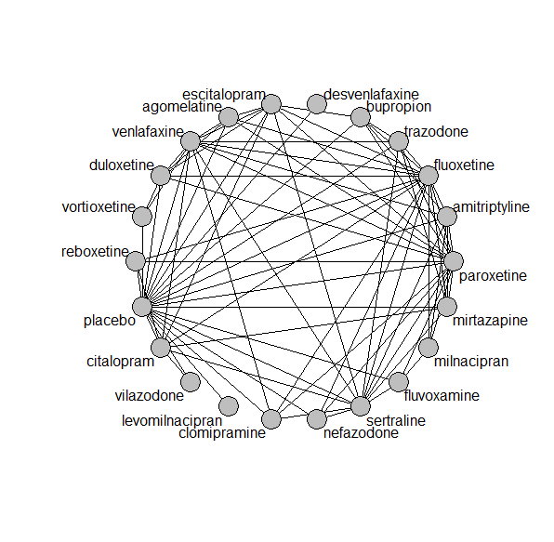

## **Pairwise MA**

### **Grouping all drugs together, comparison vs. placebo**

Number of studies: 155

Random effects meta-analysis: OR=1.85. 95% CI 1.69 to 2.02

Prediction interval 1.06 to 3.22

Heterogeneity (tau squared) was estimated to be 0.08

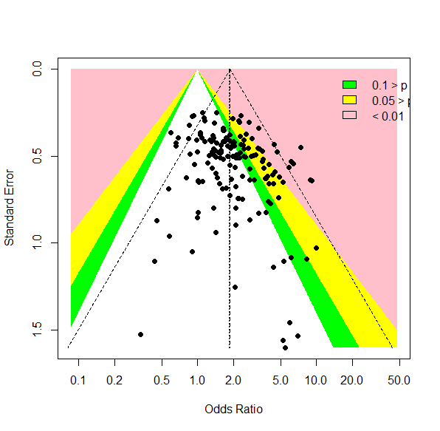

There is no evidence of small-study effects or publication bias (Harbord’s test p-value 0.4)

**Meta-analyses of comparisons with 10 or more studies**

We show results from pairwise comparisons informed by 10 studies or more. An OR larger than 1 favors the first treatment in the comparison.

comparisons Number.of.studies OR lower.CI upper.CI tau.sq I.sq

1 placebo - bupropion 10 1.64 1.22 2.18 0.18 0.43

2 placebo - duloxetine 21 2.16 1.80 2.75 0.00 0.00

3 placebo - escitalopram 12 1.44 1.12 2.03 0.00 0.00

4 placebo - fluoxetine 21 1.46 1.14 1.73 0.09 0.26

5 placebo - paroxetine 31 1.71 1.48 2.09 0.00 0.00

6 placebo - sertraline 9 1.41 1.06 1.94 0.00 0.00

7 placebo - venlafaxine 16 3.20 2.56 4.05 0.23 0.49

8 placebo - vortioxetine 13 1.10 0.90 1.43 0.08 0.28

9 amitriptyline - paroxetine 10 0.51 0.30 0.76 0.00 0.00

10 fluoxetine - venlafaxine 10 2.28 1.46 2.38 0.26 0.60

## **Assessment of transitivity**

comparison studies baseline_SD age_SD female

1 agomelatine - escitalopram 1 26 (NA) 41 (NA) NaN (NA)

2 paroxetine - placebo 31 24 (2.8) 42 (5.6) 0.59 (0.14)

3 fluoxetine - paroxetine 8 23 (1.8) 46 (11.5) NaN (NA)

4 bupropion - placebo 10 24 (1.6) 39 (3.3) 0.66 (0.04)

5 paroxetine - sertraline 2 22 (2) 43 (NA) NaN (NA)

6 citalopram - venlafaxine 1 22 (NA) 73 (NA) NaN (NA)

7 placebo - venlafaxine 16 22 (2) 44 (8.2) 0.6 (0.1)

8 placebo - vortioxetine 13 24 (1.8) 46 (7.7) 0.64 (0.07)

9 venlafaxine - vortioxetine 2 23 (2.5) 42 (2.2) 0.61 (0.02)

10 fluoxetine - venlafaxine 10 24 (2.8) 45 (9.6) 0.66 (0.08)

11 fluoxetine - mirtazapine 4 26 (2.1) 44 (5.2) NaN (NA)

12 amitriptyline - milnacipran 1 26 (NA) 50 (NA) NaN (NA)

13 fluvoxamine - milnacipran 1 24 (NA) 48 (NA) NaN (NA)

14 fluvoxamine - paroxetine 2 22 (1.4) 42 (1.6) 0.57 (NA)

15 fluoxetine - milnacipran 1 23 (NA) 45 (NA) NaN (NA)

16 levomilnacipran - placebo 6 24 (1.1) 43 (1.4) 0.63 (0.02)

17 amitriptyline - placebo 7 25 (2.7) 41 (1.5) NaN (NA)

18 nefazodone - paroxetine 2 25 (NA) 40 (3.4) 0.49 (0.09)

19 paroxetine - reboxetine 3 22 (2.1) 41 (2.7) 0.69 (0.07)

20 escitalopram - paroxetine 2 25 (2.8) 45 (0.5) NaN (NA)

21 duloxetine - placebo 21 21 (2.6) 47 (10.7) 0.65 (0.04)

22 duloxetine - vortioxetine 6 24 (2) 49 (10.8) 0.67 (0.04)

23 placebo - reboxetine 9 24 (3.9) 42 (3.1) 0.62 (0.09)

24 fluoxetine - trazodone 2 21 (1.1) 54 (20) 0.67 (NA)

25 mirtazapine - sertraline 1 NaN (NA) 42 (NA) NaN (NA)

26 mirtazapine - paroxetine 3 23 (1.2) 53 (16.7) NaN (NA)

27 fluoxetine - sertraline 4 22 (2.1) 52 (10.8) NaN (NA)

28 fluoxetine - nefazodone 1 24 (NA) 41 (NA) 0.77 (NA)

29 amitriptyline - sertraline 6 25 (2.3) 49 (11.3) 0.6 (0.11)

30 amitriptyline - paroxetine 10 24 (3) 50 (11.6) 0.78 (0.23)

31 fluoxetine - reboxetine 3 24 (1.1) 41 (2.8) 0.66 (0.05)

32 citalopram - fluoxetine 1 24 (NA) 42 (NA) NaN (NA)

33 desvenlafaxine - placebo 7 23 (0.5) 44 (4.6) 0.67 (0.15)

34 citalopram - escitalopram 6 25 (2.2) 39 (4.2) 0.57 (0.02)

35 citalopram - placebo 5 21 (3) 48 (17.5) 0.59 (0.02)

36 escitalopram - placebo 12 22 (2) 42 (10.5) 0.63 (0.13)

37 fluoxetine - placebo 21 22 (2.1) 44 (11.5) 0.6 (0.04)

38 agomelatine - paroxetine 2 26 (0.7) 56 (18.1) 0.62 (NA)

39 agomelatine - placebo 6 27 (0.2) 48 (11.6) 0.66 (0.05)

40 fluvoxamine - placebo 4 24 (1.3) 42 (2.3) NaN (NA)

41 amitriptyline - bupropion 1 23 (NA) 37 (NA) NaN (NA)

42 amitriptyline - fluoxetine 5 23 (1.7) 40 (2) 0.64 (0.17)

43 agomelatine - duloxetine 1 26 (NA) 43 (NA) NaN (NA)

44 bupropion - escitalopram 2 24 (NA) 36 (0.6) NaN (NA)

45 placebo - sertraline 10 21 (3.6) 43 (9.7) 0.58 (0.08)

46 bupropion - fluoxetine 3 23 (2.2) 39 (2.7) NaN (NA)

47 placebo - vilazodone 5 24 (0.6) 41 (1) 0.56 (0.03)

48 placebo - trazodone 4 22 (0.4) 46 (10.6) 0.61 (0.05)

49 trazodone - venlafaxine 1 22 (NA) 41 (NA) 0.66 (NA)

50 duloxetine - paroxetine 5 20 (1.7) 42 (2.7) NaN (NA)

51 citalopram - sertraline 3 25 (3.5) 41 (6.7) NaN (NA)

52 nefazodone - sertraline 1 23 (NA) 44 (NA) 0.52 (NA)

53 nefazodone - placebo 4 26 (1.7) 41 (2.5) 0.64 (0.04)

54 amitriptyline - venlafaxine 1 21 (NA) 38 (NA) NaN (NA)

55 clomipramine - fluoxetine 2 24 (6.4) 46 (3.7) 0.68 (0.05)

56 duloxetine - fluoxetine 2 18 (0.2) 41 (0.6) NaN (NA)

57 agomelatine - fluoxetine 2 28 (1.1) 41 (2.3) 0.74 (0.06)

58 mirtazapine - placebo 2 23 (2.4) 62 (NA) 0.54 (NA)

59 mirtazapine - trazodone 1 22 (NA) 62 (NA) 0.54 (NA)

60 milnacipran - paroxetine 1 22 (NA) 36 (NA) 0.53 (NA)

61 escitalopram - fluoxetine 3 23 (1.5) 50 (21.4) 0.68 (NA)

62 paroxetine - trazodone 2 22 (2.1) 41 (3.6) 0.63 (NA)

63 duloxetine - escitalopram 3 20 (2.5) 43 (0.9) NaN (NA)

64 escitalopram - sertraline 1 25 (NA) 34 (NA) NaN (NA)

65 clomipramine - placebo 1 18 (NA) 52 (NA) 0.66 (NA)

66 citalopram - mirtazapine 1 23 (NA) 42 (NA) NaN (NA)

67 agomelatine - venlafaxine 1 26 (NA) 40 (NA) 0.71 (NA)

68 citalopram - vilazodone 1 24 (NA) 42 (NA) 0.57 (NA)

69 paroxetine - venlafaxine 1 23 (NA) 44 (NA) NaN (NA)

70 sertraline - venlafaxine 2 23 (0.4) 40 (3.9) NaN (NA)

71 escitalopram - venlafaxine 1 20 (NA) 48 (NA) NaN (NA)

72 clomipramine - sertraline 1 24 (NA) 44 (NA) 0.5 (NA)

73 sertraline - trazodone 1 22 (NA) 46 (NA) 0.65 (NA)

74 fluvoxamine - sertraline 1 21 (NA) 40 (NA) NaN (NA)

75 duloxetine - venlafaxine 2 23 (0.5) 43 (1.4) 0.68 (0.03)

76 clomipramine - paroxetine 2 24 (1.1) 57 (20.3) 0.81 (0.12)

77 clomipramine - venlafaxine 1 25 (NA) 47 (NA) NaN (NA)

78 amitriptyline - mirtazapine 1 25 (NA) NaN (NA) NaN (NA)

79 citalopram - reboxetine 1 24 (NA) 42 (NA) 0.64 (NA)

80 bupropion - trazodone 1 22 (NA) 40 (NA) NaN (NA)

81 bupropion - paroxetine 1 22 (NA) 37 (NA) NaN (NA)

## **NMA**

A total of 22 treatments are included in the network.

A total of 257 studies are included in this analysis.

Estimated heterogeneity tau-squared 0.04

Global test for inconsistency, p-value 0.1062 (Q=110,d.o.f.93)

### **Comparison vs. placebo**

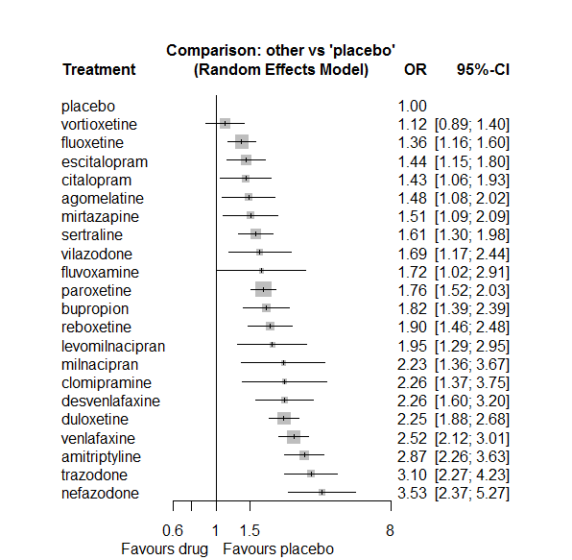

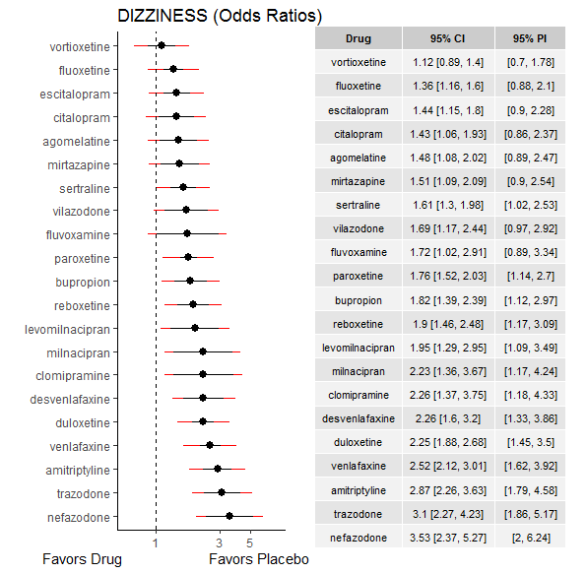

**Ranking according to P-scores**

P-score

placebo 0.99

vortioxetine 0.94

fluoxetine 0.82

escitalopram 0.76

citalopram 0.76

agomelatine 0.72

mirtazapine 0.70

sertraline 0.64

vilazodone 0.58

fluvoxamine 0.56

paroxetine 0.53

bupropion 0.50

reboxetine 0.45

levomilnacipran 0.43

milnacipran 0.32

clomipramine 0.31

desvenlafaxine 0.29

duloxetine 0.29

venlafaxine 0.19

amitriptyline 0.11

trazodone 0.08

nefazodone 0.04

### **Local inconsistency**

Percent of comparisons where there is some evidence (p-value<0.05) of disagreement between direct and indirect sources: 0.06. (5 out of 79 comparisons)

comparison TE seTE lower upper z p

6 agomelatine:duloxetine 0.2166 0.48 -0.732 1.1655 0.447 0.655

7 agomelatine:escitalopram -1.5638 1.17 -3.849 0.7218 -1.341 0.180

8 agomelatine:fluoxetine 0.0766 0.37 -0.650 0.8037 0.207 0.836

14 agomelatine:paroxetine 0.2436 0.42 -0.584 1.0714 0.577 0.564

15 agomelatine:placebo 0.0817 0.32 -0.547 0.7103 0.255 0.799

19 agomelatine:venlafaxine -1.2972 0.70 -2.660 0.0659 -1.865 0.062

22 amitriptyline:bupropion 0.1571 0.48 -0.783 1.0969 0.328 0.743

28 amitriptyline:fluoxetine -0.0589 0.32 -0.685 0.5671 -0.184 0.854

31 amitriptyline:milnacipran -0.0235 0.57 -1.141 1.0942 -0.041 0.967

32 amitriptyline:mirtazapine 0.3159 0.78 -1.205 1.8369 0.407 0.684

34 amitriptyline:paroxetine 0.2738 0.30 -0.310 0.8578 0.919 0.358

35 amitriptyline:placebo 0.0608 0.26 -0.441 0.5630 0.237 0.812

37 amitriptyline:sertraline -0.1722 0.27 -0.699 0.3546 -0.641 0.522

39 amitriptyline:venlafaxine -0.3575 0.64 -1.615 0.8996 -0.557 0.577

46 bupropion:escitalopram -0.0216 0.44 -0.883 0.8402 -0.049 0.961

47 bupropion:fluoxetine 0.8794 0.43 0.039 1.7203 2.050 0.040

53 bupropion:paroxetine 0.4338 0.58 -0.713 1.5803 0.742 0.458

54 bupropion:placebo -0.4222 0.29 -0.997 0.1530 -1.439 0.150

57 bupropion:trazodone 0.0683 0.52 -0.942 1.0790 0.132 0.895

64 citalopram:escitalopram -0.1366 0.35 -0.831 0.5575 -0.386 0.700

65 citalopram:fluoxetine 0.8694 0.75 -0.598 2.3369 1.161 0.246

69 citalopram:mirtazapine -0.7645 0.60 -1.941 0.4120 -1.274 0.203

72 citalopram:placebo -0.1588 0.32 -0.777 0.4593 -0.504 0.615

73 citalopram:reboxetine 0.4411 0.55 -0.643 1.5249 0.798 0.425

74 citalopram:sertraline -0.3839 0.38 -1.126 0.3586 -1.013 0.311

76 citalopram:venlafaxine 0.9263 0.83 -0.695 2.5475 1.120 0.263

77 citalopram:vilazodone 0.3817 0.46 -0.517 1.2799 0.833 0.405

82 clomipramine:fluoxetine 1.2877 0.70 -0.092 2.6675 1.829 0.067

88 clomipramine:paroxetine -1.0575 0.51 -2.059 -0.0558 -2.069 0.039

89 clomipramine:placebo 0.6589 0.85 -1.002 2.3195 0.778 0.437

91 clomipramine:sertraline 0.6098 0.93 -1.211 2.4304 0.657 0.511

93 clomipramine:venlafaxine -0.1074 0.78 -1.645 1.4304 -0.137 0.891

112 duloxetine:escitalopram 0.1353 0.29 -0.439 0.7098 0.462 0.644

113 duloxetine:fluoxetine -0.2623 0.59 -1.423 0.8988 -0.443 0.658

119 duloxetine:paroxetine -0.0419 0.25 -0.532 0.4480 -0.168 0.867

120 duloxetine:placebo -0.0896 0.18 -0.446 0.2671 -0.492 0.622

124 duloxetine:venlafaxine 0.1595 0.26 -0.341 0.6597 0.625 0.532

126 duloxetine:vortioxetine 0.0800 0.25 -0.412 0.5725 0.319 0.750

127 escitalopram:fluoxetine -0.1126 0.36 -0.827 0.6015 -0.309 0.757

133 escitalopram:paroxetine 0.2463 0.34 -0.414 0.9062 0.731 0.465

134 escitalopram:placebo 0.0411 0.23 -0.412 0.4939 0.178 0.859

136 escitalopram:sertraline -0.9035 0.55 -1.987 0.1800 -1.634 0.102

138 escitalopram:venlafaxine 0.4266 0.59 -0.724 1.5767 0.727 0.467

143 fluoxetine:milnacipran -1.2092 0.74 -2.667 0.2482 -1.626 0.104

144 fluoxetine:mirtazapine 0.2660 0.35 -0.424 0.9557 0.756 0.450

145 fluoxetine:nefazodone 0.1452 0.73 -1.285 1.5754 0.199 0.842

146 fluoxetine:paroxetine -0.1695 0.21 -0.582 0.2431 -0.805 0.421

147 fluoxetine:placebo 0.0842 0.17 -0.241 0.4098 0.507 0.612

148 fluoxetine:reboxetine -0.2096 0.34 -0.880 0.4604 -0.613 0.540

149 fluoxetine:sertraline 0.7825 0.34 0.117 1.4476 2.306 0.021

150 fluoxetine:trazodone -0.4031 0.57 -1.522 0.7157 -0.706 0.480

151 fluoxetine:venlafaxine -0.1368 0.20 -0.533 0.2598 -0.676 0.499

155 fluvoxamine:milnacipran 1.3908 0.60 0.205 2.5763 2.299 0.021

158 fluvoxamine:paroxetine -0.3892 0.63 -1.624 0.8456 -0.618 0.537

159 fluvoxamine:placebo -0.6768 0.56 -1.778 0.4245 -1.204 0.228

161 fluvoxamine:sertraline -0.3349 0.70 -1.713 1.0431 -0.476 0.634

179 milnacipran:paroxetine 0.4056 0.51 -0.600 1.4107 0.791 0.429

188 mirtazapine:paroxetine -0.0090 0.34 -0.674 0.6558 -0.027 0.979

189 mirtazapine:placebo 0.3736 0.55 -0.707 1.4543 0.678 0.498

191 mirtazapine:sertraline -0.4252 0.49 -1.377 0.5270 -0.875 0.381

192 mirtazapine:trazodone 0.6075 0.56 -0.499 1.7143 1.076 0.282

196 nefazodone:paroxetine -0.0089 0.47 -0.939 0.9212 -0.019 0.985

197 nefazodone:placebo -0.5108 0.41 -1.313 0.2912 -1.248 0.212

199 nefazodone:sertraline 0.8360 0.50 -0.141 1.8133 1.677 0.094

204 paroxetine:placebo -0.0335 0.15 -0.322 0.2554 -0.227 0.820

205 paroxetine:reboxetine -0.1628 0.28 -0.715 0.3897 -0.578 0.564

206 paroxetine:sertraline 0.2079 0.32 -0.420 0.8362 0.648 0.517

207 paroxetine:trazodone 0.8223 0.53 -0.208 1.8521 1.565 0.118

208 paroxetine:venlafaxine -0.2786 0.40 -1.060 0.5031 -0.699 0.485

211 placebo:reboxetine 0.0761 0.28 -0.468 0.6197 0.274 0.784

212 placebo:sertraline 0.1722 0.22 -0.262 0.6064 0.778 0.437

213 placebo:trazodone -0.1714 0.32 -0.794 0.4515 -0.539 0.590

214 placebo:venlafaxine -0.3509 0.18 -0.704 0.0022 -1.948 0.051

215 placebo:vilazodone 0.0609 0.65 -1.216 1.3382 0.093 0.926

216 placebo:vortioxetine 0.0885 0.26 -0.422 0.5991 0.340 0.734

222 sertraline:trazodone 0.2401 0.57 -0.881 1.3611 0.420 0.675

223 sertraline:venlafaxine 0.5356 0.36 -0.175 1.2459 1.478 0.139

226 trazodone:venlafaxine 1.0728 0.48 0.126 2.0191 2.222 0.026

230 venlafaxine:vortioxetine -0.2676 0.32 -0.904 0.3687 -0.824 0.410

### **League table**

Below we show the league table. Upper triangle: direct evidence. Lower triangle: NMA. An odds ratio larger than 1 in the upper triangle favors the column-defining drug. An odds ratio larger than 1 in the bottom triangle favors the row-defining drug.

|  |  |  |  |  |  |  |  |  |  |  |  |  |  |  |  |  |  |  |  |  |  |
| --- | --- | --- | --- | --- | --- | --- | --- | --- | --- | --- | --- | --- | --- | --- | --- | --- | --- | --- | --- | --- | --- |
| AGOM | . | . | . | . | . | 0.79 [0.33; 1.89] | 0.22 [0.02; 2.14] | 1.15 [0.62; 2.13] | . | . | . | . | . | 1.02 [0.49; 2.15] | 1.54 [0.97; 2.46] | . | . | . | 0.17 [0.05; 0.65] | . | . |
| 0.52 [0.35; 0.76] | AMIT | 1.80 [0.76; 4.27] | . | . | . | . | . | 2.01 [1.15; 3.51] | . | . | 1.26 [0.50; 3.22] | 2.55 [0.59; 11.10] | . | 2.01 [1.21; 3.35] | 2.98 [1.98; 4.51] | . | 1.62 [1.10; 2.40] | . | 0.81 [0.24; 2.75] | . | . |
| 0.81 [0.54; 1.22] | 1.57 [1.12; 2.21] | BUPR | . | . | . | . | 1.25 [0.57; 2.71] | 2.83 [1.30; 6.14] | . | . | . | . | . | 1.55 [0.51; 4.68] | 1.58 [1.14; 2.21] | . | . | 0.62 [0.25; 1.55] | . | . | . |
| 1.03 [0.67; 1.59] | 2.01 [1.39; 2.90] | 1.28 [0.86; 1.90] | CITA | . | . | . | 0.92 [0.53; 1.58] | 2.40 [0.57; 10.00] | . | . | . | 0.49 [0.17; 1.46] | . | . | 1.30 [0.80; 2.10] | 1.09 [0.40; 2.98] | 0.68 [0.36; 1.27] | . | 1.37 [0.28; 6.68] | 1.07 [0.53; 2.16] | . |
| 0.65 [0.36; 1.17] | 1.27 [0.74; 2.18] | 0.80 [0.46; 1.42] | 0.63 [0.35; 1.13] | CLOM | . | . | . | 4.89 [1.38; 17.26] | . | . | . | . | . | 0.81 [0.42; 1.57] | 4.09 [0.85; 19.73] | . | 2.45 [0.43; 13.87] | . | 0.82 [0.19; 3.43] | . | . |
| 0.65 [0.41; 1.04] | 1.27 [0.83; 1.92] | 0.80 [0.52; 1.25] | 0.63 [0.40; 1.00] | 1.00 [0.54; 1.84] | DESV | . | . | . | . | . | . | . | . | . | 2.26 [1.60; 3.20] | . | . | . | . | . | . |
| 0.66 [0.47; 0.93] | 1.27 [0.96; 1.69] | 0.81 [0.59; 1.11] | 0.64 [0.45; 0.89] | 1.01 [0.60; 1.70] | 1.01 [0.68; 1.49] | DULO | 1.73 [1.06; 2.81] | 1.28 [0.41; 4.01] | . | . | . | . | . | 1.24 [0.81; 1.90] | 2.16 [1.71; 2.73] | . | . | . | 1.00 [0.65; 1.54] | . | 2.09 [1.50; 2.91] |
| 1.03 [0.71; 1.50] | 2.00 [1.46; 2.73] | 1.27 [0.91; 1.78] | 1.00 [0.71; 1.40] | 1.58 [0.92; 2.72] | 1.58 [1.04; 2.38] | 1.57 [1.21; 2.03] | ESCI | 0.96 [0.50; 1.85] | . | . | . | . | . | 1.00 [0.55; 1.83] | 1.47 [1.05; 2.05] | . | 0.39 [0.14; 1.10] | . | 0.85 [0.28; 2.60] | . | . |
| 1.09 [0.78; 1.51] | 2.11 [1.63; 2.72] | 1.34 [0.99; 1.81] | 1.05 [0.76; 1.45] | 1.67 [1.00; 2.78] | 1.67 [1.14; 2.44] | 1.65 [1.32; 2.07] | 1.06 [0.82; 1.36] | FLUO | . | . | 0.22 [0.06; 0.83] | 1.07 [0.61; 1.88] | 0.44 [0.11; 1.71] | 0.68 [0.48; 0.97] | 1.43 [1.12; 1.82] | 0.61 [0.34; 1.09] | 1.65 [0.89; 3.05] | 0.30 [0.11; 0.88] | 0.50 [0.37; 0.67] | . | . |
| 0.86 [0.47; 1.57] | 1.66 [0.96; 2.90] | 1.06 [0.59; 1.90] | 0.83 [0.46; 1.51] | 1.32 [0.64; 2.69] | 1.32 [0.70; 2.46] | 1.31 [0.75; 2.26] | 0.83 [0.47; 1.47] | 0.79 [0.46; 1.35] | FLUV | . | 1.60 [0.68; 3.77] | . | . | 0.73 [0.25; 2.14] | 1.11 [0.45; 2.69] | . | 0.82 [0.24; 2.82] | . | . | . | . |
| 0.76 [0.45; 1.27] | 1.47 [0.91; 2.36] | 0.93 [0.57; 1.53] | 0.73 [0.44; 1.22] | 1.16 [0.60; 2.22] | 1.16 [0.68; 1.99] | 1.15 [0.73; 1.80] | 0.73 [0.46; 1.18] | 0.70 [0.45; 1.08] | 0.88 [0.45; 1.72] | LEVO | . | . | . | . | 1.95 [1.29; 2.95] | . | . | . | . | . | . |
| 0.66 [0.37; 1.18] | 1.28 [0.77; 2.14] | 0.82 [0.47; 1.43] | 0.64 [0.36; 1.14] | 1.01 [0.51; 2.03] | 1.01 [0.55; 1.86] | 1.01 [0.60; 1.70] | 0.64 [0.38; 1.10] | 0.61 [0.37; 1.01] | 0.77 [0.43; 1.39] | 0.88 [0.46; 1.67] | MILN | . | . | 1.62 [0.74; 3.52] | . | . | . | . | . | . | . |
| 0.98 [0.63; 1.52] | 1.90 [1.30; 2.76] | 1.21 [0.80; 1.82] | 0.95 [0.63; 1.43] | 1.50 [0.84; 2.69] | 1.50 [0.93; 2.41] | 1.49 [1.04; 2.13] | 0.95 [0.65; 1.39] | 0.90 [0.65; 1.25] | 1.14 [0.62; 2.09] | 1.29 [0.77; 2.19] | 1.48 [0.83; 2.63] | MIRT | . | 0.85 [0.51; 1.44] | 2.11 [0.76; 5.89] | . | 0.66 [0.28; 1.57] | 0.80 [0.29; 2.19] | . | . | . |
| 0.42 [0.25; 0.69] | 0.81 [0.52; 1.28] | 0.52 [0.32; 0.83] | 0.40 [0.25; 0.66] | 0.64 [0.34; 1.21] | 0.64 [0.38; 1.09] | 0.64 [0.41; 0.98] | 0.41 [0.26; 0.64] | 0.39 [0.25; 0.59] | 0.49 [0.25; 0.94] | 0.55 [0.31; 0.98] | 0.63 [0.34; 1.19] | 0.43 [0.26; 0.71] | NEFA | 1.99 [0.90; 4.43] | 2.69 [1.50; 4.83] | . | 4.10 [1.76; 9.55] | . | . | . | . |
| 0.84 [0.61; 1.17] | 1.63 [1.27; 2.09] | 1.04 [0.77; 1.39] | 0.81 [0.59; 1.12] | 1.29 [0.78; 2.12] | 1.29 [0.88; 1.87] | 1.28 [1.04; 1.57] | 0.82 [0.64; 1.05] | 0.77 [0.64; 0.93] | 0.98 [0.58; 1.66] | 1.11 [0.72; 1.72] | 1.27 [0.78; 2.08] | 0.86 [0.62; 1.18] | 2.01 [1.33; 3.02] | PARO | 1.73 [1.42; 2.11] | 0.84 [0.56; 1.27] | 1.30 [0.73; 2.33] | 1.17 [0.45; 3.09] | 0.54 [0.25; 1.14] | . | . |
| 1.48 [1.08; 2.02] | 2.87 [2.26; 3.63] | 1.82 [1.39; 2.39] | 1.43 [1.06; 1.93] | 2.26 [1.37; 3.75] | 2.26 [1.60; 3.20] | 2.25 [1.88; 2.68] | 1.44 [1.15; 1.80] | 1.36 [1.16; 1.60] | 1.72 [1.02; 2.91] | 1.95 [1.29; 2.95] | 2.23 [1.36; 3.67] | 1.51 [1.09; 2.09] | 3.53 [2.37; 5.27] | 1.76 [1.52; 2.03] | PLAC | 0.54 [0.38; 0.76] | 0.69 [0.49; 0.98] | 0.30 [0.19; 0.46] | 0.33 [0.25; 0.42] | 0.60 [0.41; 0.88] | 0.92 [0.70; 1.20] |
| 0.78 [0.52; 1.16] | 1.50 [1.07; 2.12] | 0.96 [0.66; 1.39] | 0.75 [0.51; 1.10] | 1.19 [0.68; 2.08] | 1.19 [0.77; 1.84] | 1.18 [0.86; 1.61] | 0.75 [0.54; 1.06] | 0.71 [0.54; 0.95] | 0.90 [0.51; 1.61] | 1.03 [0.63; 1.68] | 1.17 [0.67; 2.04] | 0.79 [0.53; 1.19] | 1.85 [1.15; 2.98] | 0.92 [0.70; 1.22] | 0.53 [0.40; 0.69] | REBO | . | . | . | . | . |
| 0.92 [0.64; 1.33] | 1.78 [1.37; 2.32] | 1.13 [0.81; 1.58] | 0.89 [0.64; 1.24] | 1.41 [0.83; 2.39] | 1.41 [0.94; 2.11] | 1.40 [1.08; 1.82] | 0.89 [0.67; 1.19] | 0.85 [0.67; 1.07] | 1.07 [0.62; 1.84] | 1.22 [0.77; 1.93] | 1.39 [0.83; 2.34] | 0.94 [0.66; 1.34] | 2.20 [1.44; 3.36] | 1.09 [0.87; 1.37] | 0.62 [0.51; 0.77] | 1.18 [0.86; 1.64] | SERT | 0.64 [0.22; 1.84] | 1.01 [0.52; 1.94] | . | . |
| 0.48 [0.31; 0.74] | 0.92 [0.63; 1.35] | 0.59 [0.40; 0.87] | 0.46 [0.30; 0.70] | 0.73 [0.41; 1.31] | 0.73 [0.46; 1.16] | 0.72 [0.51; 1.03] | 0.46 [0.32; 0.67] | 0.44 [0.31; 0.61] | 0.56 [0.30; 1.01] | 0.63 [0.38; 1.06] | 0.72 [0.40; 1.28] | 0.49 [0.32; 0.74] | 1.14 [0.69; 1.88] | 0.57 [0.41; 0.79] | 0.32 [0.24; 0.44] | 0.61 [0.41; 0.92] | 0.52 [0.36; 0.74] | TRAZ | 3.05 [1.28; 7.28] | . | . |
| 0.59 [0.42; 0.83] | 1.14 [0.86; 1.49] | 0.72 [0.53; 0.99] | 0.57 [0.40; 0.79] | 0.90 [0.53; 1.51] | 0.90 [0.61; 1.32] | 0.89 [0.72; 1.11] | 0.57 [0.43; 0.74] | 0.54 [0.44; 0.66] | 0.68 [0.40; 1.18] | 0.77 [0.49; 1.21] | 0.88 [0.53; 1.48] | 0.60 [0.42; 0.85] | 1.40 [0.91; 2.15] | 0.70 [0.57; 0.86] | 0.40 [0.33; 0.47] | 0.75 [0.55; 1.03] | 0.64 [0.50; 0.82] | 1.23 [0.87; 1.73] | VENL | . | 1.83 [1.05; 3.22] |
| 0.88 [0.54; 1.42] | 1.70 [1.10; 2.63] | 1.08 [0.68; 1.70] | 0.85 [0.55; 1.31] | 1.34 [0.72; 2.50] | 1.34 [0.81; 2.23] | 1.33 [0.89; 2.00] | 0.85 [0.56; 1.30] | 0.81 [0.54; 1.20] | 1.02 [0.54; 1.93] | 1.16 [0.67; 2.01] | 1.32 [0.71; 2.45] | 0.90 [0.55; 1.45] | 2.09 [1.22; 3.60] | 1.04 [0.70; 1.55] | 0.59 [0.41; 0.86] | 1.13 [0.72; 1.77] | 0.95 [0.63; 1.45] | 1.84 [1.14; 2.98] | 1.50 [1.00; 2.25] | VILA | . |
| 1.32 [0.90; 1.93] | 2.56 [1.86; 3.54] | 1.63 [1.15; 2.32] | 1.28 [0.88; 1.86] | 2.03 [1.17; 3.51] | 2.03 [1.34; 3.07] | 2.01 [1.58; 2.57] | 1.28 [0.94; 1.75] | 1.22 [0.93; 1.59] | 1.54 [0.87; 2.72] | 1.75 [1.09; 2.80] | 2.00 [1.16; 3.44] | 1.35 [0.91; 2.00] | 3.16 [2.00; 5.00] | 1.57 [1.21; 2.04] | 0.90 [0.71; 1.12] | 1.70 [1.20; 2.41] | 1.44 [1.06; 1.95] | 2.78 [1.89; 4.07] | 2.26 [1.73; 2.94] | 1.51 [0.98; 2.33] | VORT |

### **Estimated event rates**

For an event rate in placebo equal to the average event rate (i.e. fixed to 0.06) the estimated event rates for each drug are as follows

drug rate

1 agomelatine 0.08 [0.06, 0.11]

2 amitriptyline 0.15 [0.12, 0.18]

3 bupropion 0.1 [0.08, 0.13]

4 citalopram 0.08 [0.06, 0.11]

5 clomipramine 0.12 [0.08, 0.19]

6 desvenlafaxine 0.12 [0.09, 0.16]

7 duloxetine 0.12 [0.1, 0.14]

8 escitalopram 0.08 [0.07, 0.1]

9 fluoxetine 0.08 [0.07, 0.09]

10 fluvoxamine 0.1 [0.06, 0.15]

11 levomilnacipran 0.11 [0.07, 0.15]

12 milnacipran 0.12 [0.08, 0.18]

13 mirtazapine 0.08 [0.06, 0.11]

14 nefazodone 0.18 [0.13, 0.24]

15 paroxetine 0.1 [0.09, 0.11]

17 reboxetine 0.1 [0.08, 0.13]

18 sertraline 0.09 [0.07, 0.11]

19 trazodone 0.16 [0.12, 0.21]

20 venlafaxine 0.13 [0.11, 0.16]

21 vilazodone 0.09 [0.07, 0.13]

22 vortioxetine 0.06 [0.05, 0.08]

## **Sensitivity analysis: splitting nodes according to dosage**

All treatment arms for drug X, with dose_intended_min equal to or smaller to the minimum licensed dose were set as “X_L”. All other arms of X are “X_H”. Studies with no information on dose are excluded. Results shown below:

|  |  |  |
| --- | --- | --- |
| **Low dose vs. placebo** | **High dose vs. placebo** | **High dose vs. low dose** |
|  |  |  |

## **Sensitivity analysis: Keeping only low dropout arms**

We exclude all treatment arms with dropout rates larger than 25%, and we re-analyse the network.

Total number of arms included in the analysis 224. Total number of studies 107

Total events in placebo 463, out of a total of 9481 patients. Event rate placebo 0.049

Total events in drugs 2212, out of a total of 26278 patients. Event rate drugs 0.084

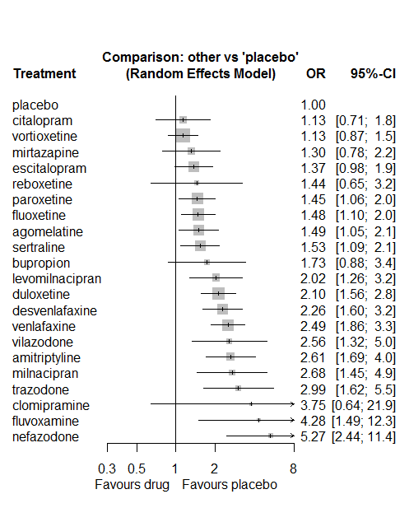

P-score

placebo 0.95

vortioxetine 0.87

citalopram 0.86

mirtazapine 0.76

escitalopram 0.73

paroxetine 0.69

fluoxetine 0.67

reboxetine 0.67

agomelatine 0.67

sertraline 0.64

bupropion 0.55

levomilnacipran 0.44

duloxetine 0.40

desvenlafaxine 0.35

vilazodone 0.30

venlafaxine 0.28

milnacipran 0.27

amitriptyline 0.26

clomipramine 0.25

trazodone 0.21

fluvoxamine 0.13

nefazodone 0.06

# **Diarrhoea**

We remove all arms for which dose range was not “Licenced”. After this:

* Removed 12 one-arm studies: Kennedy2006 (CL3-20098-043), Montgomery2004b (CL3-20098-030), Settle1999 (WELL212), Hewett2010a (AK130940) (NCT00093288), AK1102365, Kavoussi1997, Debus1988, McGrath2000, Lydiard1989, Armitage1997, 29060/299, Bosc1997a (Study 014 - Andreoli2002)
* Total number of studies with number randomized being smaller than event rates: 1. Removed the following studies: Rush1998 (excluding Armitage1997 and Gillin1997).
* Total number of arms 492. Total number of studies 205.
* Total events in placebo 1225, out of a total of 17085 patients. Event rate placebo 0.072.
* Total events in drugs 4754, out of a total of 48702 patients. Event rate drugs 0.098

## **Distribution of dose across drugs**

Here we count the number of arms per drug, and the percent of these arms where Dose_intended_min was equal to the minimum licensed dose or lower. The values we used as minimum licensed dose are as follows:

agomelatine: 25; amitriptyline: 75; bupropion:300; citalopram:20; clomipramine:30; desvenlafaxine:50; duloxetine:40; escitalopram:10; fluoxetine:20; fluvoxamine:50; levomilnacipran:40; milnacipran:50; mirtazapine:15; nefazodone:300; paroxetine:20; reboxetine:8; sertraline:50; trazodone:150; venlafaxine:75; vilazodone:20; vortioxetine:5

Drug number.arms percent.low.dose

1 agomelatine 15 0.87

2 escitalopram 28 0.79

3 paroxetine 66 0.82

5 fluoxetine 46 0.89

6 sertraline 28 0.93

7 vortioxetine 26 0.42

8 venlafaxine 23 0.78

9 mirtazapine 6 0.67

10 milnacipran 9 0.00

11 amitriptyline 10 0.80

12 fluvoxamine 9 0.44

13 levomilnacipran 8 0.50

14 reboxetine 10 0.90

15 duloxetine 31 0.13

16 trazodone 7 1.00

17 citalopram 16 0.62

18 bupropion 11 1.00

19 desvenlafaxine 4 0.75

20 vilazodone 6 0.17

21 nefazodone 2 0.50

22 clomipramine 1 0.00

## **Network graph**

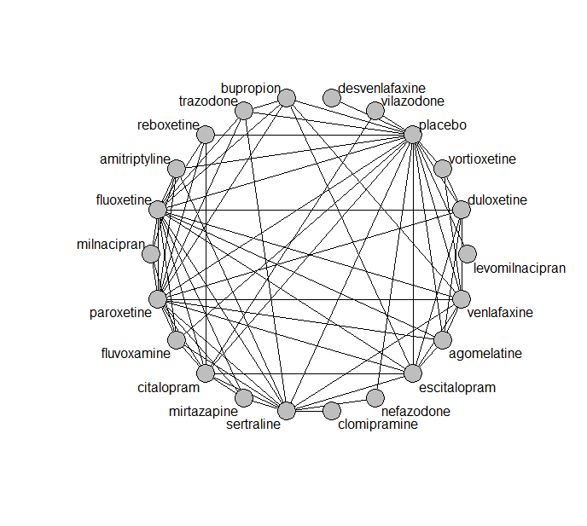

## **Pairwise MA**

### **Grouping all drugs together, comparison vs. placebo**

Number of studies: 129

Random effects meta-analysis: OR=1.54. 95% CI 1.39 to 1.71

Prediction interval 0.71 to 3.36

Heterogeneity (tau squared) was estimated to be 0.15

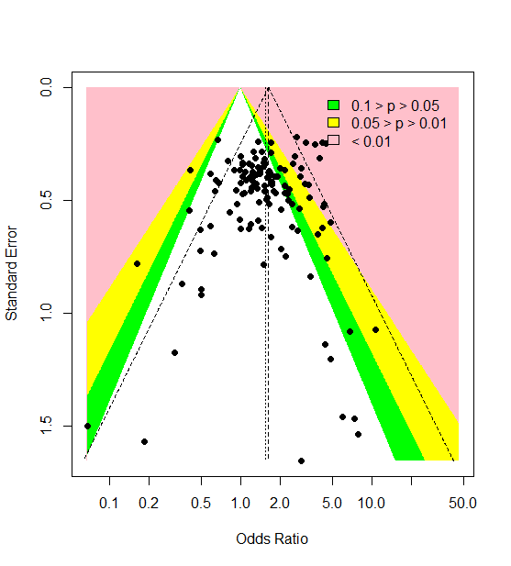

A visual inspection provides no evidence of small-study effects or publication bias. However, Harbord’s test gives a p-value of 0.003.

### **Meta-analyses of comparisons with 10 or more studies**

We show results from pairwise comparisons informed by 10 studies or more. An OR larger than 1 favors the first treatment in the comparison.

comparisons Number.of.studies OR lower.CI upper.CI tau.sq I.sq

1 placebo - duloxetine 21 1.55 1.31 1.96 0.00 0.00

2 placebo - escitalopram 15 1.61 1.29 2.04 0.04 0.15

3 placebo - fluoxetine 17 1.61 1.31 1.93 0.00 0.00

4 placebo - paroxetine 35 1.62 1.42 1.92 0.00 0.00

5 placebo - vortioxetine 13 1.12 0.93 1.44 0.09 0.36

## **Assessment of transitivity**

comparison studies baseline_SD age_SD female

1 agomelatine - escitalopram 2 26 (0.7) 42 (1.3) 0.71 (NA)

2 paroxetine - placebo 35 24 (2.6) 42 (7.2) 0.55 (0.15)

3 fluoxetine - paroxetine 9 23 (1.7) 45 (10.9) NaN (NA)

4 paroxetine - sertraline 2 22 (2) 43 (NA) NaN (NA)

5 escitalopram - placebo 15 22 (2) 44 (11.4) 0.64 (0.11)

6 escitalopram - sertraline 2 20 (0.5) 40 (0.5) NaN (NA)

7 placebo - sertraline 9 22 (2.7) 43 (10.3) 0.6 (0.06)

8 placebo - venlafaxine 9 22 (1.1) 45 (10.1) 0.59 (0.06)

9 placebo - vortioxetine 13 24 (1.8) 46 (7.7) 0.64 (0.07)

10 venlafaxine - vortioxetine 1 22 (NA) 43 (NA) 0.62 (NA)

11 fluoxetine - mirtazapine 1 26 (NA) 36 (NA) NaN (NA)

12 amitriptyline - milnacipran 1 26 (NA) 50 (NA) NaN (NA)

13 fluvoxamine - milnacipran 2 24 (0.4) 49 (2) NaN (NA)

14 fluoxetine - milnacipran 2 25 (3.3) 45 (0.4) NaN (NA)

15 levomilnacipran - placebo 5 24 (1.3) 43 (1.6) 0.64 (0.02)

16 paroxetine - reboxetine 3 22 (2.1) 41 (2.7) 0.69 (0.07)

17 escitalopram - paroxetine 2 25 (2.8) 45 (0.5) NaN (NA)

18 duloxetine - placebo 21 21 (2.6) 47 (10.7) 0.65 (0.04)

19 duloxetine - vortioxetine 6 24 (2) 49 (10.8) 0.67 (0.04)

20 placebo - reboxetine 7 24 (4.5) 42 (3.3) 0.62 (0.09)

21 fluoxetine - trazodone 2 21 (1.1) 54 (20) 0.67 (NA)

22 mirtazapine - sertraline 1 NaN (NA) 42 (NA) NaN (NA)

23 mirtazapine - paroxetine 3 23 (1.2) 53 (16.7) NaN (NA)

24 fluoxetine - sertraline 4 22 (2.4) 51 (11.6) NaN (NA)

25 escitalopram - venlafaxine 2 20 (0.4) 43 (7.5) NaN (NA)

26 amitriptyline - paroxetine 3 25 (1.8) 47 (2.6) 0.52 (NA)

27 fluoxetine - reboxetine 2 24 (1.6) 42 (2.6) 0.67 (0.06)

28 citalopram - fluoxetine 2 24 (1.1) 43 (1.1) NaN (NA)

29 citalopram - escitalopram 4 26 (3.5) 43 (2.1) NaN (NA)

30 citalopram - placebo 7 22 (2.6) 46 (14.7) 0.59 (0.02)

31 fluoxetine - placebo 17 21 (2.3) 45 (12.6) 0.6 (0.05)

32 agomelatine - paroxetine 2 26 (0.7) 55 (18.5) 0.66 (NA)

33 agomelatine - duloxetine 1 26 (NA) 43 (NA) NaN (NA)

34 agomelatine - placebo 5 27 (0.1) 55 (15.7) 0.66 (0.01)

35 amitriptyline - placebo 2 24 (0.7) 39 (0) NaN (NA)

36 fluvoxamine - placebo 3 22 (2.1) 40 (2.3) NaN (NA)

37 bupropion - escitalopram 2 24 (NA) 36 (0.6) NaN (NA)

38 bupropion - placebo 6 23 (1.3) 38 (1.6) NaN (NA)

39 desvenlafaxine - placebo 3 23 (0.6) 46 (6.3) 0.72 (0.24)

40 amitriptyline - sertraline 4 24 (1.1) 51 (13.4) 0.59 (0.16)

41 bupropion - fluoxetine 3 23 (2.2) 39 (2.7) NaN (NA)

42 placebo - vilazodone 5 24 (0.6) 41 (1) 0.56 (0.03)

43 duloxetine - paroxetine 5 20 (1.7) 42 (2.7) NaN (NA)

44 citalopram - sertraline 1 22 (NA) 48 (NA) NaN (NA)

45 nefazodone - sertraline 1 23 (NA) 44 (NA) 0.52 (NA)

46 nefazodone - placebo 1 28 (NA) 38 (NA) 0.62 (NA)

47 duloxetine - fluoxetine 2 18 (0.2) 41 (0.6) NaN (NA)

48 agomelatine - fluoxetine 1 28 (NA) 42 (NA) 0.78 (NA)

49 citalopram - paroxetine 1 24 (NA) 40 (NA) NaN (NA)

50 milnacipran - paroxetine 1 22 (NA) 36 (NA) 0.53 (NA)

51 escitalopram - fluoxetine 3 22 (NA) 50 (21.5) NaN (NA)

52 paroxetine - trazodone 2 22 (2.1) 41 (3.6) 0.63 (NA)

53 fluoxetine - venlafaxine 5 22 (1) 47 (13.6) 0.71 (NA)

54 duloxetine - escitalopram 3 20 (2.5) 43 (0.9) NaN (NA)

55 fluvoxamine - paroxetine 1 21 (NA) 41 (NA) NaN (NA)

56 citalopram - mirtazapine 1 23 (NA) 42 (NA) NaN (NA)

57 agomelatine - venlafaxine 1 26 (NA) 40 (NA) 0.71 (NA)

58 clomipramine - sertraline 1 30 (NA) 42 (NA) 0.7 (NA)

59 citalopram - vilazodone 1 24 (NA) 42 (NA) 0.57 (NA)

60 paroxetine - venlafaxine 1 23 (NA) 44 (NA) NaN (NA)

61 sertraline - venlafaxine 2 22 (0.7) 41 (2.4) NaN (NA)

62 sertraline - trazodone 1 22 (NA) 46 (NA) 0.65 (NA)

63 fluvoxamine - sertraline 1 21 (NA) 40 (NA) NaN (NA)

64 duloxetine - venlafaxine 2 23 (0.5) 43 (1.4) 0.68 (0.03)

65 fluoxetine - fluvoxamine 1 22 (NA) 39 (NA) NaN (NA)

66 placebo - trazodone 1 22 (NA) 44 (NA) 0.64 (NA)

67 citalopram - reboxetine 1 24 (NA) 42 (NA) 0.64 (NA)

68 bupropion - venlafaxine 1 24 (NA) 37 (NA) NaN (NA)

69 citalopram - fluvoxamine 1 24 (NA) NaN (NA) NaN (NA)

70 amitriptyline - fluoxetine 1 25 (NA) 41 (NA) 0.76 (NA)

71 bupropion - trazodone 1 22 (NA) 40 (NA) NaN (NA)

72 bupropion - paroxetine 1 22 (NA) 37 (NA) NaN (NA)

## **NMA**

A total of 22 treatments are included in the network.

A total of 204 studies are included in this analysis.

Estimated heterogeneity tau-squared 0.00

Global test for inconsistency, p-value 0.47893 (Q=83,d.o.f.83)

### **Comparison vs. placebo**

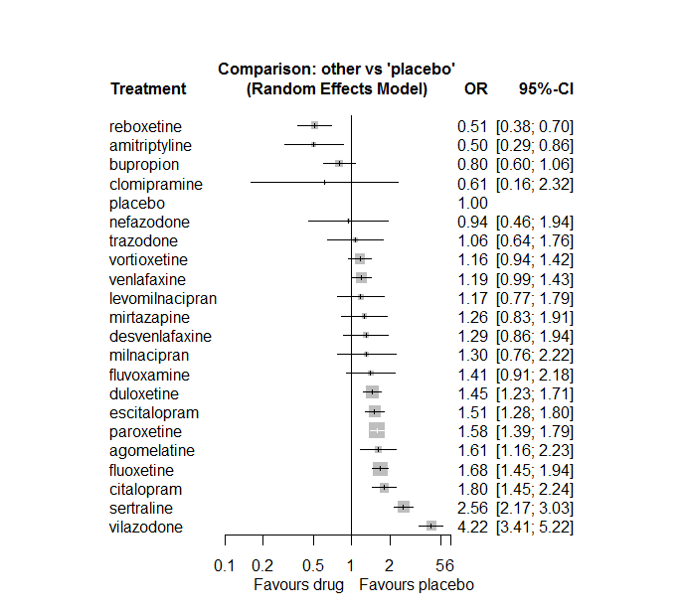

### **Ranking according to P-scores**

P-score

reboxetine 0.95

amitriptyline 0.95

bupropion 0.84

clomipramine 0.81

placebo 0.74

nefazodone 0.70

trazodone 0.65

vortioxetine 0.61

venlafaxine 0.58

levomilnacipran 0.58

mirtazapine 0.52

desvenlafaxine 0.49

milnacipran 0.48

fluvoxamine 0.41

duloxetine 0.38

escitalopram 0.33

paroxetine 0.28

agomelatine 0.28

fluoxetine 0.21

citalopram 0.16

sertraline 0.05

vilazodone 0.00

### **Local inconsistency**

Percent of comparisons where there is some evidence (p-value<0.05) of disagreement between direct and indirect sources: 0.04. (3 out of 69 comparisons)

6 agomelatine:duloxetine 0.5630 0.50 -0.42 1.55 1.1203 0.26259

7 agomelatine:escitalopram 0.1424 0.43 -0.70 0.99 0.3310 0.74063

8 agomelatine:fluoxetine 0.0991 0.58 -1.03 1.23 0.1721 0.86338

14 agomelatine:paroxetine -0.8781 0.56 -1.98 0.23 -1.5555 0.11984

15 agomelatine:placebo -0.2622 0.33 -0.92 0.39 -0.7864 0.43166

19 agomelatine:venlafaxine 0.7792 0.71 -0.62 2.18 1.0901 0.27568

28 amitriptyline:fluoxetine 2.7608 1.17 0.47 5.05 2.3661 0.01798

31 amitriptyline:milnacipran -1.1062 1.58 -4.20 1.98 -0.7016 0.48293

34 amitriptyline:paroxetine 0.6060 0.70 -0.76 1.97 0.8710 0.38377

35 amitriptyline:placebo 0.0225 0.54 -1.04 1.09 0.0413 0.96706

37 amitriptyline:sertraline -0.8941 0.55 -1.98 0.19 -1.6213 0.10496

46 bupropion:escitalopram 0.3410 0.35 -0.35 1.04 0.9613 0.33640

47 bupropion:fluoxetine 0.4649 0.32 -0.17 1.10 1.4421 0.14927

53 bupropion:paroxetine -0.2911 0.55 -1.37 0.78 -0.5307 0.59560

54 bupropion:placebo 0.0052 0.30 -0.59 0.60 0.0173 0.98623

57 bupropion:trazodone -0.7882 0.78 -2.32 0.74 -1.0081 0.31341

58 bupropion:venlafaxine -0.2908 0.47 -1.20 0.62 -0.6238 0.53276

64 citalopram:escitalopram -0.0011 0.27 -0.54 0.53 -0.0039 0.99690

65 citalopram:fluoxetine 0.4443 0.57 -0.67 1.56 0.7797 0.43557

66 citalopram:fluvoxamine -0.3000 0.59 -1.45 0.85 -0.5108 0.60949

69 citalopram:mirtazapine 0.4558 0.68 -0.87 1.78 0.6751 0.49958

71 citalopram:paroxetine -0.5894 0.38 -1.33 0.15 -1.5611 0.11851

72 citalopram:placebo -0.2815 0.22 -0.72 0.15 -1.2699 0.20412

73 citalopram:reboxetine -1.3829 0.81 -2.97 0.21 -1.7045 0.08828

74 citalopram:sertraline 1.0163 0.30 0.42 1.61 3.3599 0.00078

77 citalopram:vilazodone -0.4183 0.28 -0.98 0.14 -1.4694 0.14173

112 duloxetine:escitalopram -0.0841 0.24 -0.55 0.38 -0.3532 0.72393

113 duloxetine:fluoxetine -0.2758 0.39 -1.05 0.50 -0.6983 0.48499

119 duloxetine:paroxetine -0.1876 0.28 -0.74 0.36 -0.6699 0.50292

120 duloxetine:placebo 0.1591 0.17 -0.17 0.49 0.9412 0.34660

124 duloxetine:venlafaxine 0.1073 0.23 -0.34 0.55 0.4717 0.63711

126 duloxetine:vortioxetine 0.0062 0.23 -0.45 0.46 0.0266 0.97874

127 escitalopram:fluoxetine -0.1915 0.39 -0.96 0.58 -0.4871 0.62618

133 escitalopram:paroxetine -0.0346 0.29 -0.60 0.53 -0.1194 0.90496

134 escitalopram:placebo 0.1287 0.18 -0.22 0.47 0.7325 0.46388

136 escitalopram:sertraline -0.2591 0.31 -0.86 0.34 -0.8481 0.39636

138 escitalopram:venlafaxine -0.2785 0.39 -1.04 0.48 -0.7166 0.47362

141 fluoxetine:fluvoxamine 0.9922 0.60 -0.18 2.17 1.6545 0.09802

143 fluoxetine:milnacipran -0.0168 0.56 -1.11 1.07 -0.0303 0.97585

144 fluoxetine:mirtazapine -0.2988 1.47 -3.19 2.59 -0.2028 0.83927

146 fluoxetine:paroxetine 0.1867 0.17 -0.14 0.51 1.1181 0.26351

147 fluoxetine:placebo -0.0935 0.15 -0.38 0.20 -0.6335 0.52642

148 fluoxetine:reboxetine 0.1601 0.46 -0.74 1.06 0.3501 0.72624

149 fluoxetine:sertraline 0.0070 0.25 -0.48 0.50 0.0280 0.97770

150 fluoxetine:trazodone -0.2169 0.71 -1.62 1.18 -0.3036 0.76143

151 fluoxetine:venlafaxine -0.0151 0.20 -0.42 0.39 -0.0739 0.94106

155 fluvoxamine:milnacipran 0.2927 0.63 -0.94 1.53 0.4651 0.64186

158 fluvoxamine:paroxetine -1.0299 0.71 -2.43 0.37 -1.4442 0.14868

159 fluvoxamine:placebo 0.8492 0.52 -0.18 1.87 1.6238 0.10441

161 fluvoxamine:sertraline 0.0248 0.59 -1.14 1.19 0.0417 0.96670

179 milnacipran:paroxetine 0.0766 0.57 -1.03 1.18 0.1355 0.89225

188 mirtazapine:paroxetine 0.3660 0.45 -0.52 1.25 0.8112 0.41726

191 mirtazapine:sertraline -0.2647 0.53 -1.31 0.78 -0.4976 0.61879

197 nefazodone:placebo -0.2348 0.74 -1.69 1.22 -0.3155 0.75240

199 nefazodone:sertraline 0.2348 0.74 -1.22 1.69 0.3155 0.75240

204 paroxetine:placebo 0.0896 0.14 -0.18 0.36 0.6615 0.50832

205 paroxetine:reboxetine 0.2744 0.32 -0.36 0.91 0.8497 0.39549

206 paroxetine:sertraline -0.5419 0.24 -1.01 -0.07 -2.2492 0.02450

207 paroxetine:trazodone -0.4260 1.19 -2.76 1.91 -0.3573 0.72083

208 paroxetine:venlafaxine -0.1349 0.51 -1.14 0.87 -0.2631 0.79246

211 placebo:reboxetine -0.0683 0.37 -0.79 0.65 -0.1862 0.85232

212 placebo:sertraline -0.0432 0.17 -0.38 0.29 -0.2526 0.80055

213 placebo:trazodone 0.6901 0.53 -0.34 1.72 1.3131 0.18915

214 placebo:venlafaxine 0.1535 0.20 -0.25 0.56 0.7489 0.45393

215 placebo:vilazodone 0.5410 0.33 -0.11 1.19 1.6306 0.10298

216 placebo:vortioxetine 0.1826 0.28 -0.36 0.73 0.6596 0.50949

222 sertraline:trazodone -0.4597 0.97 -2.37 1.45 -0.4719 0.63697

223 sertraline:venlafaxine -0.5123 0.33 -1.16 0.14 -1.5394 0.12371

230 venlafaxine:vortioxetine -0.6552 0.55 -1.73 0.42 -1.1976 0.23109

### **League table**

Below we show the league table. Upper triangle: direct evidence. Lower triangle: NMA. An odds ratio larger than 1 in the upper triangle favors the column-defining drug. An odds ratio larger than 1 in the bottom triangle favors the row-defining drug.

|  |  |  |  |  |  |  |  |  |  |  |  |  |  |  |  |  |  |  |  |  |  |
| --- | --- | --- | --- | --- | --- | --- | --- | --- | --- | --- | --- | --- | --- | --- | --- | --- | --- | --- | --- | --- | --- |
| AGOM | . | . | . | . | . | 1.79 [0.72; 4.44] | 1.19 [0.56; 2.50] | 1.04 [0.36; 3.04] | . | . | . | . | . | 0.47 [0.16; 1.33] | 1.41 [0.89; 2.24] | . | . | . | 2.79 [0.72; 10.74] | . | . |
| 3.20 [1.72; 5.97] | AMIT | . | . | . | . | . | . | 4.00 [0.44; 36.72] | . | . | 0.14 [0.01; 2.73] | . | . | 0.52 [0.15; 1.77] | 0.51 [0.24; 1.08] | . | 0.13 [0.07; 0.27] | . | . | . | . |
| 2.02 [1.31; 3.10] | 0.63 [0.35; 1.15] | BUPR | . | . | . | . | 0.67 [0.37; 1.20] | 0.64 [0.39; 1.07] | . | . | . | . | . | 0.39 [0.14; 1.08] | 0.80 [0.55; 1.15] | . | . | 0.39 [0.09; 1.57] | 0.52 [0.22; 1.22] | . | . |
| 0.89 [0.61; 1.31] | 0.28 [0.16; 0.49] | 0.44 [0.31; 0.63] | CITA | . | . | . | 1.19 [0.77; 1.84] | 1.63 [0.55; 4.84] | 1.01 [0.36; 2.81] | . | . | 2.13 [0.62; 7.28] | . | 0.68 [0.34; 1.36] | 1.57 [1.16; 2.13] | 0.96 [0.20; 4.48] | 1.54 [0.91; 2.59] | . | . | 0.33 [0.21; 0.51] | . |
| 2.63 [0.67; 10.32] | 0.82 [0.20; 3.41] | 1.30 [0.33; 5.07] | 2.94 [0.77; 11.28] | CLOM | . | . | . | . | . | . | . | . | . | . | . | . | 0.24 [0.06; 0.90] | . | . | . | . |
| 1.24 [0.74; 2.09] | 0.39 [0.20; 0.76] | 0.62 [0.37; 1.01] | 1.39 [0.88; 2.20] | 0.47 [0.12; 1.90] | DESV | . | . | . | . | . | . | . | . | . | 1.29 [0.86; 1.94] | . | . | . | . | . | . |
| 1.11 [0.78; 1.57] | 0.35 [0.20; 0.60] | 0.55 [0.40; 0.76] | 1.24 [0.95; 1.62] | 0.42 [0.11; 1.61] | 0.89 [0.58; 1.38] | DULO | 0.90 [0.61; 1.34] | 0.67 [0.32; 1.41] | . | . | . | . | . | 0.78 [0.47; 1.30] | 1.55 [1.26; 1.91] | . | . | . | 1.31 [0.92; 1.87] | . | 1.26 [0.91; 1.73] |
| 1.06 [0.75; 1.51] | 0.33 [0.19; 0.58] | 0.53 [0.38; 0.72] | 1.19 [0.93; 1.53] | 0.40 [0.11; 1.54] | 0.86 [0.55; 1.33] | 0.96 [0.78; 1.18] | ESCI | 0.75 [0.36; 1.58] | . | . | . | . | . | 0.93 [0.55; 1.58] | 1.61 [1.27; 2.04] | . | 0.48 [0.28; 0.82] | . | 0.99 [0.48; 2.04] | . | . |
| 0.96 [0.68; 1.35] | 0.30 [0.17; 0.51] | 0.47 [0.35; 0.64] | 1.07 [0.84; 1.37] | 0.36 [0.10; 1.38] | 0.77 [0.50; 1.18] | 0.86 [0.71; 1.06] | 0.90 [0.73; 1.11] | FLUO | 2.71 [0.93; 7.88] | . | 1.28 [0.55; 2.99] | 1.00 [0.06; 17.36] | . | 1.19 [0.93; 1.53] | 1.61 [1.32; 1.96] | 3.76 [1.65; 8.56] | 0.66 [0.43; 1.02] | 1.32 [0.37; 4.75] | 1.40 [1.04; 1.89] | . | . |
| 1.14 [0.66; 1.97] | 0.36 [0.18; 0.71] | 0.57 [0.34; 0.95] | 1.28 [0.80; 2.04] | 0.44 [0.11; 1.76] | 0.92 [0.51; 1.67] | 1.03 [0.65; 1.64] | 1.08 [0.68; 1.71] | 1.19 [0.76; 1.87] | FLUV | . | 1.29 [0.49; 3.40] | . | . | 0.36 [0.10; 1.34] | 2.68 [1.10; 6.53] | . | 0.56 [0.20; 1.60] | . | . | . | . |
| 1.37 [0.80; 2.34] | 0.43 [0.22; 0.84] | 0.68 [0.41; 1.13] | 1.54 [0.96; 2.47] | 0.52 [0.13; 2.11] | 1.10 [0.62; 1.98] | 1.24 [0.79; 1.94] | 1.29 [0.82; 2.03] | 1.43 [0.92; 2.24] | 1.20 [0.65; 2.20] | LEVO | . | . | . | . | 1.17 [0.77; 1.79] | . | . | . | . | . | . |
| 1.23 [0.66; 2.29] | 0.39 [0.18; 0.80] | 0.61 [0.34; 1.11] | 1.38 [0.78; 2.44] | 0.47 [0.11; 1.96] | 0.99 [0.51; 1.94] | 1.11 [0.64; 1.94] | 1.16 [0.67; 2.02] | 1.29 [0.76; 2.19] | 1.08 [0.59; 1.97] | 0.90 [0.46; 1.78] | MILN | . | . | 0.87 [0.36; 2.11] | . | . | . | . | . | . | . |
| 1.28 [0.76; 2.17] | 0.40 [0.20; 0.78] | 0.63 [0.38; 1.05] | 1.44 [0.91; 2.26] | 0.49 [0.12; 1.96] | 1.03 [0.58; 1.85] | 1.16 [0.74; 1.80] | 1.21 [0.77; 1.88] | 1.34 [0.87; 2.06] | 1.12 [0.62; 2.04] | 0.93 [0.52; 1.69] | 1.04 [0.53; 2.02] | MIRT | . | 0.89 [0.54; 1.47] | . | . | 0.40 [0.16; 1.00] | . | . | . | . |
| 1.71 [0.77; 3.77] | 0.53 [0.22; 1.30] | 0.85 [0.39; 1.84] | 1.91 [0.90; 4.06] | 0.65 [0.14; 2.93] | 1.37 [0.60; 3.15] | 1.54 [0.73; 3.23] | 1.61 [0.77; 3.37] | 1.78 [0.86; 3.72] | 1.49 [0.64; 3.47] | 1.25 [0.54; 2.88] | 1.38 [0.56; 3.39] | 1.33 [0.58; 3.06] | NEFA | . | 0.83 [0.28; 2.46] | . | 0.41 [0.16; 1.06] | . | . | . | . |
| 1.02 [0.73; 1.44] | 0.32 [0.19; 0.55] | 0.51 [0.37; 0.69] | 1.14 [0.90; 1.45] | 0.39 [0.10; 1.48] | 0.82 [0.54; 1.25] | 0.92 [0.76; 1.12] | 0.96 [0.79; 1.17] | 1.07 [0.91; 1.25] | 0.89 [0.57; 1.39] | 0.74 [0.48; 1.16] | 0.83 [0.49; 1.41] | 0.80 [0.53; 1.20] | 0.60 [0.29; 1.24] | PARO | 1.62 [1.39; 1.90] | 3.45 [2.30; 5.19] | 0.40 [0.26; 0.61] | 0.99 [0.10; 9.62] | 1.16 [0.44; 3.11] | . | . |
| 1.61 [1.16; 2.23] | 0.50 [0.29; 0.86] | 0.80 [0.60; 1.06] | 1.80 [1.45; 2.24] | 0.61 [0.16; 2.32] | 1.29 [0.86; 1.94] | 1.45 [1.23; 1.71] | 1.51 [1.28; 1.80] | 1.68 [1.45; 1.94] | 1.41 [0.91; 2.18] | 1.17 [0.77; 1.79] | 1.30 [0.76; 2.22] | 1.26 [0.83; 1.91] | 0.94 [0.46; 1.94] | 1.58 [1.39; 1.79] | PLAC | 1.92 [1.35; 2.74] | 0.38 [0.30; 0.49] | 1.24 [0.65; 2.37] | 0.93 [0.67; 1.30] | 0.25 [0.20; 0.32] | 0.89 [0.71; 1.11] |
| 3.15 [2.02; 4.91] | 0.98 [0.53; 1.81] | 1.56 [1.03; 2.37] | 3.53 [2.44; 5.10] | 1.20 [0.31; 4.69] | 2.53 [1.52; 4.21] | 2.84 [2.01; 4.01] | 2.96 [2.09; 4.19] | 3.29 [2.37; 4.57] | 2.75 [1.62; 4.68] | 2.30 [1.36; 3.87] | 2.55 [1.39; 4.69] | 2.46 [1.48; 4.09] | 1.84 [0.84; 4.04] | 3.08 [2.26; 4.21] | 1.96 [1.44; 2.66] | REBO | . | . | . | . | . |
| 0.63 [0.44; 0.90] | 0.20 [0.11; 0.33] | 0.31 [0.22; 0.43] | 0.70 [0.55; 0.90] | 0.24 [0.06; 0.90] | 0.51 [0.33; 0.78] | 0.57 [0.45; 0.71] | 0.59 [0.47; 0.74] | 0.66 [0.54; 0.80] | 0.55 [0.35; 0.86] | 0.46 [0.29; 0.72] | 0.51 [0.29; 0.88] | 0.49 [0.32; 0.75] | 0.37 [0.18; 0.76] | 0.61 [0.51; 0.74] | 0.39 [0.33; 0.46] | 0.20 [0.14; 0.28] | SERT | 1.58 [0.25; 9.83] | 1.39 [0.76; 2.54] | . | . |
| 1.51 [0.83; 2.75] | 0.47 [0.23; 0.98] | 0.75 [0.43; 1.31] | 1.69 [0.98; 2.93] | 0.58 [0.14; 2.38] | 1.22 [0.64; 2.32] | 1.36 [0.81; 2.31] | 1.42 [0.84; 2.42] | 1.58 [0.94; 2.65] | 1.32 [0.68; 2.57] | 1.10 [0.57; 2.13] | 1.22 [0.59; 2.54] | 1.18 [0.61; 2.27] | 0.89 [0.37; 2.14] | 1.48 [0.88; 2.48] | 0.94 [0.57; 1.56] | 0.48 [0.27; 0.86] | 2.41 [1.42; 4.07] | TRAZ | . | . | . |
| 1.35 [0.94; 1.95] | 0.42 [0.24; 0.74] | 0.67 [0.48; 0.93] | 1.52 [1.15; 2.00] | 0.52 [0.13; 1.97] | 1.09 [0.70; 1.70] | 1.22 [0.99; 1.51] | 1.27 [1.01; 1.61] | 1.41 [1.16; 1.73] | 1.18 [0.74; 1.89] | 0.99 [0.62; 1.57] | 1.10 [0.63; 1.91] | 1.06 [0.67; 1.66] | 0.79 [0.38; 1.67] | 1.32 [1.07; 1.63] | 0.84 [0.70; 1.01] | 0.43 [0.30; 0.61] | 2.15 [1.71; 2.72] | 0.90 [0.53; 1.53] | VENL | . | 0.56 [0.20; 1.57] |
| 0.38 [0.26; 0.56] | 0.12 [0.07; 0.21] | 0.19 [0.13; 0.27] | 0.43 [0.33; 0.56] | 0.15 [0.04; 0.56] | 0.31 [0.19; 0.48] | 0.34 [0.26; 0.45] | 0.36 [0.27; 0.47] | 0.40 [0.31; 0.51] | 0.33 [0.21; 0.54] | 0.28 [0.17; 0.45] | 0.31 [0.17; 0.55] | 0.30 [0.19; 0.47] | 0.22 [0.10; 0.47] | 0.37 [0.29; 0.48] | 0.24 [0.19; 0.29] | 0.12 [0.08; 0.18] | 0.61 [0.47; 0.79] | 0.25 [0.15; 0.44] | 0.28 [0.21; 0.37] | VILA | . |
| 1.39 [0.95; 2.03] | 0.43 [0.25; 0.77] | 0.69 [0.48; 0.98] | 1.56 [1.16; 2.09] | 0.53 [0.14; 2.03] | 1.12 [0.71; 1.76] | 1.25 [1.00; 1.57] | 1.31 [1.01; 1.69] | 1.45 [1.14; 1.85] | 1.21 [0.75; 1.97] | 1.01 [0.63; 1.62] | 1.13 [0.64; 1.99] | 1.08 [0.68; 1.73] | 0.81 [0.38; 1.73] | 1.36 [1.07; 1.72] | 0.86 [0.70; 1.06] | 0.44 [0.31; 0.64] | 2.21 [1.70; 2.87] | 0.92 [0.53; 1.58] | 1.03 [0.79; 1.34] | 3.64 [2.71; 4.89] | VORT |

### **Estimated event rates**

For an event rate in placebo equal to the average event rate (i.e. fixed to 0.07) the estimated event rates for each drug are as follows

drug rate

1 agomelatine 0.11 [0.08, 0.15]

2 amitriptyline 0.04 [0.02, 0.06]

3 bupropion 0.06 [0.04, 0.08]

4 citalopram 0.12 [0.1, 0.15]

5 clomipramine 0.05 [0.01, 0.15]

6 desvenlafaxine 0.09 [0.06, 0.13]

7 duloxetine 0.1 [0.09, 0.12]

8 escitalopram 0.1 [0.09, 0.12]

9 fluoxetine 0.11 [0.1, 0.13]

10 fluvoxamine 0.1 [0.07, 0.14]

11 levomilnacipran 0.08 [0.06, 0.12]

12 milnacipran 0.09 [0.06, 0.15]

13 mirtazapine 0.09 [0.06, 0.13]

14 nefazodone 0.07 [0.03, 0.13]

15 paroxetine 0.11 [0.1, 0.12]

17 reboxetine 0.04 [0.03, 0.05]

18 sertraline 0.17 [0.14, 0.19]

19 trazodone 0.08 [0.05, 0.12]

20 venlafaxine 0.08 [0.07, 0.1]

21 vilazodone 0.25 [0.21, 0.29]

22 vortioxetine 0.08 [0.07, 0.1]

## **Sensitivity analysis: splitting nodes according to dosage**

All treatment arms for drug X, with dose_intended_min equal to or smaller to the minimum licensed dose were set as “X_L”. All other arms of X are “X_H”. Studies with no information on dose are excluded. Results shown below:

|  |  |  |
| --- | --- | --- |
| **Low dose vs. placebo** | **High dose vs. placebo** | **High dose vs. low dose** |
|  |  |  |

## **Sensitivity analysis: Keeping only low dropout arms**

We exclude all treatment arms with dropout rates larger than 25%, and we re-analyse the network.

Total number of arms included in the analysis 197. Total number of studies 93

Total events in placebo 515, out of a total of 8413 patients. Event rate placebo 0.061

Total events in drugs 1942, out of a total of 23527 patients. Event rate drugs 0.083

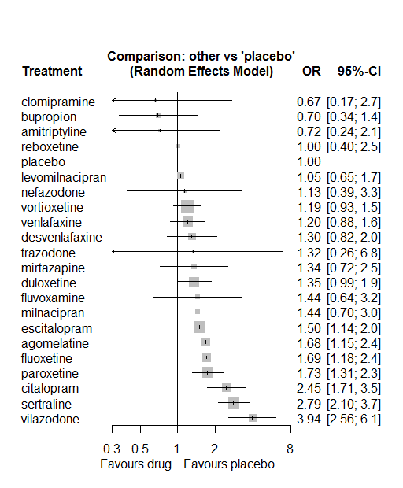

P-score

bupropion 0.87

amitriptyline 0.82

clomipramine 0.80

placebo 0.77

levomilnacipran 0.69

reboxetine 0.68

vortioxetine 0.62

venlafaxine 0.61

nefazodone 0.60

desvenlafaxine 0.54

trazodone 0.51

mirtazapine 0.51

duloxetine 0.50

fluvoxamine 0.46

milnacipran 0.46

escitalopram 0.41

agomelatine 0.32

fluoxetine 0.32

paroxetine 0.29

citalopram 0.12

sertraline 0.07

vilazodone 0.01

# **Constipation**

We remove all arms for which dose range was not “Licenced”. After this:

* Removed 17 one-arm studies: Stahl2010 (CAGO178A2302), CL3-20098-048, Roffman1982, Amsterdam1986, Carman1991, Settle1999 (WELL212), Hewett2010a (AK130940) (NCT00093288), AK1102365, Kyle1998 (Study 92032 - FDA), Lieberman2008a (Study 309)(EUCTR2004-000562-13, 3151A1-309-EU, NCT00090649), Lieberman2008b (Study 317), Masco1985, Mullin1996, Ansseau1994c, Staner1995 (063), Sacchetti2002 (BRL-29060/109), Kellams1979
* Total number of studies with number randomized being smaller than event rates: 1. Removed the following studies: Rush1998 (excluding Armitage1997 and Gillin1997).
* Total number of arms 515. Total number of studies 219.
* Total events in placebo 770, out of a total of 15409 patients. Event rate placebo 0.05.

Total events in drugs 4446, out of a total of 44128 patients. Event rate drugs 0.101

## **Distribution of dose across drugs**

Here we count the number of arms per drug, and the percent of these arms where Dose_intended_min was equal to the minimum licensed dose or lower. The values we used as minimum licensed dose are as follows:

agomelatine: 25; amitriptyline: 75; bupropion:300; citalopram:20; clomipramine:30; desvenlafaxine:50; duloxetine:40; escitalopram:10; fluoxetine:20; fluvoxamine:50; levomilnacipran:40; milnacipran:50; mirtazapine:15; nefazodone:300; paroxetine:20; reboxetine:8; sertraline:50; trazodone:150; venlafaxine:75; vilazodone:20; vortioxetine:5

Drug number.arms percent.low.dose

1 paroxetine 60 0.817

3 bupropion 20 0.900

4 sertraline 19 0.895

5 citalopram 9 0.778

6 venlafaxine 32 0.656

7 vortioxetine 24 0.458

8 fluoxetine 44 0.909

9 mirtazapine 7 0.714

10 milnacipran 11 0.091

11 amitriptyline 32 0.594

12 fluvoxamine 10 0.400

13 levomilnacipran 7 0.429

14 reboxetine 15 0.933

15 escitalopram 20 0.800

16 duloxetine 30 0.133

17 nefazodone 5 0.400

18 desvenlafaxine 11 0.545

19 agomelatine 9 0.889

20 trazodone 7 1.000

21 clomipramine 8 0.000

## **Network graph**

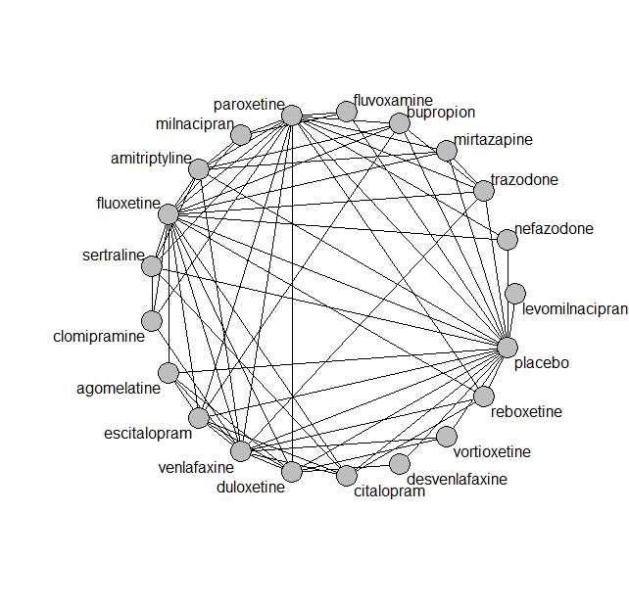

## **Pairwise MA**

### **Grouping all drugs together, comparison vs. placebo**

Number of studies: 135

Random effects meta-analysis: OR=2.02. 95% CI 1.82 to 2.24

Prediction interval 1.14 to 3.58

Heterogeneity (tau squared) was estimated to be 0.08 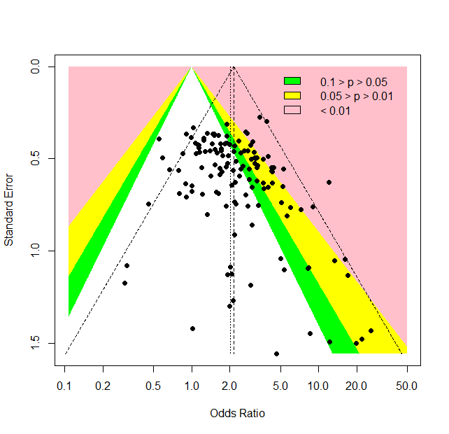

There is evidence of small-study effects or publication bias (p-value Harbord’s test 0.9)

### **Meta-analyses of comparisons with 10 or more studies**

We show results from pairwise comparisons informed by 10 studies or more. An OR larger than 1 favors the first treatment in the comparison.

comparisons Number.of.studies OR lower.CI upper.CI tau.sq I.sq

1 placebo - bupropion 13 1.40 1.11 1.8 0.00 0.00

2 placebo - duloxetine 20 2.13 1.83 2.8 0.07 0.21

3 placebo - escitalopram 10 0.97 0.69 1.4 0.17 0.30

4 placebo - fluoxetine 14 1.06 0.79 1.4 0.11 0.24

5 placebo - paroxetine 30 1.98 1.75 2.5 0.02 0.07

6 placebo - reboxetine 10 3.50 2.96 4.9 0.16 0.45

7 placebo - venlafaxine 13 2.65 2.09 3.7 0.02 0.07

8 placebo - vortioxetine 11 1.33 1.01 1.9 0.10 0.24

## **Assessment of transitivity**

comparison studies baseline_SD age_SD female

1 paroxetine - placebo 30 23 (2.7) 43 (7.6) 0.56 (0.14)

2 bupropion - placebo 13 24 (2.3) 40 (4.4) 0.52 (0.18)

3 paroxetine - sertraline 2 22 (2) 43 (NA) NaN (NA)

4 citalopram - venlafaxine 1 22 (NA) 73 (NA) NaN (NA)

5 placebo - venlafaxine 13 22 (1.9) 44 (8.4) 0.6 (0.1)

6 placebo - vortioxetine 11 23 (2) 46 (8.5) 0.64 (0.08)

7 venlafaxine - vortioxetine 2 23 (2.5) 42 (2.2) 0.61 (0.02)

8 fluoxetine - venlafaxine 6 23 (2.3) 47 (12.2) 0.6 (NA)

9 fluoxetine - mirtazapine 2 24 (1.4) 42 (7.6) NaN (NA)

10 amitriptyline - milnacipran 2 26 (1.3) 49 (0.7) 0.66 (NA)

11 fluvoxamine - milnacipran 2 24 (0.4) 49 (2) NaN (NA)

12 fluoxetine - milnacipran 2 25 (3.3) 45 (0.4) NaN (NA)

13 levomilnacipran - placebo 4 24 (1.3) 43 (1.7) 0.65 (0.02)

14 amitriptyline - placebo 8 26 (4.9) 41 (2) NaN (NA)

15 paroxetine - reboxetine 3 22 (2.1) 41 (2.7) 0.69 (0.07)

16 escitalopram - paroxetine 2 25 (2.8) 45 (0.5) NaN (NA)

17 duloxetine - placebo 20 21 (2.5) 47 (11.1) 0.64 (0.05)

18 duloxetine - vortioxetine 4 23 (3.1) 50 (13.6) 0.68 (0.04)

19 placebo - reboxetine 10 24 (3.7) 42 (2.9) 0.62 (0.08)

20 mirtazapine - paroxetine 2 22 (0) 60 (17.4) NaN (NA)

21 fluoxetine - nefazodone 1 24 (NA) 41 (NA) 0.77 (NA)

22 amitriptyline - sertraline 6 25 (2.3) 49 (11.3) 0.6 (0.11)

23 amitriptyline - paroxetine 8 25 (1.9) 48 (10) 0.85 (0.21)

24 fluoxetine - reboxetine 3 24 (1.1) 41 (2.8) 0.66 (0.05)

25 escitalopram - placebo 10 22 (2.3) 46 (14) 0.6 (0.13)

26 desvenlafaxine - placebo 7 23 (0.5) 44 (4.6) 0.69 (0.16)

27 amitriptyline - mirtazapine 2 26 (2) 38 (NA) NaN (NA)

28 mirtazapine - placebo 3 25 (3.1) 50 (16.7) 0.54 (NA)

29 citalopram - escitalopram 3 26 (3.2) 41 (3.3) 0.55 (NA)

30 citalopram - placebo 2 18 (NA) 60 (27.9) 0.58 (NA)

31 fluoxetine - placebo 14 22 (2.4) 45 (12.1) 0.63 (0.03)

32 fluvoxamine - placebo 7 23 (2.3) 41 (2.4) NaN (NA)

33 amitriptyline - bupropion 1 23 (NA) 37 (NA) NaN (NA)

34 amitriptyline - fluoxetine 7 24 (1.7) 45 (10.7) 0.65 (0.1)

35 fluoxetine - paroxetine 4 22 (1) 41 (1.8) NaN (NA)

36 agomelatine - duloxetine 1 26 (NA) 43 (NA) NaN (NA)

37 bupropion - escitalopram 2 24 (NA) 36 (0.6) NaN (NA)

38 bupropion - fluoxetine 3 23 (2.2) 39 (2.7) NaN (NA)

39 agomelatine - escitalopram 1 27 (NA) 43 (NA) 0.71 (NA)

40 placebo - sertraline 6 22 (2.4) 40 (3.2) 0.6 (0.1)

41 placebo - trazodone 3 22 (0.5) 49 (11.5) 0.61 (0.06)

42 trazodone - venlafaxine 1 22 (NA) 41 (NA) 0.66 (NA)

43 fluoxetine - trazodone 2 22 (0.7) 53 (21.9) NaN (NA)

44 duloxetine - paroxetine 5 20 (1.7) 42 (2.7) NaN (NA)

45 citalopram - sertraline 2 26 (4.9) 44 (4.9) NaN (NA)

46 fluoxetine - sertraline 2 23 (2.7) 43 (0.1) NaN (NA)

47 nefazodone - placebo 3 26 (2) 42 (2.8) 0.65 (0.04)

48 amitriptyline - venlafaxine 2 21 (0) 43 (6.2) NaN (NA)

49 clomipramine - fluoxetine 3 25 (4.5) 47 (2.8) 0.67 (0.05)

50 duloxetine - fluoxetine 2 18 (0.2) 41 (0.6) NaN (NA)

51 agomelatine - fluoxetine 1 28 (NA) 42 (NA) 0.78 (NA)

52 mirtazapine - trazodone 1 22 (NA) 62 (NA) 0.54 (NA)

53 agomelatine - placebo 3 27 (0) 54 (15.9) 0.68 (0.02)

54 nefazodone - paroxetine 1 NaN (NA) 43 (NA) 0.43 (NA)

55 milnacipran - paroxetine 1 22 (NA) 36 (NA) 0.53 (NA)

56 escitalopram - fluoxetine 2 22 (NA) 56 (26.8) NaN (NA)

57 duloxetine - escitalopram 3 20 (2.5) 43 (0.9) NaN (NA)

58 fluvoxamine - paroxetine 1 21 (NA) 41 (NA) NaN (NA)

59 agomelatine - venlafaxine 1 26 (NA) 40 (NA) 0.71 (NA)

60 clomipramine - sertraline 2 27 (4.6) 43 (1) 0.6 (0.14)

61 paroxetine - venlafaxine 1 23 (NA) 44 (NA) NaN (NA)

62 escitalopram - venlafaxine 1 20 (NA) 48 (NA) NaN (NA)

63 citalopram - fluoxetine 1 23 (NA) 44 (NA) NaN (NA)

64 duloxetine - venlafaxine 2 23 (0.5) 43 (1.4) 0.68 (0.03)

65 clomipramine - paroxetine 2 24 (1.1) 57 (20.3) 0.81 (0.12)

66 clomipramine - venlafaxine 1 25 (NA) 47 (NA) NaN (NA)

67 reboxetine - venlafaxine 1 29 (NA) 42 (NA) 0.69 (NA)

68 citalopram - reboxetine 1 24 (NA) 42 (NA) 0.64 (NA)

69 desvenlafaxine - duloxetine 1 23 (NA) 40 (NA) NaN (NA)

70 paroxetine - trazodone 1 24 (NA) 39 (NA) NaN (NA)

71 bupropion - trazodone 1 22 (NA) 40 (NA) NaN (NA)

72 bupropion - paroxetine 1 22 (NA) 37 (NA) NaN (NA)

## **NMA**

A total of 21 treatments are included in the network.

A total of 219 studies are included in this analysis.

Estimated heterogeneity tau-squared 0.02

Global test for inconsistency, p-value 0.06269 (Q=102, d.o.f.82)

### **Comparison vs. placebo**

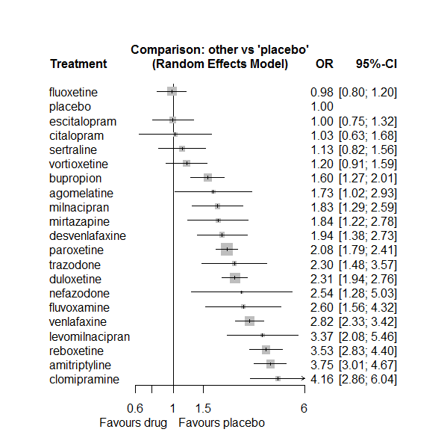

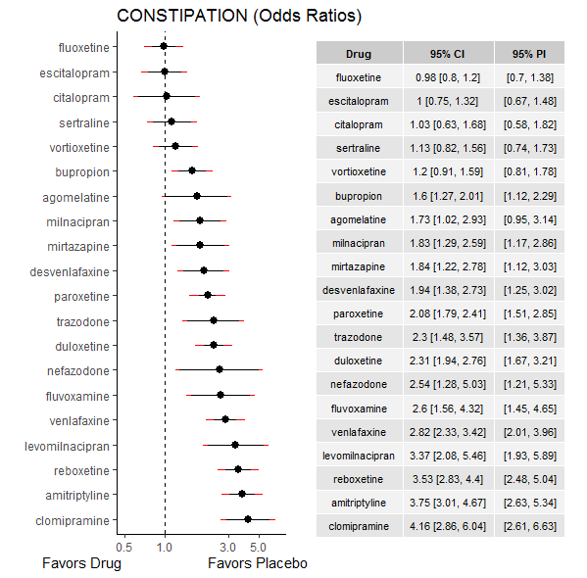

### **Ranking according to P-scores**

P-score

fluoxetine 0.92

placebo 0.91

escitalopram 0.90

citalopram 0.87

sertraline 0.82

vortioxetine 0.79

bupropion 0.64

agomelatine 0.58

milnacipran 0.55

mirtazapine 0.54

desvenlafaxine 0.50

paroxetine 0.46

trazodone 0.38

duloxetine 0.37

nefazodone 0.33

fluvoxamine 0.30

venlafaxine 0.24

levomilnacipran 0.15

reboxetine 0.11

amitriptyline 0.08

clomipramine 0.05

### **Local inconsistency**

Percent of comparisons where there is some evidence (p-value<0.05) of disagreement between direct and indirect sources: 0.07. (5 out of 71 comparisons)

comparison TE seTE lower upper z p

6 agomelatine:duloxetine -1.2400 0.62 -2.462 -0.018 -1.989 0.0467

7 agomelatine:escitalopram 1.1235 0.86 -0.566 2.813 1.304 0.1923

8 agomelatine:fluoxetine 0.5692 0.76 -0.921 2.059 0.749 0.4541

15 agomelatine:placebo -0.1059 0.58 -1.247 1.035 -0.182 0.8557

19 agomelatine:venlafaxine 0.4408 0.66 -0.857 1.739 0.666 0.5057

21 amitriptyline:bupropion -0.2607 0.45 -1.142 0.621 -0.580 0.5621

27 amitriptyline:fluoxetine 0.4421 0.31 -0.157 1.042 1.446 0.1483

30 amitriptyline:milnacipran -0.4039 0.38 -1.150 0.343 -1.060 0.2890

31 amitriptyline:mirtazapine 0.3873 0.48 -0.563 1.338 0.799 0.4244

33 amitriptyline:paroxetine -0.0758 0.24 -0.552 0.400 -0.312 0.7549

34 amitriptyline:placebo 0.0351 0.24 -0.441 0.511 0.144 0.8852

36 amitriptyline:sertraline -0.3177 0.33 -0.958 0.323 -0.972 0.3308

38 amitriptyline:venlafaxine 0.3115 0.41 -0.489 1.112 0.763 0.4457

44 bupropion:escitalopram 0.8447 0.45 -0.044 1.733 1.863 0.0625

45 bupropion:fluoxetine 0.5145 0.37 -0.208 1.237 1.395 0.1629

51 bupropion:paroxetine 0.0974 0.66 -1.197 1.392 0.147 0.8828

52 bupropion:placebo -0.6122 0.29 -1.171 -0.053 -2.146 0.0318

55 bupropion:trazodone 0.1830 0.66 -1.112 1.478 0.277 0.7818

61 citalopram:escitalopram 0.2777 0.57 -0.838 1.394 0.488 0.6258

62 citalopram:fluoxetine -1.2260 0.88 -2.951 0.499 -1.393 0.1636

69 citalopram:placebo 1.3973 0.58 0.258 2.536 2.404 0.0162

70 citalopram:reboxetine -0.6223 0.64 -1.867 0.623 -0.980 0.3273

71 citalopram:sertraline -0.4247 0.64 -1.676 0.827 -0.665 0.5060

73 citalopram:venlafaxine 0.0739 0.91 -1.705 1.853 0.081 0.9351

78 clomipramine:fluoxetine 0.2827 0.49 -0.674 1.239 0.579 0.5624

84 clomipramine:paroxetine -0.3332 0.37 -1.064 0.397 -0.894 0.3713

87 clomipramine:sertraline 0.4174 0.61 -0.781 1.616 0.683 0.4948

89 clomipramine:venlafaxine 0.0234 0.49 -0.943 0.990 0.047 0.9622

91 desvenlafaxine:duloxetine -0.5953 0.43 -1.445 0.255 -1.373 0.1698

100 desvenlafaxine:placebo 0.7787 0.50 -0.197 1.755 1.564 0.1179

106 duloxetine:escitalopram -0.7791 0.32 -1.406 -0.152 -2.436 0.0148

107 duloxetine:fluoxetine -0.6390 0.56 -1.731 0.453 -1.146 0.2516

113 duloxetine:paroxetine 0.2540 0.23 -0.195 0.703 1.108 0.2681

114 duloxetine:placebo -0.2182 0.18 -0.569 0.133 -1.219 0.2230

118 duloxetine:venlafaxine 0.0421 0.23 -0.415 0.500 0.180 0.8570

119 duloxetine:vortioxetine 0.4441 0.30 -0.139 1.027 1.493 0.1354

120 escitalopram:fluoxetine -0.8156 0.52 -1.844 0.213 -1.555 0.1201

126 escitalopram:paroxetine -0.1923 0.42 -1.010 0.626 -0.461 0.6450

127 escitalopram:placebo -0.0096 0.29 -0.570 0.551 -0.034 0.9732

131 escitalopram:venlafaxine -0.4264 0.83 -2.051 1.198 -0.515 0.6069

135 fluoxetine:milnacipran 0.4142 0.46 -0.492 1.320 0.896 0.3702

136 fluoxetine:mirtazapine -0.1663 0.57 -1.274 0.942 -0.294 0.7686

137 fluoxetine:nefazodone -0.0665 0.97 -1.960 1.827 -0.069 0.9451

138 fluoxetine:paroxetine -0.3582 0.28 -0.910 0.194 -1.272 0.2035

139 fluoxetine:placebo 0.0858 0.21 -0.320 0.492 0.414 0.6785

140 fluoxetine:reboxetine 0.0927 0.32 -0.534 0.719 0.290 0.7718

141 fluoxetine:sertraline -0.0716 0.75 -1.534 1.391 -0.096 0.9236

142 fluoxetine:trazodone -0.2820 0.86 -1.977 1.413 -0.326 0.7444

143 fluoxetine:venlafaxine 0.0760 0.25 -0.415 0.567 0.303 0.7616

146 fluvoxamine:milnacipran -0.5898 0.56 -1.688 0.509 -1.052 0.2927

149 fluvoxamine:paroxetine -1.0800 0.96 -2.960 0.800 -1.126 0.2602

150 fluvoxamine:placebo 0.8686 0.53 -0.177 1.914 1.628 0.1035

168 milnacipran:paroxetine -0.3261 0.35 -1.005 0.352 -0.942 0.3461

176 mirtazapine:paroxetine 0.3302 0.42 -0.494 1.154 0.785 0.4322

177 mirtazapine:placebo -0.2095 0.47 -1.131 0.712 -0.446 0.6557

180 mirtazapine:trazodone -0.2055 0.62 -1.415 1.004 -0.333 0.7391

183 nefazodone:paroxetine -1.5432 1.27 -4.024 0.938 -1.219 0.2228

184 nefazodone:placebo 0.6015 0.82 -1.008 2.211 0.732 0.4639

190 paroxetine:placebo -0.1087 0.15 -0.411 0.193 -0.705 0.4806

191 paroxetine:reboxetine -0.4008 0.23 -0.859 0.058 -1.713 0.0868

192 paroxetine:sertraline 0.7508 0.39 -0.010 1.512 1.933 0.0532

193 paroxetine:trazodone -0.3658 0.55 -1.441 0.709 -0.667 0.5048

194 paroxetine:venlafaxine -0.1123 0.43 -0.953 0.729 -0.262 0.7936

196 placebo:reboxetine -0.0487 0.23 -0.500 0.402 -0.212 0.8323

197 placebo:sertraline -0.5715 0.35 -1.253 0.110 -1.643 0.1004

198 placebo:trazodone -0.1515 0.45 -1.042 0.739 -0.333 0.7390

199 placebo:venlafaxine 0.1092 0.20 -0.283 0.501 0.546 0.5852

200 placebo:vortioxetine -0.2927 0.31 -0.904 0.319 -0.938 0.3481

203 reboxetine:venlafaxine -1.6092 0.58 -2.741 -0.477 -2.786 0.0053

208 trazodone:venlafaxine -0.9886 0.57 -2.109 0.132 -1.729 0.0837

210 venlafaxine:vortioxetine 0.1976 0.40 -0.588 0.983 0.493 0.6219

### **League table**

Below we show the league table. Upper triangle: direct evidence. Lower triangle: NMA. An odds ratio larger than 1 in the upper triangle favors the column-defining drug. An odds ratio larger than 1 in the bottom triangle favors the row-defining drug.

|  |  |  |  |  |  |  |  |  |  |  |  |  |  |  |  |  |  |  |  |  |
| --- | --- | --- | --- | --- | --- | --- | --- | --- | --- | --- | --- | --- | --- | --- | --- | --- | --- | --- | --- | --- |
| AGOM | . | . | . | . | . | 0.30 [0.10; 0.85] | 4.59 [0.95; 22.10] | 2.84 [0.72; 11.14] | . | . | . | . | . | . | 1.61 [0.62; 4.15] | . | . | . | 0.86 [0.27; 2.71] | . |
| 0.46 [0.26; 0.81] | AMIT | 1.87 [0.82; 4.25] | . | . | . | . | . | 5.37 [3.17; 9.07] | . | . | 1.58 [0.87; 2.88] | 2.68 [1.20; 6.00] | . | 1.71 [1.16; 2.54] | 3.84 [2.58; 5.72] | . | 2.89 [1.89; 4.40] | . | 1.74 [0.82; 3.69] | . |
| 1.08 [0.61; 1.91] | 2.34 [1.74; 3.16] | BUPR | . | . | . | . | 3.19 [1.43; 7.12] | 2.47 [1.29; 4.73] | . | . | . | . | . | 0.85 [0.24; 3.00] | 1.41 [1.09; 1.82] | . | . | 0.81 [0.25; 2.66] | . | . |
| 1.68 [0.82; 3.43] | 3.65 [2.16; 6.17] | 1.56 [0.91; 2.67] | CITA | . | . | . | 1.24 [0.50; 3.08] | 0.35 [0.07; 1.78] | . | . | . | . | . | . | 2.92 [1.09; 7.82] | 0.18 [0.06; 0.54] | 0.66 [0.23; 1.95] | . | 0.39 [0.07; 2.12] | . |
| 0.42 [0.22; 0.78] | 0.90 [0.60; 1.35] | 0.39 [0.25; 0.59] | 0.25 [0.13; 0.45] | CLOM | . | . | . | 5.30 [2.26; 12.42] | . | . | . | . | . | 1.74 [1.09; 2.79] | . | . | 5.19 [1.74; 15.46] | . | 1.50 [0.63; 3.55] | . |
| 0.89 [0.48; 1.66] | 1.93 [1.29; 2.88] | 0.82 [0.55; 1.24] | 0.53 [0.29; 0.96] | 2.14 [1.29; 3.53] | DESV | 0.54 [0.26; 1.12] | . | . | . | . | . | . | . | . | 2.17 [1.50; 3.13] | . | . | . | . | . |
| 0.75 [0.44; 1.27] | 1.62 [1.24; 2.11] | 0.69 [0.52; 0.92] | 0.44 [0.27; 0.74] | 1.80 [1.21; 2.67] | 0.84 [0.58; 1.21] | DULO | 1.40 [0.84; 2.32] | 1.29 [0.45; 3.73] | . | . | . | . | . | 1.34 [0.91; 1.95] | 2.10 [1.67; 2.65] | . | . | . | 0.84 [0.58; 1.22] | 2.39 [1.60; 3.58] |
| 1.73 [0.98; 3.08] | 3.76 [2.67; 5.30] | 1.61 [1.14; 2.27] | 1.03 [0.61; 1.74] | 4.17 [2.65; 6.56] | 1.95 [1.26; 3.01] | 2.32 [1.72; 3.13] | ESCI | 0.49 [0.19; 1.30] | . | . | . | . | . | 0.41 [0.19; 0.87] | 0.99 [0.67; 1.48] | . | . | . | 0.23 [0.05; 1.15] | . |
| 1.76 [1.02; 3.04] | 3.82 [2.97; 4.93] | 1.63 [1.23; 2.17] | 1.05 [0.63; 1.75] | 4.24 [2.87; 6.25] | 1.98 [1.34; 2.93] | 2.36 [1.85; 3.01] | 1.02 [0.74; 1.41] | FLUO | . | . | 0.75 [0.33; 1.67] | 0.46 [0.17; 1.27] | 0.37 [0.06; 2.06] | 0.35 [0.21; 0.58] | 1.03 [0.76; 1.41] | 0.30 [0.17; 0.51] | 0.81 [0.20; 3.34] | 0.33 [0.06; 1.67] | 0.36 [0.25; 0.54] | . |
| 0.67 [0.32; 1.38] | 1.44 [0.84; 2.48] | 0.62 [0.35; 1.07] | 0.40 [0.20; 0.80] | 1.60 [0.86; 2.98] | 0.75 [0.41; 1.38] | 0.89 [0.52; 1.52] | 0.38 [0.22; 0.68] | 0.38 [0.22; 0.65] | FLUV | . | 1.01 [0.44; 2.33] | . | . | 0.46 [0.08; 2.81] | 3.63 [1.90; 6.95] | . | . | . | . | . |
| 0.51 [0.25; 1.05] | 1.11 [0.66; 1.89] | 0.48 [0.28; 0.81] | 0.30 [0.15; 0.61] | 1.23 [0.67; 2.27] | 0.58 [0.32; 1.04] | 0.69 [0.41; 1.15] | 0.30 [0.17; 0.52] | 0.29 [0.17; 0.49] | 0.77 [0.38; 1.55] | LEVO | . | . | . | . | 3.37 [2.08; 5.46] | . | . | . | . | . |
| 0.95 [0.51; 1.77] | 2.05 [1.44; 2.94] | 0.88 [0.58; 1.32] | 0.56 [0.31; 1.02] | 2.28 [1.40; 3.70] | 1.06 [0.66; 1.73] | 1.27 [0.87; 1.85] | 0.55 [0.35; 0.84] | 0.54 [0.37; 0.77] | 1.42 [0.83; 2.44] | 1.85 [1.02; 3.35] | MILN | . | . | 0.74 [0.45; 1.21] | . | . | . | . | . | . |
| 0.94 [0.48; 1.82] | 2.03 [1.33; 3.12] | 0.87 [0.55; 1.38] | 0.56 [0.30; 1.05] | 2.26 [1.32; 3.85] | 1.05 [0.62; 1.80] | 1.26 [0.81; 1.94] | 0.54 [0.33; 0.88] | 0.53 [0.35; 0.82] | 1.41 [0.74; 2.69] | 1.83 [0.97; 3.45] | 0.99 [0.59; 1.66] | MIRT | . | 1.08 [0.57; 2.01] | 1.58 [0.72; 3.47] | . | . | 0.70 [0.25; 1.91] | . | . |
| 0.68 [0.29; 1.61] | 1.48 [0.72; 3.02] | 0.63 [0.31; 1.30] | 0.40 [0.17; 0.94] | 1.64 [0.75; 3.56] | 0.77 [0.36; 1.64] | 0.91 [0.45; 1.84] | 0.39 [0.19; 0.82] | 0.39 [0.19; 0.78] | 1.02 [0.44; 2.40] | 1.33 [0.58; 3.07] | 0.72 [0.34; 1.54] | 0.73 [0.33; 1.61] | NEFA | 0.30 [0.03; 3.20] | 2.93 [1.34; 6.40] | . | . | . | . | . |
| 0.83 [0.49; 1.43] | 1.81 [1.45; 2.25] | 0.77 [0.59; 1.00] | 0.49 [0.30; 0.82] | 2.00 [1.40; 2.87] | 0.94 [0.65; 1.35] | 1.11 [0.91; 1.37] | 0.48 [0.36; 0.65] | 0.47 [0.38; 0.59] | 1.25 [0.75; 2.10] | 1.62 [0.98; 2.69] | 0.88 [0.63; 1.23] | 0.89 [0.59; 1.33] | 1.22 [0.61; 2.45] | PARO | 1.98 [1.61; 2.42] | 0.48 [0.34; 0.66] | 3.26 [1.68; 6.35] | 0.68 [0.26; 1.75] | 0.66 [0.29; 1.49] | . |
| 1.73 [1.02; 2.93] | 3.75 [3.01; 4.67] | 1.60 [1.27; 2.01] | 1.03 [0.63; 1.68] | 4.16 [2.86; 6.04] | 1.94 [1.38; 2.73] | 2.31 [1.94; 2.76] | 1.00 [0.75; 1.32] | 0.98 [0.80; 1.20] | 2.60 [1.56; 4.32] | 3.37 [2.08; 5.46] | 1.83 [1.29; 2.59] | 1.84 [1.22; 2.78] | 2.54 [1.28; 5.03] | 2.08 [1.79; 2.41] | PLAC | 0.28 [0.21; 0.37] | 0.60 [0.34; 1.05] | 0.40 [0.20; 0.78] | 0.38 [0.28; 0.51] | 0.76 [0.55; 1.07] |
| 0.49 [0.28; 0.86] | 1.06 [0.79; 1.42] | 0.45 [0.33; 0.62] | 0.29 [0.17; 0.49] | 1.18 [0.78; 1.78] | 0.55 [0.37; 0.82] | 0.66 [0.50; 0.86] | 0.28 [0.20; 0.40] | 0.28 [0.21; 0.36] | 0.73 [0.42; 1.27] | 0.95 [0.56; 1.62] | 0.52 [0.35; 0.77] | 0.52 [0.33; 0.82] | 0.72 [0.35; 1.47] | 0.59 [0.47; 0.74] | 0.28 [0.23; 0.35] | REBO | . | . | 0.28 [0.09; 0.83] | . |
| 1.53 [0.83; 2.81] | 3.31 [2.41; 4.55] | 1.41 [0.96; 2.08] | 0.91 [0.53; 1.57] | 3.67 [2.34; 5.77] | 1.72 [1.08; 2.73] | 2.05 [1.44; 2.91] | 0.88 [0.58; 1.33] | 0.87 [0.61; 1.23] | 2.29 [1.27; 4.15] | 2.98 [1.67; 5.31] | 1.61 [1.04; 2.51] | 1.63 [0.99; 2.68] | 2.24 [1.06; 4.76] | 1.83 [1.33; 2.53] | 0.88 [0.64; 1.22] | 3.12 [2.15; 4.53] | SERT | . | . | . |
| 0.75 [0.38; 1.48] | 1.63 [1.01; 2.63] | 0.70 [0.43; 1.12] | 0.45 [0.23; 0.86] | 1.81 [1.03; 3.18] | 0.85 [0.49; 1.47] | 1.01 [0.63; 1.60] | 0.43 [0.26; 0.73] | 0.43 [0.27; 0.68] | 1.13 [0.58; 2.20] | 1.47 [0.76; 2.82] | 0.79 [0.46; 1.38] | 0.80 [0.46; 1.40] | 1.10 [0.49; 2.49] | 0.90 [0.58; 1.41] | 0.44 [0.28; 0.68] | 1.54 [0.95; 2.49] | 0.49 [0.29; 0.84] | TRAZ | 0.38 [0.14; 1.01] | . |
| 0.61 [0.36; 1.05] | 1.33 [1.02; 1.73] | 0.57 [0.42; 0.76] | 0.36 [0.22; 0.61] | 1.47 [1.00; 2.18] | 0.69 [0.47; 1.01] | 0.82 [0.66; 1.02] | 0.35 [0.26; 0.49] | 0.35 [0.27; 0.44] | 0.92 [0.54; 1.58] | 1.19 [0.71; 2.01] | 0.65 [0.44; 0.95] | 0.65 [0.42; 1.01] | 0.90 [0.44; 1.82] | 0.74 [0.59; 0.91] | 0.35 [0.29; 0.43] | 1.25 [0.95; 1.65] | 0.40 [0.28; 0.57] | 0.81 [0.51; 1.29] | VENL | 2.76 [1.37; 5.58] |
| 1.44 [0.80; 2.59] | 3.13 [2.21; 4.43] | 1.34 [0.93; 1.91] | 0.86 [0.49; 1.50] | 3.47 [2.19; 5.48] | 1.62 [1.05; 2.50] | 1.93 [1.44; 2.58] | 0.83 [0.57; 1.22] | 0.82 [0.59; 1.14] | 2.17 [1.21; 3.86] | 2.81 [1.61; 4.91] | 1.52 [0.98; 2.37] | 1.54 [0.94; 2.52] | 2.12 [1.01; 4.43] | 1.73 [1.27; 2.36] | 0.83 [0.63; 1.10] | 2.95 [2.07; 4.19] | 0.94 [0.62; 1.44] | 1.92 [1.14; 3.21] | 2.36 [1.72; 3.22] | VORT |

### **Estimated event rates**

For an event rate in placebo equal to the average event rate (i.e. fixed to 0.05) the estimated event rates for each drug are as follows

drug rate

1 agomelatine 0.08 [0.05, 0.13]

2 amitriptyline 0.16 [0.14, 0.2]

3 bupropion 0.08 [0.06, 0.1]

4 citalopram 0.05 [0.03, 0.08]

5 clomipramine 0.18 [0.13, 0.24]

6 desvenlafaxine 0.09 [0.07, 0.13]

7 duloxetine 0.11 [0.09, 0.13]

8 escitalopram 0.05 [0.04, 0.06]

9 fluoxetine 0.05 [0.04, 0.06]

10 fluvoxamine 0.12 [0.08, 0.19]

11 levomilnacipran 0.15 [0.1, 0.22]

12 milnacipran 0.09 [0.06, 0.12]

13 mirtazapine 0.09 [0.06, 0.13]

14 nefazodone 0.12 [0.06, 0.21]

15 paroxetine 0.1 [0.09, 0.11]

17 reboxetine 0.16 [0.13, 0.19]

18 sertraline 0.06 [0.04, 0.08]

19 trazodone 0.11 [0.07, 0.16]

20 venlafaxine 0.13 [0.11, 0.15]

21 vortioxetine 0.06 [0.05, 0.08]

## **Sensitivity analysis: splitting nodes according to dosage**

All treatment arms for drug X, with dose_intended_min equal to or smaller to the minimum licensed dose were set as “X_L”. All other arms of X are “X_H”. Studies with no information on dose are excluded. Results shown below:

|  |  |  |
| --- | --- | --- |
| **Low dose vs. placebo** | **High dose vs. placebo** | **High dose vs. low dose** |
|  |  |  |

## **Sensitivity analysis: Keeping only low dropout arms**

We exclude all treatment arms with dropout rates larger than 25%, and we re-analyse the network.

Total number of arms included in the analysis 165. Total number of studies 79

Total events in placebo 236, out of a total of 6319 patients. Event rate placebo 0.037

Total events in drugs 1576, out of a total of 19145 patients. Event rate drugs 0.082

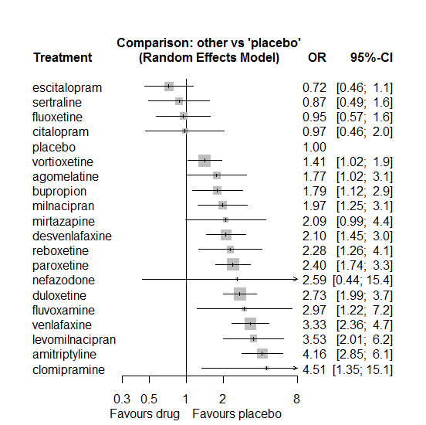

P-score

escitalopram 0.95

sertraline 0.89

fluoxetine 0.86

placebo 0.84

citalopram 0.83

vortioxetine 0.69

agomelatine 0.57

bupropion 0.56

milnacipran 0.51

desvenlafaxine 0.47

mirtazapine 0.47

reboxetine 0.41

nefazodone 0.39

paroxetine 0.38

duloxetine 0.30

fluvoxamine 0.28

venlafaxine 0.18

levomilnacipran 0.18

clomipramine 0.15

amitriptyline 0.09

# **Fatigue**

We remove all arms for which dose range was not “Licenced”. After this:

* Removed 16 one-arm studies: Kennedy2006 (CL3-20098-043), Roffman1982, Hewett2010a (AK130940) (NCT00093288), Kavoussi1997, Kyle1998 (Study 92032 - FDA), Lieberman2008a (Study 309)(EUCTR2004-000562-13, 3151A1-309-EU, NCT00090649), Lieberman2008b (Study 317), Chouinard1985, Masco1985, Lydiard1989, Hutchinson1992, Miura2000, Sacchetti2002 (BRL-29060/109), Study 032a (CTN032-FCE20124), Kellams1979, Allard2004
* Total number of studies with number randomized being smaller than event rates: 1. Removed the following studies: Rush1998 (excluding Armitage1997 and Gillin1997).
* Total number of arms 455. Total number of studies 190.
* Total events in placebo 685, out of a total of 14587 patients. Event rate placebo 0.047.
* Total events in drugs 3278, out of a total of 40406 patients. Event rate drugs 0.081

## **Distribution of dose across drugs**

Here we count the number of arms per drug, and the percent of these arms where Dose_intended_min was equal to the minimum licensed dose or lower. The values we used as minimum licensed dose are as follows:

agomelatine: 25; amitriptyline: 75; bupropion:300; citalopram:20; clomipramine:30; desvenlafaxine:50; duloxetine:40; escitalopram:10; fluoxetine:20; fluvoxamine:50; levomilnacipran:40; milnacipran:50; mirtazapine:15; nefazodone:300; paroxetine:20; reboxetine:8; sertraline:50; trazodone:150; venlafaxine:75; vilazodone:20; vortioxetine:5

Drug number.arms percent.low.dose

1 agomelatine 9 0.78

2 escitalopram 26 0.81

3 paroxetine 62 0.81

4 fluoxetine 40 0.92

5 sertraline 22 0.91

7 vortioxetine 25 0.44

8 venlafaxine 21 0.67

9 nefazodone 6 0.50

10 reboxetine 12 0.92

11 duloxetine 28 0.14

12 trazodone 7 1.00

13 mirtazapine 9 0.78

14 amitriptyline 15 0.60

15 desvenlafaxine 8 0.50

16 citalopram 14 0.64

17 bupropion 12 0.92

18 fluvoxamine 8 0.50

19 milnacipran 3 0.00

20 vilazodone 3 0.33

21 clomipramine 1 0.00

## **Network graph**

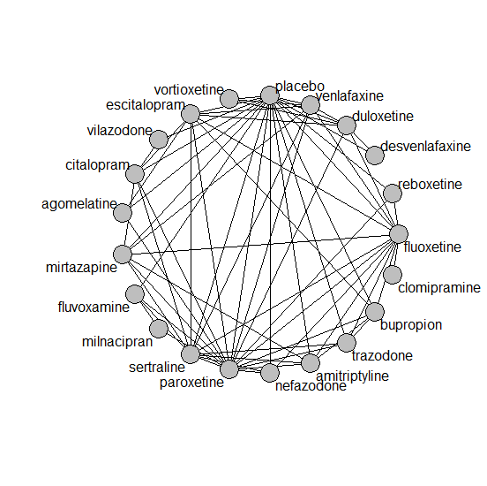

## **Pairwise MA**

### **Grouping all drugs together, comparison vs. placebo**

Number of studies: 123

Random effects meta-analysis: OR=1.7. 95% CI 1.53 to 1.88

Prediction interval 1.12 to 2.57

Heterogeneity (tau squared) was estimated to be 0.04 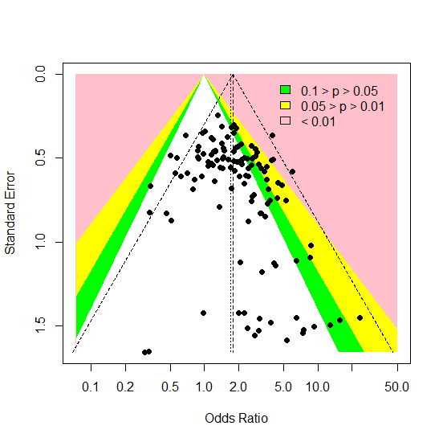

A visual inspection provides some evidence of small-study effects or publication bias, but the p-value Harbords’s test is 0.3.

### **Meta-analyses of comparisons with 10 or more studies**

We show results from pairwise comparisons informed by 10 studies or more. An OR larger than 1 favors the first treatment in the comparison.

comparisons Number.of.studies OR lower.CI upper.CI tau.sq I.sq

1 placebo - duloxetine 19 2.24 1.79 2.93 0.13 0.29

2 placebo - escitalopram 13 1.50 1.19 2.14 0.25 0.44

3 placebo - fluoxetine 17 1.70 1.37 2.20 0.02 0.07

4 placebo - paroxetine 31 2.12 1.83 2.63 0.06 0.18

5 placebo - venlafaxine 10 1.92 1.43 2.74 0.00 0.00

6 placebo - vortioxetine 12 1.01 0.78 1.51 0.05 0.12

## **Assessment of transitivity**

comparison studies baseline_SD age_SD female

1 agomelatine - escitalopram 2 26 (0.7) 42 (1.3) 0.71 (NA)

2 fluoxetine - paroxetine 8 23 (1.8) 46 (11.5) NaN (NA)

3 paroxetine - sertraline 2 22 (2) 43 (NA) NaN (NA)

4 escitalopram - placebo 13 21 (2.4) 42 (8.3) 0.57 (0.13)

5 escitalopram - sertraline 2 20 (0.5) 40 (0.5) NaN (NA)

6 placebo - sertraline 7 22 (3.8) 45 (11.3) 0.55 (0.06)

7 placebo - venlafaxine 10 22 (1.4) 44 (9.6) 0.62 (0.07)

8 placebo - vortioxetine 12 24 (1.9) 46 (8.1) 0.64 (0.07)

9 venlafaxine - vortioxetine 1 22 (NA) 43 (NA) 0.62 (NA)

10 nefazodone - paroxetine 2 25 (NA) 40 (3.4) 0.49 (0.09)

11 paroxetine - reboxetine 3 22 (2.1) 41 (2.7) 0.69 (0.07)

12 escitalopram - paroxetine 1 23 (NA) 45 (NA) NaN (NA)

13 duloxetine - placebo 19 21 (2.6) 46 (9.4) 0.65 (0.05)

14 duloxetine - vortioxetine 5 23 (2.4) 50 (11.8) 0.67 (0.04)

15 placebo - reboxetine 9 24 (3.9) 42 (3.1) 0.62 (0.09)

16 fluoxetine - trazodone 2 21 (1.1) 54 (20) 0.67 (NA)

17 mirtazapine - sertraline 1 NaN (NA) 42 (NA) NaN (NA)

18 mirtazapine - paroxetine 3 23 (1.2) 53 (16.7) NaN (NA)

19 fluoxetine - nefazodone 1 24 (NA) 41 (NA) 0.77 (NA)

20 amitriptyline - sertraline 4 24 (2.9) 49 (14.6) 0.56 (0.11)

21 escitalopram - venlafaxine 2 20 (0.4) 43 (7.5) NaN (NA)

22 amitriptyline - paroxetine 5 26 (0) 47 (2.5) 0.8 (0.25)

23 fluoxetine - reboxetine 3 24 (1.1) 41 (2.8) 0.66 (0.05)

24 desvenlafaxine - placebo 5 23 (0.4) 42 (2.3) 0.63 (0.06)

25 amitriptyline - mirtazapine 1 28 (NA) 38 (NA) NaN (NA)

26 amitriptyline - placebo 4 25 (2.8) 40 (1.1) NaN (NA)

27 mirtazapine - placebo 2 25 (3.4) 42 (5.4) 0.53 (NA)

28 citalopram - escitalopram 5 25 (2.6) 41 (3.8) 0.59 (NA)

29 citalopram - placebo 7 22 (2.6) 46 (14.7) 0.59 (0.02)

30 fluoxetine - placebo 17 22 (1.8) 43 (10) 0.6 (0.05)

31 agomelatine - paroxetine 1 27 (NA) 43 (NA) 0.62 (NA)

32 agomelatine - placebo 5 27 (0.1) 49 (12.6) 0.67 (0.04)

33 paroxetine - placebo 31 23 (2.8) 43 (7.5) 0.59 (0.14)

34 amitriptyline - bupropion 1 23 (NA) 37 (NA) NaN (NA)

35 fluvoxamine - placebo 5 23 (1.6) 41 (2.7) NaN (NA)

36 bupropion - escitalopram 2 24 (NA) 36 (0.6) NaN (NA)

37 bupropion - placebo 7 25 (2.7) 41 (5.6) 0.5 (NA)

38 fluvoxamine - milnacipran 1 24 (NA) 50 (NA) NaN (NA)

39 duloxetine - paroxetine 5 20 (1.7) 42 (2.7) NaN (NA)

40 fluoxetine - venlafaxine 5 23 (2.5) 47 (13.7) 0.64 (NA)

41 citalopram - sertraline 2 26 (4.9) 44 (4.9) NaN (NA)

42 fluoxetine - sertraline 2 23 (2.7) 43 (0.1) NaN (NA)

43 nefazodone - sertraline 1 23 (NA) 44 (NA) 0.52 (NA)

44 bupropion - fluoxetine 2 24 (2.2) 40 (3) NaN (NA)

45 nefazodone - placebo 2 26 (2.8) 41 (3.7) 0.63 (0.01)

46 duloxetine - fluoxetine 2 18 (0.2) 41 (0.6) NaN (NA)

47 citalopram - paroxetine 1 24 (NA) 40 (NA) NaN (NA)

48 amitriptyline - fluoxetine 3 24 (0.7) 42 (0.3) 0.71 (0.07)

49 milnacipran - paroxetine 1 22 (NA) 36 (NA) 0.53 (NA)

50 paroxetine - trazodone 2 22 (2.1) 41 (3.6) 0.63 (NA)

51 escitalopram - fluoxetine 2 NaN (NA) 38 (1.1) NaN (NA)

52 duloxetine - escitalopram 3 20 (2.5) 43 (0.9) NaN (NA)

53 fluvoxamine - paroxetine 1 21 (NA) 41 (NA) NaN (NA)

54 citalopram - mirtazapine 1 23 (NA) 42 (NA) NaN (NA)

55 citalopram - vilazodone 1 24 (NA) 42 (NA) 0.57 (NA)

56 placebo - vilazodone 2 24 (0.7) 41 (1.3) 0.57 (NA)

57 paroxetine - venlafaxine 1 23 (NA) 44 (NA) NaN (NA)

58 sertraline - trazodone 1 22 (NA) 46 (NA) 0.65 (NA)

59 fluvoxamine - sertraline 1 21 (NA) 40 (NA) NaN (NA)

60 duloxetine - venlafaxine 2 23 (0.5) 43 (1.4) 0.68 (0.03)

61 clomipramine - fluoxetine 1 20 (NA) 44 (NA) 0.65 (NA)

62 placebo - trazodone 1 22 (NA) 44 (NA) 0.64 (NA)

63 sertraline - venlafaxine 1 24 (NA) 37 (NA) NaN (NA)

64 mirtazapine - venlafaxine 1 25 (NA) NaN (NA) NaN (NA)

65 desvenlafaxine - duloxetine 1 23 (NA) 40 (NA) NaN (NA)

66 bupropion - trazodone 1 22 (NA) 40 (NA) NaN (NA)

67 bupropion - paroxetine 1 22 (NA) 37 (NA) NaN (NA)

68 fluoxetine - mirtazapine 1 26 (NA) 47 (NA) NaN (NA)

## **NMA**

A total of 21 treatments are included in the network.

A total of 190 studies are included in this analysis.

Estimated heterogeneity tau-squared 0.02

Global test for inconsistency, p-value 0.1873 (Q=90,d.o.f.79)

### **Comparison vs. placebo**

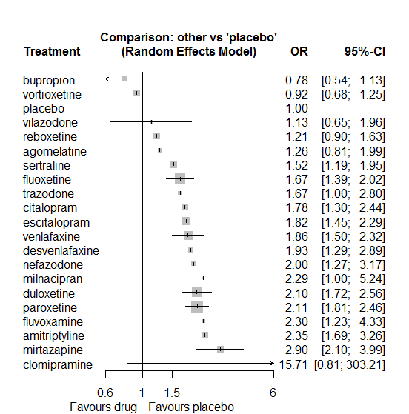

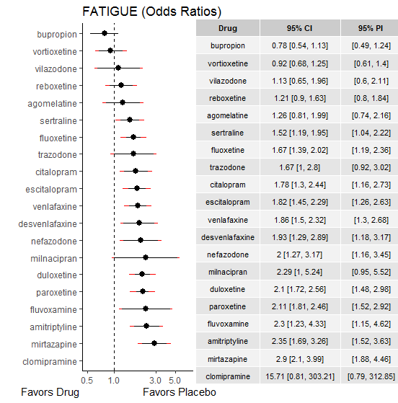

### **Ranking according to P-scores**

P-score

bupropion 0.97

vortioxetine 0.92

placebo 0.89

vilazodone 0.80

reboxetine 0.78

agomelatine 0.74

sertraline 0.64

fluoxetine 0.56

trazodone 0.53

citalopram 0.48

escitalopram 0.46

venlafaxine 0.43

desvenlafaxine 0.40

nefazodone 0.37

milnacipran 0.30

duloxetine 0.30

paroxetine 0.29

fluvoxamine 0.28

amitriptyline 0.21

mirtazapine 0.09

clomipramine 0.07

### **Local inconsistency**

Percent of comparisons where there is some evidence (p-value<0.05) of disagreement between direct and indirect sources: 0.01. (1 out of 67 comparisons)

comparison TE seTE lower upper z p

7 agomelatine:escitalopram -0.4098 0.61 -1.60 0.778 -0.676 0.4989

13 agomelatine:paroxetine -0.2527 0.53 -1.29 0.787 -0.476 0.6339

14 agomelatine:placebo 0.4800 0.51 -0.53 1.485 0.936 0.3494

21 amitriptyline:bupropion -0.6700 0.50 -1.64 0.304 -1.348 0.1778

27 amitriptyline:fluoxetine 0.3715 0.49 -0.60 1.338 0.753 0.4515

30 amitriptyline:mirtazapine -0.2668 0.73 -1.70 1.167 -0.365 0.7153

32 amitriptyline:paroxetine 0.3133 0.47 -0.61 1.234 0.667 0.5046

33 amitriptyline:placebo -0.0266 0.35 -0.71 0.661 -0.076 0.9397

35 amitriptyline:sertraline 0.1258 0.35 -0.55 0.803 0.364 0.7159

44 bupropion:escitalopram -0.5552 0.44 -1.42 0.309 -1.260 0.2078

45 bupropion:fluoxetine 0.5600 0.55 -0.52 1.644 1.012 0.3114

50 bupropion:paroxetine -0.4776 0.85 -2.14 1.184 -0.563 0.5731

51 bupropion:placebo -0.1323 0.38 -0.89 0.621 -0.344 0.7307

54 bupropion:trazodone 0.2209 0.84 -1.42 1.865 0.263 0.7923

61 citalopram:escitalopram -0.4431 0.38 -1.19 0.303 -1.164 0.2445

65 citalopram:mirtazapine 0.8106 0.46 -0.09 1.711 1.765 0.0776

67 citalopram:paroxetine 0.3104 0.44 -0.55 1.174 0.704 0.4814

68 citalopram:placebo -0.0901 0.32 -0.73 0.547 -0.277 0.7816

70 citalopram:sertraline -1.2081 0.69 -2.56 0.143 -1.753 0.0797

73 citalopram:vilazodone 0.5335 0.60 -0.64 1.705 0.893 0.3719

91 desvenlafaxine:duloxetine -0.4660 0.44 -1.34 0.404 -1.050 0.2938

99 desvenlafaxine:placebo 0.6092 0.50 -0.38 1.594 1.213 0.2251

106 duloxetine:escitalopram -0.2654 0.30 -0.84 0.314 -0.898 0.3692

107 duloxetine:fluoxetine -0.3289 0.40 -1.12 0.463 -0.814 0.4156

112 duloxetine:paroxetine 0.0035 0.28 -0.55 0.557 0.013 0.9900

113 duloxetine:placebo 0.0612 0.21 -0.34 0.466 0.297 0.7668

117 duloxetine:venlafaxine 0.1514 0.34 -0.51 0.815 0.447 0.6550

119 duloxetine:vortioxetine 0.0875 0.33 -0.55 0.725 0.269 0.7879

120 escitalopram:fluoxetine -0.4561 0.59 -1.62 0.705 -0.770 0.4414

125 escitalopram:paroxetine -0.3436 0.57 -1.47 0.782 -0.598 0.5498

126 escitalopram:placebo -0.3862 0.23 -0.84 0.071 -1.654 0.0981

128 escitalopram:sertraline 0.0907 0.40 -0.70 0.883 0.224 0.8224

130 escitalopram:venlafaxine -0.2288 0.42 -1.05 0.596 -0.544 0.5865

135 fluoxetine:mirtazapine 0.2412 0.82 -1.36 1.844 0.295 0.7680

136 fluoxetine:nefazodone 1.2845 0.92 -0.52 3.087 1.397 0.1624

137 fluoxetine:paroxetine 0.0844 0.21 -0.32 0.492 0.406 0.6844

138 fluoxetine:placebo 0.0402 0.19 -0.33 0.415 0.210 0.8337

139 fluoxetine:reboxetine -0.2648 0.38 -1.01 0.477 -0.700 0.4842

140 fluoxetine:sertraline -0.2682 0.48 -1.20 0.667 -0.562 0.5740

141 fluoxetine:trazodone 0.1260 0.71 -1.26 1.515 0.178 0.8589

142 fluoxetine:venlafaxine -0.1048 0.25 -0.59 0.380 -0.423 0.6721

145 fluvoxamine:milnacipran -0.8351 1.36 -3.51 1.840 -0.612 0.5406

148 fluvoxamine:paroxetine 0.7545 0.79 -0.80 2.310 0.951 0.3418

149 fluvoxamine:placebo 0.5738 0.65 -0.70 1.845 0.885 0.3762

151 fluvoxamine:sertraline -1.4939 0.84 -3.14 0.154 -1.777 0.0755

158 milnacipran:paroxetine -0.8351 1.36 -3.51 1.840 -0.612 0.5406

167 mirtazapine:paroxetine 0.3537 0.33 -0.29 1.000 1.072 0.2837

168 mirtazapine:placebo -0.8885 0.51 -1.89 0.115 -1.736 0.0826

170 mirtazapine:sertraline 0.0364 0.46 -0.87 0.945 0.079 0.9373

172 mirtazapine:venlafaxine 0.6051 0.41 -0.20 1.405 1.482 0.1384

175 nefazodone:paroxetine 0.1243 0.49 -0.83 1.077 0.256 0.7980

176 nefazodone:placebo 0.1222 0.51 -0.87 1.115 0.241 0.8093

178 nefazodone:sertraline 0.1350 0.51 -0.87 1.137 0.264 0.7918

183 paroxetine:placebo -0.0395 0.16 -0.35 0.274 -0.247 0.8049

184 paroxetine:reboxetine 0.2946 0.31 -0.31 0.896 0.959 0.3374

185 paroxetine:sertraline 0.8900 0.28 0.34 1.444 3.151 0.0016

186 paroxetine:trazodone -0.0534 0.80 -1.63 1.520 -0.066 0.9470

187 paroxetine:venlafaxine -1.0476 0.54 -2.10 0.003 -1.954 0.0507

190 placebo:reboxetine -0.4205 0.32 -1.04 0.199 -1.330 0.1834

191 placebo:sertraline -0.1549 0.27 -0.68 0.375 -0.573 0.5665

192 placebo:trazodone -0.2881 0.53 -1.33 0.754 -0.542 0.5878

193 placebo:venlafaxine -0.0681 0.23 -0.52 0.381 -0.297 0.7664

194 placebo:vilazodone -0.5474 0.63 -1.78 0.689 -0.868 0.3856

195 placebo:vortioxetine -0.3118 0.35 -1.00 0.372 -0.893 0.3718

201 sertraline:trazodone 0.8826 1.28 -1.63 3.394 0.689 0.4909

202 sertraline:venlafaxine 0.3384 0.42 -0.49 1.163 0.804 0.4215

209 venlafaxine:vortioxetine 0.0649 0.52 -0.95 1.075 0.126 0.8999

### **League table**

Below we show the league table. Upper triangle: direct evidence. Lower triangle: NMA. An odds ratio larger than 1 in the upper triangle favors the column-defining drug. An odds ratio larger than 1 in the bottom triangle favors the row-defining drug.

|  |  |  |  |  |  |  |  |  |  |  |  |  |  |  |  |  |  |  |  |  |
| --- | --- | --- | --- | --- | --- | --- | --- | --- | --- | --- | --- | --- | --- | --- | --- | --- | --- | --- | --- | --- |
| AGOM | . | . | . | . | . | . | 0.50 [0.17; 1.44] | . | . | . | . | . | 0.50 [0.21; 1.21] | 1.45 [0.85; 2.46] | . | . | . | . | . | . |
| 0.54 [0.31; 0.93] | AMIT | 1.88 [0.83; 4.27] | . | . | . | . | . | 1.92 [0.79; 4.67] | . | . | 0.64 [0.16; 2.49] | . | 1.45 [0.62; 3.38] | 2.31 [1.32; 4.03] | . | 1.63 [1.04; 2.56] | . | . | . | . |
| 1.63 [0.91; 2.90] | 3.02 [1.94; 4.71] | BUPR | . | . | . | . | 0.29 [0.15; 0.60] | 0.74 [0.28; 2.01] | . | . | . | . | 0.24 [0.05; 1.18] | 0.74 [0.46; 1.19] | . | . | 0.56 [0.12; 2.52] | . | . | . |
| 0.71 [0.41; 1.22] | 1.32 [0.85; 2.05] | 0.44 [0.27; 0.70] | CITA | . | . | . | 0.73 [0.40; 1.34] | . | . | . | 1.10 [0.51; 2.38] | . | 1.09 [0.50; 2.38] | 1.71 [1.12; 2.61] | . | 0.39 [0.11; 1.41] | . | . | 1.90 [0.96; 3.76] | . |
| 0.08 [0.00; 1.61] | 0.15 [0.01; 2.93] | 0.05 [0.00; 0.97] | 0.11 [0.01; 2.22] | CLOM | . | . | . | 9.39 [0.49; 180.24] | . | . | . | . | . | . | . | . | . | . | . | . |
| 0.65 [0.36; 1.20] | 1.22 [0.72; 2.04] | 0.40 [0.23; 0.69] | 0.92 [0.55; 1.53] | 8.13 [0.41; 161.18] | DESV | 0.69 [0.35; 1.37] | . | . | . | . | . | . | . | 2.20 [1.40; 3.47] | . | . | . | . | . | . |
| 0.60 [0.37; 0.98] | 1.12 [0.77; 1.63] | 0.37 [0.25; 0.56] | 0.85 [0.59; 1.22] | 7.48 [0.39; 145.15] | 0.92 [0.60; 1.41] | DULO | 0.96 [0.60; 1.55] | 0.94 [0.45; 1.98] | . | . | . | . | 1.00 [0.61; 1.63] | 2.15 [1.66; 2.80] | . | . | . | 1.27 [0.70; 2.30] | . | 2.36 [1.56; 3.56] |
| 0.69 [0.43; 1.13] | 1.29 [0.88; 1.89] | 0.43 [0.28; 0.64] | 0.98 [0.68; 1.39] | 8.62 [0.44; 167.52] | 1.06 [0.67; 1.68] | 1.15 [0.88; 1.51] | ESCI | 0.71 [0.23; 2.19] | . | . | . | . | 0.62 [0.21; 1.87] | 1.51 [1.10; 2.08] | . | 1.29 [0.63; 2.63] | . | 0.80 [0.38; 1.72] | . | . |
| 0.76 [0.47; 1.23] | 1.40 [0.99; 1.99] | 0.46 [0.31; 0.69] | 1.06 [0.75; 1.52] | 9.39 [0.49; 180.24] | 1.16 [0.74; 1.80] | 1.26 [0.97; 1.62] | 1.09 [0.83; 1.44] | FLUO | . | . | 0.73 [0.15; 3.47] | 2.73 [0.48; 15.45] | 0.83 [0.61; 1.14] | 1.71 [1.31; 2.21] | 1.13 [0.60; 2.15] | 0.86 [0.36; 2.09] | 1.11 [0.32; 3.90] | 0.85 [0.59; 1.22] | . | . |
| 0.55 [0.25; 1.19] | 1.02 [0.51; 2.05] | 0.34 [0.16; 0.70] | 0.77 [0.38; 1.56] | 6.82 [0.33; 140.56] | 0.84 [0.40; 1.77] | 0.91 [0.47; 1.76] | 0.79 [0.41; 1.54] | 0.73 [0.38; 1.39] | FLUV | 0.50 [0.04; 5.77] | . | . | 1.98 [0.50; 7.86] | 2.96 [1.28; 6.88] | . | 0.46 [0.10; 2.00] | . | . | . | . |
| 0.55 [0.22; 1.41] | 1.03 [0.43; 2.47] | 0.34 [0.14; 0.84] | 0.78 [0.32; 1.87] | 6.86 [0.32; 147.86] | 0.84 [0.34; 2.11] | 0.92 [0.39; 2.13] | 0.80 [0.34; 1.87] | 0.73 [0.32; 1.69] | 1.01 [0.37; 2.71] | MILN | . | . | 1.00 [0.42; 2.36] | . | . | . | . | . | . | . |
| 0.44 [0.25; 0.75] | 0.81 [0.53; 1.24] | 0.27 [0.17; 0.43] | 0.61 [0.41; 0.92] | 5.43 [0.28; 106.24] | 0.67 [0.40; 1.11] | 0.73 [0.50; 1.04] | 0.63 [0.43; 0.92] | 0.58 [0.41; 0.82] | 0.80 [0.40; 1.60] | 0.79 [0.33; 1.90] | MIRT | . | 1.69 [1.03; 2.78] | 1.32 [0.51; 3.39] | . | 1.96 [0.87; 4.42] | . | 2.43 [1.22; 4.84] | . | . |
| 0.63 [0.33; 1.19] | 1.17 [0.68; 2.01] | 0.39 [0.22; 0.69] | 0.89 [0.51; 1.54] | 7.84 [0.39; 156.36] | 0.96 [0.52; 1.77] | 1.05 [0.64; 1.72] | 0.91 [0.55; 1.50] | 0.83 [0.52; 1.35] | 1.15 [0.53; 2.48] | 1.14 [0.45; 2.91] | 1.45 [0.84; 2.48] | NEFA | 1.03 [0.48; 2.20] | 2.18 [0.95; 4.98] | . | 1.44 [0.64; 3.24] | . | . | . | . |
| 0.60 [0.38; 0.95] | 1.11 [0.80; 1.56] | 0.37 [0.25; 0.54] | 0.84 [0.61; 1.18] | 7.45 [0.39; 143.96] | 0.92 [0.60; 1.41] | 1.00 [0.79; 1.25] | 0.86 [0.67; 1.12] | 0.79 [0.65; 0.97] | 1.09 [0.58; 2.06] | 1.09 [0.48; 2.45] | 1.37 [1.00; 1.89] | 0.95 [0.60; 1.50] | PARO | 2.07 [1.70; 2.53] | 2.00 [1.32; 3.03] | 2.59 [1.63; 4.12] | 1.21 [0.28; 5.23] | 0.42 [0.15; 1.17] | . | . |
| 1.26 [0.81; 1.99] | 2.35 [1.69; 3.26] | 0.78 [0.54; 1.13] | 1.78 [1.30; 2.44] | 15.71 [0.81; 303.21] | 1.93 [1.29; 2.89] | 2.10 [1.72; 2.56] | 1.82 [1.45; 2.29] | 1.67 [1.39; 2.02] | 2.30 [1.23; 4.33] | 2.29 [1.00; 5.24] | 2.90 [2.10; 3.99] | 2.00 [1.27; 3.17] | 2.11 [1.81; 2.46] | PLAC | 0.71 [0.49; 1.03] | 0.59 [0.38; 0.92] | 0.53 [0.26; 1.05] | 0.52 [0.36; 0.73] | 0.76 [0.40; 1.46] | 0.99 [0.69; 1.42] |
| 1.04 [0.61; 1.78] | 1.94 [1.26; 2.97] | 0.64 [0.40; 1.02] | 1.47 [0.96; 2.25] | 12.95 [0.66; 252.85] | 1.59 [0.97; 2.62] | 1.73 [1.22; 2.46] | 1.50 [1.04; 2.17] | 1.38 [1.00; 1.90] | 1.90 [0.95; 3.79] | 1.89 [0.79; 4.50] | 2.39 [1.56; 3.64] | 1.65 [0.97; 2.82] | 1.74 [1.29; 2.35] | 0.82 [0.61; 1.11] | REBO | . | . | . | . | . |
| 0.83 [0.50; 1.38] | 1.54 [1.10; 2.16] | 0.51 [0.33; 0.78] | 1.17 [0.80; 1.71] | 10.32 [0.53; 200.68] | 1.27 [0.79; 2.03] | 1.38 [1.02; 1.87] | 1.20 [0.88; 1.63] | 1.10 [0.83; 1.46] | 1.51 [0.78; 2.92] | 1.50 [0.64; 3.52] | 1.90 [1.32; 2.73] | 1.32 [0.82; 2.12] | 1.38 [1.08; 1.78] | 0.66 [0.51; 0.84] | 0.80 [0.55; 1.16] | SERT | 2.10 [0.18; 24.23] | 1.09 [0.51; 2.32] | . | . |
| 0.76 [0.38; 1.50] | 1.41 [0.77; 2.56] | 0.47 [0.25; 0.85] | 1.07 [0.58; 1.95] | 9.41 [0.47; 189.42] | 1.16 [0.60; 2.23] | 1.26 [0.73; 2.18] | 1.09 [0.62; 1.91] | 1.00 [0.59; 1.71] | 1.38 [0.61; 3.11] | 1.37 [0.52; 3.62] | 1.73 [0.95; 3.16] | 1.20 [0.61; 2.38] | 1.26 [0.74; 2.14] | 0.60 [0.36; 1.00] | 0.73 [0.40; 1.31] | 0.91 [0.52; 1.60] | TRAZ | . | . | . |
| 0.68 [0.41; 1.11] | 1.26 [0.87; 1.83] | 0.42 [0.27; 0.63] | 0.95 [0.66; 1.38] | 8.43 [0.43; 163.28] | 1.04 [0.66; 1.63] | 1.13 [0.86; 1.47] | 0.98 [0.73; 1.31] | 0.90 [0.71; 1.14] | 1.24 [0.64; 2.40] | 1.23 [0.53; 2.87] | 1.55 [1.09; 2.21] | 1.07 [0.65; 1.77] | 1.13 [0.89; 1.44] | 0.54 [0.43; 0.67] | 0.65 [0.46; 0.93] | 0.82 [0.60; 1.10] | 0.90 [0.51; 1.56] | VENL | . | 2.14 [0.84; 5.43] |
| 1.12 [0.55; 2.28] | 2.08 [1.10; 3.94] | 0.69 [0.36; 1.34] | 1.58 [0.91; 2.75] | 13.94 [0.69; 283.01] | 1.71 [0.87; 3.40] | 1.86 [1.04; 3.34] | 1.62 [0.90; 2.91] | 1.48 [0.83; 2.65] | 2.04 [0.89; 4.72] | 2.03 [0.75; 5.48] | 2.57 [1.38; 4.79] | 1.78 [0.87; 3.63] | 1.87 [1.06; 3.30] | 0.89 [0.51; 1.54] | 1.08 [0.58; 2.01] | 1.35 [0.74; 2.46] | 1.48 [0.70; 3.15] | 1.65 [0.92; 2.99] | VILA | . |
| 1.37 [0.80; 2.36] | 2.55 [1.63; 3.96] | 0.84 [0.52; 1.36] | 1.93 [1.25; 2.98] | 17.03 [0.87; 333.56] | 2.09 [1.28; 3.44] | 2.28 [1.66; 3.12] | 1.98 [1.37; 2.86] | 1.81 [1.28; 2.57] | 2.50 [1.24; 5.02] | 2.48 [1.03; 5.98] | 3.14 [2.03; 4.85] | 2.17 [1.26; 3.75] | 2.29 [1.64; 3.19] | 1.08 [0.80; 1.47] | 1.32 [0.86; 2.01] | 1.65 [1.12; 2.43] | 1.81 [0.99; 3.29] | 2.02 [1.41; 2.89] | 1.22 [0.65; 2.29] | VORT |

### **Estimated event rates**

For an event rate in placebo equal to the average event rate (i.e. fixed to 0.05) the estimated event rates for each drug are as follows

drug rate

1 agomelatine 0.06 [0.04, 0.09]

2 amitriptyline 0.1 [0.08, 0.14]

3 bupropion 0.04 [0.03, 0.05]

4 citalopram 0.08 [0.06, 0.11]

5 clomipramine 0.44 [0.04, 0.94]

6 desvenlafaxine 0.09 [0.06, 0.12]

7 duloxetine 0.09 [0.08, 0.11]

8 escitalopram 0.08 [0.07, 0.1]

9 fluoxetine 0.08 [0.06, 0.09]

10 fluvoxamine 0.1 [0.06, 0.18]

11 milnacipran 0.1 [0.05, 0.21]

12 mirtazapine 0.12 [0.09, 0.16]

13 nefazodone 0.09 [0.06, 0.14]

14 paroxetine 0.09 [0.08, 0.11]

16 reboxetine 0.06 [0.04, 0.07]

17 sertraline 0.07 [0.06, 0.09]

18 trazodone 0.08 [0.05, 0.12]

19 venlafaxine 0.08 [0.07, 0.1]

20 vilazodone 0.05 [0.03, 0.09]

21 vortioxetine 0.04 [0.03, 0.06]

## **Sensitivity analysis: splitting nodes according to dosage**

All treatment arms for drug X, with dose_intended_min equal to or smaller to the minimum licensed dose were set as “X_L”. All other arms of X are “X_H”. Studies with no information on dose are excluded. Results shown below:

|  |  |  |
| --- | --- | --- |
| **Low dose vs. placebo** | **High dose vs. placebo** | **High dose vs. low dose** |
|  |  |  |

## **Sensitivity analysis: Keeping only low dropout arms**

We exclude all treatment arms with dropout rates larger than 25%, and we re-analyse the network.

Total number of arms included in the analysis 158. Total number of studies 73

Total events in placebo 230, out of a total of 6621 patients. Event rate placebo 0.035

Total events in drugs 1180, out of a total of 18325 patients. Event rate drugs 0.064

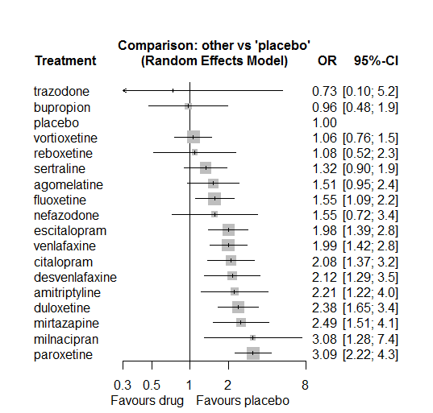

P-score

placebo 0.87

bupropion 0.84

vortioxetine 0.83

trazodone 0.78

reboxetine 0.78

sertraline 0.70

agomelatine 0.60

fluoxetine 0.59

nefazodone 0.56

escitalopram 0.39

venlafaxine 0.38

citalopram 0.35

desvenlafaxine 0.34

amitriptyline 0.31

duloxetine 0.24

mirtazapine 0.22

milnacipran 0.15

paroxetine 0.07

# **Hyperhidrosis**

We remove all arms for which dose range was not “Licenced”. After this:

* Removed 12 one-arm studies: Hormazabal1985, Amsterdam1986, Hewett2010a (AK130940) (NCT00093288), Kavoussi1997, Mendels1999 (Study 85A - FDA), Lieberman2008a (Study 309)(EUCTR2004-000562-13, 3151A1-309-EU, NCT00090649), Lieberman2008b (Study 317), Masco1985, 29060/299, Sacchetti2002 (BRL-29060/109), Bosc1997a (Study 014 - Andreoli2002), Lecrubier1997
* Total number of arms 408. Total number of studies 174.
* Total events in placebo 342, out of a total of 11258 patients. Event rate placebo 0.03.

Total events in drugs 3057, out of a total of 37134 patients. Event rate drugs 0.082

## **Distribution of dose across drugs**

Here we count the number of arms per drug, and the percent of these arms where Dose_intended_min was equal to the minimum licensed dose or lower. The values we used as minimum licensed dose are as follows:

agomelatine: 25; amitriptyline: 75; bupropion:300; citalopram:20; clomipramine:30; desvenlafaxine:50; duloxetine:40; escitalopram:10; fluoxetine:20; fluvoxamine:50; levomilnacipran:40; milnacipran:50; mirtazapine:15; nefazodone:300; paroxetine:20; reboxetine:8; sertraline:50; trazodone:150; venlafaxine:75; vilazodone:20; vortioxetine:5

Drug number.arms percent.low.dose

1 agomelatine 3 1.00

2 escitalopram 18 0.72

3 paroxetine 56 0.82

4 fluoxetine 35 0.94

5 bupropion 8 0.88

7 sertraline 24 0.92

8 citalopram 13 0.69

9 venlafaxine 32 0.78

10 vortioxetine 19 0.53

11 fluvoxamine 10 0.50

12 levomilnacipran 8 0.50

13 reboxetine 13 0.92

14 duloxetine 26 0.15

15 trazodone 6 1.00

16 mirtazapine 5 0.80

17 amitriptyline 17 0.59

18 milnacipran 3 0.00

19 desvenlafaxine 3 0.33

20 nefazodone 3 0.67

21 clomipramine 6 0.00

## **Network graph**

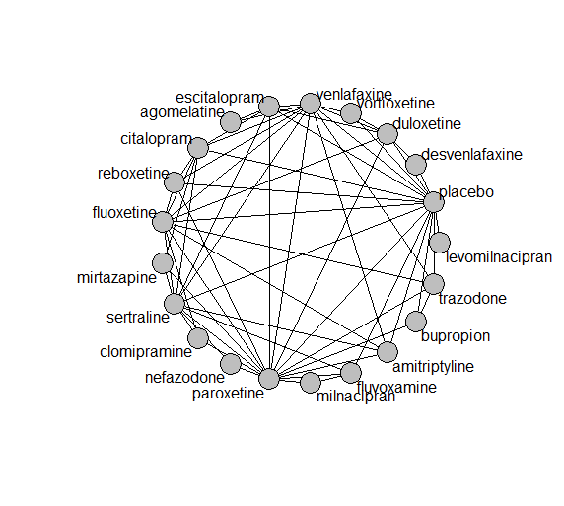

## **Pairwise MA**

### **Grouping all drugs together, comparison vs. placebo**

Number of studies: 97

Random effects meta-analysis: OR=2.71. 95% CI 2.32 to 3.16

Prediction interval 1.4 to 5.25

Heterogeneity (tau squared) was estimated to be 0.11 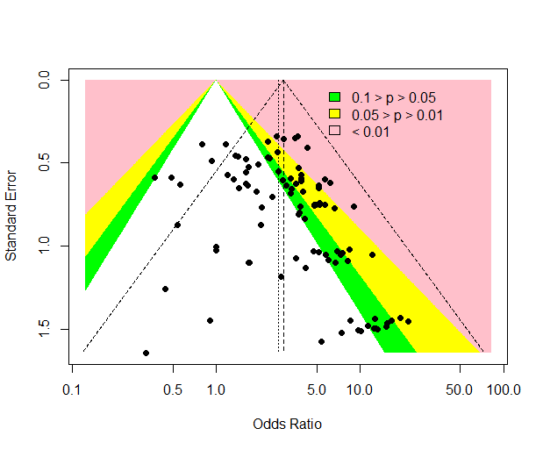

There is no evidence of small-study effects or publication bias (Harbord’s p-value 0.4)

### **Meta-analyses of comparisons with 10 or more studies**

We show results from pairwise comparisons informed by 10 studies or more. An OR larger than 1 favors the first treatment in the comparison.

comparisons Number.of.studies OR lower.CI upper.CI tau.sq I.sq

1 placebo - duloxetine 18 3.74 3.10 6.17 0 0

2 placebo - fluoxetine 12 2.47 1.80 3.50 0 0

3 placebo - paroxetine 24 3.23 2.68 5.00 0 0

4 placebo - venlafaxine 13 4.07 3.16 6.08 0 0

## **Assessment of transitivity**

comparison studies baseline_SD age_SD female

1 agomelatine - escitalopram 2 26 (0.7) 42 (1.3) 0.71 (NA)

2 fluoxetine - paroxetine 7 24 (1.7) 47 (11.9) NaN (NA)

3 bupropion - placebo 4 26 (3.1) 42 (6) 0.47 (0.23)

4 paroxetine - sertraline 2 22 (2) 43 (NA) NaN (NA)

5 escitalopram - placebo 8 21 (2.6) 45 (9.7) 0.74 (0.03)

6 escitalopram - sertraline 1 19 (NA) 40 (NA) NaN (NA)

7 placebo - sertraline 8 22 (2.9) 40 (2.4) 0.61 (0.07)

8 citalopram - venlafaxine 1 22 (NA) 73 (NA) NaN (NA)

9 placebo - venlafaxine 13 22 (1.5) 45 (9) 0.61 (0.06)

10 placebo - vortioxetine 9 23 (1.9) 47 (8.9) 0.65 (0.04)

11 venlafaxine - vortioxetine 1 22 (NA) 43 (NA) 0.62 (NA)

12 fluvoxamine - paroxetine 2 22 (1.4) 42 (1.6) 0.57 (NA)

13 levomilnacipran - placebo 5 24 (1.1) 43 (1.5) 0.64 (0.02)

14 paroxetine - reboxetine 3 22 (2.1) 41 (2.7) 0.69 (0.07)

15 escitalopram - paroxetine 2 25 (2.8) 45 (0.5) NaN (NA)

16 duloxetine - placebo 18 21 (2.6) 44 (6.8) 0.66 (0.04)

17 duloxetine - vortioxetine 5 23 (2.4) 50 (11.8) 0.67 (0.04)

18 placebo - reboxetine 8 24 (4.1) 42 (3.2) 0.62 (0.09)

19 fluoxetine - trazodone 2 21 (1.1) 54 (20) 0.67 (NA)

20 mirtazapine - sertraline 1 NaN (NA) 42 (NA) NaN (NA)

21 mirtazapine - paroxetine 3 23 (1.2) 53 (16.7) NaN (NA)

22 escitalopram - venlafaxine 2 20 (0.4) 43 (7.5) NaN (NA)

23 fluoxetine - reboxetine 2 25 (0.5) 41 (3.9) 0.67 (0.07)

24 citalopram - fluoxetine 1 24 (NA) 42 (NA) NaN (NA)

25 citalopram - escitalopram 5 25 (2.8) 42 (2.5) 0.55 (NA)

26 citalopram - placebo 4 22 (1.2) 41 (2) 0.6 (NA)

27 fluvoxamine - placebo 6 23 (2.3) 42 (2.5) NaN (NA)

28 amitriptyline - placebo 2 24 (0.7) 39 (0) NaN (NA)

29 fluvoxamine - milnacipran 1 24 (NA) 50 (NA) NaN (NA)

30 fluoxetine - placebo 12 21 (2.1) 45 (11.6) 0.6 (0.05)

31 amitriptyline - sertraline 4 24 (1.1) 51 (13.4) 0.59 (0.16)

32 fluoxetine - venlafaxine 9 24 (3) 45 (10) 0.68 (0.05)

33 placebo - trazodone 1 22 (NA) 41 (NA) 0.66 (NA)

34 trazodone - venlafaxine 1 22 (NA) 41 (NA) 0.66 (NA)

35 desvenlafaxine - placebo 2 23 (0.2) 40 (0.5) 0.66 (NA)

36 duloxetine - paroxetine 5 20 (1.7) 42 (2.7) NaN (NA)

37 paroxetine - placebo 24 23 (2.4) 41 (3.1) 0.54 (0.14)

38 citalopram - sertraline 2 26 (4.9) 44 (4.9) NaN (NA)

39 fluoxetine - sertraline 1 21 (NA) 43 (NA) NaN (NA)

40 nefazodone - sertraline 1 23 (NA) 44 (NA) 0.52 (NA)

41 nefazodone - placebo 1 26 (NA) 43 (NA) 0.7 (NA)

42 amitriptyline - venlafaxine 1 21 (NA) 38 (NA) NaN (NA)

43 amitriptyline - paroxetine 7 25 (1.3) 49 (10.2) 0.74 (0.24)

44 duloxetine - fluoxetine 2 18 (0.2) 41 (0.6) NaN (NA)

45 nefazodone - paroxetine 1 NaN (NA) 43 (NA) 0.43 (NA)

46 amitriptyline - fluoxetine 4 25 (0.8) 42 (1.2) 0.72 (0.05)

47 milnacipran - paroxetine 1 22 (NA) 36 (NA) 0.53 (NA)

48 paroxetine - trazodone 2 22 (2.1) 41 (3.6) 0.63 (NA)

49 citalopram - mirtazapine 1 23 (NA) 42 (NA) NaN (NA)

50 agomelatine - venlafaxine 1 26 (NA) 40 (NA) 0.71 (NA)

51 clomipramine - sertraline 2 27 (4.6) 43 (1) 0.6 (0.14)

52 clomipramine - fluoxetine 2 23 (3.9) 46 (3.1) 0.64 (0.01)

53 paroxetine - venlafaxine 1 23 (NA) 44 (NA) NaN (NA)

54 sertraline - venlafaxine 2 23 (0.4) 40 (3.9) NaN (NA)

55 fluvoxamine - sertraline 1 21 (NA) 40 (NA) NaN (NA)

56 duloxetine - escitalopram 2 20 (3.5) 43 (1.1) NaN (NA)

57 duloxetine - venlafaxine 2 23 (0.5) 43 (1.4) 0.68 (0.03)

58 clomipramine - paroxetine 2 24 (1.1) 57 (20.3) 0.81 (0.12)

59 reboxetine - venlafaxine 1 29 (NA) 42 (NA) 0.69 (NA)

60 citalopram - reboxetine 1 24 (NA) 42 (NA) 0.64 (NA)

61 desvenlafaxine - duloxetine 1 23 (NA) 40 (NA) NaN (NA)

62 bupropion - trazodone 1 22 (NA) 40 (NA) NaN (NA)

63 bupropion - paroxetine 1 22 (NA) 37 (NA) NaN (NA)

## **NMA**

A total of 21 treatments are included in the network.

A total of 173 studies are included in this analysis.

Estimated heterogeneity tau-squared 0.04

Global test for inconsistency, p-value 0.36356 (Q=65,d.o.f.62)

### **Comparison vs. placebo**

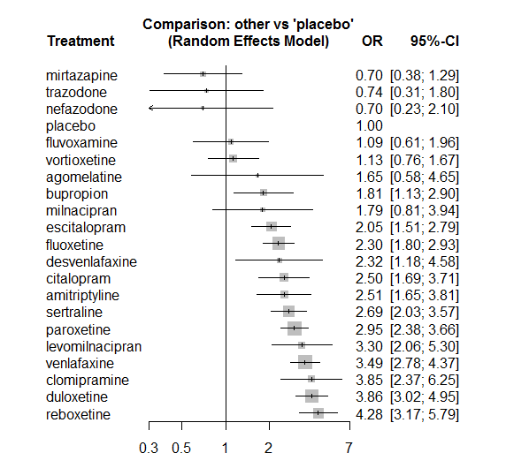

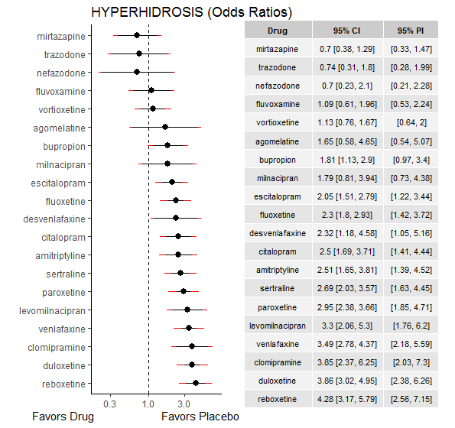

### **Ranking according to P-scores**

P-score

mirtazapine 0.93

trazodone 0.90

nefazodone 0.90

placebo 0.84

fluvoxamine 0.80

vortioxetine 0.79

agomelatine 0.60

bupropion 0.60

milnacipran 0.58

escitalopram 0.55

fluoxetine 0.48

desvenlafaxine 0.44

citalopram 0.41

amitriptyline 0.41

sertraline 0.35

paroxetine 0.28

levomilnacipran 0.22

venlafaxine 0.16

clomipramine 0.12

duloxetine 0.10

reboxetine 0.05

### **Local inconsistency**

Percent of comparisons where there is some evidence (p-value<0.05) of disagreement between direct and indirect sources: 0.08. (5 out of 61 comparisons)

7 agomelatine:escitalopram -2.41211 1.05 -4.474 -0.35 -2.29256 0.022

19 agomelatine:venlafaxine 2.41211 1.05 0.350 4.47 2.29256 0.022

27 amitriptyline:fluoxetine 0.26263 0.48 -0.687 1.21 0.54207 0.588

33 amitriptyline:paroxetine 0.14831 0.43 -0.701 1.00 0.34210 0.732

34 amitriptyline:placebo -0.41615 0.55 -1.486 0.65 -0.76217 0.446

36 amitriptyline:sertraline -0.46683 0.47 -1.390 0.46 -0.99086 0.322

38 amitriptyline:venlafaxine 0.05661 0.77 -1.443 1.56 0.07399 0.941

51 bupropion:paroxetine 0.23651 0.60 -0.932 1.40 0.39680 0.692

52 bupropion:placebo -0.10291 0.54 -1.169 0.96 -0.18921 0.850

55 bupropion:trazodone -0.29796 0.97 -2.196 1.60 -0.30772 0.758

61 citalopram:escitalopram -0.65265 0.43 -1.504 0.20 -1.50292 0.133

62 citalopram:fluoxetine 1.11345 0.88 -0.611 2.84 1.26539 0.206

66 citalopram:mirtazapine 1.06741 0.77 -0.445 2.58 1.38285 0.167

69 citalopram:placebo -0.27687 0.47 -1.189 0.64 -0.59498 0.552

70 citalopram:reboxetine -0.50552 0.54 -1.573 0.56 -0.92794 0.353

71 citalopram:sertraline 0.32402 0.42 -0.504 1.15 0.76656 0.443

73 citalopram:venlafaxine 0.36122 1.06 -1.711 2.43 0.34158 0.733

78 clomipramine:fluoxetine -0.96056 0.85 -2.617 0.70 -1.13637 0.256

84 clomipramine:paroxetine 0.12445 0.50 -0.846 1.09 0.25141 0.802

87 clomipramine:sertraline 0.24030 0.54 -0.810 1.29 0.44834 0.654

91 desvenlafaxine:duloxetine -0.66422 0.72 -2.076 0.75 -0.92234 0.356

100 desvenlafaxine:placebo 0.65470 0.70 -0.713 2.02 0.93832 0.348

106 duloxetine:escitalopram -0.14615 0.39 -0.913 0.62 -0.37341 0.709

107 duloxetine:fluoxetine 0.08923 0.48 -0.858 1.04 0.18457 0.854

113 duloxetine:paroxetine -0.10506 0.30 -0.703 0.49 -0.34461 0.730

114 duloxetine:placebo -0.03163 0.25 -0.531 0.47 -0.12410 0.901

118 duloxetine:venlafaxine 0.11947 0.27 -0.414 0.65 0.43899 0.661

119 duloxetine:vortioxetine 0.06132 0.41 -0.747 0.87 0.14860 0.882

126 escitalopram:paroxetine -0.27581 0.37 -0.998 0.45 -0.74901 0.454

127 escitalopram:placebo -0.03219 0.33 -0.678 0.61 -0.09777 0.922

129 escitalopram:sertraline -0.17045 0.55 -1.258 0.92 -0.30718 0.759

131 escitalopram:venlafaxine -0.35075 0.42 -1.167 0.47 -0.84244 0.400

138 fluoxetine:paroxetine 0.18360 0.27 -0.343 0.71 0.68350 0.494

139 fluoxetine:placebo 0.14490 0.25 -0.345 0.63 0.58002 0.562

140 fluoxetine:reboxetine 0.27680 0.59 -0.873 1.43 0.47173 0.637

141 fluoxetine:sertraline 0.00019 0.53 -1.040 1.04 0.00035 1.000

142 fluoxetine:trazodone 1.06864 1.21 -1.303 3.44 0.88296 0.377

143 fluoxetine:venlafaxine -0.35421 0.25 -0.848 0.14 -1.40478 0.160

146 fluvoxamine:milnacipran 1.96370 1.30 -0.578 4.51 1.51423 0.130

149 fluvoxamine:paroxetine -0.44280 0.73 -1.878 0.99 -0.60451 0.546

150 fluvoxamine:placebo -0.32571 0.61 -1.525 0.87 -0.53233 0.594

152 fluvoxamine:sertraline 0.39227 0.86 -1.298 2.08 0.45496 0.649

168 milnacipran:paroxetine 1.96370 1.30 -0.578 4.51 1.51423 0.130

176 mirtazapine:paroxetine 0.90611 0.65 -0.368 2.18 1.39349 0.163

179 mirtazapine:sertraline -0.27678 0.89 -2.016 1.46 -0.31192 0.755

183 nefazodone:paroxetine -1.95048 1.63 -5.150 1.25 -1.19469 0.232

186 nefazodone:sertraline 1.95048 1.63 -1.249 5.15 1.19469 0.232

190 paroxetine:placebo 0.19301 0.23 -0.248 0.63 0.85719 0.391

191 paroxetine:reboxetine -0.77310 0.31 -1.386 -0.16 -2.47351 0.013

192 paroxetine:sertraline 0.41251 0.32 -0.224 1.05 1.26983 0.204

193 paroxetine:trazodone -0.37679 1.09 -2.516 1.76 -0.34524 0.730

194 paroxetine:venlafaxine 1.30565 0.64 0.044 2.57 2.02771 0.043

196 placebo:reboxetine 0.65342 0.31 0.049 1.26 2.11874 0.034

197 placebo:sertraline -0.22186 0.31 -0.827 0.38 -0.71913 0.472

198 placebo:trazodone -1.14047 1.34 -3.775 1.49 -0.84851 0.396

199 placebo:venlafaxine -0.29785 0.24 -0.759 0.16 -1.26591 0.206

200 placebo:vortioxetine 0.10120 0.41 -0.712 0.91 0.24401 0.807

203 reboxetine:venlafaxine -0.12067 0.56 -1.215 0.97 -0.21604 0.829

206 sertraline:venlafaxine 0.44934 0.37 -0.278 1.18 1.21049 0.226

208 trazodone:venlafaxine -0.09937 0.99 -2.040 1.84 -0.10037 0.920

210 venlafaxine:vortioxetine -0.19563 0.50 -1.179 0.79 -0.39003 0.697

### **League table**

Below we show the league table. Upper triangle: direct evidence. Lower triangle: NMA. An odds ratio larger than 1 in the upper triangle favors the column-defining drug. An odds ratio larger than 1 in the bottom triangle favors the row-defining drug.

|  |  |  |  |  |  |  |  |  |  |  |  |  |  |  |  |  |  |  |  |  |
| --- | --- | --- | --- | --- | --- | --- | --- | --- | --- | --- | --- | --- | --- | --- | --- | --- | --- | --- | --- | --- |
| AGOM | . | . | . | . | . | . | 0.28 [0.07; 1.09] | . | . | . | . | . | . | . | . | . | . | . | 1.71 [0.38; 7.69] | . |
| 0.66 [0.22; 1.98] | AMIT | . | . | . | . | . | . | 1.32 [0.59; 2.95] | . | . | . | . | . | 0.93 [0.48; 1.83] | 1.79 [0.68; 4.69] | . | 0.68 [0.32; 1.45] | . | 0.76 [0.18; 3.16] | . |
| 0.91 [0.29; 2.82] | 1.38 [0.74; 2.56] | BUPR | . | . | . | . | . | . | . | . | . | . | . | 0.74 [0.27; 2.05] | 1.77 [1.02; 3.06] | . | . | 2.04 [0.46; 9.04] | . | . |
| 0.66 [0.22; 1.95] | 1.00 [0.58; 1.72] | 0.73 [0.40; 1.33] | CITA | . | . | . | 0.84 [0.44; 1.60] | 3.08 [0.58; 16.31] | . | . | . | 7.91 [2.14; 29.17] | . | . | 2.03 [0.92; 4.48] | 0.39 [0.15; 1.01] | 1.13 [0.59; 2.15] | . | 1.01 [0.13; 7.71] | . |
| 0.43 [0.14; 1.32] | 0.65 [0.36; 1.18] | 0.47 [0.24; 0.91] | 0.65 [0.36; 1.17] | CLOM | . | . | . | 0.71 [0.15; 3.40] | . | . | . | . | . | 1.36 [0.78; 2.35] | . | . | 1.68 [0.71; 4.00] | . | . | . |
| 0.71 [0.21; 2.42] | 1.08 [0.49; 2.37] | 0.78 [0.34; 1.78] | 1.08 [0.50; 2.33] | 1.66 [0.73; 3.77] | DESV | 0.48 [0.21; 1.10] | . | . | . | . | . | . | . | . | 3.08 [1.26; 7.58] | . | . | . | . | . |
| 0.43 [0.15; 1.21] | 0.65 [0.41; 1.02] | 0.47 [0.28; 0.79] | 0.65 [0.42; 1.00] | 1.00 [0.60; 1.67] | 0.60 [0.31; 1.18] | DULO | 1.69 [0.88; 3.26] | 1.82 [0.74; 4.44] | . | . | . | . | . | 1.22 [0.74; 2.01] | 3.79 [2.60; 5.53] | . | . | . | 1.19 [0.79; 1.80] | 3.50 [2.15; 5.70] |
| 0.80 [0.29; 2.24] | 1.22 [0.75; 1.99] | 0.88 [0.51; 1.54] | 1.22 [0.80; 1.86] | 1.88 [1.09; 3.22] | 1.13 [0.55; 2.35] | 1.88 [1.34; 2.64] | ESCI | . | . | . | . | . | . | 0.57 [0.31; 1.05] | 2.01 [1.19; 3.38] | . | 0.66 [0.24; 1.81] | . | 0.44 [0.21; 0.92] | . |
| 0.72 [0.25; 2.04] | 1.09 [0.71; 1.67] | 0.79 [0.47; 1.32] | 1.09 [0.71; 1.67] | 1.67 [1.02; 2.76] | 1.01 [0.50; 2.05] | 1.68 [1.25; 2.26] | 0.89 [0.63; 1.27] | FLUO | . | . | . | . | . | 0.87 [0.58; 1.32] | 2.49 [1.73; 3.59] | 0.69 [0.23; 2.05] | 0.85 [0.32; 2.28] | 7.51 [0.87; 64.96] | 0.56 [0.40; 0.78] | . |
| 1.51 [0.46; 4.95] | 2.30 [1.14; 4.66] | 1.67 [0.79; 3.52] | 2.30 [1.15; 4.59] | 3.54 [1.69; 7.42] | 2.14 [0.88; 5.21] | 3.55 [1.90; 6.64] | 1.88 [0.98; 3.61] | 2.11 [1.13; 3.94] | FLUV | . | 3.17 [0.31; 32.60] | . | . | 0.26 [0.07; 0.93] | 0.96 [0.45; 2.04] | . | 0.56 [0.12; 2.63] | . | . | . |
| 0.50 [0.16; 1.56] | 0.76 [0.40; 1.42] | 0.55 [0.28; 1.07] | 0.76 [0.41; 1.40] | 1.17 [0.59; 2.29] | 0.70 [0.31; 1.61] | 1.17 [0.69; 1.99] | 0.62 [0.35; 1.09] | 0.70 [0.41; 1.18] | 0.33 [0.16; 0.70] | LEVO | . | . | . | . | 3.30 [2.06; 5.30] | . | . | . | . | . |
| 0.92 [0.25; 3.35] | 1.40 [0.59; 3.32] | 1.01 [0.41; 2.51] | 1.40 [0.59; 3.30] | 2.15 [0.89; 5.22] | 1.30 [0.46; 3.64] | 2.16 [0.96; 4.84] | 1.15 [0.50; 2.61] | 1.29 [0.58; 2.87] | 0.61 [0.24; 1.54] | 1.85 [0.74; 4.63] | MILN | . | . | 0.74 [0.33; 1.65] | . | . | . | . | . | . |
| 2.35 [0.72; 7.72] | 3.58 [1.76; 7.26] | 2.59 [1.21; 5.55] | 3.57 [1.85; 6.91] | 5.50 [2.63; 11.47] | 3.32 [1.34; 8.20] | 5.51 [2.91; 10.44] | 2.93 [1.52; 5.62] | 3.28 [1.75; 6.17] | 1.55 [0.68; 3.57] | 4.72 [2.18; 10.23] | 2.55 [0.98; 6.69] | MIRT | . | 0.31 [0.15; 0.64] | . | . | 0.21 [0.04; 1.02] | . | . | . |
| 2.37 [0.53; 10.60] | 3.59 [1.14; 11.38] | 2.60 [0.79; 8.58] | 3.59 [1.15; 11.24] | 5.52 [1.71; 17.85] | 3.33 [0.92; 12.09] | 5.54 [1.81; 16.95] | 2.94 [0.95; 9.08] | 3.30 [1.08; 10.04] | 1.56 [0.45; 5.37] | 4.74 [1.43; 15.72] | 2.57 [0.67; 9.78] | 1.00 [0.29; 3.46] | NEFA | 0.04 [0.00; 0.86] | . | . | 0.33 [0.11; 1.05] | . | . | . |
| 0.56 [0.20; 1.58] | 0.85 [0.56; 1.28] | 0.62 [0.38; 1.01] | 0.85 [0.57; 1.27] | 1.31 [0.83; 2.05] | 0.79 [0.39; 1.58] | 1.31 [1.00; 1.72] | 0.70 [0.50; 0.96] | 0.78 [0.60; 1.01] | 0.37 [0.20; 0.67] | 1.12 [0.67; 1.88] | 0.61 [0.28; 1.30] | 0.24 [0.13; 0.43] | 0.24 [0.08; 0.71] | PARO | 3.31 [2.35; 4.67] | 0.48 [0.31; 0.73] | 1.47 [0.86; 2.53] | 2.97 [0.45; 19.55] | 2.95 [0.86; 10.13] | . |
| 1.65 [0.58; 4.65] | 2.51 [1.65; 3.81] | 1.81 [1.13; 2.90] | 2.50 [1.69; 3.71] | 3.85 [2.37; 6.25] | 2.32 [1.18; 4.58] | 3.86 [3.02; 4.95] | 2.05 [1.51; 2.79] | 2.30 [1.80; 2.93] | 1.09 [0.61; 1.96] | 3.30 [2.06; 5.30] | 1.79 [0.81; 3.94] | 0.70 [0.38; 1.29] | 0.70 [0.23; 2.10] | 2.95 [2.38; 3.66] | PLAC | 0.32 [0.21; 0.48] | 0.32 [0.19; 0.53] | 0.50 [0.04; 5.83] | 0.24 [0.17; 0.34] | 0.92 [0.56; 1.52] |
| 0.39 [0.13; 1.12] | 0.59 [0.36; 0.95] | 0.42 [0.24; 0.73] | 0.58 [0.37; 0.91] | 0.90 [0.53; 1.54] | 0.54 [0.26; 1.13] | 0.90 [0.63; 1.30] | 0.48 [0.32; 0.71] | 0.54 [0.38; 0.76] | 0.25 [0.13; 0.49] | 0.77 [0.44; 1.35] | 0.42 [0.18; 0.95] | 0.16 [0.09; 0.31] | 0.16 [0.05; 0.50] | 0.69 [0.51; 0.94] | 0.23 [0.17; 0.32] | REBO | . | . | 1.10 [0.39; 3.10] | . |
| 0.61 [0.21; 1.76] | 0.93 [0.60; 1.44] | 0.67 [0.39; 1.15] | 0.93 [0.62; 1.39] | 1.43 [0.88; 2.33] | 0.86 [0.42; 1.78] | 1.43 [1.02; 2.01] | 0.76 [0.53; 1.10] | 0.85 [0.62; 1.18] | 0.40 [0.22; 0.75] | 1.23 [0.71; 2.12] | 0.66 [0.30; 1.49] | 0.26 [0.14; 0.49] | 0.26 [0.09; 0.76] | 1.09 [0.82; 1.46] | 0.37 [0.28; 0.49] | 1.59 [1.09; 2.32] | SERT | . | 1.09 [0.58; 2.06] | . |
| 2.22 [0.57; 8.59] | 3.38 [1.29; 8.85] | 2.45 [0.97; 6.15] | 3.37 [1.29; 8.79] | 5.19 [1.92; 13.99] | 3.13 [1.03; 9.50] | 5.20 [2.10; 12.89] | 2.76 [1.10; 6.98] | 3.10 [1.27; 7.59] | 1.47 [0.51; 4.22] | 4.45 [1.63; 12.17] | 2.41 [0.75; 7.78] | 0.94 [0.33; 2.73] | 0.94 [0.23; 3.83] | 3.98 [1.63; 9.68] | 1.35 [0.55; 3.27] | 5.77 [2.29; 14.54] | 3.63 [1.45; 9.08] | TRAZ | 0.20 [0.04; 1.00] | . |
| 0.47 [0.17; 1.32] | 0.72 [0.47; 1.11] | 0.52 [0.31; 0.87] | 0.72 [0.47; 1.09] | 1.10 [0.67; 1.82] | 0.67 [0.33; 1.34] | 1.11 [0.85; 1.44] | 0.59 [0.42; 0.82] | 0.66 [0.52; 0.84] | 0.31 [0.17; 0.58] | 0.95 [0.56; 1.60] | 0.51 [0.23; 1.14] | 0.20 [0.11; 0.38] | 0.20 [0.07; 0.61] | 0.85 [0.65; 1.09] | 0.29 [0.23; 0.36] | 1.23 [0.87; 1.73] | 0.77 [0.57; 1.05] | 0.21 [0.09; 0.52] | VENL | 2.66 [1.12; 6.31] |
| 1.46 [0.49; 4.37] | 2.22 [1.27; 3.88] | 1.61 [0.88; 2.96] | 2.22 [1.29; 3.81] | 3.41 [1.86; 6.27] | 2.06 [0.96; 4.40] | 3.42 [2.32; 5.05] | 1.82 [1.13; 2.92] | 2.04 [1.32; 3.16] | 0.96 [0.48; 1.94] | 2.93 [1.58; 5.41] | 1.59 [0.66; 3.79] | 0.62 [0.30; 1.27] | 0.62 [0.19; 1.98] | 2.61 [1.71; 4.00] | 0.89 [0.60; 1.31] | 3.79 [2.34; 6.14] | 2.39 [1.50; 3.80] | 0.66 [0.25; 1.72] | 3.09 [2.05; 4.66] | VORT |

### **Estimated event rates**

For an event rate in placebo equal to the average event rate (i.e. fixed to 0.03) the estimated event rates for each drug are as follows

drug rate

1 agomelatine 0.05 [0.02, 0.13]

2 amitriptyline 0.07 [0.05, 0.11]

3 bupropion 0.05 [0.03, 0.08]

4 citalopram 0.07 [0.05, 0.1]

5 clomipramine 0.11 [0.07, 0.16]

6 desvenlafaxine 0.07 [0.04, 0.13]

7 duloxetine 0.11 [0.09, 0.13]

8 escitalopram 0.06 [0.05, 0.08]

9 fluoxetine 0.07 [0.05, 0.08]

10 fluvoxamine 0.03 [0.02, 0.06]

11 levomilnacipran 0.09 [0.06, 0.14]

12 milnacipran 0.05 [0.02, 0.11]

13 mirtazapine 0.02 [0.01, 0.04]

14 nefazodone 0.02 [0.01, 0.06]

15 paroxetine 0.08 [0.07, 0.1]

17 reboxetine 0.12 [0.09, 0.15]

18 sertraline 0.08 [0.06, 0.1]

19 trazodone 0.02 [0.01, 0.05]

20 venlafaxine 0.1 [0.08, 0.12]

21 vortioxetine 0.03 [0.02, 0.05]

## **Sensitivity analysis: splitting nodes according to dosage**

All treatment arms for drug X, with dose_intended_min equal to or smaller to the minimum licensed dose were set as “X_L”. All other arms of X are “X_H”. Studies with no information on dose are excluded. Results shown below:

|  |  |  |
| --- | --- | --- |
| **Low dose vs. placebo** | **High dose vs. placebo** | **High dose vs. low dose** |
|  |  |  |

## **Sensitivity analysis: Keeping only low dropout arms**

We exclude all treatment arms with dropout rates larger than 25%, and we re-analyse the network.

Total number of arms included in the analysis 147. Total number of studies 69

Total events in placebo 154, out of a total of 5139 patients. Event rate placebo 0.03

Total events in drugs 1163, out of a total of 16472 patients. Event rate drugs 0.071

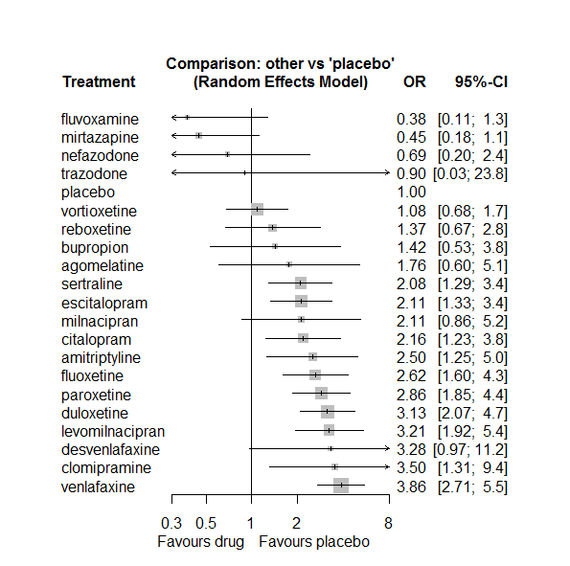

P-score

fluvoxamine 0.94

mirtazapine 0.93

nefazodone 0.84

placebo 0.79

vortioxetine 0.76

reboxetine 0.66

trazodone 0.65

bupropion 0.62

agomelatine 0.53

sertraline 0.48

escitalopram 0.47

milnacipran 0.45

citalopram 0.45

amitriptyline 0.36

fluoxetine 0.33

paroxetine 0.26

desvenlafaxine 0.26

duloxetine 0.22

levomilnacipran 0.21

clomipramine 0.20

venlafaxine 0.10

# **Sexual disfunction**

We remove all arms for which dose range was not “Licenced”. After this:

* Removed 6 one-arm studies: Olie2007 (CL3-20098-042), Feighner1991, Kavoussi1997, Goodarzi 2015(IRCT2012101811155N1), Study 015, Bosc1997b (Study 016 - Massana 1999)
* Total number of arms 216. Total number of studies 87.
* Total events in placebo 259, out of a total of 7362 patients. Event rate placebo 0.035.
* Total events in drugs 1967, out of a total of 21475 patients. Event rate drugs 0.092

## **Distribution of dose across drugs**

Here we count the number of arms per drug, and the percent of these arms where Dose_intended_min was equal to the minimum licensed dose or lower. The values we used as minimum licensed dose are as follows:

agomelatine: 25; amitriptyline: 75; bupropion:300; citalopram:20; clomipramine:30; desvenlafaxine:50; duloxetine:40; escitalopram:10; fluoxetine:20; fluvoxamine:50; levomilnacipran:40; milnacipran:50; mirtazapine:15; nefazodone:300; paroxetine:20; reboxetine:8; sertraline:50; trazodone:150; venlafaxine:75; vilazodone:20; vortioxetine:5

Drug number.arms percent.low.dose

1 agomelatine 3 0.67

2 escitalopram 16 0.81

3 paroxetine 17 0.88

4 sertraline 20 0.85

6 vortioxetine 18 0.44

7 venlafaxine 12 0.67

8 mirtazapine 3 0.33

9 fluoxetine 17 1.00

10 reboxetine 8 0.88

11 duloxetine 18 0.17

12 amitriptyline 7 0.71

13 bupropion 6 1.00

14 desvenlafaxine 2 0.50

15 citalopram 6 0.83

16 nefazodone 2 0.50

17 vilazodone 3 0.33

18 fluvoxamine 2 1.00

19 clomipramine 1 0.00

20 trazodone 1 1.00

## **Network graph**

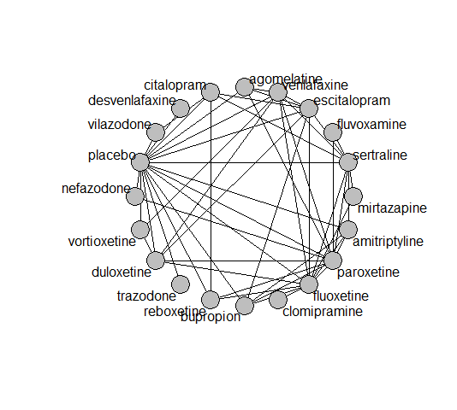

## **Pairwise MA**

### **Grouping all drugs together, comparison vs. placebo**

Number of studies: 52

Random effects meta-analysis: OR=2.79. 95% CI 2.28 to 3.42

Prediction interval 1.34 to 5.82

Heterogeneity (tau squared) was estimated to be 0.12

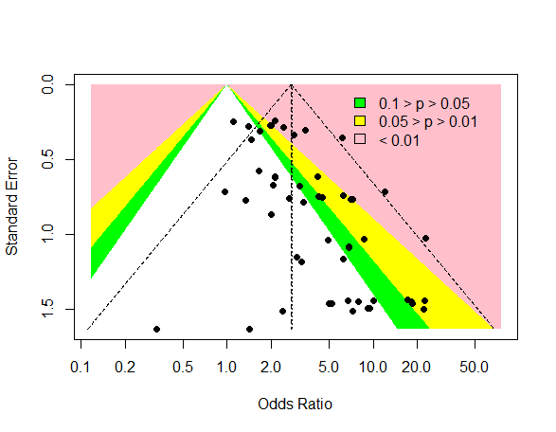

There is evidence of an asymmetry (Harbord’s test p-value 0.007)

### **Meta-analyses of comparisons with 10 or more studies**

We show results from pairwise comparisons informed by 10 studies or more. An OR larger than 1 favors the first treatment in the comparison.

comparisons Number.of.studies OR lower.CI upper.CI tau.sq I.sq

1 placebo - duloxetine 12 2.15 1.63 3.19 0.03 0.06

2 placebo - paroxetine 10 5.29 3.68 10.72 0.11 0.12

## **Assessment of transitivity**

comparison studies baseline_SD age_SD female

1 agomelatine - escitalopram 1 26 (NA) 41 (NA) NaN (NA)

2 paroxetine - sertraline 2 22 (2) 43 (NA) NaN (NA)

3 escitalopram - placebo 9 21 (2.5) 40 (2.4) 0.61 (0.13)

4 escitalopram - sertraline 3 22 (3.3) 38 (3.1) NaN (NA)

5 placebo - sertraline 7 21 (4.2) 40 (2.6) 0.56 (0.09)

6 placebo - venlafaxine 3 21 (0.5) 52 (16.7) 0.62 (0.01)

7 placebo - vortioxetine 9 24 (2) 47 (9.1) 0.66 (0.05)

8 venlafaxine - vortioxetine 1 22 (NA) 43 (NA) 0.62 (NA)

9 fluoxetine - mirtazapine 2 26 (0.4) 42 (7.8) NaN (NA)

10 paroxetine - reboxetine 3 22 (2.1) 41 (2.7) 0.69 (0.07)

11 duloxetine - placebo 12 20 (2.7) 45 (8.3) 0.68 (0.04)

12 duloxetine - vortioxetine 4 23 (3.1) 50 (13.6) 0.68 (0.04)

13 placebo - reboxetine 6 24 (4.9) 41 (2.8) 0.62 (0.1)

14 mirtazapine - sertraline 1 NaN (NA) 42 (NA) NaN (NA)

15 fluoxetine - sertraline 2 22 (1.6) 46 (5) NaN (NA)

16 escitalopram - venlafaxine 1 20 (NA) 37 (NA) NaN (NA)

17 agomelatine - paroxetine 1 27 (NA) 43 (NA) 0.62 (NA)

18 agomelatine - placebo 1 27 (NA) 43 (NA) 0.62 (NA)

19 paroxetine - placebo 10 21 (2.9) 41 (1.9) 0.7 (0.06)

20 amitriptyline - bupropion 1 23 (NA) 37 (NA) NaN (NA)

21 agomelatine - venlafaxine 1 22 (NA) 41 (NA) 0.72 (NA)

22 fluoxetine - placebo 7 22 (2) 44 (12) 0.65 (0.03)

23 fluoxetine - reboxetine 1 23 (NA) 40 (NA) 0.63 (NA)

24 bupropion - escitalopram 2 24 (NA) 36 (0.6) NaN (NA)

25 bupropion - placebo 4 23 (1.3) 37 (0.8) NaN (NA)

26 desvenlafaxine - placebo 2 23 (0.4) 47 (9.1) 0.83 (0.24)

27 amitriptyline - sertraline 2 24 (1.1) 55 (22.2) 0.48 (NA)

28 bupropion - fluoxetine 2 22 (0.7) 37 (0.6) NaN (NA)

29 amitriptyline - fluoxetine 3 25 (1) 51 (15.8) 0.71 (0.07)

30 duloxetine - paroxetine 3 18 (1.3) 43 (1.8) NaN (NA)

31 citalopram - sertraline 2 24 (2.4) 41 (9.5) NaN (NA)

32 fluoxetine - paroxetine 2 21 (0) 42 (1.1) NaN (NA)

33 citalopram - escitalopram 3 25 (0.9) 37 (4.2) 0.59 (NA)

34 citalopram - placebo 2 24 (NA) 42 (0.1) 0.57 (NA)

35 nefazodone - paroxetine 1 NaN (NA) 43 (NA) 0.43 (NA)

36 fluoxetine - venlafaxine 2 22 (1.6) 55 (22.1) NaN (NA)

37 escitalopram - fluoxetine 1 NaN (NA) 37 (NA) NaN (NA)

38 placebo - vilazodone 2 24 (0.7) 42 (0) 0.57 (NA)

39 fluvoxamine - paroxetine 1 21 (NA) 41 (NA) NaN (NA)

40 citalopram - vilazodone 1 24 (NA) 42 (NA) 0.57 (NA)

41 paroxetine - venlafaxine 1 23 (NA) 44 (NA) NaN (NA)

42 sertraline - venlafaxine 2 22 (0.7) 41 (2.4) NaN (NA)

43 amitriptyline - paroxetine 1 26 (NA) 47 (NA) NaN (NA)

44 fluvoxamine - sertraline 1 21 (NA) 40 (NA) NaN (NA)

45 duloxetine - escitalopram 2 20 (3.5) 43 (1.1) NaN (NA)

46 duloxetine - venlafaxine 2 23 (0.5) 43 (1.4) 0.68 (0.03)

47 amitriptyline - placebo 1 23 (NA) 39 (NA) NaN (NA)

48 nefazodone - placebo 1 24 (NA) 44 (NA) 0.64 (NA)

49 clomipramine - fluoxetine 1 20 (NA) 44 (NA) 0.65 (NA)

50 placebo - trazodone 1 22 (NA) 44 (NA) 0.64 (NA)

51 citalopram - reboxetine 1 24 (NA) 42 (NA) 0.64 (NA)

52 duloxetine - fluoxetine 1 19 (NA) 40 (NA) NaN (NA)

53 bupropion - paroxetine 1 22 (NA) 37 (NA) NaN (NA)

## **NMA**

A total of 20 treatments are included in the network.

A total of 87 studies are included in this analysis.

Estimated heterogeneity tau-squared 0.00

Global test for inconsistency, p-value 0.32016 (Q=60,d.o.f.56)

### **Comparison vs. placebo**

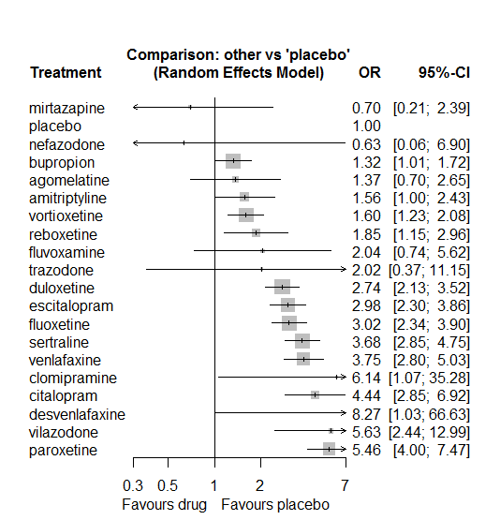

### **Ranking according to P-scores**

P-score

mirtazapine 0.91

placebo 0.90

nefazodone 0.83

bupropion 0.78

agomelatine 0.76

amitriptyline 0.70

vortioxetine 0.69

reboxetine 0.63

fluvoxamine 0.58

trazodone 0.56

duloxetine 0.47

escitalopram 0.41

fluoxetine 0.41

sertraline 0.28

venlafaxine 0.27

clomipramine 0.20

citalopram 0.20

desvenlafaxine 0.16

vilazodone 0.15

paroxetine 0.11

### **Local inconsistency**

Percent of comparisons where there is some evidence (p-value<0.05) of disagreement between direct and indirect sources: 0.06. (3 out of 50 comparisons)

comparison TE seTE lower upper z p

7 agomelatine:escitalopram -0.4109 1.68 -3.705 2.883 -0.2445 0.8069

12 agomelatine:paroxetine -0.9776 0.75 -2.451 0.496 -1.3006 0.1934

13 agomelatine:placebo 0.0938 0.99 -1.845 2.032 0.0949 0.9244

17 agomelatine:venlafaxine 0.8733 0.71 -0.528 2.274 1.2216 0.2219

20 amitriptyline:bupropion -0.7057 0.53 -1.741 0.330 -1.3353 0.1818

26 amitriptyline:fluoxetine 0.5306 0.47 -0.392 1.453 1.1276 0.2595

30 amitriptyline:paroxetine 0.9433 0.96 -0.946 2.832 0.9788 0.3277

31 amitriptyline:placebo 1.4680 0.80 -0.095 3.031 1.8407 0.0657

33 amitriptyline:sertraline -0.3527 0.44 -1.222 0.517 -0.7949 0.4267

42 bupropion:escitalopram 0.1478 0.31 -0.454 0.750 0.4811 0.6304

43 bupropion:fluoxetine -0.0594 0.30 -0.639 0.520 -0.2010 0.8407

47 bupropion:paroxetine -0.7787 0.44 -1.643 0.086 -1.7658 0.0774

48 bupropion:placebo 0.1199 0.30 -0.477 0.717 0.3936 0.6939

58 citalopram:escitalopram -0.2902 0.53 -1.338 0.758 -0.5429 0.5872

64 citalopram:placebo -0.5891 0.59 -1.753 0.575 -0.9922 0.3211

65 citalopram:reboxetine 0.5143 0.53 -0.522 1.551 0.9723 0.3309

66 citalopram:sertraline 0.0012 0.44 -0.869 0.872 0.0028 0.9978

69 citalopram:vilazodone -0.2815 0.89 -2.024 1.461 -0.3167 0.7515

100 duloxetine:escitalopram 0.4943 0.37 -0.231 1.219 1.3359 0.1816

101 duloxetine:fluoxetine -0.8245 0.69 -2.169 0.520 -1.2016 0.2295

105 duloxetine:paroxetine 0.8044 0.42 -0.014 1.623 1.9266 0.0540

106 duloxetine:placebo -0.5992 0.26 -1.103 -0.095 -2.3310 0.0198

110 duloxetine:venlafaxine 0.3126 0.29 -0.246 0.871 1.0967 0.2728

112 duloxetine:vortioxetine -0.9407 0.31 -1.555 -0.326 -3.0005 0.0027

113 escitalopram:fluoxetine 0.6580 0.66 -0.644 1.960 0.9903 0.3220

118 escitalopram:placebo 0.0703 0.27 -0.454 0.595 0.2627 0.7928

120 escitalopram:sertraline 0.2448 0.38 -0.493 0.983 0.6503 0.5155

122 escitalopram:venlafaxine -0.2301 0.58 -1.361 0.901 -0.3987 0.6901

126 fluoxetine:mirtazapine -0.0917 1.28 -2.602 2.419 -0.0716 0.9429

128 fluoxetine:paroxetine 0.0759 0.39 -0.690 0.842 0.1942 0.8460

129 fluoxetine:placebo 0.0978 0.26 -0.413 0.609 0.3750 0.7077

130 fluoxetine:reboxetine -0.4138 0.63 -1.658 0.831 -0.6518 0.5145

131 fluoxetine:sertraline 0.8921 0.48 -0.052 1.837 1.8516 0.0641

133 fluoxetine:venlafaxine -0.0356 0.32 -0.665 0.594 -0.1108 0.9118

138 fluvoxamine:paroxetine 1.4411 1.03 -0.570 3.452 1.4045 0.1602

141 fluvoxamine:sertraline -1.4411 1.03 -3.452 0.570 -1.4045 0.1602

150 mirtazapine:sertraline -0.0917 1.28 -2.602 2.419 -0.0716 0.9429

155 nefazodone:paroxetine -0.7084 2.53 -5.658 4.241 -0.2805 0.7791

156 nefazodone:placebo 0.7084 2.53 -4.241 5.658 0.2805 0.7791

163 paroxetine:placebo -0.0724 0.35 -0.751 0.606 -0.2092 0.8343

164 paroxetine:reboxetine -0.1599 0.48 -1.110 0.790 -0.3298 0.7416

165 paroxetine:sertraline 0.5728 0.42 -0.242 1.388 1.3771 0.1685

167 paroxetine:venlafaxine -0.1288 0.71 -1.514 1.256 -0.1822 0.8554

170 placebo:reboxetine -0.0499 0.49 -1.009 0.909 -0.1020 0.9187

171 placebo:sertraline -0.4140 0.26 -0.925 0.097 -1.5874 0.1124

173 placebo:venlafaxine -0.9172 0.69 -2.275 0.441 -1.3236 0.1856

174 placebo:vilazodone 0.6108 0.88 -1.111 2.332 0.6955 0.4867

175 placebo:vortioxetine 0.9668 0.36 0.264 1.669 2.6976 0.0070

182 sertraline:venlafaxine -0.2507 0.40 -1.026 0.525 -0.6339 0.5262

189 venlafaxine:vortioxetine 2.5647 1.48 -0.329 5.459 1.7370 0.0824

### **League table**

Below we show the league table. Upper triangle: direct evidence. Lower triangle: NMA. An odds ratio larger than 1 in the upper triangle favors the column-defining drug. An odds ratio larger than 1 in the bottom triangle favors the row-defining drug.

|  |  |  |  |  |  |  |  |  |  |  |  |  |  |  |  |  |  |  |  |
| --- | --- | --- | --- | --- | --- | --- | --- | --- | --- | --- | --- | --- | --- | --- | --- | --- | --- | --- | --- |
| AGOM | . | . | . | . | . | . | 0.31 [0.01; 7.74] | . | . | . | . | 0.13 [0.04; 0.43] | 1.48 [0.24; 8.98] | . | . | . | 0.46 [0.22; 0.97] | . | . |
| 0.87 [0.40; 1.89] | AMIT | 0.70 [0.29; 1.71] | . | . | . | . | . | 0.73 [0.35; 1.53] | . | . | . | 0.68 [0.11; 4.22] | 5.96 [1.34; 26.51] | . | 0.36 [0.19; 0.66] | . | . | . | . |
| 1.04 [0.52; 2.06] | 1.18 [0.75; 1.87] | BUPR | . | . | . | . | 0.47 [0.32; 0.70] | 0.43 [0.29; 0.62] | . | . | . | 0.13 [0.06; 0.28] | 1.36 [1.00; 1.86] | . | . | . | . | . | . |
| 0.31 [0.14; 0.67] | 0.35 [0.20; 0.63] | 0.30 [0.18; 0.48] | CITA | . | . | . | 1.21 [0.50; 2.95] | . | . | . | . | . | 2.74 [0.95; 7.86] | 3.12 [1.49; 6.52] | 1.21 [0.66; 2.22] | . | . | 0.72 [0.26; 2.01] | . |
| 0.22 [0.03; 1.43] | 0.25 [0.04; 1.52] | 0.22 [0.04; 1.24] | 0.72 [0.12; 4.36] | CLOM | . | . | . | 2.03 [0.36; 11.45] | . | . | . | . | . | . | . | . | . | . | . |
| 0.17 [0.02; 1.48] | 0.19 [0.02; 1.59] | 0.16 [0.02; 1.31] | 0.54 [0.06; 4.54] | 0.74 [0.05; 11.30] | DESV | . | . | . | . | . | . | . | 8.27 [1.03; 66.63] | . | . | . | . | . | . |
| 0.50 [0.26; 0.97] | 0.57 [0.35; 0.93] | 0.48 [0.35; 0.67] | 1.62 [1.00; 2.64] | 2.24 [0.39; 13.01] | 3.02 [0.37; 24.72] | DULO | 1.33 [0.71; 2.49] | 0.42 [0.11; 1.53] | . | . | . | 0.92 [0.45; 1.88] | 2.04 [1.44; 2.91] | . | . | . | 0.81 [0.58; 1.13] | . | 1.26 [0.89; 1.79] |
| 0.46 [0.23; 0.91] | 0.52 [0.33; 0.85] | 0.44 [0.33; 0.60] | 1.49 [0.93; 2.38] | 2.06 [0.35; 11.97] | 2.78 [0.34; 22.74] | 0.92 [0.67; 1.26] | ESCI | 1.82 [0.52; 6.43] | . | . | . | . | 3.07 [2.17; 4.34] | . | 0.97 [0.51; 1.86] | . | 0.65 [0.22; 1.89] | . | . |
| 0.45 [0.23; 0.89] | 0.52 [0.33; 0.80] | 0.44 [0.33; 0.58] | 1.47 [0.91; 2.37] | 2.03 [0.36; 11.45] | 2.73 [0.33; 22.38] | 0.90 [0.66; 1.23] | 0.98 [0.72; 1.35] | FLUO | . | 4.08 [0.57; 29.07] | . | 0.59 [0.30; 1.13] | 3.17 [2.23; 4.50] | 1.17 [0.39; 3.58] | 1.79 [0.74; 4.34] | . | 0.79 [0.49; 1.28] | . | . |
| 0.67 [0.20; 2.20] | 0.77 [0.26; 2.25] | 0.65 [0.23; 1.82] | 2.18 [0.74; 6.41] | 3.01 [0.40; 22.50] | 4.05 [0.40; 41.26] | 1.34 [0.48; 3.76] | 1.46 [0.52; 4.10] | 1.48 [0.53; 4.14] | FLUV | . | . | 0.77 [0.19; 3.20] | . | . | 0.28 [0.07; 1.12] | . | . | . | . |
| 1.95 [0.49; 7.74] | 2.23 [0.62; 7.99] | 1.88 [0.55; 6.51] | 6.34 [1.76; 22.85] | 8.76 [1.05; 72.93] | 11.80 [1.05; 132.75] | 3.91 [1.13; 13.51] | 4.25 [1.23; 14.68] | 4.32 [1.27; 14.68] | 2.91 [0.61; 13.98] | MIRT | . | . | . | . | 0.18 [0.04; 0.85] | . | . | . | . |
| 2.16 [0.18; 25.50] | 2.47 [0.22; 27.84] | 2.09 [0.19; 22.94] | 7.02 [0.62; 79.19] | 9.69 [0.50; 186.25] | 13.06 [0.55; 311.56] | 4.32 [0.39; 47.51] | 4.70 [0.43; 51.82] | 4.78 [0.43; 52.46] | 3.22 [0.24; 42.57] | 1.11 [0.08; 16.14] | NEFA | 0.09 [0.00; 1.78] | 0.99 [0.02; 50.39] | . | . | . | . | . | . |
| 0.25 [0.13; 0.49] | 0.29 [0.17; 0.47] | 0.24 [0.17; 0.34] | 0.81 [0.50; 1.33] | 1.12 [0.19; 6.55] | 1.51 [0.18; 12.48] | 0.50 [0.35; 0.71] | 0.54 [0.38; 0.79] | 0.55 [0.39; 0.78] | 0.37 [0.14; 1.02] | 0.13 [0.04; 0.45] | 0.12 [0.01; 1.26] | PARO | 5.20 [2.95; 9.15] | 2.74 [1.43; 5.27] | 2.29 [1.13; 4.67] | . | 1.29 [0.34; 4.90] | . | . |
| 1.37 [0.70; 2.65] | 1.56 [1.00; 2.43] | 1.32 [1.01; 1.72] | 4.44 [2.85; 6.92] | 6.14 [1.07; 35.28] | 8.27 [1.03; 66.63] | 2.74 [2.13; 3.52] | 2.98 [2.30; 3.86] | 3.02 [2.34; 3.90] | 2.04 [0.74; 5.62] | 0.70 [0.21; 2.39] | 0.63 [0.06; 6.90] | 5.46 [4.00; 7.47] | PLAC | 0.53 [0.25; 1.10] | 0.22 [0.16; 0.32] | 0.50 [0.09; 2.73] | 0.11 [0.03; 0.42] | 0.22 [0.08; 0.65] | 0.74 [0.55; 0.98] |
| 0.74 [0.34; 1.62] | 0.85 [0.46; 1.56] | 0.71 [0.43; 1.19] | 2.41 [1.43; 4.04] | 3.32 [0.55; 20.10] | 4.48 [0.53; 38.03] | 1.48 [0.89; 2.47] | 1.61 [0.97; 2.69] | 1.64 [1.00; 2.69] | 1.10 [0.37; 3.28] | 0.38 [0.10; 1.39] | 0.34 [0.03; 3.87] | 2.96 [1.84; 4.76] | 0.54 [0.34; 0.87] | REBO | . | . | . | . | . |
| 0.37 [0.19; 0.74] | 0.42 [0.27; 0.66] | 0.36 [0.26; 0.50] | 1.21 [0.78; 1.87] | 1.67 [0.29; 9.67] | 2.25 [0.27; 18.38] | 0.74 [0.54; 1.03] | 0.81 [0.59; 1.11] | 0.82 [0.60; 1.12] | 0.55 [0.20; 1.51] | 0.19 [0.06; 0.64] | 0.17 [0.02; 1.89] | 1.48 [1.05; 2.10] | 0.27 [0.21; 0.35] | 0.50 [0.31; 0.82] | SERT | . | 0.81 [0.41; 1.59] | . | . |
| 0.68 [0.11; 4.23] | 0.77 [0.13; 4.52] | 0.65 [0.12; 3.68] | 2.20 [0.38; 12.85] | 3.04 [0.26; 35.03] | 4.09 [0.28; 60.72] | 1.35 [0.24; 7.62] | 1.47 [0.26; 8.30] | 1.50 [0.27; 8.42] | 1.01 [0.14; 7.36] | 0.35 [0.04; 2.84] | 0.31 [0.02; 5.91] | 2.71 [0.48; 15.37] | 0.50 [0.09; 2.73] | 0.91 [0.16; 5.38] | 1.82 [0.32; 10.25] | TRAZ | . | . | . |
| 0.36 [0.19; 0.68] | 0.42 [0.26; 0.68] | 0.35 [0.25; 0.50] | 1.18 [0.72; 1.95] | 1.64 [0.28; 9.49] | 2.20 [0.27; 18.13] | 0.73 [0.56; 0.95] | 0.79 [0.56; 1.12] | 0.81 [0.59; 1.10] | 0.54 [0.19; 1.53] | 0.19 [0.05; 0.65] | 0.17 [0.02; 1.86] | 1.46 [1.01; 2.10] | 0.27 [0.20; 0.36] | 0.49 [0.29; 0.83] | 0.98 [0.70; 1.37] | 0.54 [0.10; 3.05] | VENL | . | 29.37 [1.66; 519.14] |
| 0.24 [0.08; 0.70] | 0.28 [0.11; 0.71] | 0.23 [0.10; 0.56] | 0.79 [0.34; 1.81] | 1.09 [0.16; 7.55] | 1.47 [0.16; 13.92] | 0.49 [0.20; 1.16] | 0.53 [0.22; 1.25] | 0.54 [0.23; 1.28] | 0.36 [0.10; 1.33] | 0.12 [0.03; 0.54] | 0.11 [0.01; 1.41] | 0.97 [0.40; 2.34] | 0.18 [0.08; 0.41] | 0.33 [0.13; 0.82] | 0.65 [0.28; 1.53] | 0.36 [0.05; 2.41] | 0.67 [0.28; 1.60] | VILA | . |
| 0.86 [0.43; 1.72] | 0.98 [0.59; 1.62] | 0.83 [0.58; 1.19] | 2.78 [1.68; 4.62] | 3.84 [0.66; 22.44] | 5.18 [0.63; 42.40] | 1.71 [1.28; 2.28] | 1.86 [1.31; 2.65] | 1.89 [1.34; 2.68] | 1.28 [0.45; 3.62] | 0.44 [0.13; 1.53] | 0.40 [0.04; 4.38] | 3.42 [2.32; 5.05] | 0.63 [0.48; 0.81] | 1.16 [0.68; 1.97] | 2.30 [1.62; 3.28] | 1.26 [0.22; 7.12] | 2.35 [1.65; 3.34] | 3.52 [1.47; 8.44] | VORT |

### **Estimated event rates**

For an event rate in placebo equal to the average event rate (i.e. fixed to 0.03) the estimated event rates for each drug are as follows

drug rate

1 agomelatine 0.05 [0.03, 0.09]

2 amitriptyline 0.05 [0.04, 0.08]

3 bupropion 0.05 [0.04, 0.06]

4 citalopram 0.14 [0.09, 0.2]

5 clomipramine 0.18 [0.04, 0.56]

6 desvenlafaxine 0.23 [0.04, 0.71]

7 duloxetine 0.09 [0.07, 0.11]

8 escitalopram 0.1 [0.08, 0.12]

9 fluoxetine 0.1 [0.08, 0.12]

10 fluvoxamine 0.07 [0.03, 0.17]

11 mirtazapine 0.02 [0.01, 0.08]

12 nefazodone 0.02 [0, 0.2]

13 paroxetine 0.17 [0.13, 0.21]

15 reboxetine 0.06 [0.04, 0.1]

16 sertraline 0.12 [0.09, 0.15]

17 trazodone 0.07 [0.01, 0.29]

18 venlafaxine 0.12 [0.09, 0.16]

19 vilazodone 0.17 [0.08, 0.32]

20 vortioxetine 0.06 [0.04, 0.07]

## **Sensitivity analysis: splitting nodes according to dosage**

All treatment arms for drug X, with dose_intended_min equal to or smaller to the minimum licensed dose were set as “X_L”. All other arms of X are “X_H”. Studies with no information on dose are excluded. Results shown below:

|  |  |  |
| --- | --- | --- |
| **Low dose vs. placebo** | **High dose vs. placebo** | **High dose vs. low dose** |
|  |  |  |

## **Sensitivity analysis: Keeping only low dropout arms**

We exclude all treatment arms with dropout rates larger than 25%, and we re-analyse the network.

Total number of arms included in the analysis 83. Total number of studies 38

Total events in placebo 74, out of a total of 3253 patients. Event rate placebo 0.023

Total events in drugs 732, out of a total of 9410 patients. Event rate drugs 0.077

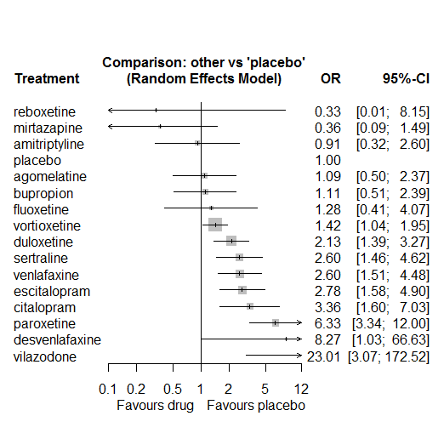

P-score

mirtazapine 0.94

reboxetine 0.83

amitriptyline 0.78

placebo 0.77

agomelatine 0.72

bupropion 0.72

fluoxetine 0.64

vortioxetine 0.62

duloxetine 0.44

sertraline 0.35

venlafaxine 0.34

escitalopram 0.31

citalopram 0.25

desvenlafaxine 0.15

paroxetine 0.11

vilazodone 0.03

# **Anxiety**

We remove all arms for which dose range was not “Licenced”. After this:

* Removed 12 one-arm studies: Stahl2010 (CAGO178A2302), Settle1999 (WELL212), Hewett2010a (AK130940) (NCT00093288), Kavoussi1997, Study 19 (FDA) (Fabre1985), Study 25 (FDA) (Rickels1986), Masco1985, Debus1988, Staner1995 (063), Schwartz2002 (iQWIG), Kellams1979, Allard2004
* Total number of studies with number randomized being smaller than event rates: 1.
* Removed the following studies: Rush1998 (excluding Armitage1997 and Gillin1997)
* Total number of arms 324. Total number of studies 137.
* Total events in placebo 370, out of a total of 8496 patients. Event rate placebo 0.044.

Total events in drugs 2110, out of a total of 29076 patients. Event rate drugs 0.073

## **Distribution of dose across drugs**

Here we count the number of arms per drug, and the percent of these arms where Dose_intended_min was equal to the minimum licensed dose or lower. The values we used as minimum licensed dose are as follows:

agomelatine: 25; amitriptyline: 75; bupropion:300; citalopram:20; clomipramine:30; desvenlafaxine:50; duloxetine:40; escitalopram:10; fluoxetine:20; fluvoxamine:50; levomilnacipran:40; milnacipran:50; mirtazapine:15; nefazodone:300; paroxetine:20; reboxetine:8; sertraline:50; trazodone:150; venlafaxine:75; vilazodone:20; vortioxetine:5

Drug number.arms percent.low.dose

1 paroxetine 40 0.92

2 fluoxetine 54 0.89

3 sertraline 19 0.95

4 venlafaxine 22 0.64

5 fluvoxamine 7 0.57

6 reboxetine 10 1.00

7 escitalopram 17 0.82

9 trazodone 7 1.00

10 mirtazapine 2 1.00

11 nefazodone 2 0.50

12 amitriptyline 14 0.71

13 citalopram 7 0.57

14 desvenlafaxine 3 0.33

15 bupropion 8 1.00

16 milnacipran 3 0.00

17 agomelatine 3 1.00

18 duloxetine 19 0.21

19 vortioxetine 8 0.25

20 clomipramine 1 0.00

21 levomilnacipran 1 1.00

## **Network graph**

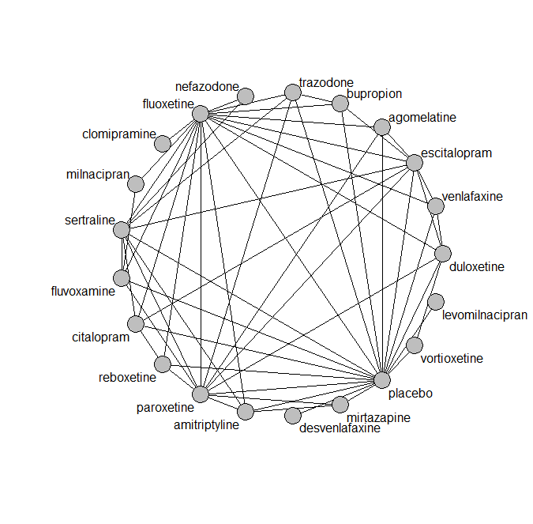

## **Pairwise MA**

### **Grouping all drugs together, comparison vs. placebo**

Number of studies: 74

Random effects meta-analysis: OR=1.54. 95% CI 1.31 to 1.81

Prediction interval 0.77 to 3.08"

Heterogeneity (tau squared) was estimated to be 0.11

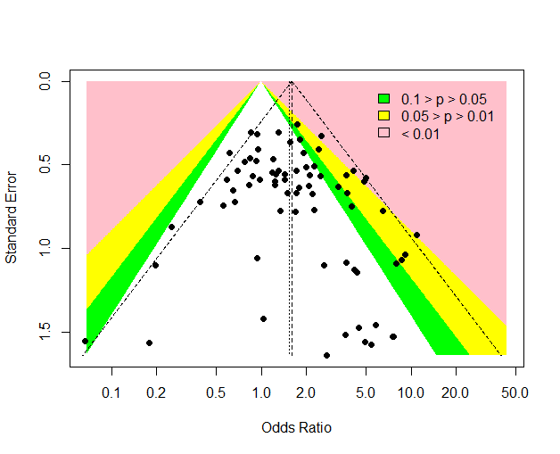

No evidence of an asymmetry (Harbord’s test p-value 0.9)

### **Meta-analyses of comparisons with 10 or more studies**

We show results from pairwise comparisons informed by 10 studies or more. An OR larger than 1 favors the first treatment in the comparison.

comparisons Number.of.studies OR lower.CI upper.CI tau.sq I.sq

1 placebo - duloxetine 12 1.31 0.92 1.93 0.12 0.19

2 placebo - fluoxetine 19 1.76 1.45 2.20 0.00 0.00

3 placebo - paroxetine 20 1.33 1.07 1.71 0.10 0.23

4 placebo - venlafaxine 11 2.37 1.81 3.61 0.37 0.48

5 fluoxetine - venlafaxine 10 1.07 0.82 1.40 0.17 0.44

## **Assessment of transitivity**

comparison studies baseline_SD age_SD female

1 fluoxetine - paroxetine 9 23 (1.7) 42 (1.7) NaN (NA)

2 paroxetine - sertraline 2 22 (2) 43 (NA) NaN (NA)

3 fluoxetine - sertraline 6 23 (2.3) 51 (9.7) NaN (NA)

4 fluoxetine - venlafaxine 10 24 (2.9) 45 (9.6) 0.62 (0.03)

5 fluvoxamine - paroxetine 2 22 (1.4) 42 (1.6) 0.57 (NA)

6 paroxetine - reboxetine 3 22 (2.1) 41 (2.7) 0.69 (0.07)

7 escitalopram - paroxetine 1 23 (NA) 45 (NA) NaN (NA)

8 placebo - reboxetine 7 23 (2) 41 (2.9) 0.63 (0.08)

9 fluoxetine - trazodone 2 21 (1.1) 54 (20) 0.67 (NA)

10 mirtazapine - paroxetine 1 22 (NA) 47 (NA) NaN (NA)

11 fluoxetine - nefazodone 1 24 (NA) 41 (NA) 0.77 (NA)

12 amitriptyline - paroxetine 4 25 (1.3) 54 (11.8) NaN (NA)

13 fluoxetine - reboxetine 2 24 (1.6) 42 (2.6) 0.67 (0.06)

14 citalopram - fluoxetine 2 24 (1.1) 43 (1.1) NaN (NA)

15 desvenlafaxine - placebo 2 24 (0.7) 43 (3.6) 0.68 (0.02)

16 amitriptyline - mirtazapine 1 28 (NA) 38 (NA) NaN (NA)

17 amitriptyline - placebo 3 27 (4.1) 40 (1.6) NaN (NA)

18 mirtazapine - placebo 1 28 (NA) 38 (NA) NaN (NA)

19 citalopram - escitalopram 3 27 (1.9) 40 (5.4) NaN (NA)

20 citalopram - placebo 1 NaN (NA) 40 (NA) NaN (NA)

21 escitalopram - placebo 9 23 (2.8) 44 (11.7) 0.69 (0.06)

22 amitriptyline - fluoxetine 4 24 (0.9) 41 (2.5) 0.67 (0.13)

23 fluvoxamine - placebo 2 24 (0.7) 41 (2.8) NaN (NA)

24 fluoxetine - placebo 19 22 (2.5) 45 (11.6) 0.6 (0.04)

25 bupropion - escitalopram 1 24 (NA) 36 (NA) NaN (NA)

26 bupropion - placebo 5 23 (1) 39 (2.2) NaN (NA)

27 fluvoxamine - milnacipran 1 24 (NA) 50 (NA) NaN (NA)

28 amitriptyline - sertraline 4 24 (1.6) 52 (13) 0.59 (0.16)

29 agomelatine - escitalopram 1 27 (NA) 43 (NA) 0.71 (NA)

30 duloxetine - placebo 12 20 (2.3) 42 (1.7) 0.66 (0.07)

31 duloxetine - paroxetine 4 19 (1.7) 43 (2) NaN (NA)

32 paroxetine - placebo 20 23 (2.8) 41 (2.6) 0.6 (0.15)

33 citalopram - sertraline 2 24 (2.4) 41 (9.5) NaN (NA)

34 nefazodone - sertraline 1 23 (NA) 44 (NA) 0.52 (NA)

35 bupropion - fluoxetine 2 24 (2.2) 40 (3) NaN (NA)

36 duloxetine - fluoxetine 2 18 (0.2) 41 (0.6) NaN (NA)

37 placebo - venlafaxine 11 23 (1.9) 45 (9.7) 0.58 (0.12)

38 fluoxetine - milnacipran 1 28 (NA) 46 (NA) NaN (NA)

39 placebo - vortioxetine 4 25 (0.4) 43 (1.1) 0.7 (0.05)

40 escitalopram - fluoxetine 2 22 (NA) 56 (26.8) NaN (NA)

41 paroxetine - trazodone 2 22 (2.1) 41 (3.6) 0.63 (NA)

42 duloxetine - escitalopram 2 19 (1.4) 42 (0.1) NaN (NA)

43 escitalopram - sertraline 1 25 (NA) 34 (NA) NaN (NA)

44 agomelatine - paroxetine 1 27 (NA) 42 (NA) 0.66 (NA)

45 agomelatine - placebo 1 27 (NA) 42 (NA) 0.66 (NA)

46 placebo - sertraline 4 20 (4.7) 42 (2.3) 0.56 (0.1)

47 duloxetine - vortioxetine 2 25 (NA) 43 (0.1) 0.69 (0.07)

48 clomipramine - fluoxetine 1 26 (NA) 48 (NA) 0.63 (NA)

49 escitalopram - venlafaxine 1 20 (NA) 48 (NA) NaN (NA)

50 sertraline - trazodone 1 22 (NA) 46 (NA) 0.65 (NA)

51 levomilnacipran - placebo 1 NaN (NA) 42 (NA) 0.62 (NA)

52 fluvoxamine - sertraline 1 21 (NA) 40 (NA) NaN (NA)

53 duloxetine - venlafaxine 2 23 (0.5) 43 (1.4) 0.68 (0.03)

54 fluoxetine - fluvoxamine 1 22 (NA) 39 (NA) NaN (NA)

55 placebo - trazodone 1 22 (NA) 44 (NA) 0.64 (NA)

56 agomelatine - fluoxetine 1 27 (NA) 39 (NA) 0.69 (NA)

57 citalopram - reboxetine 1 24 (NA) 42 (NA) 0.64 (NA)

58 bupropion - trazodone 1 22 (NA) 40 (NA) NaN (NA)

## **NMA**

A total of 21 treatments are included in the network.

A total of 137 studies are included in this analysis.

Estimated heterogeneity tau-squared 0.03

Global test for inconsistency, p-value 0.72765 (Q=55,d.o.f.62)

### **Comparison vs. placebo**

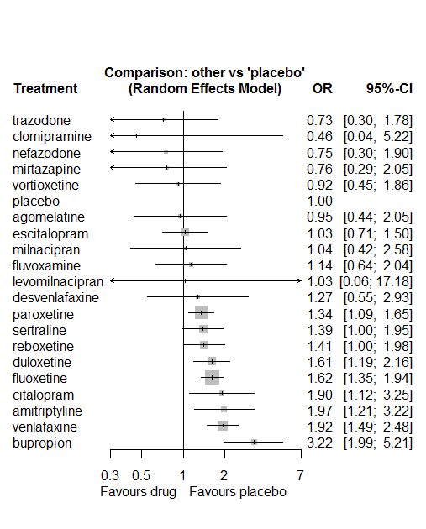

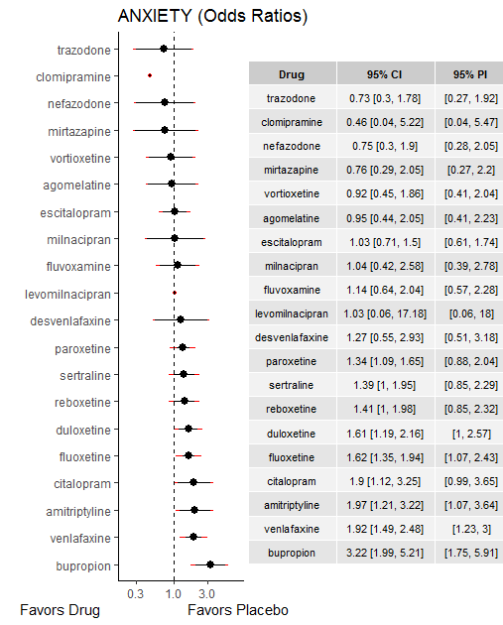

### **Ranking according to P-scores**

P-score

trazodone 0.79

clomipramine 0.77

nefazodone 0.77

mirtazapine 0.76

vortioxetine 0.70

placebo 0.69

agomelatine 0.67

escitalopram 0.66

milnacipran 0.61

fluvoxamine 0.57

levomilnacipran 0.54

desvenlafaxine 0.49

paroxetine 0.46

sertraline 0.43

reboxetine 0.42

duloxetine 0.30

fluoxetine 0.29

citalopram 0.21

amitriptyline 0.18

venlafaxine 0.16

bupropion 0.03

### **Local inconsistency**

Percent of comparisons where there is some evidence (p-value<0.05) of disagreement between direct and indirect sources: 0. (0 out of 55 comparisons)

comparison TE seTE lower upper z p

7 agomelatine:escitalopram -1.626 0.96 -3.50 0.247 -1.701 0.089

8 agomelatine:fluoxetine 0.546 0.80 -1.03 2.124 0.678 0.498

14 agomelatine:paroxetine 0.936 0.85 -0.73 2.602 1.102 0.270

15 agomelatine:placebo 0.097 0.82 -1.52 1.712 0.117 0.907

27 amitriptyline:fluoxetine -0.641 0.52 -1.66 0.380 -1.231 0.218

31 amitriptyline:mirtazapine 0.052 1.10 -2.10 2.201 0.047 0.962

33 amitriptyline:paroxetine 0.698 0.66 -0.60 1.994 1.056 0.291

34 amitriptyline:placebo 0.714 0.57 -0.41 1.840 1.243 0.214

36 amitriptyline:sertraline -0.376 0.53 -1.42 0.666 -0.707 0.479

44 bupropion:escitalopram 0.315 0.88 -1.41 2.043 0.357 0.721

45 bupropion:fluoxetine 0.207 0.54 -0.84 1.258 0.387 0.699

52 bupropion:placebo -0.373 0.53 -1.41 0.659 -0.709 0.478

55 bupropion:trazodone 1.027 1.22 -1.36 3.418 0.842 0.400

61 citalopram:escitalopram 0.147 0.64 -1.10 1.397 0.231 0.817

62 citalopram:fluoxetine -0.228 0.53 -1.28 0.820 -0.426 0.670

69 citalopram:placebo 2.038 1.51 -0.92 4.998 1.350 0.177

70 citalopram:reboxetine -0.032 0.86 -1.72 1.652 -0.038 0.970

71 citalopram:sertraline 0.048 0.63 -1.19 1.288 0.076 0.939

106 duloxetine:escitalopram 0.494 0.48 -0.45 1.433 1.030 0.303

107 duloxetine:fluoxetine 1.021 0.82 -0.59 2.628 1.246 0.213

113 duloxetine:paroxetine 0.105 0.41 -0.71 0.918 0.253 0.800

114 duloxetine:placebo -0.445 0.30 -1.04 0.146 -1.475 0.140

118 duloxetine:venlafaxine 0.107 0.32 -0.51 0.728 0.339 0.735

119 duloxetine:vortioxetine -0.363 0.74 -1.82 1.094 -0.488 0.625

120 escitalopram:fluoxetine -0.043 0.51 -1.04 0.948 -0.086 0.932

126 escitalopram:paroxetine 0.253 0.56 -0.85 1.356 0.451 0.652

127 escitalopram:placebo -0.237 0.38 -0.98 0.509 -0.622 0.534

129 escitalopram:sertraline 0.336 1.46 -2.52 3.191 0.231 0.818

131 escitalopram:venlafaxine 0.341 0.62 -0.88 1.565 0.546 0.585

133 fluoxetine:fluvoxamine -0.067 0.64 -1.32 1.189 -0.105 0.917

135 fluoxetine:milnacipran 0.945 1.38 -1.75 3.643 0.687 0.492

137 fluoxetine:nefazodone -1.752 0.94 -3.60 0.092 -1.862 0.063

138 fluoxetine:paroxetine -0.272 0.21 -0.68 0.140 -1.294 0.196

139 fluoxetine:placebo 0.221 0.19 -0.15 0.596 1.154 0.249

140 fluoxetine:reboxetine 0.041 0.44 -0.82 0.905 0.092 0.926

141 fluoxetine:sertraline 0.048 0.33 -0.59 0.686 0.148 0.882

142 fluoxetine:trazodone -1.531 0.92 -3.33 0.270 -1.666 0.096

143 fluoxetine:venlafaxine 0.172 0.26 -0.34 0.679 0.664 0.507

146 fluvoxamine:milnacipran -0.945 1.38 -3.64 1.753 -0.687 0.492

149 fluvoxamine:paroxetine 0.322 0.72 -1.09 1.730 0.448 0.655

150 fluvoxamine:placebo -0.166 0.70 -1.55 1.215 -0.235 0.814

152 fluvoxamine:sertraline 0.022 0.70 -1.34 1.389 0.032 0.974

176 mirtazapine:paroxetine -0.244 1.07 -2.34 1.847 -0.229 0.819

177 mirtazapine:placebo 1.171 1.37 -1.51 3.856 0.855 0.392

186 nefazodone:sertraline -1.752 0.94 -3.60 0.092 -1.862 0.063

190 paroxetine:placebo -0.061 0.21 -0.48 0.360 -0.283 0.777

191 paroxetine:reboxetine -0.531 0.37 -1.25 0.185 -1.453 0.146

192 paroxetine:sertraline 0.099 0.36 -0.61 0.806 0.273 0.785

193 paroxetine:trazodone 1.465 1.22 -0.92 3.853 1.203 0.229

196 placebo:reboxetine 0.439 0.39 -0.32 1.198 1.134 0.257

197 placebo:sertraline 0.291 0.45 -0.60 1.181 0.640 0.522

198 placebo:trazodone 1.573 1.22 -0.82 3.968 1.287 0.198

199 placebo:venlafaxine -0.378 0.26 -0.89 0.133 -1.450 0.147

200 placebo:vortioxetine 0.263 0.81 -1.32 1.849 0.325 0.745

205 sertraline:trazodone -2.487 1.65 -5.72 0.742 -1.510 0.131

### **League table**

Below we show the league table. Upper triangle: direct evidence. Lower triangle: NMA. An odds ratio larger than 1 in the upper triangle favors the column-defining drug. An odds ratio larger than 1 in the bottom triangle favors the row-defining drug.

|  |  |  |  |  |  |  |  |  |  |  |  |  |  |  |  |  |  |  |  |
| --- | --- | --- | --- | --- | --- | --- | --- | --- | --- | --- | --- | --- | --- | --- | --- | --- | --- | --- | --- |
| AGOM | . | . | . | . | . | . | 0.27 [0.05; 1.37] | 0.83 [0.24; 2.90] | . | . | . | . | . | 1.35 [0.34; 5.40] | 1.02 [0.27; 3.77] | . | . | . | . |
| 0.48 [0.20; 1.18] | AMIT | . | . | . | . | . | . | 0.80 [0.35; 1.83] | . | . | . | 2.67 [0.47; 15.01] | . | 2.61 [0.80; 8.47] | 3.35 [1.27; 8.86] | . | 1.13 [0.51; 2.52] | . | . |
| 0.30 [0.12; 0.72] | 0.61 [0.31; 1.21] | BUPR | . | . | . | . | 4.09 [0.82; 20.44] | 2.29 [0.97; 5.41] | . | . | . | . | . | . | 2.85 [1.59; 5.12] | . | . | 10.00 [1.19; 84.09] | . |
| 0.50 [0.20; 1.24] | 1.04 [0.52; 2.07] | 1.69 [0.84; 3.42] | CITA | . | . | . | 2.03 [0.73; 5.68] | 1.04 [0.48; 2.26] | . | . | . | . | . | . | 13.64 [0.74; 250.33] | 1.32 [0.28; 6.22] | 1.41 [0.50; 4.01] | . | . |
| 2.06 [0.16; 26.04] | 4.27 [0.36; 50.23] | 6.97 [0.59; 82.23] | 4.12 [0.35; 48.91] | CLOM | . | . | . | 0.29 [0.03; 3.21] | . | . | . | . | . | . | . | . | . | . | . |
| 0.75 [0.24; 2.32] | 1.55 [0.59; 4.08] | 2.53 [0.96; 6.63] | 1.50 [0.56; 4.03] | 0.36 [0.03; 4.71] | DESV | . | . | . | . | . | . | . | . | . | 1.27 [0.55; 2.93] | . | . | . | . |
| 0.59 [0.26; 1.33] | 1.23 [0.70; 2.14] | 2.00 [1.15; 3.50] | 1.19 [0.66; 2.14] | 0.29 [0.03; 3.29] | 0.79 [0.33; 1.92] | DULO | 2.20 [1.00; 4.85] | 2.65 [0.55; 12.79] | . | . | . | . | . | 1.30 [0.63; 2.68] | 1.29 [0.85; 1.95] | . | . | . | 0.88 [0.57; 1.37] |
| 0.92 [0.41; 2.06] | 1.91 [1.05; 3.46] | 3.11 [1.73; 5.59] | 1.84 [1.03; 3.30] | 0.45 [0.04; 5.16] | 1.23 [0.49; 3.07] | 1.55 [1.01; 2.38] | ESCI | 0.62 [0.25; 1.52] | . | . | . | . | . | 0.96 [0.35; 2.64] | 0.91 [0.52; 1.58] | . | 1.03 [0.06; 17.19] | . | 0.72 [0.23; 2.27] |
| 0.59 [0.28; 1.26] | 1.22 [0.75; 1.98] | 1.99 [1.22; 3.26] | 1.18 [0.70; 1.98] | 0.29 [0.03; 3.21] | 0.79 [0.34; 1.85] | 0.99 [0.73; 1.36] | 0.64 [0.44; 0.93] | FLUO | 1.35 [0.47; 3.85] | . | 1.74 [0.67; 4.49] | . | 1.00 [0.30; 3.38] | 1.07 [0.81; 1.40] | 1.76 [1.39; 2.23] | 1.19 [0.55; 2.54] | 1.19 [0.74; 1.91] | 0.92 [0.24; 3.62] | 0.90 [0.66; 1.22] |
| 0.83 [0.32; 2.15] | 1.73 [0.83; 3.59] | 2.82 [1.34; 5.95] | 1.67 [0.78; 3.58] | 0.40 [0.03; 4.86] | 1.11 [0.40; 3.09] | 1.41 [0.74; 2.67] | 0.91 [0.46; 1.78] | 1.42 [0.79; 2.52] | FLUV | . | 0.50 [0.04; 5.83] | . | . | 1.09 [0.32; 3.78] | 1.01 [0.30; 3.37] | . | 0.83 [0.26; 2.66] | . | . |
| 0.92 [0.05; 16.95] | 1.91 [0.11; 33.04] | 3.11 [0.18; 53.89] | 1.84 [0.11; 32.16] | 0.45 [0.01; 18.28] | 1.23 [0.07; 23.09] | 1.55 [0.09; 26.21] | 1.00 [0.06; 17.03] | 1.56 [0.09; 26.13] | 1.10 [0.06; 19.48] | LEVO | . | . | . | . | 1.03 [0.06; 17.18] | . | . | . | . |
| 0.91 [0.28; 2.94] | 1.89 [0.69; 5.18] | 3.09 [1.12; 8.50] | 1.82 [0.65; 5.10] | 0.44 [0.03; 5.82] | 1.22 [0.36; 4.18] | 1.54 [0.60; 3.94] | 0.99 [0.38; 2.60] | 1.55 [0.64; 3.76] | 1.09 [0.40; 3.03] | 0.99 [0.05; 18.98] | MILN | . | . | . | . | . | . | . | . |
| 1.25 [0.36; 4.29] | 2.58 [0.92; 7.21] | 4.21 [1.41; 12.55] | 2.49 [0.82; 7.53] | 0.60 [0.04; 8.23] | 1.67 [0.46; 6.06] | 2.10 [0.76; 5.83] | 1.35 [0.48; 3.84] | 2.12 [0.79; 5.67] | 1.49 [0.48; 4.62] | 1.35 [0.07; 26.60] | 1.37 [0.36; 5.13] | MIRT | . | 0.53 [0.16; 1.71] | 2.04 [0.17; 23.89] | . | . | . | . |
| 1.27 [0.39; 4.15] | 2.62 [0.95; 7.25] | 4.28 [1.52; 12.05] | 2.53 [0.89; 7.17] | 0.61 [0.05; 8.14] | 1.69 [0.49; 5.89] | 2.13 [0.81; 5.59] | 1.37 [0.51; 3.68] | 2.15 [0.86; 5.36] | 1.52 [0.52; 4.42] | 1.37 [0.07; 26.50] | 1.39 [0.39; 4.95] | 1.02 [0.27; 3.87] | NEFA | . | . | . | 0.21 [0.06; 0.82] | . | . |
| 0.71 [0.33; 1.53] | 1.47 [0.90; 2.40] | 2.40 [1.44; 4.00] | 1.42 [0.82; 2.44] | 0.34 [0.03; 3.89] | 0.95 [0.40; 2.24] | 1.20 [0.86; 1.66] | 0.77 [0.52; 1.14] | 1.20 [0.98; 1.48] | 0.85 [0.47; 1.53] | 0.77 [0.05; 12.89] | 0.78 [0.31; 1.93] | 0.57 [0.22; 1.50] | 0.56 [0.22; 1.42] | PARO | 1.31 [1.00; 1.71] | 0.72 [0.42; 1.21] | 1.03 [0.58; 1.83] | 6.23 [0.71; 54.76] | . |
| 0.95 [0.44; 2.05] | 1.97 [1.21; 3.22] | 3.22 [1.99; 5.21] | 1.90 [1.12; 3.25] | 0.46 [0.04; 5.22] | 1.27 [0.55; 2.93] | 1.61 [1.19; 2.16] | 1.03 [0.71; 1.50] | 1.62 [1.35; 1.94] | 1.14 [0.64; 2.04] | 1.03 [0.06; 17.18] | 1.04 [0.42; 2.58] | 0.76 [0.29; 2.05] | 0.75 [0.30; 1.90] | 1.34 [1.09; 1.65] | PLAC | 0.80 [0.54; 1.20] | 0.91 [0.41; 2.06] | 5.10 [0.57; 45.38] | 0.42 [0.28; 0.62] |
| 0.68 [0.30; 1.55] | 1.40 [0.78; 2.50] | 2.29 [1.28; 4.10] | 1.35 [0.74; 2.46] | 0.33 [0.03; 3.78] | 0.90 [0.37; 2.23] | 1.14 [0.74; 1.77] | 0.73 [0.45; 1.20] | 1.15 [0.80; 1.64] | 0.81 [0.42; 1.57] | 0.73 [0.04; 12.46] | 0.74 [0.29; 1.93] | 0.54 [0.19; 1.52] | 0.53 [0.20; 1.42] | 0.95 [0.67; 1.36] | 0.71 [0.51; 1.00] | REBO | . | . | . |
| 0.68 [0.30; 1.55] | 1.41 [0.85; 2.36] | 2.31 [1.30; 4.10] | 1.37 [0.78; 2.41] | 0.33 [0.03; 3.80] | 0.91 [0.37; 2.25] | 1.15 [0.75; 1.77] | 0.74 [0.46; 1.19] | 1.16 [0.84; 1.59] | 0.82 [0.44; 1.51] | 0.74 [0.04; 12.59] | 0.75 [0.29; 1.91] | 0.55 [0.20; 1.51] | 0.54 [0.22; 1.36] | 0.96 [0.69; 1.35] | 0.72 [0.51; 1.00] | 1.01 [0.64; 1.59] | SERT | 0.20 [0.01; 4.34] | . |
| 1.31 [0.41; 4.21] | 2.71 [0.99; 7.40] | 4.43 [1.68; 11.68] | 2.62 [0.94; 7.30] | 0.64 [0.05; 8.36] | 1.75 [0.52; 5.96] | 2.21 [0.87; 5.62] | 1.42 [0.55; 3.71] | 2.22 [0.91; 5.42] | 1.57 [0.55; 4.50] | 1.42 [0.07; 27.18] | 1.44 [0.41; 5.04] | 1.05 [0.28; 3.93] | 1.04 [0.29; 3.69] | 1.85 [0.75; 4.54] | 1.38 [0.56; 3.37] | 1.94 [0.75; 5.00] | 1.92 [0.76; 4.86] | TRAZ | . |
| 0.50 [0.22; 1.09] | 1.02 [0.60; 1.74] | 1.67 [0.98; 2.85] | 0.99 [0.56; 1.74] | 0.24 [0.02; 2.73] | 0.66 [0.28; 1.58] | 0.83 [0.61; 1.14] | 0.54 [0.36; 0.81] | 0.84 [0.66; 1.07] | 0.59 [0.32; 1.10] | 0.54 [0.03; 9.03] | 0.54 [0.22; 1.36] | 0.40 [0.15; 1.09] | 0.39 [0.15; 1.01] | 0.70 [0.52; 0.93] | 0.52 [0.40; 0.67] | 0.73 [0.49; 1.10] | 0.72 [0.49; 1.07] | 0.38 [0.15; 0.94] | VENL |
| 1.03 [0.37; 2.91] | 2.14 [0.91; 5.03] | 3.50 [1.49; 8.19] | 2.07 [0.86; 4.98] | 0.50 [0.04; 6.26] | 1.38 [0.46; 4.12] | 1.74 [0.86; 3.55] | 1.12 [0.51; 2.46] | 1.76 [0.85; 3.61] | 1.24 [0.50; 3.08] | 1.12 [0.06; 20.36] | 1.13 [0.36; 3.55] | 0.83 [0.25; 2.78] | 0.82 [0.26; 2.61] | 1.46 [0.70; 3.02] | 1.09 [0.54; 2.20] | 1.53 [0.70; 3.33] | 1.51 [0.70; 3.28] | 0.79 [0.25; 2.46] | 2.09 [1.01; 4.34] |

### **Estimated event rates**

For an event rate in placebo equal to the average event rate (i.e. fixed to 0.03) the estimated event rates for each drug are as follows

drug rate

1 agomelatine 0.04 [0.02, 0.09]

2 amitriptyline 0.08 [0.05, 0.13]

3 bupropion 0.13 [0.08, 0.19]

4 citalopram 0.08 [0.05, 0.13]

5 clomipramine 0.02 [0, 0.19]

6 desvenlafaxine 0.05 [0.02, 0.12]

7 duloxetine 0.07 [0.05, 0.09]

8 escitalopram 0.04 [0.03, 0.06]

9 fluoxetine 0.07 [0.06, 0.08]

10 fluvoxamine 0.05 [0.03, 0.09]

11 levomilnacipran 0.04 [0, 0.44]

12 milnacipran 0.05 [0.02, 0.1]

13 mirtazapine 0.03 [0.01, 0.09]

14 nefazodone 0.03 [0.01, 0.08]

15 paroxetine 0.06 [0.05, 0.07]

17 reboxetine 0.06 [0.04, 0.08]

18 sertraline 0.06 [0.04, 0.08]

19 trazodone 0.03 [0.01, 0.07]

20 venlafaxine 0.08 [0.06, 0.1]

21 vortioxetine 0.04 [0.02, 0.08]

## **Sensitivity analysis: splitting nodes according to dosage**

All treatment arms for drug X, with dose_intended_min equal to or smaller to the minimum licensed dose were set as “X_L”. All other arms of X are “X_H”. Studies with no information on dose are excluded. Results shown below:

|  |  |  |
| --- | --- | --- |
| **Low dose vs. placebo** | **High dose vs. placebo** | **High dose vs. low dose** |
|  |  |  |

## **Sensitivity analysis: Keeping only low dropout arms**

We exclude all treatment arms with dropout rates larger than 25%, and we re-analyse the network.

Total number of arms included in the analysis 114. Total number of studies 54

Total events in placebo 103, out of a total of 3186 patients. Event rate placebo 0.032

Total events in drugs 598, out of a total of 12018 patients. Event rate drugs 0.05

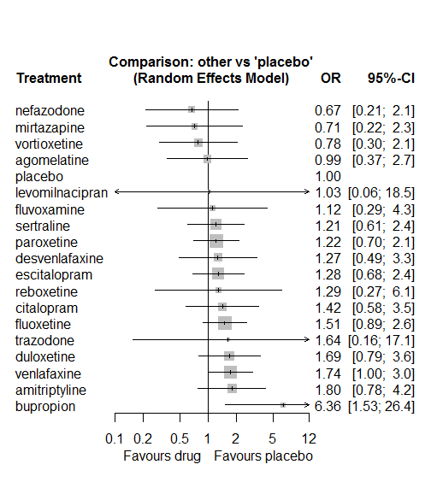

P-score

nefazodone 0.80

mirtazapine 0.77

vortioxetine 0.74

placebo 0.67

agomelatine 0.64

fluvoxamine 0.56

levomilnacipran 0.56

sertraline 0.54

paroxetine 0.53

desvenlafaxine 0.50

reboxetine 0.50

escitalopram 0.49

citalopram 0.43

trazodone 0.43

fluoxetine 0.38

duloxetine 0.33

amitriptyline 0.30

venlafaxine 0.29

bupropion 0.04

# **Tremor**

We remove all arms for which dose range was not “Licenced”. After this:

* Removed 10 one-arm studies: Amsterdam1986, Carman1991, Kavoussi1997, Masco1985, Mullin1996, Ansseau1994c, Staner1995 (063), 29060/299, Sacchetti2002 (BRL-29060/109), Bosc1997a (Study 014 - Andreoli2002)
* Total number of arms 329. Total number of studies 143.
* Total events in placebo 124, out of a total of 7137 patients. Event rate placebo 0.017.
* Total events in drugs 1959, out of a total of 25818 patients. Event rate drugs 0.076

## **Distribution of dose across drugs**

Here we count the number of arms per drug, and the percent of these arms where Dose_intended_min was equal to the minimum licensed dose or lower. The values we used as minimum licensed dose are as follows:

agomelatine: 25; amitriptyline: 75; bupropion:300; citalopram:20; clomipramine:30; desvenlafaxine:50; duloxetine:40; escitalopram:10; fluoxetine:20; fluvoxamine:50; levomilnacipran:40; milnacipran:50; mirtazapine:15; nefazodone:300; paroxetine:20; reboxetine:8; sertraline:50; trazodone:150; venlafaxine:75; vilazodone:20; vortioxetine:5

Drug number.arms percent.low.dose

1 paroxetine 46 0.85

3 fluoxetine 46 0.83

4 sertraline 24 0.88

5 vortioxetine 4 0.75

6 venlafaxine 18 0.67

7 mirtazapine 7 0.71

8 milnacipran 5 0.00

9 amitriptyline 29 0.55

10 fluvoxamine 11 0.45

11 reboxetine 13 0.92

12 trazodone 5 1.00

13 bupropion 11 0.91

14 escitalopram 3 0.67

15 desvenlafaxine 1 0.00

16 duloxetine 14 0.29

17 nefazodone 4 0.75

18 clomipramine 8 0.00

19 citalopram 5 0.80

20 agomelatine 1 1.00

## **Network graph**

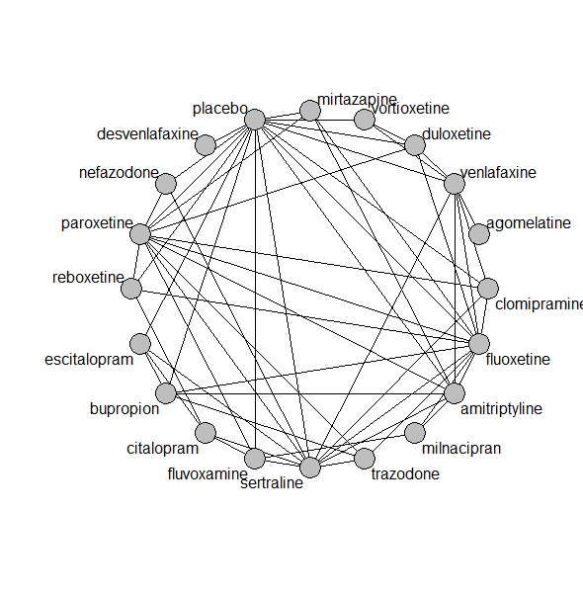

## **Pairwise MA**

### **Grouping all drugs together, comparison vs. placebo**

Number of studies: 72

Random effects meta-analysis: OR=3.45. 95% CI 2.83 to 4.22

Prediction interval 2.82 to 4.23

Heterogeneity (tau squared) was estimated to be 0.00

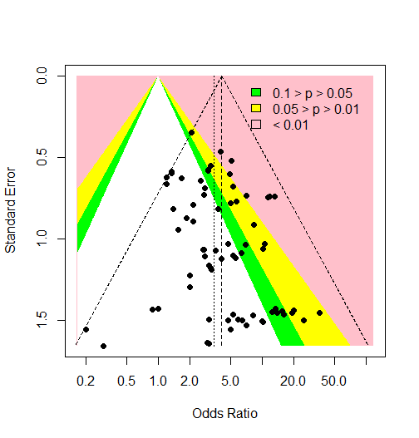

Visually there is no evidence of an asymmetry (Harbord’s test p-value =0.8)

### **Meta-analyses of comparisons with 10 or more studies**

We show results from pairwise comparisons informed by 10 studies or more. An OR larger than 1 favors the first treatment in the comparison.

comparisons Number.of.studies OR lower.CI upper.CI tau.sq I.sq

1 placebo - fluoxetine 14 3.89 3.11 6.40 0 0

2 placebo - paroxetine 19 4.02 2.99 6.99 0 0

## **Assessment of transitivity**

comparison studies baseline_SD age_SD female

1 paroxetine - placebo 19 22 (2.5) 41 (3.1) 0.52 (0.15)

2 fluoxetine - paroxetine 8 23 (1.8) 46 (11.5) NaN (NA)

3 paroxetine - sertraline 2 22 (2) 43 (NA) NaN (NA)

4 placebo - venlafaxine 7 23 (2.1) 46 (11.1) 0.62 (0.01)

5 placebo - vortioxetine 2 22 (NA) 43 (0.4) 0.63 (0.01)

6 venlafaxine - vortioxetine 1 22 (NA) 43 (NA) 0.62 (NA)

7 fluoxetine - mirtazapine 3 26 (2.5) 43 (5.7) NaN (NA)

8 amitriptyline - milnacipran 1 26 (NA) 50 (NA) NaN (NA)

9 fluvoxamine - milnacipran 2 24 (0.4) 49 (2) NaN (NA)

10 fluvoxamine - paroxetine 2 22 (1.4) 42 (1.6) 0.57 (NA)

11 fluoxetine - milnacipran 1 23 (NA) 45 (NA) NaN (NA)

12 paroxetine - reboxetine 3 22 (2.1) 41 (2.7) 0.69 (0.07)

13 placebo - reboxetine 9 24 (3.9) 42 (3.1) 0.62 (0.09)

14 fluoxetine - trazodone 1 20 (NA) 40 (NA) 0.67 (NA)

15 mirtazapine - paroxetine 2 22 (0) 60 (17.4) NaN (NA)

16 fluoxetine - sertraline 3 23 (1.9) 45 (4) NaN (NA)

17 fluoxetine - reboxetine 3 24 (1.1) 41 (2.8) 0.66 (0.05)

18 amitriptyline - mirtazapine 2 26 (2) 38 (NA) NaN (NA)

19 amitriptyline - placebo 9 27 (4.5) 40 (1.6) NaN (NA)

20 mirtazapine - placebo 2 26 (2) 38 (NA) NaN (NA)

21 fluoxetine - placebo 15 22 (2.9) 44 (10.2) 0.6 (0.04)

22 fluvoxamine - placebo 5 23 (2.5) 41 (2.2) NaN (NA)

23 amitriptyline - bupropion 1 23 (NA) 37 (NA) NaN (NA)

24 amitriptyline - fluoxetine 6 24 (0.6) 41 (3) 0.65 (0.1)

25 bupropion - escitalopram 1 NaN (NA) 37 (NA) NaN (NA)

26 bupropion - placebo 6 26 (2.7) 41 (5.1) 0.52 (0.04)

27 escitalopram - placebo 1 NaN (NA) 37 (NA) NaN (NA)

28 amitriptyline - sertraline 5 24 (1.5) 49 (12.6) 0.59 (0.16)

29 placebo - sertraline 8 22 (2.4) 44 (10.7) 0.6 (0.06)

30 fluoxetine - venlafaxine 7 25 (3.2) 45 (11.5) 0.62 (0.03)

31 desvenlafaxine - placebo 1 23 (NA) 40 (NA) 0.66 (NA)

32 duloxetine - placebo 8 19 (1.6) 42 (1.7) 0.64 (NA)

33 duloxetine - paroxetine 4 19 (1.7) 43 (2) NaN (NA)

34 nefazodone - sertraline 1 23 (NA) 44 (NA) 0.52 (NA)

35 bupropion - fluoxetine 1 26 (NA) 42 (NA) NaN (NA)

36 nefazodone - placebo 2 25 (1.4) 43 (0.6) 0.67 (0.04)

37 amitriptyline - venlafaxine 2 21 (0) 43 (6.2) NaN (NA)

38 amitriptyline - paroxetine 7 25 (1.3) 49 (10.2) 0.74 (0.24)

39 clomipramine - fluoxetine 3 25 (4.5) 47 (2.8) 0.67 (0.05)

40 duloxetine - fluoxetine 2 18 (0.2) 41 (0.6) NaN (NA)

41 nefazodone - paroxetine 1 NaN (NA) 43 (NA) 0.43 (NA)

42 citalopram - sertraline 2 27 (2.6) 38 (4.5) NaN (NA)

43 paroxetine - trazodone 2 22 (2.1) 41 (3.6) 0.63 (NA)

44 citalopram - escitalopram 2 27 (1.9) 40 (7.6) NaN (NA)

45 escitalopram - sertraline 1 25 (NA) 34 (NA) NaN (NA)

46 clomipramine - placebo 1 18 (NA) 52 (NA) 0.66 (NA)

47 agomelatine - venlafaxine 1 26 (NA) 40 (NA) 0.71 (NA)

48 clomipramine - sertraline 1 30 (NA) 42 (NA) 0.7 (NA)

49 duloxetine - vortioxetine 1 NaN (NA) 43 (NA) 0.64 (NA)

50 sertraline - venlafaxine 1 23 (NA) 43 (NA) NaN (NA)

51 sertraline - trazodone 1 22 (NA) 46 (NA) 0.65 (NA)

52 fluvoxamine - sertraline 1 21 (NA) 40 (NA) NaN (NA)

53 duloxetine - venlafaxine 2 23 (0.5) 43 (1.4) 0.68 (0.03)

54 clomipramine - paroxetine 2 24 (1.1) 57 (20.3) 0.81 (0.12)

55 clomipramine - venlafaxine 1 25 (NA) 47 (NA) NaN (NA)

56 citalopram - reboxetine 1 24 (NA) 42 (NA) 0.64 (NA)

57 citalopram - fluvoxamine 1 24 (NA) NaN (NA) NaN (NA)

58 bupropion - trazodone 1 22 (NA) 40 (NA) NaN (NA)

## **NMA**

A total of 19 treatments are included in the network.

A total of 142 studies are included in this analysis.

Estimated heterogeneity tau-squared 0.00

Global test for inconsistency, p-value 0.45573 (Q=56,d.o.f.55)

### **Comparison vs. placebo**

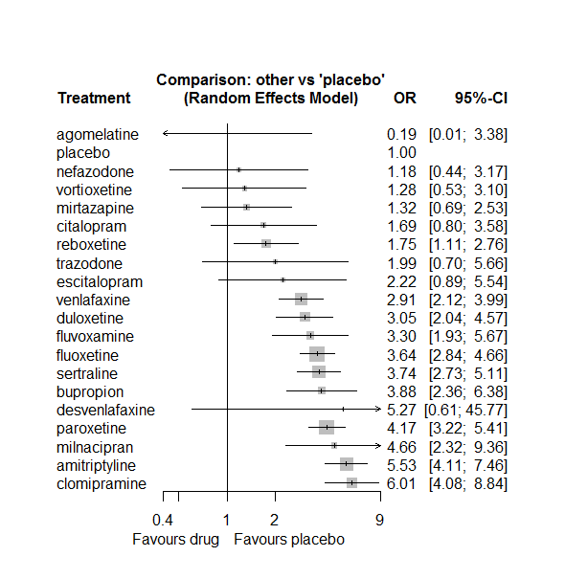

### **Ranking according to P-scores**

P-score

agomelatine 0.95

placebo 0.89

nefazodone 0.81

vortioxetine 0.79

mirtazapine 0.79

citalopram 0.71

reboxetine 0.70

trazodone 0.62

escitalopram 0.58

venlafaxine 0.49

duloxetine 0.45

fluvoxamine 0.40

fluoxetine 0.34

sertraline 0.32

bupropion 0.30

desvenlafaxine 0.28

paroxetine 0.23

milnacipran 0.20

amitriptyline 0.09

clomipramine 0.07

Note that agomelative features as the best drug, but there were no events in the single arm with agomelatine. So estimates are quite uncertain.

### **Local inconsistency**

Percent of comparisons where there is some evidence (p-value<0.05) of disagreement between direct and indirect sources: 0.09. (5 out of 56 comparisons)

comparison TE seTE lower upper z p

1 amitriptyline:bupropion 0.2759 0.52 -0.74442 1.30 0.5300 0.5961

7 amitriptyline:fluoxetine 1.0421 0.34 0.37036 1.71 3.0406 0.0024

9 amitriptyline:milnacipran -1.7816 0.77 -3.28599 -0.28 -2.3210 0.0203

10 amitriptyline:mirtazapine 0.0902 0.90 -1.67952 1.86 0.0999 0.9204

12 amitriptyline:paroxetine 0.3448 0.34 -0.32440 1.01 1.0098 0.3126

13 amitriptyline:placebo 0.0314 0.33 -0.61049 0.67 0.0959 0.9236

15 amitriptyline:sertraline -0.8791 0.31 -1.48997 -0.27 -2.8203 0.0048

17 amitriptyline:venlafaxine -0.3347 0.64 -1.57990 0.91 -0.5269 0.5983

23 bupropion:escitalopram 0.4299 0.97 -1.47614 2.34 0.4421 0.6584

24 bupropion:fluoxetine -0.5104 0.97 -2.41370 1.39 -0.5256 0.5992

30 bupropion:placebo 0.0774 0.51 -0.91536 1.07 0.1529 0.8785

33 bupropion:trazodone 1.3059 1.28 -1.21122 3.82 1.0168 0.3092

39 citalopram:escitalopram 0.7676 1.02 -1.23081 2.77 0.7528 0.4515

41 citalopram:fluvoxamine -0.5320 0.78 -2.06082 1.00 -0.6821 0.4952

47 citalopram:reboxetine -1.0515 0.93 -2.88108 0.78 -1.1264 0.2600

48 citalopram:sertraline 1.7759 0.80 0.20112 3.35 2.2103 0.0271

55 clomipramine:fluoxetine -0.3749 0.42 -1.20647 0.46 -0.8835 0.3770

60 clomipramine:paroxetine -0.3177 0.35 -1.01218 0.38 -0.8967 0.3699

61 clomipramine:placebo 1.4572 1.51 -1.50960 4.42 0.9627 0.3357

63 clomipramine:sertraline 0.8191 0.52 -0.20972 1.85 1.5604 0.1187

65 clomipramine:venlafaxine 1.2617 1.12 -0.93540 3.46 1.1255 0.2604

82 duloxetine:fluoxetine 0.0090 0.81 -1.57853 1.60 0.0111 0.9911

87 duloxetine:paroxetine -0.0981 0.46 -1.00430 0.81 -0.2122 0.8320

88 duloxetine:placebo 0.2146 0.51 -0.78139 1.21 0.4223 0.6728

92 duloxetine:venlafaxine -0.0297 0.38 -0.77418 0.71 -0.0782 0.9377

93 duloxetine:vortioxetine -0.2546 0.92 -2.05369 1.54 -0.2774 0.7815

100 escitalopram:placebo -0.6319 1.07 -2.72571 1.46 -0.5915 0.5542

102 escitalopram:sertraline 1.7929 0.96 -0.09160 3.68 1.8647 0.0622

107 fluoxetine:milnacipran 0.1440 0.76 -1.33670 1.62 0.1906 0.8489

108 fluoxetine:mirtazapine -0.2727 0.64 -1.52055 0.98 -0.4283 0.6684

110 fluoxetine:paroxetine 0.4132 0.22 -0.02078 0.85 1.8661 0.0620

111 fluoxetine:placebo 0.1115 0.25 -0.38554 0.61 0.4396 0.6602

112 fluoxetine:reboxetine -0.4453 0.52 -1.46732 0.58 -0.8539 0.3931

113 fluoxetine:sertraline -0.0157 0.44 -0.87407 0.84 -0.0358 0.9714

114 fluoxetine:trazodone 2.2886 1.58 -0.81534 5.39 1.4451 0.1484

115 fluoxetine:venlafaxine 0.0425 0.29 -0.53109 0.62 0.1453 0.8845

117 fluvoxamine:milnacipran 1.3858 0.71 -0.00011 2.77 1.9598 0.0500

120 fluvoxamine:paroxetine -0.3130 0.75 -1.77610 1.15 -0.4192 0.6750

121 fluvoxamine:placebo -0.7115 0.56 -1.80229 0.38 -1.2784 0.2011

123 fluvoxamine:sertraline -0.5329 0.82 -2.14529 1.08 -0.6478 0.5171

137 mirtazapine:paroxetine -0.2701 0.64 -1.52330 0.98 -0.4225 0.6727

138 mirtazapine:placebo 0.4173 1.32 -2.16659 3.00 0.3165 0.7516

144 nefazodone:paroxetine -1.2965 1.62 -4.46817 1.88 -0.8012 0.4230

145 nefazodone:placebo 0.7533 1.04 -1.27600 2.78 0.7275 0.4669

147 nefazodone:sertraline -0.2078 1.00 -2.16870 1.75 -0.2077 0.8355

151 paroxetine:placebo -0.0575 0.28 -0.59937 0.48 -0.2078 0.8354

152 paroxetine:reboxetine 0.2433 0.47 -0.68003 1.17 0.5164 0.6056

153 paroxetine:sertraline 0.7093 0.33 0.06670 1.35 2.1634 0.0305

154 paroxetine:trazodone -0.4892 1.05 -2.55241 1.57 -0.4647 0.6421

157 placebo:reboxetine 0.3538 0.46 -0.55737 1.26 0.7610 0.4466

158 placebo:sertraline -0.4760 0.36 -1.17656 0.22 -1.3317 0.1830

160 placebo:venlafaxine -0.0711 0.36 -0.77039 0.63 -0.1991 0.8422

161 placebo:vortioxetine 0.3555 0.90 -1.41171 2.12 0.3943 0.6934

166 sertraline:trazodone -2.1807 1.31 -4.75626 0.39 -1.6594 0.0970

167 sertraline:venlafaxine -0.4012 0.58 -1.54130 0.74 -0.6898 0.4903

171 venlafaxine:vortioxetine 0.0085 0.88 -1.72290 1.74 0.0096 0.9924

### **League table**

Below we show the league table. Upper triangle: direct evidence. Lower triangle: NMA. An odds ratio larger than 1 in the upper triangle favors the column-defining drug. An odds ratio larger than 1 in the bottom triangle favors the row-defining drug.

|  |  |  |  |  |  |  |  |  |  |  |  |  |  |  |  |  |  |  |  |
| --- | --- | --- | --- | --- | --- | --- | --- | --- | --- | --- | --- | --- | --- | --- | --- | --- | --- | --- | --- |
| AGOM | . | . | . | . | . | . | . | . | . | . | . | . | . | . | . | . | . | 0.06 [0.00; 1.14] | . |
| 0.03 [0.00; 0.61] | AMIT | 1.67 [0.77; 3.59] | . | . | . | . | . | 3.32 [1.86; 5.94] | . | 0.35 [0.10; 1.21] | 4.51 [0.89; 22.75] | . | 1.71 [0.96; 3.04] | 5.65 [3.32; 9.62] | . | 0.97 [0.63; 1.48] | . | 1.40 [0.43; 4.60] | . |
| 0.05 [0.00; 0.90] | 1.43 [0.86; 2.36] | BUPR | . | . | . | . | 2.21 [0.54; 9.02] | 0.67 [0.11; 4.14] | . | . | . | . | . | 4.03 [2.01; 8.10] | . | . | 5.17 [0.59; 45.63] | . | . |
| 0.11 [0.01; 2.18] | 3.27 [1.52; 7.06] | 2.30 [0.98; 5.40] | CITA | . | . | . | 0.97 [0.32; 2.93] | . | 0.39 [0.13; 1.15] | . | . | . | . | . | 0.45 [0.09; 2.14] | 1.42 [0.40; 5.05] | . | . | . |
| 0.03 [0.00; 0.57] | 0.92 [0.61; 1.39] | 0.65 [0.36; 1.17] | 0.28 [0.13; 0.63] | CLOM | . | . | . | 1.24 [0.60; 2.56] | . | . | . | . | 1.31 [0.90; 1.91] | 25.16 [1.33; 476.43] | . | 3.13 [1.24; 7.92] | . | 6.95 [0.81; 60.01] | . |
| 0.04 [0.00; 1.32] | 1.05 [0.12; 9.32] | 0.74 [0.08; 6.78] | 0.32 [0.03; 3.17] | 1.14 [0.13; 10.26] | DESV | . | . | . | . | . | . | . | . | 5.27 [0.61; 45.77] | . | . | . | . | . |
| 0.06 [0.00; 1.11] | 1.81 [1.16; 2.83] | 1.27 [0.69; 2.35] | 0.55 [0.24; 1.27] | 1.97 [1.21; 3.21] | 1.72 [0.19; 15.57] | DULO | . | 0.85 [0.18; 3.94] | . | . | . | . | 0.68 [0.31; 1.48] | 3.62 [1.49; 8.78] | . | . | . | 1.04 [0.71; 1.53] | 2.04 [0.50; 8.27] |
| 0.08 [0.00; 1.74] | 2.50 [0.99; 6.31] | 1.75 [0.68; 4.52] | 0.76 [0.30; 1.92] | 2.71 [1.03; 7.12] | 2.37 [0.23; 24.85] | 1.38 [0.52; 3.67] | ESCI | . | . | . | . | . | . | 1.39 [0.23; 8.43] | . | 1.77 [0.41; 7.71] | . | . | . |
| 0.05 [0.00; 0.92] | 1.52 [1.14; 2.03] | 1.07 [0.64; 1.79] | 0.46 [0.22; 0.99] | 1.65 [1.16; 2.34] | 1.45 [0.16; 12.74] | 0.84 [0.57; 1.23] | 0.61 [0.24; 1.53] | FLUO | . | 0.86 [0.25; 2.93] | 2.37 [0.94; 5.98] | . | 1.04 [0.78; 1.39] | 3.87 [2.68; 5.59] | 1.51 [0.63; 3.59] | 0.96 [0.44; 2.12] | 13.44 [0.74; 243.82] | 1.27 [0.91; 1.77] | . |
| 0.06 [0.00; 1.07] | 1.67 [0.95; 2.97] | 1.18 [0.58; 2.38] | 0.51 [0.24; 1.10] | 1.82 [0.97; 3.39] | 1.59 [0.17; 14.80] | 0.92 [0.48; 1.76] | 0.67 [0.25; 1.81] | 1.10 [0.63; 1.92] | FLUV | 1.26 [0.52; 3.06] | . | . | 0.61 [0.16; 2.31] | 2.20 [0.96; 5.02] | . | 0.56 [0.13; 2.49] | . | . | . |
| 0.04 [0.00; 0.78] | 1.19 [0.59; 2.38] | 0.83 [0.36; 1.90] | 0.36 [0.14; 0.93] | 1.29 [0.61; 2.74] | 1.13 [0.12; 10.95] | 0.65 [0.30; 1.42] | 0.48 [0.16; 1.44] | 0.78 [0.39; 1.56] | 0.71 [0.36; 1.40] | MILN | . | . | . | . | . | . | . | . | . |
| 0.14 [0.01; 2.71] | 4.18 [2.17; 8.04] | 2.93 [1.33; 6.45] | 1.28 [0.49; 3.35] | 4.54 [2.28; 9.03] | 3.98 [0.42; 38.01] | 2.31 [1.13; 4.71] | 1.67 [0.56; 5.03] | 2.75 [1.48; 5.12] | 2.50 [1.11; 5.63] | 3.52 [1.41; 8.79] | MIRT | . | 0.27 [0.11; 0.70] | 1.95 [0.16; 23.69] | . | . | . | . | . |
| 0.16 [0.01; 3.34] | 4.67 [1.72; 12.71] | 3.28 [1.10; 9.73] | 1.43 [0.42; 4.81] | 5.07 [1.81; 14.21] | 4.45 [0.41; 47.85] | 2.58 [0.91; 7.34] | 1.87 [0.50; 7.04] | 3.08 [1.14; 8.31] | 2.79 [0.92; 8.42] | 3.94 [1.20; 12.90] | 1.12 [0.35; 3.56] | NEFA | 0.09 [0.00; 1.78] | 1.89 [0.38; 9.36] | . | 0.29 [0.08; 1.09] | . | . | . |
| 0.05 [0.00; 0.81] | 1.33 [0.99; 1.78] | 0.93 [0.55; 1.57] | 0.40 [0.19; 0.86] | 1.44 [1.05; 1.98] | 1.26 [0.14; 11.14] | 0.73 [0.49; 1.09] | 0.53 [0.21; 1.34] | 0.87 [0.70; 1.08] | 0.79 [0.46; 1.38] | 1.12 [0.56; 2.25] | 0.32 [0.17; 0.59] | 0.28 [0.11; 0.76] | PARO | 4.02 [2.61; 6.21] | 2.75 [1.35; 5.57] | 1.82 [1.07; 3.09] | 1.62 [0.36; 7.25] | . | . |
| 0.19 [0.01; 3.38] | 5.53 [4.11; 7.46] | 3.88 [2.36; 6.38] | 1.69 [0.80; 3.58] | 6.01 [4.08; 8.84] | 5.27 [0.61; 45.77] | 3.05 [2.04; 4.57] | 2.22 [0.89; 5.54] | 3.64 [2.84; 4.66] | 3.30 [1.93; 5.67] | 4.66 [2.32; 9.36] | 1.32 [0.69; 2.53] | 1.18 [0.44; 3.17] | 4.17 [3.22; 5.41] | PLAC | 0.68 [0.36; 1.29] | 0.19 [0.10; 0.34] | . | 0.33 [0.18; 0.59] | 0.92 [0.27; 3.09] |
| 0.11 [0.01; 1.98] | 3.16 [1.91; 5.22] | 2.21 [1.15; 4.25] | 0.96 [0.43; 2.17] | 3.43 [1.99; 5.89] | 3.00 [0.33; 27.38] | 1.74 [0.98; 3.08] | 1.26 [0.47; 3.40] | 2.08 [1.32; 3.28] | 1.88 [0.96; 3.69] | 2.66 [1.19; 5.93] | 0.76 [0.36; 1.60] | 0.68 [0.23; 1.97] | 2.38 [1.51; 3.75] | 0.57 [0.36; 0.90] | REBO | . | . | . | . |
| 0.05 [0.00; 0.91] | 1.48 [1.09; 2.01] | 1.04 [0.61; 1.78] | 0.45 [0.21; 0.96] | 1.61 [1.08; 2.40] | 1.41 [0.16; 12.53] | 0.82 [0.52; 1.28] | 0.59 [0.24; 1.49] | 0.97 [0.72; 1.32] | 0.88 [0.50; 1.56] | 1.25 [0.61; 2.55] | 0.35 [0.18; 0.69] | 0.32 [0.12; 0.84] | 1.12 [0.83; 1.51] | 0.27 [0.20; 0.37] | 0.47 [0.28; 0.78] | SERT | 0.33 [0.03; 3.30] | 0.90 [0.31; 2.63] | . |
| 0.09 [0.00; 2.01] | 2.78 [0.97; 7.93] | 1.95 [0.65; 5.81] | 0.85 [0.24; 2.98] | 3.01 [1.03; 8.80] | 2.64 [0.24; 29.14] | 1.53 [0.51; 4.56] | 1.11 [0.29; 4.32] | 1.83 [0.65; 5.15] | 1.66 [0.52; 5.25] | 2.34 [0.68; 7.99] | 0.66 [0.20; 2.19] | 0.59 [0.14; 2.44] | 2.09 [0.75; 5.86] | 0.50 [0.18; 1.42] | 0.88 [0.29; 2.68] | 1.87 [0.66; 5.33] | TRAZ | . | . |
| 0.06 [0.00; 1.14] | 1.90 [1.33; 2.73] | 1.33 [0.76; 2.33] | 0.58 [0.26; 1.28] | 2.07 [1.36; 3.14] | 1.81 [0.20; 16.10] | 1.05 [0.76; 1.46] | 0.76 [0.30; 1.97] | 1.25 [0.95; 1.64] | 1.14 [0.63; 2.06] | 1.60 [0.77; 3.32] | 0.46 [0.23; 0.89] | 0.41 [0.15; 1.12] | 1.44 [1.05; 1.97] | 0.34 [0.25; 0.47] | 0.60 [0.36; 1.00] | 1.28 [0.89; 1.86] | 0.69 [0.24; 1.98] | VENL | 2.28 [0.68; 7.63] |
| 0.15 [0.01; 2.94] | 4.32 [1.74; 10.71] | 3.03 [1.11; 8.23] | 1.32 [0.42; 4.14] | 4.69 [1.84; 11.94] | 4.11 [0.40; 42.43] | 2.38 [0.99; 5.74] | 1.73 [0.49; 6.10] | 2.84 [1.18; 6.86] | 2.58 [0.93; 7.15] | 3.64 [1.20; 10.99] | 1.03 [0.35; 3.01] | 0.92 [0.25; 3.43] | 3.26 [1.33; 7.94] | 0.78 [0.32; 1.88] | 1.37 [0.52; 3.63] | 2.91 [1.17; 7.26] | 1.56 [0.40; 6.00] | 2.27 [0.95; 5.39] | VORT |

### **Estimated event rates**

For an event rate in placebo equal to the average event rate (i.e. fixed to 0.02) the estimated event rates for each drug are as follows

drug rate

1 agomelatine 0 [0, 0.06]

2 amitriptyline 0.09 [0.07, 0.12]

3 bupropion 0.06 [0.04, 0.1]

4 citalopram 0.03 [0.01, 0.06]

5 clomipramine 0.1 [0.07, 0.14]

6 desvenlafaxine 0.09 [0.01, 0.45]

7 duloxetine 0.05 [0.03, 0.07]

8 escitalopram 0.04 [0.02, 0.09]

9 fluoxetine 0.06 [0.05, 0.08]

10 fluvoxamine 0.06 [0.03, 0.09]

11 milnacipran 0.08 [0.04, 0.14]

12 mirtazapine 0.02 [0.01, 0.04]

13 nefazodone 0.02 [0.01, 0.05]

14 paroxetine 0.07 [0.05, 0.09]

16 reboxetine 0.03 [0.02, 0.05]

17 sertraline 0.06 [0.05, 0.08]

18 trazodone 0.03 [0.01, 0.09]

19 venlafaxine 0.05 [0.04, 0.07]

20 vortioxetine 0.02 [0.01, 0.05]

## **Sensitivity analysis: splitting nodes according to dosage**

All treatment arms for drug X, with dose_intended_min equal to or smaller to the minimum licensed dose were set as “X_L”. All other arms of X are “X_H”. Studies with no information on dose are excluded. Results shown below:

|  |  |  |
| --- | --- | --- |
| **Low dose vs. placebo** | **High dose vs. placebo** | **High dose vs. low dose** |
|  |  |  |

## **Sensitivity analysis: Keeping only low dropout arms**

We exclude all treatment arms with dropout rates larger than 25%, and we re-analyse the network.

Total number of arms included in the analysis 99. Total number of studies 47

Total events in placebo 39, out of a total of 2375 patients. Event rate placebo 0.016

Total events in drugs 671, out of a total of 8674 patients. Event rate drugs 0.077

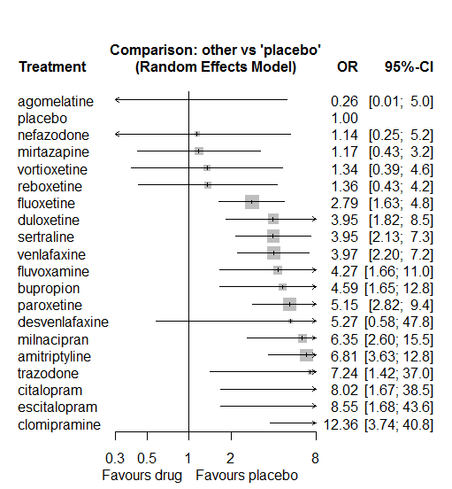

P-score

agomelatine 0.93

placebo 0.88

mirtazapine 0.84

nefazodone 0.82

vortioxetine 0.80

reboxetine 0.79

fluoxetine 0.63

sertraline 0.48

duloxetine 0.47

venlafaxine 0.47

fluvoxamine 0.44

bupropion 0.41

desvenlafaxine 0.38

paroxetine 0.34

trazodone 0.27

milnacipran 0.27

citalopram 0.24

escitalopram 0.22

amitriptyline 0.22

clomipramine 0.10

# **Arrhythmia/Heart rate disorder**

We remove all arms for which dose range was not “Licenced”. After this:

* Removed 9 one-arm studies: Hormazabal1985, Hewett2010a (AK130940) (NCT00093288), Lieberman2008a (Study 309)(EUCTR2004-000562-13, 3151A1-309-EU, NCT00090649), Lieberman2008b (Study 317), Jiang2009, Li2010, Lapierre1987, Sacchetti2002 (BRL-29060/109), Bosc1997b (Study 016 - Massana 1999)
* Total number of arms 230. Total number of studies 97.
* Total events in placebo 218, out of a total of 6528 patients. Event rate placebo 0.033
* Total events in drugs 1203, out of a total of 19766 patients. Event rate drugs 0.061

## **Distribution of dose across drugs**

Here we count the number of arms per drug, and the percent of these arms where Dose_intended_min was equal to the minimum licensed dose or lower. The values we used as minimum licensed dose are as follows:

agomelatine: 25; amitriptyline: 75; bupropion:300; citalopram:20; clomipramine:30; desvenlafaxine:50; duloxetine:40; escitalopram:10; fluoxetine:20; fluvoxamine:50; levomilnacipran:40; milnacipran:50; mirtazapine:15; nefazodone:300; paroxetine:20; reboxetine:8; sertraline:50; trazodone:150; venlafaxine:75; vilazodone:20; vortioxetine:5

Drug number.arms percent.low.dose

1 paroxetine 23 0.78

2 sertraline 13 0.85

3 milnacipran 7 0.00

4 amitriptyline 22 0.73

5 fluvoxamine 7 0.43

6 fluoxetine 14 1.00

8 levomilnacipran 9 0.56

9 reboxetine 11 1.00

10 bupropion 9 0.89

11 escitalopram 3 0.67

12 desvenlafaxine 3 0.33

13 duloxetine 15 0.27

14 venlafaxine 12 0.67

15 citalopram 4 0.75

16 mirtazapine 2 1.00

17 trazodone 4 1.00

18 vortioxetine 10 0.40

19 agomelatine 2 1.00

20 clomipramine 3 0.00

## **Network graph**

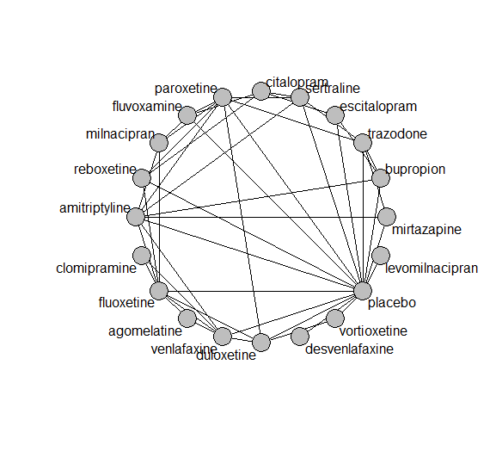

## **Pairwise MA**

### **Grouping all drugs together, comparison vs. placebo**

Number of studies: 57

Random effects meta-analysis: OR=1.67. 95% CI 1.4 to 2

Prediction interval 1.2 to 2.33

Heterogeneity (tau squared) was estimated to be 0.02 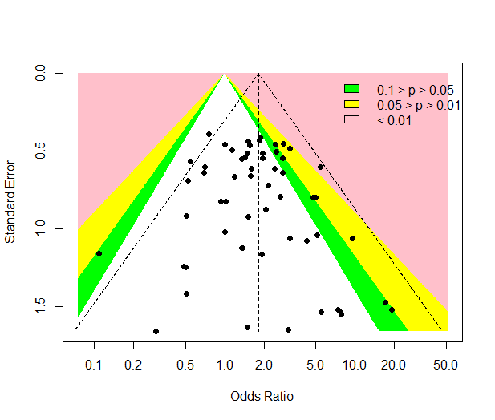

No evidence of an asymmetry (Harbord’s test p-value =0.6)

### **Meta-analyses of comparisons with 10 or more studies**

We show results from pairwise comparisons informed by 10 studies or more. An OR larger than 1 favors the first treatment in the comparison.

comparisons Number.of.studies OR lower.CI upper.CI tau.sq I.sq

1 placebo - paroxetine 11 1.29 0.85 2.21 0 0

## **Assessment of transitivity**

comparison studies baseline_SD age_SD female

1 paroxetine - sertraline 1 24 (NA) NaN (NA) NaN (NA)

2 amitriptyline - milnacipran 1 26 (NA) 50 (NA) NaN (NA)

3 fluvoxamine - milnacipran 2 24 (0.4) 49 (2) NaN (NA)

4 fluoxetine - milnacipran 1 23 (NA) 45 (NA) NaN (NA)

5 levomilnacipran - placebo 6 24 (1.1) 43 (1.4) 0.63 (0.02)

6 amitriptyline - placebo 6 25 (2.6) 41 (1.7) NaN (NA)

7 paroxetine - reboxetine 3 22 (2.1) 41 (2.7) 0.69 (0.07)

8 placebo - reboxetine 8 23 (2) 42 (3.2) 0.64 (0.07)

9 amitriptyline - sertraline 5 25 (2.1) 51 (11.7) 0.6 (0.11)

10 amitriptyline - paroxetine 5 25 (1.8) 46 (3.7) 0.81 (0.24)

11 amitriptyline - bupropion 1 23 (NA) 37 (NA) NaN (NA)

12 fluvoxamine - placebo 3 22 (2.1) 40 (2.3) NaN (NA)

13 fluoxetine - placebo 4 20 (2.1) 39 (3.3) 0.61 (0.02)

14 fluoxetine - reboxetine 2 24 (1.1) 39 (1.3) 0.63 (0)

15 bupropion - escitalopram 1 NaN (NA) 37 (NA) NaN (NA)

16 bupropion - placebo 6 26 (2.1) 43 (5.1) 0.36 (0.2)

17 escitalopram - placebo 2 NaN (NA) 38 (2.4) 0.72 (NA)

18 desvenlafaxine - placebo 2 23 (0.5) 41 (1) 0.61 (0.07)

19 amitriptyline - fluoxetine 4 24 (2.2) 47 (14.4) 0.64 (0.17)

20 duloxetine - placebo 8 20 (2.5) 42 (1.7) 0.74 (NA)

21 duloxetine - paroxetine 5 20 (1.7) 42 (2.7) NaN (NA)

22 paroxetine - placebo 11 21 (2.4) 41 (3) 0.55 (0.19)

23 fluoxetine - venlafaxine 1 27 (NA) 43 (NA) 0.64 (NA)

24 placebo - sertraline 4 21 (4.7) 42 (4) 0.56 (0.1)

25 citalopram - sertraline 1 22 (NA) 48 (NA) NaN (NA)

26 duloxetine - fluoxetine 2 18 (0.2) 41 (0.6) NaN (NA)

27 mirtazapine - placebo 2 23 (2.4) 62 (NA) 0.54 (NA)

28 mirtazapine - trazodone 1 22 (NA) 62 (NA) 0.54 (NA)

29 placebo - trazodone 1 22 (NA) 62 (NA) 0.54 (NA)

30 placebo - vortioxetine 4 24 (2.1) 43 (3.4) 0.61 (0.11)

31 placebo - venlafaxine 4 23 (0.4) 42 (2.5) 0.56 (0.09)

32 milnacipran - paroxetine 1 22 (NA) 36 (NA) 0.53 (NA)

33 fluvoxamine - paroxetine 1 21 (NA) 41 (NA) NaN (NA)

34 agomelatine - venlafaxine 1 26 (NA) 40 (NA) 0.71 (NA)

35 duloxetine - vortioxetine 1 25 (NA) 43 (NA) 0.74 (NA)

36 clomipramine - fluoxetine 2 23 (3.9) 46 (3.1) 0.64 (0.01)

37 citalopram - escitalopram 1 28 (NA) 45 (NA) NaN (NA)

38 sertraline - trazodone 1 22 (NA) 46 (NA) 0.65 (NA)

39 duloxetine - venlafaxine 2 23 (0.5) 43 (1.4) 0.68 (0.03)

40 clomipramine - venlafaxine 1 25 (NA) 47 (NA) NaN (NA)

41 amitriptyline - venlafaxine 1 21 (NA) 47 (NA) NaN (NA)

42 agomelatine - fluoxetine 1 27 (NA) 39 (NA) 0.69 (NA)

43 amitriptyline - mirtazapine 1 25 (NA) NaN (NA) NaN (NA)

44 citalopram - reboxetine 1 24 (NA) 42 (NA) 0.64 (NA)

45 citalopram - fluvoxamine 1 24 (NA) NaN (NA) NaN (NA)

46 paroxetine - trazodone 1 24 (NA) 39 (NA) NaN (NA)

47 bupropion - trazodone 1 22 (NA) 40 (NA) NaN (NA)

## **NMA**

A total of 20 treatments are included in the network.

A total of 97 studies are included in this analysis.

Estimated heterogeneity tau-squared 0.00

Global test for inconsistency, p-value 0.25443 (Q=44,d.o.f.39)

### **Comparison vs. placebo**

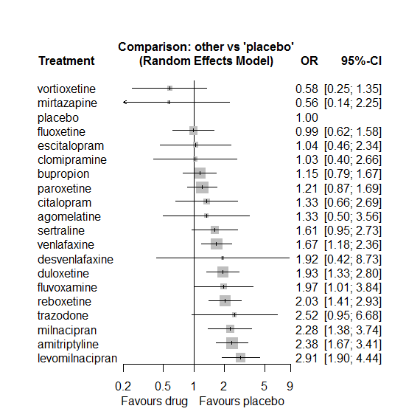

### **Ranking according to P-scores**

P-score

vortioxetine 0.92

mirtazapine 0.87

placebo 0.77

fluoxetine 0.76

escitalopram 0.70

clomipramine 0.70

bupropion 0.67

paroxetine 0.64

citalopram 0.57

agomelatine 0.56

sertraline 0.44

venlafaxine 0.42

desvenlafaxine 0.38

duloxetine 0.31

fluvoxamine 0.31

reboxetine 0.28

trazodone 0.21

milnacipran 0.21

amitriptyline 0.17

levomilnacipran 0.09

### **Local inconsistency**

Percent of comparisons where there is some evidence (p-value<0.05) of disagreement between direct and indirect sources: 0.07. (3 out of 45 comparisons)

comparison TE seTE lower upper z p

8 agomelatine:fluoxetine -0.583 1.00 -2.54 1.3717 -0.585 0.559

18 agomelatine:venlafaxine 0.583 1.00 -1.37 2.5386 0.585 0.559

20 amitriptyline:bupropion -1.011 0.51 -2.02 -0.0065 -1.973 0.049

26 amitriptyline:fluoxetine 0.245 0.54 -0.82 1.3056 0.453 0.650

29 amitriptyline:milnacipran -0.566 0.61 -1.75 0.6211 -0.934 0.350

30 amitriptyline:mirtazapine 1.651 1.43 -1.15 4.4525 1.155 0.248

31 amitriptyline:paroxetine 1.154 0.49 0.20 2.1096 2.366 0.018

32 amitriptyline:placebo 0.133 0.37 -0.59 0.8558 0.359 0.719

34 amitriptyline:sertraline -0.180 0.53 -1.22 0.8554 -0.341 0.733

36 amitriptyline:venlafaxine -0.691 0.82 -2.30 0.9135 -0.844 0.399

42 bupropion:escitalopram 0.413 0.94 -1.44 2.2614 0.438 0.661

49 bupropion:placebo -0.986 0.47 -1.91 -0.0605 -2.088 0.037

52 bupropion:trazodone 0.014 1.00 -1.95 1.9741 0.014 0.989

58 citalopram:escitalopram -1.587 1.73 -4.98 1.8045 -0.917 0.359

60 citalopram:fluvoxamine -0.888 0.70 -2.25 0.4777 -1.274 0.203

66 citalopram:reboxetine 0.626 0.91 -1.16 2.4139 0.687 0.492

67 citalopram:sertraline 0.890 0.74 -0.57 2.3488 1.195 0.232

74 clomipramine:fluoxetine 0.766 0.98 -1.16 2.6901 0.781 0.435

84 clomipramine:venlafaxine -0.766 0.98 -2.69 1.1575 -0.781 0.435

101 duloxetine:fluoxetine -0.594 0.90 -2.36 1.1736 -0.659 0.510

106 duloxetine:paroxetine -0.225 0.42 -1.04 0.5923 -0.540 0.589

107 duloxetine:placebo -0.341 0.41 -1.14 0.4600 -0.834 0.404

111 duloxetine:venlafaxine 0.519 0.37 -0.21 1.2520 1.388 0.165

112 duloxetine:vortioxetine -0.994 0.89 -2.74 0.7565 -1.113 0.266

119 escitalopram:placebo -1.392 1.33 -4.00 1.2195 -1.045 0.296

127 fluoxetine:milnacipran 0.571 0.62 -0.64 1.7855 0.922 0.356

130 fluoxetine:placebo 0.602 0.52 -0.42 1.6262 1.152 0.249

131 fluoxetine:reboxetine -0.694 0.56 -1.79 0.4029 -1.240 0.215

134 fluoxetine:venlafaxine -0.909 0.86 -2.59 0.7709 -1.061 0.289

137 fluvoxamine:milnacipran -0.695 0.69 -2.04 0.6505 -1.012 0.311

139 fluvoxamine:paroxetine 1.108 1.20 -1.25 3.4697 0.920 0.358

140 fluvoxamine:placebo -0.719 0.80 -2.29 0.8530 -0.897 0.370

156 milnacipran:paroxetine -0.341 0.47 -1.27 0.5844 -0.722 0.470

164 mirtazapine:placebo 1.625 1.48 -1.27 4.5228 1.099 0.272

167 mirtazapine:trazodone 0.963 1.48 -1.94 3.8662 0.651 0.515

170 paroxetine:placebo 0.113 0.34 -0.56 0.7867 0.330 0.741

171 paroxetine:reboxetine 0.379 0.42 -0.44 1.2002 0.903 0.366

172 paroxetine:sertraline 0.756 0.61 -0.44 1.9513 1.239 0.215

173 paroxetine:trazodone -0.040 1.35 -2.69 2.6138 -0.029 0.977

176 placebo:reboxetine 0.071 0.43 -0.78 0.9167 0.164 0.870

177 placebo:sertraline -1.168 0.60 -2.35 0.0115 -1.941 0.052

178 placebo:trazodone -1.225 1.23 -3.64 1.1915 -0.994 0.320

179 placebo:venlafaxine -0.157 0.36 -0.86 0.5417 -0.441 0.659

180 placebo:vortioxetine 0.775 1.09 -1.36 2.9111 0.711 0.477

185 sertraline:trazodone 0.564 1.54 -2.46 3.5838 0.366 0.714

### **League table**

Below we show the league table. Upper triangle: direct evidence. Lower triangle: NMA. An odds ratio larger than 1 in the upper triangle favors the column-defining drug. An odds ratio larger than 1 in the bottom triangle favors the row-defining drug.

|  |  |  |  |  |  |  |  |  |  |  |  |  |  |  |  |  |  |  |  |
| --- | --- | --- | --- | --- | --- | --- | --- | --- | --- | --- | --- | --- | --- | --- | --- | --- | --- | --- | --- |
| AGOM | . | . | . | . | . | . | . | 1.00 [0.25; 4.03] | . | . | . | . | . | . | . | . | . | 1.01 [0.29; 3.56] | . |
| 0.56 [0.20; 1.54] | AMIT | 1.03 [0.45; 2.38] | . | . | . | . | . | 2.84 [1.20; 6.73] | . | . | 0.69 [0.25; 1.92] | 10.76 [1.31; 88.47] | 4.77 [2.06; 11.02] | 2.58 [1.48; 4.47] | . | 1.37 [0.69; 2.73] | . | 0.76 [0.16; 3.51] | . |
| 1.16 [0.41; 3.31] | 2.08 [1.31; 3.31] | BUPR | . | . | . | . | 1.45 [0.32; 6.61] | . | . | . | . | . | . | 0.93 [0.61; 1.42] | . | . | 0.46 [0.11; 1.92] | . | . |
| 1.00 [0.30; 3.27] | 1.79 [0.86; 3.70] | 0.86 [0.39; 1.88] | CITA | . | . | . | 0.31 [0.01; 7.65] | . | 0.56 [0.30; 1.05] | . | . | . | . | . | 1.07 [0.22; 5.22] | 1.35 [0.46; 3.96] | . | . | . |
| 1.29 [0.35; 4.74] | 2.32 [0.87; 6.22] | 1.12 [0.40; 3.09] | 1.30 [0.41; 4.14] | CLOM | . | . | . | 1.60 [0.38; 6.76] | . | . | . | . | . | . | . | . | . | 0.47 [0.15; 1.48] | . |
| 0.69 [0.11; 4.21] | 1.24 [0.26; 5.87] | 0.60 [0.13; 2.83] | 0.69 [0.13; 3.67] | 0.53 [0.09; 3.19] | DESV | . | . | . | . | . | . | . | . | 1.92 [0.42; 8.73] | . | . | . | . | . |
| 0.69 [0.25; 1.87] | 1.23 [0.77; 1.98] | 0.59 [0.35; 1.00] | 0.69 [0.32; 1.48] | 0.53 [0.20; 1.39] | 1.00 [0.21; 4.73] | DULO | . | 1.15 [0.22; 6.12] | . | . | . | . | 1.42 [0.80; 2.54] | 1.53 [0.79; 2.97] | . | . | . | 1.33 [0.91; 1.94] | 2.01 [0.57; 7.07] |
| 1.28 [0.36; 4.56] | 2.29 [0.95; 5.50] | 1.10 [0.46; 2.62] | 1.28 [0.45; 3.62] | 0.99 [0.28; 3.43] | 1.85 [0.33; 10.28] | 1.86 [0.76; 4.51] | ESCI | . | . | . | . | . | . | 0.90 [0.38; 2.11] | . | . | . | . | . |
| 1.35 [0.51; 3.58] | 2.41 [1.46; 3.99] | 1.16 [0.65; 2.09] | 1.35 [0.61; 2.99] | 1.04 [0.40; 2.70] | 1.95 [0.40; 9.50] | 1.96 [1.14; 3.36] | 1.05 [0.41; 2.68] | FLUO | . | . | 0.64 [0.24; 1.72] | . | . | 1.50 [0.64; 3.53] | 0.31 [0.13; 0.75] | . | . | 0.26 [0.05; 1.28] | . |
| 0.68 [0.21; 2.17] | 1.21 [0.60; 2.44] | 0.58 [0.27; 1.24] | 0.68 [0.39; 1.18] | 0.52 [0.17; 1.63] | 0.98 [0.19; 5.11] | 0.98 [0.47; 2.04] | 0.53 [0.19; 1.48] | 0.50 [0.23; 1.08] | FLUV | . | 0.61 [0.23; 1.59] | . | 4.46 [0.47; 42.51] | 1.14 [0.29; 4.49] | . | . | . | . | . |
| 0.46 [0.16; 1.34] | 0.82 [0.47; 1.43] | 0.39 [0.22; 0.70] | 0.46 [0.20; 1.04] | 0.35 [0.12; 1.00] | 0.66 [0.14; 3.19] | 0.67 [0.38; 1.17] | 0.36 [0.14; 0.89] | 0.34 [0.18; 0.64] | 0.68 [0.31; 1.49] | LEVO | . | . | . | 2.91 [1.90; 4.44] | . | . | . | . | . |
| 0.58 [0.20; 1.69] | 1.05 [0.63; 1.75] | 0.50 [0.28; 0.92] | 0.59 [0.28; 1.23] | 0.45 [0.16; 1.27] | 0.85 [0.17; 4.16] | 0.85 [0.48; 1.49] | 0.46 [0.18; 1.17] | 0.43 [0.25; 0.77] | 0.87 [0.44; 1.70] | 1.28 [0.66; 2.45] | MILN | . | 1.64 [0.92; 2.93] | . | . | . | . | . | . |
| 2.36 [0.44; 12.77] | 4.23 [1.05; 16.96] | 2.03 [0.50; 8.28] | 2.37 [0.51; 10.95] | 1.82 [0.34; 9.68] | 3.41 [0.44; 26.53] | 3.43 [0.83; 14.24] | 1.85 [0.37; 9.14] | 1.75 [0.41; 7.43] | 3.49 [0.76; 15.96] | 5.15 [1.21; 21.93] | 4.04 [0.95; 17.19] | MIRT | . | 1.00 [0.18; 5.59] | . | . | 0.31 [0.06; 1.59] | . | . |
| 1.10 [0.40; 3.01] | 1.97 [1.31; 2.95] | 0.95 [0.58; 1.54] | 1.10 [0.54; 2.24] | 0.85 [0.32; 2.26] | 1.59 [0.34; 7.48] | 1.60 [1.06; 2.40] | 0.86 [0.36; 2.05] | 0.82 [0.49; 1.36] | 1.63 [0.83; 3.18] | 2.40 [1.40; 4.12] | 1.88 [1.20; 2.95] | 0.47 [0.11; 1.90] | PARO | 1.29 [0.78; 2.12] | 0.72 [0.40; 1.27] | 1.29 [0.47; 3.55] | 0.47 [0.04; 5.20] | . | . |
| 1.33 [0.50; 3.56] | 2.38 [1.67; 3.41] | 1.15 [0.79; 1.67] | 1.33 [0.66; 2.69] | 1.03 [0.40; 2.66] | 1.92 [0.42; 8.73] | 1.93 [1.33; 2.80] | 1.04 [0.46; 2.34] | 0.99 [0.62; 1.58] | 1.97 [1.01; 3.84] | 2.91 [1.90; 4.44] | 2.28 [1.38; 3.74] | 0.56 [0.14; 2.25] | 1.21 [0.87; 1.69] | PLAC | 0.50 [0.33; 0.76] | 0.27 [0.10; 0.73] | 0.15 [0.02; 1.29] | 0.56 [0.35; 0.88] | 2.02 [0.78; 5.22] |
| 0.65 [0.23; 1.83] | 1.17 [0.73; 1.88] | 0.56 [0.34; 0.95] | 0.66 [0.31; 1.37] | 0.51 [0.19; 1.37] | 0.95 [0.20; 4.49] | 0.95 [0.58; 1.55] | 0.51 [0.21; 1.24] | 0.49 [0.29; 0.82] | 0.97 [0.47; 1.98] | 1.43 [0.82; 2.50] | 1.12 [0.64; 1.95] | 0.28 [0.07; 1.15] | 0.60 [0.40; 0.90] | 0.49 [0.34; 0.71] | REBO | . | . | . | . |
| 0.83 [0.28; 2.47] | 1.48 [0.89; 2.48] | 0.71 [0.38; 1.33] | 0.83 [0.40; 1.72] | 0.64 [0.22; 1.85] | 1.20 [0.24; 5.94] | 1.20 [0.65; 2.21] | 0.65 [0.25; 1.69] | 0.61 [0.32; 1.18] | 1.22 [0.58; 2.57] | 1.81 [0.92; 3.56] | 1.41 [0.75; 2.68] | 0.35 [0.08; 1.49] | 0.75 [0.44; 1.29] | 0.62 [0.37; 1.05] | 1.26 [0.69; 2.31] | SERT | 1.03 [0.06; 16.91] | . | . |
| 0.53 [0.13; 2.09] | 0.95 [0.35; 2.58] | 0.45 [0.17; 1.21] | 0.53 [0.16; 1.71] | 0.41 [0.11; 1.58] | 0.76 [0.13; 4.62] | 0.77 [0.27; 2.15] | 0.41 [0.12; 1.45] | 0.39 [0.14; 1.14] | 0.78 [0.25; 2.49] | 1.15 [0.40; 3.34] | 0.90 [0.31; 2.62] | 0.22 [0.06; 0.87] | 0.48 [0.18; 1.31] | 0.40 [0.15; 1.05] | 0.81 [0.29; 2.26] | 0.64 [0.22; 1.84] | TRAZ | . | . |
| 0.80 [0.30; 2.08] | 1.43 [0.90; 2.25] | 0.69 [0.41; 1.13] | 0.80 [0.37; 1.71] | 0.61 [0.24; 1.55] | 1.15 [0.24; 5.43] | 1.16 [0.84; 1.60] | 0.62 [0.26; 1.50] | 0.59 [0.35; 0.99] | 1.18 [0.57; 2.44] | 1.74 [1.01; 3.00] | 1.36 [0.78; 2.39] | 0.34 [0.08; 1.39] | 0.72 [0.47; 1.11] | 0.60 [0.42; 0.85] | 1.22 [0.75; 1.96] | 0.96 [0.53; 1.76] | 1.51 [0.54; 4.20] | VENL | . |
| 2.31 [0.64; 8.36] | 4.14 [1.66; 10.33] | 1.99 [0.79; 5.04] | 2.32 [0.78; 6.92] | 1.78 [0.51; 6.29] | 3.34 [0.59; 18.95] | 3.36 [1.40; 8.05] | 1.81 [0.56; 5.85] | 1.72 [0.66; 4.48] | 3.42 [1.17; 10.00] | 5.05 [1.95; 13.05] | 3.95 [1.49; 10.45] | 0.98 [0.19; 4.96] | 2.10 [0.86; 5.17] | 1.74 [0.74; 4.06] | 3.53 [1.41; 8.86] | 2.79 [1.03; 7.54] | 4.38 [1.21; 15.90] | 2.90 [1.19; 7.06] | VORT |

### **Estimated event rates**

For an event rate in placebo equal to the average event rate (i.e. fixed to 0.03) the estimated event rates for each drug are as follows

drug rate

1 agomelatine 0.04 [0.02, 0.11]

2 amitriptyline 0.08 [0.05, 0.11]

3 bupropion 0.04 [0.03, 0.05]

4 citalopram 0.04 [0.02, 0.09]

5 clomipramine 0.03 [0.01, 0.08]

6 desvenlafaxine 0.06 [0.01, 0.23]

7 duloxetine 0.06 [0.04, 0.09]

8 escitalopram 0.03 [0.02, 0.07]

9 fluoxetine 0.03 [0.02, 0.05]

10 fluvoxamine 0.06 [0.03, 0.12]

11 levomilnacipran 0.09 [0.06, 0.13]

12 milnacipran 0.07 [0.05, 0.11]

13 mirtazapine 0.02 [0, 0.07]

14 paroxetine 0.04 [0.03, 0.06]

16 reboxetine 0.07 [0.05, 0.09]

17 sertraline 0.05 [0.03, 0.09]

18 trazodone 0.08 [0.03, 0.19]

19 venlafaxine 0.05 [0.04, 0.08]

20 vortioxetine 0.02 [0.01, 0.04]

## **Sensitivity analysis: splitting nodes according to dosage**

All treatment arms for drug X, with dose_intended_min equal to or smaller to the minimum licensed dose were set as “X_L”. All other arms of X are “X_H”. Studies with no information on dose are excluded. Results shown below:

|  |  |  |
| --- | --- | --- |
| **Low dose vs. placebo** | **High dose vs. placebo** | **High dose vs. low dose** |
|  |  |  |

## **Sensitivity analysis: Keeping only low dropout arms**

We exclude all treatment arms with dropout rates larger than 25%, and we re-analyse the network.

Total number of arms included in the analysis 91. Total number of studies 44

Total events in placebo 104, out of a total of 3623 patients. Event rate placebo 0.029

Total events in drugs 577, out of a total of 11145 patients. Event rate drugs 0.052 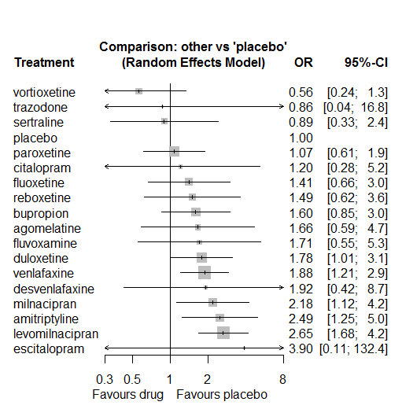

P-score

vortioxetine 0.91

sertraline 0.77

placebo 0.76

paroxetine 0.72

trazodone 0.64

citalopram 0.60

fluoxetine 0.55

reboxetine 0.51

bupropion 0.48

agomelatine 0.45

fluvoxamine 0.44

duloxetine 0.41

desvenlafaxine 0.40

venlafaxine 0.37

escitalopram 0.30

milnacipran 0.28

amitriptyline 0.21

levomilnacipran 0.19

# **Musculoskeletal pain and discomfort**

We remove all arms for which dose range was not “Licenced”. After this:

* Removed 4 one-arm studies: Stahl2010 (CAGO178A2302), Montgomery2004b (CL3-20098-030), Hewett2010a (AK130940) (NCT00093288), McGrath2000
* Total number of studies with number randomized being smaller than event rates: 1
* Removed the following studies: Rush1998 (excluding Armitage1997 and Gillin1997)
* Total number of arms 178. Total number of studies 70.
* Total events in placebo 303, out of a total of 6983 patients. Event rate placebo 0.043
* Total events in drugs 816, out of a total of 16508 patients. Event rate drugs 0.049

## **Distribution of dose across drugs**

Here we count the number of arms per drug, and the percent of these arms where Dose_intended_min was equal to the minimum licensed dose or lower. The values we used as minimum licensed dose are as follows:

agomelatine: 25; amitriptyline: 75; bupropion:300; citalopram:20; clomipramine:30; desvenlafaxine:50; duloxetine:40; escitalopram:10; fluoxetine:20; fluvoxamine:50; levomilnacipran:40; milnacipran:50; mirtazapine:15; nefazodone:300; paroxetine:20; reboxetine:8; sertraline:50; trazodone:150; venlafaxine:75; vilazodone:20; vortioxetine:5

Drug number.arms percent.low.dose

2 levomilnacipran 3 0.33

3 reboxetine 8 1.00

4 paroxetine 20 0.90

5 escitalopram 15 0.93

6 trazodone 5 1.00

7 fluoxetine 14 1.00

8 mirtazapine 2 1.00

9 citalopram 5 0.80

10 bupropion 6 1.00

11 sertraline 3 1.00

12 agomelatine 4 0.75

13 amitriptyline 1 1.00

14 duloxetine 16 0.25

15 nefazodone 1 1.00

16 vortioxetine 17 0.41

17 venlafaxine 6 0.67

## **Network graph**

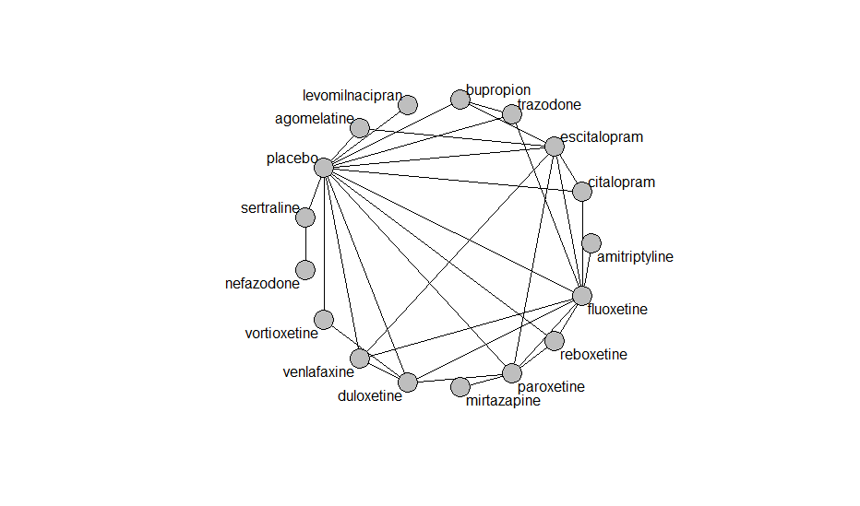

## **Pairwise MA**

### **Grouping all drugs together, comparison vs. placebo**

Number of studies: 52

Random effects meta-analysis: OR=0.72. 95% CI 0.62 to 0.85

Heterogeneity (tau squared) was estimated to be 0.00 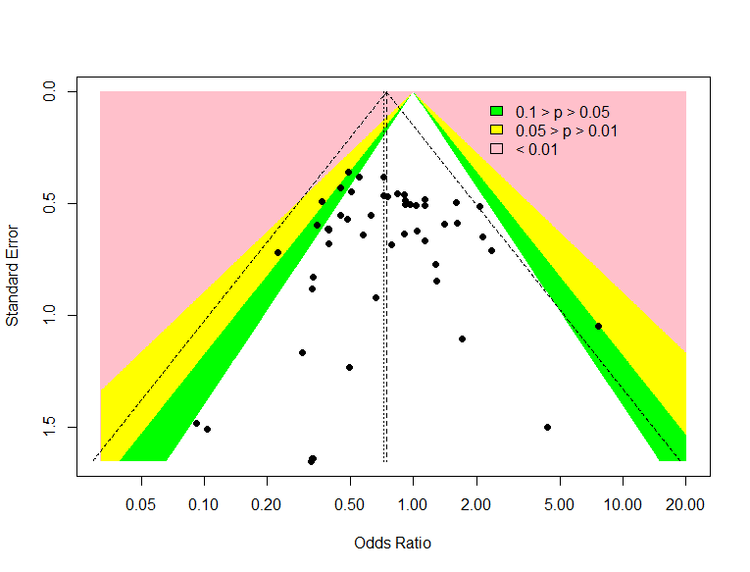

No evidence of an asymmetry (Harbord’s test p-value =0.10)

### **Meta-analyses of comparisons with 10 or more studies**

We show results from pairwise comparisons informed by 10 studies or more. An OR larger than 1 favors the first treatment in the comparison.

comparisons Number.of.studies OR lower.CI upper.CI tau.sq I.sq

1 placebo - duloxetine 10 0.69 0.47 1.01 0.00 0.00

2 placebo - escitalopram 10 0.83 0.60 1.25 0.37 0.46

3 placebo - paroxetine 14 0.57 0.41 0.79 0.00 0.00

## **Assessment of transitivity**

comparison studies baseline_SD age_SD female

1 levomilnacipran - placebo 1 25 (NA) 41 (NA) 0.63 (NA)

2 paroxetine - reboxetine 3 22 (2.1) 41 (2.7) 0.69 (0.07)

3 escitalopram - paroxetine 1 23 (NA) 45 (NA) NaN (NA)

4 placebo - reboxetine 6 23 (2.2) 42 (3.2) 0.63 (0.08)

5 fluoxetine - trazodone 3 21 (0.8) 49 (17.2) 0.67 (NA)

6 mirtazapine - paroxetine 2 23 (1.4) 44 (5.1) NaN (NA)

7 fluoxetine - reboxetine 2 24 (1.6) 42 (2.6) 0.67 (0.06)

8 escitalopram - placebo 10 22 (0.9) 47 (13.3) 0.68 (0.06)

9 citalopram - escitalopram 4 23 (0) 43 (2.5) NaN (NA)

10 citalopram - placebo 3 23 (NA) 42 (1.6) NaN (NA)

11 fluoxetine - placebo 7 20 (1.9) 50 (16.1) 0.63 (NA)

12 bupropion - escitalopram 1 NaN (NA) 37 (NA) NaN (NA)

13 bupropion - placebo 4 24 (NA) 39 (2) NaN (NA)

14 placebo - sertraline 2 26 (NA) 41 (3.8) 0.63 (NA)

15 agomelatine - escitalopram 1 27 (NA) 43 (NA) 0.71 (NA)

16 amitriptyline - fluoxetine 1 26 (NA) 69 (NA) NaN (NA)

17 duloxetine - placebo 10 20 (2.3) 42 (1.6) 0.69 (0.07)

18 duloxetine - paroxetine 4 19 (1.7) 43 (2) NaN (NA)

19 paroxetine - placebo 14 22 (2.4) 43 (7.6) 0.63 (0.13)

20 nefazodone - sertraline 1 23 (NA) 44 (NA) 0.52 (NA)

21 fluoxetine - paroxetine 2 22 (NA) 40 (2.4) NaN (NA)

22 duloxetine - fluoxetine 2 18 (0.2) 41 (0.6) NaN (NA)

23 placebo - vortioxetine 8 24 (1.6) 43 (2.4) 0.64 (0.09)

24 agomelatine - placebo 2 27 (0) 58 (19.8) 0.67 (0)

25 placebo - venlafaxine 2 22 (2) 58 (18.9) NaN (NA)

26 escitalopram - fluoxetine 1 22 (NA) 75 (NA) NaN (NA)

27 duloxetine - vortioxetine 2 25 (NA) 43 (0.1) 0.69 (0.07)

28 escitalopram - venlafaxine 1 20 (NA) 48 (NA) NaN (NA)

29 citalopram - fluoxetine 1 23 (NA) 44 (NA) NaN (NA)

30 duloxetine - venlafaxine 2 23 (0.5) 43 (1.4) 0.68 (0.03)

31 fluoxetine - venlafaxine 1 21 (NA) 71 (NA) NaN (NA)

32 placebo - trazodone 1 22 (NA) 44 (NA) 0.64 (NA)

33 bupropion - trazodone 1 22 (NA) 40 (NA) NaN (NA)

## **NMA**

A total of 17 treatments are included in the network.

A total of 70 studies are included in this analysis.

Estimated heterogeneity tau-squared 0.03

Global test for inconsistency, p-value 0.47996 (Q=30,d.o.f.30)

### **Comparison vs. placebo**

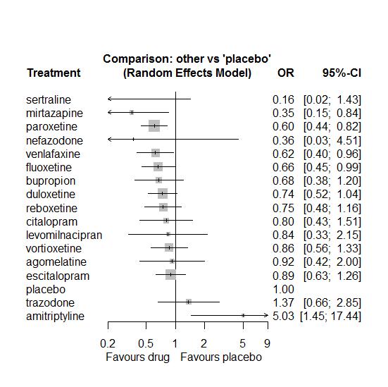

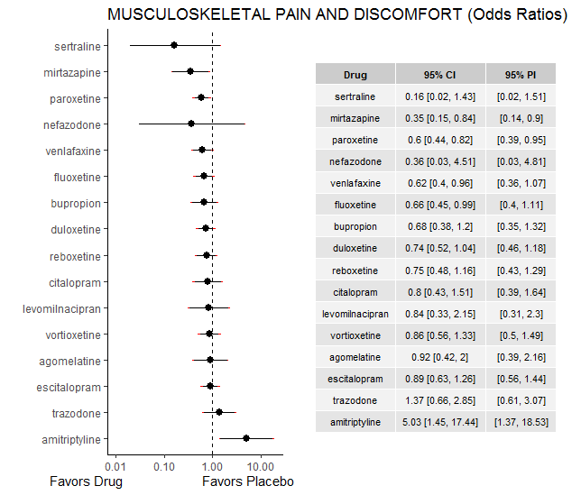

### **Ranking according to P-scores**

P-score

sertraline 0.91

mirtazapine 0.87

paroxetine 0.70

nefazodone 0.69

venlafaxine 0.67

fluoxetine 0.62

bupropion 0.59

duloxetine 0.52

reboxetine 0.51

citalopram 0.46

levomilnacipran 0.44

vortioxetine 0.39

agomelatine 0.37

escitalopram 0.35

placebo 0.24

trazodone 0.16

amitriptyline 0.01

### **Local inconsistency**

Percent of comparisons where there is some evidence (p-value<0.05) of disagreement between direct and indirect sources: 0.11. (3 out of 28 comparisons)

comparison TE seTE lower upper z p

5 agomelatine:escitalopram -0.707 0.82 -2.31 0.89 -0.8659 0.387

11 agomelatine:placebo 0.707 0.82 -0.89 2.31 0.8659 0.387

34 bupropion:escitalopram -0.914 0.92 -2.71 0.88 -0.9963 0.319

40 bupropion:placebo 0.943 1.11 -1.23 3.12 0.8486 0.396

43 bupropion:trazodone -0.908 1.25 -3.35 1.54 -0.7281 0.467

47 citalopram:escitalopram -0.264 0.74 -1.71 1.18 -0.3577 0.721

48 citalopram:fluoxetine 2.453 1.54 -0.56 5.47 1.5945 0.111

53 citalopram:placebo -0.300 0.66 -1.60 1.00 -0.4541 0.650

60 duloxetine:fluoxetine -1.429 0.64 -2.67 -0.18 -2.2482 0.025

64 duloxetine:paroxetine 0.037 0.46 -0.86 0.94 0.0807 0.936

65 duloxetine:placebo -0.252 0.39 -1.02 0.52 -0.6375 0.524

69 duloxetine:venlafaxine 0.537 0.47 -0.37 1.45 1.1547 0.248

70 duloxetine:vortioxetine -0.006 0.61 -1.21 1.20 -0.0099 0.992

71 escitalopram:fluoxetine 0.425 0.70 -0.95 1.80 0.6069 0.544

75 escitalopram:paroxetine -0.075 0.58 -1.22 1.07 -0.1288 0.898

76 escitalopram:placebo -0.192 0.38 -0.94 0.56 -0.5013 0.616

80 escitalopram:venlafaxine -0.523 0.60 -1.69 0.64 -0.8788 0.380

85 fluoxetine:paroxetine 0.851 0.50 -0.12 1.82 1.7128 0.087

86 fluoxetine:placebo -0.496 0.46 -1.40 0.41 -1.0697 0.285

87 fluoxetine:reboxetine -1.451 0.63 -2.69 -0.21 -2.2865 0.022

89 fluoxetine:trazodone 0.693 0.77 -0.81 2.20 0.9022 0.367

90 fluoxetine:venlafaxine -2.077 1.56 -5.13 0.97 -1.3356 0.182

116 paroxetine:placebo -0.240 0.40 -1.02 0.54 -0.6032 0.546

117 paroxetine:reboxetine 1.153 0.49 0.20 2.11 2.3645 0.018

122 placebo:reboxetine -0.296 0.56 -1.38 0.79 -0.5338 0.593

124 placebo:trazodone -0.330 0.75 -1.80 1.14 -0.4411 0.659

125 placebo:venlafaxine -0.212 0.58 -1.34 0.92 -0.3669 0.714

126 placebo:vortioxetine 0.642 0.99 -1.30 2.59 0.6468 0.518

### **League table**

Below we show the league table. Upper triangle: direct evidence. Lower triangle: NMA. An odds ratio larger than 1 in the upper triangle favors the column-defining drug. An odds ratio larger than 1 in the bottom triangle favors the row-defining drug.

|  |  |  |  |  |  |  |  |  |  |  |  |  |  |  |  |  |
| --- | --- | --- | --- | --- | --- | --- | --- | --- | --- | --- | --- | --- | --- | --- | --- | --- |
| AGOM | . | . | . | . | 0.69 [0.21; 2.30] | . | . | . | . | . | 1.20 [0.45; 3.22] | . | . | . | . | . |
| 0.18 [0.04; 0.79] | AMIT | . | . | . | . | 7.58 [2.33; 24.63] | . | . | . | . | . | . | . | . | . | . |
| 1.36 [0.52; 3.58] | 7.45 [1.90; 29.24] | BUPR | . | . | 0.35 [0.07; 1.82] | . | . | . | . | . | 0.73 [0.40; 1.32] | . | . | 0.23 [0.02; 2.16] | . | . |
| 1.15 [0.43; 3.04] | 6.28 [1.57; 25.09] | 0.84 [0.36; 1.97] | CITA | . | 0.84 [0.41; 1.71] | 12.04 [0.65; 223.15] | . | . | . | . | 0.71 [0.32; 1.60] | . | . | . | . | . |
| 1.25 [0.54; 2.91] | 6.83 [1.90; 24.59] | 0.92 [0.47; 1.79] | 1.09 [0.54; 2.21] | DULO | . | 0.36 [0.12; 1.08] | . | . | . | 1.25 [0.60; 2.59] | 0.69 [0.46; 1.03] | . | . | . | 1.31 [0.89; 1.93] | 0.85 [0.30; 2.38] |
| 1.03 [0.47; 2.27] | 5.62 [1.56; 20.25] | 0.75 [0.39; 1.46] | 0.90 [0.48; 1.67] | 0.82 [0.52; 1.31] | ESCI | 1.93 [0.55; 6.79] | . | . | . | 1.39 [0.49; 3.93] | 0.84 [0.56; 1.28] | . | . | . | 0.98 [0.36; 2.67] | . |
| 1.39 [0.58; 3.30] | 7.58 [2.33; 24.63] | 1.02 [0.51; 2.04] | 1.21 [0.58; 2.50] | 1.11 [0.67; 1.83] | 1.35 [0.82; 2.23] | FLUO | . | . | . | 1.93 [0.87; 4.27] | 0.58 [0.37; 0.93] | 0.31 [0.11; 0.89] | . | 0.71 [0.23; 2.14] | 0.14 [0.01; 2.88] | . |
| 1.10 [0.32; 3.72] | 5.99 [1.26; 28.54] | 0.80 [0.27; 2.43] | 0.95 [0.31; 2.97] | 0.88 [0.32; 2.39] | 1.07 [0.39; 2.91] | 0.79 [0.28; 2.20] | LEVO | . | . | . | 0.84 [0.33; 2.15] | . | . | . | . | . |
| 2.61 [0.82; 8.32] | 14.23 [3.17; 63.98] | 1.91 [0.67; 5.42] | 2.27 [0.78; 6.59] | 2.08 [0.83; 5.21] | 2.53 [1.01; 6.36] | 1.88 [0.74; 4.77] | 2.37 [0.66; 8.56] | MIRT | . | 0.59 [0.26; 1.32] | . | . | . | . | . | . |
| 2.53 [0.18; 35.18] | 13.80 [0.83; 228.55] | 1.85 [0.14; 24.49] | 2.20 [0.16; 29.44] | 2.02 [0.16; 25.61] | 2.45 [0.19; 31.13] | 1.82 [0.14; 23.26] | 2.30 [0.16; 33.83] | 0.97 [0.07; 13.90] | NEFA | . | . | . | 2.23 [0.62; 8.03] | . | . | . |
| 1.52 [0.66; 3.50] | 8.33 [2.35; 29.49] | 1.12 [0.58; 2.15] | 1.33 [0.66; 2.65] | 1.22 [0.80; 1.87] | 1.48 [0.96; 2.29] | 1.10 [0.69; 1.74] | 1.39 [0.51; 3.75] | 0.59 [0.26; 1.32] | 0.60 [0.05; 7.62] | PARO | 0.58 [0.41; 0.81] | 1.40 [0.73; 2.71] | . | . | . | . |
| 0.92 [0.42; 2.00] | 5.03 [1.45; 17.44] | 0.68 [0.38; 1.20] | 0.80 [0.43; 1.51] | 0.74 [0.52; 1.04] | 0.89 [0.63; 1.26] | 0.66 [0.45; 0.99] | 0.84 [0.33; 2.15] | 0.35 [0.15; 0.84] | 0.36 [0.03; 4.51] | 0.60 [0.44; 0.82] | PLAC | 1.26 [0.77; 2.07] | 6.12 [0.70; 53.33] | 0.62 [0.23; 1.72] | 1.35 [0.49; 3.77] | 1.20 [0.77; 1.88] |
| 1.24 [0.51; 3.01] | 6.75 [1.84; 24.80] | 0.91 [0.44; 1.87] | 1.08 [0.50; 2.31] | 0.99 [0.57; 1.71] | 1.20 [0.69; 2.08] | 0.89 [0.51; 1.55] | 1.13 [0.40; 3.19] | 0.47 [0.18; 1.22] | 0.49 [0.04; 6.29] | 0.81 [0.50; 1.31] | 1.34 [0.86; 2.08] | REBO | . | . | . | . |
| 5.63 [0.56; 56.21] | 30.76 [2.53; 373.75] | 4.13 [0.44; 38.84] | 4.90 [0.51; 46.77] | 4.50 [0.50; 40.35] | 5.47 [0.61; 49.04] | 4.06 [0.45; 36.68] | 5.13 [0.48; 54.47] | 2.16 [0.21; 22.30] | 2.23 [0.62; 8.03] | 3.69 [0.41; 32.94] | 6.12 [0.70; 53.33] | 4.56 [0.50; 41.54] | SERT | . | . | . |
| 0.67 [0.23; 1.95] | 3.68 [0.91; 14.86] | 0.49 [0.20; 1.21] | 0.59 [0.22; 1.53] | 0.54 [0.24; 1.20] | 0.65 [0.29; 1.46] | 0.48 [0.23; 1.03] | 0.61 [0.19; 2.02] | 0.26 [0.08; 0.80] | 0.27 [0.02; 3.66] | 0.44 [0.20; 0.97] | 0.73 [0.35; 1.52] | 0.54 [0.23; 1.27] | 0.12 [0.01; 1.18] | TRAZ | . | . |
| 1.48 [0.61; 3.58] | 8.10 [2.19; 29.98] | 1.09 [0.53; 2.24] | 1.29 [0.61; 2.73] | 1.19 [0.83; 1.69] | 1.44 [0.86; 2.41] | 1.07 [0.60; 1.89] | 1.35 [0.48; 3.82] | 0.57 [0.22; 1.48] | 0.59 [0.05; 7.55] | 0.97 [0.58; 1.62] | 1.61 [1.04; 2.49] | 1.20 [0.65; 2.21] | 0.26 [0.03; 2.40] | 2.20 [0.94; 5.14] | VENL | . |
| 1.07 [0.44; 2.60] | 5.84 [1.56; 21.78] | 0.78 [0.38; 1.62] | 0.93 [0.43; 2.00] | 0.85 [0.50; 1.45] | 1.04 [0.60; 1.81] | 0.77 [0.43; 1.39] | 0.97 [0.34; 2.75] | 0.41 [0.16; 1.08] | 0.42 [0.03; 5.44] | 0.70 [0.41; 1.19] | 1.16 [0.75; 1.80] | 0.86 [0.47; 1.61] | 0.19 [0.02; 1.73] | 1.59 [0.68; 3.72] | 0.72 [0.39; 1.32] | VORT |

### **Estimated event rates**

For an event rate in placebo equal to the average event rate (i.e. fixed to 0.04) the estimated event rates for each drug are as follows

drug rate

1 agomelatine 0.04 [0.02, 0.08]

2 amitriptyline 0.19 [0.06, 0.44]

3 bupropion 0.03 [0.02, 0.05]

4 citalopram 0.04 [0.02, 0.06]

5 duloxetine 0.03 [0.02, 0.05]

6 escitalopram 0.04 [0.03, 0.05]

7 fluoxetine 0.03 [0.02, 0.04]

8 levomilnacipran 0.04 [0.01, 0.09]

9 mirtazapine 0.02 [0.01, 0.04]

10 nefazodone 0.02 [0, 0.17]

11 paroxetine 0.03 [0.02, 0.04]

13 reboxetine 0.03 [0.02, 0.05]

14 sertraline 0.01 [0, 0.06]

15 trazodone 0.06 [0.03, 0.11]

16 venlafaxine 0.03 [0.02, 0.04]

17 vortioxetine 0.04 [0.02, 0.06]

## **Sensitivity analysis: splitting nodes according to dosage**

All treatment arms for drug X, with dose_intended_min equal to or smaller to the minimum licensed dose were set as “X_L”. All other arms of X are “X_H”. Studies with no information on dose are excluded. Results shown below:

|  |  |  |
| --- | --- | --- |
| **Low dose vs. placebo** | **High dose vs. placebo** | **High dose vs. low dose** |
|  |  |  |

## **Sensitivity analysis: Keeping only low dropout arms**

We exclude all treatment arms with dropout rates larger than 25%, and we re-analyse the network.

Total number of arms included in the analysis 62. Total number of studies 29

Total events in placebo 104, out of a total of 3623 patients. Event rate placebo 0.029

Total events in drugs 577, out of a total of 11145 patients. Event rate drugs 0.048 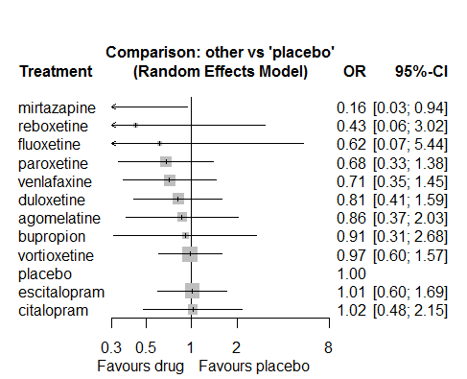

P-score

mirtazapine 0.93

reboxetine 0.69

paroxetine 0.61

venlafaxine 0.58

fluoxetine 0.56

duloxetine 0.48

agomelatine 0.44

bupropion 0.41

vortioxetine 0.35

citalopram 0.33

escitalopram 0.31

placebo 0.31

# **Visual disorder/impairment**

We remove all arms for which dose range was not “Licenced”. After this:

* Removed 9 one-arm studies: Roffman1982, Hormazabal1985, Amsterdam1986, Carman1991, Lieberman2008a (Study 309)(EUCTR2004-000562-13, 3151A1-309-EU, NCT00090649), Lieberman2008b (Study 317), Mullin1996, Goodarzi 2015(IRCT2012101811155N1), Kellams1979
* Total number of arms 207. Total number of studies 87.
* Total events in placebo 115, out of a total of 5043 patients. Event rate placebo 0.023

Total events in drugs 1025, out of a total of 15091 patients. Event rate drugs 0.068

## **Distribution of dose across drugs**

Here we count the number of arms per drug, and the percent of these arms where Dose_intended_min was equal to the minimum licensed dose or lower. The values we used as minimum licensed dose are as follows:

agomelatine: 25; amitriptyline: 75; bupropion:300; citalopram:20; clomipramine:30; desvenlafaxine:50; duloxetine:40; escitalopram:10; fluoxetine:20; fluvoxamine:50; levomilnacipran:40; milnacipran:50; mirtazapine:15; nefazodone:300; paroxetine:20; reboxetine:8; sertraline:50; trazodone:150; venlafaxine:75; vilazodone:20; vortioxetine:5

Drug number.arms percent.low.dose

1 paroxetine 20 0.90

3 sertraline 11 0.82

4 vortioxetine 12 0.33

5 venlafaxine 8 0.38

6 mirtazapine 6 0.67

7 fluoxetine 20 0.85

8 milnacipran 4 0.00

9 amitriptyline 23 0.61

10 fluvoxamine 2 0.00

11 nefazodone 5 0.80

12 reboxetine 11 0.91

13 bupropion 5 0.80

14 duloxetine 17 0.24

15 desvenlafaxine 3 0.33

16 citalopram 3 0.67

17 trazodone 3 1.00

18 escitalopram 1 0.00

19 clomipramine 2 0.00

## **Network graph**

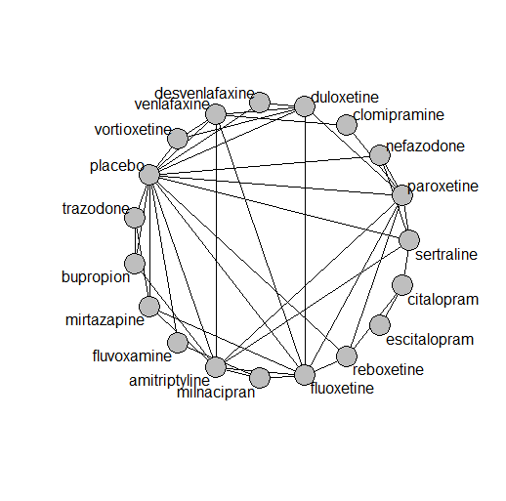

## **Pairwise MA**

### **Grouping all drugs together, comparison vs. placebo**

Number of studies: 49

Random effects meta-analysis: OR=2.35. 95% CI 1.89 to 2.93

Heterogeneity (tau squared) was estimated to be 0.00

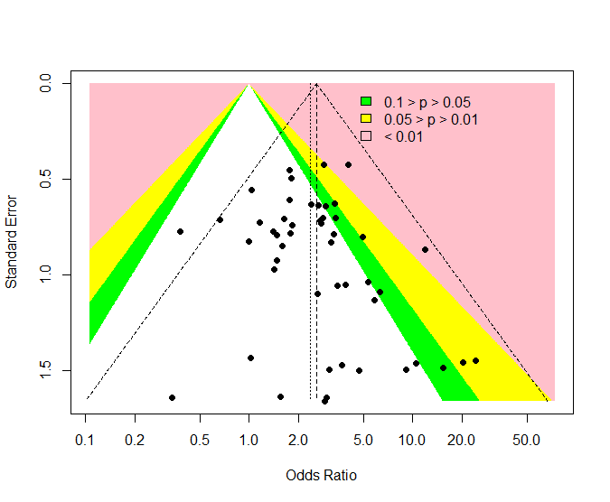

No evidence of an asymmetry (Harbord’s test p-value =1.00)

### **Meta-analyses of comparisons with 10 or more studies**

We show results from pairwise comparisons informed by 10 studies or more. An OR larger than 1 favors the first treatment in the comparison.

comparisons Number.of.studies OR lower.CI upper.CI tau.sq I.sq

1 placebo - duloxetine 11 2.14 1.46 4.18 0 0

## **Assessment of transitivity**

comparison studies baseline_SD age_SD female

1 paroxetine - placebo 9 21 (2.7) 42 (2.2) 0.59 (0.17)

2 paroxetine - sertraline 1 24 (NA) NaN (NA) NaN (NA)

3 placebo - venlafaxine 3 23 (3.2) 51 (17.1) 0.61 (0.01)

4 placebo - vortioxetine 6 24 (2.1) 43 (2.2) 0.65 (0.1)

5 venlafaxine - vortioxetine 1 22 (NA) 43 (NA) 0.62 (NA)

6 fluoxetine - mirtazapine 3 25 (1.3) 44 (6.3) NaN (NA)

7 amitriptyline - milnacipran 1 26 (NA) 50 (NA) NaN (NA)

8 fluvoxamine - milnacipran 1 24 (NA) 48 (NA) NaN (NA)

9 fluoxetine - milnacipran 1 23 (NA) 45 (NA) NaN (NA)

10 nefazodone - paroxetine 1 25 (NA) 38 (NA) 0.55 (NA)

11 paroxetine - reboxetine 3 22 (2.1) 41 (2.7) 0.69 (0.07)

12 placebo - reboxetine 8 24 (4.1) 42 (3.2) 0.62 (0.09)

13 amitriptyline - sertraline 4 25 (2.3) 51 (13.4) 0.6 (0.11)

14 fluoxetine - reboxetine 1 25 (NA) 44 (NA) 0.72 (NA)

15 amitriptyline - mirtazapine 2 26 (2) 38 (NA) NaN (NA)

16 amitriptyline - placebo 6 26 (2.7) 40 (1.2) NaN (NA)

17 mirtazapine - placebo 3 25 (3.1) 50 (16.7) 0.54 (NA)

18 fluoxetine - placebo 9 22 (3) 47 (12.8) 0.61 (0.05)

19 amitriptyline - bupropion 1 23 (NA) 37 (NA) NaN (NA)

20 amitriptyline - fluoxetine 6 24 (1.6) 41 (2.1) 0.67 (0.11)

21 duloxetine - placebo 11 21 (2.8) 42 (1.7) 0.69 (0.07)

22 desvenlafaxine - placebo 2 23 (0.2) 40 (0.5) 0.66 (NA)

23 fluoxetine - paroxetine 2 23 (2.7) 43 (2) NaN (NA)

24 placebo - sertraline 3 23 (1.7) 41 (4.5) 0.6 (0.1)

25 citalopram - sertraline 1 22 (NA) 48 (NA) NaN (NA)

26 nefazodone - sertraline 1 23 (NA) 44 (NA) 0.52 (NA)

27 nefazodone - placebo 3 26 (1.5) 40 (2.3) 0.64 (0.05)

28 amitriptyline - paroxetine 5 24 (0.4) 50 (12.1) 0.69 (0.27)

29 duloxetine - fluoxetine 2 18 (0.2) 41 (0.6) NaN (NA)

30 duloxetine - paroxetine 4 19 (1.9) 42 (3) NaN (NA)

31 mirtazapine - trazodone 1 22 (NA) 62 (NA) 0.54 (NA)

32 placebo - trazodone 2 22 (0.6) 53 (12.8) 0.59 (0.07)

33 fluvoxamine - placebo 1 24 (NA) 45 (NA) NaN (NA)

34 bupropion - placebo 2 27 (3.7) 46 (6.5) 0.5 (NA)

35 duloxetine - vortioxetine 2 25 (NA) 43 (0.1) 0.69 (0.07)

36 citalopram - escitalopram 1 28 (NA) 45 (NA) NaN (NA)

37 duloxetine - venlafaxine 2 23 (0.5) 43 (1.4) 0.68 (0.03)

38 clomipramine - paroxetine 1 24 (NA) 71 (NA) 0.89 (NA)

39 clomipramine - venlafaxine 1 25 (NA) 47 (NA) NaN (NA)

40 amitriptyline - venlafaxine 1 21 (NA) 47 (NA) NaN (NA)

41 fluoxetine - venlafaxine 2 24 (4.1) 55 (22.1) 0.6 (NA)

42 citalopram - reboxetine 1 24 (NA) 42 (NA) 0.64 (NA)

43 desvenlafaxine - duloxetine 1 23 (NA) 40 (NA) NaN (NA)

44 bupropion - trazodone 1 22 (NA) 40 (NA) NaN (NA)

## **NMA**

A total of 19 treatments are included in the network.

A total of 87 studies are included in this analysis.

Estimated heterogeneity tau-squared 0.00

Global test for inconsistency, p-value 0.99853 (Q=18,d.o.f.39)

### **Comparison vs. placebo**

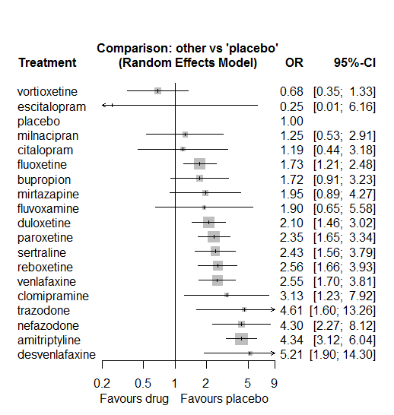

### **Ranking according to P-scores**

P-score

vortioxetine 0.93

escitalopram 0.89

placebo 0.86

milnacipran 0.76

citalopram 0.76

fluoxetine 0.64

bupropion 0.62

mirtazapine 0.55

fluvoxamine 0.54

duloxetine 0.52

paroxetine 0.44

sertraline 0.41

reboxetine 0.38

venlafaxine 0.37

clomipramine 0.30

trazodone 0.15

nefazodone 0.14

amitriptyline 0.12

desvenlafaxine 0.11

### **Local inconsistency**

Percent of comparisons where there is some evidence (p-value<0.05) of disagreement between direct and indirect sources: 0. (0 out of 43 comparisons)

comparison TE seTE lower upper z p

1 amitriptyline:bupropion 0.350 0.64 -0.906 1.61 0.5458 0.59

7 amitriptyline:fluoxetine 0.207 0.42 -0.612 1.03 0.4958 0.62

9 amitriptyline:milnacipran 0.169 0.85 -1.496 1.83 0.1991 0.84

10 amitriptyline:mirtazapine 1.610 0.86 -0.071 3.29 1.8774 0.06

12 amitriptyline:paroxetine -0.160 0.42 -0.980 0.66 -0.3817 0.70

13 amitriptyline:placebo -0.003 0.34 -0.667 0.66 -0.0088 0.99

15 amitriptyline:sertraline -0.593 0.45 -1.468 0.28 -1.3276 0.18

17 amitriptyline:venlafaxine -0.566 0.77 -2.071 0.94 -0.7371 0.46

30 bupropion:placebo 0.517 0.67 -0.792 1.82 0.7739 0.44

33 bupropion:trazodone -0.384 1.12 -2.572 1.80 -0.3436 0.73

47 citalopram:reboxetine -0.448 1.20 -2.803 1.91 -0.3728 0.71

48 citalopram:sertraline 0.448 1.20 -1.907 2.80 0.3728 0.71

60 clomipramine:paroxetine -1.493 1.05 -3.556 0.57 -1.4183 0.16

65 clomipramine:venlafaxine 1.493 1.05 -0.570 3.56 1.4183 0.16

67 desvenlafaxine:duloxetine 0.575 1.04 -1.471 2.62 0.5507 0.58

75 desvenlafaxine:placebo -0.522 1.07 -2.613 1.57 -0.4892 0.62

82 duloxetine:fluoxetine -0.375 0.69 -1.736 0.99 -0.5394 0.59

87 duloxetine:paroxetine 0.096 0.40 -0.682 0.87 0.2423 0.81

88 duloxetine:placebo 0.031 0.37 -0.700 0.76 0.0822 0.93

92 duloxetine:venlafaxine 0.012 0.38 -0.736 0.76 0.0327 0.97

93 duloxetine:vortioxetine 0.178 0.70 -1.193 1.55 0.2541 0.80

107 fluoxetine:milnacipran -0.445 0.90 -2.214 1.32 -0.4925 0.62

108 fluoxetine:mirtazapine -0.258 0.78 -1.790 1.27 -0.3309 0.74

110 fluoxetine:paroxetine 0.157 0.65 -1.114 1.43 0.2419 0.81

111 fluoxetine:placebo -0.016 0.37 -0.738 0.71 -0.0441 0.96

112 fluoxetine:reboxetine 0.724 0.63 -0.518 1.97 1.1427 0.25

115 fluoxetine:venlafaxine -0.368 0.50 -1.355 0.62 -0.7295 0.47

117 fluvoxamine:milnacipran 0.430 1.18 -1.875 2.74 0.3660 0.71

121 fluvoxamine:placebo -0.430 1.18 -2.736 1.87 -0.3660 0.71

138 mirtazapine:placebo -0.078 0.91 -1.856 1.70 -0.0863 0.93

141 mirtazapine:trazodone 1.699 1.09 -0.442 3.84 1.5552 0.12

144 nefazodone:paroxetine -0.151 0.68 -1.485 1.18 -0.2218 0.82

145 nefazodone:placebo -0.023 0.66 -1.311 1.26 -0.0352 0.97

147 nefazodone:sertraline 0.198 0.72 -1.218 1.61 0.2742 0.78

151 paroxetine:placebo 0.082 0.40 -0.694 0.86 0.2070 0.84

152 paroxetine:reboxetine -0.739 0.47 -1.654 0.18 -1.5846 0.11

153 paroxetine:sertraline 0.315 0.52 -0.713 1.34 0.6009 0.55

157 placebo:reboxetine 0.168 0.45 -0.717 1.05 0.3719 0.71

158 placebo:sertraline 0.168 0.47 -0.744 1.08 0.3619 0.72

159 placebo:trazodone -1.818 1.22 -4.200 0.56 -1.4961 0.13

160 placebo:venlafaxine 0.119 0.46 -0.781 1.02 0.2596 0.80

161 placebo:vortioxetine -0.160 0.80 -1.732 1.41 -0.1989 0.84

171 venlafaxine:vortioxetine 0.038 0.83 -1.584 1.66 0.0461 0.96

### **League table**

Below we show the league table. Upper triangle: direct evidence. Lower triangle: NMA. An odds ratio larger than 1 in the upper triangle favors the column-defining drug. An odds ratio larger than 1 in the bottom triangle favors the row-defining drug.

|  |  |  |  |  |  |  |  |  |  |  |  |  |  |  |  |  |  |  |
| --- | --- | --- | --- | --- | --- | --- | --- | --- | --- | --- | --- | --- | --- | --- | --- | --- | --- | --- |
| AMIT | 2.89 [1.32; 6.33] | . | . | . | . | . | 2.87 [1.49; 5.53] | . | 3.77 [1.22; 11.64] | 6.69 [1.67; 26.83] | . | 1.66 [0.85; 3.25] | 4.33 [2.65; 7.09] | . | 1.42 [0.83; 2.44] | . | 1.03 [0.25; 4.26] | . |
| 2.53 [1.37; 4.66] | BUPR | . | . | . | . | . | . | . | . | . | . | . | 2.38 [0.84; 6.71] | . | . | 0.30 [0.06; 1.55] | . | . |
| 3.65 [1.36; 9.77] | 1.44 [0.46; 4.52] | CITA | . | . | . | 4.73 [0.23; 99.47] | . | . | . | . | . | . | . | 0.33 [0.04; 2.56] | 0.53 [0.19; 1.47] | . | . | . |
| 1.39 [0.53; 3.60] | 0.55 [0.18; 1.66] | 0.38 [0.10; 1.44] | CLOM | . | . | . | . | . | . | . | . | 0.46 [0.08; 2.62] | . | . | . | . | 1.74 [0.64; 4.69] | . |
| 0.83 [0.29; 2.38] | 0.33 [0.10; 1.08] | 0.23 [0.06; 0.93] | 0.60 [0.16; 2.30] | DESV | 3.38 [0.75; 15.16] | . | . | . | . | . | . | . | 4.30 [1.21; 15.31] | . | . | . | . | . |
| 2.06 [1.34; 3.19] | 0.82 [0.40; 1.66] | 0.57 [0.20; 1.58] | 1.49 [0.60; 3.68] | 2.48 [0.89; 6.88] | DULO | . | 0.87 [0.24; 3.13] | . | . | . | . | 0.94 [0.55; 1.61] | 2.14 [1.24; 3.70] | . | . | . | 0.83 [0.58; 1.18] | 3.40 [1.22; 9.46] |
| 17.28 [0.70; 423.96] | 6.84 [0.26; 176.70] | 4.73 [0.23; 99.47] | 12.45 [0.45; 345.44] | 20.76 [0.73; 592.91] | 8.37 [0.34; 207.97] | ESCI | . | . | . | . | . | . | . | . | . | . | . | . |
| 2.51 [1.69; 3.71] | 0.99 [0.50; 1.97] | 0.69 [0.25; 1.90] | 1.81 [0.69; 4.71] | 3.01 [1.04; 8.69] | 1.21 [0.78; 1.89] | 0.15 [0.01; 3.60] | FLUO | . | 1.04 [0.25; 4.31] | 0.79 [0.28; 2.20] | . | 0.84 [0.26; 2.76] | 1.72 [1.04; 2.83] | 1.20 [0.40; 3.63] | . | . | 0.53 [0.24; 1.19] | . |
| 2.28 [0.78; 6.66] | 0.90 [0.27; 3.05] | 0.62 [0.15; 2.62] | 1.64 [0.40; 6.69] | 2.74 [0.63; 11.89] | 1.10 [0.36; 3.37] | 0.13 [0.00; 3.82] | 0.91 [0.31; 2.69] | FLUV | 1.64 [0.66; 4.08] | . | . | . | 1.42 [0.21; 9.52] | . | . | . | . | . |
| 3.48 [1.52; 7.99] | 1.38 [0.50; 3.81] | 0.95 [0.27; 3.40] | 2.51 [0.73; 8.64] | 4.19 [1.13; 15.53] | 1.69 [0.69; 4.14] | 0.20 [0.01; 5.46] | 1.39 [0.59; 3.25] | 1.53 [0.66; 3.54] | MILN | . | . | . | . | . | . | . | . | . |
| 2.23 [1.02; 4.86] | 0.88 [0.35; 2.24] | 0.61 [0.18; 2.09] | 1.60 [0.49; 5.27] | 2.67 [0.75; 9.51] | 1.08 [0.47; 2.48] | 0.13 [0.00; 3.44] | 0.89 [0.41; 1.90] | 0.98 [0.27; 3.57] | 0.64 [0.21; 1.93] | MIRT | . | . | 1.84 [0.40; 8.47] | . | . | 0.80 [0.22; 2.97] | . | . |
| 1.01 [0.52; 1.98] | 0.40 [0.17; 0.96] | 0.28 [0.09; 0.85] | 0.73 [0.24; 2.19] | 1.21 [0.37; 3.97] | 0.49 [0.24; 0.98] | 0.06 [0.00; 1.50] | 0.40 [0.20; 0.82] | 0.44 [0.13; 1.52] | 0.29 [0.10; 0.82] | 0.45 [0.17; 1.22] | NEFA | 1.67 [0.58; 4.77] | 4.24 [1.60; 11.24] | . | 2.01 [0.64; 6.28] | . | . | . |
| 1.85 [1.26; 2.72] | 0.73 [0.37; 1.45] | 0.51 [0.19; 1.37] | 1.33 [0.53; 3.37] | 2.22 [0.78; 6.34] | 0.90 [0.61; 1.32] | 0.11 [0.00; 2.63] | 0.74 [0.48; 1.13] | 0.81 [0.27; 2.45] | 0.53 [0.22; 1.28] | 0.83 [0.37; 1.89] | 1.83 [0.96; 3.50] | PARO | 2.49 [1.29; 4.78] | 0.64 [0.34; 1.21] | 1.21 [0.51; 2.87] | . | . | . |
| 4.34 [3.12; 6.04] | 1.72 [0.91; 3.23] | 1.19 [0.44; 3.18] | 3.13 [1.23; 7.92] | 5.21 [1.90; 14.30] | 2.10 [1.46; 3.02] | 0.25 [0.01; 6.16] | 1.73 [1.21; 2.48] | 1.90 [0.65; 5.58] | 1.25 [0.53; 2.91] | 1.95 [0.89; 4.27] | 4.30 [2.27; 8.12] | 2.35 [1.65; 3.34] | PLAC | 0.42 [0.24; 0.72] | 0.46 [0.22; 0.94] | 0.06 [0.01; 0.44] | 0.43 [0.20; 0.92] | 1.41 [0.66; 3.03] |
| 1.70 [1.03; 2.80] | 0.67 [0.32; 1.42] | 0.47 [0.17; 1.29] | 1.22 [0.45; 3.31] | 2.04 [0.69; 6.06] | 0.82 [0.49; 1.38] | 0.10 [0.00; 2.44] | 0.68 [0.41; 1.12] | 0.75 [0.24; 2.34] | 0.49 [0.19; 1.23] | 0.76 [0.32; 1.82] | 1.68 [0.81; 3.51] | 0.92 [0.58; 1.45] | 0.39 [0.25; 0.60] | REBO | . | . | . | . |
| 1.78 [1.17; 2.73] | 0.71 [0.34; 1.45] | 0.49 [0.20; 1.22] | 1.29 [0.47; 3.49] | 2.14 [0.72; 6.39] | 0.86 [0.51; 1.46] | 0.10 [0.00; 2.48] | 0.71 [0.42; 1.19] | 0.78 [0.25; 2.43] | 0.51 [0.21; 1.28] | 0.80 [0.34; 1.90] | 1.77 [0.90; 3.47] | 0.97 [0.61; 1.54] | 0.41 [0.26; 0.64] | 1.05 [0.59; 1.86] | SERT | . | . | . |
| 0.94 [0.33; 2.72] | 0.37 [0.13; 1.10] | 0.26 [0.06; 1.07] | 0.68 [0.17; 2.73] | 1.13 [0.26; 4.85] | 0.46 [0.15; 1.37] | 0.05 [0.00; 1.57] | 0.38 [0.13; 1.10] | 0.41 [0.09; 1.82] | 0.27 [0.07; 1.02] | 0.42 [0.15; 1.19] | 0.93 [0.28; 3.16] | 0.51 [0.17; 1.52] | 0.22 [0.08; 0.62] | 0.55 [0.18; 1.71] | 0.53 [0.17; 1.62] | TRAZ | . | . |
| 1.70 [1.07; 2.71] | 0.67 [0.33; 1.39] | 0.47 [0.16; 1.32] | 1.23 [0.51; 2.93] | 2.05 [0.72; 5.84] | 0.83 [0.60; 1.13] | 0.10 [0.00; 2.46] | 0.68 [0.43; 1.08] | 0.75 [0.24; 2.31] | 0.49 [0.20; 1.22] | 0.77 [0.33; 1.79] | 1.69 [0.82; 3.48] | 0.92 [0.59; 1.44] | 0.39 [0.26; 0.59] | 1.00 [0.58; 1.74] | 0.95 [0.55; 1.66] | 1.81 [0.59; 5.50] | VENL | 3.83 [0.94; 15.63] |
| 6.35 [3.06; 13.15] | 2.51 [1.01; 6.25] | 1.74 [0.53; 5.66] | 4.57 [1.52; 13.74] | 7.62 [2.32; 25.07] | 3.07 [1.56; 6.07] | 0.37 [0.01; 9.62] | 2.53 [1.21; 5.29] | 2.79 [0.79; 9.80] | 1.82 [0.63; 5.31] | 2.85 [1.03; 7.89] | 6.28 [2.53; 15.62] | 3.43 [1.66; 7.07] | 1.46 [0.75; 2.85] | 3.74 [1.71; 8.16] | 3.56 [1.62; 7.81] | 6.74 [1.94; 23.36] | 3.73 [1.85; 7.51] | VORT |

### **Estimated event rates**

For an event rate in placebo equal to the average event rate (i.e. fixed to 0.02) the estimated event rates for each drug are as follows

drug rate

1 amitriptyline 0.09 [0.07, 0.12]

2 bupropion 0.04 [0.02, 0.07]

3 citalopram 0.03 [0.01, 0.07]

4 clomipramine 0.07 [0.03, 0.16]

5 desvenlafaxine 0.11 [0.04, 0.25]

6 duloxetine 0.05 [0.03, 0.07]

7 escitalopram 0.01 [0, 0.13]

8 fluoxetine 0.04 [0.03, 0.05]

9 fluvoxamine 0.04 [0.01, 0.12]

10 milnacipran 0.03 [0.01, 0.06]

11 mirtazapine 0.04 [0.02, 0.09]

12 nefazodone 0.09 [0.05, 0.16]

13 paroxetine 0.05 [0.04, 0.07]

15 reboxetine 0.06 [0.04, 0.08]

16 sertraline 0.05 [0.04, 0.08]

17 trazodone 0.1 [0.04, 0.24]

18 venlafaxine 0.06 [0.04, 0.08]

19 vortioxetine 0.02 [0.01, 0.03]

## **Sensitivity analysis: splitting nodes according to dosage**

All treatment arms for drug X, with dose_intended_min equal to or smaller to the minimum licensed dose were set as “X_L”. All other arms of X are “X_H”. Studies with no information on dose are excluded. Results shown below:

|  |  |  |
| --- | --- | --- |
| **Low dose vs. placebo** | **High dose vs. placebo** | **High dose vs. low dose** |
|  |  |  |

## **Sensitivity analysis: Keeping only low dropout arms**

We exclude all treatment arms with dropout rates larger than 25%, and we re-analyse the network.

Total number of arms included in the analysis 66. Total number of studies 31

Total events in placebo 104, out of a total of 3623 patients. Event rate placebo 0.014

Total events in drugs 577, out of a total of 11145 patients. Event rate drugs 0.066 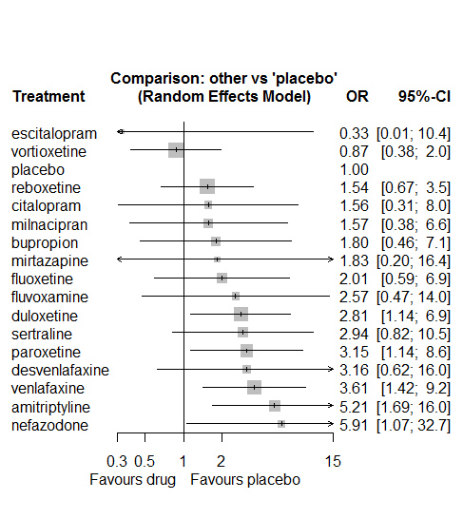

P-score

escitalopram 0.85

vortioxetine 0.84

placebo 0.81

milnacipran 0.65

citalopram 0.63

reboxetine 0.63

bupropion 0.59

mirtazapine 0.55

fluoxetine 0.54

fluvoxamine 0.42

duloxetine 0.39

sertraline 0.37

desvenlafaxine 0.36

paroxetine 0.33

venlafaxine 0.27

nefazodone 0.15

amitriptyline 0.12

# **Vomiting**

We remove all arms for which dose range was not “Licenced”. After this:

* Removed 10 one-arm studies: Montgomery2004b (CL3-20098-030), AK1102365, Lieberman2008a (Study 309)(EUCTR2004-000562-13, 3151A1-309-EU, NCT00090649), Lieberman2008b (Study 317), Hu2009, Lv2013, Montgomery2013 (F02695LP202, EudraCT2006-002404-34), Ansseau1994c, 29060/299, Sacchetti2002 (BRL-29060/109)
* Total number of arms 218. Total number of studies 86.
* Total events in placebo 164, out of a total of 6876 patients. Event rate placebo 0.024
* Total events in drugs 994, out of a total of 21906 patients. Event rate drugs 0.045

## **Distribution of dose across drugs**

Here we count the number of arms per drug, and the percent of these arms where Dose_intended_min was equal to the minimum licensed dose or lower. The values we used as minimum licensed dose are as follows:

agomelatine: 25; amitriptyline: 75; bupropion:300; citalopram:20; clomipramine:30; desvenlafaxine:50; duloxetine:40; escitalopram:10; fluoxetine:20; fluvoxamine:50; levomilnacipran:40; milnacipran:50; mirtazapine:15; nefazodone:300; paroxetine:20; reboxetine:8; sertraline:50; trazodone:150; venlafaxine:75; vilazodone:20; vortioxetine:5

Drug number.arms percent.low.dose

1 paroxetine 24 0.88

3 vortioxetine 19 0.42

4 venlafaxine 13 0.69

5 fluoxetine 22 0.95

6 mirtazapine 4 0.75

7 fluvoxamine 3 0.00

8 milnacipran 4 0.00

9 levomilnacipran 5 0.60

10 nefazodone 1 1.00

11 reboxetine 11 0.91

12 duloxetine 21 0.19

13 citalopram 6 0.50

14 sertraline 9 0.78

15 bupropion 1 1.00

16 desvenlafaxine 3 0.33

17 agomelatine 4 0.75

18 amitriptyline 4 0.50

19 vilazodone 3 0.33

20 escitalopram 6 0.67

21 clomipramine 2 0.00

22 trazodone 2 1.00

## **Network graph**

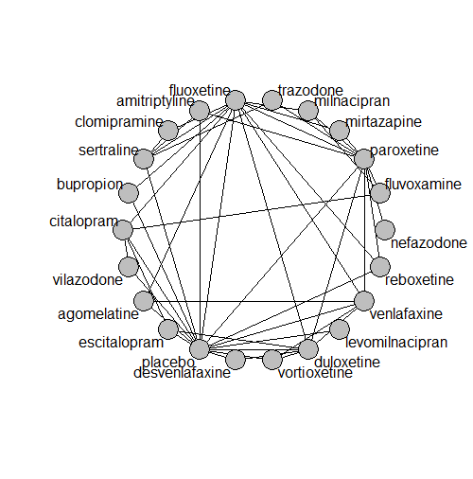

## **Pairwise MA**

### **Grouping all drugs together, comparison vs. placebo**

Number of studies: 51

Random effects meta-analysis: OR=1.63. 95% CI 1.26 to 2.11

Heterogeneity (tau squared) was estimated to be 0.29

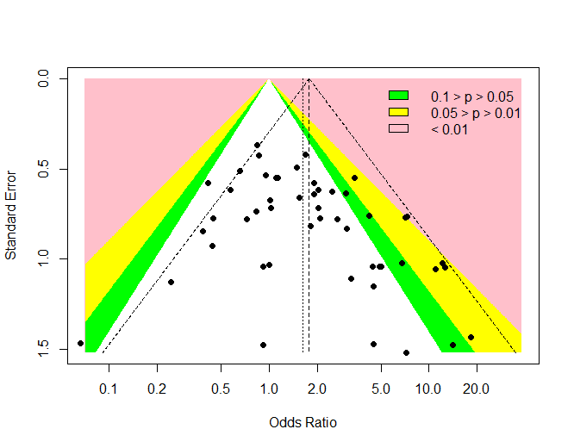

Some evidence of an asymmetry (Harbord’s test p-value =0.20)

### **Meta-analyses of comparisons with 10 or more studies**

We show results from pairwise comparisons informed by 10 studies or more. An OR larger than 1 favors the first treatment in the comparison.

comparisons Number.of.studies OR lower.CI upper.CI tau.sq I.sq

1 placebo - duloxetine 13 2.8 2 4.6 0.41 0.37

## **Assessment of transitivity**

comparison studies baseline_SD age_SD female

1 paroxetine - placebo 9 21 (2.7) 41 (3.2) 0.6 (0.14)

2 placebo - venlafaxine 5 22 (2.7) 46 (13.9) 0.58 (0.07)

3 placebo - vortioxetine 9 24 (1.8) 43 (2) 0.64 (0.08)

4 venlafaxine - vortioxetine 1 22 (NA) 43 (NA) 0.62 (NA)

5 fluoxetine - venlafaxine 5 23 (2.5) 48 (13.1) 0.6 (NA)

6 fluoxetine - mirtazapine 2 27 (2.1) 41 (6.1) NaN (NA)

7 fluvoxamine - paroxetine 1 23 (NA) 44 (NA) 0.57 (NA)

8 fluoxetine - milnacipran 1 23 (NA) 45 (NA) NaN (NA)

9 levomilnacipran - placebo 3 24 (1) 43 (1.9) 0.63 (0.03)

10 nefazodone - paroxetine 1 25 (NA) 38 (NA) 0.55 (NA)

11 paroxetine - reboxetine 3 22 (2.1) 41 (2.7) 0.69 (0.07)

12 duloxetine - placebo 13 20 (2.4) 42 (1.8) 0.69 (0.05)

13 duloxetine - vortioxetine 3 25 (NA) 44 (1.2) 0.69 (0.05)

14 placebo - reboxetine 9 24 (3.9) 42 (3.1) 0.62 (0.09)

15 mirtazapine - paroxetine 2 23 (1.4) 44 (5.1) NaN (NA)

16 fluoxetine - reboxetine 2 24 (1.6) 42 (2.6) 0.67 (0.06)

17 citalopram - fluoxetine 2 24 (1.1) 43 (1.1) NaN (NA)

18 fluoxetine - placebo 8 21 (2.6) 44 (11.1) 0.62 (0.02)

19 fluvoxamine - milnacipran 1 24 (NA) 50 (NA) NaN (NA)

20 placebo - sertraline 4 22 (3.4) 39 (1.1) 0.53 (NA)

21 bupropion - fluoxetine 1 21 (NA) 37 (NA) NaN (NA)

22 bupropion - placebo 1 21 (NA) 37 (NA) NaN (NA)

23 desvenlafaxine - placebo 2 23 (0.2) 40 (0.5) 0.66 (NA)

24 duloxetine - paroxetine 5 20 (1.7) 42 (2.7) NaN (NA)

25 fluoxetine - paroxetine 3 24 (2.2) 52 (19) NaN (NA)

26 duloxetine - fluoxetine 2 18 (0.2) 41 (0.6) NaN (NA)

27 agomelatine - fluoxetine 1 28 (NA) 42 (NA) 0.78 (NA)

28 amitriptyline - paroxetine 3 21 (3.9) 54 (15.3) 0.52 (NA)

29 milnacipran - paroxetine 1 22 (NA) 36 (NA) 0.53 (NA)

30 placebo - vilazodone 2 24 (0.7) 42 (0) 0.57 (NA)

31 agomelatine - venlafaxine 1 26 (NA) 40 (NA) 0.71 (NA)

32 citalopram - escitalopram 2 26 (3.5) 44 (1.3) NaN (NA)

33 citalopram - placebo 2 24 (0.7) 43 (1.1) 0.57 (NA)

34 escitalopram - placebo 4 21 (2.5) 42 (1.4) 0.67 (0.06)

35 citalopram - vilazodone 1 24 (NA) 42 (NA) 0.57 (NA)

36 paroxetine - venlafaxine 1 23 (NA) 44 (NA) NaN (NA)

37 clomipramine - sertraline 1 24 (NA) 44 (NA) 0.5 (NA)

38 sertraline - trazodone 1 22 (NA) 46 (NA) 0.65 (NA)

39 duloxetine - escitalopram 2 20 (3.5) 43 (1.1) NaN (NA)

40 duloxetine - venlafaxine 2 23 (0.5) 43 (1.4) 0.68 (0.03)

41 amitriptyline - placebo 1 23 (NA) 39 (NA) NaN (NA)

42 amitriptyline - sertraline 1 23 (NA) 39 (NA) NaN (NA)

43 clomipramine - fluoxetine 1 20 (NA) 44 (NA) 0.65 (NA)

44 fluoxetine - sertraline 1 24 (NA) 43 (NA) NaN (NA)

45 citalopram - fluvoxamine 1 24 (NA) NaN (NA) NaN (NA)

46 desvenlafaxine - duloxetine 1 23 (NA) 40 (NA) NaN (NA)

47 paroxetine - trazodone 1 24 (NA) 39 (NA) NaN (NA)

48 agomelatine - placebo 1 27 (NA) 44 (NA) 0.67 (NA)

## **NMA**

A total of 22 treatments are included in the network.

A total of 86 studies are included in this analysis.

Estimated heterogeneity tau-squared 0.04

Global test for inconsistency, p-value 0.77217 (Q=36,d.o.f.43)

### **Comparison vs. placebo**

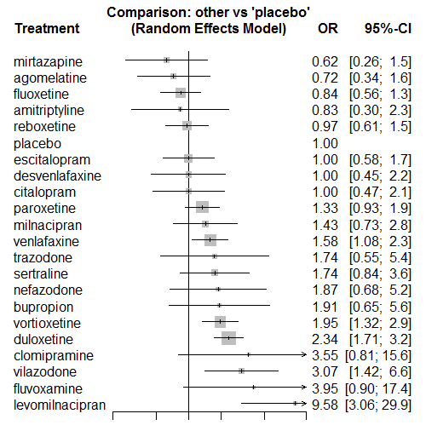

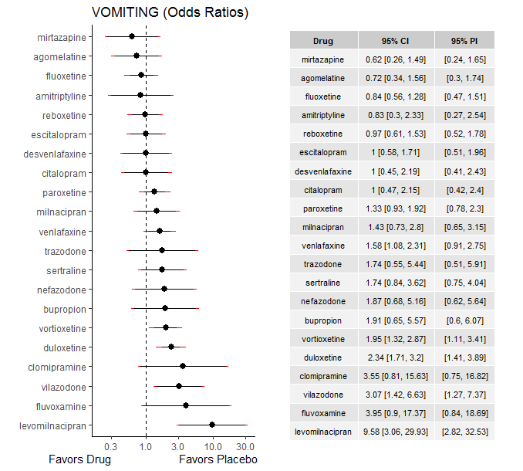

### **Ranking according to P-scores**

P-score

mirtazapine 0.89

agomelatine 0.85

fluoxetine 0.81

amitriptyline 0.77

reboxetine 0.73

placebo 0.72

escitalopram 0.71

desvenlafaxine 0.70

citalopram 0.70

paroxetine 0.53

milnacipran 0.50

venlafaxine 0.43

trazodone 0.42

sertraline 0.40

nefazodone 0.38

bupropion 0.37

vortioxetine 0.32

duloxetine 0.23

clomipramine 0.19

vilazodone 0.17

fluvoxamine 0.16

levomilnacipran 0.02

### **Local inconsistency**

Percent of comparisons where there is some evidence (p-value<0.05) of disagreement between direct and indirect sources: 0.02. (1 out of 46 comparisons)

comparison TE seTE lower upper z p

8 agomelatine:fluoxetine -0.249 0.81 -1.842 1.34 -0.307 0.759

15 agomelatine:placebo 0.811 0.79 -0.733 2.35 1.030 0.303

19 agomelatine:venlafaxine -0.833 0.95 -2.687 1.02 -0.880 0.379

34 amitriptyline:paroxetine 0.204 1.09 -1.930 2.34 0.188 0.851

35 amitriptyline:placebo 0.245 1.20 -2.116 2.61 0.203 0.839

37 amitriptyline:sertraline -0.436 1.16 -2.717 1.84 -0.375 0.708

47 bupropion:fluoxetine 0.568 1.14 -1.656 2.79 0.501 0.617

54 bupropion:placebo -0.667 1.33 -3.280 1.95 -0.501 0.617

64 citalopram:escitalopram -0.845 0.94 -2.684 0.99 -0.901 0.367

65 citalopram:fluoxetine 1.773 0.90 0.013 3.53 1.974 0.048

66 citalopram:fluvoxamine -1.487 1.77 -4.957 1.98 -0.840 0.401

72 citalopram:placebo -1.378 0.79 -2.936 0.18 -1.735 0.083

77 citalopram:vilazodone -0.025 0.95 -1.882 1.83 -0.026 0.979

82 clomipramine:fluoxetine -0.545 1.53 -3.552 2.46 -0.355 0.723

91 clomipramine:sertraline 0.545 1.53 -2.463 3.55 0.355 0.723

96 desvenlafaxine:duloxetine -1.026 0.83 -2.656 0.60 -1.234 0.217

105 desvenlafaxine:placebo 1.151 0.85 -0.509 2.81 1.359 0.174

112 duloxetine:escitalopram -0.162 0.55 -1.240 0.92 -0.294 0.768

113 duloxetine:fluoxetine -0.650 1.07 -2.747 1.45 -0.608 0.543

119 duloxetine:paroxetine -0.467 0.39 -1.235 0.30 -1.192 0.233

120 duloxetine:placebo 0.160 0.32 -0.466 0.79 0.500 0.617

124 duloxetine:venlafaxine 0.132 0.38 -0.615 0.88 0.347 0.728

126 duloxetine:vortioxetine 0.370 0.41 -0.435 1.18 0.902 0.367

134 escitalopram:placebo -0.189 0.55 -1.267 0.89 -0.344 0.731

143 fluoxetine:milnacipran 0.445 0.82 -1.169 2.06 0.540 0.589

144 fluoxetine:mirtazapine 1.679 0.88 -0.036 3.39 1.919 0.055

146 fluoxetine:paroxetine -0.149 0.58 -1.286 0.99 -0.257 0.797

147 fluoxetine:placebo 0.420 0.43 -0.426 1.27 0.973 0.330

148 fluoxetine:reboxetine 0.092 0.74 -1.361 1.54 0.124 0.902

149 fluoxetine:sertraline -0.301 0.98 -2.219 1.62 -0.307 0.759

151 fluoxetine:venlafaxine -0.365 0.47 -1.281 0.55 -0.780 0.435

155 fluvoxamine:milnacipran -1.406 1.49 -4.331 1.52 -0.943 0.346

158 fluvoxamine:paroxetine 0.501 1.79 -2.998 4.00 0.281 0.779

179 milnacipran:paroxetine 0.014 0.76 -1.468 1.50 0.018 0.985

188 mirtazapine:paroxetine 1.679 0.88 -0.036 3.39 1.919 0.055

204 paroxetine:placebo -0.224 0.37 -0.956 0.51 -0.600 0.548

205 paroxetine:reboxetine -0.448 0.52 -1.463 0.57 -0.865 0.387

207 paroxetine:trazodone 0.662 1.24 -1.771 3.10 0.533 0.594

208 paroxetine:venlafaxine 0.497 0.55 -0.572 1.57 0.911 0.362

211 placebo:reboxetine 0.956 0.62 -0.251 2.16 1.553 0.120

212 placebo:sertraline -0.134 0.77 -1.646 1.38 -0.174 0.862

214 placebo:venlafaxine -0.384 0.41 -1.178 0.41 -0.948 0.343

215 placebo:vilazodone 0.288 1.06 -1.782 2.36 0.273 0.785

216 placebo:vortioxetine -0.349 0.42 -1.174 0.48 -0.830 0.407

222 sertraline:trazodone -0.662 1.24 -3.096 1.77 -0.533 0.594

230 venlafaxine:vortioxetine -0.247 0.68 -1.584 1.09 -0.362 0.718

### **League table**

Below we show the league table. Upper triangle: direct evidence. Lower triangle: NMA. An odds ratio larger than 1 in the upper triangle favors the column-defining drug. An odds ratio larger than 1 in the bottom triangle favors the row-defining drug.

|  |  |  |  |  |  |  |  |  |  |  |  |  |  |  |  |  |  |  |  |  |  |
| --- | --- | --- | --- | --- | --- | --- | --- | --- | --- | --- | --- | --- | --- | --- | --- | --- | --- | --- | --- | --- | --- |
| AGOM | . | . | . | . | . | . | . | 0.74 [0.22; 2.52] | . | . | . | . | . | . | 1.13 [0.36; 3.55] | . | . | . | 0.24 [0.05; 1.22] | . | . |
| 0.87 [0.25; 3.08] | AMIT | . | . | . | . | . | . | . | . | . | . | . | . | 0.67 [0.20; 2.25] | 1.00 [0.13; 7.69] | . | 0.37 [0.07; 2.08] | . | . | . | . |
| 0.38 [0.10; 1.38] | 0.44 [0.10; 1.90] | BUPR | . | . | . | . | . | 2.84 [0.70; 11.53] | . | . | . | . | . | . | 1.66 [0.50; 5.54] | . | . | . | . | . | . |
| 0.72 [0.25; 2.09] | 0.83 [0.23; 2.95] | 1.91 [0.52; 6.99] | CITA | . | . | . | 0.58 [0.13; 2.56] | 4.07 [0.94; 17.68] | 0.09 [0.00; 1.65] | . | . | . | . | . | 0.57 [0.21; 1.54] | . | . | . | . | 0.32 [0.12; 0.91] | . |
| 0.20 [0.04; 1.05] | 0.23 [0.04; 1.33] | 0.54 [0.09; 3.27] | 0.28 [0.05; 1.47] | CLOM | . | . | . | 3.04 [0.30; 31.00] | . | . | . | . | . | . | . | . | 2.45 [0.43; 13.84] | . | . | . | . |
| 0.73 [0.24; 2.16] | 0.84 [0.23; 3.01] | 1.92 [0.51; 7.21] | 1.01 [0.34; 2.99] | 3.57 [0.67; 18.98] | DESV | 0.29 [0.11; 0.78] | . | . | . | . | . | . | . | . | 1.48 [0.56; 3.90] | . | . | . | . | . | . |
| 0.31 [0.14; 0.69] | 0.36 [0.13; 1.01] | 0.82 [0.27; 2.46] | 0.43 [0.19; 0.96] | 1.52 [0.34; 6.81] | 0.43 [0.19; 0.93] | DULO | 2.18 [1.07; 4.47] | 1.50 [0.19; 11.52] | . | . | . | . | . | 1.36 [0.77; 2.40] | 2.55 [1.62; 4.01] | . | . | . | 1.58 [0.93; 2.67] | . | 1.42 [0.83; 2.43] |
| 0.73 [0.29; 1.83] | 0.83 [0.27; 2.62] | 1.91 [0.58; 6.30] | 1.00 [0.42; 2.41] | 3.56 [0.74; 17.09] | 1.00 [0.40; 2.52] | 2.35 [1.37; 4.01] | ESCI | . | . | . | . | . | . | . | 0.92 [0.44; 1.89] | . | . | . | . | . | . |
| 0.86 [0.39; 1.88] | 0.99 [0.34; 2.87] | 2.26 [0.76; 6.72] | 1.19 [0.53; 2.67] | 4.21 [0.96; 18.42] | 1.18 [0.49; 2.83] | 2.77 [1.74; 4.40] | 1.18 [0.62; 2.27] | FLUO | . | . | 0.83 [0.20; 3.36] | 3.37 [0.95; 11.93] | . | 0.56 [0.20; 1.55] | 1.07 [0.57; 2.03] | 0.94 [0.25; 3.48] | 0.38 [0.07; 2.11] | . | 0.44 [0.22; 0.86] | . | . |
| 0.18 [0.04; 0.95] | 0.21 [0.04; 1.23] | 0.48 [0.08; 2.96] | 0.25 [0.05; 1.21] | 0.90 [0.11; 7.15] | 0.25 [0.05; 1.33] | 0.59 [0.13; 2.63] | 0.25 [0.05; 1.20] | 0.21 [0.05; 0.95] | FLUV | . | 1.56 [0.24; 10.10] | . | . | 4.37 [0.20; 95.36] | . | . | . | . | . | . | . |
| 0.08 [0.02; 0.30] | 0.09 [0.02; 0.40] | 0.20 [0.04; 0.95] | 0.10 [0.03; 0.41] | 0.37 [0.06; 2.41] | 0.10 [0.03; 0.42] | 0.24 [0.07; 0.80] | 0.10 [0.03; 0.37] | 0.09 [0.03; 0.30] | 0.41 [0.06; 2.67] | LEVO | . | . | . | . | 9.58 [3.06; 29.93] | . | . | . | . | . | . |
| 0.51 [0.19; 1.36] | 0.58 [0.18; 1.86] | 1.34 [0.39; 4.63] | 0.70 [0.26; 1.87] | 2.49 [0.50; 12.26] | 0.70 [0.25; 1.93] | 1.64 [0.82; 3.26] | 0.70 [0.30; 1.61] | 0.59 [0.30; 1.18] | 2.77 [0.66; 11.65] | 6.70 [1.78; 25.18] | MILN | . | . | 1.07 [0.55; 2.09] | . | . | . | . | . | . | . |
| 1.16 [0.38; 3.56] | 1.34 [0.37; 4.86] | 3.06 [0.79; 11.83] | 1.61 [0.52; 4.97] | 5.70 [1.06; 30.62] | 1.60 [0.50; 5.09] | 3.75 [1.55; 9.10] | 1.60 [0.59; 4.36] | 1.35 [0.58; 3.18] | 6.34 [1.20; 33.63] | 15.36 [3.66; 64.50] | 2.29 [0.84; 6.28] | MIRT | . | 0.89 [0.31; 2.56] | . | . | . | . | . | . | . |
| 0.39 [0.11; 1.35] | 0.45 [0.11; 1.77] | 1.02 [0.24; 4.41] | 0.54 [0.15; 1.88] | 1.90 [0.32; 11.19] | 0.53 [0.15; 1.89] | 1.25 [0.45; 3.48] | 0.53 [0.17; 1.65] | 0.45 [0.16; 1.29] | 2.12 [0.37; 12.05] | 5.12 [1.11; 23.57] | 0.76 [0.25; 2.34] | 0.33 [0.09; 1.18] | NEFA | 1.40 [0.54; 3.61] | . | . | . | . | . | . | . |
| 0.54 [0.24; 1.23] | 0.62 [0.23; 1.70] | 1.43 [0.47; 4.35] | 0.75 [0.33; 1.70] | 2.66 [0.60; 11.90] | 0.75 [0.32; 1.73] | 1.75 [1.20; 2.57] | 0.75 [0.40; 1.38] | 0.63 [0.40; 0.99] | 2.96 [0.69; 12.74] | 7.17 [2.17; 23.73] | 1.07 [0.59; 1.94] | 0.47 [0.20; 1.07] | 1.40 [0.54; 3.61] | PARO | 1.18 [0.68; 2.03] | 1.14 [0.58; 2.22] | . | 0.94 [0.25; 3.53] | 1.25 [0.48; 3.24] | . | . |
| 0.72 [0.34; 1.56] | 0.83 [0.30; 2.33] | 1.91 [0.65; 5.57] | 1.00 [0.47; 2.15] | 3.55 [0.81; 15.63] | 1.00 [0.45; 2.19] | 2.34 [1.71; 3.20] | 1.00 [0.58; 1.71] | 0.84 [0.56; 1.28] | 3.95 [0.90; 17.37] | 9.58 [3.06; 29.93] | 1.43 [0.73; 2.80] | 0.62 [0.26; 1.49] | 1.87 [0.68; 5.16] | 1.33 [0.93; 1.92] | PLAC | 1.22 [0.74; 2.02] | 0.55 [0.22; 1.39] | . | 0.49 [0.26; 0.93] | 0.34 [0.15; 0.80] | 0.46 [0.29; 0.73] |
| 0.75 [0.31; 1.80] | 0.86 [0.29; 2.58] | 1.98 [0.62; 6.26] | 1.04 [0.43; 2.50] | 3.68 [0.79; 17.09] | 1.03 [0.42; 2.54] | 2.42 [1.43; 4.10] | 1.03 [0.52; 2.06] | 0.87 [0.50; 1.54] | 4.09 [0.89; 18.82] | 9.90 [2.90; 33.82] | 1.48 [0.69; 3.16] | 0.64 [0.25; 1.66] | 1.93 [0.66; 5.65] | 1.38 [0.83; 2.28] | 1.03 [0.65; 1.63] | REBO | . | . | . | . | . |
| 0.42 [0.15; 1.18] | 0.48 [0.15; 1.48] | 1.10 [0.31; 3.96] | 0.58 [0.20; 1.64] | 2.05 [0.50; 8.43] | 0.57 [0.20; 1.67] | 1.35 [0.62; 2.93] | 0.57 [0.23; 1.41] | 0.49 [0.22; 1.06] | 2.27 [0.45; 11.63] | 5.51 [1.42; 21.36] | 0.82 [0.32; 2.14] | 0.36 [0.12; 1.08] | 1.08 [0.32; 3.65] | 0.77 [0.36; 1.66] | 0.58 [0.28; 1.20] | 0.56 [0.24; 1.30] | SERT | 0.68 [0.10; 4.39] | . | . | . |
| 0.42 [0.11; 1.62] | 0.48 [0.11; 2.07] | 1.10 [0.23; 5.20] | 0.58 [0.15; 2.25] | 2.05 [0.34; 12.26] | 0.57 [0.15; 2.27] | 1.35 [0.42; 4.29] | 0.57 [0.16; 2.00] | 0.49 [0.15; 1.57] | 2.28 [0.37; 14.19] | 5.52 [1.10; 27.72] | 0.82 [0.23; 2.89] | 0.36 [0.09; 1.43] | 1.08 [0.25; 4.64] | 0.77 [0.25; 2.34] | 0.58 [0.18; 1.81] | 0.56 [0.17; 1.85] | 1.00 [0.30; 3.32] | TRAZ | . | . | . |
| 0.46 [0.21; 1.01] | 0.53 [0.18; 1.53] | 1.21 [0.40; 3.69] | 0.63 [0.28; 1.45] | 2.25 [0.50; 10.14] | 0.63 [0.27; 1.46] | 1.48 [1.02; 2.15] | 0.63 [0.34; 1.17] | 0.53 [0.34; 0.84] | 2.50 [0.56; 11.23] | 6.06 [1.82; 20.13] | 0.90 [0.44; 1.84] | 0.39 [0.16; 0.97] | 1.18 [0.42; 3.35] | 0.84 [0.55; 1.30] | 0.63 [0.43; 0.92] | 0.61 [0.35; 1.07] | 1.10 [0.49; 2.44] | 1.10 [0.34; 3.55] | VENL | . | 0.66 [0.19; 2.26] |
| 0.24 [0.08; 0.70] | 0.27 [0.08; 0.98] | 0.62 [0.17; 2.32] | 0.33 [0.14; 0.77] | 1.16 [0.22; 6.12] | 0.32 [0.11; 0.97] | 0.76 [0.34; 1.74] | 0.33 [0.13; 0.81] | 0.28 [0.12; 0.65] | 1.29 [0.25; 6.60] | 3.12 [0.79; 12.37] | 0.47 [0.17; 1.28] | 0.20 [0.06; 0.64] | 0.61 [0.17; 2.17] | 0.44 [0.19; 1.01] | 0.33 [0.15; 0.71] | 0.32 [0.13; 0.77] | 0.57 [0.20; 1.63] | 0.57 [0.14; 2.23] | 0.52 [0.22; 1.21] | VILA | . |
| 0.37 [0.16; 0.86] | 0.43 [0.14; 1.26] | 0.98 [0.32; 3.04] | 0.51 [0.22; 1.20] | 1.82 [0.40; 8.37] | 0.51 [0.22; 1.20] | 1.20 [0.80; 1.79] | 0.51 [0.27; 0.96] | 0.43 [0.25; 0.74] | 2.03 [0.44; 9.26] | 4.91 [1.47; 16.36] | 0.73 [0.35; 1.55] | 0.32 [0.13; 0.81] | 0.96 [0.33; 2.79] | 0.68 [0.42; 1.12] | 0.51 [0.35; 0.75] | 0.50 [0.28; 0.89] | 0.89 [0.39; 2.02] | 0.89 [0.27; 2.93] | 0.81 [0.50; 1.31] | 1.57 [0.67; 3.71] | VORT |

### **Estimated event rates**

For an event rate in placebo equal to the average event rate (i.e. fixed to 0.02) the estimated event rates for each drug are as follows

drug rate

1 agomelatine 0.02 [0.01, 0.04]

2 amitriptyline 0.02 [0.01, 0.05]

3 bupropion 0.04 [0.02, 0.12]

4 citalopram 0.02 [0.01, 0.05]

5 clomipramine 0.08 [0.02, 0.28]

6 desvenlafaxine 0.02 [0.01, 0.05]

7 duloxetine 0.05 [0.04, 0.07]

8 escitalopram 0.02 [0.01, 0.04]

9 fluoxetine 0.02 [0.01, 0.03]

10 fluvoxamine 0.09 [0.02, 0.3]

11 levomilnacipran 0.19 [0.07, 0.42]

12 milnacipran 0.03 [0.02, 0.06]

13 mirtazapine 0.02 [0.01, 0.04]

14 nefazodone 0.04 [0.02, 0.11]

15 paroxetine 0.03 [0.02, 0.04]

17 reboxetine 0.02 [0.01, 0.04]

18 sertraline 0.04 [0.02, 0.08]

19 trazodone 0.04 [0.01, 0.12]

20 venlafaxine 0.04 [0.03, 0.05]

21 vilazodone 0.07 [0.03, 0.14]

22 vortioxetine 0.05 [0.03, 0.07]

## **Sensitivity analysis: splitting nodes according to dosage**

All treatment arms for drug X, with dose_intended_min equal to or smaller to the minimum licensed dose were set as “X_L”. All other arms of X are “X_H”. Studies with no information on dose are excluded. Results shown below:

|  |  |  |
| --- | --- | --- |
| **Low dose vs. placebo** | **High dose vs. placebo** | **High dose vs. low dose** |
|  |  |  |

## **Sensitivity analysis: Keeping only low dropout arms**

We exclude all treatment arms with dropout rates larger than 25%, and we re-analyse the network.

Total number of arms included in the analysis 83. Total number of studies 40

Total events in placebo 104, out of a total of 3623 patients. Event rate placebo 0.023

Total events in drugs 577, out of a total of 11145 patients. Event rate drugs 0.046 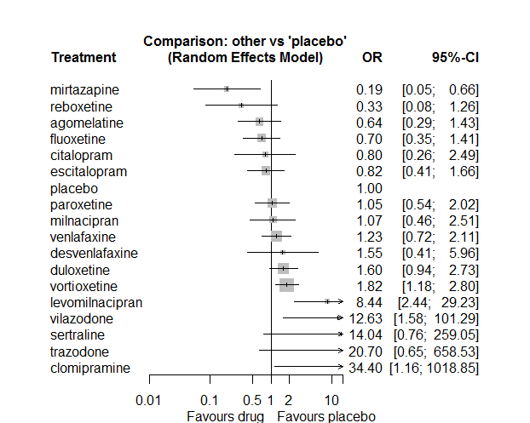

P-score

mirtazapine 0.98

reboxetine 0.90

agomelatine 0.79

fluoxetine 0.77

escitalopram 0.70

citalopram 0.69

placebo 0.62

paroxetine 0.59

milnacipran 0.58

venlafaxine 0.51

desvenlafaxine 0.46

duloxetine 0.39

vortioxetine 0.35

sertraline 0.17

levomilnacipran 0.16

vilazodone 0.14

trazodone 0.14

clomipramine 0.08

# **Agitation**

We remove all arms for which dose range was not “Licenced”. After this:

* Removed 6 one-arm studies: Hormazabal1985, Hewett2010a (AK130940) (NCT00093288), Itil1983, Goodarzi 2015(IRCT2012101811155N1), Bosc1997a (Study 014 - Andreoli2002), Allard2004
* Total number of studies with number randomized being smaller than event rates: 1. Removed the following studies: Rush1998 (excluding Armitage1997 and Gillin1997)
* Total number of arms 160. Total number of studies 66.
* Total events in placebo 247, out of a total of 4965 patients. Event rate placebo 0.05
* Total events in drugs 994, out of a total of 21906 patients. Event rate drugs 0.063

## **Distribution of dose across drugs**

Here we count the number of arms per drug, and the percent of these arms where Dose_intended_min was equal to the minimum licensed dose or lower. The values we used as minimum licensed dose are as follows:

agomelatine: 25; amitriptyline: 75; bupropion:300; citalopram:20; clomipramine:30; desvenlafaxine:50; duloxetine:40; escitalopram:10; fluoxetine:20; fluvoxamine:50; levomilnacipran:40; milnacipran:50; mirtazapine:15; nefazodone:300; paroxetine:20; reboxetine:8; sertraline:50; trazodone:150; venlafaxine:75; vilazodone:20; vortioxetine:5

Drug number.arms percent.low.dose

1 paroxetine 15 0.93

2 fluoxetine 16 0.94

3 bupropion 15 0.93

5 sertraline 10 0.70

6 milnacipran 6 0.00

7 amitriptyline 8 0.62

8 fluvoxamine 4 0.25

9 reboxetine 7 1.00

10 escitalopram 5 1.00

11 agomelatine 3 0.67

12 duloxetine 8 0.25

13 nefazodone 2 1.00

14 vortioxetine 14 0.43

15 citalopram 1 1.00

16 venlafaxine 2 0.50

17 clomipramine 1 0.00

18 mirtazapine 1 1.00

19 trazodone 1 1.00

## **Network graph**

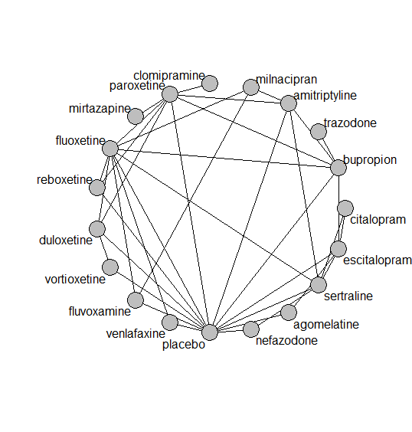

## **Pairwise MA**

### **Grouping all drugs together, comparison vs. placebo**

Number of studies: 41

Random effects meta-analysis: OR=1.09. 95% CI 0.88 to 1.34

Prediction interval 0.7 to 1.69

Heterogeneity (tau squared) was estimated to be 0.04

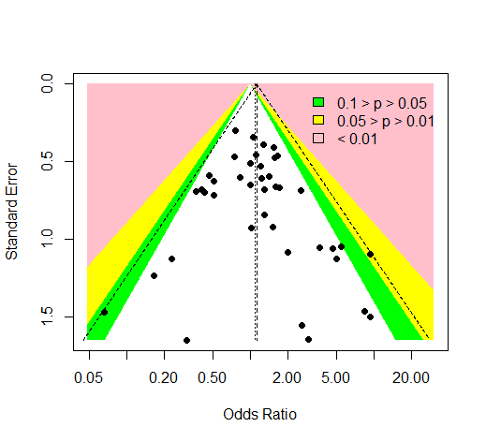

No evidence of an asymmetry (Harbord’s test p-value =0.7)

### **Meta-analyses of comparisons with 10 or more studies**

We show results from pairwise comparisons informed by 10 studies or more. An OR larger than 1 favors the first treatment in the comparison.

comparisons Number.of.studies OR lower.CI upper.CI tau.sq I.sq

1 placebo - bupropion 10 1.2 0.88 1.6 0 0

## **Assessment of transitivity**

comparison studies baseline_SD age_SD female

1 fluoxetine - paroxetine 3 24 (1.6) 52 (19) NaN (NA)

2 bupropion - placebo 10 25 (2.5) 40 (4.9) 0.47 (0.23)

3 fluoxetine - sertraline 1 25 (NA) 58 (NA) NaN (NA)

4 amitriptyline - milnacipran 1 26 (NA) 50 (NA) NaN (NA)

5 fluvoxamine - milnacipran 1 24 (NA) 48 (NA) NaN (NA)

6 fluoxetine - milnacipran 2 25 (3.3) 45 (0.4) NaN (NA)

7 paroxetine - reboxetine 3 22 (2.1) 41 (2.7) 0.69 (0.07)

8 placebo - reboxetine 5 23 (2.5) 42 (3.5) 0.64 (0.09)

9 fluoxetine - reboxetine 2 24 (1.6) 42 (2.6) 0.67 (0.06)

10 fluoxetine - placebo 7 21 (2.1) 44 (12.2) 0.63 (NA)

11 fluvoxamine - placebo 2 23 (3.9) 42 (NA) NaN (NA)

12 amitriptyline - bupropion 1 23 (NA) 37 (NA) NaN (NA)

13 amitriptyline - placebo 1 24 (NA) 39 (NA) NaN (NA)

14 bupropion - escitalopram 2 24 (NA) 36 (0.6) NaN (NA)

15 escitalopram - placebo 3 24 (NA) 37 (2.3) 0.72 (NA)

16 placebo - sertraline 3 25 (NA) 37 (0.9) 0.53 (NA)

17 bupropion - fluoxetine 3 23 (2.2) 39 (2.7) NaN (NA)

18 agomelatine - escitalopram 1 27 (NA) 43 (NA) 0.71 (NA)

19 duloxetine - placebo 7 21 (3.3) 42 (1.5) 0.66 (0.07)

20 duloxetine - paroxetine 1 20 (NA) 43 (NA) NaN (NA)

21 paroxetine - placebo 5 21 (2.1) 40 (2.4) 0.68 (0.08)

22 nefazodone - sertraline 1 23 (NA) 44 (NA) 0.52 (NA)

23 amitriptyline - paroxetine 3 25 (1.3) 55 (14.1) NaN (NA)

24 duloxetine - fluoxetine 2 18 (0.2) 41 (0.6) NaN (NA)

25 placebo - vortioxetine 7 24 (1.7) 43 (2.5) 0.64 (0.09)

26 citalopram - escitalopram 1 25 (NA) 34 (NA) NaN (NA)

27 citalopram - sertraline 1 25 (NA) 34 (NA) NaN (NA)

28 escitalopram - sertraline 1 25 (NA) 34 (NA) NaN (NA)

29 placebo - venlafaxine 2 21 (NA) 57 (20.2) 0.62 (NA)

30 duloxetine - vortioxetine 2 25 (NA) 43 (0.1) 0.69 (0.07)

31 amitriptyline - sertraline 2 25 (0.9) 48 (0.5) 0.7 (NA)

32 fluoxetine - fluvoxamine 1 22 (NA) 39 (NA) NaN (NA)

33 nefazodone - placebo 1 24 (NA) 44 (NA) 0.64 (NA)

34 clomipramine - paroxetine 1 24 (NA) 71 (NA) 0.89 (NA)

35 fluoxetine - venlafaxine 1 21 (NA) 71 (NA) NaN (NA)

36 mirtazapine - paroxetine 1 24 (NA) 40 (NA) NaN (NA)

37 bupropion - trazodone 1 22 (NA) 40 (NA) NaN (NA)

38 bupropion - paroxetine 1 22 (NA) 37 (NA) NaN (NA)

39 agomelatine - placebo 1 27 (NA) 44 (NA) 0.67 (NA)

## **NMA**

A total of 19 treatments are included in the network.

A total of 66 studies are included in this analysis.

Estimated heterogeneity tau-squared 0.04

Global test for inconsistency, p-value 0.05269 (Q=45,d.o.f.31)

### **Comparison vs. placebo**

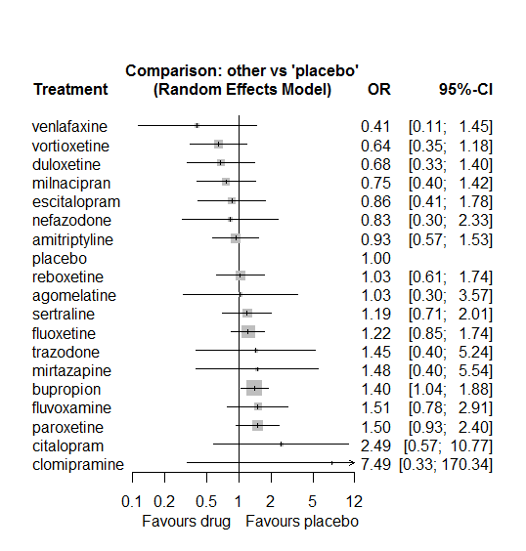

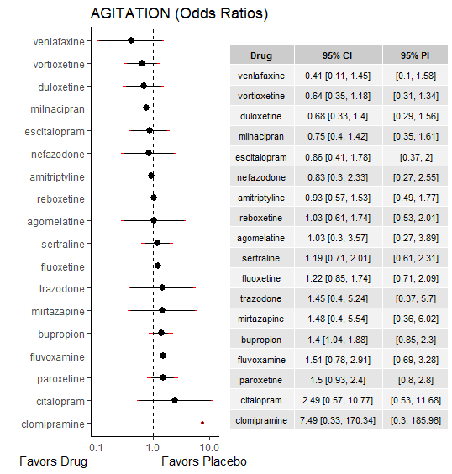

### **Ranking according to P-scores**

P-score

venlafaxine 0.89

vortioxetine 0.81

duloxetine 0.78

milnacipran 0.74

escitalopram 0.65

nefazodone 0.65

amitriptyline 0.62

placebo 0.57

reboxetine 0.54

agomelatine 0.53

sertraline 0.43

fluoxetine 0.41

trazodone 0.37

mirtazapine 0.36

bupropion 0.30

fluvoxamine 0.28

paroxetine 0.26

citalopram 0.19

clomipramine 0.12

### **Local inconsistency**

Percent of comparisons where there is some evidence (p-value<0.05) of disagreement between direct and indirect sources: 0.08. (3 out of 36 comparisons)

comparison TE seTE lower upper z p

6 agomelatine:escitalopram -3.108 1.70 -6.45 0.232 -1.82 0.0682

13 agomelatine:placebo 3.108 1.70 -0.23 6.447 1.82 0.0682

19 amitriptyline:bupropion -0.438 0.61 -1.63 0.755 -0.72 0.4720

26 amitriptyline:milnacipran 0.407 0.73 -1.02 1.835 0.56 0.5769

29 amitriptyline:paroxetine -0.117 0.56 -1.21 0.978 -0.21 0.8346

30 amitriptyline:placebo -0.306 0.59 -1.46 0.845 -0.52 0.6023

32 amitriptyline:sertraline 0.722 0.66 -0.56 2.007 1.10 0.2712

39 bupropion:escitalopram 1.301 0.81 -0.29 2.888 1.61 0.1082

40 bupropion:fluoxetine 0.182 0.40 -0.61 0.973 0.45 0.6521

45 bupropion:paroxetine 1.388 0.90 -0.38 3.153 1.54 0.1233

46 bupropion:placebo -1.104 0.42 -1.93 -0.280 -2.63 0.0086

54 citalopram:escitalopram -0.631 1.64 -3.85 2.585 -0.38 0.7004

63 citalopram:sertraline 0.631 1.64 -2.59 3.848 0.38 0.7004

82 duloxetine:fluoxetine -0.879 0.97 -2.77 1.015 -0.91 0.3629

87 duloxetine:paroxetine -1.177 1.71 -4.53 2.176 -0.69 0.4916

88 duloxetine:placebo -0.298 0.89 -2.05 1.455 -0.33 0.7388

93 duloxetine:vortioxetine 1.352 0.83 -0.27 2.969 1.64 0.1014

100 escitalopram:placebo -0.609 0.86 -2.30 1.081 -0.71 0.4799

102 escitalopram:sertraline 0.439 1.14 -1.80 2.676 0.38 0.7004

106 fluoxetine:fluvoxamine 1.652 0.64 0.41 2.898 2.60 0.0094

107 fluoxetine:milnacipran -1.034 0.60 -2.20 0.135 -1.73 0.0829

110 fluoxetine:paroxetine -0.112 0.48 -1.06 0.836 -0.23 0.8167

111 fluoxetine:placebo -0.101 0.37 -0.82 0.617 -0.27 0.7833

112 fluoxetine:reboxetine 0.450 0.61 -0.74 1.641 0.74 0.4589

113 fluoxetine:sertraline -1.212 0.94 -3.05 0.628 -1.29 0.1966

115 fluoxetine:venlafaxine -0.193 1.38 -2.89 2.504 -0.14 0.8882

117 fluvoxamine:milnacipran 1.018 0.69 -0.33 2.370 1.48 0.1398

121 fluvoxamine:placebo 1.030 0.73 -0.40 2.455 1.42 0.1570

145 nefazodone:placebo 2.751 1.61 -0.41 5.910 1.71 0.0879

147 nefazodone:sertraline -2.751 1.61 -5.91 0.408 -1.71 0.0879

151 paroxetine:placebo 0.166 0.54 -0.89 1.220 0.31 0.7583

152 paroxetine:reboxetine 0.087 0.62 -1.13 1.300 0.14 0.8884

157 placebo:reboxetine -0.942 0.57 -2.06 0.172 -1.66 0.0974

158 placebo:sertraline 0.128 0.55 -0.95 1.208 0.23 0.8168

160 placebo:venlafaxine -0.949 1.30 -3.50 1.602 -0.73 0.4661

161 placebo:vortioxetine -2.118 1.04 -4.15 -0.085 -2.04 0.0412

### **League table**

Below we show the league table. Upper triangle: direct evidence. Lower triangle: NMA. An odds ratio larger than 1 in the upper triangle favors the column-defining drug. An odds ratio larger than 1 in the bottom triangle favors the row-defining drug.

|  |  |  |  |  |  |  |  |  |  |  |  |  |  |  |  |  |  |  |
| --- | --- | --- | --- | --- | --- | --- | --- | --- | --- | --- | --- | --- | --- | --- | --- | --- | --- | --- |
| AGOM | . | . | . | . | . | 0.11 [0.01; 2.03] | . | . | . | . | . | . | 1.73 [0.44; 6.73] | . | . | . | . | . |
| 1.11 [0.29; 4.21] | AMIT | 0.48 [0.17; 1.35] | . | . | . | . | . | . | 1.60 [0.51; 5.02] | . | . | 0.59 [0.26; 1.30] | 0.74 [0.27; 2.01] | . | 1.23 [0.44; 3.38] | . | . | . |
| 0.74 [0.21; 2.64] | 0.67 [0.40; 1.13] | BUPR | . | . | . | 3.72 [1.05; 13.17] | 1.25 [0.73; 2.13] | . | . | . | . | 3.29 [0.61; 17.66] | 1.18 [0.85; 1.63] | . | . | 0.96 [0.28; 3.38] | . | . |
| 0.41 [0.06; 2.76] | 0.37 [0.08; 1.71] | 0.56 [0.13; 2.47] | CITA | . | . | 2.43 [0.44; 13.53] | . | . | . | . | . | . | . | . | 2.50 [0.45; 13.93] | . | . | . |
| 0.14 [0.00; 3.98] | 0.12 [0.01; 2.87] | 0.19 [0.01; 4.27] | 0.33 [0.01; 10.42] | CLOM | . | . | . | . | . | . | . | 5.00 [0.23; 109.73] | . | . | . | . | . | . |
| 1.52 [0.36; 6.42] | 1.38 [0.58; 3.29] | 2.06 [0.95; 4.49] | 3.68 [0.72; 18.82] | 11.06 [0.45; 272.46] | DULO | . | 0.28 [0.05; 1.49] | . | . | . | . | 0.15 [0.01; 3.84] | 0.63 [0.28; 1.44] | . | . | . | . | 1.66 [0.65; 4.23] |
| 1.21 [0.30; 4.77] | 1.09 [0.46; 2.60] | 1.63 [0.76; 3.50] | 2.91 [0.68; 12.42] | 8.75 [0.35; 216.08] | 0.79 [0.28; 2.21] | ESCI | . | . | . | . | . | . | 0.73 [0.31; 1.72] | . | 1.03 [0.14; 7.81] | . | . | . |
| 0.85 [0.23; 3.08] | 0.77 [0.45; 1.31] | 1.15 [0.77; 1.70] | 2.04 [0.46; 9.14] | 6.15 [0.27; 139.89] | 0.56 [0.25; 1.22] | 0.70 [0.31; 1.57] | FLUO | 1.96 [0.79; 4.86] | 1.03 [0.48; 2.23] | . | . | 0.77 [0.38; 1.54] | 1.16 [0.71; 1.90] | 1.60 [0.60; 4.27] | 0.35 [0.06; 1.98] | . | 2.82 [0.61; 13.09] | . |
| 0.69 [0.17; 2.79] | 0.62 [0.29; 1.32] | 0.93 [0.47; 1.85] | 1.65 [0.33; 8.16] | 4.97 [0.21; 119.23] | 0.45 [0.17; 1.18] | 0.57 [0.21; 1.51] | 0.81 [0.43; 1.51] | FLUV | 3.25 [1.28; 8.26] | . | . | . | 3.08 [0.94; 10.09] | . | . | . | . | . |
| 1.37 [0.34; 5.50] | 1.24 [0.62; 2.45] | 1.85 [0.96; 3.57] | 3.30 [0.68; 16.06] | 9.92 [0.42; 235.64] | 0.90 [0.35; 2.32] | 1.13 [0.43; 2.96] | 1.61 [0.90; 2.88] | 2.00 [1.02; 3.92] | MILN | . | . | . | . | . | . | . | . | . |
| 0.70 [0.11; 4.26] | 0.63 [0.16; 2.42] | 0.94 [0.25; 3.57] | 1.68 [0.24; 11.95] | 5.05 [0.18; 140.46] | 0.46 [0.10; 2.04] | 0.58 [0.13; 2.60] | 0.82 [0.22; 3.07] | 1.02 [0.24; 4.29] | 0.51 [0.12; 2.10] | MIRT | . | 0.99 [0.29; 3.39] | . | . | . | . | . | . |
| 1.25 [0.25; 6.24] | 1.12 [0.38; 3.35] | 1.68 [0.58; 4.88] | 3.00 [0.54; 16.63] | 9.03 [0.34; 240.84] | 0.82 [0.23; 2.87] | 1.03 [0.30; 3.57] | 1.47 [0.50; 4.30] | 1.82 [0.54; 6.08] | 0.91 [0.28; 2.99] | 1.79 [0.34; 9.40] | NEFA | . | 9.29 [0.48; 179.54] | . | 0.54 [0.20; 1.41] | . | . | . |
| 0.69 [0.18; 2.60] | 0.62 [0.36; 1.07] | 0.93 [0.56; 1.55] | 1.66 [0.36; 7.66] | 5.00 [0.23; 109.73] | 0.45 [0.19; 1.06] | 0.57 [0.24; 1.35] | 0.81 [0.51; 1.30] | 1.01 [0.48; 2.12] | 0.50 [0.25; 1.02] | 0.99 [0.29; 3.39] | 0.55 [0.18; 1.69] | PARO | 1.69 [0.69; 4.12] | 1.53 [0.61; 3.84] | . | . | . | . |
| 1.03 [0.30; 3.57] | 0.93 [0.57; 1.53] | 1.40 [1.04; 1.88] | 2.49 [0.57; 10.77] | 7.49 [0.33; 170.34] | 0.68 [0.33; 1.40] | 0.86 [0.41; 1.78] | 1.22 [0.85; 1.74] | 1.51 [0.78; 2.91] | 0.75 [0.40; 1.42] | 1.48 [0.40; 5.54] | 0.83 [0.30; 2.33] | 1.50 [0.93; 2.40] | PLAC | 0.71 [0.37; 1.35] | 0.88 [0.46; 1.70] | . | 1.53 [0.25; 9.34] | 1.26 [0.66; 2.39] |
| 1.00 [0.26; 3.85] | 0.90 [0.46; 1.78] | 1.35 [0.76; 2.42] | 2.41 [0.51; 11.37] | 7.26 [0.31; 168.70] | 0.66 [0.27; 1.59] | 0.83 [0.34; 2.03] | 1.18 [0.68; 2.06] | 1.46 [0.66; 3.25] | 0.73 [0.34; 1.58] | 1.44 [0.37; 5.64] | 0.80 [0.25; 2.53] | 1.45 [0.80; 2.64] | 0.97 [0.57; 1.64] | REBO | . | . | . | . |
| 0.87 [0.23; 3.32] | 0.78 [0.42; 1.46] | 1.17 [0.65; 2.10] | 2.09 [0.49; 8.92] | 6.28 [0.27; 148.01] | 0.57 [0.23; 1.38] | 0.72 [0.30; 1.69] | 1.02 [0.56; 1.86] | 1.26 [0.56; 2.86] | 0.63 [0.29; 1.39] | 1.24 [0.31; 5.04] | 0.70 [0.28; 1.74] | 1.26 [0.65; 2.44] | 0.84 [0.50; 1.41] | 0.87 [0.42; 1.79] | SERT | . | . | . |
| 0.71 [0.12; 4.26] | 0.64 [0.17; 2.50] | 0.96 [0.28; 3.38] | 1.72 [0.25; 11.99] | 5.18 [0.18; 150.75] | 0.47 [0.11; 2.04] | 0.59 [0.14; 2.57] | 0.84 [0.23; 3.13] | 1.04 [0.25; 4.35] | 0.52 [0.13; 2.15] | 1.02 [0.16; 6.37] | 0.57 [0.11; 2.96] | 1.04 [0.27; 4.00] | 0.69 [0.19; 2.50] | 0.71 [0.18; 2.83] | 0.82 [0.21; 3.28] | TRAZ | . | . |
| 2.54 [0.43; 15.08] | 2.30 [0.60; 8.85] | 3.44 [0.94; 12.56] | 6.14 [0.88; 42.58] | 18.46 [0.64; 533.02] | 1.67 [0.39; 7.19] | 2.11 [0.49; 9.16] | 3.00 [0.85; 10.61] | 3.71 [0.92; 15.00] | 1.86 [0.47; 7.40] | 3.65 [0.60; 22.37] | 2.04 [0.40; 10.46] | 3.69 [0.98; 13.96] | 2.47 [0.69; 8.83] | 2.54 [0.65; 9.89] | 2.94 [0.75; 11.54] | 3.57 [0.59; 21.61] | VENL | . |
| 1.60 [0.40; 6.40] | 1.45 [0.66; 3.17] | 2.17 [1.10; 4.27] | 3.87 [0.79; 18.90] | 11.64 [0.48; 280.48] | 1.05 [0.49; 2.26] | 1.33 [0.51; 3.45] | 1.89 [0.94; 3.81] | 2.34 [0.96; 5.72] | 1.17 [0.49; 2.81] | 2.30 [0.54; 9.82] | 1.29 [0.39; 4.27] | 2.33 [1.08; 5.01] | 1.55 [0.84; 2.86] | 1.60 [0.72; 3.57] | 1.85 [0.83; 4.13] | 2.25 [0.54; 9.33] | 0.63 [0.15; 2.59] | VORT |

### **Estimated event rates**

For an event rate in placebo equal to the average event rate (i.e. fixed to 0.05) the estimated event rates for each drug are as follows

drug rate

1 agomelatine 0.05 [0.02, 0.16]

2 amitriptyline 0.05 [0.03, 0.07]

3 bupropion 0.07 [0.05, 0.09]

4 citalopram 0.12 [0.03, 0.36]

5 clomipramine 0.28 [0.02, 0.9]

6 duloxetine 0.03 [0.02, 0.07]

7 escitalopram 0.04 [0.02, 0.09]

8 fluoxetine 0.06 [0.04, 0.08]

9 fluvoxamine 0.07 [0.04, 0.13]

10 milnacipran 0.04 [0.02, 0.07]

11 mirtazapine 0.07 [0.02, 0.22]

12 nefazodone 0.04 [0.02, 0.11]

13 paroxetine 0.07 [0.05, 0.11]

15 reboxetine 0.05 [0.03, 0.08]

16 sertraline 0.06 [0.04, 0.1]

17 trazodone 0.07 [0.02, 0.22]

18 venlafaxine 0.02 [0.01, 0.07]

19 vortioxetine 0.03 [0.02, 0.06]

## **Sensitivity analysis: splitting nodes according to dosage**

All treatment arms for drug X, with dose_intended_min equal to or smaller to the minimum licensed dose were set as “X_L”. All other arms of X are “X_H”. Studies with no information on dose are excluded. Results shown below:

|  |  |  |
| --- | --- | --- |
| **Low dose vs. placebo** | **High dose vs. placebo** | **High dose vs. low dose** |
|  |  |  |

## **Sensitivity analysis: Keeping only low dropout arms**

We exclude all treatment arms with dropout rates larger than 25%, and we re-analyse the network.

Total number of arms included in the analysis 53. Total number of studies 25

Total events in placebo 104, out of a total of 3623 patients. Event rate placebo 0.031

Total events in drugs 577, out of a total of 11145 patients. Event rate drugs 0.057 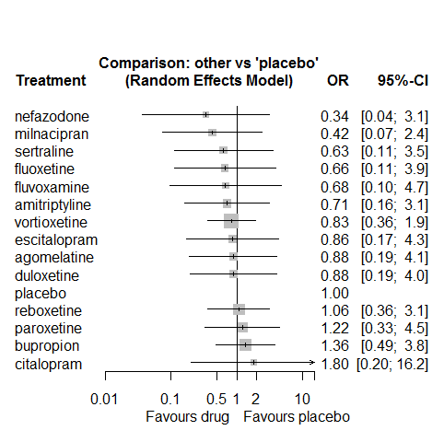

P-score

nefazodone 0.79

milnacipran 0.77

sertraline 0.61

fluoxetine 0.58

amitriptyline 0.56

fluvoxamine 0.56

vortioxetine 0.52

escitalopram 0.49

duloxetine 0.48

agomelatine 0.48

placebo 0.42

reboxetine 0.40

paroxetine 0.34

bupropion 0.27

citalopram 0.24

# **Ejaculation disorder/erectile disfunction**

We remove all arms for which dose range was not “Licenced”. After this:

* Removed 6 one-arm studies: Feighner1991, Coleman1999 (AK1A4002), Lieberman2008a (Study 309)(EUCTR2004-000562-13, 3151A1-309-EU, NCT00090649), Lieberman2008b (Study 317), DeMartinis2007 (Study 306, NCT00072774), Study 015Total number of studies with number randomized being smaller than event rates: 1. Removed the following studies: Rush1998 (excluding Armitage1997 and Gillin1997)
* Total number of arms 191. Total number of studies 79.
* Total events in placebo 67, out of a total of 7130 patients. Event rate placebo 0.009
* Total events in drugs 745, out of a total of 19604 patients. Event rate drugs 0.038

## **Distribution of dose across drugs**

Here we count the number of arms per drug, and the percent of these arms where Dose_intended_min was equal to the minimum licensed dose or lower. The values we used as minimum licensed dose are as follows:

agomelatine: 25; amitriptyline: 75; bupropion:300; citalopram:20; clomipramine:30; desvenlafaxine:50; duloxetine:40; escitalopram:10; fluoxetine:20; fluvoxamine:50; levomilnacipran:40; milnacipran:50; mirtazapine:15; nefazodone:300; paroxetine:20; reboxetine:8; sertraline:50; trazodone:150; venlafaxine:75; vilazodone:20; vortioxetine:5

Drug number.arms percent.low.dose

1 agomelatine 1 1.00

2 escitalopram 19 0.79

3 paroxetine 31 0.81

4 sertraline 9 0.89

6 vortioxetine 6 0.50

7 venlafaxine 7 0.71

8 levomilnacipran 7 0.57

9 reboxetine 7 1.00

10 fluoxetine 9 1.00

11 amitriptyline 3 0.67

12 mirtazapine 1 1.00

13 citalopram 9 0.56

14 fluvoxamine 5 0.80

15 vilazodone 3 0.33

16 duloxetine 10 0.30

17 bupropion 4 1.00

18 milnacipran 1 0.00

19 clomipramine 2 0.00

20 nefazodone 1 1.00

21 trazodone 1 1.00

## **Network graph**

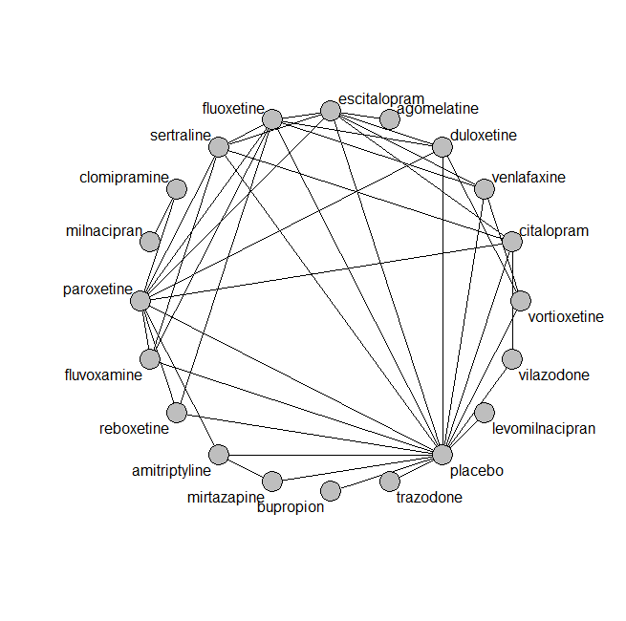

## **Pairwise MA**

### **Grouping all drugs together, comparison vs. placebo**

Number of studies: 52

Random effects meta-analysis: OR=4.29. 95% CI 3.18 to 5.78

Prediction interval 3.16 to 5.82

Heterogeneity (tau squared) was estimated to be 0.00

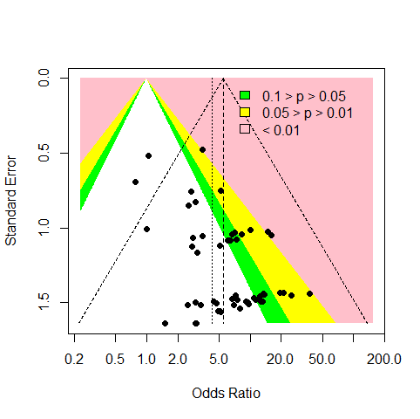

No evidence of an asymmetry (Harbord’s test p-value 0.7)

### **Meta-analyses of comparisons with 10 or more studies**

We show results from pairwise comparisons informed by 10 studies or more. An OR larger than 1 favors the first treatment in the comparison.

comparisons Number.of.studies OR lower.CI upper.CI tau.sq I.sq

1 placebo - paroxetine 18 6.1 4.5 12 0 0

## **Assessment of transitivity**

comparison studies baseline_SD age_SD female

1 agomelatine - escitalopram 1 26 (NA) 41 (NA) NaN (NA)

2 paroxetine - sertraline 2 22 (2) 43 (NA) NaN (NA)

3 escitalopram - placebo 8 22 (1.7) 44 (9.8) 0.7 (0.09)

4 escitalopram - sertraline 3 22 (3.3) 38 (3.1) NaN (NA)

5 placebo - sertraline 3 19 (0.6) 39 (1.9) NaN (NA)

6 placebo - venlafaxine 3 21 (0.1) 42 (1.4) 0.62 (0.01)

7 placebo - vortioxetine 4 23 (2) 50 (13.8) 0.65 (0.07)

8 venlafaxine - vortioxetine 1 22 (NA) 43 (NA) 0.62 (NA)

9 levomilnacipran - placebo 4 24 (0.9) 43 (1.5) 0.63 (0.02)

10 paroxetine - reboxetine 3 22 (2.1) 41 (2.7) 0.69 (0.07)

11 escitalopram - paroxetine 2 25 (2.8) 45 (0.5) NaN (NA)

12 escitalopram - venlafaxine 2 20 (0.4) 43 (7.5) NaN (NA)

13 fluoxetine - reboxetine 2 24 (1.6) 42 (2.5) 0.68 (0.05)

14 amitriptyline - mirtazapine 1 28 (NA) 38 (NA) NaN (NA)

15 amitriptyline - placebo 2 27 (0.9) 40 (1.8) NaN (NA)

16 mirtazapine - placebo 1 28 (NA) 38 (NA) NaN (NA)

17 citalopram - escitalopram 5 25 (2.5) 41 (4.1) NaN (NA)

18 citalopram - placebo 5 24 (0.7) 41 (1.4) 0.57 (NA)

19 fluoxetine - paroxetine 3 22 (1.2) 42 (1) NaN (NA)

20 fluvoxamine - placebo 2 24 (0.7) 41 (2.8) NaN (NA)

21 placebo - vilazodone 2 24 (0) 41 (1.1) 0.56 (0.03)

22 fluoxetine - fluvoxamine 1 22 (NA) 42 (NA) NaN (NA)

23 duloxetine - placebo 7 20 (2.8) 46 (11) 0.66 (0.07)

24 paroxetine - placebo 18 23 (2.4) 42 (7.5) 0.57 (0.17)

25 citalopram - sertraline 2 24 (2.4) 41 (9.5) NaN (NA)

26 fluoxetine - sertraline 1 21 (NA) 43 (NA) NaN (NA)

27 duloxetine - fluoxetine 1 18 (NA) 41 (NA) NaN (NA)

28 fluoxetine - placebo 3 21 (2.5) 50 (15.1) 0.55 (NA)

29 duloxetine - paroxetine 2 18 (0.4) 42 (2.2) NaN (NA)

30 bupropion - placebo 3 25 (1.8) 42 (4.1) NaN (NA)

31 citalopram - paroxetine 1 24 (NA) 40 (NA) NaN (NA)

32 duloxetine - vortioxetine 2 23 (3.1) 57 (19.5) 0.7 (0.06)

33 fluoxetine - venlafaxine 1 23 (NA) 40 (NA) NaN (NA)

34 escitalopram - fluoxetine 1 NaN (NA) 37 (NA) NaN (NA)

35 duloxetine - escitalopram 1 20 (NA) 42 (NA) NaN (NA)

36 fluvoxamine - paroxetine 1 21 (NA) 41 (NA) NaN (NA)

37 clomipramine - milnacipran 1 24 (NA) 48 (NA) NaN (NA)

38 placebo - reboxetine 4 22 (1.3) 40 (1) 0.67 (0.08)

39 citalopram - vilazodone 1 24 (NA) 42 (NA) 0.57 (NA)

40 amitriptyline - paroxetine 1 24 (NA) 46 (NA) NaN (NA)

41 fluvoxamine - sertraline 1 21 (NA) 40 (NA) NaN (NA)

42 clomipramine - paroxetine 1 23 (NA) 43 (NA) 0.73 (NA)

43 placebo - trazodone 1 22 (NA) 44 (NA) 0.64 (NA)

## **NMA**

A total of 20 treatments are included in the network.

A total of 78 studies are included in this analysis.

Estimated heterogeneity tau-squared 0.00

Global test for inconsistency, p-value 0.99678 (Q=20,d.o.f.40)

### **Comparison vs. placebo**

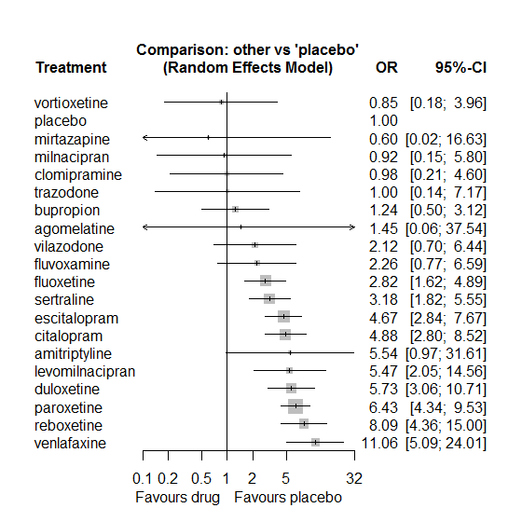

### **Ranking according to P-scores**

P-score

vortioxetine 0.81

placebo 0.81

mirtazapine 0.78

milnacipran 0.78

clomipramine 0.78

trazodone 0.75

bupropion 0.74

agomelatine 0.62

vilazodone 0.59

fluvoxamine 0.58

fluoxetine 0.52

sertraline 0.48

escitalopram 0.32

citalopram 0.30

amitriptyline 0.29

levomilnacipran 0.27

duloxetine 0.24

paroxetine 0.19

reboxetine 0.12

venlafaxine 0.05

### **Local inconsistency**

Percent of comparisons where there is some evidence (p-value<0.05) of disagreement between direct and indirect sources: 0. (0 out of 37 comparisons)

comparison TE seTE lower upper z p

29 amitriptyline:mirtazapine 8.098 17.32 -25.84 42.04 0.468 0.64

30 amitriptyline:paroxetine -1.495 1.96 -5.33 2.34 -0.763 0.45

31 amitriptyline:placebo 1.495 1.96 -2.34 5.33 0.763 0.45

57 citalopram:escitalopram -0.046 0.50 -1.03 0.93 -0.092 0.93

63 citalopram:paroxetine 0.280 0.59 -0.87 1.43 0.477 0.63

64 citalopram:placebo -0.492 0.62 -1.71 0.72 -0.793 0.43

66 citalopram:sertraline 0.273 0.56 -0.82 1.37 0.488 0.63

69 citalopram:vilazodone -0.990 1.18 -3.31 1.33 -0.836 0.40

86 duloxetine:escitalopram 0.239 0.73 -1.19 1.66 0.328 0.74

87 duloxetine:fluoxetine -0.821 0.89 -2.56 0.92 -0.923 0.36

92 duloxetine:paroxetine 0.145 0.65 -1.13 1.42 0.223 0.82

93 duloxetine:placebo -0.114 0.64 -1.38 1.15 -0.176 0.86

99 duloxetine:vortioxetine 0.893 1.58 -2.20 3.99 0.566 0.57

100 escitalopram:fluoxetine 0.995 1.17 -1.30 3.29 0.850 0.40

105 escitalopram:paroxetine -0.435 0.66 -1.72 0.85 -0.662 0.51

106 escitalopram:placebo 0.704 0.54 -0.35 1.76 1.308 0.19

108 escitalopram:sertraline -0.176 0.49 -1.15 0.79 -0.356 0.72

110 escitalopram:venlafaxine -0.244 0.79 -1.79 1.30 -0.311 0.76

113 fluoxetine:fluvoxamine 0.550 1.38 -2.16 3.26 0.398 0.69

117 fluoxetine:paroxetine -0.407 0.51 -1.40 0.59 -0.801 0.42

118 fluoxetine:placebo 1.051 0.81 -0.54 2.64 1.297 0.19

119 fluoxetine:reboxetine -0.696 0.92 -2.51 1.11 -0.755 0.45

120 fluoxetine:sertraline 0.208 0.81 -1.38 1.79 0.257 0.80

122 fluoxetine:venlafaxine 0.557 0.81 -1.03 2.15 0.688 0.49

128 fluvoxamine:paroxetine 0.887 1.15 -1.37 3.14 0.770 0.44

129 fluvoxamine:placebo 0.268 1.38 -2.43 2.97 0.195 0.85

131 fluvoxamine:sertraline -0.668 1.13 -2.88 1.55 -0.591 0.55

156 mirtazapine:placebo 1.744 3.73 -5.56 9.05 0.468 0.64

163 paroxetine:placebo -0.155 0.42 -0.98 0.67 -0.371 0.71

164 paroxetine:reboxetine -0.301 0.65 -1.57 0.97 -0.466 0.64

165 paroxetine:sertraline 0.135 0.57 -0.98 1.25 0.237 0.81

170 placebo:reboxetine 0.603 0.71 -0.79 2.00 0.848 0.40

171 placebo:sertraline -0.045 0.70 -1.42 1.33 -0.063 0.95

173 placebo:venlafaxine -0.253 0.87 -1.97 1.46 -0.290 0.77

174 placebo:vilazodone 2.334 1.46 -0.54 5.20 1.594 0.11

175 placebo:vortioxetine -0.734 1.71 -4.08 2.61 -0.430 0.67

189 venlafaxine:vortioxetine 0.392 1.79 -3.12 3.91 0.219 0.83

### **League table**

Below we show the league table. Upper triangle: direct evidence. Lower triangle: NMA. An odds ratio larger than 1 in the upper triangle favors the column-defining drug. An odds ratio larger than 1 in the bottom triangle favors the row-defining drug.

|  |  |  |  |  |  |  |  |  |  |  |  |  |  |  |  |  |  |  |  |
| --- | --- | --- | --- | --- | --- | --- | --- | --- | --- | --- | --- | --- | --- | --- | --- | --- | --- | --- | --- |
| AGOM | . | . | . | . | . | 0.31 [0.01; 7.74] | . | . | . | . | . | . | . | . | . | . | . | . | . |
| 0.26 [0.01; 10.41] | AMIT | . | . | . | . | . | . | . | . | . | 9.77 [0.51; 186.52] | 0.30 [0.01; 7.51] | 8.54 [1.08; 67.48] | . | . | . | . | . | . |
| 1.16 [0.04; 34.28] | 4.46 [0.62; 31.92] | BUPR | . | . | . | . | . | . | . | . | . | . | 1.24 [0.50; 3.12] | . | . | . | . | . | . |
| 0.30 [0.01; 7.67] | 1.13 [0.18; 6.96] | 0.25 [0.09; 0.75] | CITA | . | . | 1.03 [0.54; 1.95] | . | . | . | . | . | 0.92 [0.36; 2.38] | 3.46 [1.25; 9.58] | . | 1.80 [0.78; 4.18] | . | . | 1.52 [0.34; 6.83] | . |
| 1.47 [0.04; 52.90] | 5.64 [0.56; 56.77] | 1.27 [0.21; 7.64] | 4.98 [1.02; 24.33] | CLOM | . | . | . | . | . | 1.06 [0.39; 2.87] | . | 0.15 [0.03; 0.68] | . | . | . | . | . | . | . |
| 0.25 [0.01; 6.75] | 0.97 [0.15; 6.08] | 0.22 [0.07; 0.66] | 0.85 [0.41; 1.79] | 0.17 [0.03; 0.86] | DULO | 1.44 [0.45; 4.66] | 1.06 [0.22; 5.01] | . | . | . | . | 0.98 [0.36; 2.68] | 5.37 [2.08; 13.87] | . | . | . | . | . | 10.21 [1.25; 83.40] |
| 0.31 [0.01; 7.74] | 1.19 [0.20; 7.17] | 0.27 [0.09; 0.76] | 1.05 [0.64; 1.70] | 0.21 [0.04; 1.01] | 1.23 [0.63; 2.39] | ESCI | 4.16 [0.46; 37.90] | . | . | . | . | 0.51 [0.16; 1.64] | 7.46 [3.15; 17.65] | . | 1.36 [0.73; 2.55] | . | 0.37 [0.12; 1.16] | . | . |
| 0.51 [0.02; 13.55] | 1.97 [0.32; 11.97] | 0.44 [0.15; 1.29] | 1.73 [0.90; 3.35] | 0.35 [0.07; 1.66] | 2.03 [1.01; 4.10] | 1.66 [0.91; 3.01] | FLUO | 1.93 [0.17; 21.72] | . | . | . | 0.39 [0.22; 0.67] | 6.96 [1.60; 30.32] | 0.19 [0.04; 1.02] | 1.05 [0.25; 4.31] | . | 0.35 [0.11; 1.17] | . | . |
| 0.64 [0.02; 19.20] | 2.46 [0.32; 18.72] | 0.55 [0.13; 2.26] | 2.17 [0.70; 6.66] | 0.44 [0.07; 2.70] | 2.54 [0.78; 8.29] | 2.07 [0.69; 6.19] | 1.25 [0.42; 3.73] | FLUV | . | . | . | 0.64 [0.10; 4.15] | 2.80 [0.25; 31.37] | . | 0.47 [0.08; 2.68] | . | . | . | . |
| 0.26 [0.01; 7.93] | 1.01 [0.14; 7.47] | 0.23 [0.06; 0.87] | 0.89 [0.29; 2.75] | 0.18 [0.03; 1.12] | 1.05 [0.33; 3.35] | 0.85 [0.28; 2.56] | 0.52 [0.17; 1.58] | 0.41 [0.10; 1.76] | LEVO | . | . | . | 5.47 [2.05; 14.56] | . | . | . | . | . | . |
| 1.56 [0.04; 64.29] | 5.99 [0.49; 73.94] | 1.34 [0.17; 10.48] | 5.28 [0.81; 34.35] | 1.06 [0.39; 2.87] | 6.19 [0.93; 41.29] | 5.05 [0.79; 32.35] | 3.05 [0.48; 19.41] | 2.44 [0.31; 19.50] | 5.91 [0.74; 47.39] | MILN | . | . | . | . | . | . | . | . | . |
| 2.40 [0.02; 249.64] | 9.19 [0.49; 173.51] | 2.06 [0.07; 64.55] | 8.11 [0.28; 232.80] | 1.63 [0.04; 62.62] | 9.50 [0.33; 276.41] | 7.74 [0.27; 220.42] | 4.68 [0.16; 133.81] | 3.74 [0.12; 121.45] | 9.08 [0.29; 288.64] | 1.53 [0.03; 67.35] | MIRT | . | 1.00 [0.02; 51.38] | . | . | . | . | . | . |
| 0.22 [0.01; 5.82] | 0.86 [0.15; 5.01] | 0.19 [0.07; 0.53] | 0.76 [0.44; 1.30] | 0.15 [0.03; 0.68] | 0.89 [0.48; 1.65] | 0.73 [0.45; 1.18] | 0.44 [0.28; 0.69] | 0.35 [0.12; 1.00] | 0.85 [0.30; 2.44] | 0.14 [0.02; 0.86] | 0.09 [0.00; 2.62] | PARO | 6.08 [3.72; 9.95] | 0.74 [0.40; 1.36] | 2.21 [0.88; 5.54] | . | . | . | . |
| 1.45 [0.06; 37.54] | 5.54 [0.97; 31.61] | 1.24 [0.50; 3.12] | 4.88 [2.80; 8.52] | 0.98 [0.21; 4.60] | 5.73 [3.06; 10.71] | 4.67 [2.84; 7.67] | 2.82 [1.62; 4.89] | 2.26 [0.77; 6.59] | 5.47 [2.05; 14.56] | 0.92 [0.15; 5.80] | 0.60 [0.02; 16.63] | 6.43 [4.34; 9.53] | PLAC | 0.19 [0.06; 0.63] | 0.30 [0.09; 1.04] | 1.00 [0.14; 7.17] | 0.08 [0.02; 0.32] | 0.72 [0.21; 2.46] | 0.94 [0.15; 6.00] |
| 0.18 [0.01; 4.81] | 0.69 [0.11; 4.26] | 0.15 [0.05; 0.47] | 0.60 [0.29; 1.26] | 0.12 [0.02; 0.59] | 0.71 [0.32; 1.57] | 0.58 [0.29; 1.16] | 0.35 [0.18; 0.68] | 0.28 [0.09; 0.89] | 0.68 [0.21; 2.15] | 0.11 [0.02; 0.74] | 0.07 [0.00; 2.16] | 0.80 [0.47; 1.36] | 0.12 [0.07; 0.23] | REBO | . | . | . | . | . |
| 0.45 [0.02; 11.77] | 1.74 [0.28; 10.67] | 0.39 [0.13; 1.14] | 1.54 [0.90; 2.63] | 0.31 [0.06; 1.50] | 1.80 [0.86; 3.75] | 1.47 [0.91; 2.37] | 0.89 [0.47; 1.67] | 0.71 [0.24; 2.08] | 1.72 [0.56; 5.30] | 0.29 [0.04; 1.88] | 0.19 [0.01; 5.44] | 2.02 [1.20; 3.42] | 0.31 [0.18; 0.55] | 2.54 [1.23; 5.27] | SERT | . | . | . | . |
| 1.45 [0.03; 65.02] | 5.54 [0.40; 76.79] | 1.24 [0.14; 10.93] | 4.88 [0.63; 37.82] | 0.98 [0.08; 12.00] | 5.73 [0.72; 45.22] | 4.67 [0.61; 35.57] | 2.82 [0.36; 21.78] | 2.26 [0.24; 21.24] | 5.47 [0.61; 49.33] | 0.92 [0.06; 13.66] | 0.60 [0.01; 28.56] | 6.43 [0.86; 47.93] | 1.00 [0.14; 7.17] | 8.09 [1.03; 63.72] | 3.18 [0.41; 24.62] | TRAZ | . | . | . |
| 0.13 [0.00; 3.58] | 0.50 [0.08; 3.33] | 0.11 [0.03; 0.37] | 0.44 [0.19; 1.03] | 0.09 [0.02; 0.48] | 0.52 [0.21; 1.29] | 0.42 [0.20; 0.91] | 0.25 [0.12; 0.56] | 0.20 [0.06; 0.72] | 0.49 [0.14; 1.72] | 0.08 [0.01; 0.59] | 0.05 [0.00; 1.64] | 0.58 [0.27; 1.26] | 0.09 [0.04; 0.20] | 0.73 [0.29; 1.83] | 0.29 [0.12; 0.67] | 0.09 [0.01; 0.75] | VENL | . | 17.14 [0.91; 321.34] |
| 0.68 [0.02; 20.88] | 2.61 [0.33; 20.48] | 0.59 [0.14; 2.47] | 2.30 [0.73; 7.23] | 0.46 [0.07; 3.04] | 2.70 [0.77; 9.42] | 2.20 [0.68; 7.05] | 1.33 [0.40; 4.46] | 1.06 [0.23; 4.85] | 2.58 [0.59; 11.31] | 0.44 [0.05; 3.67] | 0.28 [0.01; 9.36] | 3.03 [0.96; 9.56] | 0.47 [0.16; 1.43] | 3.81 [1.09; 13.27] | 1.50 [0.46; 4.93] | 0.47 [0.05; 4.52] | 5.21 [1.38; 19.64] | VILA | . |
| 1.71 [0.05; 61.35] | 6.54 [0.64; 66.46] | 1.47 [0.24; 8.83] | 5.76 [1.16; 28.65] | 1.16 [0.13; 10.01] | 6.76 [1.45; 31.56] | 5.51 [1.14; 26.54] | 3.33 [0.68; 16.27] | 2.66 [0.42; 16.93] | 6.45 [1.04; 40.08] | 1.09 [0.10; 11.72] | 0.71 [0.02; 27.49] | 7.59 [1.60; 35.97] | 1.18 [0.25; 5.51] | 9.54 [1.87; 48.77] | 3.75 [0.76; 18.62] | 1.18 [0.10; 14.39] | 13.05 [2.59; 65.84] | 2.51 [0.38; 16.55] | VORT |

### **Estimated event rates**

For an event rate in placebo equal to the average event rate (i.e. fixed to 0.01) the estimated event rates for each drug are as follows

drug rate

1 agomelatine 0.01 [0, 0.26]

2 amitriptyline 0.05 [0.01, 0.23]

3 bupropion 0.01 [0, 0.03]

4 citalopram 0.04 [0.03, 0.07]

5 clomipramine 0.01 [0, 0.04]

6 duloxetine 0.05 [0.03, 0.09]

7 escitalopram 0.04 [0.03, 0.07]

8 fluoxetine 0.03 [0.02, 0.04]

9 fluvoxamine 0.02 [0.01, 0.06]

10 levomilnacipran 0.05 [0.02, 0.12]

11 milnacipran 0.01 [0, 0.05]

12 mirtazapine 0.01 [0, 0.14]

13 paroxetine 0.06 [0.04, 0.08]

15 reboxetine 0.07 [0.04, 0.12]

16 sertraline 0.03 [0.02, 0.05]

17 trazodone 0.01 [0, 0.06]

18 venlafaxine 0.09 [0.05, 0.19]

19 vilazodone 0.02 [0.01, 0.06]

20 vortioxetine 0.01 [0, 0.04]

## **Sensitivity analysis: Mantel-Haenszel NMA**

Some drugs are removed from the network. No big differences for the rest.

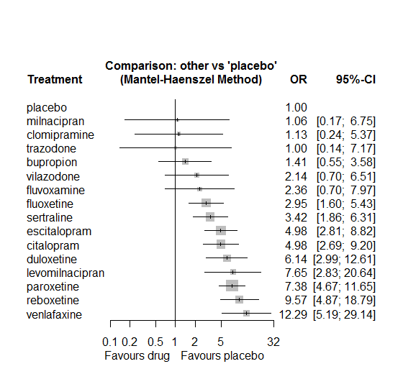

P-score

placebo 0.8782

milnacipran 0.8107

clomipramine 0.8103

trazodone 0.8101

bupropion 0.7783

vilazodone 0.6582

fluvoxamine 0.6288

fluoxetine 0.5765

sertraline 0.5242

escitalopram 0.3557

citalopram 0.3546

duloxetine 0.2686

levomilnacipran 0.2044

paroxetine 0.1851

reboxetine 0.1018

venlafaxine 0.0544

## **Sensitivity analysis: splitting nodes according to dosage**

All treatment arms for drug X, with dose_intended_min equal to or smaller to the minimum licensed dose were set as “X_L”. All other arms of X are “X_H”. Studies with no information on dose are excluded. Results shown below:

|  |  |  |
| --- | --- | --- |
| **Low dose vs. placebo** | **High dose vs. placebo** | **High dose vs. low dose** |
|  |  |  |

## **Sensitivity analysis: Keeping only low dropout arms**

We exclude all treatment arms with dropout rates larger than 25%, and we re-analyse the network.

Total number of arms included in the analysis 68. Total number of studies 30

Total events in placebo 8, out of a total of 3581 patients. Event rate placebo 0.002

Total events in drugs 231, out of a total of 7872 patients. Event rate drugs 0.029

We fit a Mantel-Haenszel NMA. Results shown below.

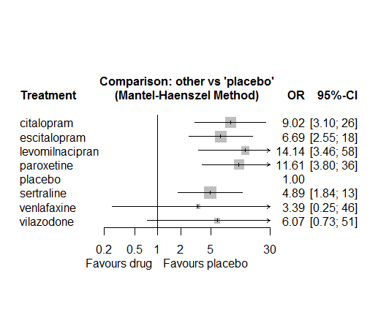

P-score

placebo 0.97

sertraline 0.67

venlafaxine 0.65

vilazodone 0.49

escitalopram 0.49

citalopram 0.32

levomilnacipran 0.21

paroxetine 0.20

# **Weight increase**

We remove all arms for which dose range was not “Licenced”. After this:

* Removed 5 one-arm studies: Stahl2010 (CAGO178A2302), Carman1991, Masco1985, Halikas1995 (MIR 003-023 - FDA), Study 015
* Total number of arms 123. Total number of studies 52.
* Total events in placebo 121, out of a total of 4146 patients. Event rate placebo 0.029
* Total events in drugs 510, out of a total of 13002 patients. Event rate drugs 0.039

## **Distribution of dose across drugs**

Here we count the number of arms per drug, and the percent of these arms where Dose_intended_min was equal to the minimum licensed dose or lower. The values we used as minimum licensed dose are as follows:

agomelatine: 25; amitriptyline: 75; bupropion:300; citalopram:20; clomipramine:30; desvenlafaxine:50; duloxetine:40; escitalopram:10; fluoxetine:20; fluvoxamine:50; levomilnacipran:40; milnacipran:50; mirtazapine:15; nefazodone:300; paroxetine:20; reboxetine:8; sertraline:50; trazodone:150; venlafaxine:75; vilazodone:20; vortioxetine:5

Drug number.arms percent.low.dose

1 bupropion 6 1.00

3 vortioxetine 10 0.60

4 venlafaxine 4 0.75

5 mirtazapine 9 0.67

6 fluoxetine 9 0.89

7 milnacipran 4 0.00

8 amitriptyline 6 0.33

9 fluvoxamine 1 0.00

10 reboxetine 5 1.00

11 paroxetine 11 1.00

12 duloxetine 7 0.00

13 sertraline 5 1.00

14 agomelatine 2 1.00

15 desvenlafaxine 6 0.83

16 escitalopram 3 0.67

17 citalopram 5 0.80

18 vilazodone 1 0.00

19 trazodone 1 1.00

20 clomipramine 1 0.00

## **Network graph**

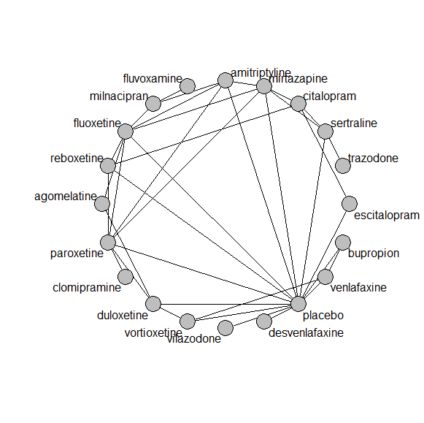

## **Pairwise MA**

### **Grouping all drugs together, comparison vs. placebo**

Number of studies: 26

Random effects meta-analysis: OR=0.86. 95% CI 0.61 to 1.22

Prediction interval 0.38 to 1.93

Heterogeneity (tau squared) was estimated to be 0.12

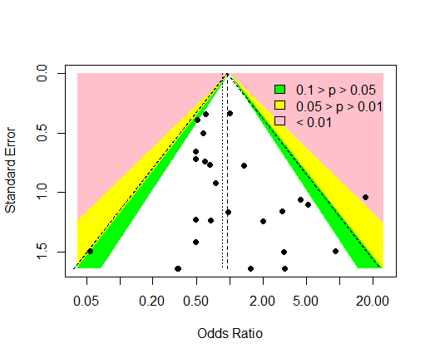

No evidence of an asymmetry (Harbord’s test p-value =0.8)

### **Meta-analyses of comparisons with 10 or more studies**

We show results from pairwise comparisons informed by 10 studies or more. An OR larger than 1 favors the first treatment in the comparison.

No meta-analyses had 10 studies or more

## **Assessment of transitivity**

comparison studies baseline_SD age_SD female

1 bupropion - placebo 4 24 (1.9) 39 (1.9) 0.45 (0.33)

2 placebo - venlafaxine 3 23 (1) 43 (1) 0.62 (NA)

3 placebo - vortioxetine 4 21 (0.1) 43 (3.5) 0.6 (0.09)

4 venlafaxine - vortioxetine 1 22 (NA) 43 (NA) 0.62 (NA)

5 fluoxetine - mirtazapine 3 26 (2.5) 43 (5.7) NaN (NA)

6 amitriptyline - milnacipran 1 26 (NA) 50 (NA) NaN (NA)

7 fluvoxamine - milnacipran 1 24 (NA) 48 (NA) NaN (NA)

8 fluoxetine - milnacipran 1 23 (NA) 45 (NA) NaN (NA)

9 paroxetine - reboxetine 3 22 (2.1) 41 (2.7) 0.69 (0.07)

10 duloxetine - placebo 4 22 (2.6) 44 (1.8) 0.69 (NA)

11 duloxetine - vortioxetine 1 NaN (NA) 45 (NA) 0.69 (NA)

12 mirtazapine - sertraline 1 NaN (NA) 42 (NA) NaN (NA)

13 mirtazapine - paroxetine 3 23 (1.2) 53 (16.7) NaN (NA)

14 amitriptyline - fluoxetine 2 24 (0.7) 41 (0.9) 0.76 (NA)

15 agomelatine - duloxetine 1 26 (NA) 43 (NA) NaN (NA)

16 fluoxetine - placebo 1 23 (NA) 40 (NA) 0.63 (NA)

17 fluoxetine - reboxetine 1 23 (NA) 40 (NA) 0.63 (NA)

18 placebo - reboxetine 3 21 (1.5) 39 (0.7) 0.7 (0.07)

19 desvenlafaxine - placebo 5 23 (0.6) 44 (5.3) 0.68 (0.19)

20 citalopram - escitalopram 2 26 (3.5) 46 (0.6) NaN (NA)

21 placebo - vilazodone 1 24 (NA) 40 (NA) 0.54 (NA)

22 duloxetine - paroxetine 2 20 (0.7) 44 (1.3) NaN (NA)

23 paroxetine - placebo 4 20 (0.6) 42 (3.1) 0.73 (0.04)

24 citalopram - sertraline 1 22 (NA) 48 (NA) NaN (NA)

25 agomelatine - fluoxetine 1 28 (NA) 42 (NA) 0.78 (NA)

26 citalopram - mirtazapine 1 23 (NA) 42 (NA) NaN (NA)

27 sertraline - trazodone 1 22 (NA) 46 (NA) 0.65 (NA)

28 placebo - sertraline 2 24 (1.4) 41 (3.8) 0.63 (NA)

29 clomipramine - paroxetine 1 24 (NA) 71 (NA) 0.89 (NA)

30 amitriptyline - paroxetine 1 NaN (NA) 40 (NA) 0.54 (NA)

31 amitriptyline - mirtazapine 1 25 (NA) NaN (NA) NaN (NA)

32 amitriptyline - placebo 2 24 (0.7) 40 (NA) NaN (NA)

33 mirtazapine - placebo 1 25 (NA) NaN (NA) NaN (NA)

34 citalopram - reboxetine 1 24 (NA) 42 (NA) 0.64 (NA)

35 bupropion - venlafaxine 1 24 (NA) 37 (NA) NaN (NA)

36 fluoxetine - paroxetine 1 24 (NA) 44 (NA) NaN (NA)

37 escitalopram - placebo 1 NaN (NA) 40 (NA) 0.72 (NA)

## **NMA**

A total of 20 treatments are included in the network.

A total of 52 studies are included in this analysis.

Estimated heterogeneity tau-squared 0.00

Global test for inconsistency, p-value 0.67925 (Q=18,d.o.f.21)

### **Comparison vs. placebo**

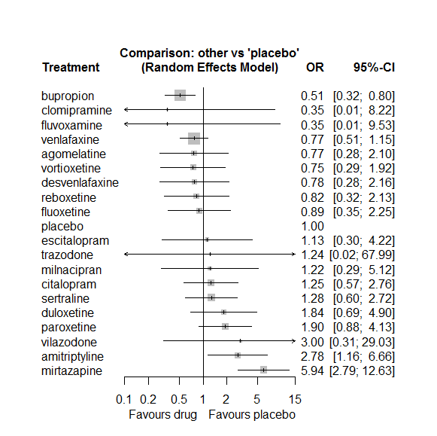

### **Ranking according to P-scores**

P-score

bupropion 0.84

clomipramine 0.75

fluvoxamine 0.74

venlafaxine 0.67

agomelatine 0.67

vortioxetine 0.67

desvenlafaxine 0.64

reboxetine 0.63

fluoxetine 0.60

placebo 0.53

escitalopram 0.49

trazodone 0.48

milnacipran 0.46

citalopram 0.43

sertraline 0.42

duloxetine 0.28

paroxetine 0.25

vilazodone 0.24

amitriptyline 0.15

mirtazapine 0.03

### **Local inconsistency**

Percent of comparisons where there is some evidence (p-value<0.05) of disagreement between direct and indirect sources: 0. (0 out of 32 comparisons)

comparison TE seTE lower upper z p

6 agomelatine:duloxetine 0.045 0.94 -1.80 1.89 0.048 0.962

8 agomelatine:fluoxetine -0.045 0.94 -1.89 1.80 -0.048 0.962

26 amitriptyline:fluoxetine 1.600 1.01 -0.39 3.59 1.576 0.115

28 amitriptyline:milnacipran -2.250 1.44 -5.07 0.57 -1.566 0.117

29 amitriptyline:mirtazapine 0.272 0.68 -1.06 1.61 0.401 0.689

30 amitriptyline:paroxetine -0.727 0.72 -2.14 0.69 -1.008 0.314

31 amitriptyline:placebo 1.021 0.97 -0.88 2.92 1.051 0.293

48 bupropion:placebo 0.074 0.49 -0.89 1.04 0.150 0.881

52 bupropion:venlafaxine -0.074 0.49 -1.04 0.89 -0.150 0.881

58 citalopram:escitalopram 2.424 1.39 -0.30 5.15 1.741 0.082

62 citalopram:mirtazapine 0.449 0.69 -0.91 1.81 0.647 0.518

65 citalopram:reboxetine -0.504 1.08 -2.63 1.62 -0.465 0.642

66 citalopram:sertraline -0.783 0.67 -2.09 0.53 -1.171 0.242

105 duloxetine:paroxetine 0.531 1.03 -1.48 2.54 0.517 0.605

106 duloxetine:placebo -0.398 1.00 -2.35 1.56 -0.398 0.690

112 duloxetine:vortioxetine 0.207 2.13 -3.96 4.38 0.097 0.922

118 escitalopram:placebo 2.424 1.39 -0.30 5.15 1.741 0.082

126 fluoxetine:milnacipran 2.250 1.44 -0.57 5.07 1.566 0.117

127 fluoxetine:mirtazapine -0.090 0.78 -1.62 1.44 -0.115 0.908

128 fluoxetine:paroxetine 1.483 1.03 -0.54 3.50 1.439 0.150

129 fluoxetine:placebo -1.662 1.63 -4.86 1.53 -1.020 0.308

130 fluoxetine:reboxetine -2.385 1.64 -5.59 0.82 -1.457 0.145

155 mirtazapine:paroxetine 0.059 0.58 -1.07 1.19 0.103 0.918

156 mirtazapine:placebo 1.564 1.13 -0.66 3.78 1.381 0.167

158 mirtazapine:sertraline 0.261 0.77 -1.25 1.77 0.338 0.735

163 paroxetine:placebo -0.437 0.85 -2.10 1.22 -0.517 0.605

164 paroxetine:reboxetine 0.870 0.97 -1.03 2.77 0.898 0.369

170 placebo:reboxetine -0.418 0.99 -2.35 1.52 -0.423 0.672

171 placebo:sertraline 0.786 0.77 -0.73 2.30 1.016 0.309

173 placebo:venlafaxine 0.021 0.49 -0.94 0.99 0.042 0.967

175 placebo:vortioxetine 1.579 1.91 -2.17 5.33 0.825 0.409

189 venlafaxine:vortioxetine -1.564 1.61 -4.73 1.60 -0.969 0.332

### **League table**

Below we show the league table. Upper triangle: direct evidence. Lower triangle: NMA. An odds ratio larger than 1 in the upper triangle favors the column-defining drug. An odds ratio larger than 1 in the bottom triangle favors the row-defining drug.

|  |  |  |  |  |  |  |  |  |  |  |  |  |  |  |  |  |  |  |  |
| --- | --- | --- | --- | --- | --- | --- | --- | --- | --- | --- | --- | --- | --- | --- | --- | --- | --- | --- | --- |
| AGOM | . | . | . | . | . | 0.42 [0.17; 1.04] | . | 0.85 [0.41; 1.77] | . | . | . | . | . | . | . | . | . | . | . |
| 0.28 [0.10; 0.75] | AMIT | . | . | . | . | . | . | 10.53 [1.85; 59.74] | . | 1.32 [0.33; 5.27] | 0.53 [0.21; 1.32] | 0.95 [0.32; 2.81] | 5.66 [1.16; 27.71] | . | . | . | . | . | . |
| 1.50 [0.50; 4.55] | 5.46 [2.04; 14.61] | BUPR | . | . | . | . | . | . | . | . | . | . | 0.52 [0.30; 0.90] | . | . | . | 0.64 [0.33; 1.23] | . | . |
| 0.61 [0.21; 1.79] | 2.22 [0.90; 5.46] | 0.41 [0.16; 1.01] | CITA | . | . | . | 2.20 [0.52; 9.33] | . | . | . | 0.26 [0.10; 0.67] | . | . | 1.08 [0.19; 6.16] | 0.85 [0.48; 1.49] | . | . | . | . |
| 2.20 [0.09; 54.06] | 7.97 [0.34; 184.62] | 1.46 [0.06; 35.55] | 3.59 [0.15; 85.16] | CLOM | . | . | . | . | . | . | . | 0.18 [0.01; 3.92] | . | . | . | . | . | . | . |
| 0.98 [0.23; 4.15] | 3.57 [0.93; 13.73] | 0.65 [0.21; 2.00] | 1.61 [0.44; 5.87] | 0.45 [0.02; 12.42] | DESV | . | . | . | . | . | . | . | 0.78 [0.28; 2.16] | . | . | . | . | . | . |
| 0.42 [0.19; 0.91] | 1.51 [0.53; 4.32] | 0.28 [0.09; 0.81] | 0.68 [0.23; 2.03] | 0.19 [0.01; 4.69] | 0.42 [0.10; 1.74] | DULO | . | . | . | . | . | 1.37 [0.27; 7.00] | 1.51 [0.37; 6.06] | . | . | . | . | . | 2.97 [0.06; 150.21] |
| 0.68 [0.14; 3.22] | 2.47 [0.58; 10.52] | 0.45 [0.11; 1.82] | 1.11 [0.33; 3.79] | 0.31 [0.01; 8.96] | 0.69 [0.13; 3.67] | 1.64 [0.34; 7.77] | ESCI | . | . | . | . | . | 5.13 [0.59; 44.44] | . | . | . | . | . | . |
| 0.86 [0.44; 1.68] | 3.11 [1.33; 7.26] | 0.57 [0.20; 1.59] | 1.40 [0.54; 3.66] | 0.39 [0.02; 9.25] | 0.87 [0.22; 3.46] | 2.06 [0.84; 5.09] | 1.26 [0.29; 5.57] | FLUO | . | 3.20 [0.33; 31.33] | 0.14 [0.05; 0.45] | 1.55 [0.25; 9.53] | 0.20 [0.01; 4.15] | 0.14 [0.01; 2.73] | . | . | . | . | . |
| 2.21 [0.08; 61.10] | 8.00 [0.32; 200.58] | 1.47 [0.05; 41.49] | 3.60 [0.13; 99.65] | 1.00 [0.01; 88.86] | 2.24 [0.07; 71.78] | 5.30 [0.19; 150.94] | 3.24 [0.10; 108.45] | 2.57 [0.10; 67.84] | FLUV | 0.28 [0.01; 5.63] | . | . | . | . | . | . | . | . | . |
| 0.63 [0.15; 2.68] | 2.27 [0.68; 7.60] | 0.42 [0.09; 1.87] | 1.02 [0.24; 4.36] | 0.29 [0.01; 8.07] | 0.64 [0.11; 3.70] | 1.51 [0.33; 6.85] | 0.92 [0.15; 5.82] | 0.73 [0.19; 2.78] | 0.28 [0.01; 5.63] | MILN | . | . | . | . | . | . | . | . | . |
| 0.13 [0.05; 0.32] | 0.47 [0.24; 0.91] | 0.09 [0.04; 0.21] | 0.21 [0.11; 0.42] | 0.06 [0.00; 1.32] | 0.13 [0.04; 0.47] | 0.31 [0.12; 0.82] | 0.19 [0.05; 0.73] | 0.15 [0.07; 0.32] | 0.06 [0.00; 1.53] | 0.21 [0.05; 0.77] | MIRT | 3.19 [1.61; 6.31] | 23.06 [2.92; 182.21] | . | 5.57 [1.59; 19.47] | . | . | . | . |
| 0.40 [0.16; 1.02] | 1.46 [0.73; 2.93] | 0.27 [0.11; 0.66] | 0.66 [0.30; 1.46] | 0.18 [0.01; 3.92] | 0.41 [0.11; 1.48] | 0.97 [0.37; 2.52] | 0.59 [0.15; 2.38] | 0.47 [0.21; 1.04] | 0.18 [0.01; 4.81] | 0.64 [0.17; 2.45] | 3.12 [1.81; 5.38] | PARO | 1.41 [0.36; 5.54] | 3.51 [0.94; 13.06] | . | . | . | . | . |
| 0.77 [0.28; 2.10] | 2.78 [1.16; 6.66] | 0.51 [0.32; 0.80] | 1.25 [0.57; 2.76] | 0.35 [0.01; 8.22] | 0.78 [0.28; 2.16] | 1.84 [0.69; 4.90] | 1.13 [0.30; 4.22] | 0.89 [0.35; 2.25] | 0.35 [0.01; 9.53] | 1.22 [0.29; 5.12] | 5.94 [2.79; 12.63] | 1.90 [0.88; 4.13] | PLAC | 1.03 [0.30; 3.51] | 1.14 [0.40; 3.27] | . | 1.31 [0.82; 2.08] | 0.33 [0.03; 3.23] | 1.50 [0.56; 3.98] |
| 0.93 [0.28; 3.13] | 3.37 [1.14; 9.98] | 0.62 [0.22; 1.77] | 1.52 [0.56; 4.12] | 0.42 [0.02; 10.47] | 0.94 [0.23; 3.82] | 2.24 [0.66; 7.58] | 1.37 [0.30; 6.19] | 1.08 [0.35; 3.32] | 0.42 [0.01; 12.30] | 1.48 [0.31; 7.12] | 7.22 [2.73; 19.11] | 2.31 [0.89; 5.97] | 1.21 [0.47; 3.14] | REBO | . | . | . | . | . |
| 0.60 [0.20; 1.76] | 2.18 [0.88; 5.40] | 0.40 [0.17; 0.96] | 0.98 [0.59; 1.63] | 0.27 [0.01; 6.50] | 0.61 [0.17; 2.18] | 1.44 [0.49; 4.29] | 0.88 [0.24; 3.21] | 0.70 [0.27; 1.84] | 0.27 [0.01; 7.54] | 0.96 [0.22; 4.11] | 4.66 [2.30; 9.41] | 1.49 [0.66; 3.36] | 0.78 [0.37; 1.67] | 0.65 [0.23; 1.79] | SERT | 1.03 [0.02; 52.90] | . | . | . |
| 0.62 [0.01; 36.68] | 2.25 [0.04; 127.69] | 0.41 [0.01; 23.25] | 1.01 [0.02; 53.58] | 0.28 [0.00; 44.18] | 0.63 [0.01; 39.40] | 1.49 [0.03; 88.50] | 0.91 [0.01; 57.38] | 0.72 [0.01; 41.61] | 0.28 [0.00; 48.48] | 0.99 [0.01; 65.74] | 4.81 [0.09; 262.12] | 1.54 [0.03; 85.69] | 0.81 [0.01; 44.56] | 0.67 [0.01; 38.89] | 1.03 [0.02; 52.90] | TRAZ | . | . | . |
| 1.00 [0.34; 2.96] | 3.62 [1.38; 9.50] | 0.66 [0.41; 1.07] | 1.63 [0.67; 3.97] | 0.45 [0.02; 10.99] | 1.01 [0.34; 3.05] | 2.40 [0.83; 6.92] | 1.47 [0.37; 5.84] | 1.16 [0.42; 3.19] | 0.45 [0.02; 12.73] | 1.59 [0.36; 7.06] | 7.74 [3.29; 18.24] | 2.48 [1.03; 5.95] | 1.30 [0.87; 1.96] | 1.07 [0.38; 3.01] | 1.66 [0.70; 3.93] | 1.61 [0.03; 90.44] | VENL | . | 0.26 [0.01; 5.06] |
| 0.26 [0.02; 3.06] | 0.93 [0.08; 10.54] | 0.17 [0.02; 1.72] | 0.42 [0.04; 4.61] | 0.12 [0.00; 5.69] | 0.26 [0.02; 3.13] | 0.61 [0.05; 7.27] | 0.38 [0.03; 5.19] | 0.30 [0.03; 3.45] | 0.12 [0.00; 6.42] | 0.41 [0.03; 5.97] | 1.98 [0.18; 21.65] | 0.63 [0.06; 6.98] | 0.33 [0.03; 3.23] | 0.27 [0.02; 3.21] | 0.43 [0.04; 4.66] | 0.41 [0.00; 41.21] | 0.26 [0.03; 2.57] | VILA | . |
| 1.03 [0.26; 4.02] | 3.73 [1.04; 13.39] | 0.68 [0.24; 1.94] | 1.68 [0.49; 5.73] | 0.47 [0.02; 12.62] | 1.04 [0.26; 4.20] | 2.47 [0.65; 9.37] | 1.51 [0.30; 7.64] | 1.20 [0.32; 4.43] | 0.47 [0.01; 14.54] | 1.64 [0.30; 9.06] | 7.97 [2.40; 26.48] | 2.55 [0.76; 8.58] | 1.34 [0.52; 3.46] | 1.10 [0.29; 4.20] | 1.71 [0.51; 5.72] | 1.66 [0.03; 101.71] | 1.03 [0.37; 2.85] | 4.03 [0.34; 47.08] | VORT |

### **Estimated event rates**

For an event rate in placebo equal to the average event rate (i.e. fixed to 0.01) the estimated event rates for each drug are as follows

drug rate

1 agomelatine 0.02 [0.01, 0.06]

2 amitriptyline 0.08 [0.03, 0.17]

3 bupropion 0.02 [0.01, 0.02]

4 citalopram 0.04 [0.02, 0.08]

5 clomipramine 0.01 [0, 0.2]

6 desvenlafaxine 0.02 [0.01, 0.06]

7 duloxetine 0.05 [0.02, 0.13]

8 escitalopram 0.03 [0.01, 0.11]

9 fluoxetine 0.03 [0.01, 0.06]

10 fluvoxamine 0.01 [0, 0.22]

11 milnacipran 0.04 [0.01, 0.13]

12 mirtazapine 0.15 [0.08, 0.28]

13 paroxetine 0.05 [0.03, 0.11]

15 reboxetine 0.02 [0.01, 0.06]

16 sertraline 0.04 [0.02, 0.08]

17 trazodone 0.04 [0, 0.67]

18 venlafaxine 0.02 [0.02, 0.03]

19 vilazodone 0.08 [0.01, 0.47]

20 vortioxetine 0.02 [0.01, 0.05]

## **Sensitivity analysis: Mantel-Haenszel NMA**

Some drugs are removed from the network. No big differences for the rest.

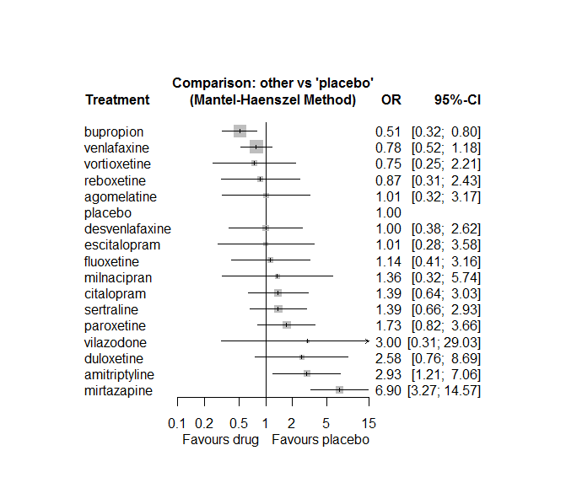

P-score

bupropion 0.927

venlafaxine 0.754

vortioxetine 0.735

reboxetine 0.684

agomelatine 0.626

placebo 0.617

desvenlafaxine 0.611

escitalopram 0.610

fluoxetine 0.564

milnacipran 0.486

citalopram 0.447

sertraline 0.445

paroxetine 0.335

vilazodone 0.270

duloxetine 0.216

amitriptyline 0.153

mirtazapine 0.019

## **Sensitivity analysis: splitting nodes according to dosage**

All treatment arms for drug X, with dose_intended_min equal to or smaller to the minimum licensed dose were set as “X_L”. All other arms of X are “X_H”. Studies with no information on dose are excluded. Results shown below:

|  |  |  |
| --- | --- | --- |
| **Low dose vs. placebo** | **High dose vs. placebo** | **High dose vs. low dose** |
|  |  |  |

## **Sensitivity analysis: Keeping only low dropout arms**

We exclude all treatment arms with dropout rates larger than 25%, and we re-analyse the network.

Total number of arms included in the analysis 69. Total number of studies 33

Total events in placebo 8, out of a total of 3581 patients. Event rate placebo 0.024

Total events in drugs 231, out of a total of 7872 patients. Event rate drugs 0.039

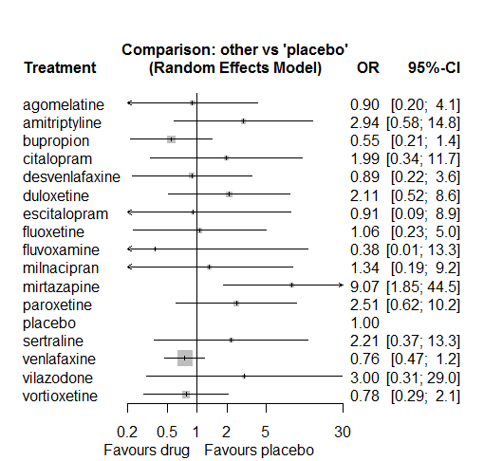

P-score

bupropion 0.81

fluvoxamine 0.76

venlafaxine 0.72

vortioxetine 0.69

agomelatine 0.68

escitalopram 0.64

desvenlafaxine 0.63

fluoxetine 0.61

placebo 0.59

milnacipran 0.52

citalopram 0.37

duloxetine 0.33

sertraline 0.33

vilazodone 0.30

paroxetine 0.27

amitriptyline 0.23

mirtazapine 0.02

# **Blood pressure decreased**

We remove all arms for which dose range was not “Licenced”. After this:

* Removed 5 one-arm studies: Chouinard1985, Mullin1996, Sacchetti2002 (BRL-29060/109), Bosc1997a (Study 014 - Andreoli2002), Feighner1980
* Total number of arms 98. Total number of studies 45.
* Total events in placebo 116, out of a total of 3693 patients. Event rate placebo 0.031
* Total events in drugs 428, out of a total of 8006 patients. Event rate drugs 0.053

## **Distribution of dose across drugs**

Here we count the number of arms per drug, and the percent of these arms where Dose_intended_min was equal to the minimum licensed dose or lower. The values we used as minimum licensed dose are as follows:

agomelatine: 25; amitriptyline: 75; bupropion:300; citalopram:20; clomipramine:30; desvenlafaxine:50; duloxetine:40; escitalopram:10; fluoxetine:20; fluvoxamine:50; levomilnacipran:40; milnacipran:50; mirtazapine:15; nefazodone:300; paroxetine:20; reboxetine:8; sertraline:50; trazodone:150; venlafaxine:75; vilazodone:20; vortioxetine:5

Drug number.arms percent.low.dose

1 milnacipran 5 0.00

2 amitriptyline 8 0.50

3 fluvoxamine 4 0.25

4 paroxetine 10 0.90

5 fluoxetine 10 1.00

6 reboxetine 9 0.89

8 desvenlafaxine 6 0.67

9 vilazodone 3 0.33

10 clomipramine 4 0.00

11 nefazodone 2 1.00

12 venlafaxine 1 0.00

13 escitalopram 2 0.50

14 citalopram 2 0.00

15 sertraline 2 1.00

16 duloxetine 1 0.00

17 mirtazapine 2 1.00

18 bupropion 1 1.00

19 trazodone 1 1.00

## **Network graph**

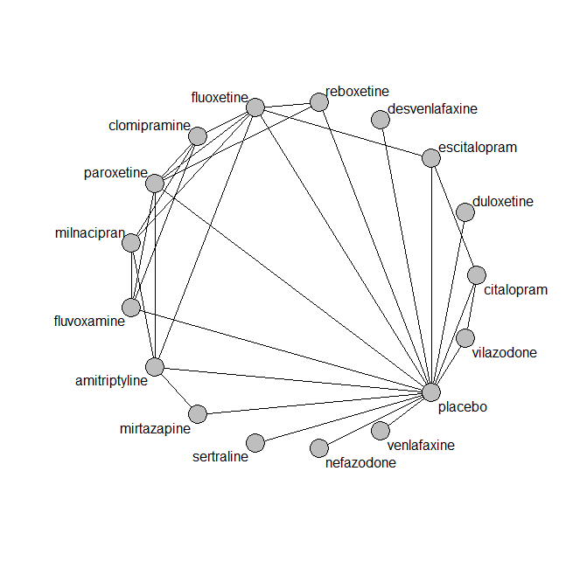

## **Pairwise MA**

### **Grouping all drugs together, comparison vs. placebo**

Number of studies: 24

Random effects meta-analysis: OR=1.27. 95% CI 0.94 to 1.73

Prediction interval 0.63 to 2.57

Heterogeneity (tau squared) was estimated to be 0.09

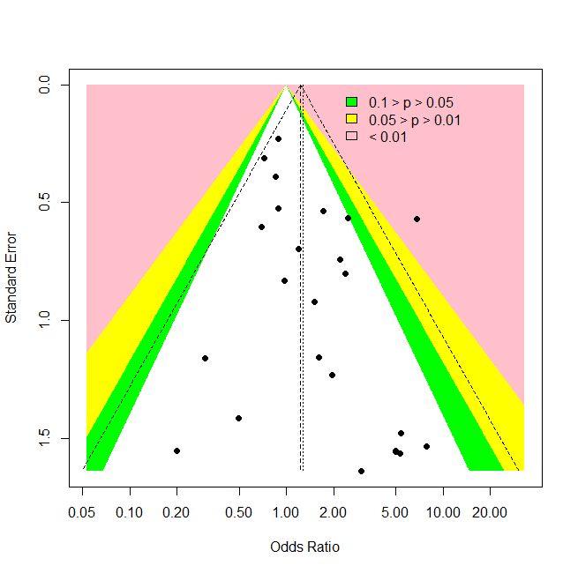

Some evidence of an asymmetry (Harbord’s test p-value =0.08)

### **Meta-analyses of comparisons with 10 or more studies**

We show results from pairwise comparisons informed by 10 studies or more. An OR larger than 1 favors the first treatment in the comparison.

No meta-analyses had 10 studies or more

## **Assessment of transitivity**

comparison studies baseline_SD age_SD female

1 amitriptyline - milnacipran 1 26 (NA) 50 (NA) NaN (NA)

2 fluvoxamine - milnacipran 1 24 (NA) 48 (NA) NaN (NA)

3 fluvoxamine - paroxetine 1 23 (NA) 44 (NA) 0.57 (NA)

4 fluoxetine - milnacipran 1 23 (NA) 45 (NA) NaN (NA)

5 paroxetine - reboxetine 2 22 (2.8) 42 (3) 0.66 (0.05)

6 placebo - reboxetine 6 25 (4.6) 42 (2.9) 0.59 (0.08)

7 fluoxetine - reboxetine 2 25 (0.5) 41 (3.9) 0.67 (0.07)

8 desvenlafaxine - placebo 5 23 (0.6) 44 (5.5) 0.69 (0.18)

9 fluvoxamine - placebo 1 26 (NA) 42 (NA) NaN (NA)

10 amitriptyline - placebo 2 24 (0.7) 39 (NA) NaN (NA)

11 placebo - vilazodone 2 24 (0) 41 (1.1) 0.56 (0.03)

12 amitriptyline - fluoxetine 3 25 (1.3) 50 (16.6) 0.63 (0.15)

13 clomipramine - fluvoxamine 1 24 (NA) NaN (NA) NaN (NA)

14 fluoxetine - paroxetine 2 24 (0) 44 (0.1) NaN (NA)

15 nefazodone - placebo 2 25 (1.4) 43 (0.6) 0.67 (0.04)

16 clomipramine - fluoxetine 1 29 (NA) 49 (NA) 0.72 (NA)

17 placebo - venlafaxine 1 26 (NA) 56 (NA) NaN (NA)

18 escitalopram - fluoxetine 1 22 (NA) 75 (NA) NaN (NA)

19 escitalopram - placebo 1 22 (NA) 75 (NA) NaN (NA)

20 fluoxetine - placebo 1 22 (NA) 75 (NA) NaN (NA)

21 clomipramine - milnacipran 1 24 (NA) 48 (NA) NaN (NA)

22 paroxetine - placebo 2 21 (1.4) 55 (21.5) 0.7 (NA)

23 citalopram - placebo 1 24 (NA) 42 (NA) 0.57 (NA)

24 citalopram - vilazodone 1 24 (NA) 42 (NA) 0.57 (NA)

25 amitriptyline - paroxetine 2 25 (1.8) 47 (0.4) NaN (NA)

26 citalopram - escitalopram 1 28 (NA) 45 (NA) NaN (NA)

27 placebo - sertraline 2 23 (3.2) 57 (18.4) 0.6 (0.05)

28 duloxetine - placebo 1 19 (NA) 73 (NA) 0.59 (NA)

29 clomipramine - paroxetine 1 24 (NA) 71 (NA) 0.89 (NA)

30 amitriptyline - mirtazapine 1 25 (NA) NaN (NA) NaN (NA)

31 mirtazapine - placebo 2 24 (1.4) 46 (NA) 0.53 (NA)

32 bupropion - trazodone 1 22 (NA) 40 (NA) NaN (NA)

## **NMA**

A total of 17 treatments are included in the network.

A total of 43 studies are included in this analysis.

Estimated heterogeneity tau-squared 0.00

Global test for inconsistency, p-value 0.79564 (Q=12,d.o.f.17)

### **Comparison vs. placebo**

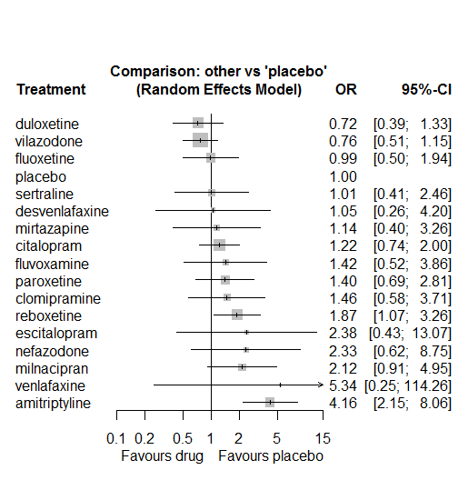

### **Ranking according to P-scores**

P-score

duloxetine 0.85

vilazodone 0.85

fluoxetine 0.70

placebo 0.69

sertraline 0.67

desvenlafaxine 0.63

mirtazapine 0.60

citalopram 0.56

fluvoxamine 0.50

paroxetine 0.49

clomipramine 0.48

reboxetine 0.32

escitalopram 0.31

nefazodone 0.30

milnacipran 0.27

venlafaxine 0.21

amitriptyline 0.08

### **Local inconsistency**

Percent of comparisons where there is some evidence (p-value<0.05) of disagreement between direct and indirect sources: 0. (0 out of 26 comparisons)

comparison TE seTE lower upper z p

6 amitriptyline:fluoxetine -0.6817 0.69 -2.03 0.67 -0.99053 0.32

8 amitriptyline:milnacipran 0.4479 0.79 -1.09 1.99 0.56990 0.57

9 amitriptyline:mirtazapine 0.1220 1.15 -2.13 2.37 0.10620 0.92

11 amitriptyline:paroxetine -0.8789 1.05 -2.93 1.18 -0.83803 0.40

12 amitriptyline:placebo 0.6478 0.68 -0.68 1.97 0.95936 0.34

20 citalopram:escitalopram -0.7079 1.95 -4.52 3.10 -0.36393 0.72

27 citalopram:placebo -0.1302 0.80 -1.71 1.44 -0.16205 0.87

31 citalopram:vilazodone 0.4375 1.03 -1.57 2.45 0.42673 0.67

35 clomipramine:fluoxetine 0.6290 0.88 -1.09 2.35 0.71831 0.47

36 clomipramine:fluvoxamine 0.0223 1.17 -2.28 2.32 0.01900 0.98

37 clomipramine:milnacipran -0.4118 0.74 -1.87 1.04 -0.55453 0.58

40 clomipramine:paroxetine -0.1199 1.16 -2.39 2.15 -0.10368 0.92

71 escitalopram:fluoxetine -0.5031 1.77 -3.98 2.97 -0.28363 0.78

77 escitalopram:placebo -0.2707 1.74 -3.67 3.13 -0.15592 0.88

83 fluoxetine:milnacipran -0.1169 0.84 -1.77 1.54 -0.13855 0.89

86 fluoxetine:paroxetine 1.1079 0.80 -0.47 2.68 1.37825 0.17

87 fluoxetine:placebo 0.1127 1.46 -2.75 2.98 0.07705 0.94

88 fluoxetine:reboxetine -1.0046 0.66 -2.30 0.29 -1.52519 0.13

92 fluvoxamine:milnacipran 0.1389 0.86 -1.55 1.83 0.16069 0.87

95 fluvoxamine:paroxetine 1.5864 1.28 -0.92 4.09 1.24207 0.21

96 fluvoxamine:placebo -1.9101 1.29 -4.44 0.62 -1.47709 0.14

111 mirtazapine:placebo 0.0003 1.62 -3.17 3.18 0.00018 1.00

122 paroxetine:placebo 1.0596 0.72 -0.35 2.47 1.47322 0.14

123 paroxetine:reboxetine -0.0831 0.80 -1.65 1.48 -0.10403 0.92

127 placebo:reboxetine 0.8842 0.63 -0.35 2.12 1.39869 0.16

130 placebo:vilazodone -1.1621 3.19 -7.42 5.10 -0.36393 0.72

### **League table**

Below we show the league table. Upper triangle: direct evidence. Lower triangle: NMA. An odds ratio larger than 1 in the upper triangle favors the column-defining drug. An odds ratio larger than 1 in the bottom triangle favors the row-defining drug.

|  |  |  |  |  |  |  |  |  |  |  |  |  |  |  |  |  |
| --- | --- | --- | --- | --- | --- | --- | --- | --- | --- | --- | --- | --- | --- | --- | --- | --- |
| AMIT | . | . | . | . | . | 2.88 [1.05; 7.89] | . | 2.45 [0.83; 7.28] | 3.91 [0.77; 19.83] | . | 1.45 [0.23; 9.34] | 5.70 [2.27; 14.30] | . | . | . | . |
| 3.42 [1.50; 7.79] | CITA | . | . | . | 0.31 [0.01; 7.65] | . | . | . | . | . | . | 1.20 [0.71; 2.03] | . | . | . | 1.63 [1.02; 2.62] |
| 2.84 [1.16; 6.95] | 0.83 [0.29; 2.38] | CLOM | . | . | . | 2.21 [0.56; 8.68] | 1.05 [0.13; 8.24] | 0.61 [0.28; 1.35] | . | . | 0.96 [0.13; 7.09] | . | . | . | . | . |
| 3.97 [0.85; 18.51] | 1.16 [0.27; 5.08] | 1.40 [0.26; 7.44] | DESV | . | . | . | . | . | . | . | . | 1.05 [0.26; 4.20] | . | . | . | . |
| 5.76 [2.34; 14.15] | 1.68 [0.77; 3.69] | 2.03 [0.67; 6.16] | 1.45 [0.32; 6.61] | DULO | . | . | . | . | . | . | . | 0.72 [0.39; 1.33] | . | . | . | . |
| 1.75 [0.29; 10.36] | 0.51 [0.09; 2.89] | 0.61 [0.09; 4.02] | 0.44 [0.05; 3.95] | 0.30 [0.05; 1.85] | ESCI | 1.90 [0.17; 21.10] | . | . | . | . | . | 2.08 [0.19; 23.16] | . | . | . | . |
| 4.21 [2.16; 8.24] | 1.23 [0.54; 2.83] | 1.48 [0.65; 3.39] | 1.06 [0.23; 4.97] | 0.73 [0.29; 1.82] | 2.41 [0.42; 13.71] | FLUO | . | 0.43 [0.11; 1.71] | . | . | 1.52 [0.41; 5.59] | 1.10 [0.07; 17.70] | 0.35 [0.15; 0.80] | . | . | . |
| 2.94 [1.09; 7.90] | 0.86 [0.28; 2.63] | 1.03 [0.41; 2.60] | 0.74 [0.13; 4.11] | 0.51 [0.16; 1.65] | 1.68 [0.25; 11.56] | 0.70 [0.26; 1.84] | FLUV | 0.69 [0.28; 1.73] | . | . | 3.54 [0.38; 32.66] | 0.30 [0.03; 2.96] | . | . | . | . |
| 1.96 [0.91; 4.23] | 0.57 [0.22; 1.52] | 0.69 [0.35; 1.34] | 0.49 [0.10; 2.51] | 0.34 [0.12; 0.97] | 1.12 [0.18; 7.08] | 0.47 [0.22; 0.99] | 0.67 [0.31; 1.44] | MILN | . | . | . | . | . | . | . | . |
| 3.67 [1.19; 11.30] | 1.07 [0.33; 3.44] | 1.29 [0.34; 4.96] | 0.92 [0.16; 5.28] | 0.64 [0.19; 2.15] | 2.10 [0.29; 15.35] | 0.87 [0.26; 2.87] | 1.25 [0.31; 5.08] | 1.87 [0.52; 6.75] | MIRT | . | . | 1.14 [0.37; 3.51] | . | . | . | . |
| 1.79 [0.41; 7.86] | 0.52 [0.13; 2.15] | 0.63 [0.12; 3.17] | 0.45 [0.07; 3.07] | 0.31 [0.07; 1.33] | 1.02 [0.12; 8.84] | 0.42 [0.10; 1.88] | 0.61 [0.12; 3.20] | 0.91 [0.19; 4.39] | 0.49 [0.09; 2.65] | NEFA | . | 2.33 [0.62; 8.75] | . | . | . | . |
| 2.98 [1.36; 6.56] | 0.87 [0.37; 2.05] | 1.05 [0.41; 2.68] | 0.75 [0.16; 3.56] | 0.52 [0.20; 1.31] | 1.71 [0.28; 10.32] | 0.71 [0.34; 1.47] | 1.01 [0.36; 2.82] | 1.52 [0.63; 3.68] | 0.81 [0.24; 2.77] | 1.67 [0.37; 7.47] | PARO | 2.51 [0.88; 7.15] | 0.71 [0.19; 2.57] | . | . | . |
| 4.16 [2.15; 8.06] | 1.22 [0.74; 2.00] | 1.46 [0.58; 3.71] | 1.05 [0.26; 4.20] | 0.72 [0.39; 1.33] | 2.38 [0.43; 13.07] | 0.99 [0.50; 1.94] | 1.42 [0.52; 3.86] | 2.12 [0.91; 4.95] | 1.14 [0.40; 3.26] | 2.33 [0.62; 8.75] | 1.40 [0.69; 2.81] | PLAC | 0.68 [0.36; 1.32] | 0.99 [0.41; 2.42] | 0.19 [0.01; 4.01] | 1.30 [0.86; 1.97] |
| 2.23 [1.06; 4.69] | 0.65 [0.31; 1.37] | 0.78 [0.30; 2.02] | 0.56 [0.13; 2.50] | 0.39 [0.17; 0.88] | 1.28 [0.22; 7.36] | 0.53 [0.28; 1.00] | 0.76 [0.27; 2.14] | 1.14 [0.47; 2.73] | 0.61 [0.19; 1.95] | 1.25 [0.30; 5.24] | 0.75 [0.36; 1.55] | 0.53 [0.31; 0.93] | REBO | . | . | . |
| 4.13 [1.36; 12.53] | 1.21 [0.44; 3.35] | 1.45 [0.40; 5.27] | 1.04 [0.20; 5.42] | 0.72 [0.24; 2.11] | 2.37 [0.35; 16.14] | 0.98 [0.32; 3.00] | 1.40 [0.37; 5.38] | 2.11 [0.62; 7.20] | 1.13 [0.28; 4.48] | 2.31 [0.47; 11.40] | 1.38 [0.45; 4.30] | 0.99 [0.41; 2.42] | 1.86 [0.65; 5.30] | SERT | . | . |
| 0.78 [0.03; 17.92] | 0.23 [0.01; 5.08] | 0.27 [0.01; 6.74] | 0.20 [0.01; 5.67] | 0.14 [0.01; 3.08] | 0.45 [0.01; 14.86] | 0.19 [0.01; 4.26] | 0.27 [0.01; 6.67] | 0.40 [0.02; 9.55] | 0.21 [0.01; 5.43] | 0.44 [0.02; 12.28] | 0.26 [0.01; 6.06] | 0.19 [0.01; 4.01] | 0.35 [0.02; 7.88] | 0.19 [0.01; 4.59] | VENL | . |
| 5.45 [2.50; 11.87] | 1.59 [1.01; 2.52] | 1.92 [0.69; 5.30] | 1.37 [0.32; 5.84] | 0.95 [0.45; 1.98] | 3.12 [0.55; 17.69] | 1.29 [0.59; 2.85] | 1.85 [0.63; 5.48] | 2.78 [1.09; 7.12] | 1.49 [0.48; 4.62] | 3.05 [0.76; 12.21] | 1.83 [0.81; 4.12] | 1.31 [0.87; 1.98] | 2.45 [1.23; 4.89] | 1.32 [0.49; 3.52] | 6.99 [0.32; 153.83] | VILA |

### **Estimated event rates**

For an event rate in placebo equal to the average event rate (i.e. fixed to 0.03) the estimated event rates for each drug are as follows

drug rate

1 amitriptyline 0.12 [0.07, 0.21]

2 citalopram 0.04 [0.02, 0.06]

3 clomipramine 0.05 [0.02, 0.11]

4 desvenlafaxine 0.03 [0.01, 0.12]

5 duloxetine 0.02 [0.01, 0.04]

6 escitalopram 0.07 [0.01, 0.3]

7 fluoxetine 0.03 [0.02, 0.06]

8 fluvoxamine 0.04 [0.02, 0.11]

9 milnacipran 0.06 [0.03, 0.14]

10 mirtazapine 0.04 [0.01, 0.1]

11 nefazodone 0.07 [0.02, 0.22]

12 paroxetine 0.04 [0.02, 0.08]

14 reboxetine 0.06 [0.03, 0.1]

15 sertraline 0.03 [0.01, 0.07]

16 venlafaxine 0.15 [0.01, 0.79]

17 vilazodone 0.02 [0.02, 0.04]

## **Sensitivity analysis: Mantel-Haenszel NMA**

No big differences with the regular NMA.

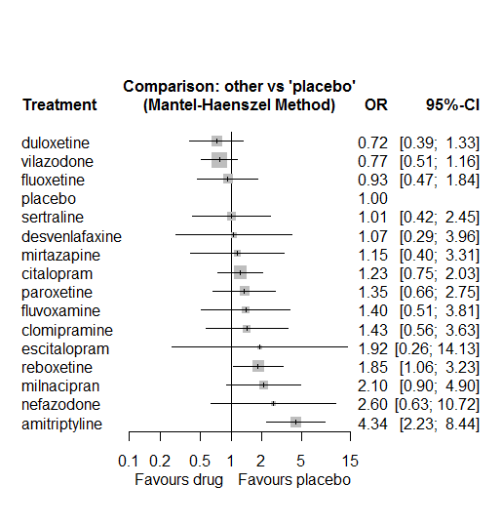

P-score

duloxetine 0.8412

vilazodone 0.8352

fluoxetine 0.7197

placebo 0.6676

sertraline 0.6432

desvenlafaxine 0.6024

mirtazapine 0.5723

citalopram 0.5191

paroxetine 0.4780

fluvoxamine 0.4767

clomipramine 0.4599

escitalopram 0.3788

reboxetine 0.2898

milnacipran 0.2409

nefazodone 0.2355

amitriptyline 0.0397

## **Sensitivity analysis: splitting nodes according to dosage**

All treatment arms for drug X, with dose_intended_min equal to or smaller to the minimum licensed dose were set as “X_L”. All other arms of X are “X_H”. Studies with no information on dose are excluded. Results shown below:

|  |  |  |
| --- | --- | --- |
| **Low dose vs. placebo** | **High dose vs. placebo** | **High dose vs. low dose** |
|  |  |  |

## **Sensitivity analysis: Keeping only low dropout arms**

We exclude all treatment arms with dropout rates larger than 25%, and we re-analyse the network.

Total number of arms included in the analysis 38. Total number of studies 19

Total events in placebo 8, out of a total of 3581 patients. Event rate placebo 0.026

Total events in drugs 231, out of a total of 7872 patients. Event rate drugs 0.038

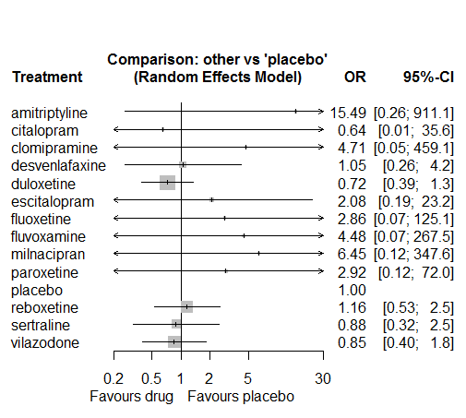

P-score

duloxetine 0.76

vilazodone 0.68

citalopram 0.67

sertraline 0.66

placebo 0.61

desvenlafaxine 0.60

reboxetine 0.55

fluoxetine 0.48

escitalopram 0.44

paroxetine 0.43

fluvoxamine 0.38

clomipramine 0.37

milnacipran 0.27

amitriptyline 0.10

# **Accidental overdose**

We remove all arms for which dose range was not “Licenced”. After this:

* Total number of arms 22. Total number of studies 8.
* Total events in placebo 27, out of a total of 1309 patients. Event rate placebo 0.021
* Total events in drugs 85, out of a total of 2933 patients. Event rate drugs 0.029

## **Distribution of dose across drugs**

Here we count the number of arms per drug, and the percent of these arms where Dose_intended_min was equal to the minimum licensed dose or lower. The values we used as minimum licensed dose are as follows:

agomelatine: 25; amitriptyline: 75; bupropion:300; citalopram:20; clomipramine:30; desvenlafaxine:50; duloxetine:40; escitalopram:10; fluoxetine:20; fluvoxamine:50; levomilnacipran:40; milnacipran:50; mirtazapine:15; nefazodone:300; paroxetine:20; reboxetine:8; sertraline:50; trazodone:150; venlafaxine:75; vilazodone:20; vortioxetine:5

Drug number.arms percent.low.dose

1 reboxetine 3 1.00

3 fluoxetine 1 1.00

4 vortioxetine 6 0.67

5 escitalopram 1 0.00

6 paroxetine 2 1.00

7 duloxetine 1 0.00

8 venlafaxine 1 0.00

## **Network graph**

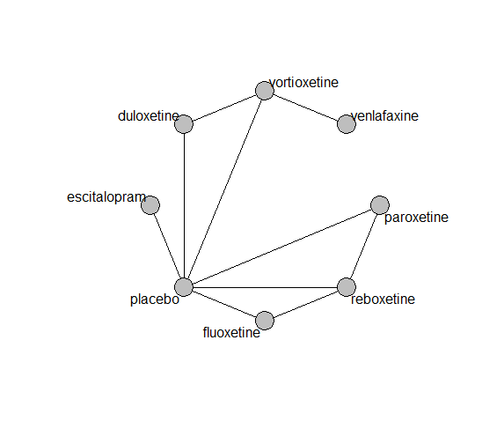

## **Pairwise MA**

### **Grouping all drugs together, comparison vs. placebo**

Number of studies: 7

Fixed effects (Mantel Haenszel) OR=1.21. 95% CI 0.77 to 1.90.

Heterogeneity (tau squared) was estimated to be 0.

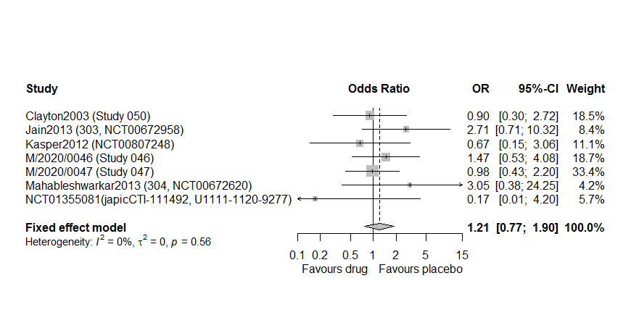

Too few studies to test small study effects

### **Meta-analyses of comparisons with 10 or more studies**

We show results from pairwise comparisons informed by 10 studies or more. An OR larger than 1 favors the first treatment in the comparison.

No meta-analyses had 10 studies or more

## **Assessment of transitivity**

comparison studies baseline_SD age_SD female

1 fluoxetine - placebo 1 23 (NA) 40 (NA) 0.63 (NA)

2 fluoxetine - reboxetine 1 23 (NA) 40 (NA) 0.63 (NA)

3 placebo - reboxetine 3 21 (1.5) 39 (0.7) 0.7 (0.07)

4 placebo - vortioxetine 3 22 (1.5) 41 (2.4) 0.56 (0.09)

5 escitalopram - placebo 1 27 (NA) 42 (NA) 0.72 (NA)

6 paroxetine - placebo 2 20 (0.7) 39 (0.6) 0.73 (0.04)

7 paroxetine - reboxetine 2 20 (0.7) 39 (0.6) 0.73 (0.04)

8 duloxetine - placebo 1 NaN (NA) 43 (NA) 0.64 (NA)

9 duloxetine - vortioxetine 1 NaN (NA) 43 (NA) 0.64 (NA)

10 venlafaxine - vortioxetine 1 25 (NA) 40 (NA) 0.6 (NA)

## **NMA**

A total of 8 treatments are included in the network.

A total of 8 studies are included in this analysis.

We fit a Mantel Haenszel (fixed effects) NMA model. In sensitivity analyses we also fit a NMA with a non-central Hypergeometric likelihood (fixed effects), an inverse variance fixed effects and an inverse variance random effects model.

For the random effects model:

Estimated heterogeneity tau-squared 0.52. Global test for inconsistency, p-value 0.85496 (Q=0,d.o.f.2)

### **Comparison vs. placebo**

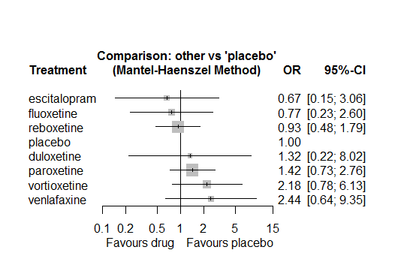

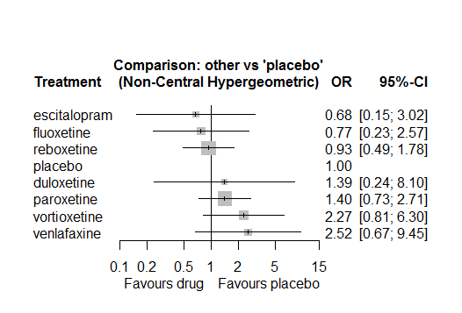

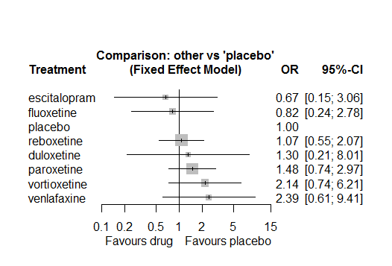

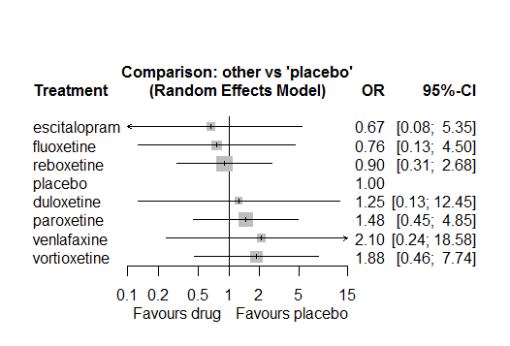

### **Ranking according to P-scores**

P-score

escitalopram 0.75

fluoxetine 0.72

reboxetine 0.66

placebo 0.62

duloxetine 0.48

paroxetine 0.37

vortioxetine 0.21

venlafaxine 0.19

### **Local inconsistency**

Inconsistency could not be assessed using the SIDDE approach. Using the Back-calculation method we got the following results:

Percent of comparisons where there is some evidence (p-value<0.05) of disagreement between direct and indirect sources: 0. (0 out of 7 comparisons)

comparison TE seTE lower upper z p

4 duloxetine:placebo 1.486 2.5 -3.4 6.4 0.59 0.55

7 duloxetine:vortioxetine -2.668 4.5 -11.5 6.1 -0.59 0.55

15 fluoxetine:placebo 0.315 2.5 -4.6 5.2 0.13 0.90

16 fluoxetine:reboxetine -0.315 2.5 -5.2 4.6 -0.13 0.90

19 paroxetine:placebo -0.869 2.3 -5.3 3.6 -0.38 0.70

20 paroxetine:reboxetine 0.038 2.0 -3.8 3.9 0.02 0.98

23 placebo:reboxetine 12.761 8.2 -3.3 28.8 1.56 0.12

### **League table**

Below we show the league table. Upper triangle: direct evidence. Lower triangle: NMA. An odds ratio larger than 1 in the upper triangle favors the column-defining drug. An odds ratio larger than 1 in the bottom triangle favors the row-defining drug.

|  |  |  |  |  |  |  |  |
| --- | --- | --- | --- | --- | --- | --- | --- |
| DULO | . | . | . | 2.03 [0.18; 22.6] | . | . | 0.57 [0.12; 2.8] |
| 1.98 [0.19; 21.0] | ESCI | . | . | 0.67 [0.15; 3.1] | . | . | . |
| 1.72 [0.20; 15.2] | 0.87 [0.12; 6.1] | FLUO | . | 0.79 [0.21; 3.0] | 0.79 [0.21; 3.0] | . | . |
| 0.93 [0.14; 6.4] | 0.47 [0.09; 2.5] | 0.54 [0.15; 2.0] | PARO | 1.40 [0.70; 2.8] | 1.54 [0.76; 3.1] | . | . |
| 1.32 [0.22; 8.0] | 0.67 [0.15; 3.1] | 0.77 [0.23; 2.6] | 1.42 [0.73; 2.8] | PLAC | 1.07 [0.56; 2.1] | . | 0.44 [0.16; 1.2] |
| 1.42 [0.21; 9.7] | 0.72 [0.14; 3.8] | 0.82 [0.24; 2.8] | 1.52 [0.77; 3.0] | 1.07 [0.56; 2.1] | REBO | . | . |
| 0.54 [0.09; 3.2] | 0.27 [0.04; 2.1] | 0.31 [0.05; 1.9] | 0.58 [0.13; 2.6] | 0.41 [0.11; 1.6] | 0.38 [0.09; 1.7] | VENL | 1.12 [0.47; 2.6] |
| 0.61 [0.13; 2.9] | 0.31 [0.05; 1.9] | 0.35 [0.07; 1.7] | 0.65 [0.19; 2.2] | 0.46 [0.16; 1.3] | 0.43 [0.13; 1.4] | 1.12 [0.47; 2.6] | VORT |

### **Estimated event rates**

For an event rate in placebo equal to the average event rate (i.e. fixed to 0.03) the estimated event rates for each drug are as follows

drug rate

1 duloxetine 0.03 [0, 0.14]

2 escitalopram 0.01 [0, 0.06]

3 fluoxetine 0.02 [0, 0.05]

4 paroxetine 0.03 [0.02, 0.05]

6 reboxetine 0.02 [0.01, 0.04]

7 venlafaxine 0.05 [0.01, 0.17]

8 vortioxetine 0.04 [0.02, 0.12]

### **Additional sensitivity analyses**

No other analyses were performed due to the low amount of information in the studies.

# **Cardiac disorders signs and symptoms**

We remove all arms for which dose range was not “Licenced”. After this:

* Removed 4 one-arm studies: Leinonen1997, Study 015, Bosc1997b (Study 016 - Massana 1999), Kellams1979.
* Total number of arms 45. Total number of studies 21.
* Total events in placebo 28, out of a total of 751 patients. Event rate placebo 0.037
* Total events in drugs 163, out of a total of 2474 patients. Event rate drugs 0.066

## **Distribution of dose across drugs**

Here we count the number of arms per drug, and the percent of these arms where Dose_intended_min was equal to the minimum licensed dose or lower. The values we used as minimum licensed dose are as follows:

agomelatine: 25; amitriptyline: 75; bupropion:300; citalopram:20; clomipramine:30; desvenlafaxine:50; duloxetine:40; escitalopram:10; fluoxetine:20; fluvoxamine:50; levomilnacipran:40; milnacipran:50; mirtazapine:15; nefazodone:300; paroxetine:20; reboxetine:8; sertraline:50; trazodone:150; venlafaxine:75; vilazodone:20; vortioxetine:5

Drug number.arms percent.low.dose

1 milnacipran 4 0.00

2 amitriptyline 7 0.14

3 fluvoxamine 3 0.00

4 fluoxetine 2 1.00

6 paroxetine 11 0.18

7 levomilnacipran 2 0.50

8 clomipramine 1 0.00

9 duloxetine 2 0.00

10 venlafaxine 3 0.33

11 escitalopram 1 1.00

## **Network graph**

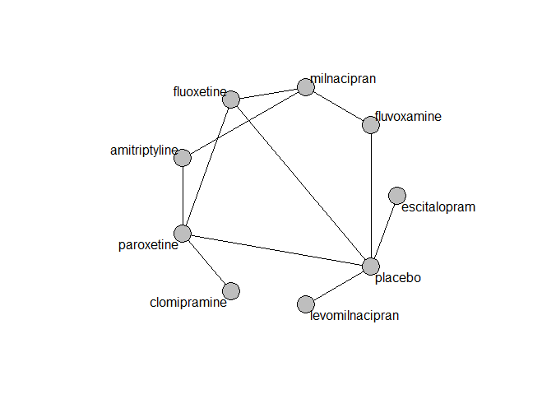

## **Pairwise MA**

### **Grouping all drugs together, comparison vs. placebo**

Number of studies: 9

Fixed effects (Mantel-Haenszel) meta-analysis: OR=1.31. 95% CI 0.80 to 2.17

Heterogeneity (tau squared) was estimated to be 0

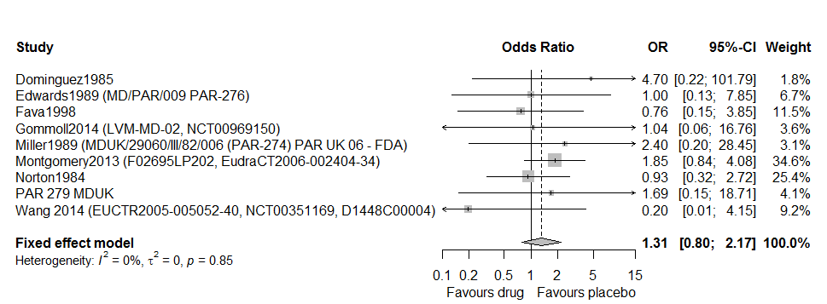

Too few studies to test small study effects

### **Meta-analyses of comparisons with 10 or more studies**

We show results from pairwise comparisons informed by 10 studies or more. An OR larger than 1 favors the first treatment in the comparison.

No meta-analyses had 10 studies or more

## **Assessment of transitivity**

comparison studies baseline_SD age_SD female

1 amitriptyline - milnacipran 1 26 (NA) 50 (NA) NaN (NA)

2 fluvoxamine - milnacipran 1 24 (NA) 48 (NA) NaN (NA)

3 fluoxetine - milnacipran 1 23 (NA) 45 (NA) NaN (NA)

4 fluvoxamine - placebo 2 20 (0.4) 39 (NA) NaN (NA)

5 paroxetine - placebo 4 23 (3.3) 43 (1.9) 0.63 (0.09)

6 fluoxetine - paroxetine 1 21 (NA) 41 (NA) NaN (NA)

7 fluoxetine - placebo 1 21 (NA) 41 (NA) NaN (NA)

8 levomilnacipran - placebo 2 25 (1.1) 44 (0.9) 0.63 (0.04)

9 clomipramine - paroxetine 1 25 (NA) 69 (NA) NaN (NA)

10 amitriptyline - paroxetine 6 24 (0.7) 43 (2.3) 0.67 (0.15)

11 duloxetine - venlafaxine 2 23 (0.5) 43 (1.4) 0.68 (0.03)

12 escitalopram - placebo 1 NaN (NA) 40 (NA) 0.72 (NA)

## **NMA**

A total of 9 treatments are included in the network.

A total of 19 studies are included in this analysis.

Estimated heterogeneity tau-squared 0.00

Global test for inconsistency, p-value 0.39918 (Q=3,d.o.f.3)

### **Comparison vs. placebo**

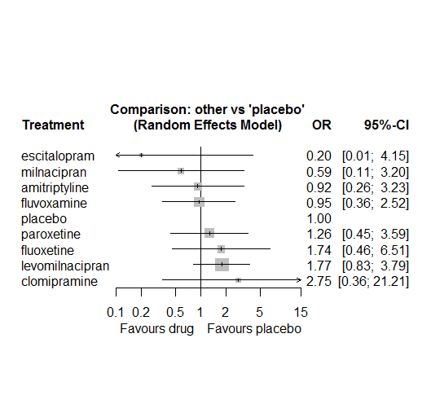

### **Ranking according to P-scores**

P-score

escitalopram 0.86

milnacipran 0.74

amitriptyline 0.60

fluvoxamine 0.57

placebo 0.57

paroxetine 0.42

fluoxetine 0.29

levomilnacipran 0.26

clomipramine 0.19

### **Local inconsistency**

Percent of comparisons where there is some evidence (p-value<0.05) of disagreement between direct and indirect sources: 0. (0 out of 8 comparisons)

comparison TE seTE lower upper z p

6 amitriptyline:milnacipran 2.15 1.6 -1.1 5.4 1.31 0.19

7 amitriptyline:paroxetine -2.15 1.6 -5.4 1.1 -1.31 0.19

24 fluoxetine:milnacipran -0.64 1.7 -4.0 2.7 -0.38 0.71

25 fluoxetine:paroxetine 1.62 1.4 -1.1 4.3 1.17 0.24

26 fluoxetine:placebo -1.26 1.4 -4.0 1.5 -0.91 0.36

28 fluvoxamine:milnacipran -2.14 1.9 -5.9 1.7 -1.11 0.27

30 fluvoxamine:placebo 2.14 1.9 -1.7 5.9 1.11 0.27

36 paroxetine:placebo -2.93 2.1 -7.1 1.2 -1.39 0.16

### **League table**

Below we show the league table. Upper triangle: direct evidence. Lower triangle: NMA. An odds ratio larger than 1 in the upper triangle favors the column-defining drug. An odds ratio larger than 1 in the bottom triangle favors the row-defining drug.

|  |  |  |  |  |  |  |  |  |
| --- | --- | --- | --- | --- | --- | --- | --- | --- |
| AMIT | . | . | . | . | . | 4.41 [0.47; 41.17] | 0.64 [0.29; 1.40] | . |
| 0.34 [0.05; 2.27] | CLOM | . | . | . | . | . | 2.17 [0.37; 12.60] | . |
| 4.66 [0.17; 125.50] | 13.91 [0.36; 544.29] | ESCI | . | . | . | . | . | 0.20 [0.01; 4.15] |
| 0.53 [0.13; 2.12] | 1.58 [0.19; 13.46] | 0.11 [0.00; 3.14] | FLUO | . | . | 2.11 [0.19; 23.67] | 2.17 [0.51; 9.15] | 1.06 [0.20; 5.78] |
| 0.97 [0.21; 4.48] | 2.89 [0.31; 27.04] | 0.21 [0.01; 5.09] | 1.83 [0.37; 8.93] | FLUV | . | 0.40 [0.02; 8.57] | . | 1.11 [0.40; 3.05] |
| 0.52 [0.12; 2.26] | 1.55 [0.18; 13.74] | 0.11 [0.00; 2.57] | 0.98 [0.21; 4.51] | 0.54 [0.16; 1.85] | LEVO | . | . | 1.77 [0.83; 3.79] |
| 1.57 [0.31; 7.86] | 4.69 [0.43; 50.72] | 0.34 [0.01; 11.00] | 2.96 [0.56; 15.55] | 1.62 [0.27; 9.87] | 3.02 [0.47; 19.40] | MILN | . | . |
| 0.73 [0.34; 1.55] | 2.17 [0.37; 12.60] | 0.16 [0.01; 3.90] | 1.37 [0.40; 4.65] | 0.75 [0.19; 2.98] | 1.40 [0.38; 5.09] | 0.46 [0.09; 2.31] | PARO | 1.04 [0.35; 3.05] |
| 0.92 [0.26; 3.23] | 2.75 [0.36; 21.21] | 0.20 [0.01; 4.15] | 1.74 [0.46; 6.51] | 0.95 [0.36; 2.52] | 1.77 [0.83; 3.79] | 0.59 [0.11; 3.20] | 1.26 [0.45; 3.59] | PLAC |

### **Estimated event rates**

For an event rate in placebo equal to the average event rate (i.e. fixed to 0.04) the estimated event rates for each drug are as follows

drug rate

1 amitriptyline 0.03 [0.01, 0.11]

2 clomipramine 0.1 [0.01, 0.45]

3 escitalopram 0.01 [0, 0.14]

4 fluoxetine 0.06 [0.02, 0.2]

5 fluvoxamine 0.04 [0.01, 0.09]

6 levomilnacipran 0.06 [0.03, 0.13]

7 milnacipran 0.02 [0, 0.11]

8 paroxetine 0.05 [0.02, 0.12]

## **Sensitivity analysis: Mantel-Haenszel NMA**

No big differences with the regular NMA, but escitalopram is removed from the network

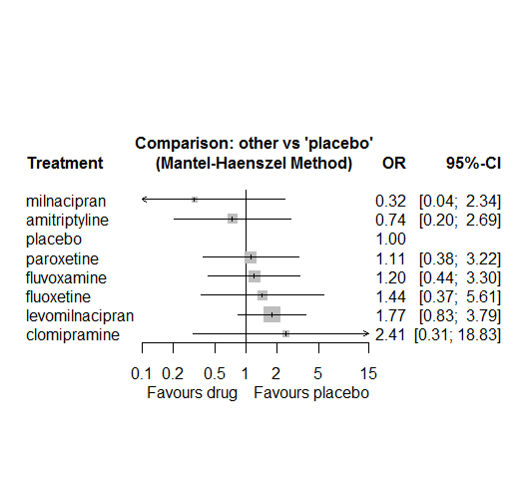

## **Sensitivity analysis: splitting nodes according to dosage**

Not enough data to perform the analysis

## **Sensitivity analysis: Keeping only low dropout arms**

Not enough data to perform the analysis

# **ECG Abnormalities**

We remove all arms for which dose range was not “Licenced”. After this:

* Removed 2 one-arm studies: Masco1985, Moises1981
* Total number of arms 45. Total number of studies 18
* Total events in placebo 31, out of a total of 1355 patients. Event rate placebo 0.023
* Total events in drugs 126, out of a total of 4571 patients. Event rate drugs 0.028

## **Distribution of dose across drugs**

Here we count the number of arms per drug, and the percent of these arms where Dose_intended_min was equal to the minimum licensed dose or lower. The values we used as minimum licensed dose are as follows:

agomelatine: 25; amitriptyline: 75; bupropion:300; citalopram:20; clomipramine:30; desvenlafaxine:50; duloxetine:40; escitalopram:10; fluoxetine:20; fluvoxamine:50; levomilnacipran:40; milnacipran:50; mirtazapine:15; nefazodone:300; paroxetine:20; reboxetine:8; sertraline:50; trazodone:150; venlafaxine:75; vilazodone:20; vortioxetine:5

Drug number.arms percent.low.dose

2 vortioxetine 3 0.67

3 duloxetine 8 0.25

4 reboxetine 5 1.00

5 fluoxetine 1 1.00

6 amitriptyline 4 0.50

7 bupropion 1 1.00

8 agomelatine 1 1.00

9 paroxetine 5 1.00

10 vilazodone 3 0.33

11 citalopram 1 0.00

12 sertraline 1 1.00

13 trazodone 1 1.00

14 venlafaxine 1 0.00

## **Network graph**

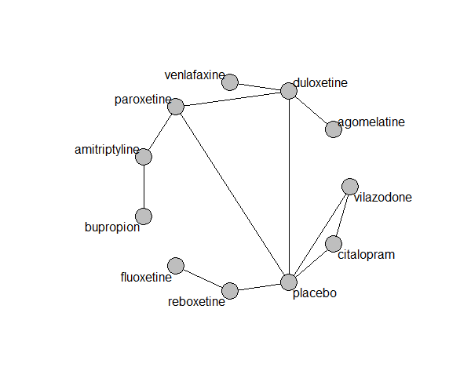

## **Pairwise MA**

### **Grouping all drugs together, comparison vs. placebo**

Number of studies: 8

Fixed effects (Mantel Haenszel) meta-analysis: OR=0.98. 95% CI 0.63 to 1.51

Random effects meta-analysis: OR=0.92. 95% CI 0.59 to 1.43

heterogeneity (tau squared) was estimated to be 0.00

Not enough studies to explore small-study effects

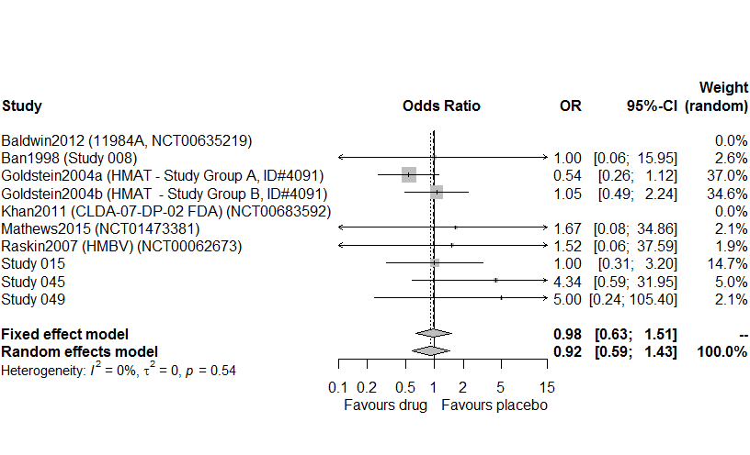

### **Meta-analyses of comparisons with 10 or more studies**

We show results from pairwise comparisons informed by 10 studies or more. An OR larger than 1 favors the first treatment in the comparison.

No meta-analyses had 10 studies or more

## **Assessment of transitivity**

comparison studies baseline_SD age_SD female

1 duloxetine - placebo 4 18 (0.8) 51 (15.1) 0.64 (0.07)

2 duloxetine - vortioxetine 1 NaN (NA) 45 (NA) 0.69 (NA)

3 placebo - vortioxetine 1 NaN (NA) 45 (NA) 0.69 (NA)

4 placebo - reboxetine 4 24 (1.8) 43 (3.1) 0.59 (0.05)

5 fluoxetine - reboxetine 1 25 (NA) 44 (NA) 0.72 (NA)

6 amitriptyline - bupropion 1 23 (NA) 37 (NA) NaN (NA)

7 agomelatine - duloxetine 1 26 (NA) 43 (NA) NaN (NA)

8 amitriptyline - paroxetine 3 24 (0.4) 53 (16.3) 0.54 (NA)

9 duloxetine - paroxetine 2 18 (0.4) 42 (2.2) NaN (NA)

10 paroxetine - placebo 2 18 (0.4) 42 (2.2) NaN (NA)

11 placebo - vilazodone 2 24 (0.7) 42 (0) 0.57 (NA)

12 citalopram - placebo 1 24 (NA) 42 (NA) 0.57 (NA)

13 citalopram - vilazodone 1 24 (NA) 42 (NA) 0.57 (NA)

14 sertraline - trazodone 1 22 (NA) 46 (NA) 0.65 (NA)

15 duloxetine - venlafaxine 1 23 (NA) 44 (NA) 0.7 (NA)

## **NMA**

A total of 11 treatments are included in the network.

Sertaline and trazodone are excluded from the network (disconnected nodes)

A total of 15 studies are included in this analysis.

Estimated heterogeneity tau-squared 0.14

Global test for inconsistency, p-value 0.63071 (Q=0,d.o.f.1)

### **Comparison vs. placebo**

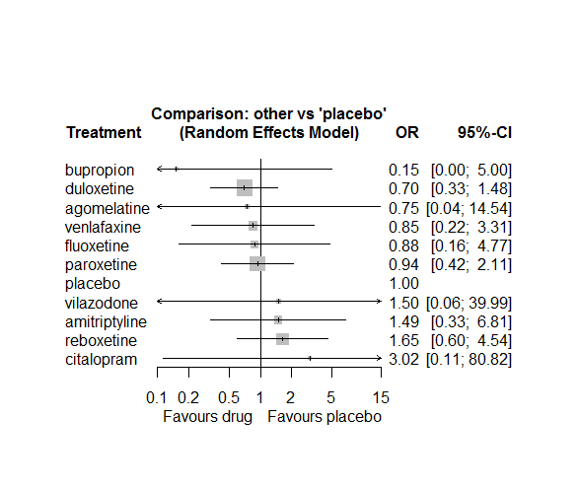

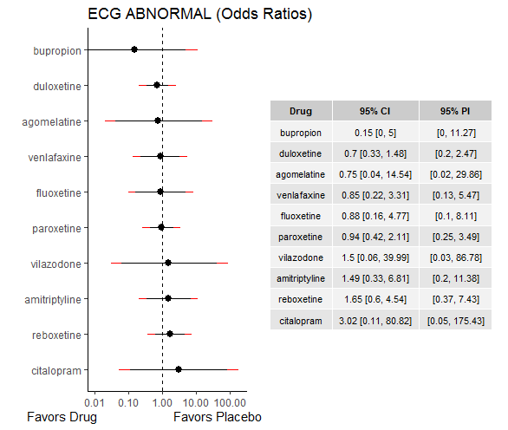

### **Ranking according to P-scores**

P-score

bupropion 0.84

duloxetine 0.68

agomelatine 0.56

venlafaxine 0.56

fluoxetine 0.55

paroxetine 0.52

placebo 0.49

vilazodone 0.42

amitriptyline 0.34

reboxetine 0.28

citalopram 0.26

### **Local inconsistency**

Percent of comparisons where there is some evidence (p-value<0.05) of disagreement between direct and indirect sources: 0. (0 out of 3 comparisons)

comparison TE seTE lower upper z p

36 duloxetine:paroxetine -2.8 3.5 -9.7 4.0 -0.81 0.42

37 duloxetine:placebo -3.0 6.7 -16.1 10.1 -0.45 0.65

46 paroxetine:placebo -1.2 3.5 -8.0 5.7 -0.34 0.74

### **League table**

Below we show the league table. Upper triangle: direct evidence. Lower triangle: NMA. An odds ratio larger than 1 in the upper triangle favors the column-defining drug. An odds ratio larger than 1 in the bottom triangle favors the row-defining drug.

|  |  |  |  |  |  |  |  |  |  |  |
| --- | --- | --- | --- | --- | --- | --- | --- | --- | --- | --- |
| AGOM | . | . | . | 1.07 [0.06; 18.91] | . | . | . | . | . | . |
| 0.50 [0.02; 12.79] | AMIT | 9.81 [0.42; 228.05] | . | . | . | 1.59 [0.44; 5.75] | . | . | . | . |
| 4.90 [0.05; 449.27] | 9.81 [0.42; 228.05] | BUPR | . | . | . | . | . | . | . | . |
| 0.25 [0.00; 20.72] | 0.49 [0.01; 18.44] | 0.05 [0.00; 6.09] | CITA | . | . | . | 3.02 [0.11; 80.82] | . | . | 2.02 [0.19; 21.86] |
| 1.07 [0.06; 18.91] | 2.14 [0.48; 9.61] | 0.22 [0.01; 7.13] | 4.33 [0.15; 126.33] | DULO | . | 0.72 [0.33; 1.57] | 0.69 [0.32; 1.47] | . | 0.82 [0.26; 2.56] | . |
| 0.85 [0.03; 25.77] | 1.69 [0.17; 16.39] | 0.17 [0.00; 8.35] | 3.43 [0.09; 137.91] | 0.79 [0.12; 5.03] | FLUO | . | . | 0.53 [0.14; 2.06] | . | . |
| 0.80 [0.04; 15.62] | 1.59 [0.44; 5.75] | 0.16 [0.01; 4.85] | 3.22 [0.11; 95.19] | 0.74 [0.34; 1.62] | 0.94 [0.14; 6.13] | PARO | 0.92 [0.41; 2.09] | . | . | . |
| 0.75 [0.04; 14.54] | 1.49 [0.33; 6.81] | 0.15 [0.00; 5.00] | 3.02 [0.11; 80.82] | 0.70 [0.33; 1.48] | 0.88 [0.16; 4.77] | 0.94 [0.42; 2.11] | PLAC | 0.61 [0.22; 1.67] | . | 0.67 [0.03; 17.86] |
| 0.45 [0.02; 10.42] | 0.90 [0.15; 5.61] | 0.09 [0.00; 3.50] | 1.83 [0.06; 57.05] | 0.42 [0.12; 1.49] | 0.53 [0.14; 2.06] | 0.57 [0.16; 2.08] | 0.61 [0.22; 1.67] | REBO | . | . |
| 0.88 [0.04; 19.31] | 1.76 [0.27; 11.56] | 0.18 [0.00; 7.02] | 3.57 [0.10; 125.11] | 0.82 [0.26; 2.56] | 1.04 [0.12; 9.11] | 1.11 [0.28; 4.38] | 1.18 [0.30; 4.61] | 1.95 [0.36; 10.63] | VENL | . |
| 0.50 [0.01; 41.80] | 1.00 [0.03; 37.20] | 0.10 [0.00; 12.30] | 2.02 [0.19; 21.86] | 0.47 [0.02; 13.57] | 0.59 [0.01; 23.70] | 0.63 [0.02; 18.47] | 0.67 [0.03; 17.86] | 1.10 [0.04; 34.32] | 0.57 [0.02; 19.85] | VILA |

### **Estimated event rates**

For an event rate in placebo equal to the average event rate (i.e. fixed to 0.02) the estimated event rates for each drug are as follows

drug rate

1 agomelatine 0.02 [0, 0.26]

2 amitriptyline 0.03 [0.01, 0.14]

3 bupropion 0 [0, 0.11]

4 citalopram 0.07 [0, 0.66]

5 duloxetine 0.02 [0.01, 0.03]

6 fluoxetine 0.02 [0, 0.1]

7 paroxetine 0.02 [0.01, 0.05]

9 reboxetine 0.04 [0.01, 0.1]

10 venlafaxine 0.02 [0.01, 0.07]

11 vilazodone 0.03 [0, 0.49]

## **Sensitivity analysis: Mantel-Haenszel NMA**

MH-NMA could not be performed due to network becoming disconnected when removing designs with zero events in one of the arms

## **Sensitivity analysis: splitting nodes according to dosage**

This analysis could not be performed, due to not having enough data

## **Sensitivity analysis: Keeping only low dropout arms**

This analysis could not be performed, due to not having enough data

# **Suicide attempt**

We remove all arms for which dose range was not “Licenced”. After this:

* Removed 9 one-arm studies: Liebowitz2008 (Study 332, NCT00277823), Tourian2009 (NCT00384033), Burke2002 (SCT-MD-01), Dube2010 (NCT00420004), Chouinard1985, Masco1985, Clayton2003 (Study 050), M/2020/0046 (Study 046), Mahableshwarkar2015c (NCT01564862)
* Total number of arms 112. Total number of studies 47
* Total events in placebo 9, out of a total of 4527 patients. Event rate placebo 0.002
* Total events in drugs 90, out of a total of 15110 patients. Event rate drugs 0.006

## **Distribution of dose across drugs**

Here we count the number of arms per drug, and the percent of these arms where Dose_intended_min was equal to the minimum licensed dose or lower. The values we used as minimum licensed dose are as follows:

agomelatine: 25; amitriptyline: 75; bupropion:300; citalopram:20; clomipramine:30; desvenlafaxine:50; duloxetine:40; escitalopram:10; fluoxetine:20; fluvoxamine:50; levomilnacipran:40; milnacipran:50; mirtazapine:15; nefazodone:300; paroxetine:20; reboxetine:8; sertraline:50; trazodone:150; venlafaxine:75; vilazodone:20; vortioxetine:5

Drug number.arms percent.low.dose

1 reboxetine 5 1.00

2 paroxetine 7 0.86

3 escitalopram 7 1.00

5 vortioxetine 17 0.35

6 duloxetine 7 0.00

7 fluoxetine 8 1.00

8 citalopram 6 0.67

9 desvenlafaxine 5 0.60

10 agomelatine 4 1.00

11 sertraline 2 1.00

12 vilazodone 4 0.25

13 venlafaxine 9 0.67

14 amitriptyline 1 1.00

15 clomipramine 1 0.00

16 bupropion 2 1.00

17 fluvoxamine 1 0.00

## **Network graph**

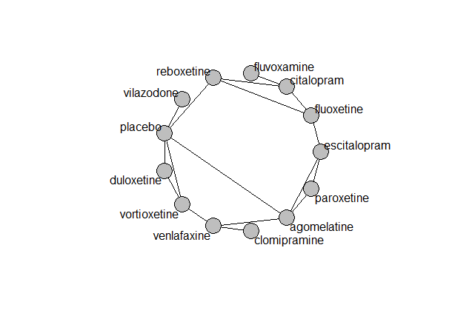

## **Pairwise MA**

### **Grouping all drugs together, comparison vs. placebo**

Number of studies: 20

Random effects meta-analysis: OR=1.26. 95% CI 0.64 to 2.45

Heterogeneity (tau squared) was estimated to be 0

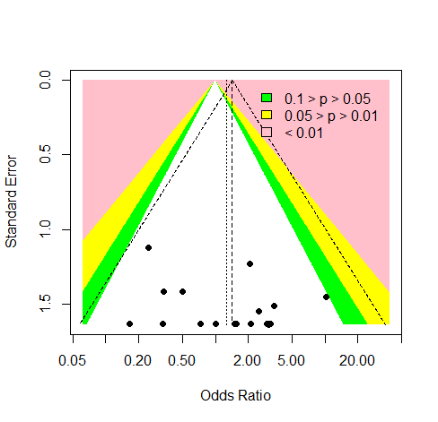

No evidence of asymmetry (Harbord’s test p-value 0.80)

### **Meta-analyses of comparisons with 10 or more studies**

We show results from pairwise comparisons informed by 10 studies or more. An OR larger than 1 favors the first treatment in the comparison.

No meta-analyses had 10 studies or more

## **Assessment of transitivity**

comparison studies baseline_SD age_SD female

1 paroxetine - reboxetine 1 24 (NA) 44 (NA) 0.62 (NA)

2 escitalopram - paroxetine 1 23 (NA) 45 (NA) NaN (NA)

3 duloxetine - placebo 5 21 (2) 55 (15.2) 0.64 (0.04)

4 duloxetine - vortioxetine 2 21 (NA) 58 (18.1) 0.67 (0.02)

5 placebo - vortioxetine 7 24 (2) 49 (9.8) 0.67 (0.04)

6 fluoxetine - reboxetine 2 25 (0.5) 41 (3.9) 0.67 (0.07)

7 citalopram - fluoxetine 2 24 (1.1) 43 (1.1) NaN (NA)

8 desvenlafaxine - placebo 4 23 (0.5) 44 (6.3) 0.7 (0.21)

9 agomelatine - escitalopram 1 27 (NA) 43 (NA) 0.71 (NA)

10 placebo - sertraline 1 NaN (NA) 37 (NA) NaN (NA)

11 placebo - vilazodone 3 24 (0.6) 41 (1) 0.56 (0.03)

12 citalopram - sertraline 1 22 (NA) 48 (NA) NaN (NA)

13 placebo - venlafaxine 1 23 (NA) 42 (NA) NaN (NA)

14 paroxetine - placebo 2 25 (2.8) 39 (4.3) 0.66 (NA)

15 fluoxetine - venlafaxine 1 23 (NA) 40 (NA) NaN (NA)

16 escitalopram - fluoxetine 2 24 (NA) 38 (1.3) 0.68 (NA)

17 duloxetine - paroxetine 1 21 (NA) 38 (NA) NaN (NA)

18 agomelatine - venlafaxine 1 26 (NA) 40 (NA) 0.71 (NA)

19 agomelatine - paroxetine 1 27 (NA) 42 (NA) 0.66 (NA)

20 agomelatine - placebo 2 27 (0) 44 (1.9) 0.7 (0.05)

21 citalopram - placebo 1 24 (NA) 42 (NA) 0.57 (NA)

22 citalopram - vilazodone 1 24 (NA) 42 (NA) 0.57 (NA)

23 amitriptyline - paroxetine 1 24 (NA) 46 (NA) NaN (NA)

24 escitalopram - venlafaxine 1 20 (NA) 48 (NA) NaN (NA)

25 duloxetine - venlafaxine 1 22 (NA) 42 (NA) 0.66 (NA)

26 clomipramine - venlafaxine 1 25 (NA) 47 (NA) NaN (NA)

27 escitalopram - placebo 2 22 (1.4) 41 (1) 0.7 (0.09)

28 placebo - reboxetine 1 24 (NA) 45 (NA) 0.55 (NA)

29 citalopram - reboxetine 1 24 (NA) 42 (NA) 0.64 (NA)

30 bupropion - venlafaxine 1 24 (NA) 37 (NA) NaN (NA)

31 citalopram - fluvoxamine 1 24 (NA) NaN (NA) NaN (NA)

32 venlafaxine - vortioxetine 1 25 (NA) 40 (NA) 0.6 (NA)

33 bupropion - fluoxetine 1 22 (NA) 38 (NA) NaN (NA)

34 bupropion - placebo 1 22 (NA) 38 (NA) NaN (NA)

35 fluoxetine - placebo 1 22 (NA) 38 (NA) NaN (NA)

## **NMA**

A total of 13 treatments are included in the network.

A total of 25 studies are included in this analysis.

We fit a Mantel Haenszel (fixed effects) NMA model as a primary analysis. In sensitivity analyses we also fit a NMA with a non-central Hypergeometric likelihood (fixed effects), an inverse variance fixed effects and an inverse variance random effects model.

For the random effects model:

Global test for inconsistency, p-value 0.8594 (Q=13,d.o.f.20)

### **Comparison vs. placebo**

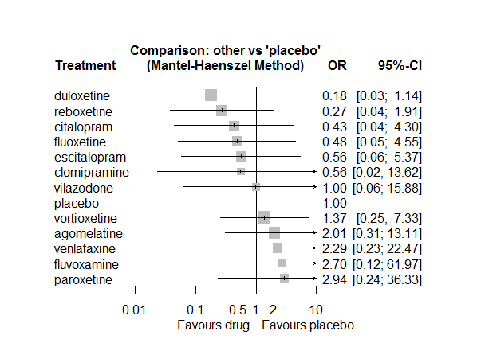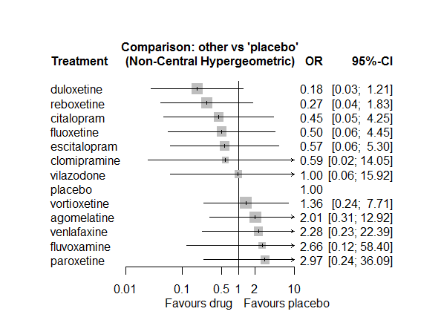

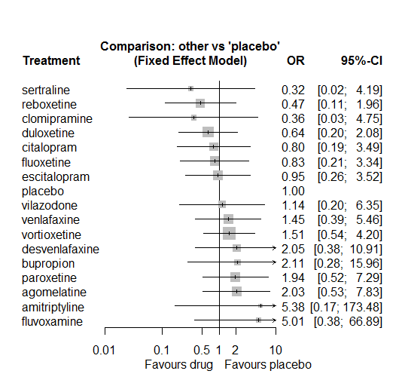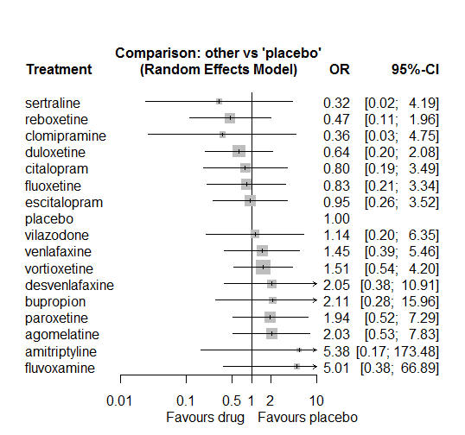

### **Ranking according to P-scores**

P-score

duloxetine 0.86

reboxetine 0.80

citalopram 0.68

fluoxetine 0.64

escitalopram 0.62

clomipramine 0.60

vilazodone 0.47

placebo 0.46

vortioxetine 0.38

agomelatine 0.27

venlafaxine 0.26

fluvoxamine 0.25

paroxetine 0.21

### **Local inconsistency**

Inconsistency could not be assessed using the SIDDE approach. Using the Back-calculation method we got the following results:

Percent of comparisons where there is some evidence (p-value<0.05) of disagreement between direct and indirect sources: 0.03. (1 out of 31 comparisons)

comparison TE seTE lower upper z p

7 agomelatine:escitalopram 1.057 1.5 -1.82 3.93 0.720 0.471

10 agomelatine:paroxetine -0.980 1.5 -3.85 1.89 -0.668 0.504

11 agomelatine:placebo 0.303 1.4 -2.39 3.00 0.220 0.826

14 agomelatine:venlafaxine -0.476 1.7 -3.84 2.89 -0.277 0.782

37 bupropion:fluoxetine 1.273 2.1 -2.91 5.46 0.596 0.551

40 bupropion:placebo 1.518 2.1 -2.55 5.59 0.731 0.465

43 bupropion:venlafaxine -2.471 2.1 -6.66 1.72 -1.155 0.248

50 citalopram:fluoxetine 0.308 1.2 -2.13 2.75 0.247 0.805

53 citalopram:placebo 0.257 2.2 -3.97 4.49 0.119 0.905

54 citalopram:reboxetine -0.926 1.4 -3.61 1.76 -0.676 0.499

55 citalopram:sertraline 2.032 2.7 -3.17 7.23 0.766 0.444

57 citalopram:vilazodone -0.090 2.1 -4.24 4.06 -0.043 0.966

85 duloxetine:paroxetine 3.764 1.8 0.20 7.33 2.068 0.039

86 duloxetine:placebo -0.039 1.2 -2.48 2.40 -0.032 0.975

89 duloxetine:venlafaxine 1.843 2.2 -2.44 6.13 0.843 0.399

91 duloxetine:vortioxetine -1.521 1.3 -3.98 0.94 -1.214 0.225

92 escitalopram:fluoxetine -0.266 1.5 -3.29 2.76 -0.172 0.863

94 escitalopram:paroxetine -1.248 1.5 -4.12 1.62 -0.852 0.394

95 escitalopram:placebo 0.764 1.5 -2.16 3.69 0.512 0.608

98 escitalopram:venlafaxine 2.716 1.8 -0.81 6.24 1.510 0.131

103 fluoxetine:placebo 0.200 2.1 -4.00 4.40 0.094 0.925

104 fluoxetine:reboxetine 0.202 1.4 -2.47 2.88 0.148 0.882

106 fluoxetine:venlafaxine 0.730 1.9 -2.97 4.43 0.387 0.699

116 paroxetine:placebo 0.810 1.4 -1.95 3.57 0.575 0.565

117 paroxetine:reboxetine -0.494 1.9 -4.26 3.28 -0.257 0.797

122 placebo:reboxetine 1.130 1.5 -1.76 4.02 0.765 0.444

123 placebo:sertraline -2.032 2.7 -7.23 3.17 -0.766 0.444

124 placebo:venlafaxine -0.944 1.8 -4.47 2.58 -0.525 0.599

125 placebo:vilazodone -0.030 2.6 -5.06 5.00 -0.012 0.991

126 placebo:vortioxetine 0.531 1.1 -1.71 2.77 0.465 0.642

135 venlafaxine:vortioxetine 1.030 1.5 -1.98 4.04 0.671 0.502

### **League table**

Below we show the league table. Upper triangle: direct evidence. Lower triangle: NMA. An odds ratio larger than 1 in the upper triangle favors the column-defining drug. An odds ratio larger than 1 in the bottom triangle favors the row-defining drug.

|  |  |  |  |  |  |  |  |  |  |  |  |  |
| --- | --- | --- | --- | --- | --- | --- | --- | --- | --- | --- | --- | --- |
| AGOM | . | . | . | 3.98 [0.44; 35.96] | . | . | 0.53 [0.05; 5.95] | 2.05 [0.18; 22.94] | . | 1.01 [0.06; 16.32] | . | . |
| 4.65 [0.38; 56.24] | CITA | . | . | . | 1.03 [0.33; 3.23] | 0.16 [0.02; 1.36] | . | . | 1.04 [0.14; 7.47] | . | . | . |
| 3.59 [0.15; 83.34] | 0.77 [0.02; 32.83] | CLOM | . | . | . | . | . | . | . | 0.24 [0.03; 2.27] | . | . |
| 11.20 [0.94; 132.76] | 2.41 [0.13; 43.50] | 3.12 [0.11; 91.19] | DULO | . | . | . | . | 0.25 [0.02; 2.75] | . | . | . | 0.10 [0.01; 0.83] |
| 3.58 [0.66; 19.38] | 0.77 [0.07; 8.61] | 1.00 [0.03; 32.59] | 0.32 [0.02; 5.27] | ESCI | 0.98 [0.06; 16.00] | . | 0.23 [0.03; 2.12] | . | . | . | . | . |
| 4.15 [0.38; 45.34] | 0.89 [0.31; 2.57] | 1.16 [0.03; 46.62] | 0.37 [0.02; 6.38] | 1.16 [0.12; 11.18] | FLUO | . | . | . | 2.82 [0.30; 26.44] | . | . | . |
| 0.75 [0.03; 19.86] | 0.16 [0.02; 1.36] | 0.21 [0.00; 15.52] | 0.07 [0.00; 2.43] | 0.21 [0.01; 5.22] | 0.18 [0.02; 1.95] | FLUV | . | . | . | . | . | . |
| 0.68 [0.11; 4.43] | 0.15 [0.01; 2.46] | 0.19 [0.01; 7.07] | 0.06 [0.00; 1.23] | 0.19 [0.03; 1.15] | 0.16 [0.01; 2.48] | 0.92 [0.03; 31.43] | PARO | . | . | . | . | . |
| 2.01 [0.31; 13.11] | 0.43 [0.04; 4.30] | 0.56 [0.02; 13.62] | 0.18 [0.03; 1.14] | 0.56 [0.06; 5.37] | 0.48 [0.05; 4.55] | 2.70 [0.12; 61.97] | 2.94 [0.24; 36.33] | PLAC | 4.11 [0.45; 37.37] | . | 1.00 [0.06; 16.01] | 0.89 [0.09; 8.28] |
| 7.45 [0.71; 77.82] | 1.60 [0.36; 7.17] | 2.07 [0.06; 76.52] | 0.67 [0.05; 9.43] | 2.08 [0.19; 22.50] | 1.80 [0.40; 8.09] | 9.99 [0.74; 135.58] | 10.90 [0.70; 169.56] | 3.70 [0.52; 26.25] | REBO | . | . | . |
| 0.88 [0.10; 8.09] | 0.19 [0.01; 3.86] | 0.24 [0.03; 2.27] | 0.08 [0.01; 0.99] | 0.25 [0.02; 3.59] | 0.21 [0.01; 4.06] | 1.18 [0.03; 47.45] | 1.29 [0.07; 22.16] | 0.44 [0.04; 4.29] | 0.12 [0.01; 2.02] | VENL | . | 1.86 [0.17; 20.66] |
| 2.02 [0.07; 57.22] | 0.43 [0.01; 15.85] | 0.56 [0.01; 38.44] | 0.18 [0.01; 5.03] | 0.56 [0.02; 20.08] | 0.49 [0.01; 17.14] | 2.71 [0.04; 177.42] | 2.95 [0.07; 124.32] | 1.00 [0.06; 16.01] | 0.27 [0.01; 8.05] | 2.30 [0.06; 83.21] | VILA | . |
| 1.47 [0.16; 13.59] | 0.32 [0.02; 4.97] | 0.41 [0.02; 8.48] | 0.13 [0.02; 0.74] | 0.41 [0.03; 5.55] | 0.35 [0.02; 5.27] | 1.97 [0.06; 64.30] | 2.15 [0.13; 35.66] | 0.73 [0.14; 3.92] | 0.20 [0.02; 2.43] | 1.67 [0.21; 13.06] | 0.73 [0.03; 18.58] | VORT |

### **Estimated event rates**

For an event rate in placebo equal to the average event rate (i.e. fixed to 0.002) the estimated event rates for each drug are as follows

drug rate

1 agomelatine 0.004 [0.0006, 0.0255]

2 citalopram 0.0009 [0.0001, 0.0085]

3 clomipramine 0.0011 [0, 0.0264]

4 duloxetine 0.0004 [0.0001, 0.0023]

5 escitalopram 0.0011 [0.0001, 0.0106]

6 fluoxetine 0.001 [0.0001, 0.009]

7 fluvoxamine 0.0053 [0.0002, 0.1099]

8 paroxetine 0.0058 [0.0005, 0.0675]

10 reboxetine 0.0005 [0.0001, 0.0038]

11 venlafaxine 0.0045 [0.0005, 0.0428]

12 vilazodone 0.002 [0.0001, 0.0307]

13 vortioxetine 0.0027 [0.0005, 0.0144]

### **Additional sensitivity analyses**

No other analyses were performed due to the low amount of information in the studies.

# **Suicidal ideation**

We remove all arms for which dose range was not “Licenced”. After this:

* Removed 7 one-arm studies: Feighner1991, Hewett2010a (AK130940) (NCT00093288), Heiligenstein1994, Rapaport1996, Montgomery2013 (F02695LP202, EudraCT2006-002404-34), Rickels2009 (GNSC-04-DP-02 FDA) (NCT00285376), Jacobsen2015 (316, NCT01163266)
* Total number of arms 78. Total number of studies 29
* Total events in placebo 89, out of a total of 4661 patients. Event rate placebo 0.019
* Total events in drugs 123, out of a total of 9868 patients. Event rate drugs 0.012

## **Distribution of dose across drugs**

Here we count the number of arms per drug, and the percent of these arms where Dose_intended_min was equal to the minimum licensed dose or lower. The values we used as minimum licensed dose are as follows:

agomelatine: 25; amitriptyline: 75; bupropion:300; citalopram:20; clomipramine:30; desvenlafaxine:50; duloxetine:40; escitalopram:10; fluoxetine:20; fluvoxamine:50; levomilnacipran:40; milnacipran:50; mirtazapine:15; nefazodone:300; paroxetine:20; reboxetine:8; sertraline:50; trazodone:150; venlafaxine:75; vilazodone:20; vortioxetine:5

Drug number.arms percent.low.dose

2 vortioxetine 17 0.29

3 duloxetine 5 0.00

4 sertraline 2 1.00

5 escitalopram 3 1.00

6 bupropion 2 1.00

7 desvenlafaxine 4 0.75

8 vilazodone 4 0.25

9 levomilnacipran 2 1.00

10 venlafaxine 5 0.80

11 fluoxetine 4 0.75

12 amitriptyline 1 1.00

13 citalopram 1 0.00

14 agomelatine 2 0.50

## **Network graph**

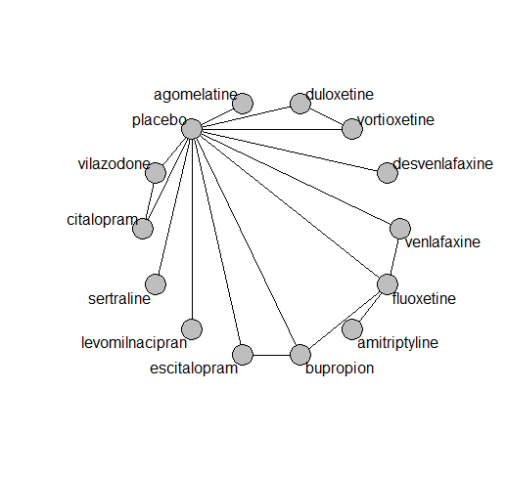

## **Pairwise MA**

### **Grouping all drugs together, comparison vs. placebo**

Number of studies: 18

Fixed effects (Mantel-Haenszel) meta-analysis: OR=0.88. 95% CI 0.65 to 1.18

Random effects meta-analysis: OR=0.85. 95% CI 0.63 to 1.16

Heterogeneity (tau squared) was estimated to be 0

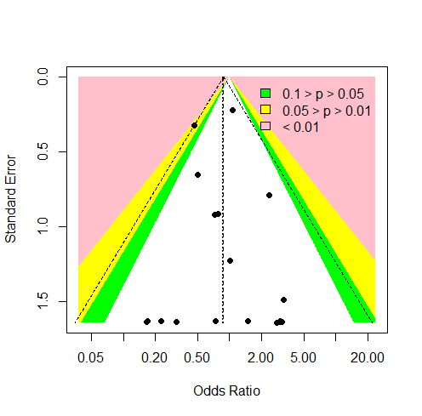

No evidence of asymmetry (Harbord’s test p-value 0.6)

### **Meta-analyses of comparisons with 10 or more studies**

We show results from pairwise comparisons informed by 10 studies or more. An OR larger than 1 favors the first treatment in the comparison.

No meta-analyses had 10 studies or more

## **Assessment of transitivity**

comparison studies baseline_SD age_SD female

1 duloxetine - placebo 4 23 (3.3) 52 (14.2) 0.67 (0.06)

2 duloxetine - vortioxetine 4 25 (0.4) 44 (1.9) 0.68 (0.05)

3 placebo - vortioxetine 7 24 (1.5) 44 (2.7) 0.65 (0.09)

4 placebo - sertraline 2 19 (NA) 38 (0.2) NaN (NA)

5 bupropion - escitalopram 1 24 (NA) 36 (NA) NaN (NA)

6 bupropion - placebo 2 23 (1.2) 37 (1.4) NaN (NA)

7 escitalopram - placebo 3 22 (2.1) 39 (3.2) 0.67 (0.06)

8 desvenlafaxine - placebo 3 23 (0.6) 45 (7.3) 0.71 (0.26)

9 placebo - vilazodone 3 24 (0) 41 (1.1) 0.56 (0.03)

10 levomilnacipran - placebo 2 24 (1.1) 44 (1.1) 0.63 (0.04)

11 placebo - venlafaxine 3 25 (2.1) 41 (3.1) 0.55 (0.07)

12 fluoxetine - venlafaxine 2 25 (2.5) 40 (0) 0.6 (NA)

13 amitriptyline - fluoxetine 1 26 (NA) 44 (NA) 0.74 (NA)

14 citalopram - placebo 1 24 (NA) 42 (NA) 0.57 (NA)

15 citalopram - vilazodone 1 24 (NA) 42 (NA) 0.57 (NA)

16 fluoxetine - placebo 2 24 (2.9) 39 (1.5) 0.6 (NA)

17 bupropion - fluoxetine 1 22 (NA) 38 (NA) NaN (NA)

18 agomelatine - placebo 1 27 (NA) 44 (NA) 0.67 (NA)

## **NMA**

A total of 8 treatments are included in the network (MH analysis).

A total of 16 studies are included in this analysis.

We fit a Mantel Haenszel (fixed effects) NMA model as a primary analysis. In sensitivity analyses we also fit a NMA with a non-central Hypergeometric likelihood (fixed effects), an inverse variance fixed effects and an inverse variance random effects model.

For the random effects model:

Global test for inconsistency, p-value 0.90495 (Q=4,d.o.f.9).

### **Comparison vs. placebo**

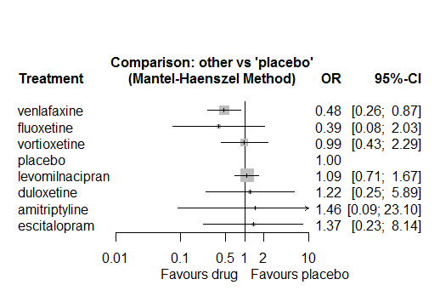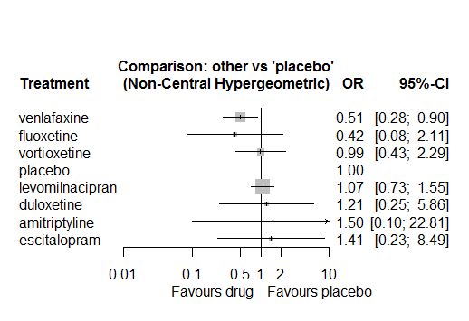

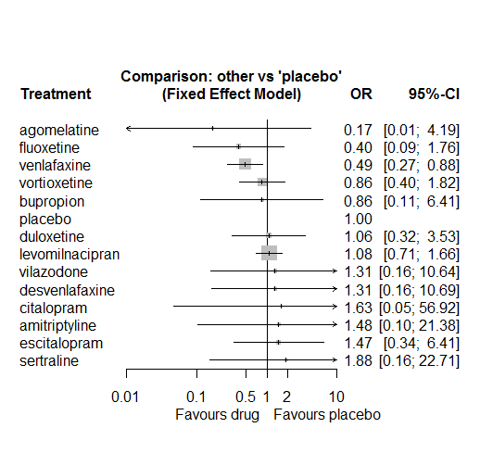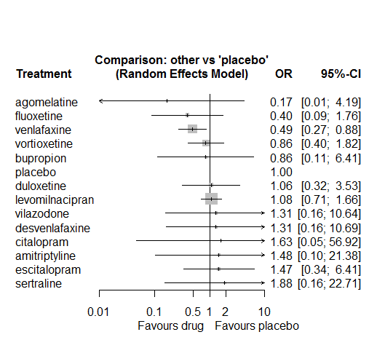

The only drug for which there is strong evidence is venlafaxine.

### **Ranking according to P-scores**

P-score

venlafaxine 0.83

fluoxetine 0.82

vortioxetine 0.45

placebo 0.45

levomilnacipran 0.38

duloxetine 0.38

amitriptyline 0.35

escitalopram 0.34

### **Local inconsistency**

Using the SIDDE method we found no evidence of inconsistency.

Using the Back-calculation method we got the following results:

Percent of comparisons where there is some evidence (p-value<0.05) of disagreement between direct and indirect sources: 0. (0 out of 12 comparisons)

comparison TE seTE lower upper z p

29 bupropion:escitalopram -2.408 2.3 -6.9 2.1 -1.050 0.29

30 bupropion:fluoxetine 0.615 2.3 -3.8 5.1 0.271 0.79

32 bupropion:placebo 0.664 2.5 -4.2 5.6 0.265 0.79

42 citalopram:placebo -2.702 4.7 -12.0 6.6 -0.570 0.57

45 citalopram:vilazodone 2.703 4.7 -6.6 12.0 0.570 0.57

59 duloxetine:placebo -0.063 1.2 -2.5 2.3 -0.052 0.96

63 duloxetine:vortioxetine 0.995 1.6 -2.0 4.0 0.641 0.52

66 escitalopram:placebo -3.212 3.3 -9.7 3.3 -0.963 0.34

72 fluoxetine:placebo 0.792 1.5 -2.2 3.8 0.521 0.60

74 fluoxetine:venlafaxine -0.669 1.8 -4.2 2.9 -0.372 0.71

83 placebo:venlafaxine -0.328 2.1 -4.4 3.7 -0.158 0.87

85 placebo:vortioxetine -1.805 1.9 -5.5 1.8 -0.968 0.33

### **League table**

Below we show the league table. Upper triangle: direct evidence. Lower triangle: NMA. An odds ratio larger than 1 in the upper triangle favors the column-defining drug. An odds ratio larger than 1 in the bottom triangle favors the row-defining drug.

|  |  |  |  |  |  |  |  |
| --- | --- | --- | --- | --- | --- | --- | --- |
| AMIT | . | . | 3.72 [0.41; 34.13] | . | . | . | . |
| 1.20 [0.05; 28.91] | DULO | . | . | . | . | . | 1.22 [0.32; 4.68] |
| 1.07 [0.04; 28.53] | 0.89 [0.08; 9.60] | ESCI | . | . | 1.39 [0.24; 8.00] | . | . |
| 3.72 [0.41; 34.13] | 3.09 [0.32; 30.14] | 3.48 [0.31; 39.31] | FLUO | . | 0.47 [0.04; 5.32] | 0.70 [0.13; 3.68] | . |
| 1.34 [0.08; 21.94] | 1.12 [0.22; 5.73] | 1.26 [0.20; 7.87] | 0.36 [0.07; 1.98] | LEVO | 1.09 [0.71; 1.67] | . | . |
| 1.46 [0.09; 23.10] | 1.22 [0.25; 5.89] | 1.37 [0.23; 8.14] | 0.39 [0.08; 2.03] | 1.09 [0.71; 1.67] | PLAC | 2.06 [1.13; 3.78] | 1.01 [0.44; 2.32] |
| 3.06 [0.20; 46.71] | 2.54 [0.47; 13.75] | 2.86 [0.44; 18.78] | 0.82 [0.17; 4.02] | 2.27 [1.08; 4.77] | 2.09 [1.14; 3.81] | VENL | . |
| 1.47 [0.08; 26.30] | 1.22 [0.32; 4.67] | 1.38 [0.19; 9.87] | 0.40 [0.06; 2.50] | 1.10 [0.43; 2.80] | 1.01 [0.44; 2.32] | 0.48 [0.17; 1.35] | VORT |

### **Estimated event rates**

For an event rate in placebo equal to the average event rate (i.e. fixed to 0.02) the estimated event rates for each drug are as follows

drug rate

1 amitriptyline 0.03 [0, 0.31]

2 duloxetine 0.02 [0, 0.1]

3 escitalopram 0.03 [0, 0.14]

4 fluoxetine 0.01 [0, 0.04]

5 levomilnacipran 0.02 [0.01, 0.03]

7 venlafaxine 0.01 [0.01, 0.02]

8 vortioxetine 0.02 [0.01, 0.04]

### **Additional sensitivity analyses**

No other analyses were performed due to the low amount of information in the studies.

# **Suicidal behavior or self harm**

We remove all arms for which dose range was not “Licenced”. After this:

* Removed 3 one-arm studies: Grunebaum2011 (NCT00429169), Bosc1997b (Study 016 - Massana 1999), Higuchi 2016(NCT01441440)
* Total number of arms 37. Total number of studies 12
* Total events in placebo 20, out of a total of 1974 patients. Event rate placebo 0.01
* Total events in drugs 34, out of a total of 4142 patients. Event rate drugs 0.008

## **Distribution of dose across drugs**

Here we count the number of arms per drug, and the percent of these arms where Dose_intended_min was equal to the minimum licensed dose or lower. The values we used as minimum licensed dose are as follows:

agomelatine: 25; amitriptyline: 75; bupropion:300; citalopram:20; clomipramine:30; desvenlafaxine:50; duloxetine:40; escitalopram:10; fluoxetine:20; fluvoxamine:50; levomilnacipran:40; milnacipran:50; mirtazapine:15; nefazodone:300; paroxetine:20; reboxetine:8; sertraline:50; trazodone:150; venlafaxine:75; vilazodone:20; vortioxetine:5

Drug number.arms percent.low.dose

2 vortioxetine 11 0.27

3 duloxetine 2 0.00

4 escitalopram 5 0.80

5 citalopram 2 0.00

6 vilazodone 2 0.50

7 levomilnacipran 1 1.00

8 fluoxetine 1 0.00

9 venlafaxine 1 0.00

## **Network graph**

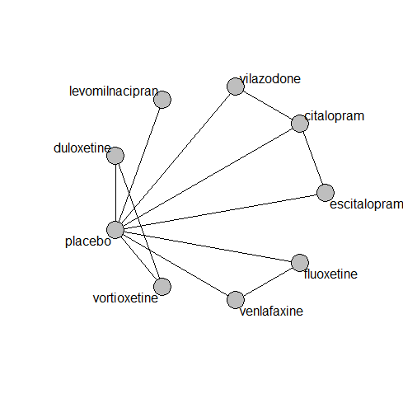

## **Pairwise MA**

### **Grouping all drugs together, comparison vs. placebo**

Number of studies: 10

Fixed effects (Mantel-Haenszel) meta-analysis: OR=1.02. 95% CI 0.59 to 1.75

Random effects meta-analysis: OR=0.96. 95% CI 0.55 to 1.7

Heterogeneity (tau squared) was estimated to be 0

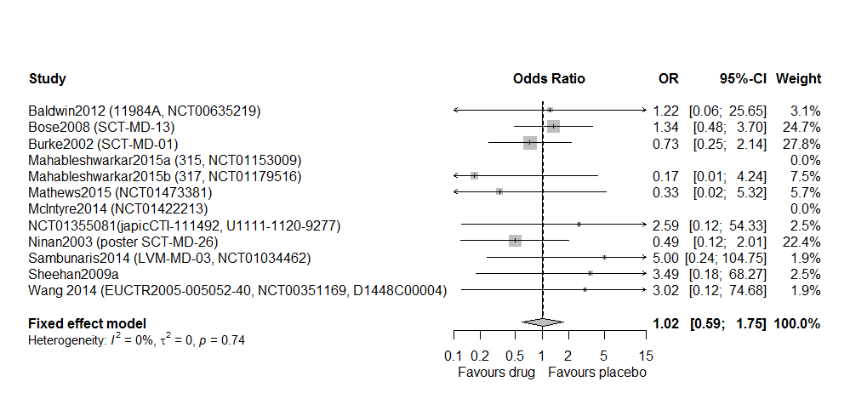

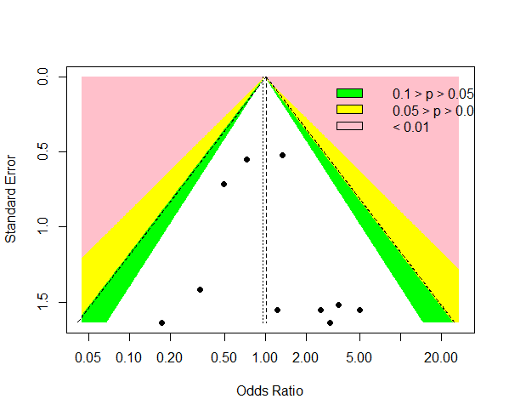

No evidence of asymmetry (Harbord’s test p-value 0.5)

### **Meta-analyses of comparisons with 10 or more studies**

We show results from pairwise comparisons informed by 10 studies or more. An OR larger than 1 favors the first treatment in the comparison.

No meta-analyses had 10 studies or more

## **Assessment of transitivity**

comparison studies baseline_SD age_SD female

1 duloxetine - placebo 2 25 (NA) 44 (1.4) 0.71 (0.04)

2 duloxetine - vortioxetine 2 25 (NA) 44 (1.4) 0.71 (0.04)

3 placebo - vortioxetine 5 24 (1.9) 43 (3) 0.65 (0.11)

4 escitalopram - placebo 4 23 (NA) 47 (14.4) 0.72 (NA)

5 citalopram - escitalopram 1 NaN (NA) 40 (NA) NaN (NA)

6 citalopram - placebo 2 24 (NA) 41 (1.2) 0.57 (NA)

7 citalopram - vilazodone 1 24 (NA) 42 (NA) 0.57 (NA)

8 placebo - vilazodone 1 24 (NA) 42 (NA) 0.57 (NA)

9 levomilnacipran - placebo 1 23 (NA) 45 (NA) 0.66 (NA)

10 fluoxetine - placebo 1 26 (NA) 40 (NA) 0.6 (NA)

11 fluoxetine - venlafaxine 1 26 (NA) 40 (NA) 0.6 (NA)

12 placebo - venlafaxine 1 26 (NA) 40 (NA) 0.6 (NA)

## **NMA**

A total of 9 treatments are included in the network.

A total of 12 studies are included in this analysis.

Mantel-Haenszel model could not be fit, due to designs with zero events. Removing these designs disconnected the network.

For the random effects NMA model:

Estimated heterogeneity tau-squared 0

Global test for inconsistency, p-value 0.9496 (Q=0,d.o.f.3)

### **Comparison vs. placebo**

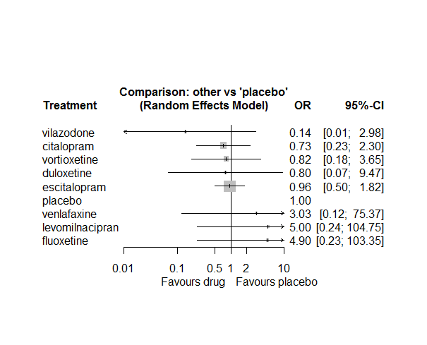

No usable evidence for the effects of any drug.

### **Ranking according to P-scores**

P-score

vilazodone 0.89

citalopram 0.64

vortioxetine 0.59

duloxetine 0.58

escitalopram 0.54

placebo 0.51

venlafaxine 0.32

levomilnacipran 0.21

fluoxetine 0.21

### **Local inconsistency**

Percent of comparisons where there is some evidence (p-value<0.05) of disagreement between direct and indirect sources: 0. (0 out of 8 comparisons)

comparison TE seTE lower upper z p

2 citalopram:escitalopram -0.126 1.36 -2.79 2.54 -0.0927 0.926

5 citalopram:placebo -0.485 1.83 -4.07 3.10 -0.2651 0.791

7 citalopram:vilazodone 1.716 5.35 -8.78 12.21 0.3204 0.749

12 duloxetine:placebo 1.142 3.11 -4.96 7.24 0.3669 0.714

15 duloxetine:vortioxetine -0.540 4.15 -8.68 7.60 -0.1301 0.896

18 escitalopram:placebo -0.697 2.18 -4.96 3.57 -0.3204 0.749

32 placebo:vilazodone -1.716 5.35 -12.21 8.78 -0.3204 0.749

33 placebo:vortioxetine 2.674 6.99 -11.04 16.38 0.3823 0.702

### **League table**

Below we show the league table. Upper triangle: direct evidence. Lower triangle: NMA. An odds ratio larger than 1 in the upper triangle favors the column-defining drug. An odds ratio larger than 1 in the bottom triangle favors the row-defining drug.

|  |  |  |  |  |  |  |  |  |
| --- | --- | --- | --- | --- | --- | --- | --- | --- |
| CITA | . | 0.74 [0.19; 2.83] | . | . | 0.69 [0.20; 2.34] | . | 6.07 [0.25; 149.41] | . |
| 0.91 [0.06; 13.93] | DULO | . | . | . | 1.01 [0.06; 16.26] | . | . | 0.93 [0.08; 10.29] |
| 0.76 [0.24; 2.43] | 0.84 [0.06; 10.76] | ESCI | . | . | 0.94 [0.49; 1.81] | . | . | . |
| 0.15 [0.01; 3.87] | 0.16 [0.00; 8.27] | 0.20 [0.01; 4.41] | FLUO | . | 4.90 [0.23; 103.35] | 1.62 [0.21; 12.47] | . | . |
| 0.15 [0.01; 3.77] | 0.16 [0.00; 8.06] | 0.19 [0.01; 4.29] | 0.98 [0.01; 72.72] | LEVO | 5.00 [0.24; 104.75] | . | . | . |
| 0.73 [0.23; 2.30] | 0.80 [0.07; 9.47] | 0.96 [0.50; 1.82] | 4.90 [0.23; 103.35] | 5.00 [0.24; 104.75] | PLAC | 0.33 [0.01; 8.20] | 6.05 [0.25; 148.89] | 1.26 [0.28; 5.66] |
| 0.24 [0.01; 7.30] | 0.26 [0.00; 15.20] | 0.32 [0.01; 8.36] | 1.62 [0.21; 12.47] | 1.65 [0.02; 137.71] | 0.33 [0.01; 8.20] | VENL | . | . |
| 5.17 [0.24; 109.28] | 5.67 [0.11; 287.77] | 6.79 [0.31; 148.68] | 34.75 [0.47; 2595.72] | 35.47 [0.48; 2636.35] | 7.09 [0.34; 149.93] | 21.51 [0.26; 1806.84] | VILA | . |
| 0.89 [0.13; 5.85] | 0.97 [0.10; 9.69] | 1.17 [0.23; 5.93] | 5.97 [0.20; 178.13] | 6.10 [0.21; 180.66] | 1.22 [0.27; 5.43] | 3.70 [0.11; 127.84] | 0.17 [0.01; 5.13] | VORT |

### **Estimated event rates**

For an event rate in placebo equal to the average event rate (i.e. fixed to 0.01) the estimated event rates for each drug are as follows

drug rate

1 citalopram 0.01 [0, 0.02]

2 duloxetine 0.01 [0, 0.09]

3 escitalopram 0.01 [0.01, 0.02]

4 fluoxetine 0.05 [0, 0.51]

5 levomilnacipran 0.05 [0, 0.52]

7 venlafaxine 0.03 [0, 0.44]

8 vilazodone 0 [0, 0.03]

9 vortioxetine 0.01 [0, 0.04]

### **Additional sensitivity analyses**

No other analyses were performed due to the low amount of information in the studies.

# **Completed suicide**

We remove all arms for which dose range was not “Licenced”. After this:

* Removed 8 one-arm studies: Timmerman1993 (Study 89422 - FDA and Haffmans 1996), Mendels1999 (Study 85A - FDA), DeMartinis2007 (Study 306, NCT00072774), Oakes2012b (NCT00536471), Moore2005, Wade2007 (Study 10990), Dierick1996, FDA 245 (EMD 68 843-010)
* Total number of arms 16. Total number of studies 6
* Total events in placebo 4, out of a total of 761 patients. Event rate placebo 0.005.
* Total events in drugs 34, out of a total of 4142 patients. Event rate drugs 0.003

## **Distribution of dose across drugs**

Here we count the number of arms per drug, and the percent of these arms where Dose_intended_min was equal to the minimum licensed dose or lower. The values we used as minimum licensed dose are as follows:

agomelatine: 25; amitriptyline: 75; bupropion:300; citalopram:20; clomipramine:30; desvenlafaxine:50; duloxetine:40; escitalopram:10; fluoxetine:20; fluvoxamine:50; levomilnacipran:40; milnacipran:50; mirtazapine:15; nefazodone:300; paroxetine:20; reboxetine:8; sertraline:50; trazodone:150; venlafaxine:75; vilazodone:20; vortioxetine:5

Drug number.arms percent.low.dose

1 paroxetine 4 0.5

2 fluoxetine 1 1.0

3 venlafaxine 2 1.0

5 citalopram 2 0.5

6 escitalopram 1 1.0

7 agomelatine 1 1.0

## **Network graph**

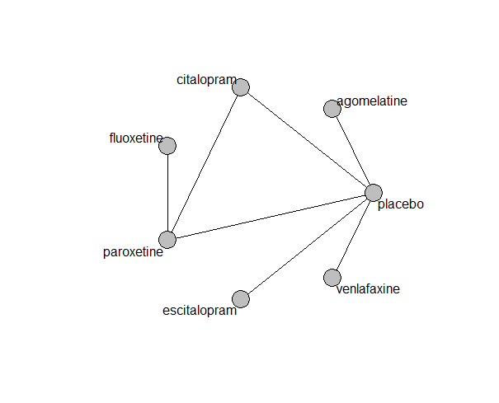

## **Pairwise MA**

### **Grouping all drugs together, comparison vs. placebo**

Number of studies: 5

Fixed effects (Mantel-Haenszel) meta-analysis: OR=0.56. 95% CI 0.16 to 1.93

Random effects meta-analysis: OR=0.55. 95% CI 0.14 to 2.13

Heterogeneity (tau squared) was estimated to be 0

Not enough studies to assess asymmetry

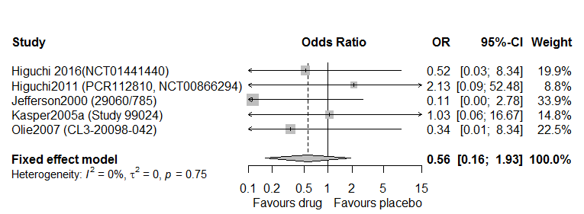

### **Meta-analyses of comparisons with 10 or more studies**

We show results from pairwise comparisons informed by 10 studies or more. An OR larger than 1 favors the first treatment in the comparison.

No meta-analyses had 10 studies or more

## **Assessment of transitivity**

comparison studies baseline_SD age_SD female

1 fluoxetine - paroxetine 1 NaN (NA) 75 (NA) NaN (NA)

2 placebo - venlafaxine 1 NaN (NA) 38 (NA) 0.5 (NA)

3 paroxetine - placebo 2 24 (0.9) 38 (2.6) NaN (NA)

4 citalopram - paroxetine 1 24 (NA) 40 (NA) NaN (NA)

5 citalopram - placebo 1 24 (NA) 40 (NA) NaN (NA)

6 escitalopram - placebo 1 22 (NA) 75 (NA) NaN (NA)

7 agomelatine - placebo 1 27 (NA) 45 (NA) 0.74 (NA)

## **NMA**

A total of 7 treatments are included in the network.

A total of 6 studies are included in this analysis.

Mantel-Haenszel model could not be fit, due to designs with zero events. Removing these designs disconnected the network.

For the random effects NMA model:

Estimated heterogeneity tau-squared 0

Global test for inconsistency, p-value 0.42613 (Q=1,d.o.f.1)

### **Comparison vs. placebo**

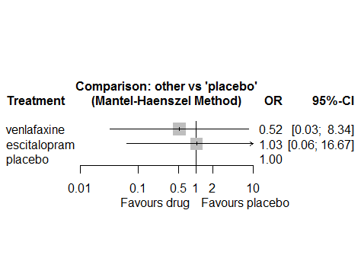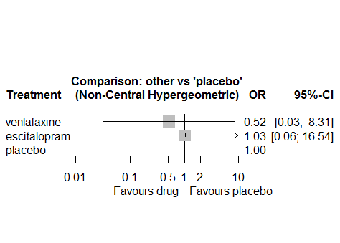

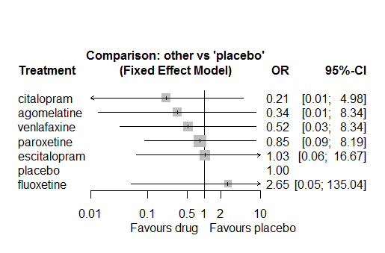 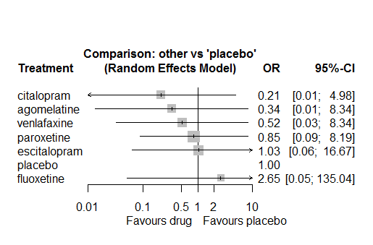

No usable evidence for the effects of any drug.

### **Ranking according to P-scores**

P-score

venlafaxine 0.66

escitalopram 0.43

placebo 0.42

### **Local inconsistency**

We could not assess local inconsistency

### **League table**

Below we show the league table. Upper triangle: direct evidence. Lower triangle: NMA. An odds ratio larger than 1 in the upper triangle favors the column-defining drug. An odds ratio larger than 1 in the bottom triangle favors the row-defining drug.

|  |  |  |
| --- | --- | --- |
| ESCI | 1.03 [0.06; 16.67] | . |
| 1.03 [0.06; 16.67] | PLAC | 1.93 [0.12; 31.02] |
| 2.00 [0.04; 101.56] | 1.93 [0.12; 31.02] | VENL |

### **Estimated event rates**

For an event rate in placebo equal to the average event rate (i.e. fixed to 0.01) the estimated event rates for each drug are as follows

drug rate

1 escitalopram 0.01 [0, 0.08]

3 venlafaxine 0 [0, 0.04]

### **Additional sensitivity analyses**

No other analyses were performed due to the low amount of information in the studies.

# **Death**

We remove all arms for which dose range was not “Licenced”. After this:

* Removed 8 one-arm studies: Olie2007 (CL3-20098-042), Settle1999 (WELL212), Hewett2010a (AK130940) (NCT00093288), AK1102365, Kavoussi1997, Mendels1999 (Study 85A - FDA), Moore2005, FDA 245 (EMD 68 843-010)
* Total number of arms 279. Total number of studies 110
* Total events in placebo 5, out of a total of 11249 patients. Event rate placebo 0.00044.
* Total events in drugs 23, out of a total of 30990 patients. Event rate drugs 0.00074.

## **Distribution of dose across drugs**

Here we count the number of arms per drug, and the percent of these arms where Dose_intended_min was equal to the minimum licensed dose or lower. The values we used as minimum licensed dose are as follows:

agomelatine: 25; amitriptyline: 75; bupropion:300; citalopram:20; clomipramine:30; desvenlafaxine:50; duloxetine:40; escitalopram:10; fluoxetine:20; fluvoxamine:50; levomilnacipran:40; milnacipran:50; mirtazapine:15; nefazodone:300; paroxetine:20; reboxetine:8; sertraline:50; trazodone:150; venlafaxine:75; vilazodone:20; vortioxetine:5

Drug number.arms percent.low.dose

1 bupropion 17 0.88

3 escitalopram 28 0.82

4 sertraline 5 1.00

5 citalopram 8 0.75

6 venlafaxine 22 0.55

7 vortioxetine 22 0.41

8 reboxetine 7 1.00

9 paroxetine 15 0.93

10 duloxetine 29 0.14

11 desvenlafaxine 11 0.55

12 agomelatine 15 0.87

13 fluoxetine 12 0.92

14 vilazodone 4 0.25

15 trazodone 2 1.00

16 amitriptyline 1 1.00

17 fluvoxamine 1 0.00

## **Network graph**

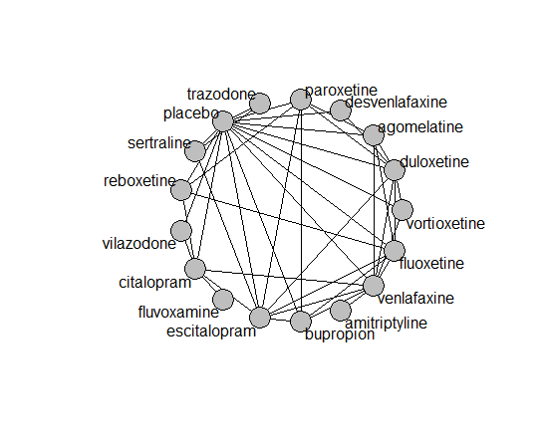

## **Pairwise MA**

### **Grouping all drugs together, comparison vs. placebo**

Number of studies: 11

Fixed effects (Mantel Haenszel) meta-analysis: OR=1.20. 95% CI 0.41 to 3.53

Random effects meta-analysis: OR=0.84. 95% CI 0.34 to 2.07

Heterogeneity (tau squared) was estimated to be 0

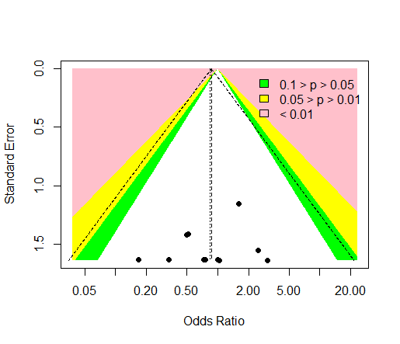

Not evidence of asymmetry (Harbord’s test p-value=0.9)

### **Meta-analyses of comparisons with 10 or more studies**

We show results from pairwise comparisons informed by 10 studies or more. An OR larger than 1 favors the first treatment in the comparison.

comparisons Number.of.studies OR lower.CI upper.CI tau.sq I.sq

1 placebo - bupropion 1 0.33 0.01 8.19 NA NA

2 placebo - duloxetine 2 0.81 0.11 6.45 0 0

3 placebo - escitalopram 3 1.18 0.25 5.21 0 0

4 placebo - vortioxetine 1 0.98 0.04 24.20 NA NA

## **Assessment of transitivity**

comparison studies baseline_SD age_SD female

1 bupropion - placebo 12 24 (2.4) 40 (4.5) 0.51 (0.21)

2 escitalopram - placebo 17 22 (2.6) 44 (10.8) 0.62 (0.13)

3 escitalopram - sertraline 2 20 (0.5) 40 (0.5) NaN (NA)

4 placebo - sertraline 3 19 (NA) 38 (1.7) NaN (NA)

5 citalopram - venlafaxine 1 22 (NA) 73 (NA) NaN (NA)

6 placebo - venlafaxine 8 23 (2.4) 42 (2.4) 0.62 (0.06)

7 placebo - vortioxetine 11 24 (1.8) 47 (8) 0.66 (0.04)

8 venlafaxine - vortioxetine 2 23 (2.5) 42 (2.2) 0.61 (0.02)

9 paroxetine - reboxetine 3 22 (2.1) 41 (2.7) 0.69 (0.07)

10 escitalopram - paroxetine 2 25 (2.8) 45 (0.5) NaN (NA)

11 duloxetine - placebo 19 21 (2.5) 47 (11.2) 0.66 (0.04)

12 duloxetine - vortioxetine 6 24 (2) 49 (10.8) 0.67 (0.04)

13 escitalopram - venlafaxine 2 20 (0.4) 43 (7.5) NaN (NA)

14 citalopram - escitalopram 4 23 (0) 43 (2.5) NaN (NA)

15 citalopram - placebo 4 24 (0.7) 42 (1.3) 0.57 (NA)

16 agomelatine - paroxetine 3 27 (0.6) 51 (14.9) 0.64 (0.03)

17 agomelatine - placebo 6 27 (0) 53 (14.7) 0.67 (0.03)

18 paroxetine - placebo 9 22 (3.6) 42 (2.2) 0.69 (0.05)

19 agomelatine - duloxetine 1 26 (NA) 43 (NA) NaN (NA)

20 fluoxetine - placebo 7 22 (2.8) 44 (13.6) 0.62 (0.02)

21 fluoxetine - reboxetine 1 23 (NA) 40 (NA) 0.63 (NA)

22 placebo - reboxetine 5 22 (1.3) 40 (0.8) 0.66 (0.07)

23 bupropion - escitalopram 2 24 (NA) 36 (0.6) NaN (NA)

24 desvenlafaxine - placebo 6 23 (0.6) 43 (4.9) 0.7 (0.18)

25 bupropion - fluoxetine 2 22 (0.7) 37 (0.6) NaN (NA)

26 placebo - vilazodone 3 24 (0.6) 41 (1) 0.56 (0.03)

27 duloxetine - paroxetine 5 20 (1.7) 42 (2.7) NaN (NA)

28 duloxetine - fluoxetine 2 18 (0.2) 41 (0.6) NaN (NA)

29 agomelatine - fluoxetine 2 28 (1.1) 41 (2.3) 0.74 (0.06)

30 escitalopram - fluoxetine 3 22 (NA) 50 (21.5) NaN (NA)

31 fluoxetine - venlafaxine 2 25 (2.5) 40 (0) 0.6 (NA)

32 duloxetine - escitalopram 3 20 (2.5) 43 (0.9) NaN (NA)

33 agomelatine - venlafaxine 1 26 (NA) 40 (NA) 0.71 (NA)

34 citalopram - vilazodone 1 24 (NA) 42 (NA) 0.57 (NA)

35 sertraline - trazodone 1 22 (NA) 46 (NA) 0.65 (NA)

36 duloxetine - venlafaxine 2 23 (0.5) 43 (1.4) 0.68 (0.03)

37 amitriptyline - venlafaxine 1 21 (NA) 47 (NA) NaN (NA)

38 placebo - trazodone 1 22 (NA) 44 (NA) 0.64 (NA)

39 citalopram - reboxetine 1 24 (NA) 42 (NA) 0.64 (NA)

40 bupropion - venlafaxine 1 24 (NA) 37 (NA) NaN (NA)

41 citalopram - fluvoxamine 1 24 (NA) NaN (NA) NaN (NA)

42 desvenlafaxine - duloxetine 1 23 (NA) 40 (NA) NaN (NA)

43 bupropion - paroxetine 1 22 (NA) 37 (NA) NaN (NA)

## **NMA**

A total of 7 treatments are included in the network.

A total of 6 studies are included in this analysis.

Mantel-Haenszel model could not be fit, due to designs with zero events. Removing these designs disconnected the network.

For the random effects NMA model:

Estimated heterogeneity tau-squared 0

Global test for inconsistency, p-value 1 (Q=5,d.o.f.50).

### **Comparison vs. placebo**

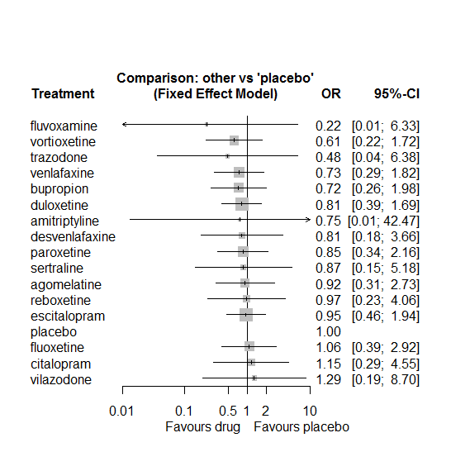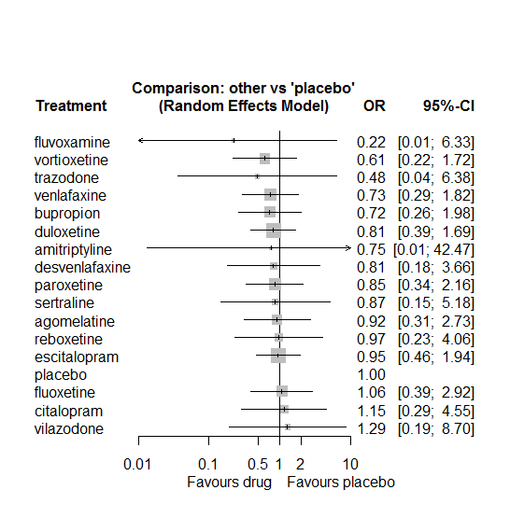

No usable evidence for the effects of any drug.

### **Ranking according to P-scores**

P-score

fluvoxamine 0.77

vortioxetine 0.65

trazodone 0.64

venlafaxine 0.57

bupropion 0.57

duloxetine 0.52

amitriptyline 0.51

desvenlafaxine 0.51

paroxetine 0.49

sertraline 0.48

agomelatine 0.45

reboxetine 0.44

escitalopram 0.43

placebo 0.39

fluoxetine 0.38

citalopram 0.36

vilazodone 0.35

### **Local inconsistency**

Percent of comparisons where there is some evidence (p-value<0.05) of disagreement between direct and indirect sources: 0. (0 out of 41 comparisons)

comparison TE seTE lower upper z p

5 agomelatine:duloxetine -0.069 2.11 -4.2 4.1 -0.033 0.97

7 agomelatine:fluoxetine 0.216 1.62 -3.0 3.4 0.134 0.89

9 agomelatine:paroxetine 0.475 1.19 -1.9 2.8 0.400 0.69

10 agomelatine:placebo -0.197 1.11 -2.4 2.0 -0.178 0.86

14 agomelatine:venlafaxine -0.248 2.13 -4.4 3.9 -0.116 0.91

35 bupropion:escitalopram 0.364 1.57 -2.7 3.4 0.232 0.82

36 bupropion:fluoxetine 0.506 1.62 -2.7 3.7 0.313 0.75

38 bupropion:paroxetine 0.214 2.13 -4.0 4.4 0.100 0.92

39 bupropion:placebo -0.448 1.34 -3.1 2.2 -0.335 0.74

43 bupropion:venlafaxine 0.049 2.12 -4.1 4.2 0.023 0.98

48 citalopram:escitalopram -0.075 1.44 -2.9 2.8 -0.052 0.96

52 citalopram:placebo -0.290 1.40 -3.0 2.5 -0.206 0.84

53 citalopram:reboxetine -0.169 2.27 -4.6 4.3 -0.075 0.94

56 citalopram:venlafaxine 0.870 1.87 -2.8 4.5 0.466 0.64

57 citalopram:vilazodone -0.505 2.18 -4.8 3.8 -0.232 0.82

59 desvenlafaxine:duloxetine -0.833 2.20 -5.2 3.5 -0.378 0.71

64 desvenlafaxine:placebo 1.022 3.64 -6.1 8.1 0.281 0.78

71 duloxetine:escitalopram 0.188 1.14 -2.0 2.4 0.166 0.87

72 duloxetine:fluoxetine -0.599 1.57 -3.7 2.5 -0.382 0.70

74 duloxetine:paroxetine -0.377 1.10 -2.5 1.8 -0.344 0.73

75 duloxetine:placebo -0.097 0.83 -1.7 1.5 -0.117 0.91

79 duloxetine:venlafaxine 0.308 1.54 -2.7 3.3 0.201 0.84

81 duloxetine:vortioxetine 0.086 1.15 -2.2 2.3 0.075 0.94

82 escitalopram:fluoxetine 0.716 1.17 -1.6 3.0 0.613 0.54

84 escitalopram:paroxetine 0.640 1.41 -2.1 3.4 0.455 0.65

85 escitalopram:placebo 0.111 0.76 -1.4 1.6 0.145 0.88

87 escitalopram:sertraline -0.136 1.88 -3.8 3.6 -0.072 0.94

89 escitalopram:venlafaxine -1.140 1.40 -3.9 1.6 -0.815 0.42

94 fluoxetine:placebo 0.283 1.03 -1.7 2.3 0.274 0.78

95 fluoxetine:reboxetine -0.115 2.22 -4.5 4.2 -0.052 0.96

98 fluoxetine:venlafaxine 0.481 1.37 -2.2 3.2 0.351 0.73

109 paroxetine:placebo 0.700 0.95 -1.2 2.6 0.737 0.46

110 paroxetine:reboxetine 0.204 1.58 -2.9 3.3 0.129 0.90

116 placebo:reboxetine -0.042 1.55 -3.1 3.0 -0.027 0.98

117 placebo:sertraline -0.409 1.88 -4.1 3.3 -0.218 0.83

118 placebo:trazodone 1.061 2.77 -4.4 6.5 0.384 0.70

119 placebo:venlafaxine -0.070 0.93 -1.9 1.8 -0.075 0.94

120 placebo:vilazodone 0.490 2.58 -4.6 5.5 0.190 0.85

121 placebo:vortioxetine -0.149 1.30 -2.7 2.4 -0.115 0.91

127 sertraline:trazodone -1.061 2.77 -6.5 4.4 -0.384 0.70

135 venlafaxine:vortioxetine 0.117 1.60 -3.0 3.2 0.073 0.94

### **League table**

Below we show the league table. Upper triangle: direct evidence. Lower triangle: NMA. An odds ratio larger than 1 in the upper triangle favors the column-defining drug. An odds ratio larger than 1 in the bottom triangle favors the row-defining drug.

|  |  |  |  |  |  |  |  |  |  |  |  |  |  |  |  |  |
| --- | --- | --- | --- | --- | --- | --- | --- | --- | --- | --- | --- | --- | --- | --- | --- | --- |
| AGOM | . | . | . | . | 1.07 [0.02; 54.13] | . | 1.02 [0.06; 16.37] | . | 1.33 [0.29; 6.09] | 0.83 [0.18; 3.89] | . | . | . | 1.01 [0.02; 51.31] | . | . |
| 1.23 [0.02; 78.10] | AMIT | . | . | . | . | . | . | . | . | . | . | . | . | 1.03 [0.02; 52.35] | . | . |
| 1.27 [0.30; 5.40] | 1.04 [0.02; 65.07] | BUPR | . | . | . | 1.03 [0.06; 16.51] | 1.00 [0.06; 16.12] | . | 1.03 [0.02; 52.57] | 0.67 [0.22; 2.03] | . | . | . | 1.03 [0.02; 52.45] | . | . |
| 0.80 [0.14; 4.46] | 0.65 [0.01; 44.40] | 0.63 [0.12; 3.39] | CITA | . | . | 1.17 [0.16; 8.32] | . | 5.14 [0.24; 108.34] | . | 0.99 [0.14; 7.06] | 1.04 [0.02; 52.68] | . | . | 3.08 [0.12; 76.83] | 0.67 [0.03; 16.52] | . |
| 1.13 [0.18; 7.18] | 0.92 [0.01; 68.24] | 0.89 [0.15; 5.43] | 1.41 [0.18; 10.80] | DESV | 0.51 [0.01; 25.60] | . | . | . | . | 0.85 [0.18; 3.98] | . | . | . | . | . | . |
| 1.14 [0.34; 3.86] | 0.93 [0.02; 54.66] | 0.89 [0.26; 3.03] | 1.42 [0.31; 6.50] | 1.01 [0.19; 5.19] | DULO | 0.99 [0.14; 7.04] | 0.46 [0.03; 7.54] | . | 0.76 [0.14; 4.04] | 0.79 [0.33; 1.88] | . | . | . | 1.44 [0.09; 23.09] | . | 1.37 [0.29; 6.40] |
| 0.97 [0.28; 3.35] | 0.79 [0.01; 46.30] | 0.76 [0.23; 2.49] | 1.21 [0.29; 4.97] | 0.86 [0.16; 4.51] | 0.85 [0.34; 2.16] | ESCI | 1.41 [0.23; 8.74] | . | 1.87 [0.16; 22.45] | 0.99 [0.41; 2.39] | . | 1.01 [0.06; 16.27] | . | 0.51 [0.04; 6.11] | . | . |
| 0.87 [0.23; 3.33] | 0.71 [0.01; 43.22] | 0.68 [0.18; 2.61] | 1.08 [0.21; 5.60] | 0.77 [0.13; 4.66] | 0.76 [0.24; 2.45] | 0.89 [0.30; 2.68] | FLUO | . | . | 1.22 [0.30; 4.88] | 1.00 [0.02; 50.73] | . | . | 2.05 [0.21; 19.78] | . | . |
| 4.12 [0.12; 136.28] | 3.36 [0.02; 611.68] | 3.24 [0.10; 105.27] | 5.14 [0.24; 108.34] | 3.64 [0.09; 142.22] | 3.62 [0.12; 109.34] | 4.25 [0.15; 122.19] | 4.76 [0.15; 152.03] | FLUV | . | . | . | . | . | . | . | . |
| 1.08 [0.34; 3.42] | 0.88 [0.01; 54.47] | 0.85 [0.23; 3.16] | 1.35 [0.27; 6.76] | 0.96 [0.16; 5.55] | 0.95 [0.33; 2.72] | 1.11 [0.38; 3.28] | 1.25 [0.34; 4.55] | 0.26 [0.01; 8.25] | PARO | 1.18 [0.33; 4.23] | 0.98 [0.10; 9.45] | . | . | . | . | . |
| 0.92 [0.31; 2.73] | 0.75 [0.01; 42.47] | 0.72 [0.26; 1.98] | 1.15 [0.29; 4.55] | 0.81 [0.18; 3.66] | 0.81 [0.39; 1.69] | 0.95 [0.46; 1.94] | 1.06 [0.39; 2.92] | 0.22 [0.01; 6.33] | 0.85 [0.34; 2.16] | PLAC | 1.02 [0.18; 5.89] | 0.99 [0.10; 9.52] | 3.01 [0.12; 74.43] | 1.32 [0.36; 4.88] | 0.84 [0.10; 6.87] | 1.58 [0.50; 5.02] |
| 0.95 [0.17; 5.33] | 0.77 [0.01; 55.31] | 0.75 [0.13; 4.21] | 1.19 [0.19; 7.51] | 0.84 [0.11; 6.68] | 0.84 [0.17; 4.03] | 0.98 [0.21; 4.64] | 1.10 [0.21; 5.88] | 0.23 [0.01; 8.14] | 0.88 [0.19; 4.10] | 1.03 [0.25; 4.32] | REBO | . | . | . | . | . |
| 1.06 [0.13; 8.47] | 0.86 [0.01; 70.68] | 0.83 [0.11; 6.41] | 1.32 [0.14; 12.22] | 0.94 [0.09; 9.66] | 0.93 [0.14; 6.32] | 1.09 [0.18; 6.82] | 1.23 [0.16; 9.28] | 0.26 [0.01; 11.19] | 0.98 [0.13; 7.21] | 1.15 [0.19; 6.86] | 1.12 [0.11; 10.89] | SERT | 1.03 [0.02; 52.90] | . | . | . |
| 1.92 [0.12; 31.54] | 1.56 [0.01; 187.81] | 1.51 [0.09; 24.10] | 2.39 [0.13; 44.31] | 1.69 [0.09; 33.71] | 1.69 [0.12; 24.66] | 1.97 [0.14; 28.15] | 2.21 [0.14; 35.28] | 0.47 [0.01; 31.66] | 1.77 [0.11; 27.50] | 2.08 [0.16; 27.62] | 2.02 [0.11; 38.61] | 1.81 [0.12; 27.09] | TRAZ | . | . | . |
| 1.26 [0.33; 4.78] | 1.03 [0.02; 52.35] | 0.99 [0.27; 3.62] | 1.57 [0.34; 7.26] | 1.11 [0.19; 6.42] | 1.11 [0.38; 3.26] | 1.30 [0.45; 3.71] | 1.45 [0.43; 4.90] | 0.31 [0.01; 9.26] | 1.16 [0.34; 4.04] | 1.37 [0.55; 3.39] | 1.32 [0.25; 6.97] | 1.19 [0.16; 8.63] | 0.66 [0.04; 10.13] | VENL | . | 1.30 [0.08; 20.94] |
| 0.71 [0.08; 6.36] | 0.58 [0.01; 49.93] | 0.56 [0.07; 4.83] | 0.89 [0.11; 7.43] | 0.63 [0.06; 7.16] | 0.63 [0.08; 4.81] | 0.74 [0.10; 5.49] | 0.82 [0.10; 7.05] | 0.17 [0.00; 7.10] | 0.66 [0.08; 5.45] | 0.77 [0.11; 5.22] | 0.75 [0.07; 7.91] | 0.67 [0.05; 9.11] | 0.37 [0.02; 9.24] | 0.57 [0.07; 4.58] | VILA | . |
| 1.50 [0.35; 6.50] | 1.22 [0.02; 76.44] | 1.18 [0.28; 4.92] | 1.87 [0.34; 10.21] | 1.32 [0.22; 8.13] | 1.32 [0.43; 4.05] | 1.54 [0.46; 5.24] | 1.73 [0.42; 7.09] | 0.36 [0.01; 11.91] | 1.39 [0.36; 5.34] | 1.63 [0.58; 4.56] | 1.58 [0.27; 9.08] | 1.41 [0.18; 11.03] | 0.78 [0.05; 12.63] | 1.19 [0.33; 4.30] | 2.10 [0.24; 18.28] | VORT |

### **Estimated event rates**

For an event rate in placebo equal to the average event rate (i.e. fixed to 0.000444) the estimated event rates for each drug are as follows

drug rate

1 agomelatine 0.00041 [0.000138, 0.001211]

2 amitriptyline 0.000334 [0.000006, 0.018539]

3 bupropion 0.000322 [0.000118, 0.000881]

4 citalopram 0.000511 [0.000129, 0.002018]

5 desvenlafaxine 0.000362 [0.000081, 0.001626]

6 duloxetine 0.00036 [0.000173, 0.00075]

7 escitalopram 0.000422 [0.000207, 0.000862]

8 fluoxetine 0.000473 [0.000172, 0.001299]

9 fluvoxamine 0.000099 [0.000004, 0.002809]

10 paroxetine 0.000379 [0.00015, 0.000958]

12 reboxetine 0.000431 [0.000103, 0.001801]

13 sertraline 0.000386 [0.000065, 0.002297]

14 trazodone 0.000214 [0.000016, 0.00283]

15 venlafaxine 0.000325 [0.000131, 0.000807]

16 vilazodone 0.000574 [0.000085, 0.003853]

17 vortioxetine 0.000273 [0.000097, 0.000766]

### **Additional sensitivity analyses**

No other analyses were performed due to the low amount of information in the studies.

# **Aggression**

We remove all arms for which dose range was not “Licenced”. After this:

* Removed 2 one-arm studies: Sacchetti2002 (BRL-29060/109), Study 032a (CTN032-FCE20124)
* Total number of arms 38. Total number of studies 17
* Total events in placebo 36, out of a total of 1121 patients. Event rate placebo 0.032.
* Total events in drugs 148, out of a total of 3189 patients. Event rate drugs 0.046.

## **Distribution of dose across drugs**

Here we count the number of arms per drug, and the percent of these arms where Dose_intended_min was equal to the minimum licensed dose or lower. The values we used as minimum licensed dose are as follows:

agomelatine: 25; amitriptyline: 75; bupropion:300; citalopram:20; clomipramine:30; desvenlafaxine:50; duloxetine:40; escitalopram:10; fluoxetine:20; fluvoxamine:50; levomilnacipran:40; milnacipran:50; mirtazapine:15; nefazodone:300; paroxetine:20; reboxetine:8; sertraline:50; trazodone:150; venlafaxine:75; vilazodone:20; vortioxetine:5

Drug number.arms percent.low.dose

1 sertraline 4 1.0

2 fluoxetine 4 1.0

3 reboxetine 10 0.9

4 paroxetine 2 1.0

6 fluvoxamine 1 1.0

7 amitriptyline 2 1.0

8 venlafaxine 1 1.0

9 trazodone 1 1.0

10 escitalopram 1 0.0

11 citalopram 1 0.0

## **Network graph**

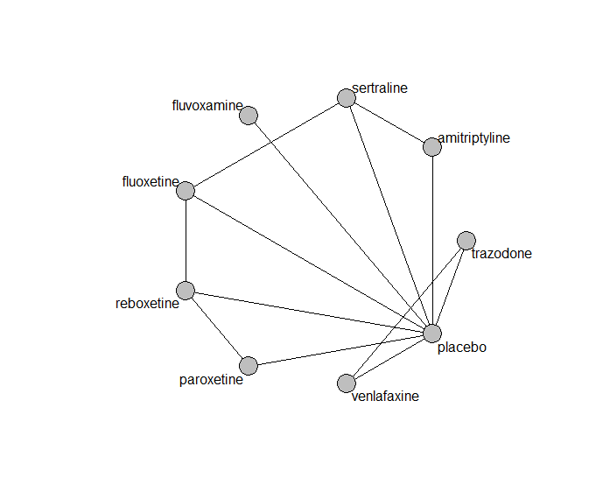

## **Pairwise MA**

### **Grouping all drugs together, comparison vs. placebo**

Number of studies: 11

Fixed effects meta-analysis: OR=1.47. 95% CI 0.98 to 2.21

Random effects meta-analysis: OR=1.43. 95% CI 0.94 to 2.19

Heterogeneity (tau squared) was estimated to be 0

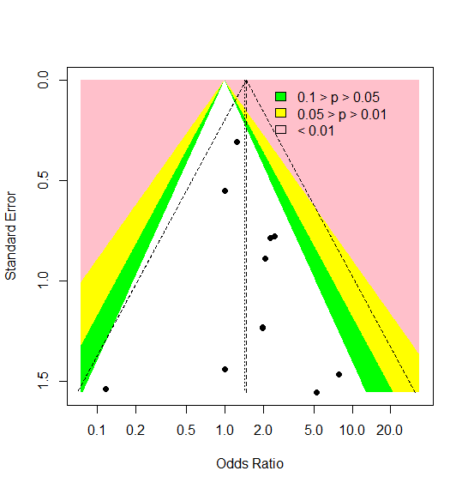

No evidence of asymmetry (Harbord’s test p-value=0.6)

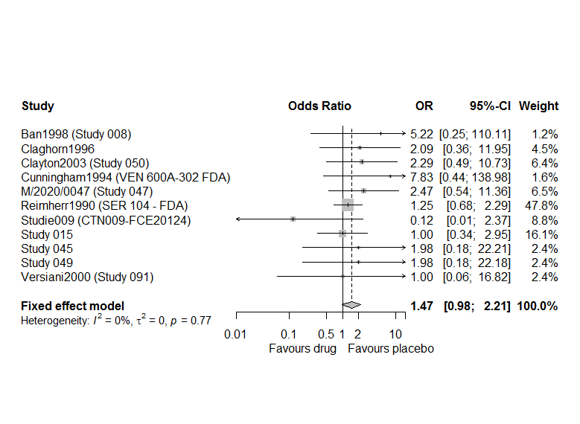

### **Meta-analyses of comparisons with 10 or more studies**

We show results from pairwise comparisons informed by 10 studies or more. An OR larger than 1 favors the first treatment in the comparison.

No meta-analyses had 10 studies or more

## **Assessment of transitivity**

comparison studies baseline_SD age_SD female

1 fluoxetine - sertraline 2 24 (1.4) 54 (5.9) NaN (NA)

2 paroxetine - reboxetine 2 22 (2.1) 41 (3.5) 0.69 (0.1)

3 placebo - reboxetine 8 25 (3.8) 42 (3.1) 0.61 (0.09)

4 fluoxetine - reboxetine 2 24 (1.6) 42 (2.6) 0.67 (0.06)

5 fluvoxamine - placebo 1 23 (NA) 39 (NA) NaN (NA)

6 fluoxetine - placebo 1 23 (NA) 40 (NA) 0.63 (NA)

7 amitriptyline - sertraline 2 24 (1.1) 55 (22.2) 0.48 (NA)

8 placebo - trazodone 1 22 (NA) 41 (NA) 0.66 (NA)

9 placebo - venlafaxine 1 22 (NA) 41 (NA) 0.66 (NA)

10 trazodone - venlafaxine 1 22 (NA) 41 (NA) 0.66 (NA)

11 paroxetine - placebo 1 21 (NA) 39 (NA) 0.76 (NA)

12 citalopram - escitalopram 1 28 (NA) 45 (NA) NaN (NA)

13 amitriptyline - placebo 1 23 (NA) 39 (NA) NaN (NA)

14 placebo - sertraline 1 23 (NA) 39 (NA) NaN (NA)

## **NMA**

A total of 7 treatments are included in the network.

A total of 615 studies are included in this analysis.

Wi fit the Mantel-Haenszel model (primary analysis) and also the non-central hypergeometric model (fixed effects), the fixed effects inverse variance and the random effects inverse variance NMA model.

Global test for inconsistency, p-value 0.35 (Q=6.8, d.o.f. 6).

For the random effects NMA model:

Estimated heterogeneity tau-squared 0

Global test for inconsistency, p-value 0.37 (Q=6,d.o.f.6).

### **Comparison vs. placebo**

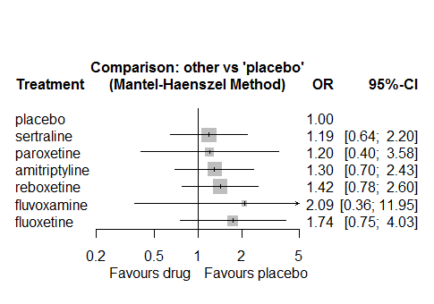 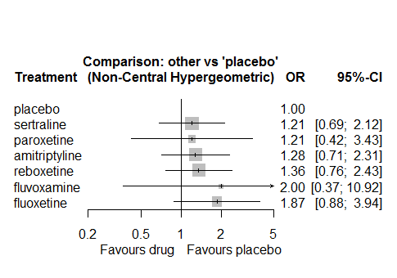

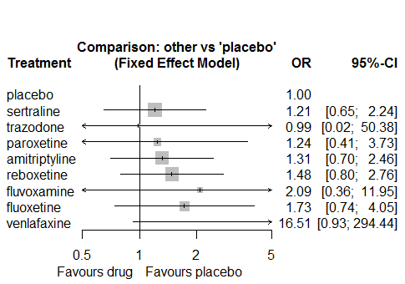 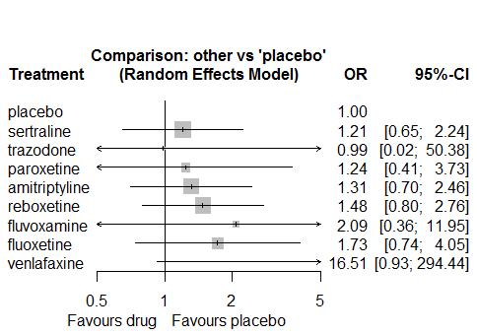

No strong eveidence for any drug

### **Ranking according to P-scores**

P-score

placebo 0.78

sertraline 0.61

paroxetine 0.58

amitriptyline 0.51

reboxetine 0.43

fluvoxamine 0.31

fluoxetine 0.29

### **Local inconsistency**

No evidence of inconsistency using the SIDDE approach

comparison k nma direct indir. RoR z p-value

amitriptyline:fluoxetine 0 0.7487 . . . . .

amitriptyline:fluvoxamine 0 0.6243 . . . . .

amitriptyline:paroxetine 0 1.0843 . . . . .

amitriptyline:placebo 1 1.3028 1.4289 0.8912 1.6033 0.49 0.6261

amitriptyline:reboxetine 0 0.9150 . . . . .

amitriptyline:sertraline 2 1.0942 1.0865 . . . .

fluoxetine:fluvoxamine 0 0.8338 . . . . .

fluoxetine:paroxetine 0 1.4483 . . . . .

fluoxetine:placebo 1 1.7402 1.5102 2.4682 0.6119 -0.47 0.6416

fluoxetine:reboxetine 2 1.2221 1.3681 1.3885 0.9853 -0.02 0.9860

fluoxetine:sertraline 2 1.4615 1.4862 1.4046 1.0581 0.07 0.9477

fluvoxamine:paroxetine 0 1.7369 . . . . .

fluvoxamine:placebo 1 2.0870 2.0870 . . . .

fluvoxamine:reboxetine 0 1.4657 . . . . .

fluvoxamine:sertraline 0 1.7528 . . . . .

paroxetine:placebo 1 1.2015 1.9535 1.2119 1.6119 0.38 0.7012

paroxetine:reboxetine 2 0.8438 0.7539 . . . .

paroxetine:sertraline 0 1.0091 . . . . .

placebo:reboxetine 8 0.7023 0.6528 3.7296 0.1750 -1.38 0.1689

placebo:sertraline 1 0.8399 0.9255 0.8808 1.0507 0.06 0.9545

reboxetine:sertraline 0 1.1959 . . . . .

No evidence of inconsistency using the back-calculation method (results not shown)

### **League table**

Below we show the league table. Upper triangle: direct evidence. Lower triangle: NMA. An odds ratio larger than 1 in the upper triangle favors the column-defining drug. An odds ratio larger than 1 in the bottom triangle favors the row-defining drug.

|  |  |  |  |  |  |  |
| --- | --- | --- | --- | --- | --- | --- |
| AMIT | . | . | . | 1.43 [0.73; 2.80] | . | 1.09 [0.65; 1.83] |
| 0.75 [0.31; 1.80] | FLUO | . | . | 1.51 [0.25; 9.17] | 1.37 [0.51; 3.66] | 1.49 [0.59; 3.72] |
| 0.62 [0.10; 3.98] | 0.83 [0.12; 5.78] | FLUV | . | 2.09 [0.36; 11.95] | . | . |
| 1.08 [0.32; 3.73] | 1.45 [0.40; 5.23] | 1.74 [0.22; 13.61] | PARO | 1.95 [0.35; 10.76] | 0.75 [0.28; 2.04] | . |
| 1.30 [0.70; 2.43] | 1.74 [0.75; 4.03] | 2.09 [0.36; 11.95] | 1.20 [0.40; 3.58] | PLAC | 0.65 [0.35; 1.21] | 0.93 [0.46; 1.87] |
| 0.91 [0.40; 2.09] | 1.22 [0.51; 2.94] | 1.47 [0.23; 9.29] | 0.84 [0.32; 2.23] | 0.70 [0.38; 1.28] | REBO | . |
| 1.09 [0.65; 1.84] | 1.46 [0.68; 3.16] | 1.75 [0.28; 11.15] | 1.01 [0.30; 3.41] | 0.84 [0.45; 1.55] | 1.20 [0.54; 2.66] | SERT |

### **Estimated event rates**

For an event rate in placebo equal to the average event rate (i.e. fixed to 0.03) the estimated event rates for each drug are as follows

drug rate

1 amitriptyline 0.04 [0.02, 0.07]

2 fluoxetine 0.05 [0.02, 0.12]

3 fluvoxamine 0.06 [0.01, 0.28]

4 paroxetine 0.04 [0.01, 0.11]

6 reboxetine 0.05 [0.03, 0.08]

7 sertraline 0.04 [0.02, 0.07]

### **Additional sensitivity analyses**

No other analyses were performed due to the low amount of information in the studies.

# **Confusional state**

We remove all arms for which dose range was not “Licenced”. After this:

* Removed 2 one-arm studies: Montgomery2004b (CL3-20098-030), Study 015
* Total number of arms 39. Total number of studies 17
* Total events in placebo 16, out of a total of 761 patients. Event rate placebo 0.021.
* Total events in drugs 72, out of a total of 2493 patients. Event rate drugs 0.029.

## **Distribution of dose across drugs**

Here we count the number of arms per drug, and the percent of these arms where Dose_intended_min was equal to the minimum licensed dose or lower. The values we used as minimum licensed dose are as follows:

agomelatine: 25; amitriptyline: 75; bupropion:300; citalopram:20; clomipramine:30; desvenlafaxine:50; duloxetine:40; escitalopram:10; fluoxetine:20; fluvoxamine:50; levomilnacipran:40; milnacipran:50; mirtazapine:15; nefazodone:300; paroxetine:20; reboxetine:8; sertraline:50; trazodone:150; venlafaxine:75; vilazodone:20; vortioxetine:5

Drug number.arms percent.low.dose

1 milnacipran 5 0.00

2 amitriptyline 6 0.33

3 fluvoxamine 3 0.00

4 fluoxetine 1 1.00

6 paroxetine 6 0.67

7 mirtazapine 1 1.00

8 trazodone 1 1.00

9 reboxetine 4 1.00

10 clomipramine 1 0.00

11 citalopram 1 1.00

12 bupropion 2 0.50

## **Network graph**

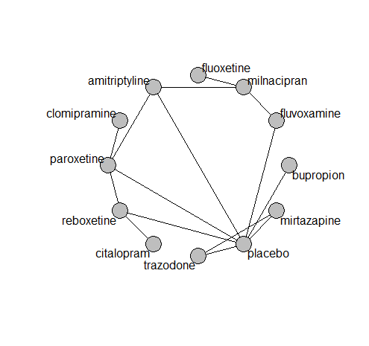

## **Pairwise MA**

### **Grouping all drugs together, comparison vs. placebo**

Number of studies: 8

Fixed effects meta-analysis (Mantel-Haenszel): OR=2.18. 95% CI 1.24 to 3.83

Random effects meta-analysis: OR=2.03. 95% CI 0.87 to 4.74

Heterogeneity (tau squared) was estimated to be 0.44

Not enough studies to assess asymmetry

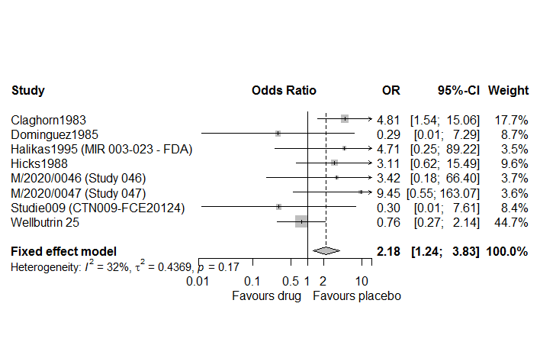

### **Meta-analyses of comparisons with 10 or more studies**

We show results from pairwise comparisons informed by 10 studies or more. An OR larger than 1 favors the first treatment in the comparison.

No meta-analyses had 10 studies or more

## **Assessment of transitivity**

comparison studies baseline_SD age_SD female

1 amitriptyline - milnacipran 1 26 (NA) 50 (NA) NaN (NA)

2 fluvoxamine - milnacipran 2 24 (0.4) 49 (2) NaN (NA)

3 fluoxetine - milnacipran 1 23 (NA) 45 (NA) NaN (NA)

4 amitriptyline - placebo 2 27 (4.2) 40 (1.7) NaN (NA)

5 fluvoxamine - placebo 1 20 (NA) NaN (NA) NaN (NA)

6 amitriptyline - paroxetine 3 24 (NA) 55 (14.5) 0.94 (0.08)

7 mirtazapine - placebo 1 22 (NA) 62 (NA) 0.54 (NA)

8 mirtazapine - trazodone 1 22 (NA) 62 (NA) 0.54 (NA)

9 placebo - trazodone 1 22 (NA) 62 (NA) 0.54 (NA)

10 paroxetine - placebo 2 20 (0.7) 39 (0.6) 0.73 (0.04)

11 paroxetine - reboxetine 2 20 (0.7) 39 (0.6) 0.73 (0.04)

12 placebo - reboxetine 3 22 (2.6) 42 (4.2) 0.71 (0.05)

13 clomipramine - paroxetine 1 24 (NA) 71 (NA) 0.89 (NA)

14 citalopram - reboxetine 1 24 (NA) 42 (NA) 0.64 (NA)

15 bupropion - placebo 1 29 (NA) 51 (NA) 0.5 (NA))

## **NMA**

A total of 12 treatments are included in the network.

A total of 17 studies are included in this analysis.

We could not fit the Mantel-Haenszel model or the non-central hypergeometric model, because of designs with zero events in some or all of their arms.

We fit only the fixed effects inverse variance and the random effects inverse variance NMA model.

Global test for inconsistency, p-value 0.46286 (Q=3,d.o.f.3)

Estimated heterogeneity tau-squared 0

### **Comparison vs. placebo**

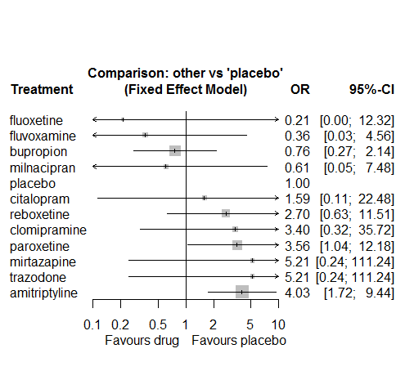 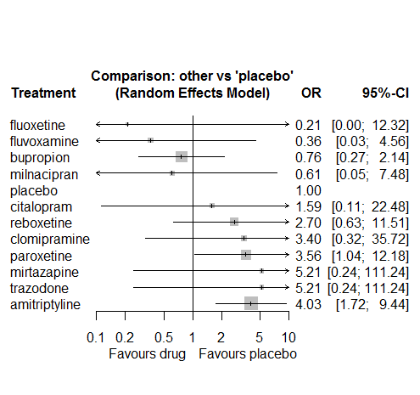

There is strong evidence against amitriptyline and also paroxetine.

### **Ranking according to P-scores**

P-score

fluoxetine 0.82

fluvoxamine 0.81

bupropion 0.72

milnacipran 0.70

placebo 0.65

citalopram 0.52

reboxetine 0.37

clomipramine 0.33

paroxetine 0.28

mirtazapine 0.27

trazodone 0.27

amitriptyline 0.25

### **Local inconsistency**

Percent of comparisons where there is some evidence (p-value<0.05) of disagreement between direct and indirect sources: 0. (0 out of 8 comparisons)

comparison TE seTE lower upper z p

6 amitriptyline:milnacipran -0.615 2.6 -5.8 4.6 -0.232 0.82

8 amitriptyline:paroxetine -0.073 1.3 -2.5 2.4 -0.058 0.95

9 amitriptyline:placebo 0.183 1.2 -2.1 2.5 0.156 0.88

46 fluvoxamine:milnacipran 0.615 2.6 -4.6 5.8 0.232 0.82

49 fluvoxamine:placebo -0.615 2.6 -5.8 4.6 -0.232 0.82

61 paroxetine:placebo 1.207 1.3 -1.4 3.8 0.916 0.36

62 paroxetine:reboxetine -1.548 1.8 -5.1 2.0 -0.855 0.39

64 placebo:reboxetine 0.942 1.5 -2.0 3.9 0.627 0.53

### **League table**

Below we show the league table. Upper triangle: direct evidence. Lower triangle: NMA. An odds ratio larger than 1 in the upper triangle favors the column-defining drug. An odds ratio larger than 1 in the bottom triangle favors the row-defining drug.

|  |  |  |  |  |  |  |  |  |  |  |  |
| --- | --- | --- | --- | --- | --- | --- | --- | --- | --- | --- | --- |
| AMIT | . | . | . | . | . | 5.36 [0.25; 115.00] | . | 1.11 [0.28; 4.43] | 4.16 [1.64; 10.53] | . | . |
| 5.28 [1.39; 20.02] | BUPR | . | . | . | . | . | . | . | 0.76 [0.27; 2.14] | . | . |
| 2.54 [0.18; 36.00] | 0.48 [0.03; 8.29] | CITA | . | . | . | . | . | . | . | 0.59 [0.06; 5.41] | . |
| 1.19 [0.12; 11.94] | 0.22 [0.02; 2.93] | 0.47 [0.02; 11.26] | CLOM | . | . | . | . | 0.96 [0.13; 7.09] | . | . | . |
| 19.33 [0.34; 1113.30] | 3.66 [0.05; 245.78] | 7.60 [0.06; 938.17] | 16.30 [0.16; 1696.12] | FLUO | . | 0.34 [0.01; 8.55] | . | . | . | . | . |
| 11.08 [0.86; 142.63] | 2.10 [0.14; 32.14] | 4.35 [0.12; 163.03] | 9.34 [0.31; 279.46] | 0.57 [0.01; 27.93] | FLUV | 0.69 [0.06; 8.38] | . | . | 0.29 [0.01; 7.29] | . | . |
| 6.65 [0.56; 78.70] | 1.26 [0.08; 19.02] | 2.61 [0.07; 94.48] | 5.61 [0.20; 160.51] | 0.34 [0.01; 8.55] | 0.60 [0.07; 5.34] | MILN | . | . | . | . | . |
| 0.77 [0.03; 18.58] | 0.15 [0.01; 3.71] | 0.30 [0.01; 17.49] | 0.65 [0.01; 31.03] | 0.04 [0.00; 6.57] | 0.07 [0.00; 3.71] | 0.12 [0.00; 6.11] | MIRT | . | 5.21 [0.24; 111.24] | . | 1.00 [0.17; 6.04] |
| 1.13 [0.36; 3.57] | 0.21 [0.04; 1.07] | 0.45 [0.04; 5.29] | 0.96 [0.13; 7.09] | 0.06 [0.00; 3.87] | 0.10 [0.01; 1.59] | 0.17 [0.01; 2.51] | 1.46 [0.05; 39.65] | PARO | 7.81 [0.97; 62.80] | 1.12 [0.35; 3.56] | . |
| 4.03 [1.72; 9.44] | 0.76 [0.27; 2.14] | 1.59 [0.11; 22.48] | 3.40 [0.32; 35.72] | 0.21 [0.00; 12.32] | 0.36 [0.03; 4.56] | 0.61 [0.05; 7.48] | 5.21 [0.24; 111.24] | 3.56 [1.04; 12.18] | PLAC | 0.55 [0.08; 3.64] | 0.19 [0.01; 4.10] |
| 1.49 [0.35; 6.34] | 0.28 [0.05; 1.67] | 0.59 [0.06; 5.41] | 1.26 [0.13; 12.36] | 0.08 [0.00; 5.55] | 0.13 [0.01; 2.36] | 0.22 [0.01; 3.76] | 1.93 [0.07; 57.06] | 1.32 [0.44; 3.94] | 0.37 [0.09; 1.58] | REBO | . |
| 0.77 [0.03; 18.58] | 0.15 [0.01; 3.71] | 0.30 [0.01; 17.49] | 0.65 [0.01; 31.03] | 0.04 [0.00; 6.57] | 0.07 [0.00; 3.71] | 0.12 [0.00; 6.11] | 1.00 [0.17; 6.04] | 0.68 [0.03; 18.53] | 0.19 [0.01; 4.10] | 0.52 [0.02; 15.36] | TRAZ |

### **Estimated event rates**

For an event rate in placebo equal to the average event rate (i.e. fixed to 0.02) the estimated event rates for each drug are as follows

drug rate

1 amitriptyline 0.08 [0.036, 0.169]

2 bupropion 0.016 [0.006, 0.044]

3 citalopram 0.033 [0.002, 0.326]

4 clomipramine 0.068 [0.007, 0.434]

5 fluoxetine 0.004 [0, 0.209]

6 fluvoxamine 0.008 [0.001, 0.089]

7 milnacipran 0.013 [0.001, 0.138]

8 mirtazapine 0.101 [0.005, 0.705]

9 paroxetine 0.071 [0.022, 0.207]

11 reboxetine 0.055 [0.013, 0.198]

12 trazodone 0.101 [0.005, 0.705]

### **Additional sensitivity analyses**

No other analyses were performed due to the low amount of information in the studies.

# **Fall**

We remove all arms for which dose range was not “Licenced”. After this:

* Total number of arms 9. Total number of studies 3
* Total events in placebo 17, out of a total of 439 patients. Event rate placebo 0.039.
* Total events in drugs 50, out of a total of 1007 patients. Event rate drugs 0.05.

## **Distribution of dose across drugs**

Here we count the number of arms per drug, and the percent of these arms where Dose_intended_min was equal to the minimum licensed dose or lower. The values we used as minimum licensed dose are as follows:

agomelatine: 25; amitriptyline: 75; bupropion:300; citalopram:20; clomipramine:30; desvenlafaxine:50; duloxetine:40; escitalopram:10; fluoxetine:20; fluvoxamine:50; levomilnacipran:40; milnacipran:50; mirtazapine:15; nefazodone:300; paroxetine:20; reboxetine:8; sertraline:50; trazodone:150; venlafaxine:75; vilazodone:20; vortioxetine:5

Drug number.arms percent.low.dose

2 vortioxetine 4 0

3 duloxetine 2 0

## **Network graph**

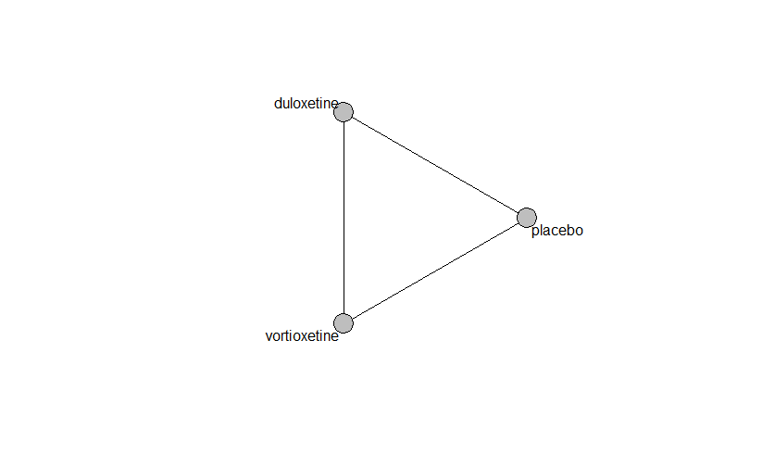

## **Pairwise MA**

### **Grouping all drugs together, comparison vs. placebo**

Number of studies: 3

Fixed effects meta-analysis (Mantel-Haenszel): OR=1.4. 95% CI 0.8 to 2.47

Random effects meta-analysis: OR=1.12. 95% CI 0.19 to 6.51

Heterogeneity (tau squared) was estimated to be 1.72

Not enough studies to assess small study effects and publication bias

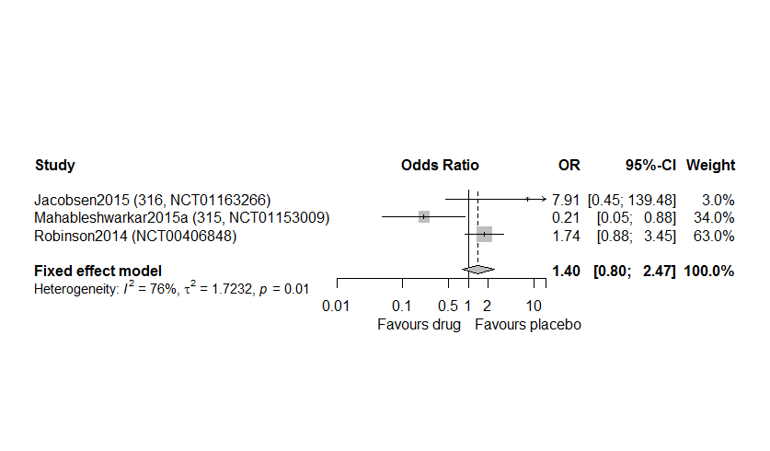

### **Meta-analyses of comparisons with 10 or more studies**

We show results from pairwise comparisons informed by 10 studies or more. An OR larger than 1 favors the first treatment in the comparison.

No meta-analyses had 10 studies or more

## **Assessment of transitivity**

comparison studies baseline_SD age_SD female

1 placebo - vortioxetine 2 25 (0) 43 (0.1) 0.73 (0.01)

2 duloxetine - placebo 2 22 (4.2) 58 (21.3) 0.68 (0.08)

3 duloxetine - vortioxetine 1 25 (NA) 43 (NA) 0.74 (NA)

## **NMA**

A total of 3 treatments are included in the network.

A total of 2 studies are included in this analysis.

We fit the Mantel-Haenszel model, the non-central hypergeometric model, and inverse variance NMA model (fixed and random)

Global test for inconsistency, p-value 0.07 (Q=3.4,d.o.f. 1) (Mantel Haenszel model)

Estimated heterogeneity tau-squared 2.43. This is quite extreme.

### **Comparison vs. placebo**

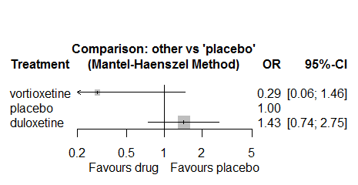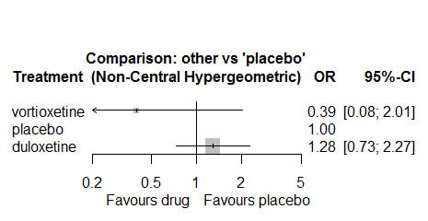

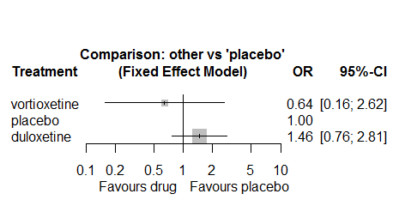 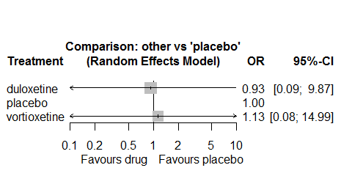

There is no strong evidence for any of the drugs. Also, heterogeneity is quite extended. Thus, no usable information can be extracted for this outcome.

### **Ranking according to P-scores**

According to our primary analysis (MH-NMA)

P-score

vortioxetine 0.95

placebo 0.46

duloxetine 0.09

### **Local inconsistency**

No evidence of local inconsistency

comparison TE seTE lower upper z p

1 duloxetine:placebo -8.1 7.0 -21.7 5.6 -1.16 0.25

2 duloxetine:vortioxetine 0.5 3.3 -5.9 6.9 0.15 0.88

3 placebo:vortioxetine 3.2 5.4 -7.3 13.8 0.60 0.55

### **League table**

Below we show the league table. Upper triangle: direct evidence. Lower triangle: NMA. An odds ratio larger than 1 in the upper triangle favors the column-defining drug. An odds ratio larger than 1 in the bottom triangle favors the row-defining drug.

|  |  |  |
| --- | --- | --- |
| DULO | 1.34 [0.72; 2.46] | 0.99 [0.09; 11.01] |
| 1.43 [0.74; 2.75] | PLAC | 4.79 [0.92; 24.98] |
| 4.93 [0.90; 26.96] | 3.45 [0.69; 17.31] | VORT |

### **Estimated event rates**

For an event rate in placebo equal to the average event rate (i.e. fixed to 0.02) the estimated event rates for each drug are as follows

drug rate

1 duloxetine 0.05 [0.03, 0.1]

3 vortioxetine 0.01 [0, 0.06]

### **Additional sensitivity analyses**

No other analyses were performed due to the low amount of information in the studies.

# **Memory impairment**

We remove all arms for which dose range was not “Licenced”. After this:

* Removed 2 one-arm studies: Montgomery2004b (CL3-20098-030), Raft1981
* Total number of arms 26. Total number of studies 11
* Total events in placebo 36, out of a total of 797 patients. Event rate placebo 0.045.
* Total events in drugs 61, out of a total of 3209 patients. Event rate drugs 0.019.

## **Distribution of dose across drugs**

Here we count the number of arms per drug, and the percent of these arms where Dose_intended_min was equal to the minimum licensed dose or lower. The values we used as minimum licensed dose are as follows:

agomelatine: 25; amitriptyline: 75; bupropion:300; citalopram:20; clomipramine:30; desvenlafaxine:50; duloxetine:40; escitalopram:10; fluoxetine:20; fluvoxamine:50; levomilnacipran:40; milnacipran:50; mirtazapine:15; nefazodone:300; paroxetine:20; reboxetine:8; sertraline:50; trazodone:150; venlafaxine:75; vilazodone:20; vortioxetine:5

Drug number.arms percent.low.dose

1 reboxetine 4 1.00

2 paroxetine 4 1.00

4 fluoxetine 2 1.00

5 sertraline 3 1.00

6 citalopram 3 0.67

7 amitriptyline 2 1.00

8 escitalopram 1 0.00

9 vortioxetine 2 0.50

## **Network graph**

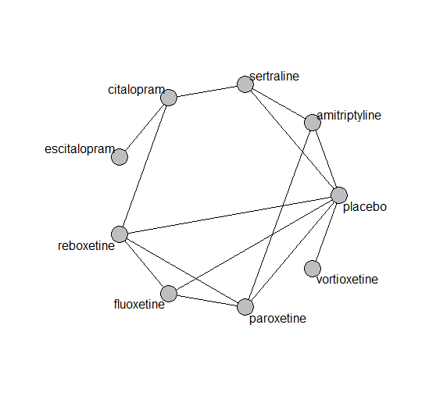

## **Pairwise MA**

### **Grouping all drugs together, comparison vs. placebo**

Number of studies: 5

Fixed effects meta-analysis (Mantel-Haenszel): OR=0.65. 95% CI 0.39 to 1.09

Random effects meta-analysis: OR=0.73. 95% CI 0.3 to 1.8

Prediction interval 0.06 to 9.16

Heterogeneity (tau squared) was estimated to be 0.42

Not enough studies to assess small study effects and publication bias

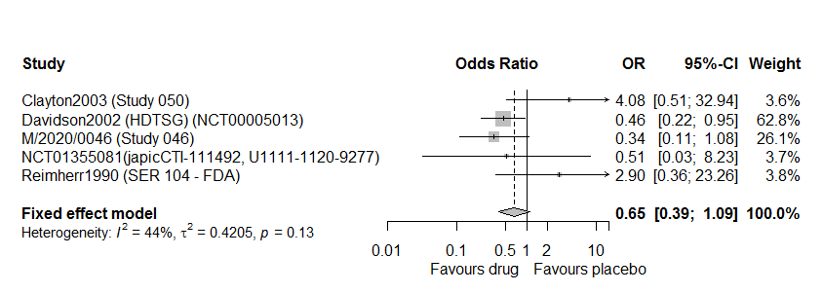

### **Meta-analyses of comparisons with 10 or more studies**

We show results from pairwise comparisons informed by 10 studies or more. An OR larger than 1 favors the first treatment in the comparison.

No meta-analyses had 10 studies or more

## **Assessment of transitivity**

comparison studies baseline_SD age_SD female

1 paroxetine - reboxetine 2 22 (2.8) 42 (3) 0.66 (0.05)

2 fluoxetine - placebo 1 23 (NA) 40 (NA) 0.63 (NA)

3 fluoxetine - reboxetine 1 23 (NA) 40 (NA) 0.63 (NA)

4 placebo - reboxetine 2 22 (2.1) 40 (0.4) 0.66 (0.05)

5 placebo - sertraline 2 23 (0.4) 40 (2.1) 0.67 (NA)

6 citalopram - sertraline 1 22 (NA) 48 (NA) NaN (NA)

7 paroxetine - placebo 1 20 (NA) 40 (NA) 0.7 (NA)

8 amitriptyline - paroxetine 1 24 (NA) 46 (NA) NaN (NA)

9 citalopram - escitalopram 1 28 (NA) 45 (NA) NaN (NA)

10 placebo - vortioxetine 1 21 (NA) 38 (NA) 0.47 (NA)

11 fluoxetine - paroxetine 1 23 (NA) 41 (NA) NaN (NA)

12 amitriptyline - placebo 1 23 (NA) 39 (NA) NaN (NA)

13 amitriptyline - sertraline 1 23 (NA) 39 (NA) NaN (NA)

14 citalopram - reboxetine 1 24 (NA) 42 (NA) 0.64 (NA)

## **NMA**

A total of 9 treatments are included in the network.

A total of 11 studies are included in this analysis.

We fit the Mantel-Haenszel model, the non-central hypergeometric model, and inverse variance NMA model (fixed and random)

Global test for inconsistency, p-value 0.15 (Q=5.3,d.o.f. 3) (Mantel Haenszel model)

For the inverse variance NMA:

Estimated heterogeneity tau-squared 0.04.

Global test for inconsistency, p-value 0.39624 (Q=6,d.o.f.6)

### **Comparison vs. placebo**

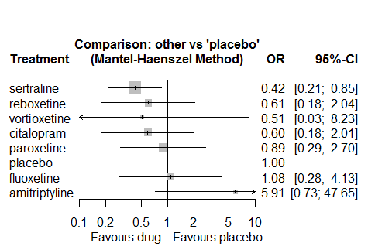 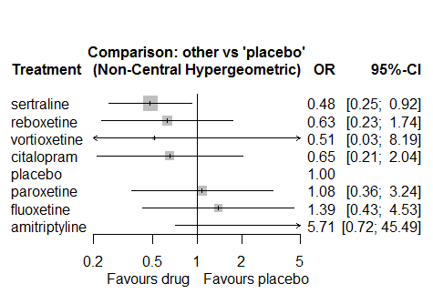

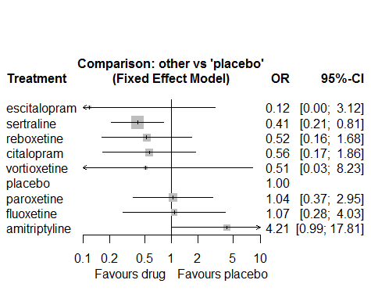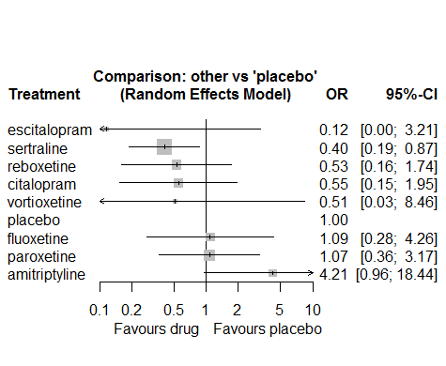

There is strong evidence in favor of sertraline. Also, weak evidence against amitriptyline.

### **Ranking according to P-scores**

According to our primary analysis (MH-NMA)

P-score

sertraline 0.82

reboxetine 0.65

vortioxetine 0.64

citalopram 0.64

paroxetine 0.46

placebo 0.38

fluoxetine 0.37

amitriptyline 0.05

### **Local inconsistency**

No evidence of local inconsistency using SIDDE

comparison k nma direct indir. RoR z p-value

amitriptyline:citalopram 0 9.8718 . . . . .

amitriptyline:fluoxetine 0 5.4565 . . . . .

amitriptyline:paroxetine 0 6.6752 . . . . .

amitriptyline:placebo 1 5.9107 5.9107 . . . .

amitriptyline:reboxetine 0 9.7680 . . . . .

amitriptyline:sertraline 0 13.9222 . . . . .

amitriptyline:vortioxetine 0 11.5812 . . . . .

citalopram:fluoxetine 0 0.5527 . . . . .

citalopram:paroxetine 0 0.6762 . . . . .

citalopram:placebo 0 0.5987 . . . . .

citalopram:reboxetine 1 0.9895 0.6342 1.8431 0.3441 -0.78 0.4340

citalopram:sertraline 1 1.4103 1.7772 0.6115 2.9064 0.78 0.4340

citalopram:vortioxetine 0 1.1732 . . . . .

fluoxetine:paroxetine 1 1.2234 0.6333 2.6230 0.2415 -1.04 0.2991

fluoxetine:placebo 1 1.0832 5.1379 0.3964 12.9609 1.63 0.1033

fluoxetine:reboxetine 1 1.7902 1.6897 1.0244 1.6495 0.33 0.7394

fluoxetine:sertraline 0 2.5515 . . . . .

fluoxetine:vortioxetine 0 2.1225 . . . . .

paroxetine:placebo 1 0.8855 0.5473 5.8605 0.0934 -1.64 0.1019

paroxetine:reboxetine 1 1.4633 4.0460 2.9777 1.3588 0.19 0.8500

paroxetine:sertraline 0 2.0857 . . . . .

paroxetine:vortioxetine 0 1.7350 . . . . .

placebo:reboxetine 2 1.6526 2.0469 . . . .

placebo:sertraline 1 2.3554 2.1778 6.3295 0.3441 -0.78 0.4340

placebo:vortioxetine 1 1.9593 1.9593 . . . .

reboxetine:sertraline 0 1.4253 . . . . .

reboxetine:vortioxetine 0 1.1856 . . . . .

sertraline:vortioxetine 0 0.8319 . . . . .

### **League table**

Below we show the league table. Upper triangle: direct evidence. Lower triangle: NMA. An odds ratio larger than 1 in the upper triangle favors the column-defining drug. An odds ratio larger than 1 in the bottom triangle favors the row-defining drug.

|  |  |  |  |  |  |  |  |
| --- | --- | --- | --- | --- | --- | --- | --- |
| AMIT | . | . | . | 5.91 [0.73; 47.65] | . | . | . |
| 9.87 [0.88; 110.36] | CITA | . | . | . | 0.63 [0.11; 3.56] | 1.78 [0.51; 6.17] | . |
| 5.46 [0.46; 65.13] | 0.55 [0.11; 2.74] | FLUO | 0.63 [0.10; 3.93] | 5.14 [0.59; 44.51] | 1.69 [0.40; 7.20] | . | . |
| 6.68 [0.63; 71.15] | 0.68 [0.14; 3.18] | 1.22 [0.32; 4.66] | PARO | 0.55 [0.16; 1.89] | 4.05 [0.45; 36.44] | . | . |
| 5.91 [0.73; 47.65] | 0.60 [0.18; 2.01] | 1.08 [0.28; 4.13] | 0.89 [0.29; 2.70] | PLAC | 2.05 [0.62; 6.81] | 2.18 [1.06; 4.49] | 1.96 [0.12; 31.59] |
| 9.77 [0.87; 109.37] | 0.99 [0.26; 3.70] | 1.79 [0.51; 6.23] | 1.46 [0.36; 5.88] | 1.65 [0.49; 5.58] | REBO | . | . |
| 13.92 [1.54; 125.71] | 1.41 [0.47; 4.24] | 2.55 [0.60; 10.87] | 2.09 [0.58; 7.53] | 2.36 [1.17; 4.73] | 1.43 [0.39; 5.17] | SERT | . |
| 11.58 [0.36; 374.59] | 1.17 [0.06; 24.37] | 2.12 [0.10; 46.45] | 1.73 [0.09; 34.70] | 1.96 [0.12; 31.59] | 1.19 [0.06; 24.66] | 0.83 [0.05; 14.62] | VORT |

### **Estimated event rates**

For an event rate in placebo equal to the average event rate (i.e. fixed to 0.05) the estimated event rates for each drug are as follows

drug rate

1 amitriptyline 0.22 [0.03, 0.69]

2 citalopram 0.03 [0.01, 0.09]

3 fluoxetine 0.05 [0.01, 0.16]

4 paroxetine 0.04 [0.01, 0.11]

6 reboxetine 0.03 [0.01, 0.09]

7 sertraline 0.02 [0.01, 0.04]

8 vortioxetine 0.02 [0, 0.28]

### **Additional sensitivity analyses**

No other analyses were performed due to the low amount of information in the studies.

# **Suicidal ideation/behavior or self harm**

A single study provided information on this outcome:

Wang2015 (NCT01571453, KCT0000432, 13926A)

No meta-analysis was performed

# **Weight decreased**

We remove all arms for which dose range was not “Licenced”. After this:

* Removed 2 one-arm studies: Masco1985, Halikas1995 (MIR 003-023 - FDA)
* Total number of arms 124. Total number of studies 52.
* Total events in placebo 121, out of a total of 4436 patients. Event rate placebo 0.027.
* Total events in drugs 519, out of a total of 12443 patients. Event rate drugs 0.042.

## **Distribution of dose across drugs**

Here we count the number of arms per drug, and the percent of these arms where Dose_intended_min was equal to the minimum licensed dose or lower. The values we used as minimum licensed dose are as follows:

agomelatine: 25; amitriptyline: 75; bupropion:300; citalopram:20; clomipramine:30; desvenlafaxine:50; duloxetine:40; escitalopram:10; fluoxetine:20; fluvoxamine:50; levomilnacipran:40; milnacipran:50; mirtazapine:15; nefazodone:300; paroxetine:20; reboxetine:8; sertraline:50; trazodone:150; venlafaxine:75; vilazodone:20; vortioxetine:5

Drug number.arms percent.low.dose

1 bupropion 6 1.00

3 vortioxetine 9 0.67

4 venlafaxine 7 0.86

5 mirtazapine 1 0.00

6 fluoxetine 13 0.92

7 milnacipran 4 0.00

8 amitriptyline 3 0.33

9 fluvoxamine 3 0.00

10 reboxetine 8 1.00

11 paroxetine 9 1.00

12 duloxetine 8 0.12

13 citalopram 5 0.80

14 desvenlafaxine 5 0.80

15 trazodone 3 1.00

16 sertraline 6 1.00

17 escitalopram 1 1.00

18 agomelatine 2 0.50

## **Network graph**

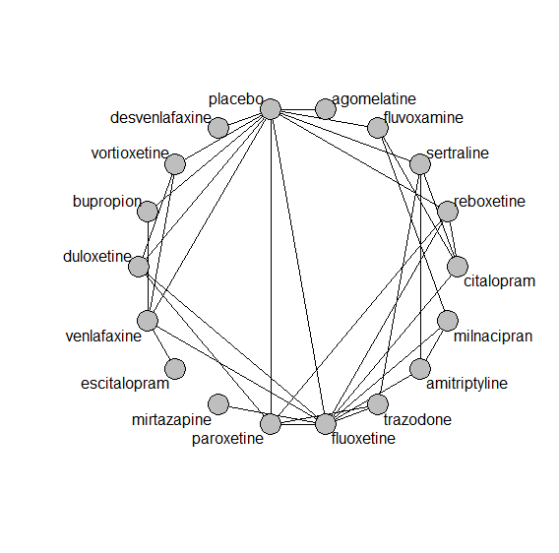

## **Pairwise MA**

### **Grouping all drugs together, comparison vs. placebo**

Number of studies: 29

Fixed effects meta-analysis (Mantel-Haenszel): OR=1.68. 95% CI 1.32 to 2.15

Random effects meta-analysis: OR=1.6. 95% CI 1.24 to 2.06

Prediction interval 1.22 to 2.09

Heterogeneity (tau squared) was estimated to be 0 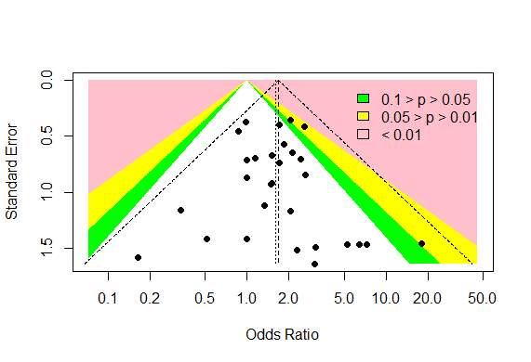

No evidence of an asymmetry (Harbord’s test p-value =0.9)

### **Meta-analyses of comparisons with 10 or more studies**

We show results from pairwise comparisons informed by 10 studies or more. An OR larger than 1 favors the first treatment in the comparison.

No comparisons had 10 studies or more

## **Assessment of transitivity**

comparison studies baseline_SD age_SD female

1 bupropion - placebo 4 24 (1.9) 39 (1.9) 0.45 (0.33)

2 placebo - venlafaxine 4 22 (1.3) 50 (13.9) 0.62 (NA)

3 placebo - vortioxetine 4 21 (0.1) 42 (2.8) 0.6 (0.09)

4 venlafaxine - vortioxetine 1 22 (NA) 43 (NA) 0.62 (NA)

5 fluoxetine - mirtazapine 1 26 (NA) 36 (NA) NaN (NA)

6 amitriptyline - milnacipran 1 26 (NA) 50 (NA) NaN (NA)

7 fluvoxamine - milnacipran 1 24 (NA) 48 (NA) NaN (NA)

8 fluoxetine - milnacipran 1 23 (NA) 45 (NA) NaN (NA)

9 paroxetine - reboxetine 3 22 (2.1) 41 (2.7) 0.69 (0.07)

10 duloxetine - placebo 6 20 (1.4) 43 (1.6) 0.66 (0.04)

11 duloxetine - vortioxetine 2 NaN (NA) 44 (1.5) 0.66 (0.04)

12 placebo - reboxetine 6 23 (2.2) 42 (3.1) 0.65 (0.08)

13 citalopram - fluoxetine 2 24 (1.1) 43 (1.1) NaN (NA)

14 amitriptyline - fluoxetine 1 24 (NA) 40 (NA) NaN (NA)

15 fluoxetine - placebo 3 21 (2.3) 51 (17.6) 0.63 (NA)

16 fluoxetine - reboxetine 1 23 (NA) 40 (NA) 0.63 (NA)

17 desvenlafaxine - placebo 5 23 (0.4) 44 (5.5) 0.7 (0.17)

18 fluoxetine - trazodone 1 21 (NA) 37 (NA) NaN (NA)

19 duloxetine - paroxetine 2 20 (0.7) 44 (1.3) NaN (NA)

20 paroxetine - placebo 4 20 (0.6) 42 (3.1) 0.73 (0.04)

21 fluoxetine - paroxetine 3 24 (0.9) 43 (1.8) NaN (NA)

22 citalopram - sertraline 1 22 (NA) 48 (NA) NaN (NA)

23 duloxetine - fluoxetine 1 18 (NA) 41 (NA) NaN (NA)

24 fluoxetine - venlafaxine 2 22 (1.6) 55 (22.1) NaN (NA)

25 fluvoxamine - placebo 1 24 (NA) 45 (NA) NaN (NA)

26 amitriptyline - sertraline 1 24 (NA) 48 (NA) NaN (NA)

27 escitalopram - venlafaxine 1 20 (NA) 48 (NA) NaN (NA)

28 sertraline - trazodone 1 22 (NA) 46 (NA) 0.65 (NA)

29 placebo - sertraline 3 23 (2.3) 51 (16.8) 0.6 (0.05)

30 agomelatine - placebo 1 27 (NA) 43 (NA) 0.65 (NA)

31 citalopram - reboxetine 1 24 (NA) 42 (NA) 0.64 (NA)

32 bupropion - venlafaxine 1 24 (NA) 37 (NA) NaN (NA)

33 citalopram - fluvoxamine 1 24 (NA) NaN (NA) NaN (NA)

34 paroxetine - trazodone 1 24 (NA) 39 (NA) NaN (NA)

## **NMA**

A total of 18 treatments are included in the network..

A total of 52 studies are included in this analysis.

Estimated heterogeneity tau-squared 0.00

Global test for inconsistency, p-value 0.74189 (Q=19,d.o.f.24)

### **Comparison vs. placebo**

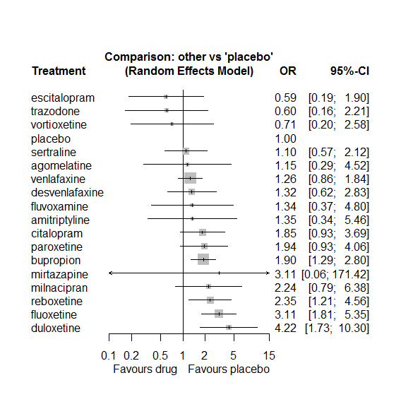

### **Ranking according to P-scores**

P-score

escitalopram 0.85

trazodone 0.84

vortioxetine 0.79

placebo 0.73

sertraline 0.67

agomelatine 0.60

venlafaxine 0.60

desvenlafaxine 0.56

fluvoxamine 0.56

amitriptyline 0.55

citalopram 0.38

paroxetine 0.37

bupropion 0.36

mirtazapine 0.36

milnacipran 0.30

reboxetine 0.26

fluoxetine 0.13

duloxetine 0.09

### **Local inconsistency**

Percent of comparisons where there is some evidence (p-value<0.05) of disagreement between direct and indirect sources: 0. (0 out of 30 comparisons)

comparison TE seTE lower upper z p

23 amitriptyline:fluoxetine -2.056 1.70 -5.38 1.27 -1.212 0.225

25 amitriptyline:milnacipran 0.301 1.39 -2.43 3.03 0.217 0.829

30 amitriptyline:sertraline 1.733 1.76 -1.72 5.18 0.984 0.325

43 bupropion:placebo -0.436 0.44 -1.31 0.43 -0.982 0.326

47 bupropion:venlafaxine 0.436 0.44 -0.43 1.31 0.982 0.326

52 citalopram:fluoxetine 0.077 0.66 -1.22 1.37 0.116 0.907

53 citalopram:fluvoxamine -0.355 2.13 -4.52 3.81 -0.167 0.867

58 citalopram:reboxetine -2.001 1.08 -4.12 0.12 -1.852 0.064

59 citalopram:sertraline 0.821 0.71 -0.58 2.22 1.152 0.249

77 duloxetine:fluoxetine -0.436 1.36 -3.10 2.22 -0.322 0.748

81 duloxetine:paroxetine -0.101 1.05 -2.16 1.96 -0.096 0.924

82 duloxetine:placebo -0.299 0.99 -2.24 1.64 -0.302 0.763

87 duloxetine:vortioxetine 0.784 1.52 -2.20 3.77 0.515 0.607

100 fluoxetine:milnacipran -1.097 1.09 -3.24 1.05 -1.002 0.316

102 fluoxetine:paroxetine -0.081 0.78 -1.61 1.45 -0.104 0.917

103 fluoxetine:placebo -0.287 0.68 -1.61 1.04 -0.424 0.671

104 fluoxetine:reboxetine -0.071 0.80 -1.65 1.51 -0.088 0.930

106 fluoxetine:trazodone 2.222 1.48 -0.68 5.12 1.500 0.134

107 fluoxetine:venlafaxine -0.082 0.56 -1.18 1.01 -0.146 0.884

109 fluvoxamine:milnacipran 1.586 1.44 -1.25 4.42 1.098 0.272

112 fluvoxamine:placebo -2.525 1.74 -5.93 0.88 -1.455 0.146

133 paroxetine:placebo 0.145 0.76 -1.35 1.64 0.190 0.849

134 paroxetine:reboxetine 0.217 0.78 -1.32 1.75 0.277 0.782

136 paroxetine:trazodone -2.850 1.81 -6.39 0.69 -1.577 0.115

139 placebo:reboxetine 0.771 0.75 -0.69 2.23 1.033 0.302

140 placebo:sertraline -1.158 0.71 -2.54 0.23 -1.637 0.102

142 placebo:venlafaxine -0.423 0.40 -1.20 0.36 -1.065 0.287

143 placebo:vortioxetine 0.734 1.39 -2.00 3.47 0.527 0.599

148 sertraline:trazodone -0.646 2.14 -4.84 3.55 -0.302 0.763

153 venlafaxine:vortioxetine -0.803 1.35 -3.46 1.85 -0.594 0.553

### **League table**

Below we show the league table. Upper triangle: direct evidence. Lower triangle: NMA. An odds ratio larger than 1 in the upper triangle favors the column-defining drug. An odds ratio larger than 1 in the bottom triangle favors the row-defining drug.

|  |  |  |  |  |  |  |  |  |  |  |  |  |  |  |  |  |  |
| --- | --- | --- | --- | --- | --- | --- | --- | --- | --- | --- | --- | --- | --- | --- | --- | --- | --- |
| AGOM | . | . | . | . | . | . | . | . | . | . | . | 1.15 [0.29; 4.52] | . | . | . | . | . |
| 0.85 [0.12; 6.00] | AMIT | . | . | . | . | . | 0.08 [0.00; 1.64] | . | 0.65 [0.17; 2.49] | . | . | . | . | 4.76 [0.23; 100.10] | . | . | . |
| 0.61 [0.15; 2.51] | 0.71 [0.17; 2.99] | BUPR | . | . | . | . | . | . | . | . | . | 1.68 [1.06; 2.66] | . | . | . | 1.84 [1.02; 3.33] | . |
| 0.62 [0.14; 2.88] | 0.73 [0.18; 3.02] | 1.03 [0.48; 2.22] | CITA | . | . | . | 0.61 [0.30; 1.25] | 1.01 [0.02; 51.32] | . | . | . | . | 0.15 [0.02; 1.05] | 2.23 [0.98; 5.05] | . | . | . |
| 0.87 [0.18; 4.15] | 1.02 [0.21; 5.00] | 1.43 [0.61; 3.36] | 1.40 [0.50; 3.89] | DESV | . | . | . | . | . | . | . | 1.32 [0.62; 2.83] | . | . | . | . | . |
| 0.27 [0.05; 1.39] | 0.32 [0.06; 1.62] | 0.45 [0.17; 1.18] | 0.44 [0.15; 1.29] | 0.31 [0.10; 1.01] | DULO | . | 0.94 [0.08; 10.77] | . | . | . | 2.04 [0.41; 10.14] | 3.86 [1.33; 11.21] | . | . | . | . | 9.64 [0.92; 100.76] |
| 1.94 [0.32; 11.66] | 2.28 [0.38; 13.55] | 3.20 [0.98; 10.41] | 3.11 [0.84; 11.58] | 2.23 [0.56; 8.93] | 7.11 [1.67; 30.32] | ESCI | . | . | . | . | . | . | . | . | . | 0.47 [0.16; 1.42] | . |
| 0.37 [0.09; 1.61] | 0.44 [0.12; 1.64] | 0.61 [0.33; 1.14] | 0.59 [0.33; 1.08] | 0.43 [0.17; 1.08] | 1.36 [0.51; 3.60] | 0.19 [0.06; 0.65] | FLUO | . | 1.05 [0.35; 3.11] | 1.00 [0.02; 53.12] | 1.52 [0.45; 5.09] | 2.48 [0.77; 8.04] | 1.26 [0.33; 4.78] | . | 8.50 [2.15; 33.62] | 2.39 [1.17; 4.88] | . |
| 0.86 [0.13; 5.60] | 1.01 [0.24; 4.33] | 1.42 [0.38; 5.33] | 1.38 [0.37; 5.11] | 0.99 [0.22; 4.39] | 3.16 [0.69; 14.52] | 0.44 [0.08; 2.43] | 2.33 [0.69; 7.83] | FLUV | 0.72 [0.27; 1.87] | . | . | 0.16 [0.01; 3.64] | . | . | . | . | . |
| 0.51 [0.09; 2.87] | 0.60 [0.19; 1.94] | 0.85 [0.28; 2.53] | 0.82 [0.28; 2.42] | 0.59 [0.16; 2.15] | 1.88 [0.50; 7.13] | 0.27 [0.06; 1.22] | 1.39 [0.54; 3.55] | 0.60 [0.24; 1.47] | MILN | . | . | . | . | . | . | . | . |
| 0.37 [0.01; 25.60] | 0.44 [0.01; 28.68] | 0.61 [0.01; 34.05] | 0.59 [0.01; 33.00] | 0.43 [0.01; 25.19] | 1.36 [0.02; 81.16] | 0.19 [0.00; 12.21] | 1.00 [0.02; 53.12] | 0.43 [0.01; 27.33] | 0.72 [0.01; 42.69] | MIRT | . | . | . | . | . | . | . |
| 0.59 [0.13; 2.80] | 0.70 [0.16; 3.12] | 0.98 [0.43; 2.21] | 0.95 [0.39; 2.30] | 0.68 [0.24; 1.96] | 2.17 [0.79; 5.96] | 0.31 [0.08; 1.18] | 1.60 [0.76; 3.35] | 0.69 [0.17; 2.77] | 1.15 [0.36; 3.74] | 1.60 [0.03; 90.98] | PARO | 2.12 [0.67; 6.69] | 0.88 [0.38; 2.04] | . | 0.31 [0.01; 7.70] | . | . |
| 1.15 [0.29; 4.52] | 1.35 [0.34; 5.46] | 1.90 [1.29; 2.80] | 1.85 [0.93; 3.69] | 1.32 [0.62; 2.83] | 4.22 [1.73; 10.30] | 0.59 [0.19; 1.90] | 3.11 [1.81; 5.35] | 1.34 [0.37; 4.80] | 2.24 [0.79; 6.38] | 3.11 [0.06; 171.42] | 1.94 [0.93; 4.06] | PLAC | 0.53 [0.24; 1.17] | 0.61 [0.27; 1.38] | . | 0.67 [0.41; 1.10] | 1.80 [0.37; 8.75] |
| 0.49 [0.11; 2.24] | 0.58 [0.13; 2.53] | 0.81 [0.38; 1.72] | 0.79 [0.34; 1.80] | 0.56 [0.21; 1.55] | 1.80 [0.64; 5.09] | 0.25 [0.07; 0.95] | 1.32 [0.65; 2.70] | 0.57 [0.14; 2.25] | 0.95 [0.30; 3.03] | 1.32 [0.02; 74.94] | 0.83 [0.41; 1.67] | 0.43 [0.22; 0.83] | REBO | . | . | . | . |
| 1.05 [0.23; 4.77] | 1.23 [0.29; 5.14] | 1.73 [0.81; 3.66] | 1.68 [0.87; 3.26] | 1.20 [0.44; 3.29] | 3.84 [1.30; 11.33] | 0.54 [0.14; 2.01] | 2.83 [1.39; 5.76] | 1.21 [0.31; 4.68] | 2.04 [0.66; 6.29] | 2.83 [0.05; 160.06] | 1.77 [0.70; 4.44] | 0.91 [0.47; 1.76] | 2.14 [0.90; 5.09] | SERT | 1.03 [0.02; 52.90] | . | . |
| 1.91 [0.29; 12.58] | 2.25 [0.38; 13.43] | 3.15 [0.83; 12.00] | 3.07 [0.81; 11.59] | 2.20 [0.49; 9.88] | 7.01 [1.53; 32.18] | 0.99 [0.18; 5.43] | 5.16 [1.54; 17.33] | 2.22 [0.40; 12.21] | 3.72 [0.81; 17.11] | 5.16 [0.08; 328.45] | 3.23 [0.83; 12.53] | 1.66 [0.45; 6.07] | 3.90 [0.99; 15.30] | 1.82 [0.47; 7.11] | TRAZ | . | . |
| 0.92 [0.22; 3.78] | 1.08 [0.26; 4.38] | 1.51 [0.98; 2.33] | 1.47 [0.71; 3.02] | 1.05 [0.45; 2.46] | 3.36 [1.30; 8.65] | 0.47 [0.16; 1.42] | 2.47 [1.44; 4.25] | 1.06 [0.29; 3.86] | 1.78 [0.62; 5.12] | 2.47 [0.04; 136.17] | 1.54 [0.71; 3.38] | 0.79 [0.54; 1.16] | 1.87 [0.90; 3.86] | 0.87 [0.42; 1.80] | 0.48 [0.13; 1.76] | VENL | 1.10 [0.14; 8.45] |
| 1.62 [0.25; 10.61] | 1.90 [0.29; 12.51] | 2.67 [0.70; 10.12] | 2.60 [0.61; 11.01] | 1.86 [0.42; 8.32] | 5.94 [1.39; 25.35] | 0.84 [0.15; 4.60] | 4.37 [1.11; 17.23] | 1.88 [0.31; 11.36] | 3.15 [0.61; 16.25] | 4.37 [0.07; 292.42] | 2.73 [0.64; 11.70] | 1.41 [0.39; 5.11] | 3.30 [0.79; 13.85] | 1.55 [0.37; 6.51] | 0.85 [0.14; 5.17] | 1.77 [0.48; 6.52] | VORT |

### **Estimated event rates**

For an event rate in placebo equal to the average event rate (i.e. fixed to 0.03) the estimated event rates for each drug are as follows

drug rate

1 agomelatine 0.03 [0.01, 0.11]

2 amitriptyline 0.04 [0.01, 0.13]

3 bupropion 0.05 [0.03, 0.07]

4 citalopram 0.05 [0.03, 0.09]

5 desvenlafaxine 0.04 [0.02, 0.07]

6 duloxetine 0.11 [0.05, 0.22]

7 escitalopram 0.02 [0.01, 0.05]

8 fluoxetine 0.08 [0.05, 0.13]

9 fluvoxamine 0.04 [0.01, 0.12]

10 milnacipran 0.06 [0.02, 0.15]

11 mirtazapine 0.08 [0, 0.83]

12 paroxetine 0.05 [0.03, 0.1]

14 reboxetine 0.06 [0.03, 0.11]

15 sertraline 0.03 [0.02, 0.06]

16 trazodone 0.02 [0, 0.06]

17 venlafaxine 0.03 [0.02, 0.05]

18 vortioxetine 0.02 [0.01, 0.07]

## **Sensitivity analysis: Mantel-Haenszel NMA**

Some drugs are removed from the network. No big differences for the rest.

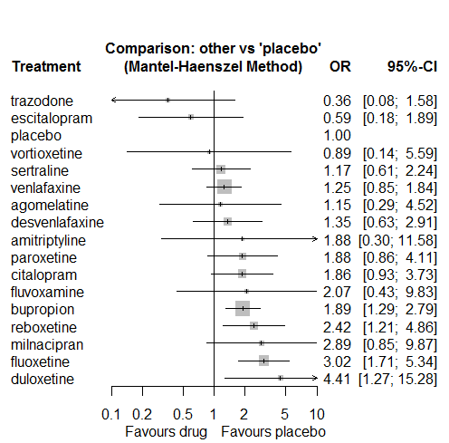

P-score

trazodone 0.93

escitalopram 0.86

placebo 0.75

vortioxetine 0.68

sertraline 0.66

venlafaxine 0.62

agomelatine 0.62

desvenlafaxine 0.57

amitriptyline 0.44

paroxetine 0.41

citalopram 0.41

fluvoxamine 0.39

bupropion 0.39

reboxetine 0.27

milnacipran 0.23

fluoxetine 0.16

duloxetine 0.11

## **Sensitivity analysis: splitting nodes according to dosage**

All treatment arms for drug X, with dose_intended_min equal to or smaller to the minimum licensed dose were set as “X_L”. All other arms of X are “X_H”. Studies with no information on dose are excluded. Results shown below:

|  |  |  |
| --- | --- | --- |
| **Low dose vs. placebo** | **High dose vs. placebo** | **High dose vs. low dose** |
|  |  |  |

# **Withdrawal syndrome**

Only one study reported information on this outcome.

Higuchi2011 (PCR112810, NCT00866294)

No meta-analysis was performed.

## C:\Users\efthimiou\Google Drive\PROJECT\APPLIED PROJECTS\Martha\data\results\heatmap.tiff